El Cerrito Richmond Fire Data Analysis

Ira Sharenow

2025-07-30

## Introduction

This report is a follow up of my report on the El Cerrito California Fire Department. In that report, I noted that two of the three departments under the auspices of the El Cerrito fire department had very low incident totals, so I questioned whether those low levels were unusual. To improve my understanding, I decided to look at El Cerrito’s neighbor, Richmond.

I gave some extra attention to the Emergency Medical Services (321) code, given that it is the largest segment of calls and is very important.

What follows are tables and charts that explore the workload and response times of the two fire departments during calendar year 2024.

## Part 1: Demographic and Incident Data

Richmond has significantly more land area and population per station than El Cerrito.

| **Table 1. Geographic and Population Overview** | | | | | |
| --- | --- | --- | --- | --- | --- |
| **Area** | **Population** | **Land Area (sq mi)** | **Fire Stations** | **Sq mi per Station** | **People per Station** |
| El Cerrito + Kensington | 30,584 | 4.6 | 3 | 1.5 | 10,195 |
| Richmond | 116,448 | 30.0 | 7 | 4.3 | 16,635 |

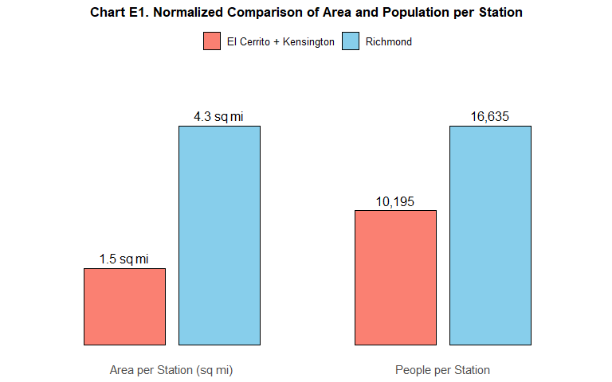

The two El Cerrito stations which are in the hills handled significantly fewer incidents than the other stations. The three El Cerrito fire stations, on average, handled significantly fewer incidents than the Richmond stations.

| **Table E3. Incident and 321 Call Counts by Station (2024)** | | | |
| --- | --- | --- | --- |
| **Station** | **Incidents** | **321 Calls** | **% 321** |
| 67 | 2,708 | 1,467 | 54.2% |
| 68 | 2,641 | 1,467 | 55.5% |
| 51 | 2,576 | 587 | 22.8% |
| 64 | 2,555 | 1,277 | 50.0% |
| 62 | 1,713 | 899 | 52.5% |
| 66 | 1,622 | 816 | 50.3% |
| 61 | 1,117 | 613 | 54.9% |
| 63 | 717 | 479 | 66.8% |
| 55 | 711 | 281 | 39.5% |
| 52 | 582 | 196 | 33.7% |

| **Table E3 (Grouped). Incident Totals and Averages by Fire Agency (2024)** | | | |
| --- | --- | --- | --- |
| **Agency** | **Incidents** | **Stations** | **Avg per Station** |
| El Cerrito | 3,869 | 3 | 1,289.7 |
| Richmond | 13,073 | 7 | 1,867.6 |

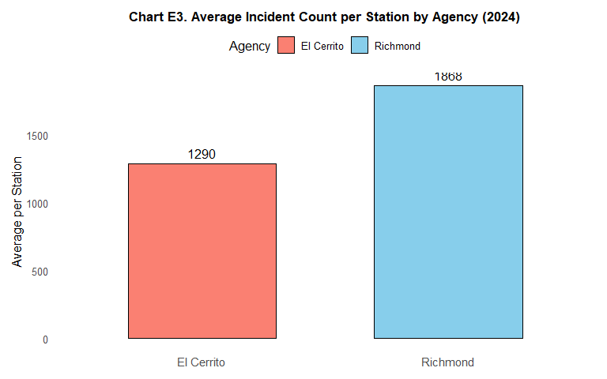

There is a mutual aid agreement between El Cerrito and Richmond. The El Cerrito stations participate in far more incidents in Richmond than vice versa.

| **Table E4. Incident Counts by Station and Incident City (2024)** | | | | | |
| --- | --- | --- | --- | --- | --- |
| **Station** | **El Cerrito** | **Kensington** | **Other** | **Richmond** | **Total** |
| Total | 2,966 | 487 | 1,173 | 12,316 | 17,551 |
| 67 | 1 | 1 | 9 | 2,697 | 2,775 |
| 68 | 1 | 0 | 555 | 2,085 | 2,709 |
| 51 | 1,967 | 38 | 55 | 516 | 2,627 |
| 64 | 147 | 1 | 8 | 2,399 | 2,619 |
| 62 | 0 | 0 | 119 | 1,594 | 1,775 |
| 66 | 125 | 46 | 93 | 1,358 | 1,688 |
| 61 | 0 | 2 | 3 | 1,112 | 1,178 |
| 63 | 0 | 0 | 267 | 450 | 780 |
| 55 | 294 | 371 | 37 | 9 | 766 |
| 52 | 431 | 28 | 27 | 96 | 634 |

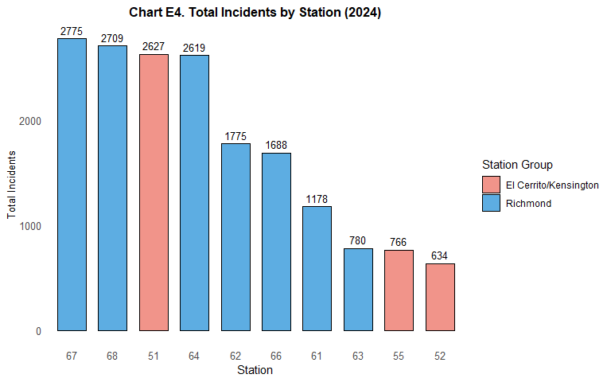

## Part 2: Response Times

It appears that response times in Kensington are slower that in El Cerrito and Richmond. This may be due to the hilly and curved roads, but warrants further investigation.

| **Chart E5. Response Time Percentiles for All Incidents (First-Arriving Unit, 2024)** | | | | | |
| --- | --- | --- | --- | --- | --- |
| **City** | **25th %ile** | **Median** | **90th %ile** | **95th %ile** | **Incidents** |
| El Cerrito | 5.6 | 7.0 | 13.2 | 17.1 | 2,492 |
| Kensington | 7.5 | 9.1 | 13.3 | 18.9 | 457 |
| Richmond | 6.2 | 7.8 | 11.3 | 12.8 | 10,162 |

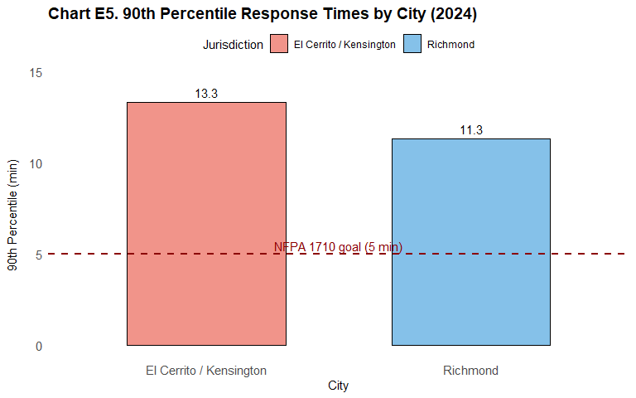

| **Table E6. Response Time Percentiles for 321 Incidents (First-Arriving Unit, 2024)** | | | | | |
| --- | --- | --- | --- | --- | --- |
| **City** | **25th %ile** | **Median** | **90th %ile** | **95th %ile** | **Incidents** |
| El Cerrito | 5.4 | 6.6 | 9.6 | 10.6 | 885 |
| Kensington | 7.1 | 8.8 | 11.4 | 12.8 | 212 |
| Richmond | 6.6 | 8.2 | 11.5 | 12.9 | 6,495 |

