# GitHub Blog Post – El Cerrito Police Incident Analysis (2019–2025)

I have completed a detailed analysis of police incident patterns in El Cerrito using data from 2019 through March 2025. The report examines the number, type, and location of incidents, with geographic visualizations showing where incidents are most concentrated.  
  
One of the most notable findings is the high concentration of incidents along San Pablo Avenue, including the proposed site for the new library, which stands out as a significant hotspot. Seasonal variations are relatively small, while incident counts dropped during the COVID years (2020–2022).  
  
### Citywide Incident Heatmap  
*Darker areas indicate higher concentrations of incidents.*

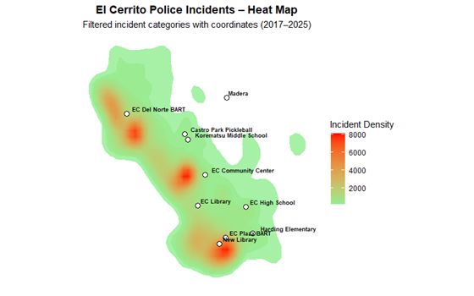

📄 Full Report: https://github.com/IraSharenow100/el-cerrito-police-report/raw/main/el-cerrito-police-report.docx  
  
📧 Contact: irasharenow100@gmail.com