El Cerrito Police Incident Analysis — Starter + Globals

Ira Sharenow

August 7, 2025

# 1) Libraries

# 1a) Global ggplot theme (charts & heat maps)

## Introduction

First I would like to thank the El Cerrito Police Department for providing police incident data from January 1, 2019-June 30, 2025. But be sure to read the technical note to see how I cleaned the data.

I have two goals for this project. One goal is to provide standard summary statistics such as number of incidents, seasonality, and so forth. The other goal is to focus in on specific landmarks. In particular, El Cerrito residents are debating whether to spend millions of dollars per year to move the library t an area near El Cerrito Plaza. Main points have been made on both sides of the issue. This report looks at police incident data, which no one else ha looked at so far.

I many case, there will be a chart and a table accompanied by a small amount of text.

All data hotspots

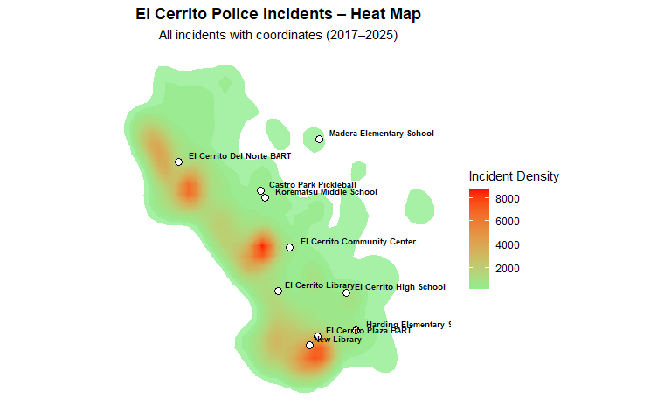

| Landmark | Incident Count (within 500 ft) |
| --- | --- |
| New Library | 1,891 |
| El Cerrito Library | 423 |
| El Cerrito High School | 413 |
| El Cerrito Community Center | 302 |
| Harding Elementary School | 289 |
| El Cerrito Plaza BART | 279 |
| El Cerrito Del Norte BART | 255 |
| Castro Park Pickleball | 189 |
| Korematsu Middle School | 186 |
| Madera Elementary School | 149 |