El Cerrito Police Incident Analysis — Starter + Globals

Ira Sharenow

August 7, 2025

## Introduction

First I would like to thank the El Cerrito Police Department for providing police incident data from January 1, 2019-June 30, 2025. But be sure to read the technical note to see how I cleaned the data.

I have two goals for this project. One goal is to provide standard summary statistics such as number of incidents, seasonality, and so forth. The other goal is to focus in on specific landmarks. In particular, El Cerrito residents are debating whether to spend millions of dollars per year to move the library t an area near El Cerrito Plaza. Main points have been made on both sides of the issue. This report looks at police incident data, which no one else ha looked at so far.

I many case, there will be a chart and a table accompanied by a small amount of text.

All data hotspots

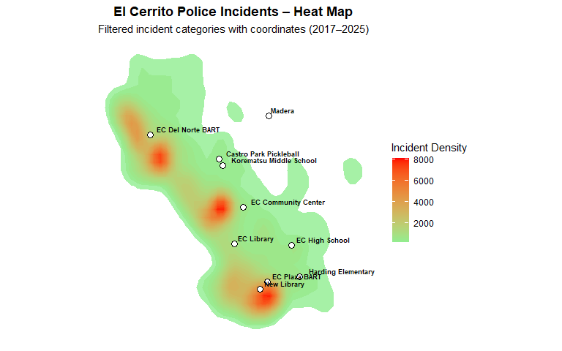

| Landmark | Incident Count (within 500 ft) |
| --- | --- |
| New Library | 1,547 |
| EC Library | 292 |
| EC High School | 265 |
| EC Del Norte BART | 214 |
| EC Community Center | 213 |
| Harding Elementary School | 211 |
| EC Plaza BART | 179 |
| Korematsu Middle School | 120 |
| Castro Park Pickleball | 114 |
| Madera | 55 |

Incident Counts by Type — New vs Current Library Sites (within 500 ft)

| call_for_service | New Library Site | Current Library Site |
| --- | --- | --- |
| unwant - unwanted person | 480 | 24 |
| 488 - petty theft | 416 | 16 |
| 415 - disturbance | 124 | 48 |
| parker - parking violation | 107 | 81 |
| 1154 - suspicious vehicle | 78 | 61 |
| 1053 - person down | 49 | 3 |
| 459a - auto burglary | 39 | 8 |
| 243a - assault / battery | 38 | 4 |
| 594 - vandalism | 34 | 4 |
| 10851 - motor vehicle theft | 27 | 10 |
| 211a - business hold up/robbery alarm | 25 | 0 |
| 211 - robbery | 22 | 1 |
| 487 - grand theft | 17 | 5 |
| 314 - indecent exposure | 12 | 3 |
| 417 - brandishing | 11 | 1 |
| 1051 - drunk / intoxicated | 10 | 2 |
| 422 - criminal threats | 9 | 1 |
| 459c - commercial burglary | 9 | 1 |
| fight - physical fight | 8 | 0 |
| 10851r - recovered stolen vehicle | 5 | 1 |
| 1027 - wanted person / warrant | 4 | 3 |
| 459r - residential burglary | 4 | 1 |
| 245 - assault with a deadly weapon | 3 | 0 |
| loiter - loitering | 3 | 0 |
| sfrmc - shots fired | 3 | 2 |
| 1179 - accident w/ medical routed | 2 | 2 |
| 459 - burglary (misc) | 2 | 0 |
| hs - narcotics use/possession | 2 | 1 |
| 207 - kidnapping | 1 | 0 |
| 215 - car jacking | 1 | 0 |
| 246 - shooting into a dwelling | 1 | 1 |
| 647b - prostition | 1 | 0 |
| 10852 - vehcile parts theft | 0 | 4 |
| 148.1 - bomb threat | 0 | 1 |
| 247b - shooting into an unoccupied vehicle | 0 | 1 |
| stalk - stalking | 0 | 2 |

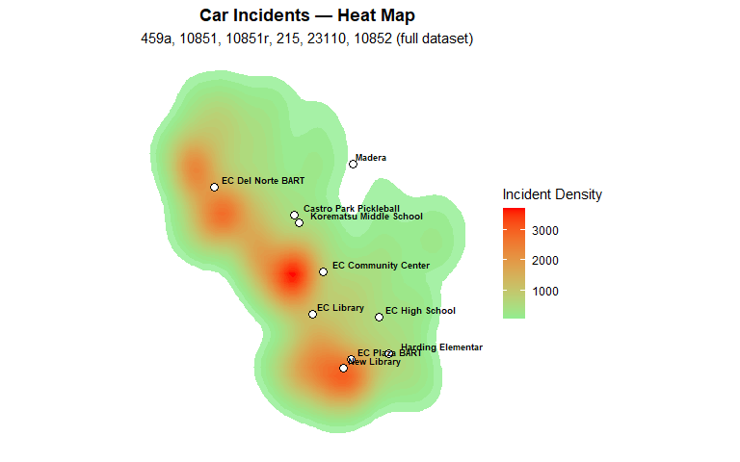

Car Incidents within 500 ft of Each Landmark (descending)

| Landmark | Incidents within 500 ft |
| --- | --- |
| New Library | 72 |
| EC Library | 23 |
| EC Plaza BART | 21 |
| EC Community Center | 21 |
| Harding Elementary School | 18 |
| EC High School | 11 |
| EC Del Norte BART | 9 |
| Castro Park Pickleball | 3 |
| Korematsu Middle School | 3 |
| Madera | 1 |

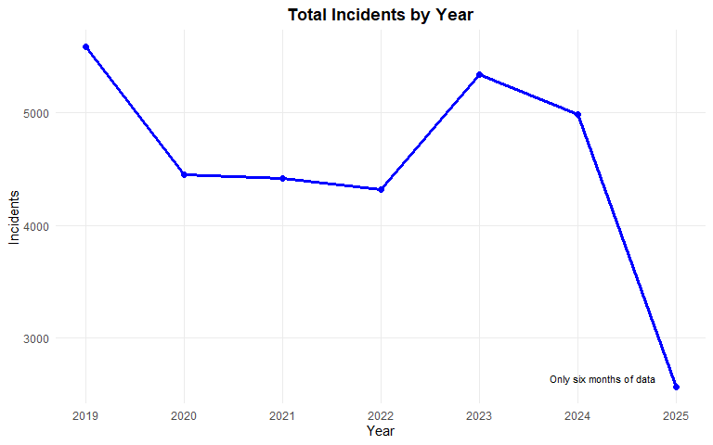

Total Police Incidents by Year

| **Year** | **Incidents** |
| --- | --- |
| 2019 | 5,582 |
| 2020 | 4,449 |
| 2021 | 4,417 |
| 2022 | 4,314 |
| 2023 | 5,342 |
| 2024 | 4,988 |
| 2025 | 2,567 |
| 2025 is Jan–Jun only. | |

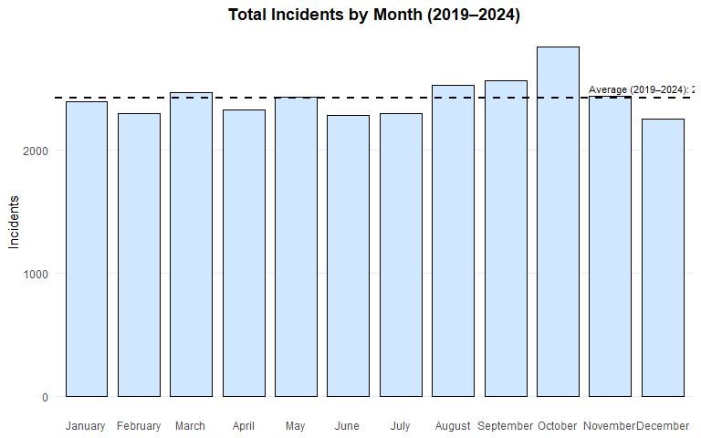

Total Incidents by Month (2019–2024)

| Month | Incidents |
| --- | --- |
| January | 2395 |
| February | 2294 |
| March | 2466 |
| April | 2327 |
| May | 2432 |
| June | 2280 |
| July | 2295 |
| August | 2526 |
| September | 2563 |
| October | 2833 |
| November | 2433 |
| December | 2248 |
| Average (2019–2024) | 2424 |
| Note: 2025 excluded (only half year available). | |

## ✅ Exported 31659 rows for Tableau.