El Cerrito Police Incident Analysis 2019-2025

Ira Sharenow

August 11, 2025

## Introduction

First I would like to thank the El Cerrito Police Department for providing police incident data from January 1, 2019-June 30, 2025. But be sure to read the technical note to see how I cleaned the data.

I have two goals for this project. One goal is to provide standard summary statistics such as number of incidents, seasonality, and so forth. The other goal is to focus in on specific landmarks. In particular, El Cerrito residents are debating whether to spend millions of dollars per year to move the library to an area near El Cerrito Plaza. Many points have been made on both sides of the issue. This report looks at police incident data, which no one else has looked at so far.

In many cases, there will be a chart and a table accompanied by an explanation.

**Main takeaways**  
– Incident counts vary considerably by location with a large number near San Pablo Avenue.  
– The proposed new library location is a significant incident hotspot.  
– Incident counts declined considerably during the Covid years of 2020-2022.  
– There is not much seasonal variability.

**Heatmap of Police Incidents Hotspots**

The first chart is a heatmap which shows the relative frequencies of incidents in the different parts of El Cerrito. In addition, I chose a number of landmarks which I thought would be of interest to El Cerrito residents. Interestingly, the chart and the first table show that the proposed location for a new library had significantly more incidents than any of the other landmarks.  
Given the significance of the proposed library site, I further explored and listed the counts of the types of incidents near the proposed library site and compared to the current site.

The counts are within 500 feet of each landmark.

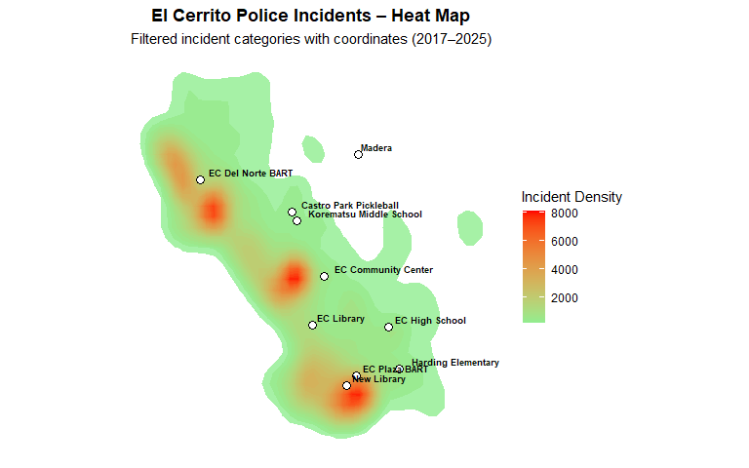

Incident Counts within 500 ft of Each Landmark

| **Landmark** | **Incidents within 500 ft** |
| --- | --- |
| New Library | 1,547 |
| EC Library | 292 |
| EC High School | 265 |
| EC Del Norte BART | 214 |
| EC Community Center | 213 |
| Harding Elementary School | 211 |
| EC Plaza BART | 179 |
| Korematsu Middle School | 120 |
| Castro Park Pickleball | 114 |
| Madera | 55 |

Incident Counts by Type — New vs Current Library Sites (within 500 ft)

| **Incident Type** | **New Library Site** | **Current Library Site** |
| --- | --- | --- |
| unwant - unwanted person | 480 | 24 |
| 488 - petty theft | 416 | 16 |
| 415 - disturbance | 124 | 48 |
| parker - parking violation | 107 | 81 |
| 1154 - suspicious vehicle | 78 | 61 |
| 1053 - person down | 49 | 3 |
| 459a - auto burglary | 39 | 8 |
| 243a - assault / battery | 38 | 4 |
| 594 - vandalism | 34 | 4 |
| 10851 - motor vehicle theft | 27 | 10 |
| 211a - business hold up/robbery alarm | 25 | 0 |
| 211 - robbery | 22 | 1 |
| 487 - grand theft | 17 | 5 |
| 314 - indecent exposure | 12 | 3 |
| 417 - brandishing | 11 | 1 |
| 1051 - drunk / intoxicated | 10 | 2 |
| 422 - criminal threats | 9 | 1 |
| 459c - commercial burglary | 9 | 1 |
| fight - physical fight | 8 | 0 |
| 10851r - recovered stolen vehicle | 5 | 1 |
| 1027 - wanted person / warrant | 4 | 3 |
| 459r - residential burglary | 4 | 1 |
| 245 - assault with a deadly weapon | 3 | 0 |
| loiter - loitering | 3 | 0 |
| sfrmc - shots fired | 3 | 2 |
| 1179 - accident w/ medical routed | 2 | 2 |
| 459 - burglary (misc) | 2 | 0 |
| hs - narcotics use/possession | 2 | 1 |
| 207 - kidnapping | 1 | 0 |
| 215 - car jacking | 1 | 0 |
| 246 - shooting into a dwelling | 1 | 1 |
| 647b - prostition | 1 | 0 |
| 10852 - vehcile parts theft | 0 | 4 |
| 148.1 - bomb threat | 0 | 1 |
| 247b - shooting into an unoccupied vehicle | 0 | 1 |
| stalk - stalking | 0 | 2 |
| Counts within 500 ft of each library site; dataset reflects filtered incident categories. | | |

**Heatmap of Car Realted Incidents**

There is considerable community interest in car related incidents, so I created a heatmap of car related incidents and a table of counts by landmark.  
Please see the appendix for a list of car incident types.

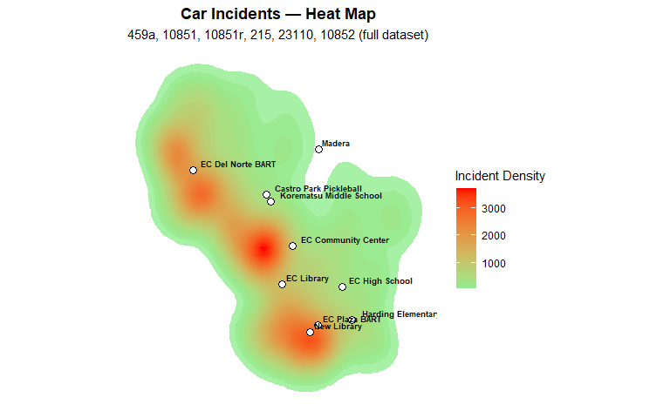

Car Incidents within 500 ft of Each Landmark (descending)

| **Landmark** | **Incidents within 500 ft** |
| --- | --- |
| New Library | 72 |
| EC Plaza BART | 21 |
| EC Community Center | 19 |
| EC Library | 19 |
| Harding Elementary School | 17 |
| EC Del Norte BART | 9 |
| EC High School | 7 |
| Castro Park Pickleball | 2 |
| Korematsu Middle School | 2 |
| Madera | 1 |
| Includes: 459a, 10851, 10851r, 215, 23110, 10852. Distances computed from landmark coordinates. | |

**Incidents by Year**

Chart 3 clearly shows the reduced incident counts during the Covid years of 2020-2022. During those years the police department was short-staffed, so it is not clear if crime was down or the ability of the department was diminished or both. I leave it to others to investigate that point.

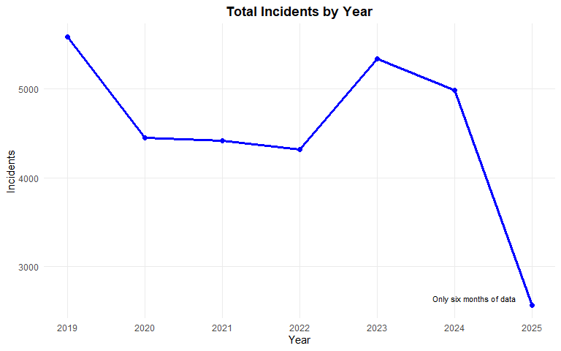

Total Police Incidents by Year

| **Year** | **Incidents** |
| --- | --- |
| 2019 | 5582 |
| 2020 | 4449 |
| 2021 | 4417 |
| 2022 | 4314 |
| 2023 | 5342 |
| 2024 | 4988 |
| 2025 | 2567 |
| 2025 is Jan–Jun only. | |

**Incidents by Month**

Chart 4 is incident by month. Since I only had data for the first six months of 2025, I did not use the 2025 data for this chart. The chart shows that incident counts are fairly similar throughout the year.

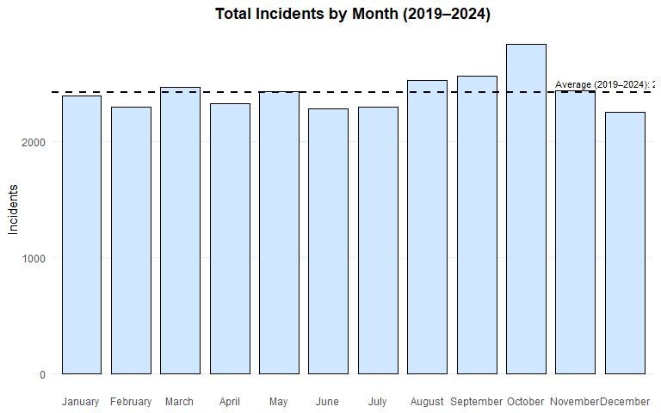

Total Incidents by Month (2019–2024)

| **Month** | **Incidents** |
| --- | --- |
| January | 2395 |
| February | 2294 |
| March | 2466 |
| April | 2327 |
| May | 2432 |
| June | 2280 |
| July | 2295 |
| August | 2526 |
| September | 2563 |
| October | 2833 |
| November | 2433 |
| December | 2248 |
| Average (2019–2024) | 2424 |
| Note: 2025 excluded (only half year available). | |

## Appendix

### Technical Note

I originally received the El Cerrito Police Department data in a PDF format, so I used Excel/Get Data (aka Power Query) to read the data into Excel. There was further clean up with Power Query.  
Then I read the data into R. I use RStudio and the tidyverse.  
I then made decisions on what to exclude. I excluded data that did not have a full address. In particular addresses such as “San Pablo Avenue” were excluded. I also limited the types of incidents to the ones listed below.

### Included Incident Types

These are the included incident types. The notation comes straight from the El Cerrito Police Department data.  
Incident Types  
unwant - unwanted person  
415 - disturbance  
488 - petty theft  
parker - parking violation  
1154 - suspicious vehicle  
459a - auto burglary  
10851 - motor vehicle theft  
594 - vandalism  
1053 - person down  
243a - assault / battery  
487 - grand theft  
211 - robbery  
417 - brandishing  
1179 - accident w/ medical routed  
422 - criminal threats  
314 - indecent exposure  
hs - narcotics use/possession  
10851r - recovered stolen vehicle  
215 - car jacking  
23110 - throwing objects at a vehicle  
459c - commercial burglary  
459r - residential burglary  
fight - physical fight  
sfrmc - shots fired  
211a - business hold up/robbery alarm  
10852 - vehcile parts theft  
dopers - narcotic sales  
1027 - wanted person / warrant  
148.1 - bomb threat  
stalk - stalking  
496 - stolen property  
245 - assault with a deadly weapon  
1071 - shooting (actual victim)  
1051 - drunk / intoxicated  
207 - kidnapping  
mgun - person with a gun  
loiter - loitering  
459 - burglary (misc)  
1070 - prowler  
647b - prostitution  
243.4 - sexual battery / assault  
370 - public nuisance  
22810 - assault with pepper spray / tear gas  
246 - shooting into a dwelling  
247b - shooting into an unoccupied vehicle  
220 - assault with intent to rape or rob  
1075 - shots fired (shotspotter)

### Automobile Related Incident Types

459a - auto burglary  
10851 - motor vehicle theft  
10851r - recovered stolen vehicle  
215 - car jacking 23110 - throwing objects at a vehicle  
10852 - vehicle parts theft