

BOOKSTORE MANAGEMENT SYSTEM

WEBTECHNOLOGY FINAL PROJECT

Done By

Iradukunda Lea, 23279

Major in

Information Management

16/052023

**Book Store Management System**

**Introduction**

A bookstore management system is a computer software designed to manage and organize books in a library or bookstore. It provides a user-friendly interface for librarians or bookstore staff to add, update, delete, retrieve and search the books in the system's database.

With this system, bookstore staff can easily add new books to the database by entering the book's information, such as title, author, publisher, and name. They can also update existing books' information.

Moreover, the bookstore management system allows bookstore staff to delete books from the database when necessary. This feature is particularly useful when a book is lost, damaged, or outdated.

Overall, a bookstore management system streamlines the book management process, reducing the workload of bookstore staff and ensuring that the books are always up-to-date and well-organized.

1. **Project requirements**

**Functional requirements**

* The user shall be able to create an account.
* The user shall be able to login to the system.
* The user shall be able to record books in system.
* The user shall be able to update books on the system.
* The user shall be able to delete books from the system.
* The user shall be able to view all books in the system.
* The user shall be able to buy books.
* The user shall be able to borrow books.

**Non -Functional requirements**

* Performance
* The system must support 4,500 users per hour
* The system must provide 6 second or less response time in a chrome desktop browser.
* Portability
* The must be run on window 10 or window 11 and Linux without change in its behavior
* Reliability
* The System must perform without failure in 95 percent of use cases during a month
* Maintainability
* The mean time to restore the system (MTTRS) following a failure must not be greater 10 minutes.
* Security
* All data inside the system shall be protected against malware attacks or unauthorized access

**The purpose of the project**

A bookstore management system is a software application designed to manage and organize books in a library or a personal collection. The purpose of a book store management system is to provide a centralized database for storing information about books, including titles, authors, publication dates, ISBN numbers, and other relevant details. Some common purposes of a book management system include:

Efficient organization: By using a bookstore management system, users can efficiently organize their books in a way that makes them easy to find and manage. The system can be used to track which books are checked out, which books are available, and which books are in need of repair or replacement.

Accurate inventory management: Bookstore management systems help keep track of the books in a library or personal collection. Users can easily see how many copies of a book they have, which books are in stock, and which books have been lost or damaged.

Easy access to information: With a bookstore management system, users can quickly find information about books, including author, title, publication date, and other details. They can also view book reviews and ratings from other users, helping them make informed decisions about which books to read.

Enhanced security: Book management systems can help improve security by tracking who has checked out a book and when it is due to be returned. This can help prevent theft and ensure that books are returned on time.

Improved circulation: A bookstore management system can help streamline the circulation process, making it easier for users to check out and return books. This can help improve overall efficiency and ensure that books are always available for those who need them.

Overall, the purpose of a book management system is to make it easier to manage, organize, and access books. By providing a centralized database for storing information, users can quickly and efficiently find the books they need and manage their collections more effectively.

**Outcomes**

A bookstore management system can bring several outcomes, including:

Efficient management of books: A bookstore management system allows librarians, book collectors, and individuals to manage books efficiently, enabling them to track books, issue new books, and return books quickly.

Improved access to information: With a bookstore management system, users can access information about books quickly, including author, publisher, publication date, and other relevant details. This can help users make informed decisions about which books to read and help librarians assist patrons in finding the books they need.

Enhanced security: A bookstore management system helps improve security by tracking which books have been checked out and who has them. It can help prevent theft and ensure that books are returned on time.

Accurate inventory management: A book management system provides accurate information about the books in a collection, including how many copies are available, which books are checked out, and which books need repair or replacement.

Improved circulation: A bookstore management system can help streamline the circulation process, making it easier for users to check out and return books. This can improve overall efficiency and ensure that books are always available for those who need them.

Better budget management: A bookstore management system can help organizations manage their budgets more effectively by providing information about which books are most popular, which books are in demand, and which books are not being used.

Improved patron experience: A bookstore management system can help librarians provide a better experience for patrons by quickly finding and issuing books, providing accurate information about books, and ensuring that the collection is well-maintained and up-to-date.

**Limitations**

While a bookstore management system can provide many benefits, there are also some potential constraints that users may face. Some common constraints of a book management system include:

Cost: Implementing a bookstore management system can be costly, especially for libraries and organizations with large collections of books. The cost includes the purchase of the software, hardware, and training of staff to use the system.

Technical expertise: A bookstore management system may require technical expertise to install and maintain the system. Users may need to hire a specialist or dedicate resources to ensure that the system is running efficiently.

Limited customization: Depending on the system used, there may be limited customization options available. Users may be restricted to a specific layout, format, or features, limiting the flexibility of the system.

Data accuracy: The accuracy of the data entered into the system is critical to the success of the book management system. If data is entered incorrectly, it can lead to inaccurate information about books, leading to issues such as lost or missing books or incorrect circulation records.

1. **Project Plan**

**Resources**

Implementing a bookstore management system requires several resources, including:

Hardware: A bookstore management system typically requires computer hardware, including servers, workstations, and a laptop to store and access data.

Time: Implementing a bookstore management system can take time. The time required will depend on the size of the collection and the complexity of the system.

Software: A bookstore management system requires an IDE where to write codes.

**Scope of project**

With this system, bookstore staff can easily add new books to the database by entering the book's information, such as title, author, publisher, and name. They can also update existing books' information.

Moreover, the book management system allows bookstore staff to delete books from the database when necessary. This feature is particularly useful when a book is lost, damaged, or outdated.

Overall, a book management system streamlines the book management process, reducing the workload of bookstore staff and ensuring that the books are always up-to-date and well-organized.

**Timeline**

The project took 2 weeks and some days:

Week 1: Planning and requirements gathering, design.

Week2: Implementation, Testing and deployment.

**DATABASE SCHEMA**

**ERD DIAGRAM**

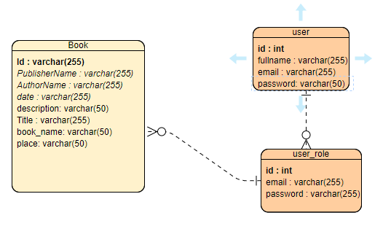

**TECHNICAL DOCUMENTATION**

Architecture

* The bookstore management system follow the Model-View-Controller (MVC) architectural pattern
* The backend is implemented using Java programming language and Spring boot framework
* The frontend is developed using HTML, CSS and JavaScript

Development Environment

* Operating system: Windows 10
* IDE: Visual studio code
* Database: MySQL

Backend Implementation

* The backend is implemented using Java and Spring boot
* The project is organized into different packages such as controllers, services, models and repositories.
* Data persistence is achieved using HTML, CSS and JavaScript
* Input validation and error handling are implemented using Spring validation and exception handling mechanisms

Frontend Implementation

* The frontend is developed using HTML, CSS and JavaScript
* Thyme leaf template engine is used for server-side rendering of dynamic webpages
* Bootstrap is used for responsive
* Client-side form validation is implemented using JavaScript

Database Implementation

* The database is implemented using MySQL
* The database Schema is used to store student information and their login credentials

Security

* User authentication and authorization are implemented using spring security
* Access control is enforced based on user role and permission

Deployment

* Configuration files such as application.properties is used to specify database connection settings and other system properties.

Testing

* Integration testing is conducted to test the interaction between different pages of the system.

**USER DOCUMENTATION**

My project of bookstore management system if you run it its starts on home page and you choose button of login when you have an account if not you Sign up and then you login to our system and you add book and after you can updating and deleting book in the system and then after registering the book you view the list that displayed from database and also you can search the book stored in the system.

1. First page

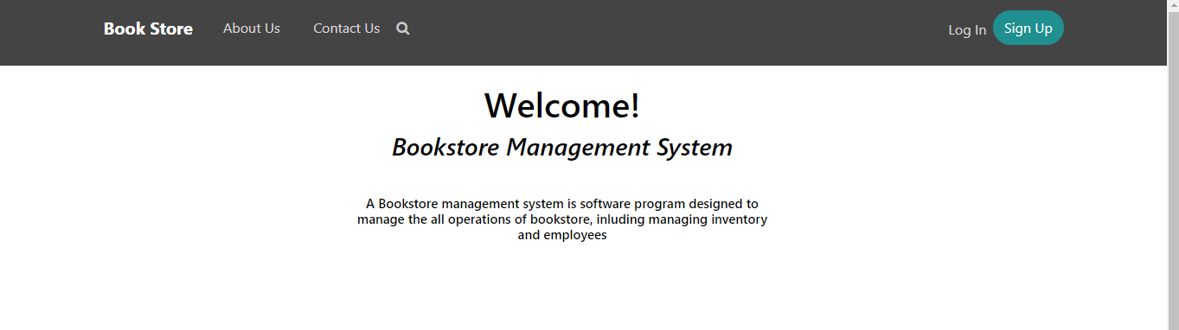

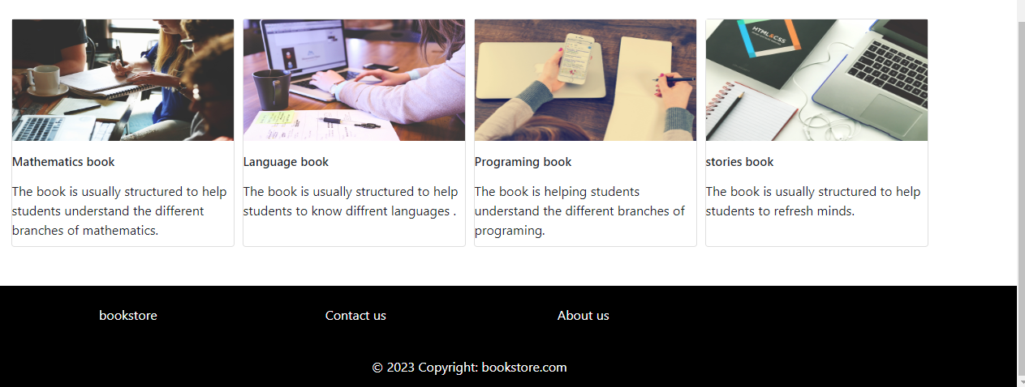

**Login form**

You login using credential from database you use from creating any account.

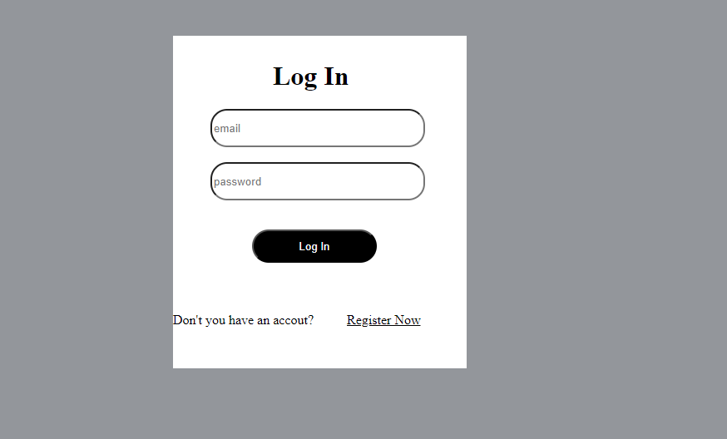

**Sign up form**

You have to register your self in the system

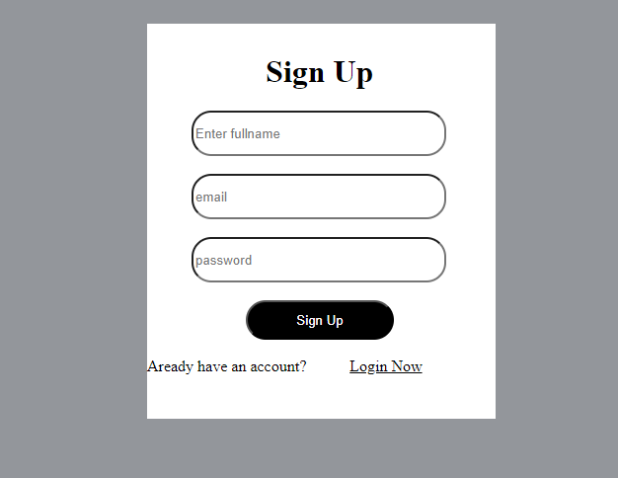

**Record book**

**This the dashboard to record book**

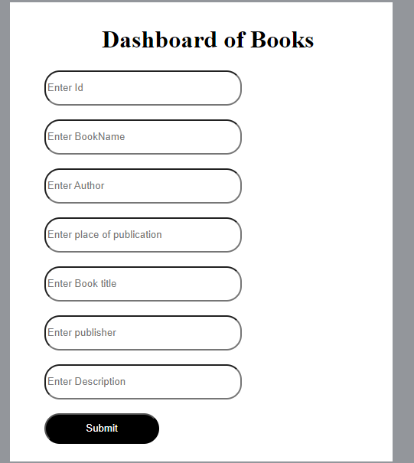

**View list**

This where you view the book from database and you can search the book you want

