Power BI ETL Process Documentation

# Introduction

The ETL (Extract, Transform, Load) process is essential for data cleaning and transformation in Power BI.This process allows users to extract data from various sources, transform it into a usable format, and load it into Power BI for analysis and reporting.

# Loading the CSV File

1. Open Power BI Desktop.
2. Click on 'Get Data'.
3. Select 'CSV' from the options.
4. Navigate to the location of the CSV file and select it.
5. Click 'Open' to load the data into Power BI.

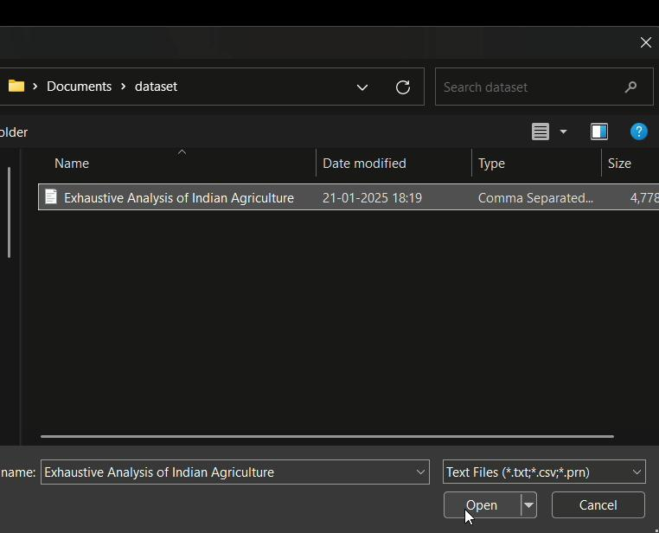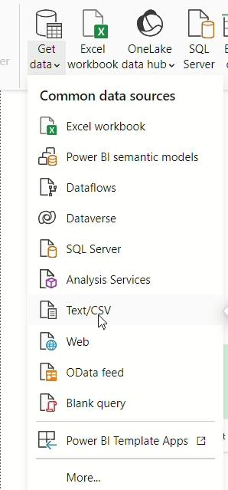

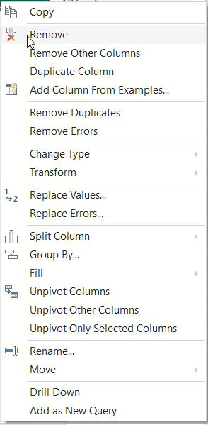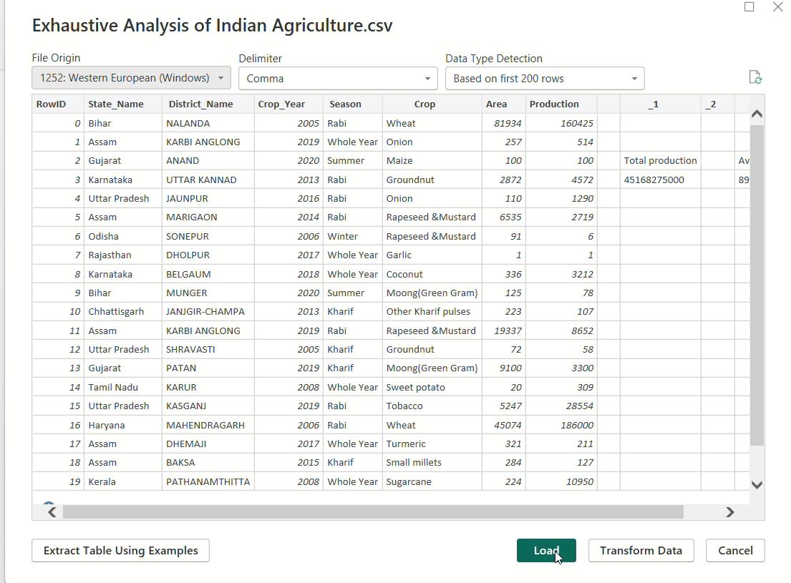

# Removing a Column

1. In the Power Query Editor, select the 'Data' tab.
2. From the 'Applied Steps' panel, click on 'Transform Data' to open the query editor.
3. Locate the column you want to remove.
4. Right-click the column header and select 'Remove'.
5. Alternatively, you can select the column, go to the 'Home' tab, and click 'Remove Columns'.
6. After the transformation, click 'Close & Apply' to load the data into Power BI.

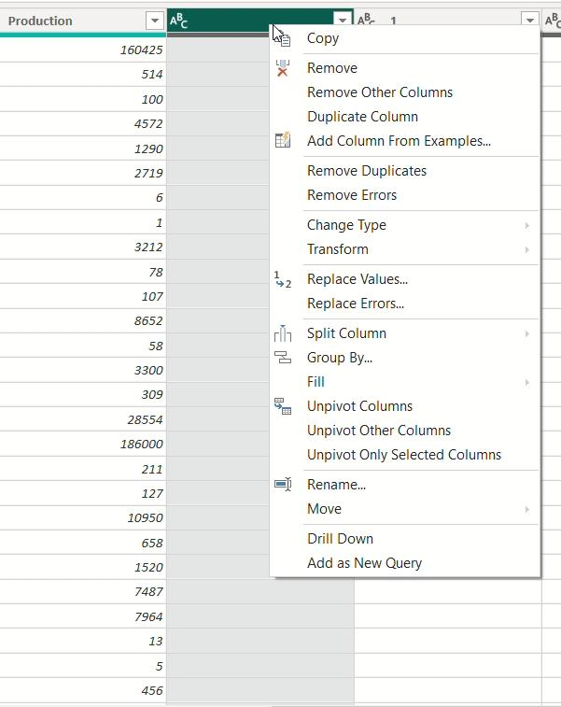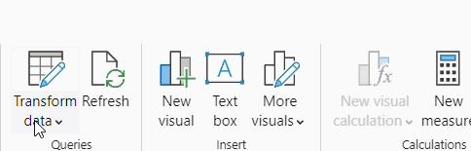

**4.Steps to Check and Ensure Column Quality:**

1. In the Power Query Editor, navigate to the ‘View’ tab in the ribbon.
2. Check the options ‘Column Quality’ to enable them.
3. Review the quality metrics for each column to identify errors, empty values, or inconsistencies.

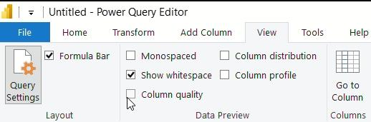



# 5.Steps to Change Column Datatype:

# In the Power Query Editor, locate the column you wish to change.

# Click the small icon on the left of the column header that indicates its current data type.

# From the dropdown menu, select the desired data type (e.g., Text, Number, Date).

# After completing all necessary transformations, click the ‘Close & Apply’ button to apply all changes.

# 