PROTECTING RENTERS ORDINANCE
Junk Fee Policy Design: What Other Cities Did, What Happened, and What Chicago Should Do
Jurisdictional Analysis | Cap vs. Ban | Policy Recommendations

Prepared for the Chief of Policy
Office of the Mayor, City of Chicago
April 2026 | RLTO Reform (Component 01)
CONFIDENTIAL AND PRE-DECISIONAL

Executive Summary
This memo examines how U.S. jurisdictions have regulated rental junk fees, what happened after they did, and what the evidence implies for Chicago's RLTO Reform under the Protecting Renters Ordinance (PRO). The central design question, whether to cap fees or ban them, has now been tested in real markets for long enough to draw inferences. This analysis synthesizes statutory text from eleven state laws, four municipal ordinances, two federal enforcement actions totaling $72 million, and the longest available panel of market-rent data (StreetEasy, 2012 to 2024) that separates fee-charging from no-fee units.
Three structural findings shape the recommendation. First, the federal backstop does not exist: the FTC's final junk-fees rule (December 2024) excluded rental housing, covering only event tickets and short-term lodging. (FTC Final Rule, 12/2024) Second, the magnitudes are large, not marginal: the Urban Institute documents that non-rent fees add 10 to 30 percent to renters' total monthly costs at large corporate landlords, (Urban Institute, 2024) and the FTC's enforcement actions confirm the upper end (Invitation Homes, $1,700+ per household per year; Greystar, roughly 800,000 units affected). (FTC, 9/2024 and 12/2025) Third, the design choice is determinative: ban jurisdictions show short-term rent pass-through (NYC citywide rents rose 8.2% in the three months after FARE Act took effect; Staten Island rose 16.4% year-over-year), but the only long-run comparative dataset available (StreetEasy, 2012 to 2024) shows no-fee units grew 4.2% annually between 2022 and 2024 versus 6.1% for fee-charging units, reversing the pre-pandemic pattern when the two cohorts grew at statistically indistinguishable rates (2.3% vs. 2.1%, 2012 to 2019).
The evidence supports a layered design: an enumerated fee allowlist (Oregon and Olympia model), an all-in pricing mandate (Colorado 2026 model), portable screening reports (Colorado 2023 model), and a rent-increase frequency limit to manage pass-through. Any single-instrument approach (a standalone cap or a single-fee ban) is vulnerable to the workarounds documented in California, Colorado, and NYC.

1. The Scale of the Problem

1.1 How much of a renter's monthly cost is fees?
The Urban Institute's 2024 review of corporate-landlord leasing practices established the working estimate that non-rent fees add 10 to 30 percent on top of base rent at large operators. (Urban Institute, 2024) For a Chicago household paying the city's median rent of approximately $1,650, that range implies $165 to $495 per month in additional mandatory charges, or $1,980 to $5,940 annually. The Zillow 2024 Consumer Housing Trends Report confirms the prevalence: 58 percent of U.S. renters reported paying a non-rent fee in the prior year, and 79 percent of renters who applied for housing paid an application fee (typical cost $50, range $25 to $250). (Zillow, 2024)
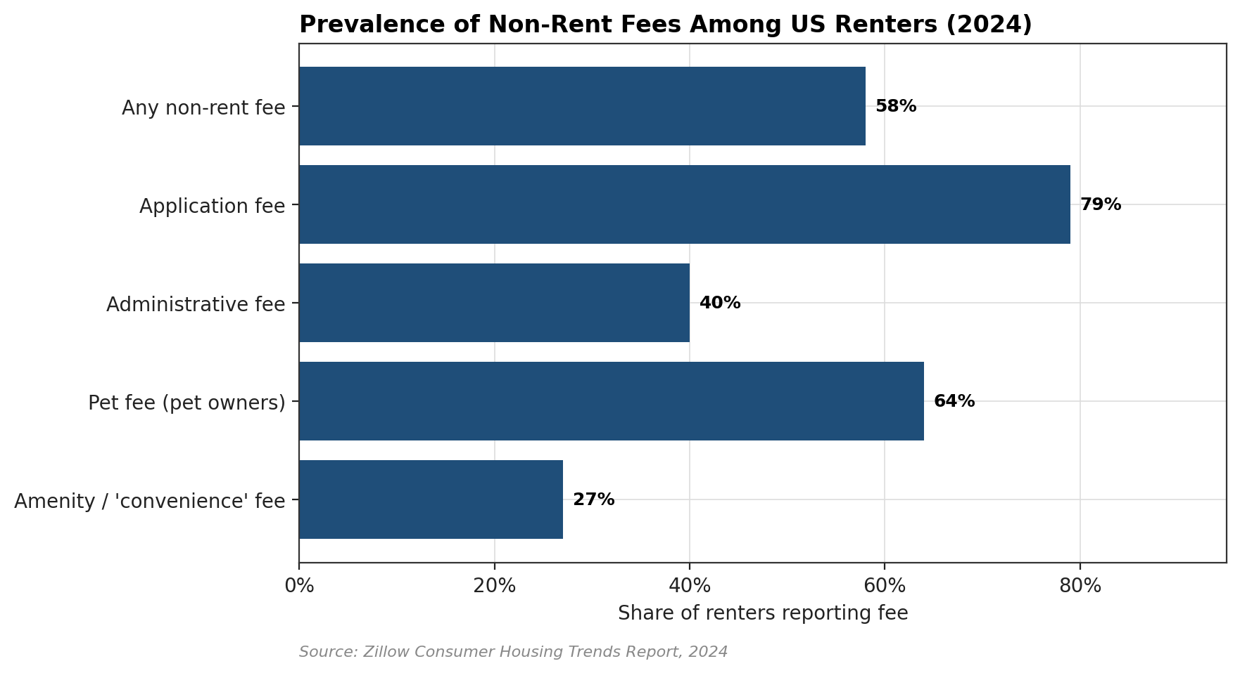
Figure 1. Share of U.S. renters reporting non-rent fees, 2024. Application fees affect nearly four-fifths of renters who apply; pet and administrative fees affect a majority of exposed renters. Source: Zillow Consumer Housing Trends Report, 2024.
The FTC's September 2024 Invitation Homes complaint documented the upper end of this distribution empirically. Invitation Homes, the nation's largest single-family rental operator with roughly 100,000 units, charged undisclosed mandatory fees that in aggregate exceeded $1,700 per household per year across smart-home services, utility management, air-filter replacement, and mandatory internet contracts. (FTC Press Release, 9/2024) The December 2025 Greystar complaint, covering approximately 800,000 units, alleged the same pattern: advertised monthly rents systematically excluded mandatory pest-control, valet-trash, package-concierge, utility-administration, and amenity fees that the company collected from every tenant. Greystar settled for $24 million. (FTC Press Release, 12/2025) Taken together, the two actions establish a $72 million federal enforcement track record in roughly 15 months, across 900,000+ units.
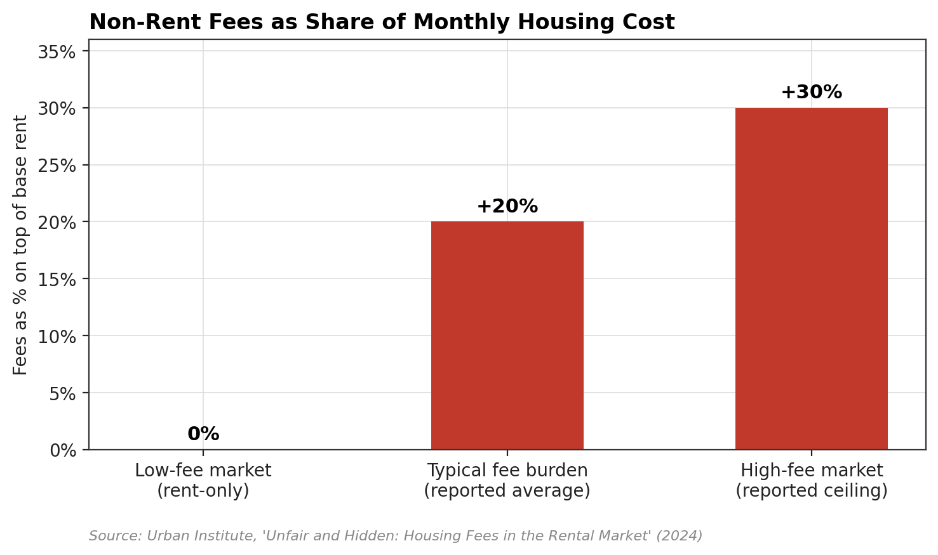
Figure 2. Non-rent fees as a share of monthly housing cost. Urban Institute's documented range of 10 to 30 percent places the median fee burden at roughly 20 percent above base rent for tenants at large corporate operators.

1.2 Why the federal government is not the answer
The FTC's final junk-fees rule (December 2024) was narrowly scoped to 'live-event tickets and short-term lodging,' and explicitly excluded rental housing. (FTC Final Rule, 12/2024) FTC Chairman Andrew Ferguson, in 2025, directed staff to propose a rental-housing-specific rule, but the Administrative Procedure Act notice-and-comment process, historical litigation record, and the rulemaking queue make a 2026 or 2027 implementation unlikely. States and cities remain the binding regulatory layer for the foreseeable future. Cities that do not act in this window default to the policies of large corporate landlords, which the Invitation Homes and Greystar cases document as non-compliant even with existing consumer-protection law.

1.3 Chicago context
Chicago's RLTO has not been substantively updated on fees since 1986. The ordinance requires disclosure of the owner, maintenance of habitability, and regulation of security deposits, but does not enumerate permissible non-rent fees, does not require all-in pricing in advertising, and does not cap application fees. Chicago's renter population is approximately 551,000 households (ACS 5-year 2022), and the city's large professionally managed multifamily stock places it squarely within the jurisdiction where FTC enforcement has documented the highest fee burdens.

2. Jurisdictional Landscape
The National Consumer Law Center's 2024 state tracker identifies 20+ states with some form of rental-fee regulation; the density of activity has accelerated sharply since 2023. (NCLC, 2024) The table below enumerates the eleven statutes and ordinances with the greatest design implications for Chicago, plus four instructive local actions.
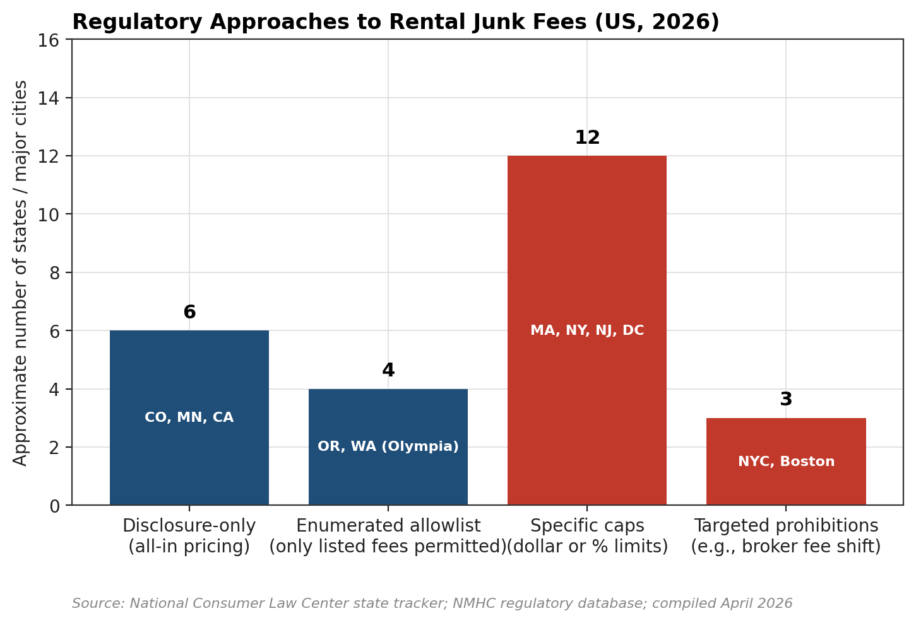
Figure 3. Distribution of U.S. state and major-city regulatory approaches to rental junk fees. Specific caps remain the most common instrument, but enumerated-allowlist models (the most workaround-resistant design) are the fastest-growing category. Sources: NCLC state tracker; NMHC regulatory database.
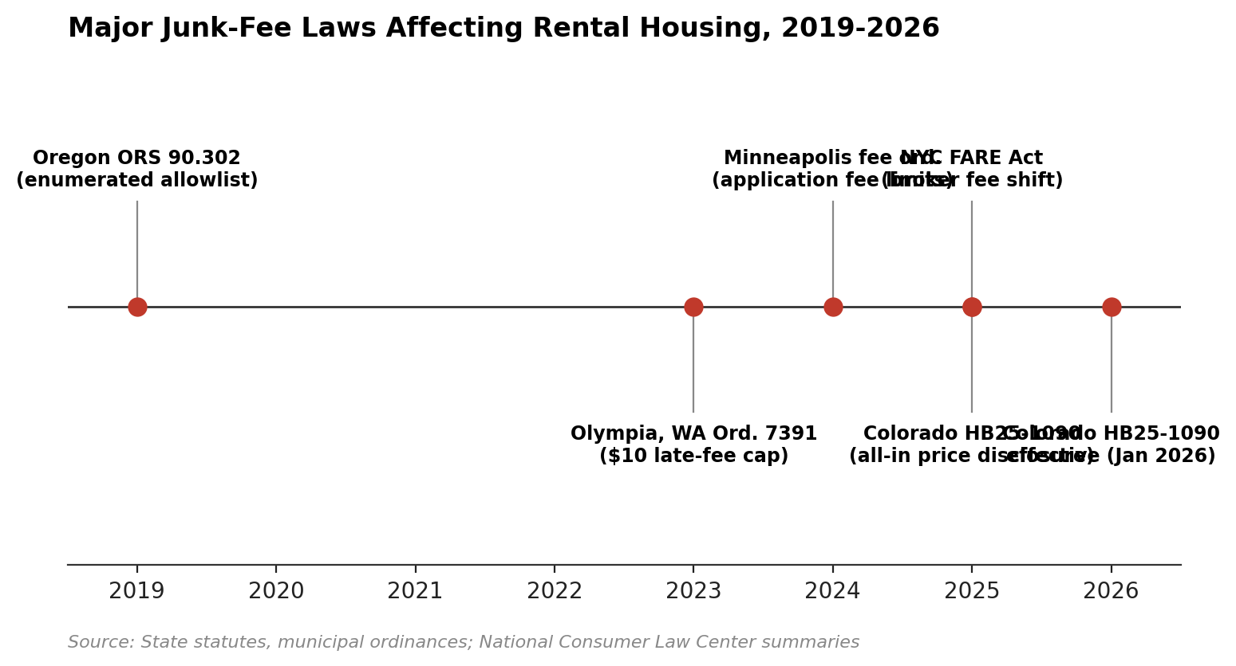
Figure 4. Timeline of major state and city junk-fee laws affecting rental housing, 2019 to 2026. Five of the six most significant statutes have passed since 2023. Source: state statutes and municipal ordinances.

2.1 State Laws
Jurisdiction | Effective | Key Provisions | Policy Type | Source
Colorado (HB25-1090) | Jan 2026 | All-in pricing mandate: landlords must include all mandatory fees (trash, pest control, CAM) in advertised rent. Separate billing prohibited for mandatory services. Optional fees allowed only at actual cost. | Transparency + Partial Ban | CO General Assembly; Otten Johnson, 2025
California (AB 2493) | Jan 2025 | Application fees capped at actual screening cost. First-come-first-served processing or full refund to rejected applicants within 7 days. Credit report must be shared with applicant. | Cap (Application Fees) | CA Legislature, 2024
NYC (FARE Act) | Jun 2025 | Bans landlords from passing broker fees to tenants when the landlord hired the broker. Broker fees typically ran 12 to 15 percent of annual rent ($3,000 to $5,000+). | Ban (Broker Fees) | NYC DCWP, 2025
Oregon (ORS 90.302) | Ongoing | Enumerated allowlist: only specifically authorized fees may be charged. Bans fees at tenancy start for anticipated expenses. Late fees must be reasonable; dishonored check max $35; smoke alarm tampering max $250. | Ban (Enumerated Allowlist) | OR Revised Statutes
Minnesota (SB 3492) | 2024 | Bans service and support animal fees. Requires all fees disclosed as total monthly rent on first page of lease and in all advertisements. | Transparency + Partial Ban | NLIHC; CBS MN, 2024
Illinois (HB 4206+) | 2024 | Limits unnecessary rental fees. Prohibits retaliatory evictions. Informs DV survivors of housing rights. | Partial Regulation | NLIHC, 2024
Georgia (HB 404) | 2024 | Caps security deposits at 2 months rent. Establishes minimum habitability duty. | Cap (Security Deposits) | NLIHC, 2024
Connecticut (SB 998) | 2024 | Regulates application fees, security deposit amounts, screening fees, and late payment charges. | Cap + Regulation | NLIHC, 2025
Rhode Island (HB 6087) | 2024 | Regulates rental application fees charged to prospective tenants. | Cap (Application Fees) | NLIHC, 2025
Colorado (HB 19-1106) | 2019 | Application fees limited to actual screening cost ($30 to $40). Consistent fees required across applicants. Unused portion refunded within 20 days. | Cap (Application Fees) | CO General Assembly, 2019
Colorado (HB 23-1099) | 2023 | Portable screening reports valid 30 days across multiple applications. Eliminates repeat application fee burden. | Structural Reform | CO General Assembly, 2023

2.2 Local Ordinances
Jurisdiction | Key Provisions | Policy Type | Source
Olympia, WA (Ord. 7391) | Enumerated allowlist of permitted fees only. Late fees capped at $10/month. All other fees prohibited by default. | Ban (Allowlist) | NLIHC/NCLC, 2024
Montgomery Co., MD | Fee regulation plus rent stabilization (annual increases capped at 3% + CPI, max 6%). Coordinated government enforcement. | Ban + Rent Stabilization | MoCo Code, 2023
San Diego, CA (Proposed) | Monthly fees capped at 5% of rent. Bans fees for basic services (pest control, trash). Eliminates monthly pet fees. Requires total cost disclosure. | Cap (5% of Rent) | KPBS/inewsource, 2025
Ann Arbor, MI | Capped rental application fees (2025). | Cap (Application Fees) | SmartCitiesDive, 2025

Three patterns stand out. First, the two jurisdictions that have implemented enumerated allowlists (Oregon statewide since 2013 amendments to ORS 90.302; Olympia, WA via Ordinance 7391) have the smallest documented workaround problem in the NCLC literature. Second, California's 2020 rent-cap experience (AB 1482) demonstrates the cap-only failure mode: San Diego reporting in 2025 documented proliferation of water, sewer, trash, and parking fees as explicit workarounds for the rent-growth limit (KPBS/inewsource, 2025). Third, Colorado has iteratively stacked reforms across three sessions (2019 HB 19-1106, 2023 HB 23-1099, 2025 HB25-1090 effective January 2026), producing a layered architecture that most closely resembles the design PRO should pursue.

3. What Happened After Implementation

3.1 New York City: FARE Act, June 2025
On June 11, 2025 New York City's Fairness in Apartment Rentals for Everyone (FARE) Act took effect, shifting broker commissions from tenants to landlords when the landlord had hired the broker. Before FARE, broker fees in NYC routinely ran 12 to 15 percent of annual rent, translating to $3,000 to $5,000+ in upfront cost per move. StreetEasy estimated that on a $3,500 per month apartment the act effectively eliminated more than $5,000 in tenant move-in costs. (StreetEasy, 2025)
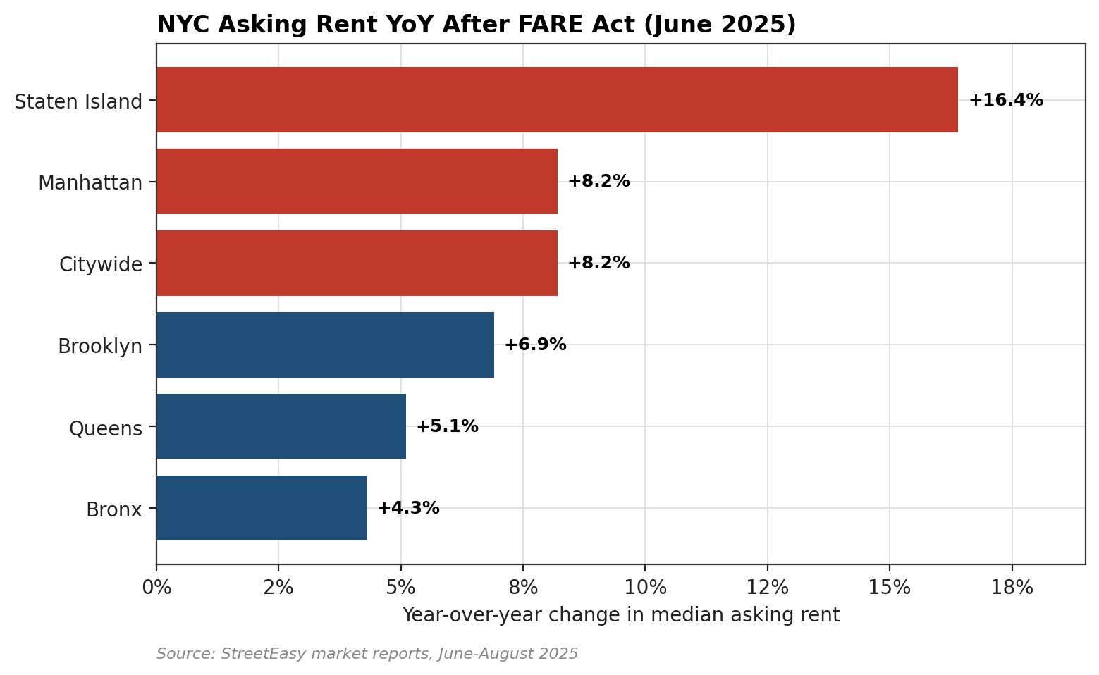
Figure 5. NYC year-over-year change in median asking rent in the months following FARE Act implementation. Rents rose 8.2 percent citywide. Staten Island, with the smallest and most rent-sensitive stock, rose 16.4 percent, the steepest borough change on record in StreetEasy's series. Source: StreetEasy market reports, June to August 2025.
The immediate pass-through was substantial. Between June and October 2025, median asking rent in the five-borough market rose 8.2 percent year over year. Staten Island (+16.4%) showed the largest change, reflecting both its smaller rental stock and its lower baseline (median $3,200). Brooklyn rose 6.9 percent on the median and 8.5 percent on the average (which reached $4,340). Manhattan rose 8.2 percent to a median of $4,600. StreetEasy data shows that less than 2 percent of individual units raised asking rent by more than 10 percent, meaning the aggregate shift reflected many small increases rather than a few large outliers.
Borough | Median Rent (Oct 2025) | YoY Change | Notes
Staten Island | $3,200 | +16.4% | Steepest increase among all boroughs
Brooklyn | $3,850 | +6.9% (median), +8.5% (avg) | Average rent reached $4,340
Manhattan | $4,600 | +8.2% | Highest absolute rent level
Citywide | N/A | +8.2% | Less than 2% of units raised rent >10%

Two further datapoints matter for cost accounting. First, the NYC Department of Consumer and Worker Protection received 1,125+ FARE Act complaints in the first months after enactment (The Real Deal, November 2025), confirming both heavy enforcement activity and detectable non-compliance. Second, StreetEasy's longer historical series provides the only multi-year comparative evidence of fee-charging versus no-fee unit trajectories available in any U.S. market.
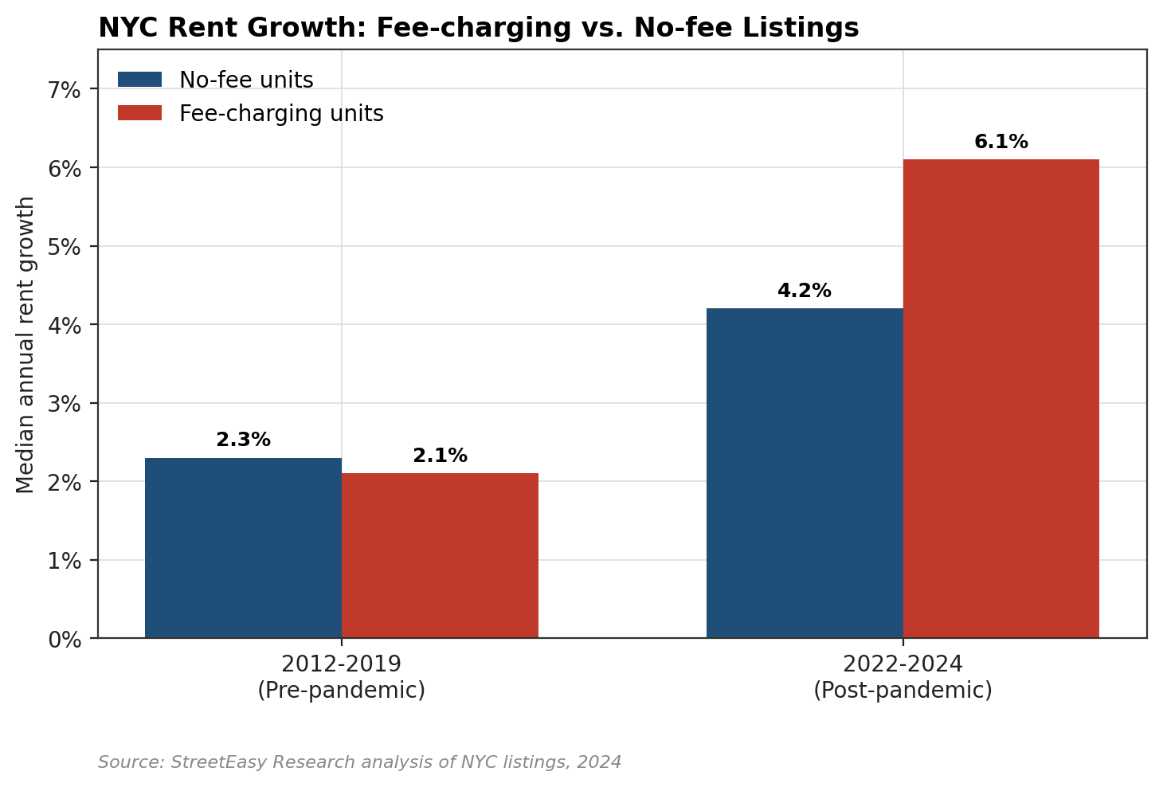
Figure 6. Median annual rent growth in NYC, fee-charging versus no-fee units, in two structurally different periods. Pre-pandemic (2012 to 2019) growth rates were statistically indistinguishable (2.3 percent vs. 2.1 percent). In the 2022 to 2024 post-pandemic tightening, no-fee units grew 4.2 percent annually versus 6.1 percent for fee-charging units, a 1.9 percentage-point gap. Source: StreetEasy Research, 2024 to 2025.
The implication: over a 12-year horizon, fee-charging units have either kept pace with or outgrown no-fee units in rent growth, not compensated downward for fee revenue. The common industry argument that fees represent a substitute for headline rent is not supported by the longest-available comparative series. Instead, fee-charging units appear to extract both rent growth and fee revenue, consistent with the FTC's Invitation Homes complaint.

3.2 Colorado: Stacked Reforms, 2019 to 2026
Colorado provides the longest natural experiment in layered fee regulation. HB 19-1106 (effective 2019) capped rental application fees at documented screening cost ($30 to $40 in most markets), required consistent fees across applicants, and mandated refund of the unused portion within 20 days of application. (CO General Assembly, 2019) HB 23-1099 (effective 2023) created portable screening reports valid across multiple applications for 30 days, addressing the repeat-application-fee burden that the 2019 cap had not fully eliminated. (CO General Assembly, 2023) HB25-1090 (effective January 2026) is the most structural: it requires all advertised rents to include all mandatory fees (trash, pest control, common-area maintenance, administrative charges), prohibits separate billing for mandatory services, and restricts optional-service fees to documented actual cost. (CO General Assembly; Otten Johnson summary, 2025)
Early post-implementation reporting reveals the substitution problem that pure-cap approaches do not fully solve. The Colorado Sun and Denver7 documented a specific tenant case (January 2026) where approximately $20 per month in eliminated fees were accompanied by a $292 per month rent increase on lease renewal, a net negative outcome for the tenant of approximately $272 per month. (Denver7 reporting on HB25-1090, 2026) This is the mechanism by which all-in pricing mandates can, in the short run, transfer fee revenue into base rent without reducing total tenant cost.
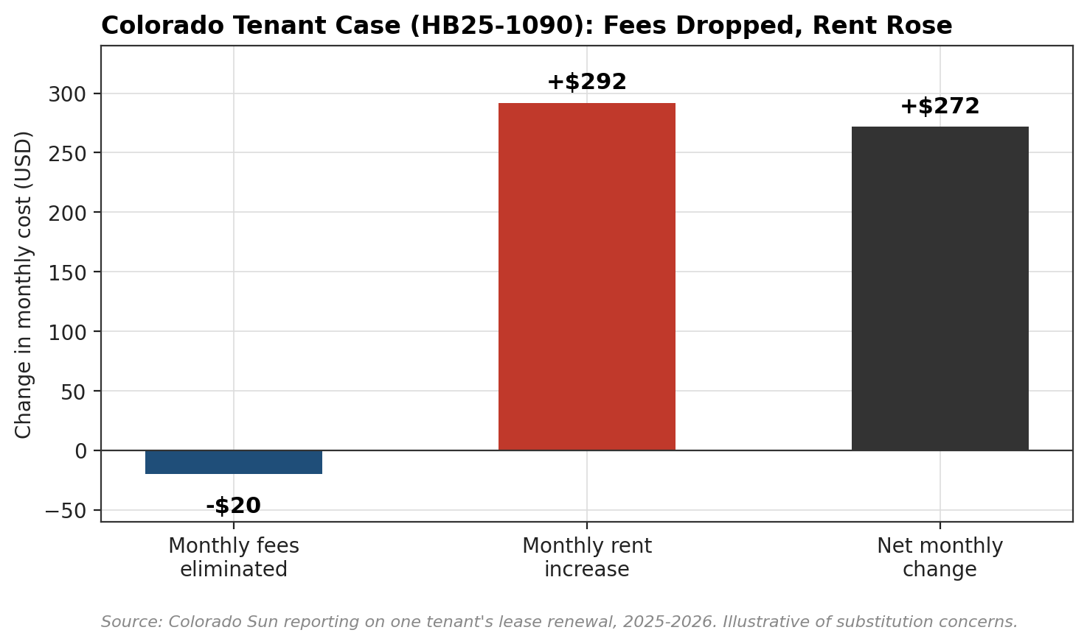
Figure 7. Illustrative tenant case under Colorado HB25-1090. Monthly fees eliminated ($20) were offset by a $292 monthly rent increase at lease renewal, producing a $272 net monthly cost increase. The case is anecdotal but illustrates the substitution mechanism that any single-instrument cap or disclosure rule cannot prevent. Source: Denver7 interviews, 2026.
Two observations temper the negative inference. First, without a rent-increase frequency limit or just-cause-for-eviction protection (PRO Components 04 and 05), landlords retain unilateral power to set renewal rent at whatever the market allows; fee rules cannot by themselves close that channel. Second, HB25-1090 is only months old; Colorado's 2019 and 2023 reforms, which had more time to settle, have not produced comparable substitution reports in the trade press, suggesting that market adjustment to price-transparency rules may attenuate over time.

3.3 Federal: FTC Enforcement, 2024 to 2025
Although the FTC's final 2024 junk-fees rule excluded rental housing, the agency has pursued two headline enforcement actions under Section 5 of the FTC Act (prohibiting unfair or deceptive practices):
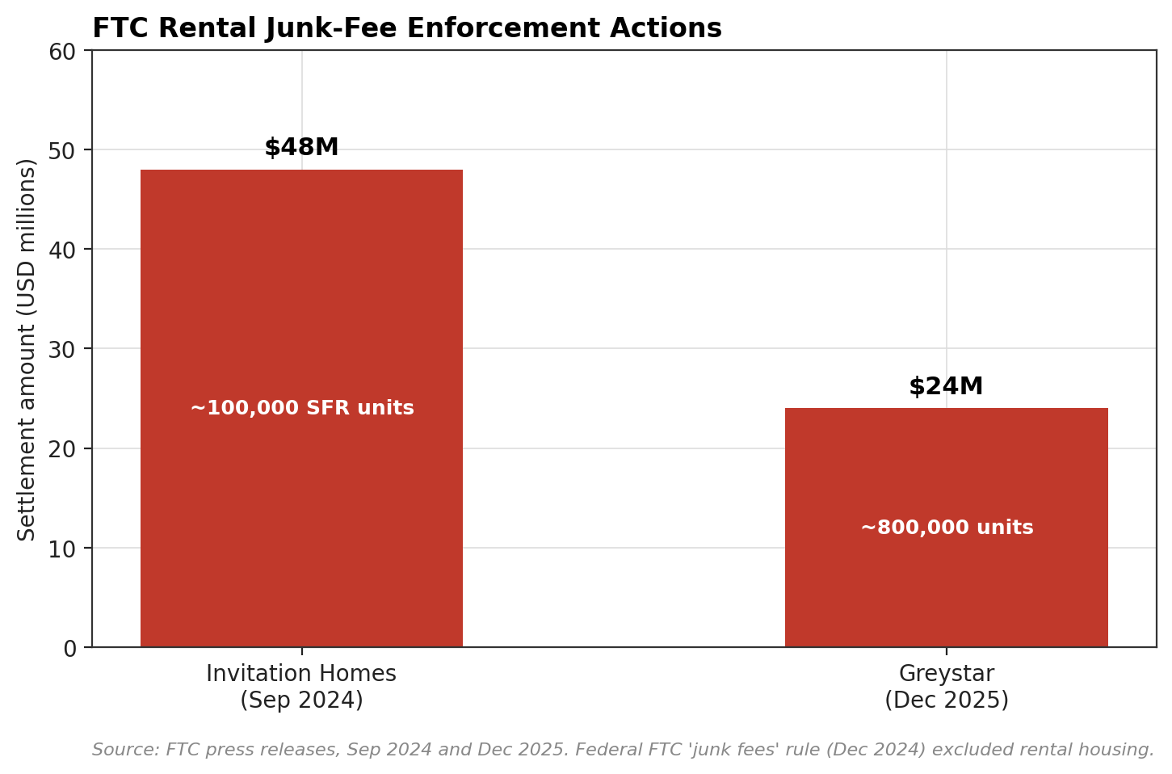
Figure 8. FTC rental-housing junk-fee enforcement actions, 2024 to 2025. Combined $72 million in settlements covering approximately 900,000 units. Sources: FTC press releases, September 2024 and December 2025.
Company | Violations | Settlement | Date | Source
Invitation Homes | Undisclosed mandatory fees ($1,700+ per year): smart home, utility management, air filters, internet. Unfair security deposit withholding. | $48 million | Sep 2024 | FTC Press Release, 9/2024
Greystar Real Estate | Deceptive advertising: displayed low base rents excluding mandatory monthly fees for pest control, valet trash, package concierge, utility admin, amenities. | $24 million | Dec 2025 | FTC Press Release, 12/2025

The Greystar action is particularly consequential for PRO because Greystar manages a significant share of Chicago's Class-A multifamily inventory. The complaint alleged that Greystar advertised base rents that systematically excluded mandatory monthly charges, and that tenants were presented with true all-in pricing only at lease execution, after application fees had been paid. The $24 million settlement requires Greystar to display all-in pricing in all future advertising and lease disclosures nationwide, functionally implementing a Colorado-style mandate on 800,000 units by consent decree. (FTC and CO AG joint press release, 12/2025)

3.4 Other Local Actions
Olympia, WA (Ordinance 7391, 2023) implemented the most restrictive ban architecture in the country: an enumerated allowlist of permitted fees, with late fees capped at $10 per month and all other fees prohibited by default. (NLIHC/NCLC, 2024) Compliance reports from NLIHC indicate the allowlist model has produced the fewest workaround-fee categories of any tracked jurisdiction. Montgomery County, MD has paired fee regulation with rent stabilization (annual increases capped at 3 percent plus CPI, maximum 6 percent), producing the most coordinated government-enforcement posture documented in NLIHC's database. San Diego's 2025 proposal (not yet enacted) would cap monthly fees at 5 percent of rent and ban fees for basic services (pest control, trash), modeled on the KPBS/inewsource reporting that documented the California AB 1482 workaround pattern.

4. Cap vs. Ban: Comparative Analysis
The central design question: when a jurisdiction chooses to cap specific fees (limiting amounts) rather than ban them (removing fee categories entirely, or using an enumerated allowlist), what changes? The table below synthesizes findings across nine dimensions.
Dimension | Fee Cap | Fee Ban
What It Does | Sets a maximum dollar amount or percentage for specific fees. The fee categories still exist; the amount is constrained. | Eliminates fee categories entirely, or restricts landlords to an enumerated list of permitted charges. Everything not on the list is prohibited.
Tenant Transparency | Multiple fee categories remain on the lease. Tenants must still add up line items to determine true cost. Moderate improvement. | Dramatically simplifies total cost. Oregon and Olympia models reduce fees to a handful of permitted categories. Colorado's all-in pricing achieves a similar result by folding mandatory fees into base rent.
Enforcement Complexity | Harder to enforce. Caps on 'actual cost' require regulators to verify cost claims. Landlords have incentives to inflate cost justifications. | Cleaner binary enforcement: a fee is either on the permitted list or it is not. Compliance monitoring still matters; NYC received 1,125+ FARE Act complaints in early months (The Real Deal, Nov 2025).
Short-Term Rent Impact | Lower pass-through risk. Fee revenue reduction is smaller, so landlords face less pressure to adjust base rent. | Higher short-term pass-through risk. NYC saw an 8.2% citywide rent increase after FARE Act. Staten Island rose 16.4% YoY. One Colorado tenant reported a $292 rent increase after about $20 per month in fees were eliminated (Denver7, 2026).
Long-Term Rent Trajectory | Unknown: no long-term data specific to capped-fee environments exists yet. | StreetEasy data (2022 to 2024): no-fee units saw 4.2% annual rent growth vs. 6.1% for fee-charging units. Pre-pandemic (2012 to 2019): no meaningful difference (2.3% vs 2.1%). Long-term data suggests ban environments produce slower rent growth after an adjustment period.
Equity Impact | Moderate. Reduces burden but does not eliminate it. Low-income renters still pay multiple fee categories. | Strongest equity impact. Eliminates the most regressive fees: application fees (a tax on housing search), move-in fees (barrier to entry). The FTC found Invitation Homes' undisclosed fees exceeded $1,700 per year, borne disproportionately by low-income tenants (FTC, Sep 2024).
Workaround Risk | HIGH. Landlords create new fee categories not covered by caps. San Diego found junk fees proliferated after California's 2020 rent cap (AB 1482) as landlords added water, sewer, trash, and parking fees as a workaround. | MODERATE for single-fee bans (NYC workarounds). LOW for enumerated allowlists (Olympia and Oregon model) because anything not listed is automatically prohibited.
Political Feasibility | Easier to pass. Framed as moderate, market-friendly. Less industry opposition. | Harder to pass. Real Estate Board of NY and CA Apartment Association have actively fought ban proposals. Industry lobby argues bans are 'harmful to property owners with rising costs.'
Federal Enforcement | FTC final junk fees rule (Dec 2024) excluded rental housing. But the FTC has pursued individual enforcement: Invitation Homes ($48M), Greystar ($24M). FTC Chairman Ferguson has directed staff to propose a rental-specific rule. | Same federal landscape applies. Key difference: ban jurisdictions create clearer standards for future FTC rulemaking to build on.

The strongest empirical distinction is in long-term rent trajectory. NYC's StreetEasy data (Figure 6) shows that in the post-pandemic period, fee-charging units grew rents 1.9 percentage points faster per year than no-fee units. Over ten years, a 1.9-point annual differential compounds to roughly a 20 percent rent-level gap. No comparable long-term dataset exists for pure-cap jurisdictions because caps leave fee categories intact, so the 'with-fee' cohort never shrinks enough to support cohort comparison. This is an important inference limitation of the cap approach: it is structurally harder to evaluate because the treated and control populations are not separated.
Policy implication: the long-term evidence, to the extent it exists, favors ban (or ban-equivalent allowlist) designs over caps. The cost is short-term pass-through risk, which must be managed by pairing the fee reform with rent-increase frequency limits or rent stabilization.

5. Policy Options for Chicago
The five design options below are ordered from least to most structural. Option E (layered) is the recommended approach and the design most consistent with the PRO's multi-component architecture.
Option | Description | Expected Impact | Political Lift
Option A: Fee Cap | Cap individual fee categories (e.g., application fees at actual cost, late fees at $10 per month, total monthly fees at 5% of rent). Require disclosure on first page of lease and in all advertisements. | Moderate improvement. Fees remain but at lower levels. Some new fee categories may emerge. | Easier. Industry sees as reasonable.
Option B: Single-Fee Ban | Ban specific high-impact fee categories (e.g., application fees, move-in fees) while leaving others unregulated. | Targeted savings on banned categories. Risk of workaround fees in unregulated categories. NYC FARE Act model. | Moderate. Concentrated opposition from affected fee categories.
Option C: Enumerated Allowlist | Permit only enumerated fee categories (security deposit, screening at cost, late fees with cap, utilities at actual cost). Everything else is prohibited by default. Oregon and Olympia model. | Strongest protection. Closes loopholes proactively. Most transparent for tenants. | Hardest. Industry will resist.
Option D: All-In Pricing | Require landlords to include all mandatory fees in advertised rent (Colorado 2026 model). Optional services may be billed separately at actual cost only. | Transparency gain is immediate. Does not eliminate fees but forces them into a single visible number. | Moderate to Hard. Industry dislikes but FTC enforcement trend supports it.
Option E: Layered (Recommended) | Combine: (1) enumerated allowlist for permitted fees, (2) all-in pricing mandate for advertising, (3) portable screening reports, (4) rent-increase frequency limit to manage pass-through. Colorado's three-law approach plus Olympia's allowlist. | Maximum protection. Transparency plus structural reform plus pass-through management. Aligns with all 5 PRO components. | Requires political will. Leverages PRO's multi-component design.

5.1 Recommended: Option E (Layered Design)
Instrument 1: Enumerated fee allowlist. Model: Oregon ORS 90.302 plus Olympia Ordinance 7391. Permit only the following fee categories, each with its own rule:
- Security deposit, capped at one month's rent (Georgia 2024 caps at two months; Chicago's RLTO already regulates). Interest requirement preserved.
- Screening fee, capped at documented actual cost, nonrefundable portion limited to verifiable third-party cost (Colorado HB 19-1106 model).
- Portable screening report valid 30 days across applications (Colorado HB 23-1099 model).
- Late fee, capped at $10 per month (Olympia Ordinance 7391 model).
- Utility pass-through at actual cost only, with itemization.
- Pet-related deposits permitted; monthly pet fees prohibited (Minnesota SB 3492 prohibits service-animal fees; San Diego 2025 proposal extends to all pet fees).
- All other fee categories prohibited by default, including application fees beyond screening cost, move-in fees, move-out fees, amenity fees for services advertised as included, and 'convenience' fees on rent payment.
Instrument 2: All-in pricing mandate. Model: Colorado HB25-1090. All advertised rents must include every mandatory recurring charge. Optional-service fees permitted only at documented actual cost and only for services the tenant has separately elected. Advertising violations trigger per-unit civil penalties.
Instrument 3: Rent-increase frequency limit. Rationale: the NYC FARE Act and Colorado HB25-1090 cases both show short-term rent pass-through when fee rules tighten. Without a frequency limit, landlords can offset fee-rule compliance with a single renewal-cycle rent increase, a pattern documented in the Colorado Sun/Denver7 case. A limit of one rent increase per 12-month lease cycle, with 90-day advance notice, mirrors mature tenant-protection regimes and is consistent with PRO Components 02 and 04.
Instrument 4: Disclosure, private right of action, and enforcement. Fee rules without enforcement fail. NYC received 1,125+ FARE Act complaints in the first months after enactment (The Real Deal, 11/2025), suggesting meaningful non-compliance volume. Recommend: (a) Office of Tenant Advocate (PRO Component 03) as complaint intake; (b) per-violation civil penalty of $1,000 plus three times the unlawful fee collected; (c) private right of action with attorney fee shifting; (d) integration with the Rental Registry (PRO Component 02) to detect systemic violators.

5.2 Alignment with PRO Components
- Component 01 (RLTO Reform): All four instruments above sit inside RLTO Reform. Fee allowlist and all-in pricing are direct RLTO amendments.
- Component 02 (Rental Registry): Registry data enables detection of systemic non-compliance by flagging landlords whose advertised rents differ from registered rents or whose lease documents list prohibited fees.
- Component 03 (Office of Tenant Advocate): Intake point for fee complaints; administers private-right-of-action assistance.
- Component 04 (Just Cause for Eviction): Prevents retaliatory non-renewal after a fee complaint, a documented risk in all cap-and-ban jurisdictions.
- Component 05 (Right to Counsel): Provides representation in private right-of-action cases, converting statutory protection into enforceable relief.

6. What We Do Not Know
Three empirical uncertainties should be flagged for the Chief of Policy before introduction:
6.1 Long-term equilibrium rent response. The StreetEasy 2022 to 2024 data is the only multi-year comparative series available. It covers 2.5 years of a post-pandemic tightening market in one city (NYC). Whether the 4.2 versus 6.1 percent annual growth differential persists in cooler markets, at longer horizons, or in Chicago specifically, cannot be known without replication. The pre-pandemic (2012 to 2019) period showed no meaningful differential (2.3 vs. 2.1 percent), implying the post-pandemic gap may be market-condition specific.
6.2 Chicago-specific fee prevalence. Neither the city nor the state systematically collects data on non-rent fees in Chicago leases. The Zillow 58 percent national figure and the Urban Institute 10 to 30 percent range are national estimates. A city-specific baseline is needed to estimate savings from any reform and to set enforcement priorities. The Rental Registry (PRO Component 02) can produce this baseline at scale.
6.3 Interaction with the corporate-landlord share. FTC enforcement documents the largest fee burdens at large corporate operators (Invitation Homes ~100,000 units; Greystar ~800,000). Chicago's corporate-landlord share in multifamily is not well measured. If the share is high, the pool of households benefiting from fee reform is large; if the share is concentrated in particular neighborhoods, equity effects will be geographically uneven. This is a priority data question for the ordinance's fiscal note.

Sources
Federal Trade Commission. (2024, December 17). FTC Announces Final 'Junk Fees' Rule. Press release.
Federal Trade Commission. (2024, September 24). FTC Takes Action Against Invitation Homes for Deceiving Renters, Saddling Them With Hidden Junk Fees. Press release.
Federal Trade Commission and Colorado Attorney General. (2025, December). FTC and Colorado AG Announce $24 Million Settlement With Greystar. Press release.
StreetEasy Research. (2024 to 2025). NYC Market Reports and FARE Act Analyses.
The Real Deal. (2025, November). FARE Act Complaints Top 1,125 in First Months.
Colorado General Assembly. (2019). HB 19-1106 (application fees).
Colorado General Assembly. (2023). HB 23-1099 (portable screening).
Colorado General Assembly. (2025). HB25-1090 (all-in pricing).
Otten Johnson. (2025). Summary of Colorado HB25-1090.
Denver7 and Colorado Sun. (2026, January). Reporting on HB25-1090 tenant renewals.
Oregon Revised Statutes. ORS 90.302 (enumerated fee allowlist).
Olympia, WA. (2023). Ordinance 7391.
California Legislature. (2024). AB 2493.
Georgia General Assembly. (2024). HB 404.
Connecticut General Assembly. (2024). SB 998.
Rhode Island General Assembly. (2024). HB 6087.
Minnesota Legislature. (2024). SB 3492; CBS Minnesota coverage.
New York City DCWP. (2025). FARE Act implementation materials.
Illinois General Assembly. (2024). HB 4206.
Montgomery County, MD. (2023). County Code, rent stabilization and fee regulation.
KPBS and inewsource. (2025). San Diego reporting on fee proliferation under AB 1482.
SmartCitiesDive. (2025). Ann Arbor rental application fee ordinance.
National Consumer Law Center. (2024). State Rental Fee Regulation Tracker.
National Multifamily Housing Council. (2024 to 2025). State and Local Regulatory Database.
National Low Income Housing Coalition. (2024 to 2025). Out of Reach and Tenant Protection Tracker.
Urban Institute / Community Economic Defense Project. (2024). Unfair and Hidden: Housing Fees in the Rental Market.
Zillow. (2024). Consumer Housing Trends Report.

