Insert your name, centre number and candidate number into the header above.
Save this evidence document as evidence_ followed by your centre number_ candidate number. For example: evidence_ zz999_9999.doc
Screenshots or program listings must be copied into appropriate cells in the following tables.
Examiners must be able to read the contents including any screenshots without the use of a magnifying glass. Answers that are not readable or missing will not be awarded any marks.
Save this evidence document at regular intervals, for example, every 10 minutes.
Question 1
Part 1(a)
global DataStored #integer
global NumberItems #integer 20 items
DataStored=[]

Part 1(b)
def Initialise():
global DataStored
global NumberItems
Valid= False
while (Valid== False):
NumberItems = int(input("How many numbers will you enter?")) #loop until <20
if NumberItems>0 and NumberItems<21:
Valid= True
for Count in range(0,NumberItems):
DataStored.append(int(input("Enter number")))

Part 1(c)(i)
NumberItems = 0
Initialise()
print(DataStored)

Part 1(c)(ii)
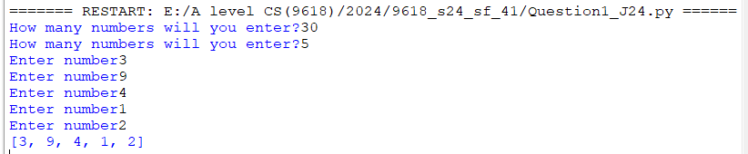

Part 1(d)(i)
def BubbleSort():
global DataStored
global NumberItems
for Count in range(0,NumberItems):
for Count2 in range(0,NumberItems-1):
if DataStored[Count2]> DataStored[Count2 +1]:
DataStored[Count2],DataStored[Count2 +1]=DataStored[Count2 +1],DataStored[Count2]

Part 1(d)(ii)
BubbleSort()
print(DataStored)

Part 1(d)(iii)
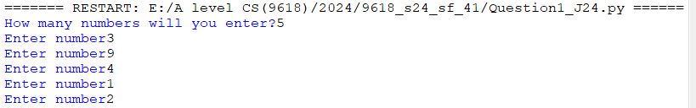

Part 1(e)(i)
def BinarySearch(DataToFind):
global DataStored
global NumberItems
First=0
Last= NumberItems
while(First <= Last):
MidValue= int((First+Last)/2)
if DataToFind == DataStored[MidValue]:
return MidValue
if DataToFind < DataStored[MidValue]:
Last= MidValue-1
else:
First= MidValue+1
return -1

Part 1(e)(ii)
Search = int(input("Enter a number to find"))
print(BinarySearch(Search))

Part 1(e)(iii)
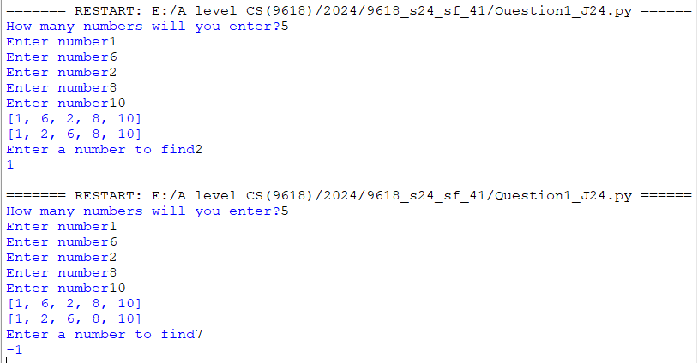

Question 2
Part 2(a)(i)
class Tree:
def __init__(self,Name,HGrowth,MaxH,MaxW,PEvergreen):
self.__TreeName= Name
self.__HeightGrowth= HGrowth
self.__MaxHeight= MaxH
self.__MaxWidth= MaxW
self.__Evergreen= PEvergreen

Part 2(a)(ii)
def GetTreeName(self):
return self.__TreeName
def GetMaxHeight(self):
return self.__MaxHeight
def GetMaxWidth(self):
return self.__MaxWidth
def GetGrowth(self):
return self.__HeightGrowth
def GetEvergreen(self):
return self.__Evergreen

Part 2(b)
def ReadData():
TreeObjects=[]
try:
File= open("Trees.txt")
TreeData=[]
TreeData= File.read().split("\n")
SplitTrees=[]
for Item in TreeData:
SplitTrees.append(Item.split(","))
File.close()
for Item in SplitTrees:
TreeObjects.append(Tree(Item[0],int(Item[1]),int(Item[2]),int(Item[3]),Item[4]))
except IOError:
print("invalid file")
return TreeObjects

Part 2(c)
def PrintTrees(Item):
Final= "does not lose its leaves"
if Item.GetEvergreen() == "No":
Final= "loses its leaves each year"
print(Item.GetTreeName(),"has a maximum height",Item.GetMaxHeight(),"a maximum width",Item.GetMaxWidth(),"and grows",Item.GetGrowth(),"cm a year. It",Final)

Part 2(d)(i)
TreeObjects=ReadData()
PrintTrees(TreeObjects[0])

Part 2(d)(ii)

Part 2(e)(i)
def ChooseTree(Trees):
Evergreen= input("Do you want a tree that loses its leaves (enter lose), or keeps its leaves (enter keep)")
MaxHeight= int(input("What is the maximum tree height in cm"))
MaxWidth= int(input("What is the maximum tree width in cm"))
Options=[]
if Evergreen.lower() == "keep" or Evergreen.lower() == "keep leaves" or Evergreen.lower() == "keeps its leaves":
keep ="Yes"
else:
keep = "No"
for Item in Trees:
if Item.GetMaxHeight() <= MaxHeight and Item.GetMaxWidth() <= MaxWidth and keep == Item.GetEvergreen():
Options.append(Item)
PrintTrees(Item)
if len(Options) == 0:
print("No suitable trees")

Part 2(e)(ii)
Valid= False
while Valid == False:
Choice= input("Enter the name of the tree you want")
for Item in Options:
if Item.GetTreeName() == Choice:
Valid= True
Selected= Item
Start= int(input("Enter the height of the tree you would like to start with in cm"))
Years= (Selected.GetMaxHeight()-Start)/Selected.GetGrowth()
print("Your tree should be full height in approximately",Years,"years")

Part 2(e)(iii)
ChooseTree(TreeObjects)

*Screenshot:
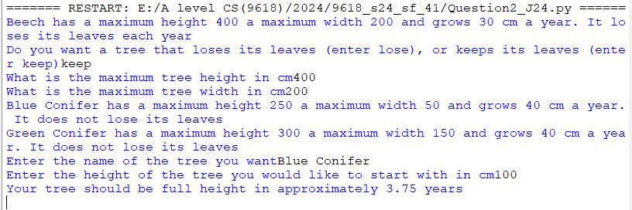

Question 3
Part 3(a)
global QueueData
global QueueHead
global QueueTail
QueueData=[]
for x in range(0,20):
QueueData.append("")
QueueHead= -1
QueueTail= -1

Part 3(b)
def Enqueue(DataToInsert):
global QueueData
global QueueHead
global QueueTail
if QueueTail == 19:
return False
elif QueueHead == -1:
QueueHead=0
QueueTail=QueueTail+1
QueueData[QueueTail]=DataToInsert
return True

Part 3(c)
def Dequeue():
global QueueData
global QueueHead
global QueueTail
if QueueHead<0 or QueueHead>20 or QueueHead>QueueTail:
return "false"
else:
QueueHead= QueueHead+1
return QueueData[QueueHead-1]

Part 3(d)(i)
def StoreItems():
global QueueData
global QueueHead
global QueueTail
Count=0
for X in range(0,10):
Data= input("Enter data")
Total= int(Data[0])+int(Data[1])*3+int(Data[2])+int(Data[3])*3+int(Data[4])+int(Data[5])*3
Total= int(Total/10)
if ((Total==10 and Data[6] == "X")or (Total == int(Data[6]))):
Result= Enqueue(Data[0:6])
if (Result == True):
print("Inserted item")
else:
print("Queue full")
else:
Count= Count+1
print("There were",Count,"Invalid items")

Part 3(d)(ii)
QueueData=[]
for x in range(0,20):
QueueData.append("")
QueueHead= -1
QueueTail= -1
StoreItems()
Value= Dequeue()
if Value == "false":
print("No data items")
else:
print("Item code", Value)

Part 3(d)(iii)
