Insert your name, centre number and candidate number into the header above.
Save this evidence document as evidence_ followed by your centre number_ candidate number. For example: evidence_ zz999_9999.doc
Screenshots or program listings must be copied into appropriate cells in the following tables.
Examiners must be able to read the contents including any screenshots without the use of a magnifying glass. Answers that are not readable or missing will not be awarded any marks.
Save this evidence document at regular intervals, for example, every 10 minutes.
Question 1
Part 1(a)
def ReadWords(FileName):
global WordArray
global NumberWords
try:
File=open(FileName,'r')
DataRead=File.read().strip()
File.close()
WordArray=DataRead.split()
NumberWords=len(WordArray)
except IOError:
print("File not found")

Part 1(b)
WordArray=[]
NumberWords=0
Choice= input("Easy, medium or hard? ").lower()
if Choice == "easy":
File= "Easy.txt"
elif Choice == "medium":
File= "Medium.txt"
else:
File= "Hard.txt"
ReadWords(File)

Part 1(c)(i)
def Play():
global WordArray
global NumberWords
Word= WordArray[0]
print("The word is: ",Word)
print("There are",NumberWords-1,"words that can be made with 3 or more letters")
WordArray[0]=""
Answer= "yes"
QuantityFound=0
while Answer != "no":
Answer= input("Enter your word or no to stop ").lower()
Found= False
if Answer != "no":
for x in range(0,NumberWords):
if Answer == WordArray[x]:
WordArray[x] == ""
QuantityFound= QuantityFound+1
print("Correct, you have found", QuantityFound, "words")
Found= True
if Found == False:
print("Sorry that was incorrect")

Part 1(c)(ii)
def Play():
global WordArray
global NumberWords
Word= WordArray[0]
print("The word is: ",Word)
print("There are",NumberWords-1,"words that can be made with 3 or more letters")
WordArray[0]=""
Answer= "yes"
QuantityFound=0
while Answer != "no":
Answer= input("Enter your word or no to stop ").lower()
Found= False
if Answer != "no":
for x in range(0,NumberWords):
if Answer == WordArray[x]:
WordArray[x] = ""
QuantityFound= QuantityFound+1
print("Correct, you have found", QuantityFound, "words")
Found= True
if Found == False:
print("Sorry that was incorrect")
Correct= (QuantityFound/(NumberWords-1))*100
print("You found", Correct,"%")
if Correct < 100:
print("The words you missed are")
for x in range(0,NumberWords):
if WordArray[x] != "":
print(WordArray[x])

Part 1(d)(i)
def ReadWords(FileName):
global WordArray
global NumberWords
try:
File=open(FileName,'r')
DataRead=File.read().strip()
File.close()
WordArray=DataRead.split()
NumberWords=len(WordArray)
except IOError:
print("File not found")
Play()

Part 1(d)(ii)
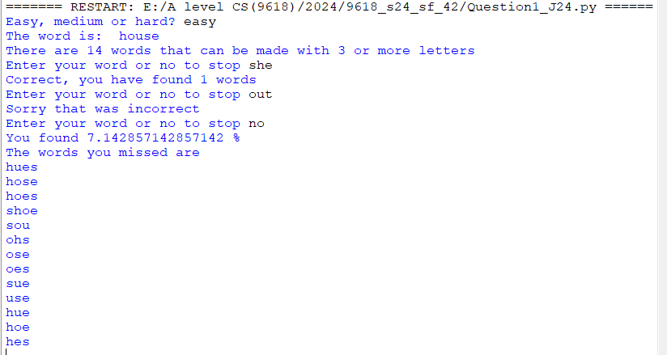

Part 1(d)(iii)
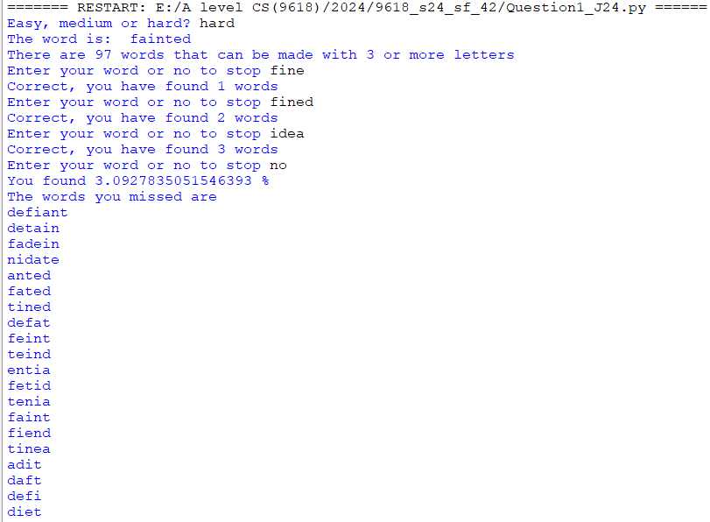
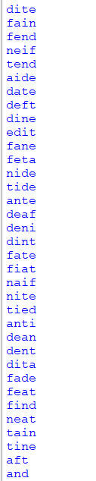
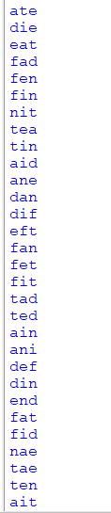
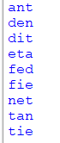

Question 2
Part 2(a)(i)
class Node():
def __init__(self,PData):
self.__LeftPointer= -1 #int
self.__Data= PData #int
self.__RightPointer= -1 #int

Part 2(a)(ii)
def GetLeft(self):
return self.__LeftPointer
def GetRight(self):
return self.__RightPointer
def GetData(self):
return self.__Data

Part 2(a)(iii)
def SetLeft(self,NewLeft):
self.__LeftPointer= NewLeft
def SetRight(self,NewRight):
self.__RightPointer= NewRight
def SetData(self,NewData):
self.__Data= NewData

Part 2(b)(i)
class TreeClass():
def __init__(self):
self.__Tree=[] #type node 20 spaces
self.__FirstNode= -1 #int
self.__NumberNodes= 0 #int
for x in range(20):
self.__Tree.append(Node(-1))

Part 2(b)(ii)
def InsertNode(self,NewNode):
if (self.__NumberNodes == 0):
self.__Tree[0]= NewNode
self.__FirstNode= 0
self.__NumberNodes= self.__NumberNodes + 1
else:
self.__Tree[self.__NumberNodes] = NewNode
NodeAccess= self.__FirstNode
Direction =""
while (NodeAccess != -1):
Previous= NodeAccess
if NewNode.GetData() < self.__Tree[NodeAccess].GetData():
NodeAccess= self.__Tree[NodeAccess].GetLeft()
Direction = "left"
elif NewNode.GetData() > self.__Tree[NodeAccess].GetData():
NodeAccess= self.__Tree[NodeAccess].GetRight()
Direction = "right"
if (Direction == "left"):
self.__Tree[Previous].SetLeft(self.__NumberNodes)
else:
self.__Tree[Previous].SetRight(self.__NumberNodes)
self.__NumberNodes= self.__NumberNodes + 1

Part 2(b)(iii)
def OutputTree(self):
if self.__NumberNodes == 0:
print("No nodes")
else:
for x in range(0,self.__NumberNodes):
print(self.__Tree[x].GetLeft()," ",self.__Tree[x].GetData()," ",self.__Tree[x].GetRight())

Part 2(c)(i)
TheTree= TreeClass()

Part 2(c)(ii)
TheTree= TreeClass()
TheTree.InsertNode(Node(10))
TheTree.InsertNode(Node(11))
TheTree.InsertNode(Node(5))
TheTree.InsertNode(Node(1))
TheTree.InsertNode(Node(20))
TheTree.InsertNode(Node(7))
TheTree.InsertNode(Node(15))
TheTree.OutputTree()

Part 2(c)(iii)
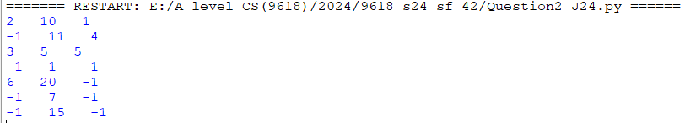

Question 3
Part 3(a)
NumberArray=[100,85,644,22,15,8,1]

Part 3(b)(i)
def RecursiveInsertion(IntegerArray,NumberElements):
if NumberElements <= 1:
return IntegerArray
else:
RecursiveInsertion(IntegerArray,NumberElements-1)
LastItem=IntegerArray[NumberElements-1]
CheckItem=NumberElements-2
LoopAgain= True
if CheckItem<0:
LoopAgain= False
elif IntegerArray[CheckItem] < LastItem:
LoopAgain= False
while (LoopAgain):
IntegerArray[CheckItem+1]=IntegerArray[CheckItem]
CheckItem= CheckItem-1
if CheckItem < 0:
LoopAgain= False
elif IntegerArray[CheckItem] < LastItem:
LoopAgain= False
IntegerArray[CheckItem+1]= LastItem
return IntegerArray

Part 3(b)(ii)
SortedArray= RecursiveInsertion(NumberArray,len(NumberArray))
print("Recursive")
for x in range(len(SortedArray)):
print(SortedArray[x])

Part 3(b)(iii)
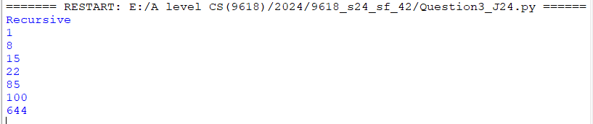

Part 3(c)(i)
def IterativeInsertion(IntegerArray,NumberElements):
CurrentSize=2
while CurrentSize<= NumberElements:
LastItem=IntegerArray[CurrentSize-1]
CheckItem=CurrentSize-2
LoopAgain= True
if CheckItem<0:
LoopAgain= False
elif IntegerArray[CheckItem] <= LastItem:
LoopAgain= False
while (LoopAgain):
IntegerArray[CheckItem+1]=IntegerArray[CheckItem]
CheckItem= CheckItem-1
if CheckItem < 0:
LoopAgain= False
elif IntegerArray[CheckItem] <= LastItem:
LoopAgain= False
IntegerArray[CheckItem+1]= LastItem
CurrentSize = CurrentSize +1
return IntegerArray

Part 3(c)(ii)
Sorted2Array= IterativeInsertion(NumberArray,len(NumberArray))
print("Iterative")
for x in range(len(Sorted2Array)):
print(Sorted2Array[x])

Part 3(c)(iii)
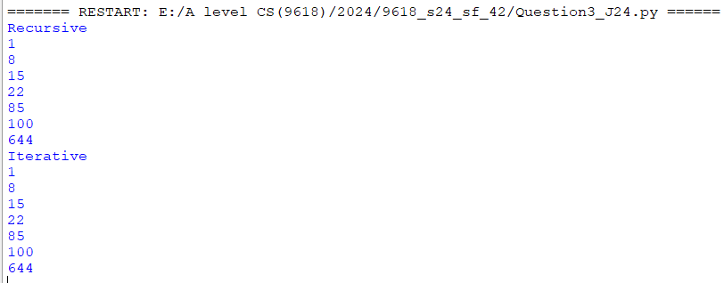

Part 3(d)(i)
def BinarySearch(IntegerArray,First,Last,ToFind):
if First > Last:
return -1
else:
Middle = int((First+Last)/2)
if IntegerArray[Middle] == ToFind:
return Middle
elif IntegerArray[Middle] > ToFind:
return BinarySearch(IntegerArray,First,Middle-1,ToFind)
else:
return BinarySearch(IntegerArray,Middle+1,Last,ToFind)

Part 3(d)(ii)
Position= BinarySearch(Sorted2Array,0,len(NumberArray)-1,644)
if Position == -1:
print("Not found")
else:
print("Index of 644 is" ,Position)

Part 3(d)(iii)
