Insert your name, centre number and candidate number into the header above.
Save this evidence document as evidence_ followed by your centre number_ candidate number. For example: evidence_ zz999_9999.doc
Screenshots or program listings must be copied into appropriate cells in the following tables.
Examiners must be able to read the contents including any screenshots without the use of a magnifying glass. Answers that are not readable or missing will not be awarded any marks.
Save this evidence document at regular intervals, for example, every 10 minutes.
Question 1
Part 1(a)
Queue=[-1 for x in range(20)]
HeadPointer=-1
TailPointer=-1
NumberItems=0

Part 1(b)
def Enqueue(InputData):
global Queue
global HeadPointer
global TailPointer
global NumberItems
if NumberItems>=20:
return False
if TailPointer <= -1:
HeadPointer=0
TailPointer=0
Queue[TailPointer]=InputData
else:
TailPointer=TailPointer+1
if TailPointer==20:
TailPointer=0
Queue[TailPointer]=InputData
NumberItems+=1
return True

Part 1(c)
for X in range (1,26):
ReturnValue= Enqueue(X)
if ReturnValue==True:
print(X,"Successful")
else:
print(X,"Unsuccessful")

Part 1(d)
def Dequeue():
global Queue
global HeadPointer
global TailPointer
global NumberItems
if NumberItems<=0:
return -1
else:
ReturnValue=Queue[HeadPointer]
HeadPointer+=1
if HeadPointer>=20:
HeadPointer=0
NumberItems-=1
if NumberItems==0:
HeadPointer=-1
TailPointer=-1
return ReturnValue

Part 1(e)(i)
NextValue=Dequeue()
print(NextValue)
NextValue=Dequeue()
print(NextValue)

Part 1(e)(ii)
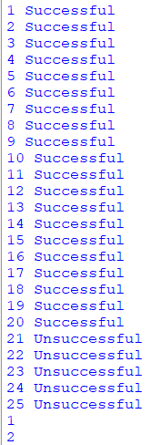

Question 2
Part 2(a)
def ReadData():
DataList=[]
FileName=input("Enter the filename")
try:
File=open(FileName)
for Line in File:
DataList.append(Line)
File.close()
except:
print("Cannot open file")
return DataList

Part 2(b)
def SplitData(DataArray):
Red=[]
Green=[]
Blue=[]
Orange=[]
Yellow=[]
Pink=[]
for Line in DataArray:
SplitLine=Line.split(",")
if SplitLine[1].strip()=="red":
Red.append(SplitLine[0])
elif SplitLine[1].strip()=="green":
Green.append(SplitLine[0])
elif SplitLine[1].strip()=="blue":
Blue.append(SplitLine[0])
elif SplitLine[1].strip()=="orange":
Orange.append(SplitLine[0])
elif SplitLine[1].strip()=="yellow":
Yellow.append(SplitLine[0])
else:
Pink.append(SplitLine[0])

Part 2(c)
def StoreData(DataToStore,FileName):
try:
File=open(FileName,"a+")
for Item in DataToStore:
File.write(Item)
File.write("\n")
File.close()
except:
print("Cannot create or write to file")

Part 2(d)
StoreData(Red,"Red.txt")
StoreData(Green,"Green.txt")
StoreData(Blue,"Blue.txt")
StoreData(Orange,"Orange.txt")
StoreData(Yellow,"Yellow.txt")
StoreData(Pink,"Pink.txt")

Part 2(e)(i)
DataFromFile=ReadData()
SplitData(DataFromFile)

Part 2(e)(ii)

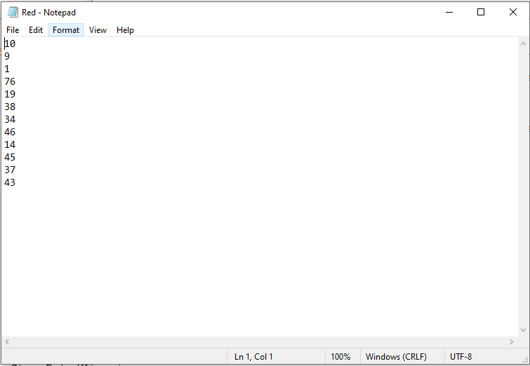

Question 3
Part 3(a)(i)
class Node:
def __init__(self, pNodeData):
#PRIVATE NodeData,LeftNode,RightNode
self.__NodeData=pNodeData #integer
self.__LeftNode=None #node
self.__RightNode=None #node

Part 3(a)(ii)
def GetLeft(self):
return self.__LeftNode
def GetRight(self):
return self.__RightNode
def GetData(self):
return self.__NodeData

Part 3(a)(iii)
def SetLeft(self,NewNode):
self.__LeftNode=NewNode
def SetRight(self,NewNode):
self.__RightNode=NewNode

Part 3(b)
FirstNode=Node(10)
SecondNode=Node(20)
ThirdNode=Node(5)
FourthNode=Node(15)
FifthNode=Node(7)

Part 3(c)(i)
class Tree:
def __init__(self,FirstNode):
self.__FirstNode=FirstNode #node

Part 3(c)(ii)
def GetRootNode(self):
return self.__FirstNode

Part 3(c)(iii)
def Insert(self,NewNode):
CurrentNode=self.__FirstNode
Inserted=True
while Inserted:
if NewNode.GetData()<CurrentNode.GetData():
if CurrentNode.GetLeft()==None:
CurrentNode.SetLeft(NewNode)
return True
else:
CurrentNode=CurrentNode.GetLeft()
else:
if CurrentNode.GetRight()==None:
CurrentNode.SetRight(NewNode)
return True
else:
CurrentNode=CurrentNode.GetRight()

Part 3(d)
def OutputInOrder(RootNode):
if RootNode.GetLeft() != None:
OutputInOrder(RootNode.GetLeft())
print(RootNode.GetData())
if RootNode.GetRight() != None:
OutputInOrder(RootNode.GetRight())

Part 3(e)(i)
FirstNode=Node(10)
SecondNode=Node(20)
ThirdNode=Node(5)
FourthNode=Node(15)
FifthNode=Node(7)
MyTree=Tree(FirstNode)
MyTree.Insert(SecondNode)
MyTree.Insert(ThirdNode)
MyTree.Insert(FourthNode)
MyTree.Insert(FifthNode)
OutputInOrder(MyTree.GetRootNode())

Part 3(e)(ii)
