Insert your name, centre number and candidate number into the header above.
Save this evidence document as evidence_ followed by your centre number_ candidate number. For example: evidence_ zz999_9999.doc
Screenshots or program listings must be copied into appropriate cells in the following tables.
Examiners must be able to read the contents including any screenshots without the use of a magnifying glass. Answers that are not readable or missing will not be awarded any marks.
Save this evidence document at regular intervals, for example, every 10 minutes.
Question 1
Part 1(a)
Stack=[]
TopOfStack= -1
#main
for x in range (20):
Stack.append("-1")

Part 1(b)
def Push(Data):
global Stack
global TopOfStack
if TopOfStack ==19:
return -1
else:
TopOfStack +=1
Stack[TopOfStack]=Data
return 1

Part 1(c)
def Pop():
global Stack
global TopOfStack
if TopOfStack == -1:
return "-1"
else:
ReturnValue=Stack[TopOfStack]
TopOfStack -=1
return ReturnValue

Part 1(d)
def ReadData(FileName):
global Stack
global TopOfStack
try:
File=open(FileName)
for Line in File:
ReturnValue=Push(Line.strip())
if ReturnValue== -1:
print("Stack full")
File.close()
except:
print("Cannot open file")

Part 1(e)
def Calculate():
global Stack
global TopOfStack
Total=Pop()
Total=int(Total)
Return=0
LastOperator=""
Operator= True
while (Return != "-1"):
Return=Pop()
if Operator== False:
Data = int(Return)
if LastOperator== "+":
Total=Total+Data
elif LastOperator== "-":
Total=Total-Data
elif LastOperator== "*":
Total=Total*Data
elif LastOperator== "/":
Total=Total/Data
elif LastOperator== "^":
Total=Total**Data
Operator= True
else:
LastOperator=Return
Operator =False
return Total

Part 1(f)(i)
FileName= input("Enter the filename:")
ReadData(FileName)
ReturnValue=Calculate()
print(ReturnValue)

Part 1(f)(ii)
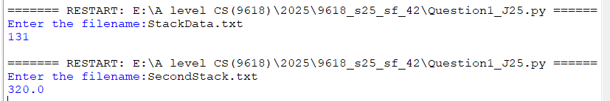

Question 2
Part 2(a)
class NewRecord:
def __init__(self,pKey,pItem1,pItem2):
self.__Key=pKey #integer
self.__Item1=pItem1 #integer
self.__Item2=pItem2 #integer
def GetKey(self):
return self.__Key
def GetItem1(self):
return self.__Item1
def GetItem2(self):
return self.__Item2

Part 2(b)(i)
HashTable=[]
Spare=[]

Part 2(b)(ii)
def Initialise():
global HashTable
global Spare
for X in range(200):
HashTable.append(NewRecord(-1,-1,-1))
for X in range(100):
Spare.append(NewRecord(-1,-1,-1))

Part 2(c)
def CalculateHash(Key):
return Key% 200

Part 2(d)
def InsertIntoHash(TheRecord):
global HashTable
global Spare
HashValue=CalculateHash(TheRecord.GetKey())
if HashTable[HashValue].GetKey()== -1:
HashTable[HashValue]=TheRecord
else:
for x in range(100):
if Spare[x].GetKey()== -1:
Spare[x]=TheRecord
break

Part 2(e)
def CreateHashTable():
global HashTable
global Spare
try:
File= open("HashData.txt")
for Line in File:
Data=Line.strip()
Data=Line.split(",")
InsertIntoHash(NewRecord(int(Data[0]),int(Data[1]),int(Data[2])))
File.close()
except:
print("Cannot open file")

Part 2(f)(i)
def PrintSpare():
global Spare
X=0
while Spare[X].GetKey() != -1:
print(Spare[X].GetKey())
X +=1

Part 2(f)(ii)
Initialise()
CreateHashTable()
PrintSpare()

Part 2(f)(iii)
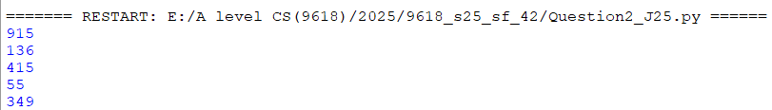
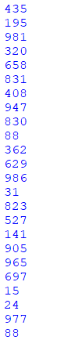

Question 3
Part 3(a)(i)
class Animal:
def __init__(self,pName,pSound,pSize,pIntelligence):
self.Name=pName #string
self.Sound=pSound #string
self.Size=pSize #integer
self.Intelligence=pIntelligence #integer

Part 3(a)(ii)
def Description(self):
Message= "The animal's name is "+ self.Name+", it makes a "+self.Sound+", its size is "+str(self.Size)+" and its intelligence level is "+str(self.Intelligence)
return Message

Part 3(b)(i)
class Parrot(Animal):
def __init__(self,pName,pSound,pSize,pIntelligence,pWingSpan,pNumberWords):
super().__init__(pName,pSound,pSize,pIntelligence)
self.WingSpan=pWingSpan #integer
self.NumberWords=pNumberWords #integer
def ChangeNumberWords(self,Change):
self.NumberWords=self.NumberWords+ Change

Part 3(b)(ii)
def Description(self):
Message= "The animal's name is "+ self.Name+", it makes a "+self.Sound+", its size is "+str(self.Size)+" and its intelligence level is "+str(self.Intelligence)+". It has a wingspan of "+str(self.WingSpan)+"cm and can say "+str(self.NumberWords)+ " words."
return Message

Part 3(c)(i)
class Wolf(Animal):
def __init__(self,pName,pSound,pSize,pIntelligence,pTerritorySize):
super().__init__(pName,pSound,pSize,pIntelligence)
self.TerritorySize=pTerritorySize #integer
def SetTerritorySize(self,Change):
self.TerritorySize=self.TerritorySize+ Change

Part 3(c)(ii)
def Description(self):
Message= "The animal's name is "+ self.Name+", it makes a "+self.Sound+", its size is "+str(self.Size)+" and its intelligence level is "+str(self.Intelligence)+". Its territory is "+ str(self.TerritorySize)+" square miles."
return Message

Part 3(d)(i)
Animal1=Parrot("Chewie","Squawk",1,10,30,29)
Animal2=Wolf("Nighteyes","Howl",8,7,100)
Animal3=Animal("Cooper","Neigh",10,6)

Part 3(d)(ii)
Animal2.SetTerritorySize(-20)
Animal1.ChangeNumberWords(2)
print(Animal1.Description())
print(Animal2.Description())
print(Animal3.Description())

Part 3(d)(iii)

