Insert your name, centre number and candidate number into the header above.
Save this evidence document as evidence_ followed by your centre number_ candidate number. For example: evidence_ zz999_9999.doc
Screenshots or program listings must be copied into appropriate cells in the following tables.
Examiners must be able to read the contents including any screenshots without the use of a magnifying glass. Answers that are not readable or missing will not be awarded any marks.
Save this evidence document at regular intervals, for example every 10 minutes.
Question 1
Part 1(a)(i)
class Bird:
def __init__(self,pDistancePerHour,pSpecies):
self.__Species=pSpecies #string
self.__DistancePerHour=pDistancePerHour #real
self.__XPosition=500.0 #real
self.__YPosition=500.0 #real

Part 1(a)(ii)
def GetSpecies(self):
return self.__Species

Part 1(a)(iii)
def GetPosition(self):
ReturnValue= "X = " + str(self.__XPosition) + " Y = " + str(self.__YPosition)
return ReturnValue

Part 1(a)(iv)
def Move(self,Direction,MinsFlying):
if Direction == "E":
self.__XPosition=self.__XPosition+ ((self.__DistancePerHour/60)*MinsFlying)
elif Direction == "W":
self.__XPosition=self.__XPosition- ((self.__DistancePerHour/60)*MinsFlying)
elif Direction == "N":
self.__YPosition=self.__YPosition+ ((self.__DistancePerHour/60)*MinsFlying)
elif Direction == "S":
self.__YPosition=self.__YPosition- ((self.__DistancePerHour/60)*MinsFlying)

Part 1(b)
FirstBird= Bird(71.0,"Cocktiel")
SecondBird= Bird(56.0,"Macaw")

Part 1(c)(i)
Choice=0
while Choice != 1 and Choice != 2:
print("Which bird do you want to move")
print("Enter 1 for", FirstBird.GetSpecies(), "is currently at", FirstBird.GetPosition())
Choice= -1
print("Enter 2 for", SecondBird.GetSpecies(), "is currently at", SecondBird.GetPosition())
Choice = int(input())
Time = -1
while Time <0 or Time > 500:
Time= int(input("To the nearest minute how long has the bird been flying"))
Valid = False
while Valid == False:
Valid = True
Direction= input("Which direction has the bird been flying, North, South, East or West ").upper()
if Direction=="NORTH" or Direction== "N":
if Choice==1:
FirstBird.Move("N",Time)
else:
SecondBird.Move("N",Time)
elif Direction=="SOUTH" or Direction== "S":
if Choice==1:
FirstBird.Move("S",Time)
else:
SecondBird.Move("S",Time)
elif Direction=="EAST" or Direction== "E":
if Choice==1:
FirstBird.Move("E",Time)
else:
SecondBird.Move("E",Time)
elif Direction=="WEST" or Direction== "W":
if Choice==1:
FirstBird.Move("W",Time)
else:
SecondBird.Move("W",Time)
else:
Valid = False
print(FirstBird.GetSpecies(), "is currently at", FirstBird.GetPosition())
print(SecondBird.GetSpecies(), "is currently at", SecondBird.GetPosition())

Part 1(c)(ii)
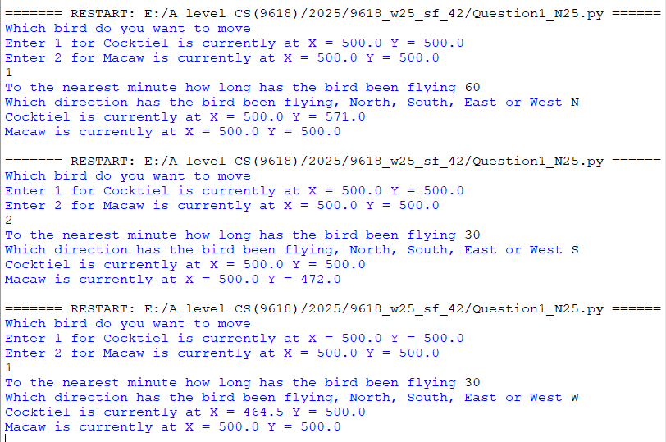
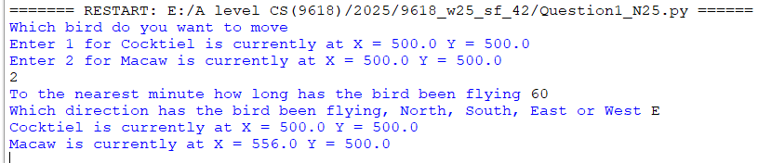

Question 2
Part 2(a)
import random
TheArray=[]
TheArray= random.sample(range(0,101),20)

Part 2(b)
def PrintArray(DataArray):
Output=""
for Item in DataArray:
Output=Output+ str(Item) + " "
print(Output)

Part 2(c)
def BubbleSort(DataArray):
Swap= True
while Swap== True:
Swap= False
for y in range(0,len(DataArray)-1):
if DataArray[y]>DataArray[y+1]:
DataArray[y],DataArray[y+1]=DataArray[y+1],DataArray[y]
Swap= True
return DataArray

Part 2(d)(i)
PrintArray(TheArray)
SortedArray=BubbleSort(TheArray)
print("Sorted")
PrintArray(SortedArray)

Part 2(d)(ii)
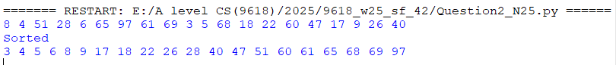

Part 2(e)
def RecursiveBinarySearch(DataArray,Lower,Upper,DataToFind):
if Upper>=Lower:
Middle= Lower+ (Upper-Lower)//2
if DataArray[Middle] == DataToFind:
return Middle
elif DataArray[Middle] > DataToFind:
return RecursiveBinarySearch(DataArray,Lower,Middle-1,DataToFind)
else:
return RecursiveBinarySearch(DataArray,Middle+1,Upper,DataToFind)
else:
return -1

Part 2(f)(i)
DataToFind= int(input("Enter the number to find "))
Location= RecursiveBinarySearch(SortedArray,0,19,DataToFind)
if Location == -1 :
print("Not found")
else:
print("Found at position", Location)

Part 2(f)(ii)
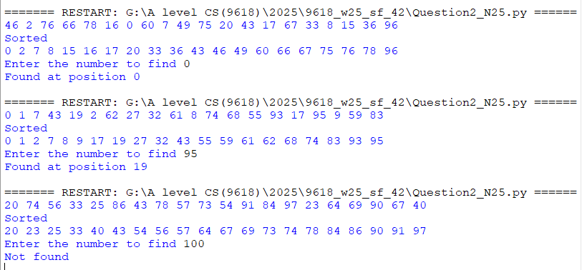

Question 3
Part 3(a)
TreeArray=[]
for x in range(50):
TreeArray.append([-1,-1,-1])
RootPointer= -1
FreeNode= 0

Part 3(b)
def AddNode(NodeData):
global FreeNode
global TreeArray
global RootPointer
if FreeNode <= 49:
TreeArray[FreeNode][0]=-1
TreeArray[FreeNode][1]=NodeData
TreeArray[FreeNode][2]=-1
if RootPointer== -1:
RootPointer= 0
else:
Placed= False
CurrentNode= RootPointer
while Placed== False:
if NodeData< TreeArray[CurrentNode][1]:
if TreeArray[CurrentNode][0] == -1:
TreeArray[CurrentNode][0]= FreeNode
Placed= True
else:
CurrentNode= TreeArray[CurrentNode][0]
else:
if TreeArray[CurrentNode][2] == -1:
TreeArray[CurrentNode][2]= FreeNode
Placed= True
else:
CurrentNode= TreeArray[CurrentNode][2]
FreeNode = FreeNode + 1
else:
print("The tree is full")

Part 3(c)
try:
File= open("TreeData.txt")
for Line in File:
AddNode(int(Line.strip()))
File.close()
except:
print("Error cannot open file")

Part 3(d)
def WriteAllToFile():
try:
File= open("Tree.txt","a+")
for x in range(0,50):
Line= str(TreeArray[x][0]) + "," + str(TreeArray[x][1]) + "," + str(TreeArray[x][2]) + "\n"
File.write(Line)
File.close()
except:
print("Cannot write to file")

Part 3(e)(i)
WriteAllToFile()

Part 3(e)(ii)
