Insert your name, centre number and candidate number into the header above.
Save this evidence document as evidence_ followed by your centre number_ candidate number. For example: evidence_ zz999_9999.doc
Screenshots or program listings must be copied into appropriate cells in the following tables.
Examiners must be able to read the contents including any screenshots without the use of a magnifying glass. Answers that are not readable or missing will not be awarded any marks.
Save this evidence document at regular intervals, for example every 10 minutes.
Question 1
Part 1(a)(i)
class BoardObject():
def __init__(self,Code,Value):
self.Code= Code #string
self.Value= Value #integer

Part 1(a)(ii)
def GetCode(self):
return self.Code
def GetValue(self):
return self.Value

Part 1(a)(iii)
Object1= BoardObject("A",2)
Object2= BoardObject("B",3)
Object3= BoardObject("C",5)
Object4= BoardObject("D",2)
Object5= BoardObject("E",7)

Part 1(b)(i)
class Board():
def __init__(self):
self.TheBoard= [] #type BoardObject
for x in range(10):
TempList=[]
for y in range(10):
TempList.append(BoardObject("-",0))
self.TheBoard.append(TempList)

Part 1(b)(ii)
def GetObject(self,Rowpos,Columnpos):
return self.TheBoard[Rowpos][Columnpos]

Part 1(b)(iii)
def SetObject(self, TheObject, Rowpos, Columnpos):
self.TheBoard[Rowpos][Columnpos]= TheObject

Part 1(b)(iv)
def DisplayObject(self):
for x in range(10):
OutputLine=""
for y in range(10):
OutputLine= OutputLine + str(self.TheBoard[x][y].GetCode()) + " "
print(OutputLine)

Part 1(c)(i)
GameBoard = Board()
Object1= BoardObject("A",2)
Object2= BoardObject("B",3)
Object3= BoardObject("C",5)
Object4= BoardObject("D",2)
Object5= BoardObject("E",7)
GameBoard.SetObject(Object1, 0, 0)
GameBoard.SetObject(Object2, 9, 9)
GameBoard.SetObject(Object3, 4, 5)
GameBoard.SetObject(Object4, 2, 2)
GameBoard.SetObject(Object5, 8, 7)
GameBoard.DisplayObject()

Part 1(c)(ii)
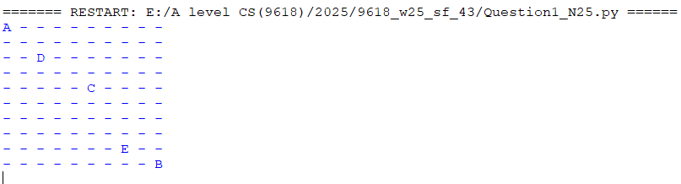

Part 1(d)(i)
InputRow= -1
while InputRow<0 or InputRow>9 :
InputRow= int(input("Enter the row position between 0 and 9 "))

InputColumn= -1
while InputColumn<0 or InputColumn>9 :
InputColumn= int(input("Enter the column position between 0 and 9 "))

GuessObject=GameBoard.GetObject(InputRow,InputColumn)
if GuessObject.GetCode() == "-":
print("Miss")
else:
print("You found "+ str(GuessObject.GetCode()) + " with value " + str(GuessObject.GetValue()))

Part 1(d)(ii)
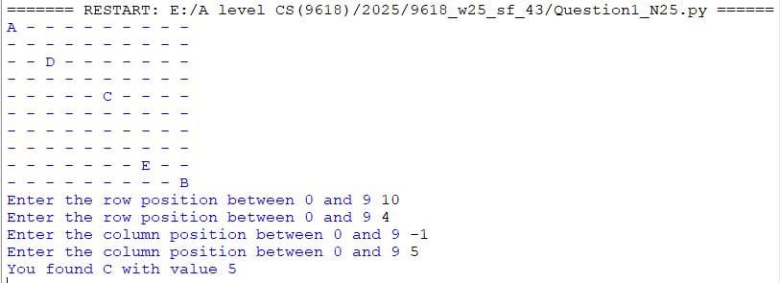

Question 2
Part 2(a)
global Queue, QueueHead, QueueTail, NumberItems
Queue=[]
for x in range(100):
Queue.append("")

QueueHead= -1
QueueTail= -1
NumberItems=0

Part 2(b)
def Enqueue (TheData):
global Queue, QueueHead, QueueTail, NumberItems
if QueueHead== -1:
Queue[0]= TheData
QueueHead= 0
QueueTail= 0
NumberItems +=1
return True
elif QueueTail < 99:
Queue[QueueTail+1]= TheData
QueueTail +=1
NumberItems +=1
return True
else:
return False

Part 2(c)
def Dequeue():
global Queue, QueueHead, QueueTail, NumberItems
if NumberItems == 0:
return False
else:
ReturnData= Queue[QueueHead]
QueueHead += 1
NumberItems -=1
return ReturnData

Part 2(d)
def ReadData():
try:
TheFile= open("BinaryData.txt")
for Line in TheFile:
ReturnValue= Enqueue(Line.strip())
if ReturnValue == False:
break
TheFile.close()
except:
print("No file found")

Part 2(e)
def Compress():
global NewString
First=Dequeue()
NewString= ""
while NumberItems>0 and First != False:
Count = 1
NextChar = Dequeue()
while NextChar == First:
Count += 1
First = NextChar
NextChar = Dequeue()
NewLine = First + str(Count)
NewString = NewString + NewLine
First = NextChar

Part 2(f)(i)
NewString= ""
Queue=[]
for x in range(100):
Queue.append("")
QueueHead= -1
QueueTail= -1
NumberItems=0
ReadData()
Compress()
print(NewString)

Part 2(f)(ii)

Question 3
Part 3(a)(i)
def RecursiveCount(DataToFind,ArrayCopy,NumberElements):
if NumberElements > 0:
NewArray= ArrayCopy[1:]
if ArrayCopy[0] == DataToFind:
return 1 + RecursiveCount(DataToFind,NewArray,NumberElements-1)
else:
return RecursiveCount(DataToFind,NewArray,NumberElements-1)
else:
return 0

Part 3(a)(ii)
MyArray = [0,5,1,2,5,9,9,6,5,0]
print(RecursiveCount(0,MyArray,10))

Part 3(a)(iii)

Part 3(b)(i)
Code = "x=0;y=1;x=x+y;y++;"

Part 3(b)(ii)
def SplitData(DataString):
SplitDataArray = []
Count = 0
for x in range(4):
TempString = ""
try:
Character = DataString[Count]
while Character != ";":
TempString = TempString + Character
Count += 1
Character = DataString[Count]
SplitDataArray.append(TempString)
except:
print("No more characters")
Count += 1
return SplitDataArray

Part 3(b)(iii)
Code = "x=0;y=1;x=x+y;y++;"
SplitDataArray = SplitData(Code)
for x in range(4):
print(SplitDataArray[x])

Part 3(b)(iv)
