Screenshots or program listings must be copied into appropriate cells in the following table.
Save this evidence document as evidence_ followed by your centre number_ candidate number, for example, evidence_ zz999_9999 and insert your name, centre number and candidate number into the header above.
Examiners must be able to read the contents including any screenshots without the use of a magnifying glass. Answers that are not readable or are missing will not be awarded any marks.
Save this evidence document at regular intervals, for example every 10 minutes.
Question 1
Part 1(a)
global Animals #array 10 elements string
Animals = []

Part 1(b)
#main
Animals = []
Animals.append("horse")
Animals.append("lion")
Animals.append("rabbit")
Animals.append("mouse")
Animals.append("bird")
Animals.append("deer")
Animals.append("whale")
Animals.append("elephant")
Animals.append("kangaroo")
Animals.append("tiger")

Part 1(c)
def SortDescending():
ArrayLength = 10
for X in range(0, ArrayLength-1):
for Y in range(0, ArrayLength-X-1):
if (Animals[Y][0] < Animals[Y+1][0]):
Temp = Animals[Y]
Animals[Y] = Animals[Y+1]
Animals[Y+1] = Temp

Part 1(d)(i)
SortDescending()
for X in range(0,10):
print(Animals[X])

Part 1(d)(ii)
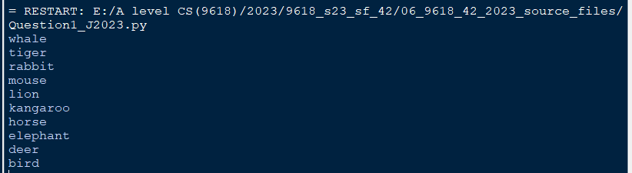

Question 2
Part 2(a)
class SaleData:
def __init__(self, SaleIDp, Quantityp):
self.SaleID = SaleIDp #string
self.Quantity = Quantityp #integer

Part 2(b)
global CircularQueue
CircularQueue = [] #SaleData, 5 items
global NumberOfItems #int
global Head #int
global Tail #int

#main
NumberOfItems = 0
Head = 0
Tail = 0
for x in range(0,5):
CircularQueue.append((SaleData("",-1)))

Part 2(c)
def Enqueue(RecordToAdd):
global CircularQueue
global NumberOfItems #int
global Head #int
global Tail #int
if (NumberOfItems == 5):
return -1
else:
CircularQueue[Tail] = RecordToAdd
if (Tail == 4):
Tail = 0
else:
Tail += 1
NumberOfItems += 1
return 1

Part 2(d)
def Dequeue():
global CircularQueue
global NumberOfItems #int
global Head #int
global Tail #int
RecordRemoved = SaleData("",-1)
if not (NumberOfItems == 0):
RecordRemoved = CircularQueue[Head]
NumberOfItems -= 1
if Head == 4:
Head = 0
else:
Head += 1
return RecordRemoved

Part 2(e)
def EnterRecord():
ID = input("Enter ID")
QuantityP = input("Enter quantity")
Record = SaleData(ID, QuantityP)
if Enqueue(Record) == -1:
print("Full")
else:
print("Stored")

Part 2(f)(i)
EnterRecord()
EnterRecord()
EnterRecord()
EnterRecord()
EnterRecord()
EnterRecord()
ReturnValue = Dequeue()
if ReturnValue.SaleID == "":
print("No items")
else:
print(ReturnValue.SaleID, " ", ReturnValue.Quantity)
EnterRecord()

for x in range(0,5):
print(CircularQueue[x].SaleID, " ", CircularQueue[x].Quantity)

Part 2(f)(ii)
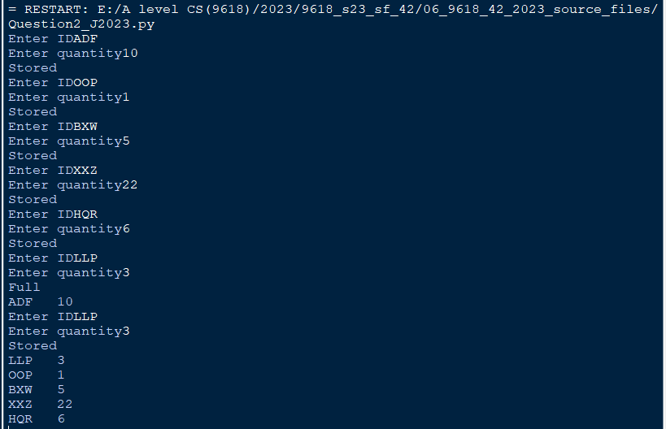

Question 3
Part 3(a)(i)
class Employee:
#self.__HourlyPay single
#self.__EmployeeNumber string
#self.__JobTitle string
def __init__(self, EmpNumP, PayP, JobP):
self.__HourlyPay = PayP
self.__EmployeeNumber = EmpNumP
self.__JobTitle = JobP
self.__PayYear2022 = [] #array 52 elements single
for x in range(0,52):
self.__PayYear2022.append(0.00)

Part 3(a)(ii)
def GetEmployeeNumber(self):
return self.__EmployeeNumber

Part 3(a)(iii)
def SetPay(self, WeekNumber, Hours):
self.__PayYear2022[WeekNumber-1] = Hours * self.__HourlyPay

Part 3(a)(iv)
def GetTotalPay(self):
TotalPay = 0
for X in range(0,52):
TotalPay = TotalPay + self.__PayYear2022[X]
return TotalPay

Part 3(b)(i)
class Manager(Employee):
#BonusValue single
def __init__(self, EmpNumP, PayP, JobP, BonusP):
super().__init__(EmpNumP, PayP, JobP)
self.__BonusValue = BonusP

Part 3(b)(ii)
def SetPay(self, WeekNumber, Hours):
Hours = Hours * (1 + self.__BonusValue/100)
super().SetPay(WeekNumber, Hours)

Part 3(c)
#main
EmployeeArray = []
Pay = 0.00
ID = ""
Bonus = 0.00
Title = ""
Temp = ""
try:
TextFile = "Employees.txt"
File = open(TextFile, 'r')
for x in range(0,8):
Pay = float(File.readline().strip())
ID = File.readline().strip()
Temp = File.readline().strip()
try:
Bonus = float(Temp)
Title = File.readline().strip()
EmployeeArray.append(Manager(ID, Pay, Title, Bonus))
except:
Title = Temp
EmployeeArray.append(Employee(ID, Pay, Title))
File.close()
except IOError:
print("Could not find file")

Part 3(d)
def EnterHours():
global EmployeeArray
try:
TextFile = "HoursWeek1.txt"
File = open(TextFile,'r')
EmpID = ""
for X in range(0,8):
EmpID = File.readline().strip()
for Y in range(0,8):
if EmployeeArray[Y].GetEmployeeNumber() == EmpID:
EmployeeArray[Y].SetPay(1,float(File.readline().strip()))
File.close()
except IOError:
print("Could not find file")

Part 3(e)(i)
EnterHours()
for Y in range(0,8):
print(EmployeeArray[Y].GetEmployeeNumber(), " ", EmployeeArray[Y].GetTotalPay())

Part 3(e)(ii)
