UNIVERSITY OF JAMMU

Website: jammuuniversity.ac.in


Practical File
on
P2CSPC280: Practical
(Session: 2025-26)

Submitted By
Name:
Class: MCA -II
Roll no:

CERTIFICATE

This is certified to be the Bonafide practical work in the C++ Programming in Second Semester of MCA programme during the academic year 2025-26.

This book is prepared by Roll no. 0019MCA25, Department of Computer Science and IT.

Teacher -In-Charge:-

Internal Examiner External Examiner

CONTENTS:

Data Structure
Program 1: Write a program to insert an element in array at a given position. 1
Program 2: Write a program to delete an element in array from a given position. 2
Program 3: Write a program to search an element from array using Linear Search . 3
Program 4: Write a program to search an element from array using Binary Search . 4
Program 5: Write a program to reverse an array (in-place). 6
Program 6: Write a program to merge two arrays. 7
Program 7: Write a program to remove duplicate elements from an array. 8
Program 8: Write a program to implement matrix Multiplication operation in array 9
Program 9: Write a program to create a singly linked list and also count the number of nodes in a singly linked list. 10
Program 10: Write a program to create Insert a node at: Beginning, End, Specific position in linked list. 11
Program 11: Write a program to reverse a singly linked. 12
Program 12: Write a program to merge two singly linked lists. 13

HTML
Program 1: Create webpage to demonstrate nested list. 13
Program 2: Create Table that stores the employee’s details. 15
Program 3: Create Nested table in HTML 17
Program 4: Create a Student Application Form in HTML. 19
Program 5: Create a website “University of Jammu” using html. 21

1. Write a program to insert an element at a given position.

#include <iostream>
using namespace std;

int main() {
int arr[100], n, pos, val;

cout << "Enter size: ";
cin >> n;

cout << "Enter elements:\n";
for(int i=0;i<n;i++) cin >> arr[i];

cout << "Enter position and value: ";
cin >> pos >> val;

for(int i=n; i>=pos; i--)
arr[i] = arr[i-1];

arr[pos-1] = val;
n++;

for(int i=0;i<n;i++) cout << arr[i] << " ";
}

Output
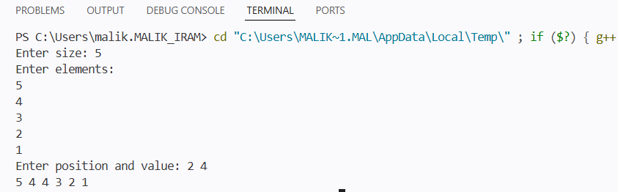

2. Write a program to delete an element from a given position.

#include <iostream>
using namespace std;

int main() {
int arr[100], n, pos;
cout << "Enter size: ";
cin >> n;
cout << "Enter elements:\n";
for(int i=0;i<n;i++) cin >> arr[i];

cout << "Enter position to delete value: ";
cin >> pos;

for(int i=pos-1;i<n-1;i++)
arr[i] = arr[i+1];

n--;

for(int i=0;i<n;i++) cout << arr[i] << " ";
}

Output
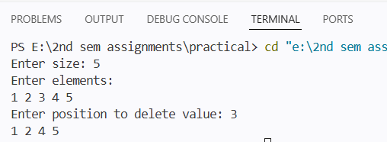

3. Write a program to search for an element using linear search.
#include <iostream>
using namespace std;

int main() {
int arr[100], n, key;
cout<<"enter the number of elements:";
cin >> n;
cout<<"enter the elements:";
for(int i=0;i<n;i++) cin >> arr[i];

cout<<"enter the key to search :";
cin >> key;

for(int i=0;i<n;i++) {
if(arr[i]==key) {
cout << "Found at " << i;
return 0;
}
}
cout << "Not Found";
}
Output

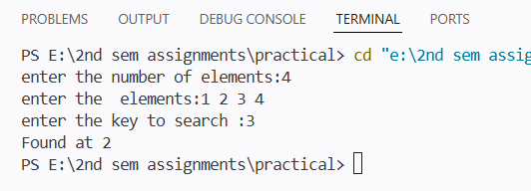

4. Write a program to search for an element using binary search.
#include <iostream>
using namespace std;

int main() {
int arr[100], n, key,i;
cout<<"enter the number of elements:";
cin >> n;

cout<<"enter the elements:";
for(int i=0;i<n;i++) cin >> arr[i];

cout<<"enter the key to search:";
cin >> key;

int low=0, high=n-1;
while(low<=high) {
int mid=(low+high)/2;

if(arr[mid]==key) {
cout<<"Found ";
return 0;
}
else if(arr[mid]<key) low=mid+1;
else high=mid-1;
}
cout<<"Not Found";
}
Output

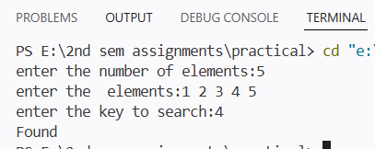

5. Write a program to reverse an array (in-place).

#include <iostream>
using namespace std;

int main() {
int arr[100], n;
cout<<"enter the number of elements:";
cin >> n;

cout<<"enter the elements:";
for(int i=0;i<n;i++) cin >> arr[i];

for(int i=0;i<n/2;i++)
swap(arr[i], arr[n-i-1]);

cout<<"reverse array :";
for(int i=0;i<n;i++) cout << arr[i] << " ";
}

Output

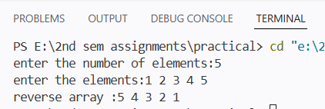

6. Write a program to merge two arrays.
#include <iostream>
using namespace std;

int main() {
int a[50], b[50], c[100], n1, n2;
cout<<"enter the number of elements of first array:";
cin >> n1;
cout<<"enter the elements:";
for(int i=0;i<n1;i++) cin >> a[i];

cout<<"enter the number of elementsof second array:";
cin >> n2;
cout<<"enter the elements:";
for(int i=0;i<n2;i++) cin >> b[i];

for(int i=0;i<n1;i++) c[i]=a[i];
for(int i=0;i<n2;i++) c[n1+i]=b[i];

cout<<"mereged array:";
for(int i=0;i<n1+n2;i++) cout << c[i] << " ";
}
Output
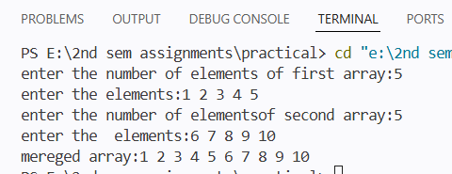

7. Write a program to remove duplicate elements from an array
#include <iostream>
using namespace std;

int main() {
int arr[100], n;
cout<<"enter the number of elements:";
cin >> n;

cout<<"enter the elements:";
for(int i=0;i<n;i++) cin >> arr[i];

for(int i=0;i<n;i++) {
for(int j=i+1;j<n;j++) {
if(arr[i]==arr[j]) {
for(int k=j;k<n-1;k++)
arr[k]=arr[k+1];
n--;
j--;
}
}
}
cout<<"after removing duplicates:";
for(int i=0;i<n;i++) cout << arr[i] << " ";
}

Output
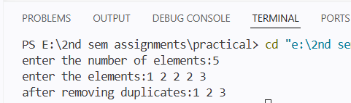

8. Write a program to implement matrix multiplication.
#include <iostream>
using namespace std;

int main() {
int a[10][10], b[10][10], c[10][10];
int r1,c1,r2,c2;

cout<<"enter the number of rows and columns of first array:";
cin >> r1 >> c1;
cout<<"enter the number of rows and columns of second array:";
cin >> r2 >> c2;

cout<<"enter the elements of first array:";
for(int i=0;i<r1;i++)
for(int j=0;j<c1;j++)
cin >> a[i][j];

cout<<"enter the elements second array:";
for(int i=0;i<r2;i++)
for(int j=0;j<c2;j++)
cin >> b[i][j];

for(int i=0;i<r1;i++) {
for(int j=0;j<c2;j++) {
c[i][j]=0;
for(int k=0;k<c1;k++)
c[i][j]+=a[i][k]*b[k][j];
}
}
cout<<"matrix multiplication:";
for(int i=0;i<r1;i++) {
for(int j=0;j<c2;j++)
cout << c[i][j] << " ";
cout << endl;
}
}
Output
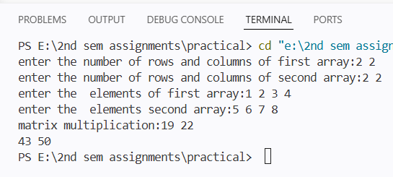
9. Write a program to create a singly linked list and count the number of nodes.
#include <iostream>
using namespace std;

struct Node {
int data;
Node* next;
};
int main() {
Node *head=NULL, *temp;
int n,x,count=0;
cout<<"enter the number of elements:";
cin >> n;

cout<<"enter the value of elements:";
for(int i=0;i<n;i++) {
Node* newNode=new Node();
cin >> x;
newNode->data=x;
newNode->next=head;
head=newNode;
}
temp=head;
while(temp!=NULL) {
count++;
temp=temp->next;
}
// Display
cout << "Linked List:\n";
temp = head;
while(temp != NULL) {
cout << temp->data << " -> ";
temp = temp->next;
}
cout << "NULL\n";
cout << "Nodes: " << count;
}
Output
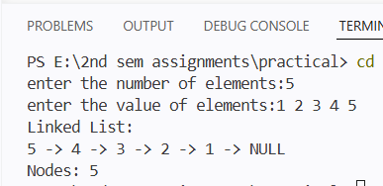
10. Write a program to insert a node at beginning, end, and specific position.
i) inseart at beginning
#include <iostream>
using namespace std;

struct Node {
int data;
Node* next;
};

int main() {
Node *head = NULL, *temp, *newNode;
int n, value;

// Create linked list
cout << "Enter number of nodes: ";
cin >> n;

cout << "Enter value of nodes: ";
for(int i = 0; i < n; i++) {
cin >> value;

newNode = new Node();
newNode->data = value;
newNode->next = NULL;

if(head == NULL) {
head = newNode;
} else {
temp = head;
while(temp->next != NULL)
temp = temp->next;
temp->next = newNode;
}
}

// Insert at beginning
cout << "Enter value to insert at beginning: ";
cin >> value;

newNode = new Node();
newNode->data = value;
newNode->next = head;
head = newNode;

// Display
cout << "Linked List:\n";
temp = head;
while(temp != NULL) {
cout << temp->data << " -> ";
temp = temp->next;
}
cout << "NULL";

return 0;
}
Output
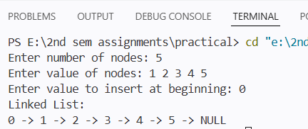
ii) inseart at position
#include <iostream>
using namespace std;

struct Node {
int data;
Node* next;
};

int main() {
Node *head = NULL, *temp, *newNode;
int n, value, pos;

// Create linked list
cout << "Enter number of nodes: ";
cin >> n;

for(int i = 0; i < n; i++) {
cin >> value;

newNode = new Node();
newNode->data = value;
newNode->next = NULL;

if(head == NULL) {
head = newNode;
} else {
temp = head;
while(temp->next != NULL)
temp = temp->next;
temp->next = newNode;
}
}
// Insert at position
cout << "Enter position: ";
cin >> pos;
cout << "Enter value: ";
cin >> value;

newNode = new Node();
newNode->data = value;
if(pos == 1) {
newNode->next = head;
head = newNode;
} else {
temp = head;
for(int i = 1; i < pos - 1 && temp != NULL; i++) {
temp = temp->next;
}

if(temp == NULL) {
cout << "Invalid position";
return 0;
}

newNode->next = temp->next;
temp->next = newNode;
}
// Display
cout << "Linked List:\n";
temp = head;
while(temp != NULL) {
cout << temp->data << " -> ";
temp = temp->next;
}
cout << "NULL";

return 0;
}
Output
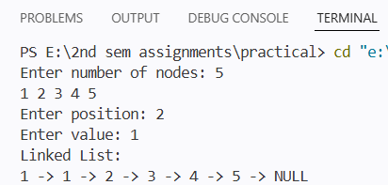

iii) inseart at end
#include <iostream>
using namespace std;

struct Node {
int data;
Node* next;
};

int main() {
Node *head = NULL, *temp, *newNode;
int n, value;

// Create linked list
cout << "Enter number of nodes: ";
cin >> n;

for(int i = 0; i < n; i++) {
cout << "Enter value: ";
cin >> value;

newNode = new Node();
newNode->data = value;
newNode->next = NULL;

if(head == NULL) {
head = newNode;
} else {
temp = head;
while(temp->next != NULL) {
temp = temp->next;
}
temp->next = newNode;
}
}

// Insert a new node at end
cout << "Enter value to insert: ";
cin >> value;

newNode = new Node();
newNode->data = value;
newNode->next = NULL;

if(head == NULL) {
head = newNode;
} else {
temp = head;
while(temp->next != NULL) {
temp = temp->next;
}
temp->next = newNode;
}

// Display linked list
cout << "Linked List:\n";
temp = head;
while(temp != NULL) {
cout << temp->data << " -> ";
temp = temp->next;
}
cout << "NULL";

return 0;
}
Output
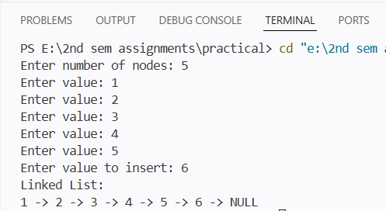

11. Write a program to reverse a singly linked list.
#include <iostream>
using namespace std;

struct Node {
int data;
Node* next;
};

int main() {
Node *head = NULL, *temp, *newNode;
int n, x;

cout << "Enter number of nodes: ";
cin >> n;

// Create list (INSERT AT END - IMPORTANT)
for(int i = 0; i < n; i++) {
cin >> x;
newNode = new Node();
newNode->data = x;
newNode->next = NULL;

if(head == NULL) {
head = newNode;
} else {
temp = head;
while(temp->next != NULL)
temp = temp->next;
temp->next = newNode;
}
}

// Print original list
cout << "Original List:\n";
temp = head;
while(temp != NULL) {
cout << temp->data << " ";
temp = temp->next;
}

// Reverse logic
Node *prev = NULL, *curr = head, *next;

while(curr != NULL) {
next = curr->next;
curr->next = prev;
prev = curr;
curr = next;
}

head = prev;

// Print reversed list
cout << "\nReversed List:\n";
temp = head;
while(temp != NULL) {
cout << temp->data << " ";
temp = temp->next;
}

return 0;
}
Output
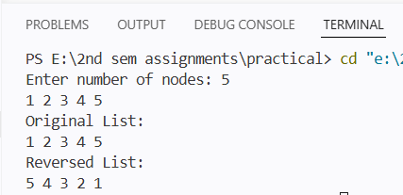

12. Write a program to merge two singly linked lists.
#include <iostream>
using namespace std;

struct Node {
int data;
Node* next;
};

int main() {
Node *head1 = NULL, *head2 = NULL, *temp, *newNode;
int n1, n2, x;

// First list
cout << "Enter number of nodes in list 1: ";
cin >> n1;

for(int i = 0; i < n1; i++) {
cin >> x;
newNode = new Node();
newNode->data = x;
newNode->next = NULL;

if(head1 == NULL) {
head1 = newNode;
} else {
temp = head1;
while(temp->next != NULL)
temp = temp->next;
temp->next = newNode;
}
}

// Second list
cout << "Enter number of nodes in list 2: ";
cin >> n2;

for(int i = 0; i < n2; i++) {
cin >> x;
newNode = new Node();
newNode->data = x;
newNode->next = NULL;

if(head2 == NULL) {
head2 = newNode;
} else {
temp = head2;
while(temp->next != NULL)
temp = temp->next;
temp->next = newNode;
}
}

// Merge logic
if(head1 == NULL) {
head1 = head2;
} else {
temp = head1;
while(temp->next != NULL)
temp = temp->next;
temp->next = head2;
}

// Display merged list
cout << "Merged List:\n";
temp = head1;
while(temp != NULL) {
cout << temp->data << " ";
temp = temp->next;
}

return 0;
}
Output
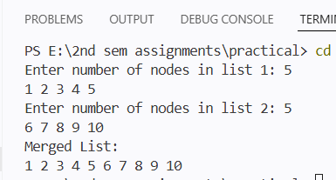

13. Write a program to traverse binary tree .
#include <iostream>
using namespace std;

struct Node {
int data;
Node* left;
Node* right;
};

Node* create(int val) {
Node* newNode = new Node();
newNode->data = val;
newNode->left = newNode->right = NULL;
return newNode;
}

void inorder(Node* root) {
if(root != NULL) {
inorder(root->left);
cout << root->data << " ";
inorder(root->right);
}
}

int main() {
Node* root = create(1);
root->left = create(2);
root->right = create(3);

inorder(root);
}
output
