IRAM ABID

Understanding jira

A Project Management Tool and Issue Tracker developed by Atlassian

# **TABLE OF CONTENTS**

1. **AGILE PROCESS AND METHODOLOGY**
2. **AGILE TERMINOLOGIES**
3. **SCRUM ROLES AND SPRINT ACTIVITIES**
4. **WHAT IS JIRA AND ITS USE**
5. **IMPORTANT JIRA TERMINOLOGIES**
6. **PRACTICAL IMPLEMENTATION**
7. **REFERENCES**

# **AGILE PROCESS AND METHODOLOGIES**

**THE AGILE PROCESS**

Agile is a time boxed, iterative approach to software development, to deliver the product incrementally, instead of all at once.

If working on review is satisfactory then feature is added to the build.

Test

Plan

Review

Implement

Functionality

**No yes**

Add to build

Satisfactory?

**WHAT IS THE AGILE METHODOLOGY?**

The Agile methodology is a project management approach that involves breaking the project into phases and emphasizes continuous collaboration and improvement. Teams follow a cycle of planning, executing, and evaluating.

# **AGILE TERMINOLOGIES**

Epic

What we are trying to achieve?

What is required to achieve the EPIC?

Feature

Tasks required to fulfill those requirements

Task

Task

Task

Story

Story

**Sprint**

A Sprint is a time-boxed period, usually 2-4 weeks, within the Scrum framework, during which specific work is completed and made ready for review.

**Kanban**

Kanban is a visual workflow management method that optimizes the flow of tasks through stages using a Kanban board. It emphasizes visualizing work, limiting work in progress, and continuous delivery.

**Scrum**

Scrum is an agile framework for managing and completing complex projects, characterized by fixed-length iterations called sprints, defined roles (Scrum Master, Product Owner, Development Team), and specific events (Sprint Planning, Daily Scrum, Sprint Review, Sprint Retrospective).

Key elements include:

1. **Roles**

* Product Owner: Defines product features and prioritizes the backlog.
* Scrum Master: Facilitates the process and removes obstacles.
* Development Team: Cross-functional team members who do the work.

1. **Artifacts**

* Product Backlog: A prioritized list of features, enhancements, and fixes.
* Sprint Backlog: The subset of the product backlog items selected for the current sprint.
* Increment: The sum of all the Product Backlog items completed during a Sprint and the value of the increments of all previous Sprints.

1. **Events**

* Sprint: A time-boxed period (usually 2-4 weeks) during which specific work is completed and made ready for review.
* Sprint Planning: Meeting to plan the work for the sprint.
* Daily Scrum: Daily stand-up meeting for the team to synchronize activities.
* Sprint Review: Meeting to review the work completed at the end of the sprint.
* Sprint Retrospective: meeting to reflect on the sprint and identify improvements.

1. **SCRUM ROLES AND SPRINT ACTIVITIES**

**SCRUM ROLES:**

Product Owner:

* Understands the requirement of the customer.
* Great vision for the final product.
* Balances the need of other stakeholders
* Maintains the product backlog
* Release management

Scrum Master:

* Responsible for gluing everything together
* Sometimes act as intermediatory between the product owner and dev team.
* Helps in planning and breaking down work
* Manages backlog, ensures completion
* Ensures transparency

Scrum Team:

* Consists of Software Developers & Quality Assurance
* Break down the work into subtasks
* Deal with the planning, implementation, testing and preliminary reviewing of goals
* Ensure timely delivery, with quality assurance
* Communicate their progress with the Scrum master

**AGILE SCRUM ROLES’S ACTIVITIES:**

**Product Owner** 🡪 Talks to the client and creates backlog 🡪**Epic:** As a customer, I want to be able to pay for my orders through online wallets.

**Scrum Master**🡪 Teaches and ensures scrum practices to the team.

**Scrum Team** 🡪Learn Scrum Practices🡪Break the Epic down into Stories. **Story 1:** As a customer, I want to be able to pay for my order through PayPal; **Story 2:** As a customer, I want to be able to pay for my order through Paytm

**Scrum Sprint Activities:** have columns like **To Do, In Progress, Testing, Done** columns.

# **JIRA AND ITS USES**

**WHAT IS JIRA?**

Jira is a project management tool and an issue tracker developed by Atlassian. It is used for bug Tracking and Agile Project Management.

**WHY WE SHOULD USE JIRA?**

Jira is an all in-one solution for multiple software and team related use cases.

It is a good tool for employee management for the following reasons:

1. Helps creating backlogs
2. Helps in creating sprints in agile environment
3. Helps in creating tasks
4. Updating status on the board
5. Helps in managing releases
6. Code Integration: can connect with repository
7. Managing workflows

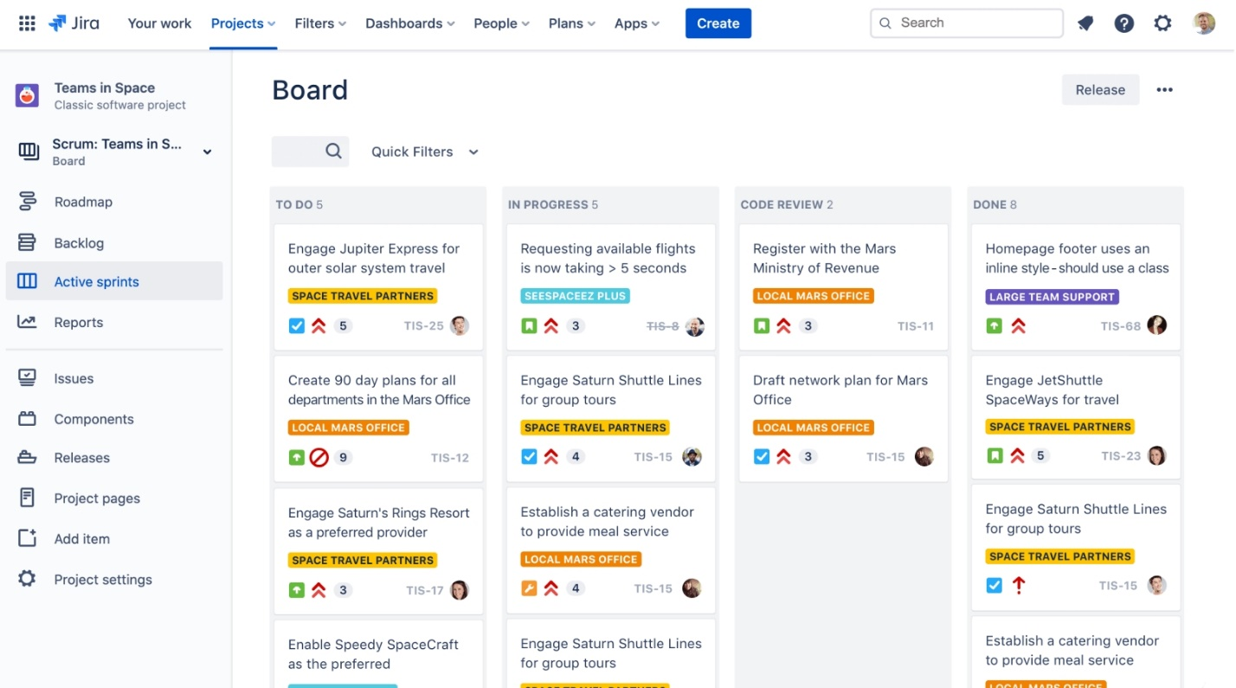

Figure 1: Active Sprints of a project

**The benefits of using Jira:**

1. A powerful issue-tracking system that allows teams to create, assign, prioritize, and monitor tasks and issues seamlessly;
2. whether you’re following Agile, Scrum, or a unique methodology, Jira adapts to your needs, ensuring efficient project management;
3. a suite of reporting and analytics tools, providing insights into project performance;
4. extensive integration capabilities with a wide range of third-party tools and applications.

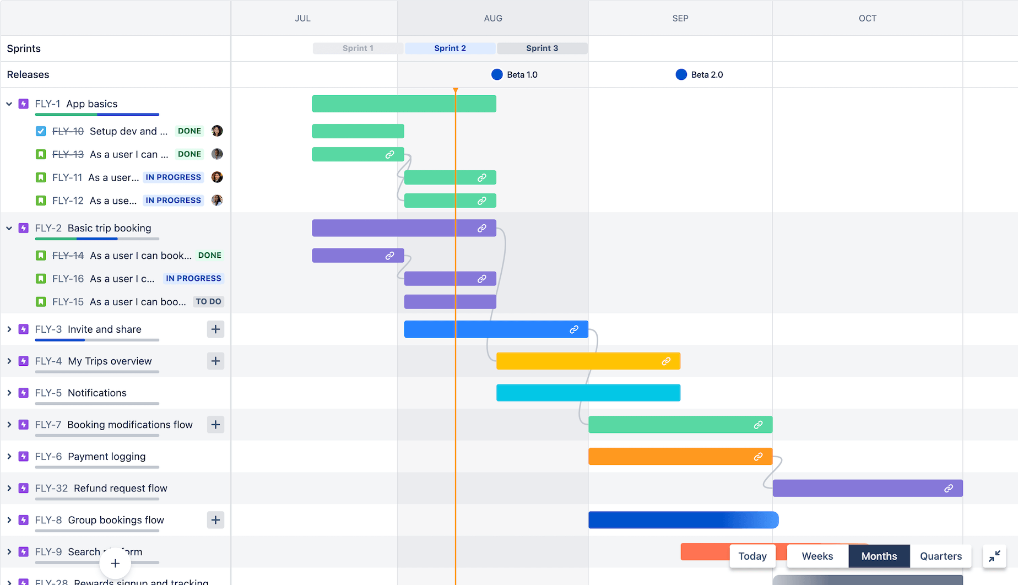

Figure 2: Timeline of project

# **IMPORTANT JIRA TERMINOLOGIES**

1. **Agile Board:** A board that displays issues from one or more projects and is used to plan, track and manage work in an Agile development process.
2. **Backlog:** A backlog is a list of the outstanding user stories, bugs and features for a product or sprint.
3. **Board:** A visual representation of issues in a project or a set of projects.
4. **Bug:** An error or defect in software that causes it to behave in unintended ways.
5. **Daily stand-up** – Also known as a daily scrum, a 15-minute mini-meeting for the software team to sync.
6. **Deployment:** The process of making a software application available to users.
7. **Epic:** A large and complex issue that is broken down into smaller tasks or stories.
8. **Escalation:** The process of moving an issue to a higher priority level due to its urgency.
9. **Event:** A change in the status of an issue, such as the creation of a new issue or the resolution of an existing issue.
10. **Issue:** An issue is simply a unit of work within Jira that will be traced through a workflow, from creation to completion. It can range from representing a single unit of work, like a simple task or bug, to a larger parent work item to be tracked, like a story or an epic.
11. **JSW:** Jira Software (although most just call this Jira)
12. **JSM:** Jira Service Management
13. **JWM:** Jira Work Management
14. **Log Work:** A feature in JIRA that allows users to log the time they spend working on an issue.
15. **Object:** An item in JIRA, such as an issue or a project.
16. **Parent Issue:** An issue in JIRA that is related to one or more child issues.
17. **Priority:** The level of importance assigned to an issue in JIRA, used to determine its order in the backlog or the queue.
18. **Project:** A collection of issues, components, and other resources in JIRA that represent a specific initiative or goal.
19. **Sprint**: A sprint, also known as an iteration, is a short (ideally two to four week) period in which the development team implements and delivers a discrete product increment, e.g. a working milestone version.
20. **Sprint planning**: A team planning meeting that determines what to complete in the coming sprint.
21. **Sprint retrospective**: A review of what did and didn't go well with actions to make the next sprint better.
22. **Story:** A story or user story is a software system requirement that is expressed in a few short sentences, ideally using non-technical language.
23. **Story Point**: A story point is an estimate of the relative complexity of a story.
24. **Subtask:** is a further defined issue, used to break down tasks, stories, or bugs into smaller work items. Subtasks must have a parent issue type. They cannot exist on their own.
25. **Release:** A version of a software application that is made available to users.
26. **Task:** A unit of work in JIRA that represents a specific action or item that needs to be completed.
27. **Workflow:** A sequence of steps in JIRA that describe the life cycle of an issue, from creation to resolution.
28. **Work Log:** A record of the time spent working on an issue in JIRA.

# **PRACTICAL IMPLEMENTATION**

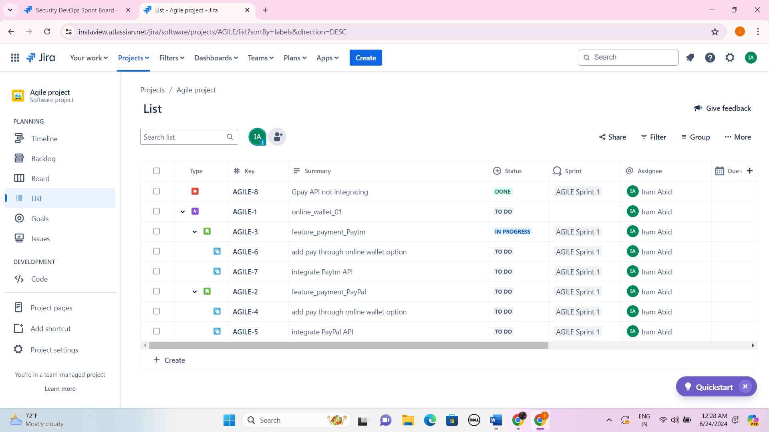

Figure 3: List

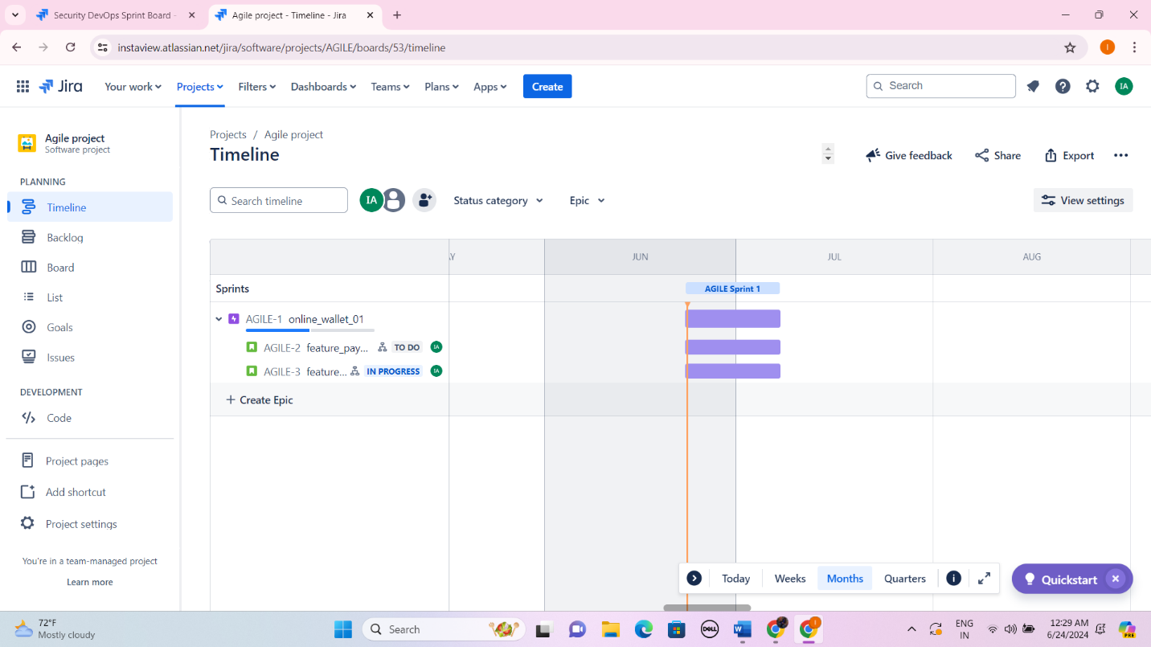

Figure 4: Timeline

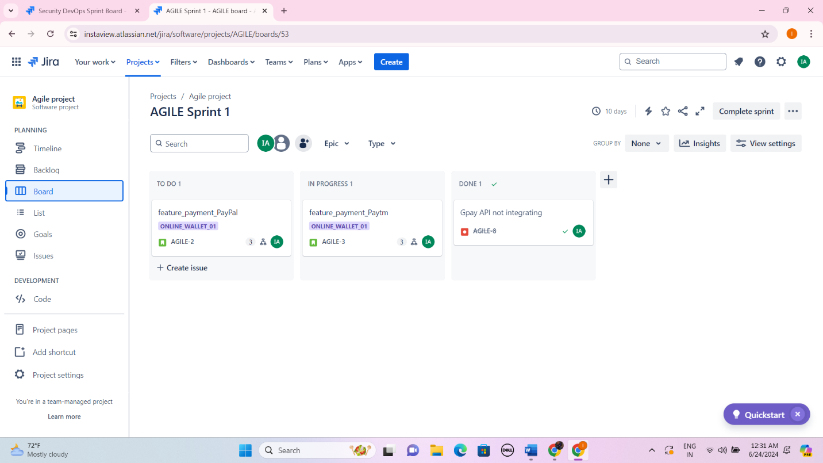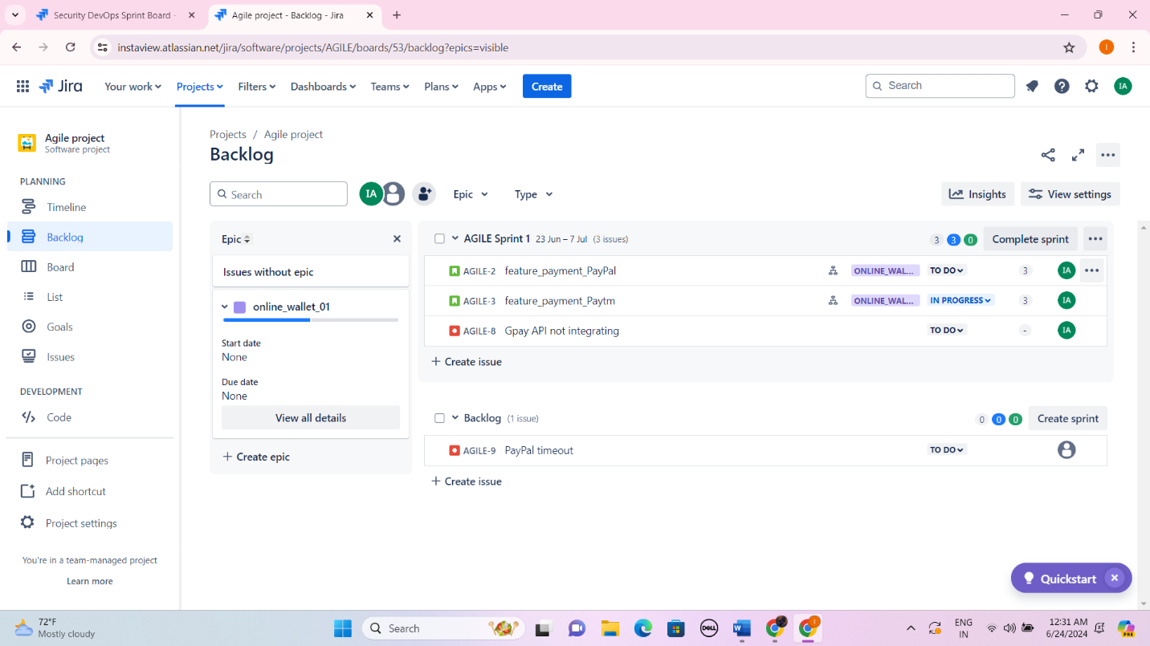

Figure 6: Board

Figure 5: Backlog

# **REFERENCES**

1. <https://community.atlassian.com/t5/App-Central/Jira-Terms-and-Definitions-for-Beginners-from-A-Z-Weekly/ba-p/2285173>
2. <https://medium.com/@amankroy98/jira-terminology-7581f254dc5b>
3. <https://almarise.com/en/products/jira-software/>
4. <https://cloudfresh.com/en/blog/top-7-jira-alternatives/>
5. <https://youtu.be/issdcnErAU8?si=1sfw0FpqNvM4rVvv> (Tutorial)
6. <https://youtu.be/uM_m6EzMg3k?si=NhCngRK-b7tJfaG1> (Tutorial)