Internal Audit Module — User Manual
Audience: all Internal Audit users Environment shown: TEST instance (screenshots captured from the live application) Module prefix: Internal Audit (/audit/*)
This manual set is organised by role. Start here for the shared concepts, then read the manual for your own role.
# | Role manual | Who it is for
01 | Head of Internal Audit | Owns the annual plan, approvals, closure and board reporting
02 | Lead Auditor | Runs engagements: preparation, programme, fieldwork, issuance
03 | Audit Team Member | Control testing, evidence, working papers, findings
04 | Quality Reviewer | Independent quality review and sign-off
05 | Management Respondent | Audited department: responses, corrective actions, evidence
06 | Audit Administrator | Master data, risk configuration, settings, templates

1. The audit lifecycle
Master data Risk Planning Execution Resolution
----------- ---- -------- --------- ----------
Departments -> Risk -> Annual plan -> Preparation -> Management response
Functions assessment Approval Programme / RCM Corrective action
Auditors Risk matrix Launch Fieldwork & evidence Follow-up verification
Risk register Findings Quality review
Report issuance Engagement closure
Plan closure
Each stage is gated. The application will not let a stage advance until the previous stage’s dependencies are satisfied, and the gates are enforced on the server — not just in the screen.

2. Navigation
Internal Audit appears in the left sidebar. The groups and their entries are:
Group | Entry | Route
Dashboard | Dashboard | /audit/dashboard
Reference data | Departments | /audit/departments
Reference data | Business Functions | /audit/functions
Reference data | Risk Register | /audit/risk-register
Risk | Risk Assessment | /audit/risk-assessment
Risk | Entity Risk Summary | /audit/entity-summary
Risk | Risk Matrix | /audit/risk-matrix
Planning | Audit Plans | /audit/audit-plans
Planning | Plan Approval | /audit/plan-approval
Execution | Audits (engagements) | /audit/audits
Execution | Audit workspace | /audit/audits/:id
Execution | Audit Queries | /audit/queries
Resolution | Action Centre | /audit/action-centre
Resources | Auditor Profiles | /audit/auditors
Resources | Workload & Capacity | /audit/workload
Resources | Time Tracking | /audit/time-tracking
Resources | Auditor Leave | /audit/leave
Reporting | Report Center | /audit/audit-reports
Reporting | Report Builder | /audit/report-builder
Reporting | Engagement Summary | /audit/reports/engagement-summary
Reporting | Plan Slippage | /audit/reports/plan-slippage
Reporting | Overdue Actions | /audit/reports/overdue-actions
Reporting | Carry-Forward Aging | /audit/reports/carry-forward-aging
Reporting | Communication Compliance | /audit/reports/communication-compliance
Configuration | Audit Configuration | /audit/config
Configuration | Risk Configuration | /audit/risk-settings
Configuration | Document & Output Settings | /audit/document-templates
Configuration | Escalation Roles | /audit/escalation-roles
Configuration | Communication Templates | /audit/templates
You only see the entries your role is entitled to. A Management Respondent, for example, sees a restricted Internal Audit → Management Workspace group with four entries only: My Work, Findings Register, Corrective Actions and Follow-Ups.
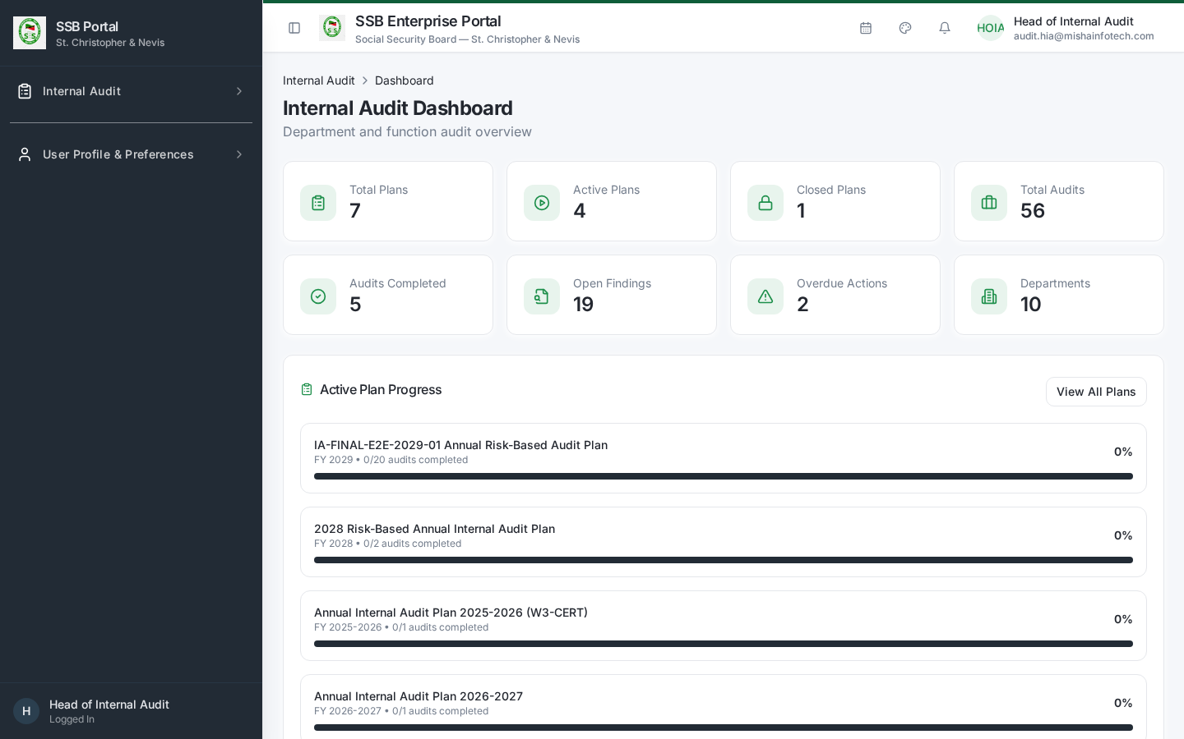
Head of Internal Audit dashboard

3. The audit workspace
Every engagement opens as a single workspace at /audit/audits/:id with a lifecycle stepper and these tabs:
Tab | Purpose
Overview | Lifecycle stage, server-derived progress, recommended next actions
Preparation | Notification, kick-off, scope confirmation, preliminary documents
Programme | Risk Control Matrix — processes, risks, controls, tests
Activities | Fieldwork activities and their completion
Control Tests | Test execution and Pass / Fail / Partial results
Evidence | Evidence files supporting tests and findings
Working Papers | Structured working paper records
Findings | Findings, severity, root cause, recommendations
Responses | Management responses per finding
Actions | Corrective actions with owner, target date, status
Follow-Ups | Independent verification of implemented actions
Quality Review | QA checklist, rating, rework or satisfactory sign-off
Timeline | Every governed event and every communication sent
Closure | Closure readiness, blockers, final rating, closure decision
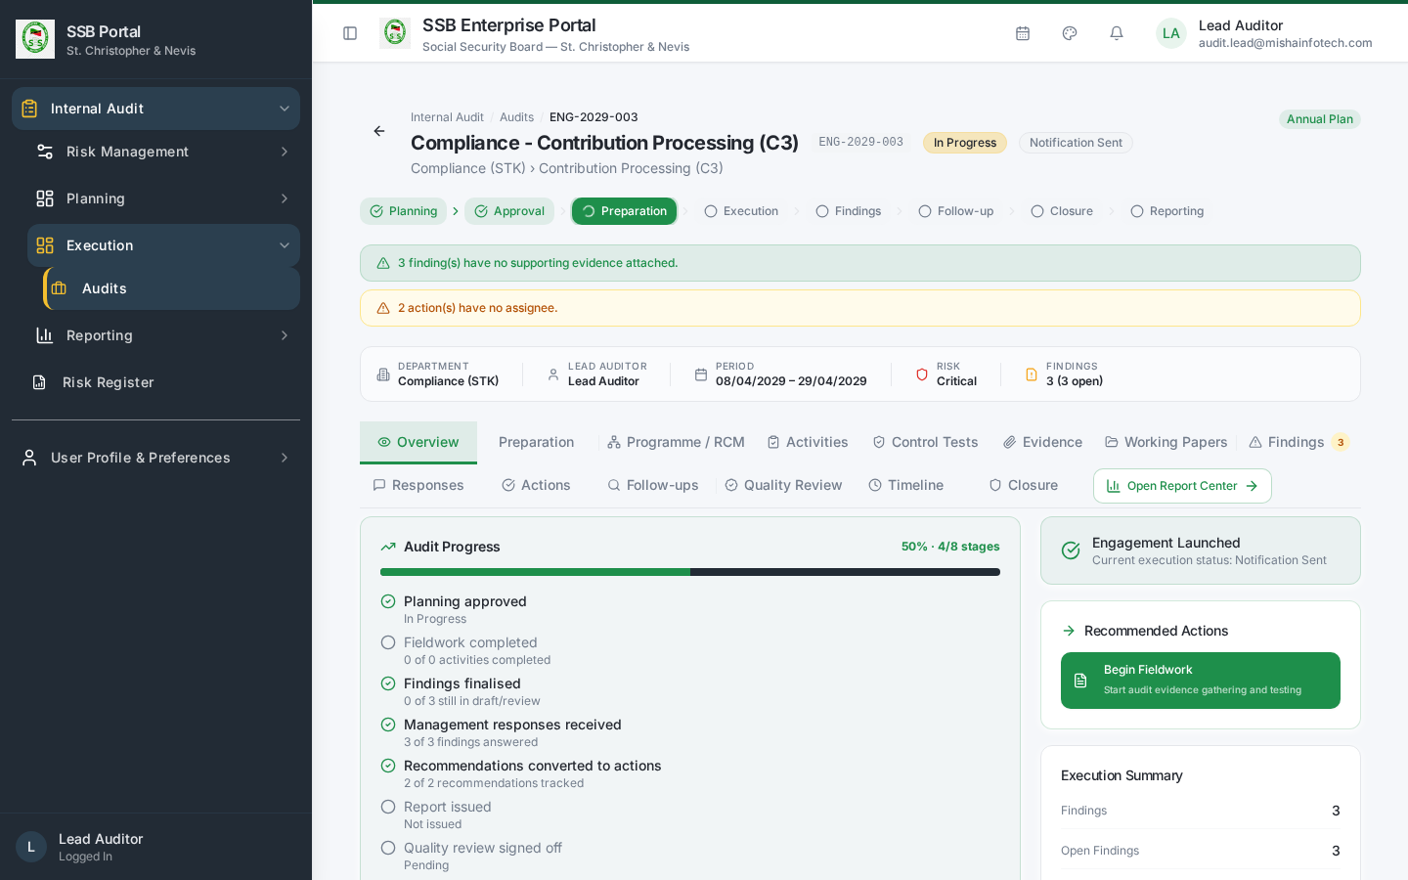
Engagement overview

4. The Action Centre
/audit/action-centre is the cross-engagement work queue. Tabs:
Tab | Shown to | Purpose
My Audit Work | Audit team | Everything assigned to you across engagements
Management Actions | All | Responses and corrective actions owed by management
Head of Audit | Audit team | Items needing the Head’s attention
Action Register | All | Every corrective action, filterable and exportable
Findings Register | All | Every finding with severity and response status
Verification | Audit team | Actions claimed complete, awaiting audit verification
Follow-Up | All | Scheduled follow-up verifications
Quality Review | Audit team | QA queue
Closure Readiness | Audit team | Engagements ready — or blocked — for closure
Filters: annual plan, audit, department, function area, action owner, severity, action status, finding status and a due-date range. Export produces CSV/Excel matching the filtered row count shown next to the Export control.
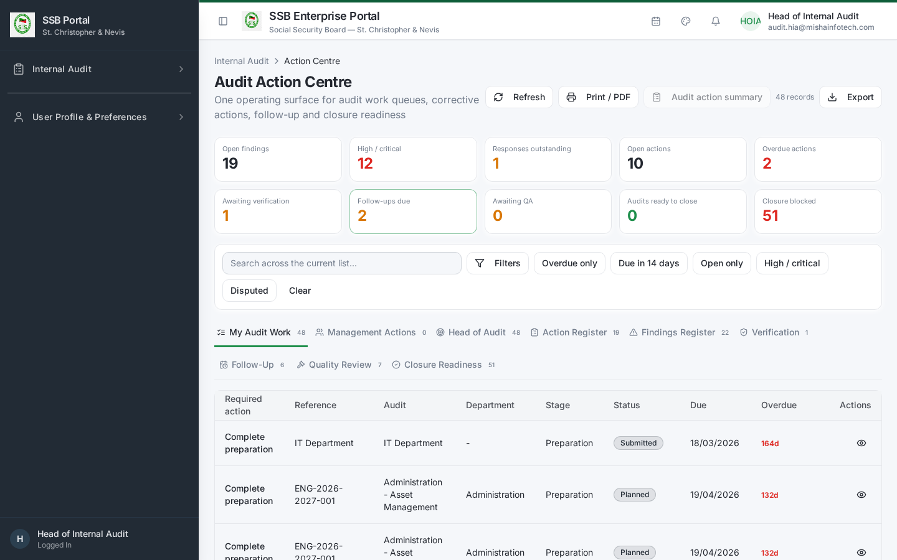
Action Centre

5. Communications
Internal Audit never sends email or in-app messages directly. Every notification — engagement notification, information request, response reminder, action due-soon and overdue escalation, report issuance, closure — is emitted as a catalogued business event and delivered by the platform’s governed communication service. Delivery outcomes are visible on the engagement Timeline tab and in the Communication Compliance report.
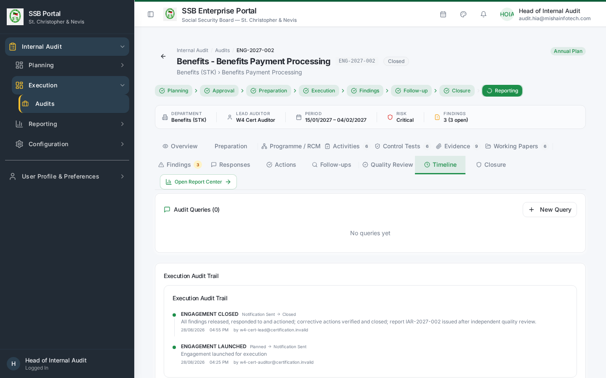
Engagement timeline

6. Governance principles you will meet in the screens
- Server-enforced gates. Launch, closure, plan closure, report issuance and action verification run as governed database commands. If a precondition fails, the screen shows the specific blocking items instead of a generic error.
- Segregation of duties. The person who prepares is not the person who approves. Where the same person must act twice (for example a small audit shop), the system records a logged exception rather than silently allowing it.
- Immutable history. Closure decisions, approvals, response versions and quality sign-offs are appended, never overwritten.
- Terminology. The audited party is the Audited Department with a Management Respondent and a Corrective Action Owner.

7. Glossary
Term | Meaning
Annual Plan | The approved portfolio of audits for a fiscal year
Engagement / Department Audit | One audit of one department, in or out of the annual plan
RCM | Risk Control Matrix: process → risk → control → test
Finding | A confirmed control weakness with severity and root cause
Management Response | The audited department’s position on a finding
Corrective Action | The remedial action with an owner and target date
Follow-Up | Independent audit verification that an action was really implemented
Closed – Actions Pending | Engagement closed while corrective actions remain open
Carry Forward | An engagement moved into the next year’s plan at plan closure

Document Control — Version History & Change Log
Document owner: Head of Internal Audit Classification: Internal
Review cycle: Annually, or on any change to the Internal Audit module.
Version | Date | Author | Summary of change | Approval
1.0 | 2026-08-30 | Internal Audit / Platform Team | First issued manual, generated from the live TEST environment (routes, tabs, governed commands and screenshots). | Reviewed: Lead Auditor. Approved by Head of Internal Audit on: Pending

How to record an update
- Add a new row at the top of the table for every content change — never edit a released row.
- Increment the minor version (1.1, 1.2 …) for clarifications and screenshot refreshes; increment the major version (2.0) when a process, role or gate changes.
- State the change in business terms (what a reader must now do differently), not file edits.
- The manual is only “released” once the Head of Internal Audit records an approval date. Until then it is marked Pending and must not be used as certification evidence.
- Re-export the PDF and DOCX from the Internal Audit User Manuals page after each approval.

Change log
Version | Change | Sections affected
1.0 | Initial release. | All

