Internal Audit — Head of Internal Audit Manual
Role: Head of Internal Audit (HIA) Test account: w4-cert-hia@certification.invalid Owns: annual planning, plan approval, resourcing oversight, engagement and plan closure, board / audit committee reporting.

1. Your dashboard
/audit/dashboard
The dashboard reconciles with the database and shows the plan portfolio, active plan progress, engagement states, findings by severity and overdue corrective actions.
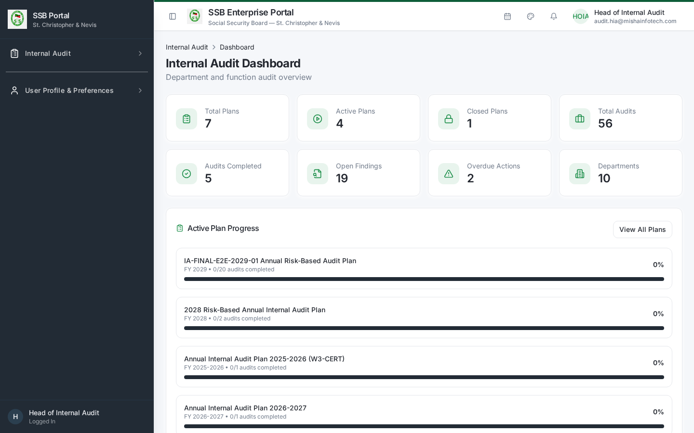
HIA dashboard

2. Annual planning

2.1 Build the plan
- Internal Audit → Audit Plans (/audit/audit-plans) → New Plan.
- Enter title and fiscal year. The plan opens in Draft.
- Add engagements. Candidates are proposed from the audit universe and risk ratings — high and critical entities are proposed at a higher audit frequency.
- For each engagement set the audited department, functions in scope, objectives, scope, planned start / end, lead auditor and team members.
- Record planning assumptions and constraints (resource days, leave, holidays).
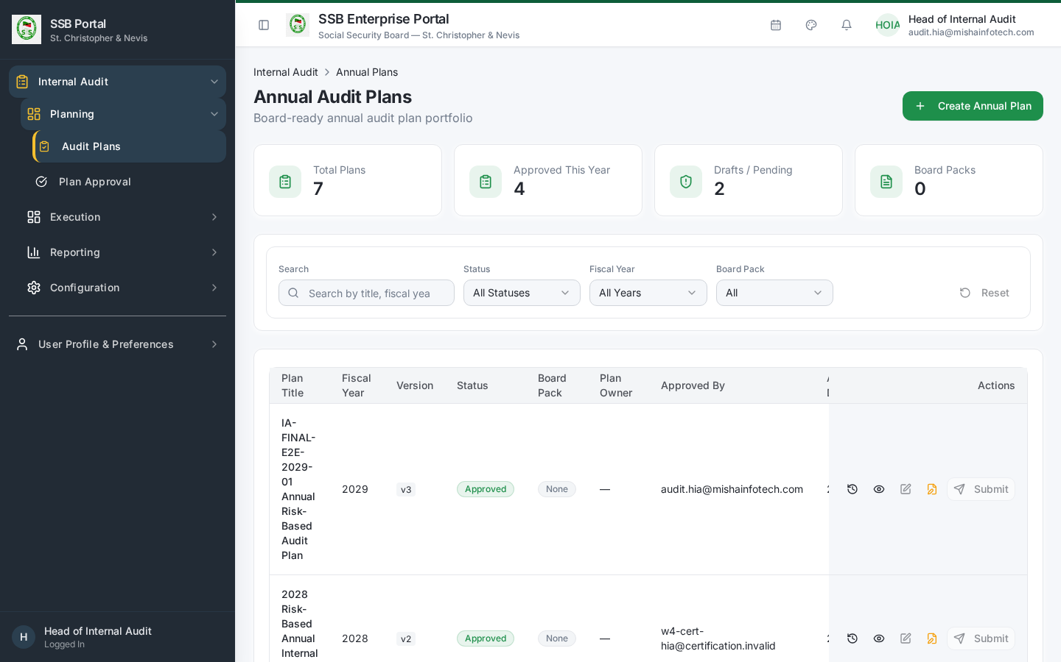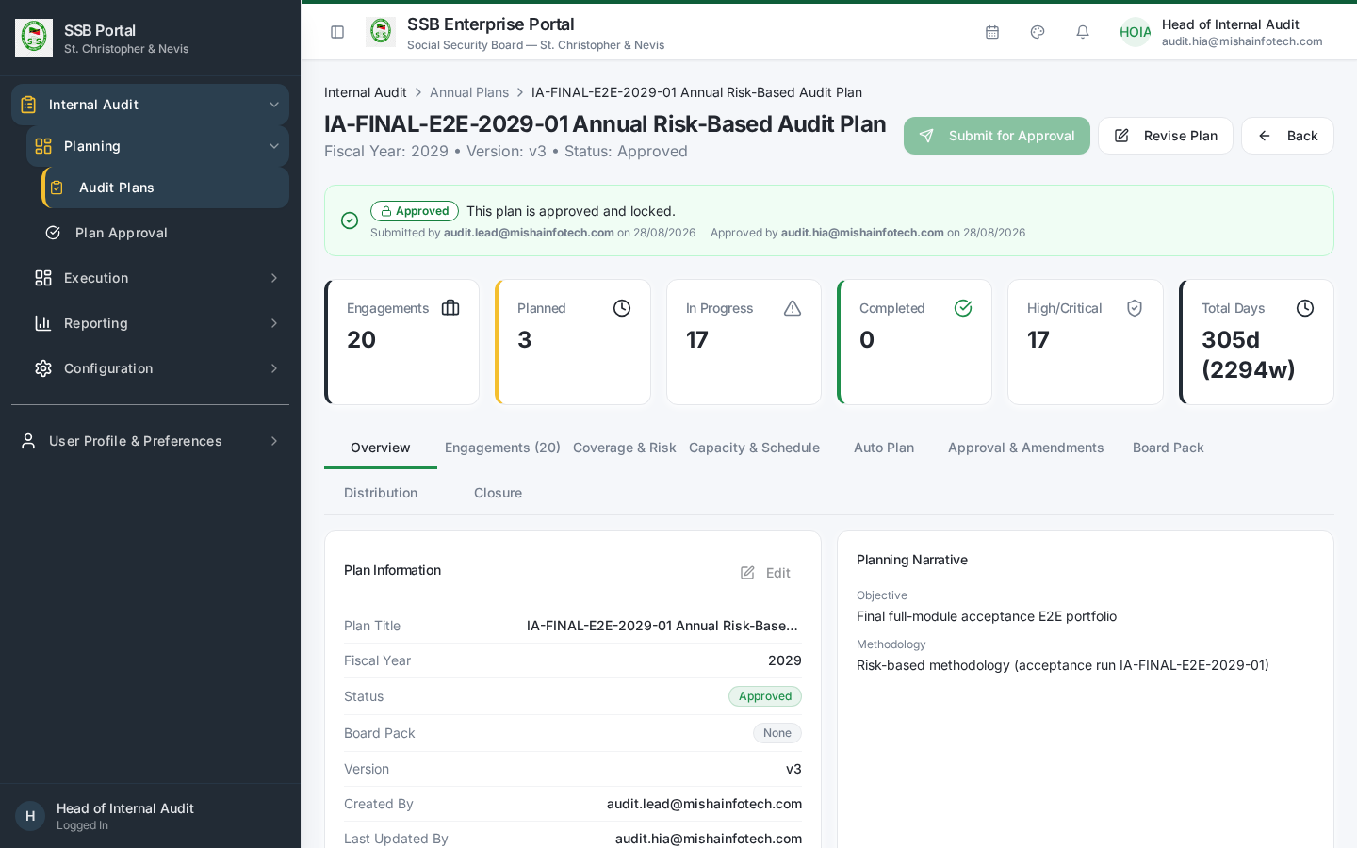

2.2 Resource check before submitting
Cross-check the draft against capacity: - Workload & Capacity (/audit/workload) — auditor availability against planned days. - Auditor Leave (/audit/leave) — approved leave in the planning window.

2.3 Submit and approve
- Submit for Approval on the plan detail screen. The plan version increments.
- Internal Audit → Plan Approval (/audit/plan-approval) shows the approval queue with Pending / Decided tabs and full approval history.
- Open the plan, review, then Approve or Return for Revision with comments.
- On approval the status becomes Approved, the approver and date are stamped, and the plan appears in Active Plan Progress on the dashboard.
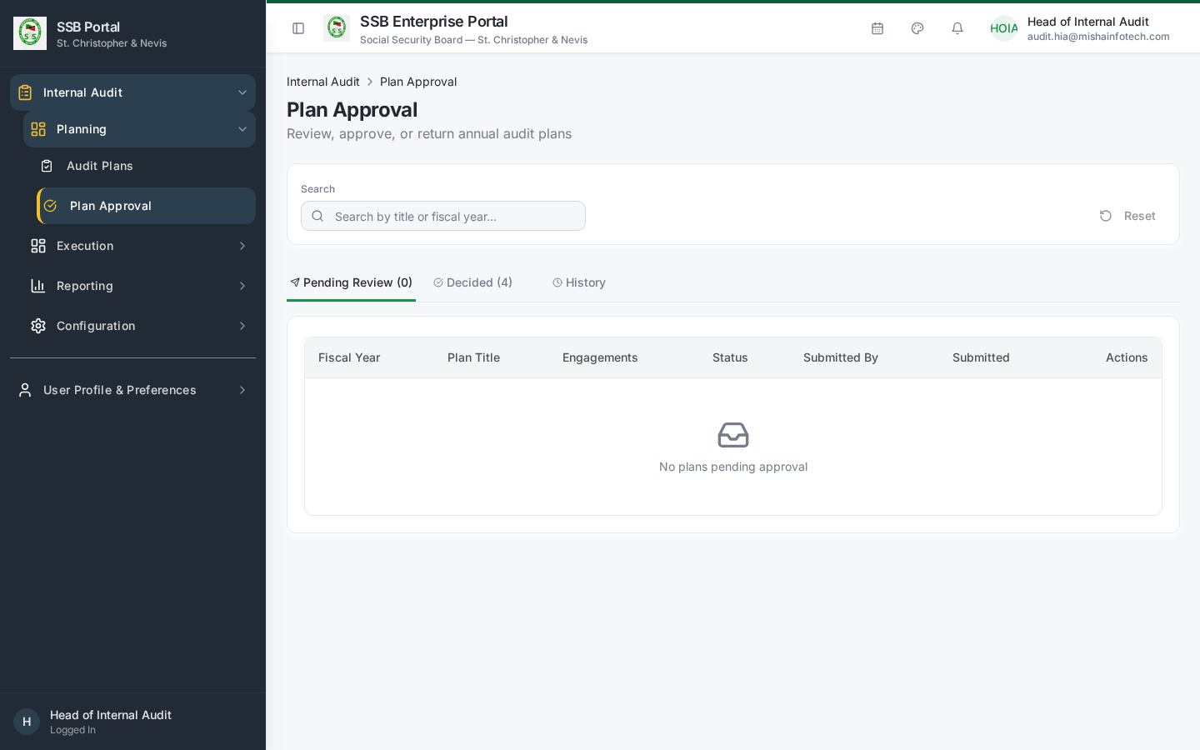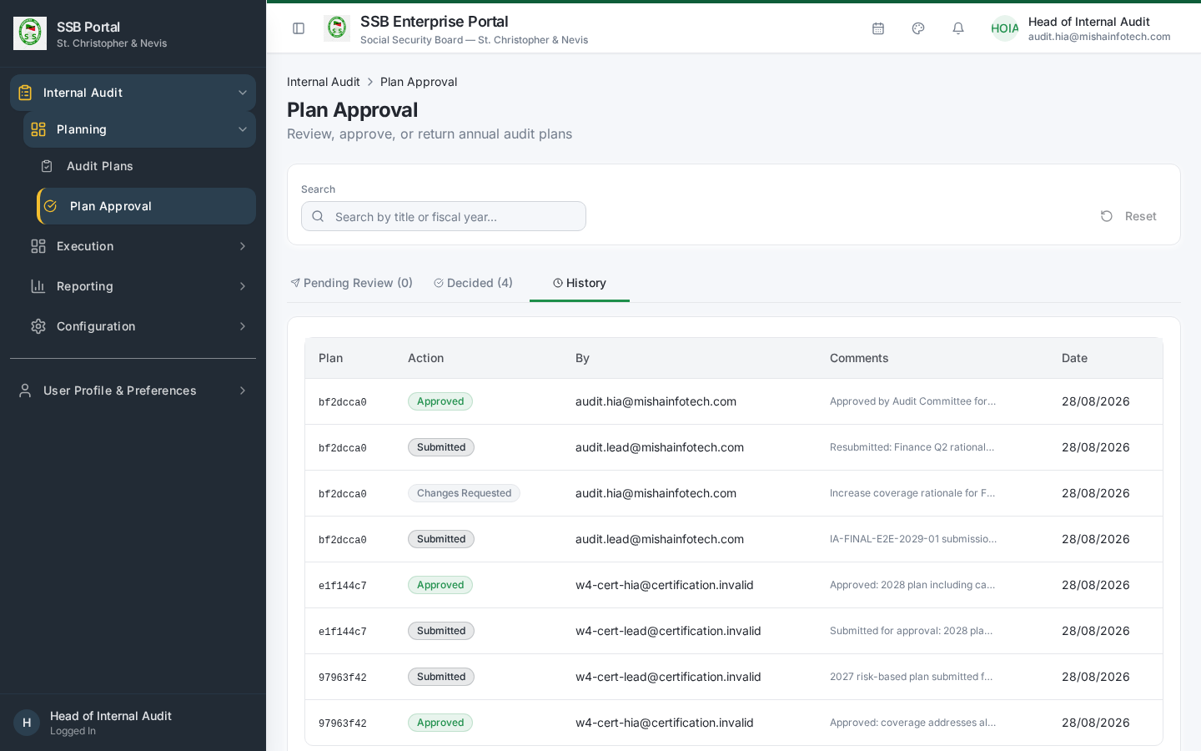
Segregation of duties. If you both prepared and approved the plan, the system records a logged SoD exception on the approval action. Have a second approver where your charter requires it.

2.4 Amending an approved plan
Amendments are versioned. Each change records the field, old value, new value, reason and requester. The Revise Plan guard in Audit Settings decides whether a revision to an in-flight plan is blocked, warned or allowed. When a plan is superseded you are prompted, per in-flight engagement, to Carry Forward or Suspend.

3. Risk oversight
- Risk Matrix (/audit/risk-matrix) — the likelihood × impact heat map used to justify the plan.
- Entity Risk Summary (/audit/entity-summary) — risk position per audited entity.
- Risk Register (/audit/risk-register) — the standing register of risks by department and business function.
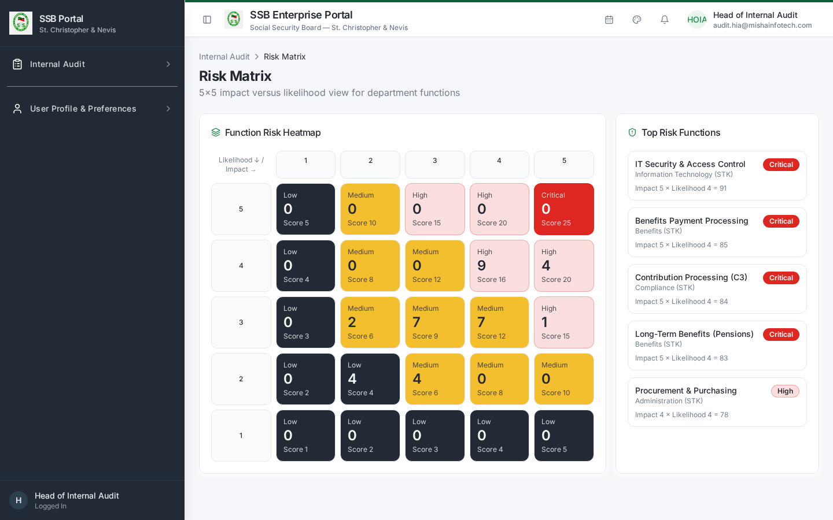
Risk matrix

4. Monitoring in-flight work
Internal Audit → Action Centre (/audit/action-centre).
- Head of Audit tab — items escalated to you: overdue responses, overdue high/critical actions, engagements past planned end date.
- My Audit Work — anything assigned to you personally.
- Closure Readiness — engagements that can be closed and, for those that cannot, the exact blocking items.
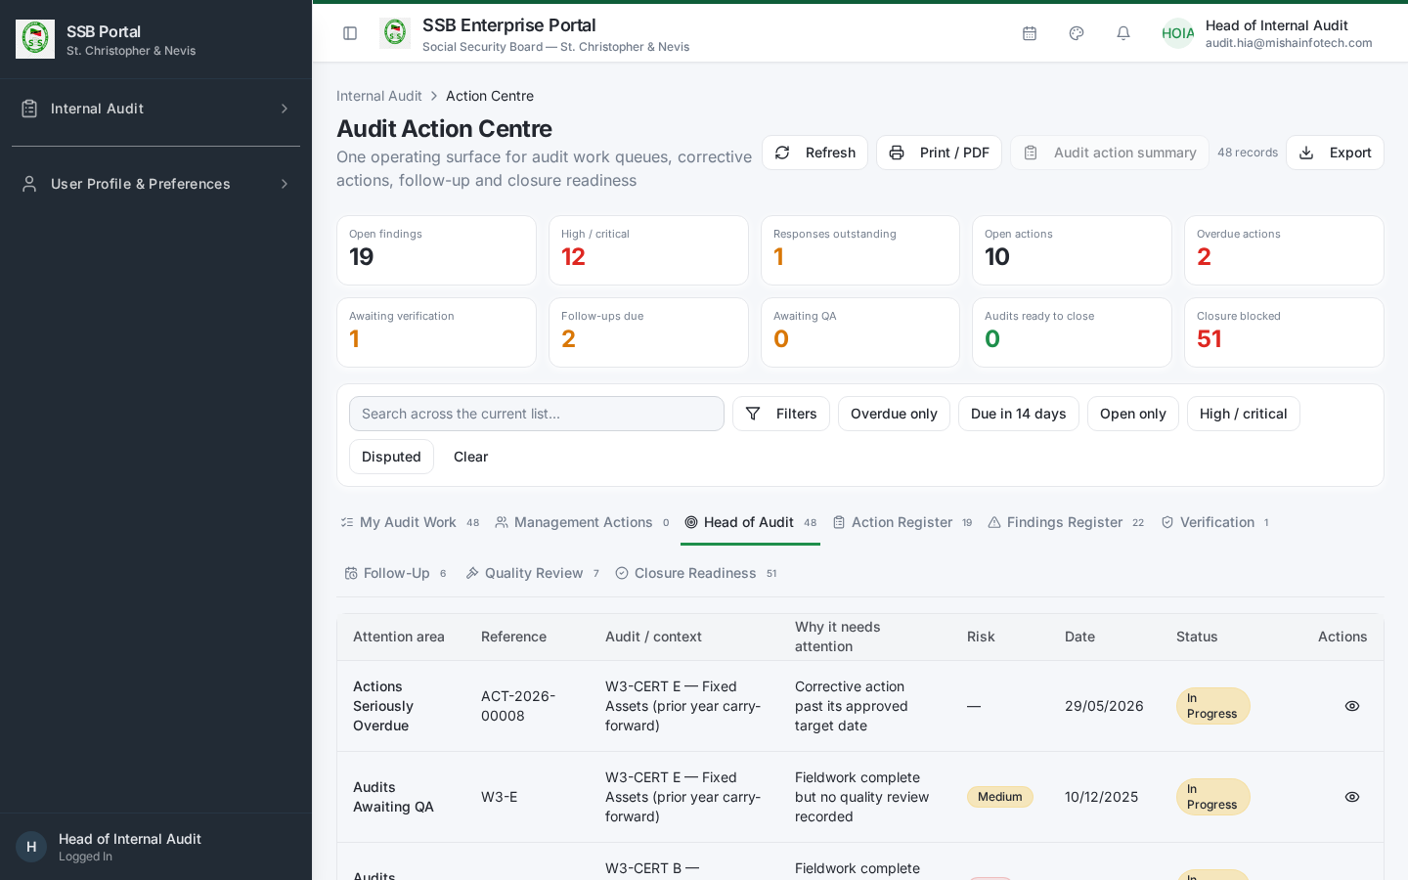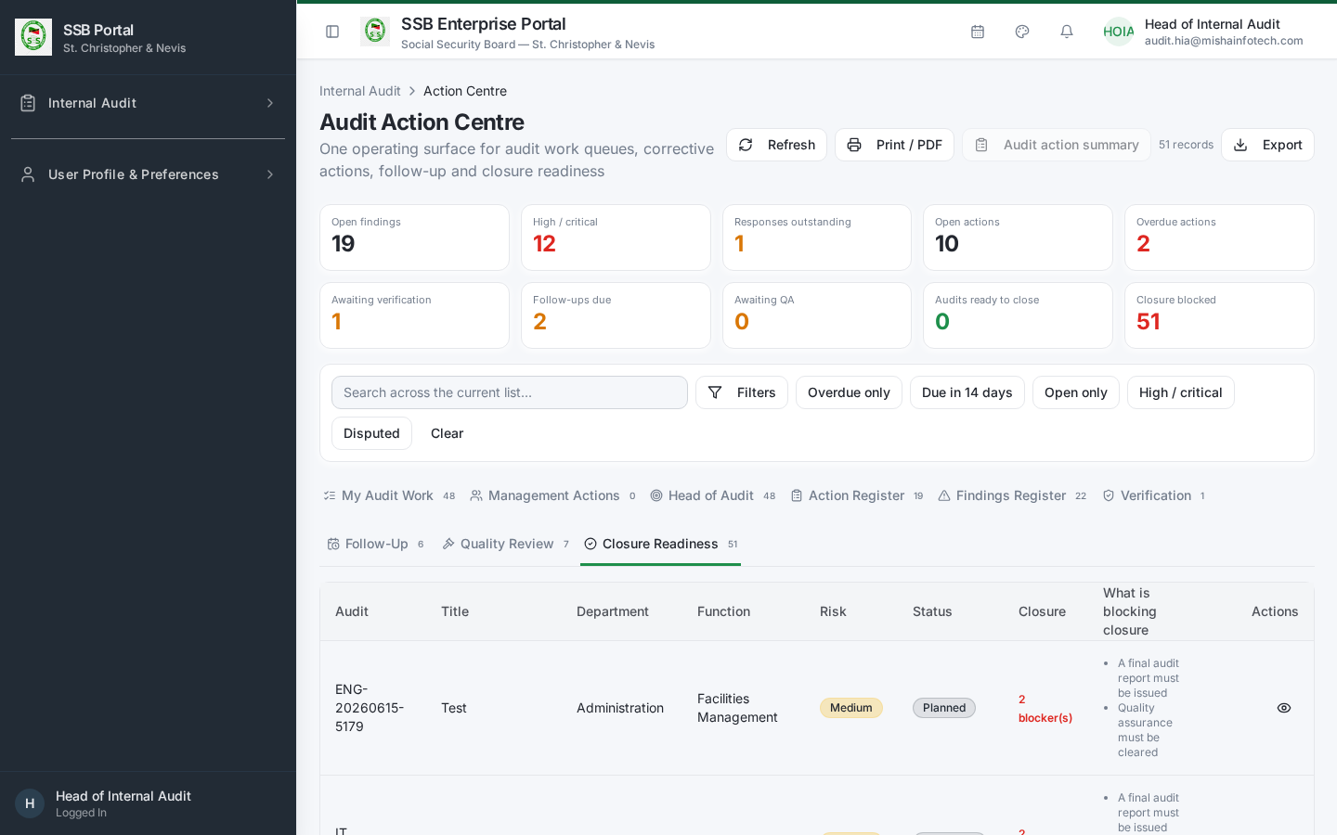

5. Closing an engagement
- Open the engagement → Closure tab.
- The screen evaluates closure readiness on the server and lists any blockers:
  - all activities Completed;
  - no finding left in Draft or Under Review;
  - every finding carries a management response;
  - the audit report is Issued;
  - quality review signed off. Corrective actions and follow-ups do not block closure.
- Record the final audit rating and closure remarks.
- Choose the terminal state:
  - Closed — nothing outstanding.
  - Closed – Actions Pending — closed with open corrective actions, which continue to be monitored in the Action Centre and keep emitting reminders.
- Confirm. The closure event is written to the timeline and cannot be edited afterwards.
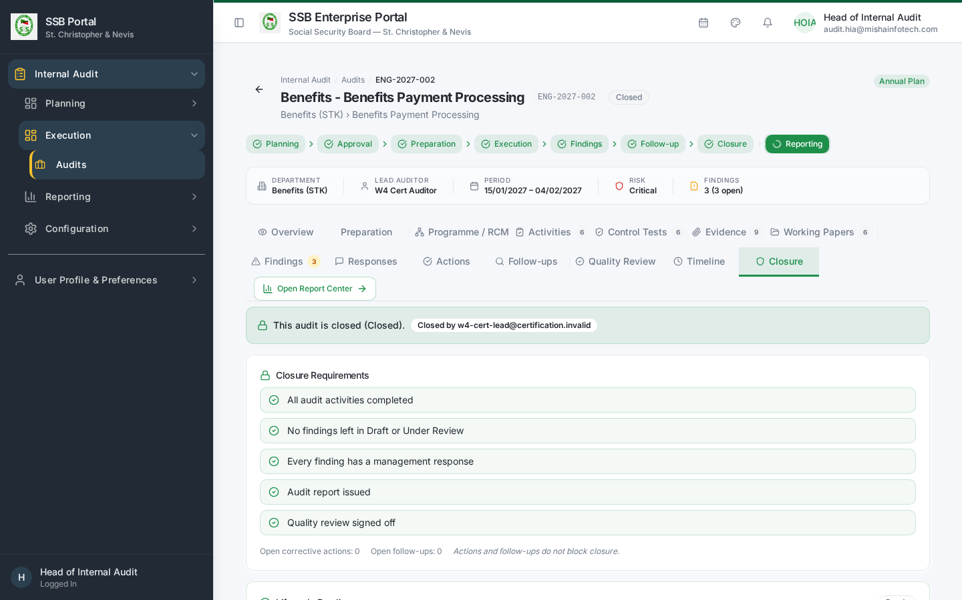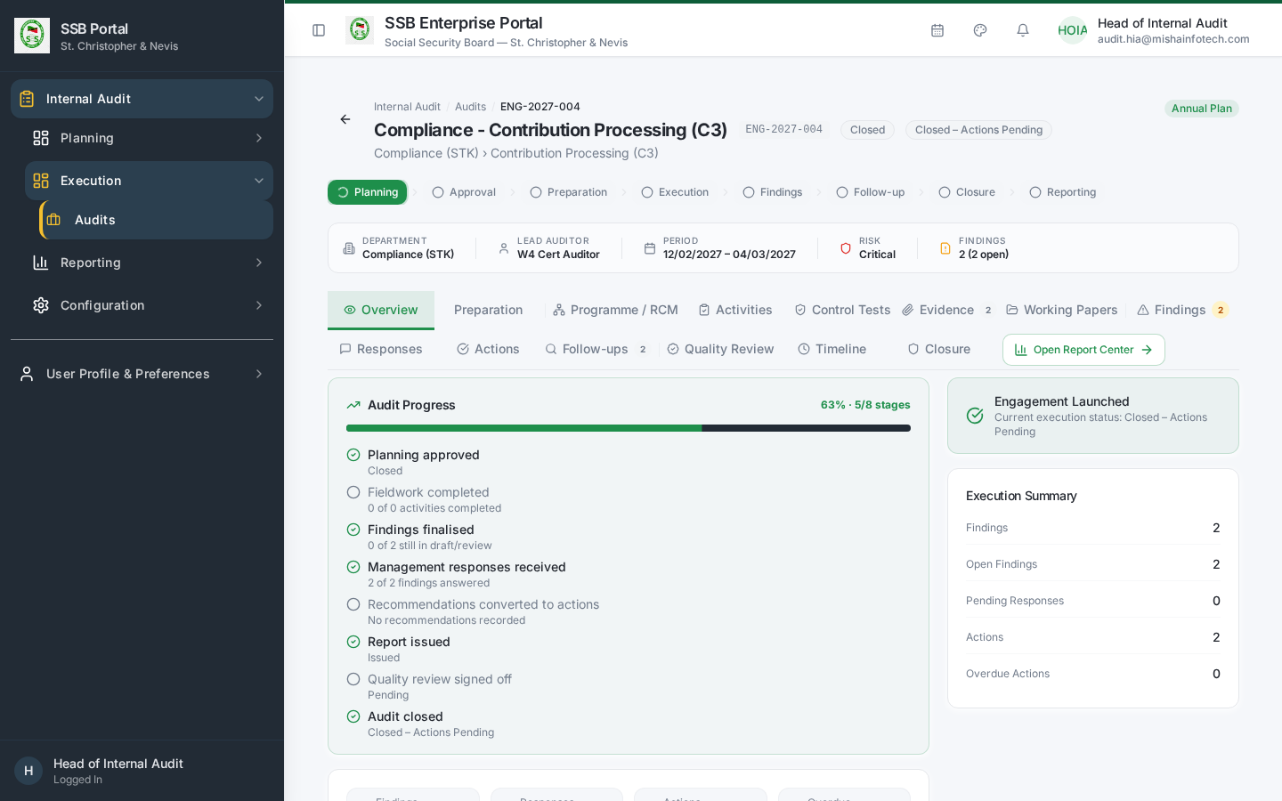

6. Closing the annual plan
- Internal Audit → Audit Plans → open the plan → Closure panel.
- Every engagement in the plan must carry a disposition: | Disposition | Use when | |————-|———-| | Closed | The audit finished with nothing outstanding | | Closed – Actions Pending | Finished, corrective actions still open | | Cancelled | Not performed — a reason is mandatory | | Carried Forward | Moved into the next fiscal year plan — a reason is mandatory |
- Engagements still sitting untouched at Planned block plan closure.
- Confirm closure. The system generates the closure summary: planned, completed, actions pending, carried forward, cancelled and the completion rate, and creates the lineage link from carried-forward engagements to the successor plan.
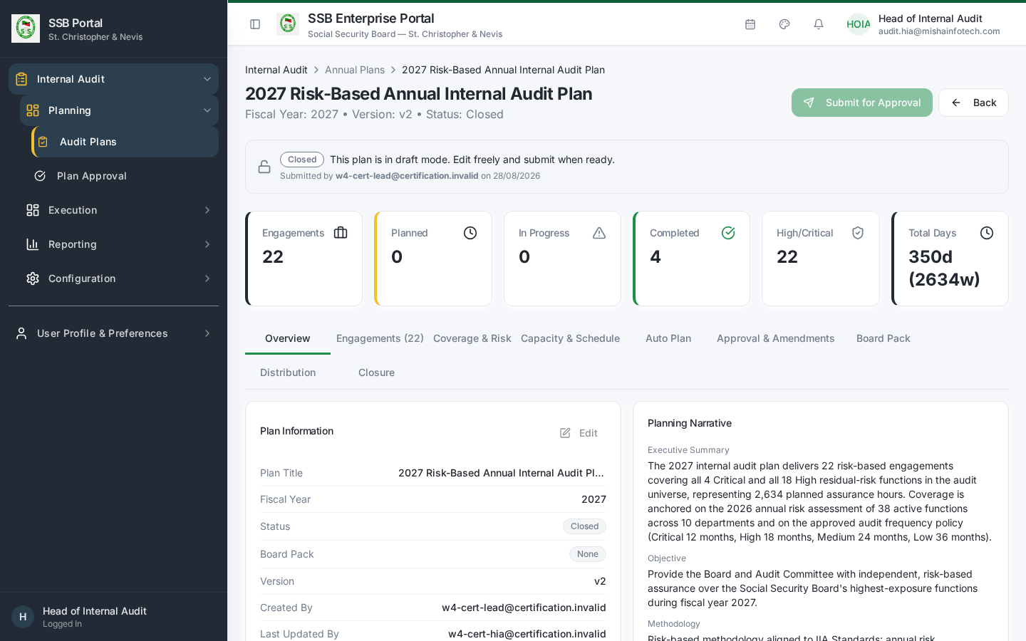
Closed plan

7. Reporting to the board / audit committee
Internal Audit → Report Center (/audit/audit-reports) plus the governed reports:
Report | Route | Answers
Engagement Summary | /audit/reports/engagement-summary | State and outcome of every engagement
Plan Slippage | /audit/reports/plan-slippage | Planned vs actual execution dates
Overdue Actions | /audit/reports/overdue-actions | Ageing of unimplemented corrective actions
Carry-Forward Aging | /audit/reports/carry-forward-aging | How long carried-forward audits have been deferred
Communication Compliance | /audit/reports/communication-compliance | Whether every required audit notification was delivered
All reports export to CSV / Excel / PDF, and the plan distribution pack is delivered to the audit committee through the governed communication service with the report attached and checksum-verified.
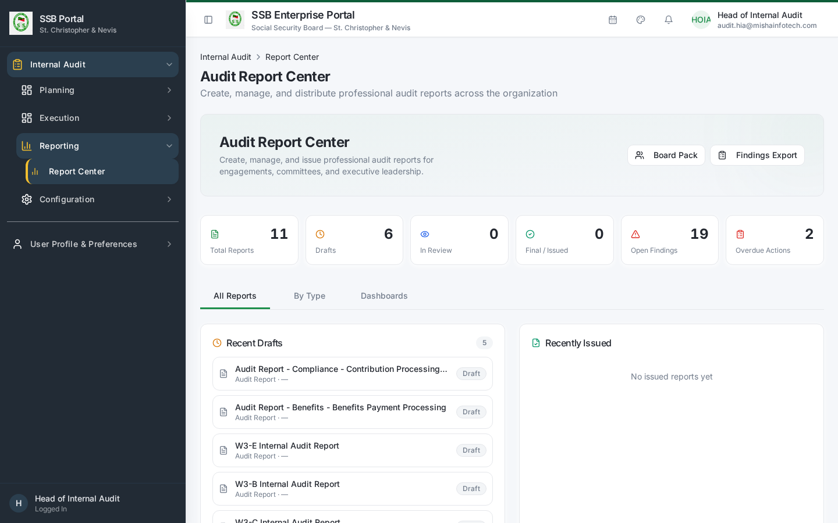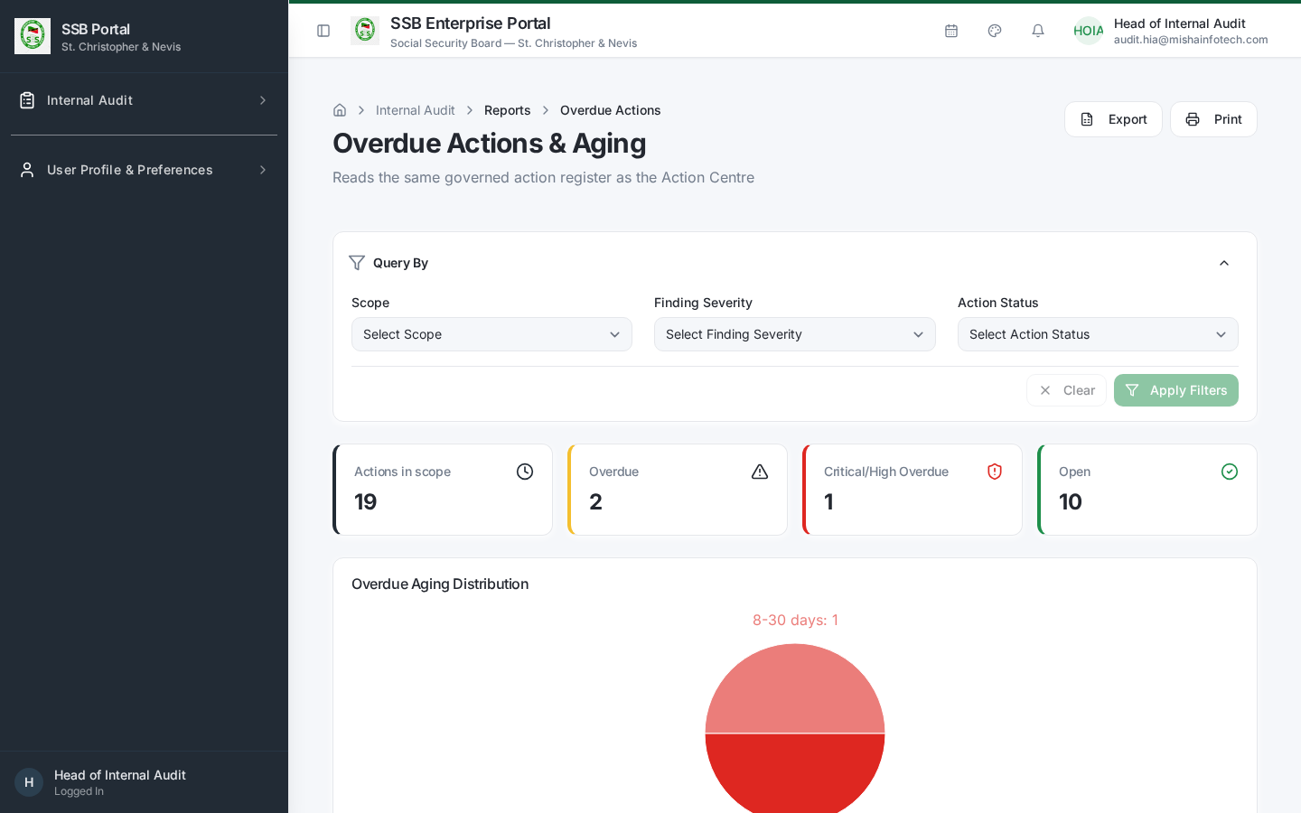

8. Your day-to-day checklist
Frequency | Action
Daily | Action Centre → Head of Audit tab; clear escalations
Weekly | Closure Readiness; Plan Slippage
Monthly | Overdue Actions; management response ageing
Quarterly | Committee pack from Report Center; carry-forward ageing
Annually | Risk assessment refresh → next-year plan → approval → prior-year plan closure

Document Control — Version History & Change Log
Document owner: Head of Internal Audit Classification: Internal
Review cycle: Annually, or on any change to the Internal Audit module.
Version | Date | Author | Summary of change | Approval
1.0 | 2026-08-30 | Internal Audit / Platform Team | First issued manual, generated from the live TEST environment (routes, tabs, governed commands and screenshots). | Reviewed: Lead Auditor. Approved by Head of Internal Audit on: Pending

How to record an update
- Add a new row at the top of the table for every content change — never edit a released row.
- Increment the minor version (1.1, 1.2 …) for clarifications and screenshot refreshes; increment the major version (2.0) when a process, role or gate changes.
- State the change in business terms (what a reader must now do differently), not file edits.
- The manual is only “released” once the Head of Internal Audit records an approval date. Until then it is marked Pending and must not be used as certification evidence.
- Re-export the PDF and DOCX from the Internal Audit User Manuals page after each approval.

Change log
Version | Change | Sections affected
1.0 | Initial release. | All

