Internal Audit — Lead Auditor Manual
Role: Lead Auditor (IA_LEAD_AUDITOR) Test account: w4-cert-lead@certification.invalid / audit.lead@… Owns: the engagement from launch to report issuance — preparation, programme, fieldwork supervision, findings quality, information requests, report drafting and issuance.

1. Where your work lives
Screen | Route | Use for
Dashboard | /audit/dashboard | Your engagement portfolio at a glance
Audits | /audit/audits | The engagement list; entry point to every workspace
Audit workspace | /audit/audits/:id | All 14 engagement tabs
Audit Queries | /audit/queries | Information requests to the audited department
Action Centre | /audit/action-centre | My Audit Work, Verification, Closure Readiness
Report Builder | /audit/report-builder | Draft the audit report
Workload & Capacity | /audit/workload | Team availability
Time Tracking | /audit/time-tracking | Team time against the engagement
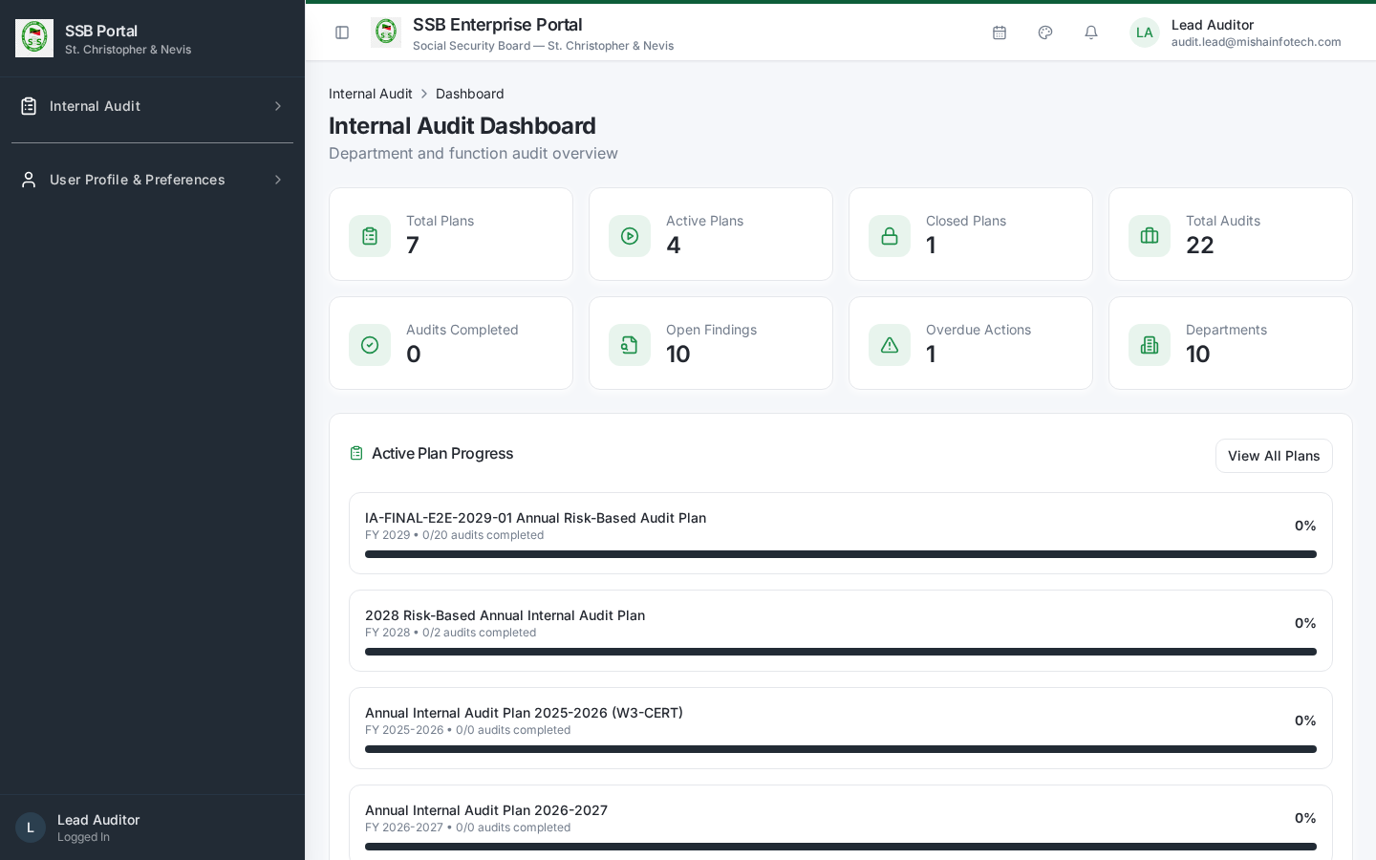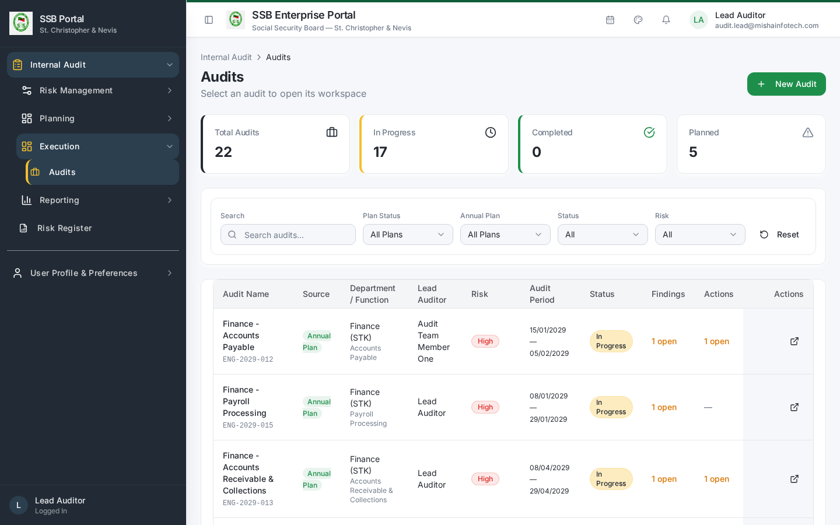
If an engagement does not appear, clear the “Approved plans” filter — engagements whose plan is closed or carried forward are hidden by that filter.

2. Launching the engagement
- Open the engagement from Audits.
- The Overview tab shows the lifecycle stepper, server-derived progress and the recommended next action.
- Launch Audit appears only when you hold the launch entitlement (audit_engagements:launch) and the readiness check passes: plan approved, lead auditor and team assigned, planned dates set, department contactable.
- Launch is a governed server command. If readiness fails, the panel lists the specific missing items — fix those and retry.
- On launch the engagement notification is emitted to the audited department through the governed communication service and appears on the Timeline tab.

3. Preparation
Preparation tab: - Confirm objectives and scope with the audited department. - Work the preparation checklist (General / Procedure / Objective / Risk items), assigning items to team members. - Upload preliminary documents supplied by the department. - Record the kick-off meeting.
The stepper only advances to fieldwork once preparation dependencies are satisfied.
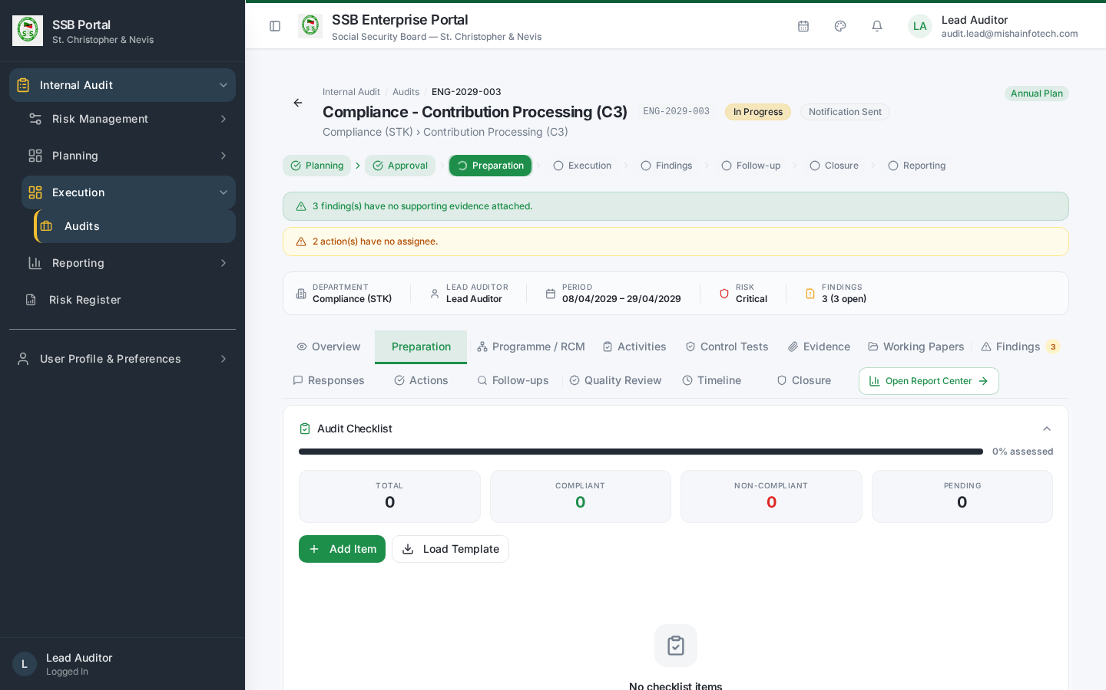
Preparation tab

4. Programme / RCM
Programme tab — build the Risk Control Matrix for the engagement:
Process -> Risk (likelihood x impact = inherent score) -> Control (preventive / detective,
frequency, owner) -> Test (procedure, sample basis, expected result)
Every test you define here becomes a testable item on the Control Tests tab. Keep the programme aligned to the risks that justified the audit in the annual plan.
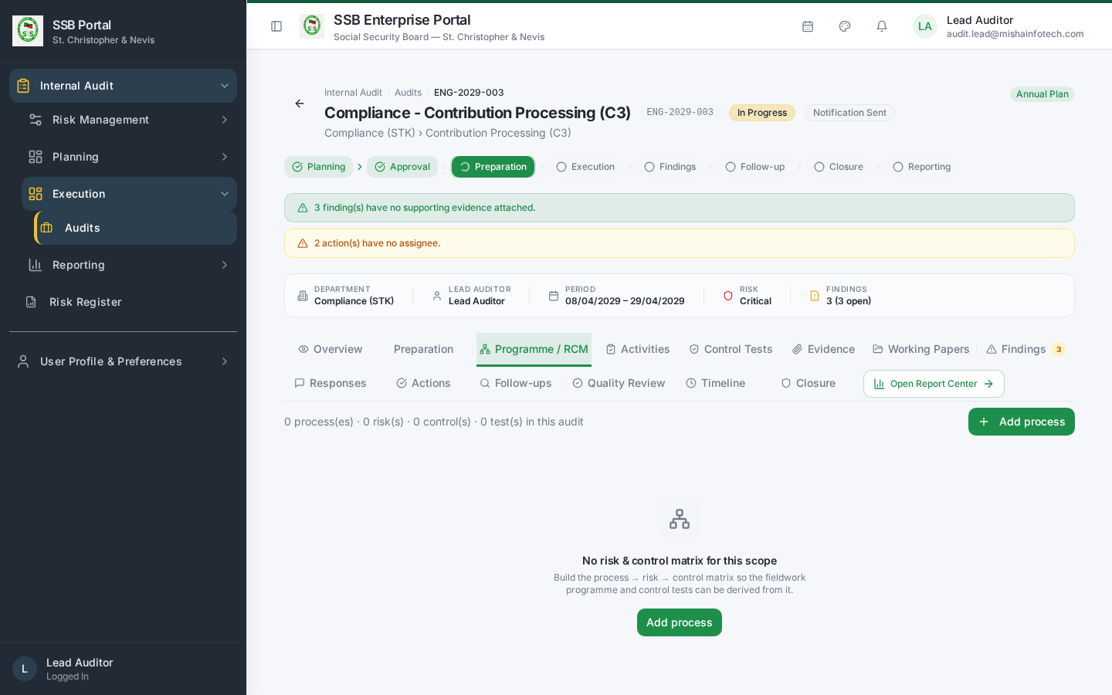
Programme / RCM

5. Information requests
Internal Audit → Audit Queries (/audit/queries).
- Raise a query against the engagement with a description, required-by date and recipient.
- The request is delivered to the department through the governed communication service; reminders follow automatically as the due date approaches.
- Record the response and close the query, or escalate if it remains outstanding.
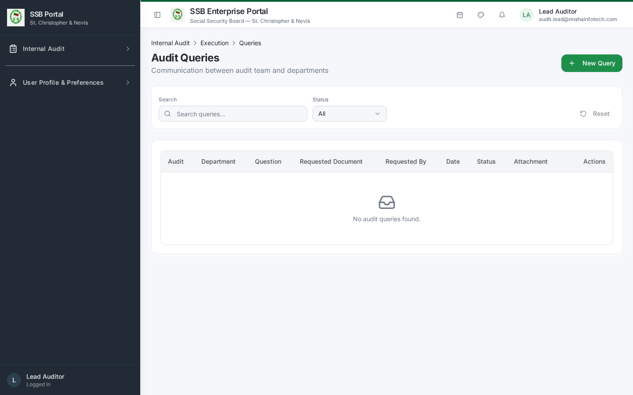
Audit queries

6. Supervising fieldwork
Tab | What you supervise
Activities | Every planned activity has an owner and a completion date
Control Tests | Each test carries a Pass / Fail / Partial result with a rationale
Evidence | Every Fail or Partial has evidence attached
Working Papers | A working paper exists for each significant procedure and is reviewed
Review each item before it is treated as complete. Reviewer sign-off is recorded on the working paper.
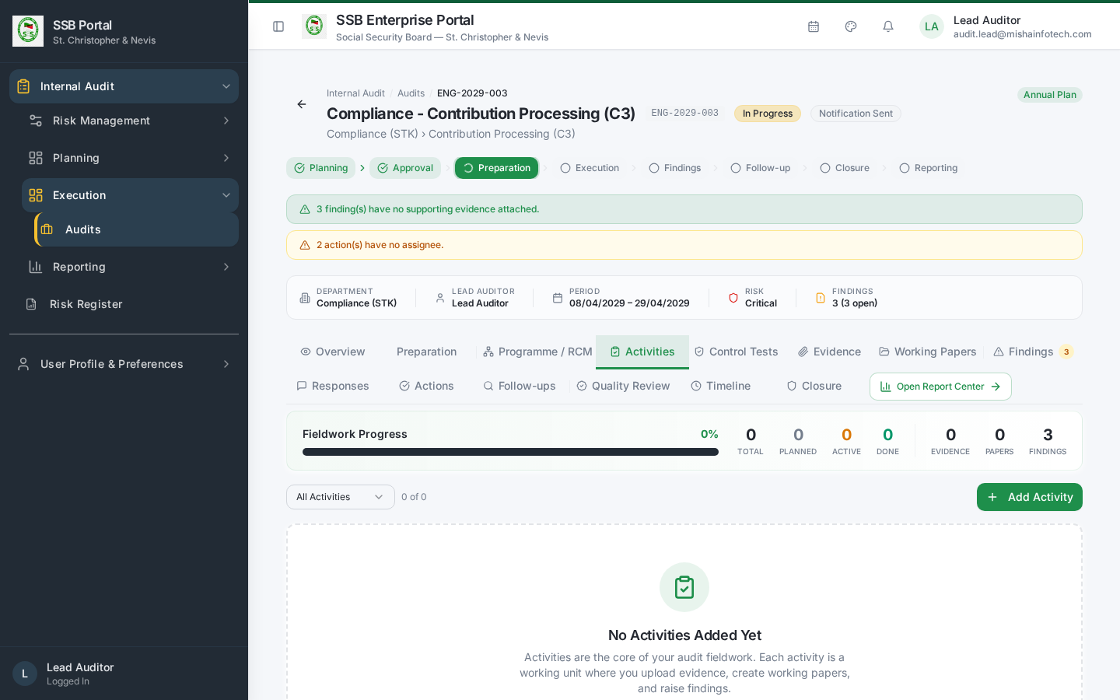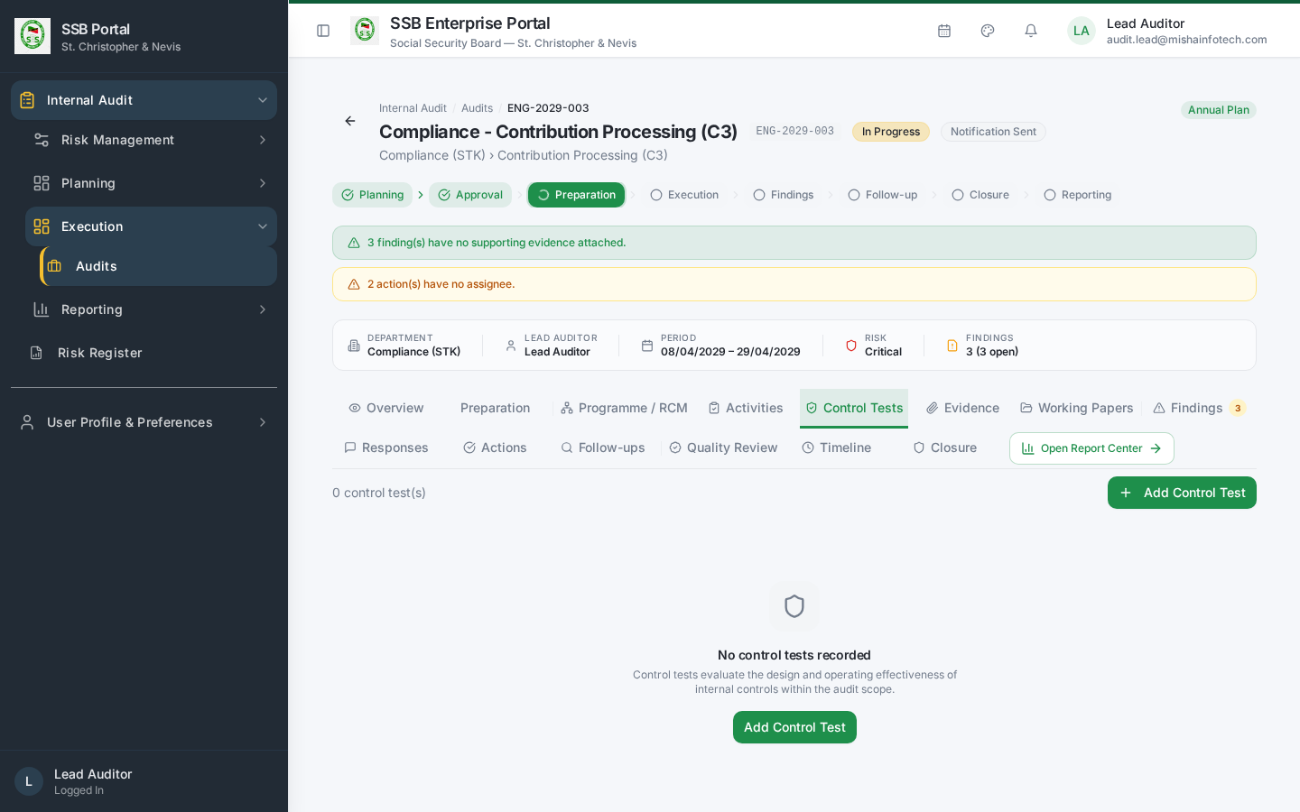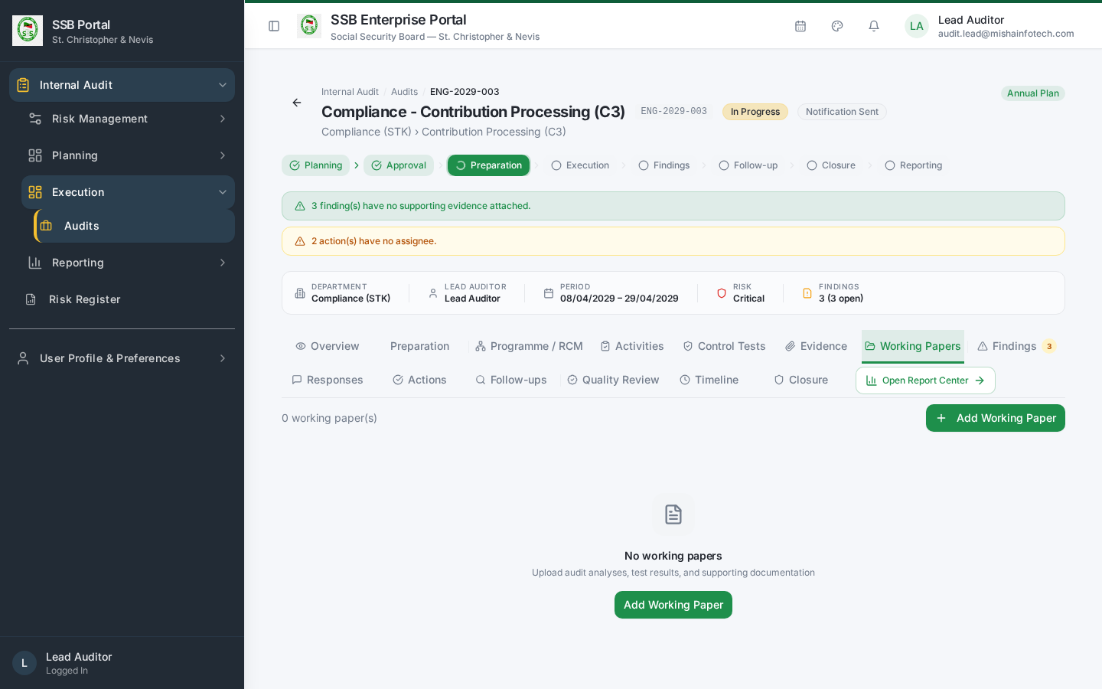

7. Findings
Findings tab: 1. A finding must state condition, criteria, cause, effect and recommendation, with a severity of Critical / High / Medium / Low. 2. It must be linked to the activity or control test that produced it, and to its evidence. 3. Move the finding from Draft to Under Review, then to For Management Response. Only findings past Draft can be sent for a response, and Draft findings block closure. 4. Add one or more recommendations. Each recommendation can be converted into a tracked corrective action in one click from the Actions tab.
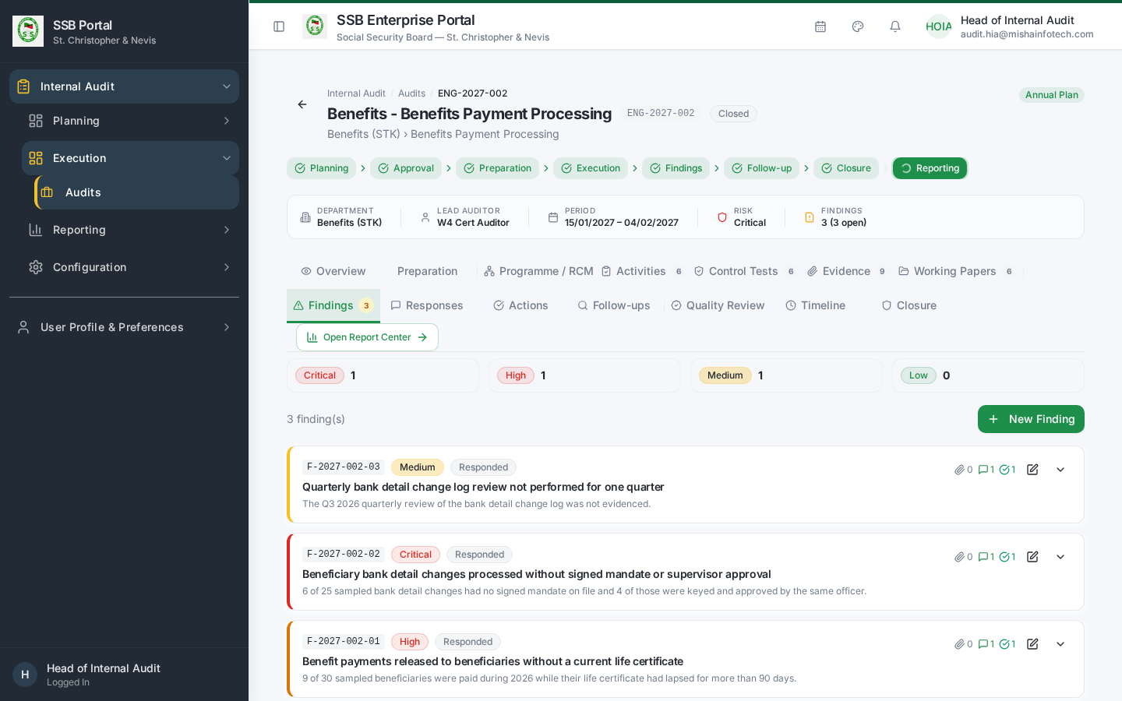
Findings

8. Management responses
Responses tab shows each finding’s response state. You can: - Chase an outstanding response (reminders are emitted automatically); - Review a submitted response and accept it, or return it for clarification — the respondent then resubmits and the version history is preserved; - Escalate a disputed response. A dispute is resolved by the Head of Internal Audit or an independent reviewer, never by you alone.
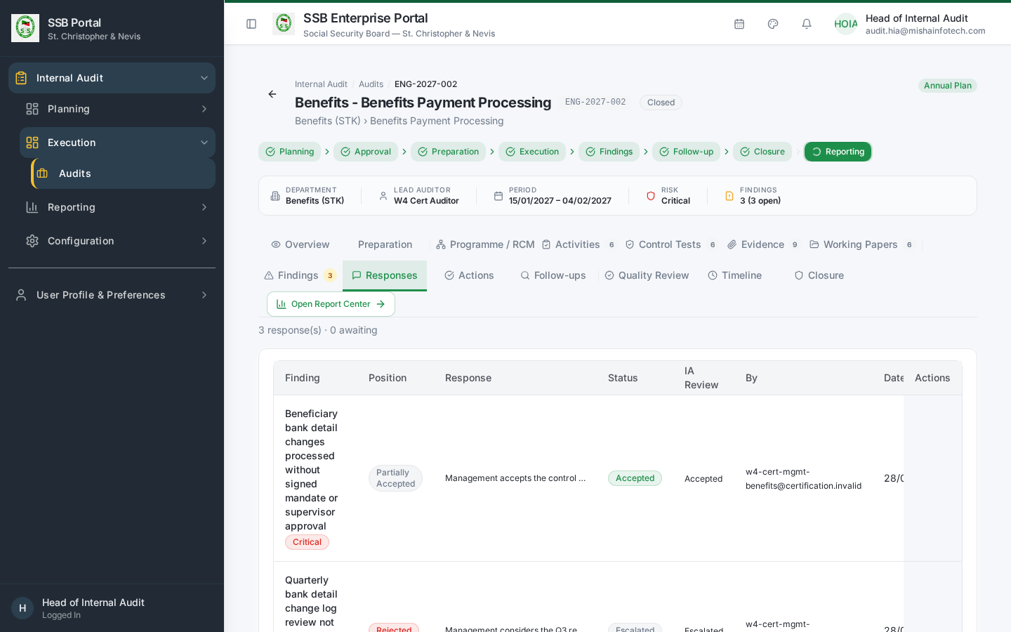
Responses

9. Report drafting and issuance
- Report Builder (/audit/report-builder) assembles the report from live engagement data: scope, work performed, findings by severity, management responses, agreed actions and the overall rating.
- Send the draft to the audited department for factual accuracy comments where your charter requires it.
- Issue the report. Issuance is blocked while quality review is outstanding or in rework.
- On issuance the report is archived as a generated document and distributed through the governed communication service with the file attached and checksum-verified.
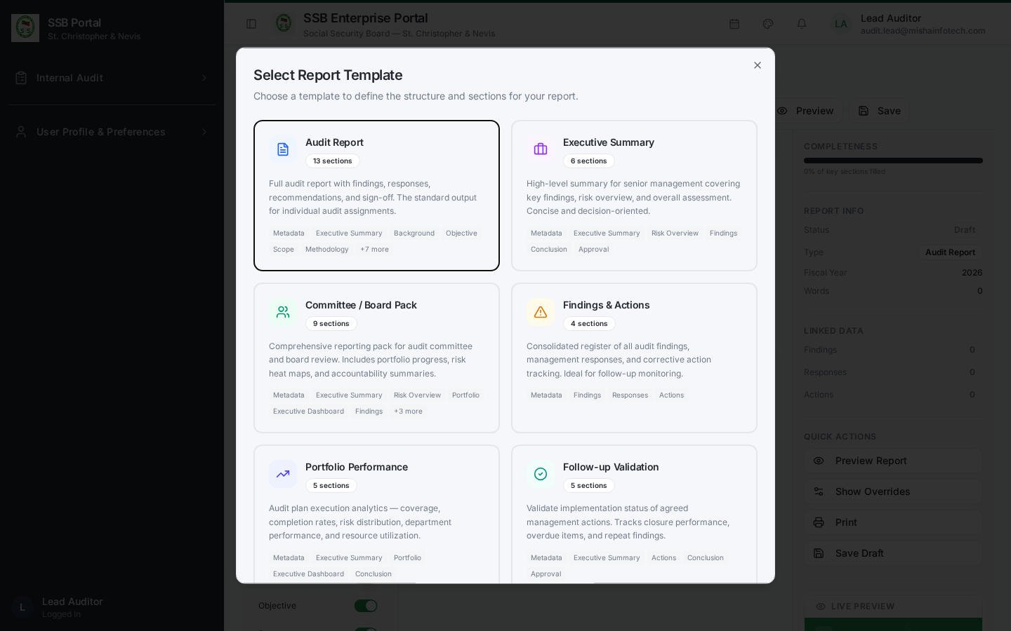
Report builder

10. Handover to closure
Once the report is issued and quality review is satisfactory, the engagement appears in Action Centre → Closure Readiness. Clear any remaining blockers, then the Head of Internal Audit records the closure decision on the engagement’s Closure tab.
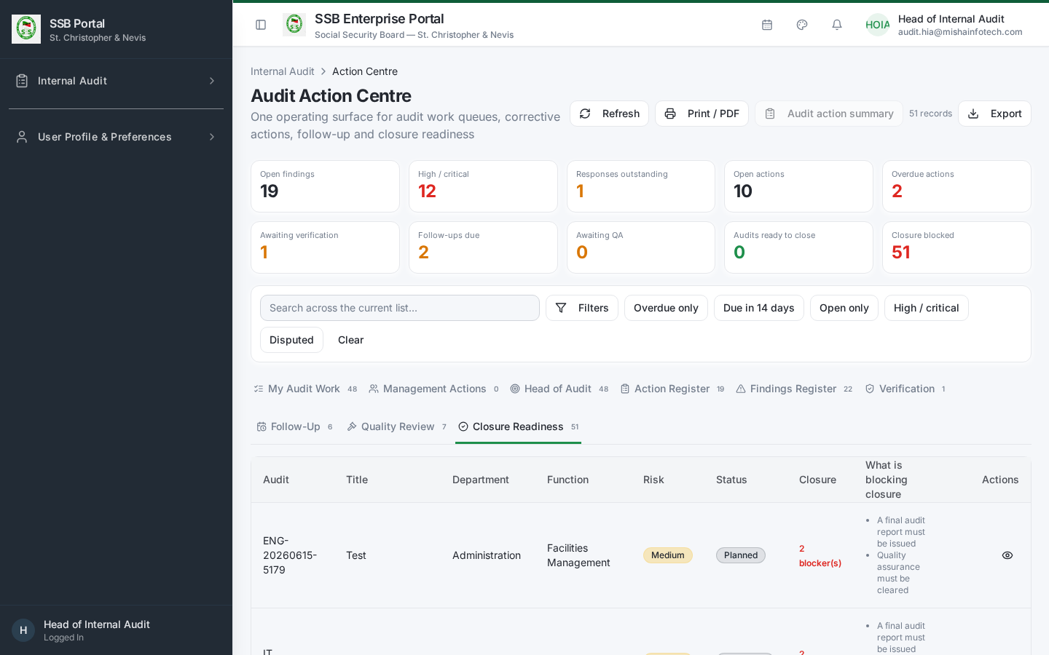
Closure readiness

11. Common blockers and what they mean
Message | Cause | Fix
Launch readiness failed | Plan not approved, or no lead auditor / team / dates | Complete the plan entry, reassign, retry
Cannot send for management response | Finding still in Draft | Move the finding to Under Review first
Report issuance blocked | Quality review outstanding or in rework | Ask the Quality Reviewer to conclude
Closure blocked | Activities incomplete, Draft findings, missing responses, report not issued, QA not signed | The Closure tab lists the exact items

Document Control — Version History & Change Log
Document owner: Head of Internal Audit Classification: Internal
Review cycle: Annually, or on any change to the Internal Audit module.
Version | Date | Author | Summary of change | Approval
1.0 | 2026-08-30 | Internal Audit / Platform Team | First issued manual, generated from the live TEST environment (routes, tabs, governed commands and screenshots). | Reviewed: Lead Auditor. Approved by Head of Internal Audit on: Pending

How to record an update
- Add a new row at the top of the table for every content change — never edit a released row.
- Increment the minor version (1.1, 1.2 …) for clarifications and screenshot refreshes; increment the major version (2.0) when a process, role or gate changes.
- State the change in business terms (what a reader must now do differently), not file edits.
- The manual is only “released” once the Head of Internal Audit records an approval date. Until then it is marked Pending and must not be used as certification evidence.
- Re-export the PDF and DOCX from the Internal Audit User Manuals page after each approval.

Change log
Version | Change | Sections affected
1.0 | Initial release. | All

