Internal Audit — Audit Team Member Manual
Role: Audit Team Member / Auditor (IA_TEAM_MEMBER) Test account: w4-cert-auditor@certification.invalid / audit.auditor1@… Owns: execution — control testing, evidence, working papers, drafting findings, logging time.

1. Start every day in the Action Centre
/audit/action-centre → My Audit Work.
The queue lists everything assigned to you across all engagements: activities to perform, tests to execute, findings to complete, actions you own and follow-ups you must verify. Click any row to jump straight to the right tab of the right engagement.
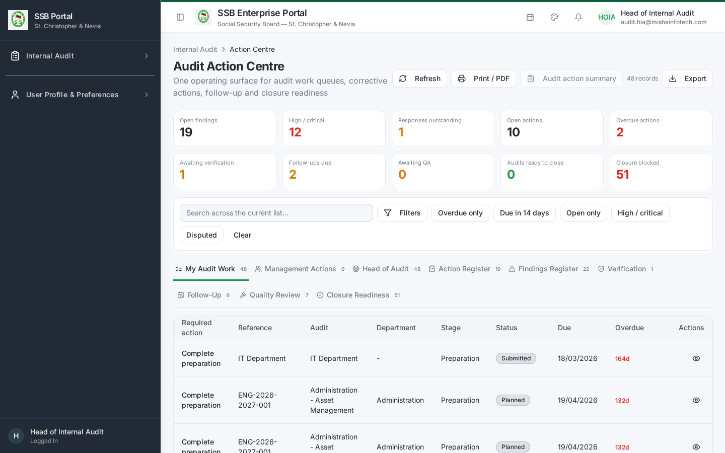
My audit work

2. Opening your engagement
Internal Audit → Audits (/audit/audits) → open the engagement. Use the tabs in lifecycle order. The Overview tab tells you which stage the engagement is at and what is recommended next.

3. Performing activities
Activities tab: 1. Open the activity assigned to you. 2. Record what you did, the period and population covered and the sample basis. 3. Attach evidence as you go — never at the end. 4. Mark the activity Completed only when the work and its evidence are both in place. Incomplete activities block engagement closure.
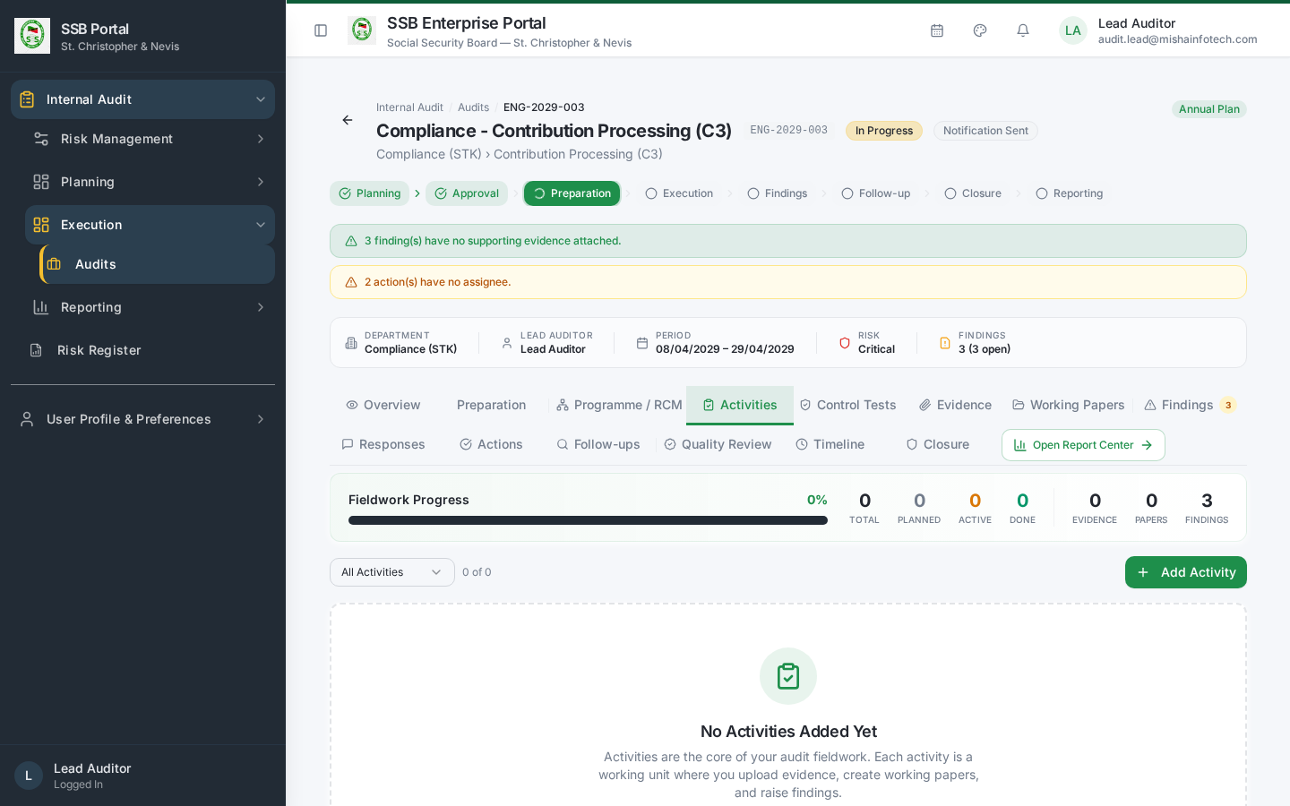
Activities

4. Control testing
Control Tests tab: 1. Each test comes from the engagement’s Risk Control Matrix and states the procedure and the expected result. 2. Record the sample tested, exceptions found, and the result: Pass, Fail or Partial. 3. A Fail or Partial requires a rationale and at least one evidence item; it is normally the origin of a finding.
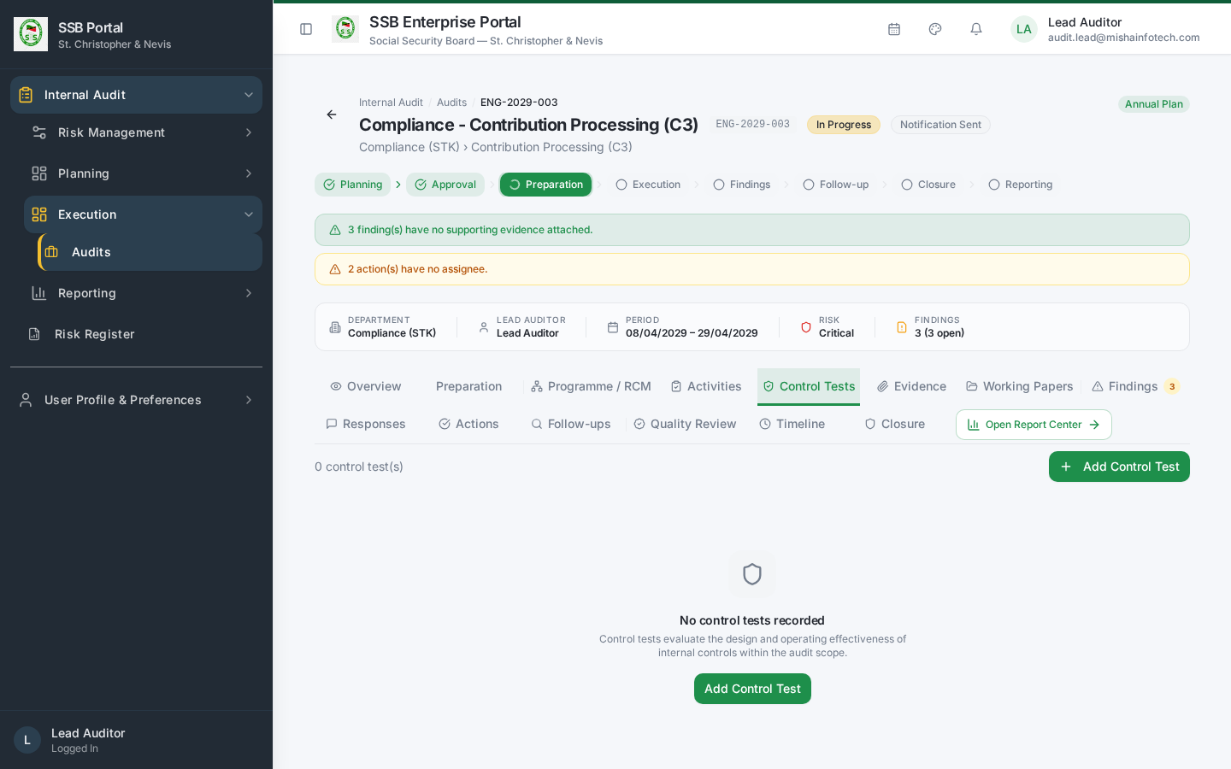
Control tests

5. Evidence
Evidence tab: 1. Upload evidence, then give it a clear name, a description of what it proves, and its source (who provided it and when). 2. Link the evidence to the activity, control test or finding it supports. Unlinked evidence is not part of the audit trail. 3. Evidence files are stored in the governed audit evidence store; every download is logged.
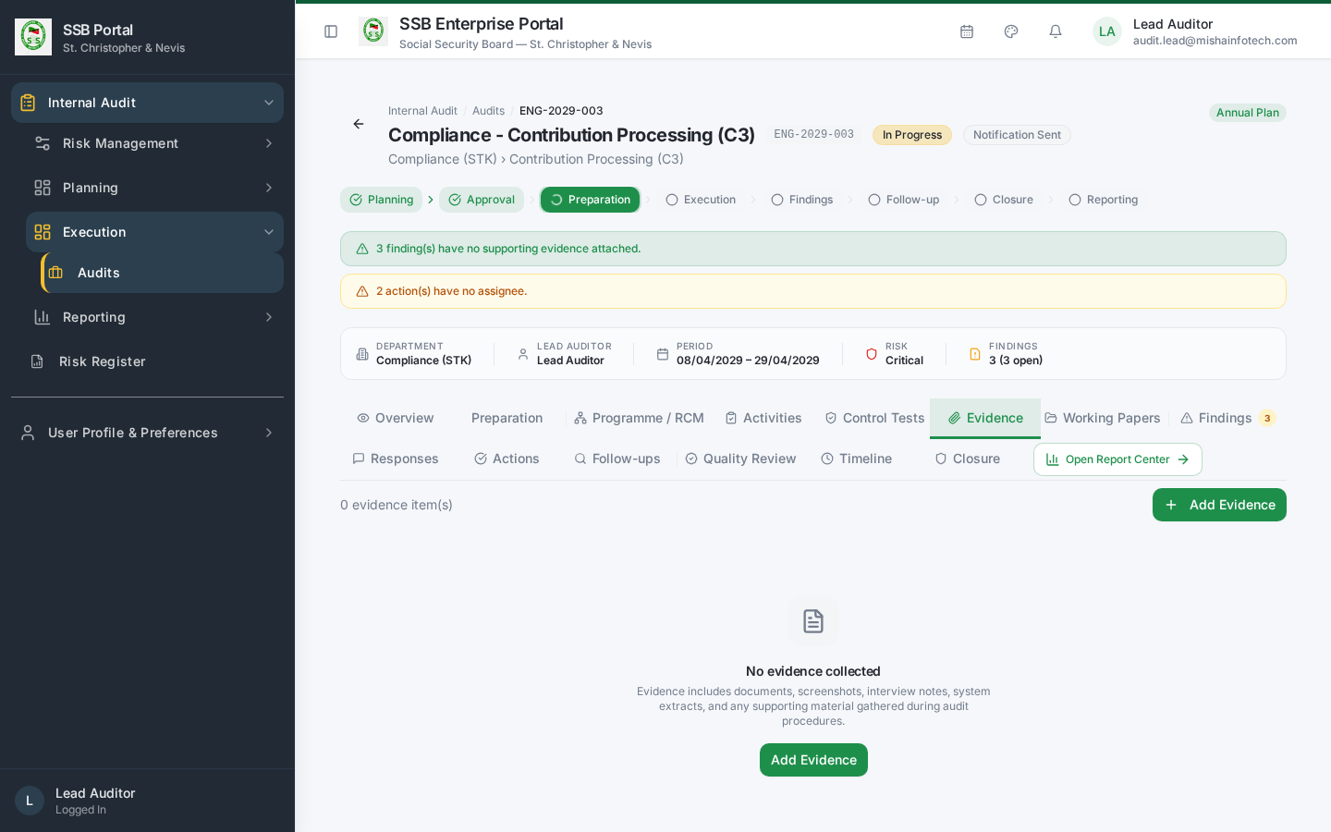
Evidence

6. Working papers
Working Papers tab — one working paper per significant procedure:
Section | What to write
Objective | What the procedure was intended to establish
Work performed | Steps, population, sample and method
Results | What you observed, with references to evidence items
Conclusion | Whether the control objective was met
Submit the paper for review. The Lead Auditor’s review sign-off is recorded on the paper.
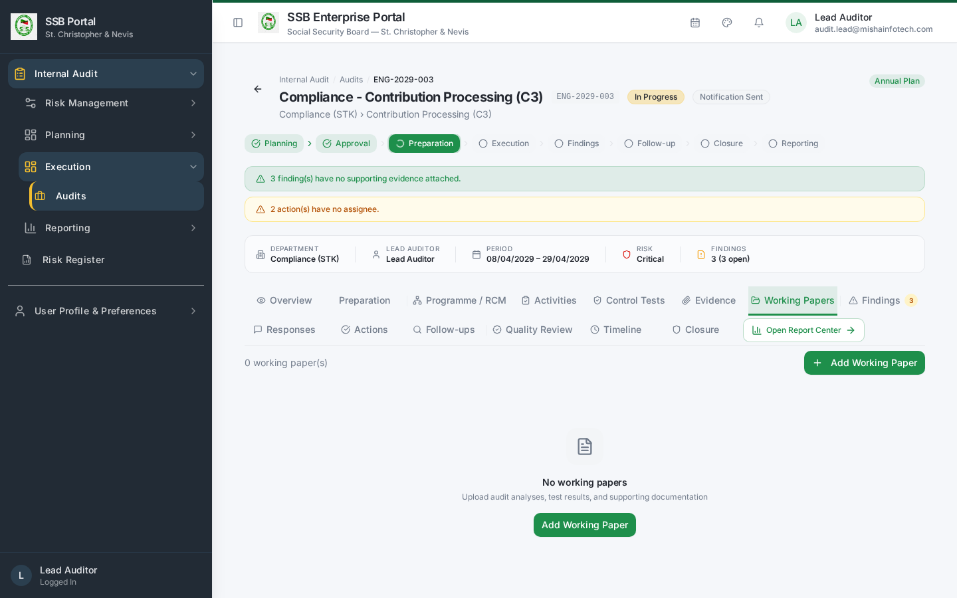
Working papers

7. Raising a finding
Findings tab → New Finding:
- Title — short and specific.
- Condition — what is happening.
- Criteria — the policy, regulation or control standard breached.
- Cause / root cause — why it happened.
- Effect — the exposure, quantified where possible.
- Severity — Critical / High / Medium / Low.
- Recommendation — one or more, each actionable and owned by a named position.
- Link the source activity or control test and the supporting evidence.
Save as Draft while you work on it, then move to Under Review for the Lead Auditor. Do not leave findings in Draft: Draft findings block engagement closure.
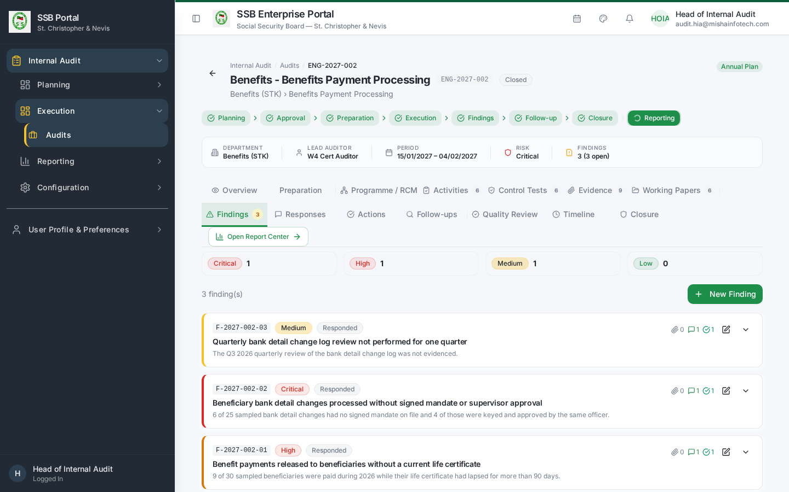
Findings

8. Follow-up verification
When a corrective action owner claims implementation, the item reaches Action Centre → Verification (audit team only).
- Open the action and read the owner’s completion note and evidence.
- Test independently — do not accept the owner’s assertion alone.
- Record the outcome: Verified (the action then closes) or Rejected with the reason, which returns the action to the owner.
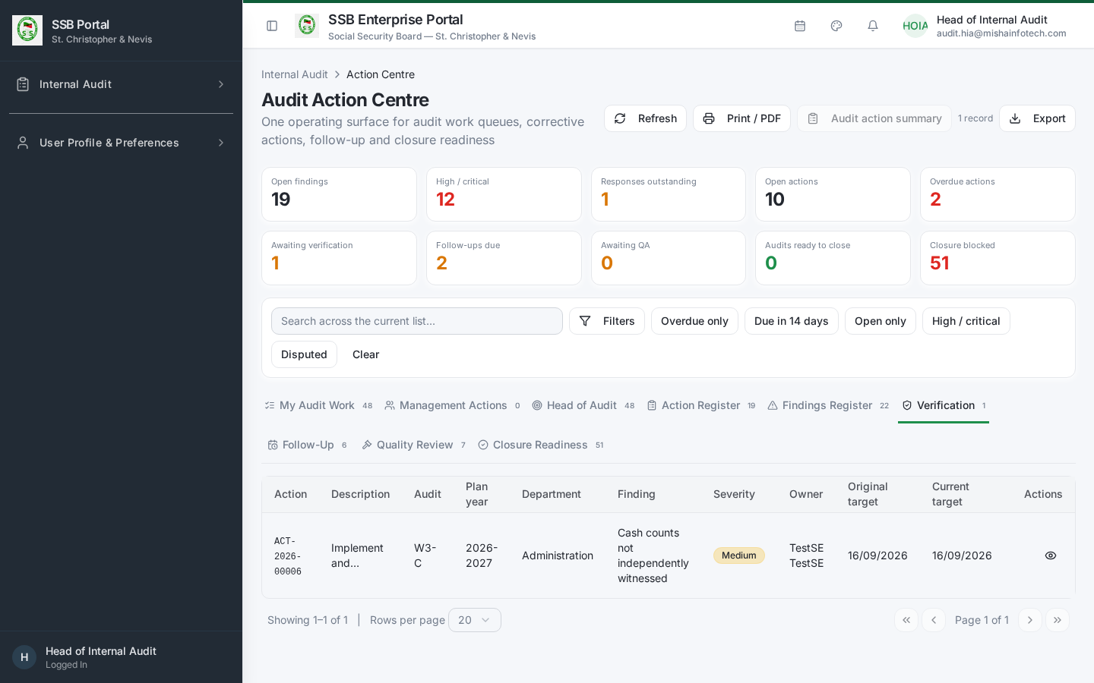
Verification queue

9. Time recording
Internal Audit → Time Tracking (/audit/time-tracking). Log hours against the engagement and activity daily. Time feeds workload, capacity planning and audit cost reporting.
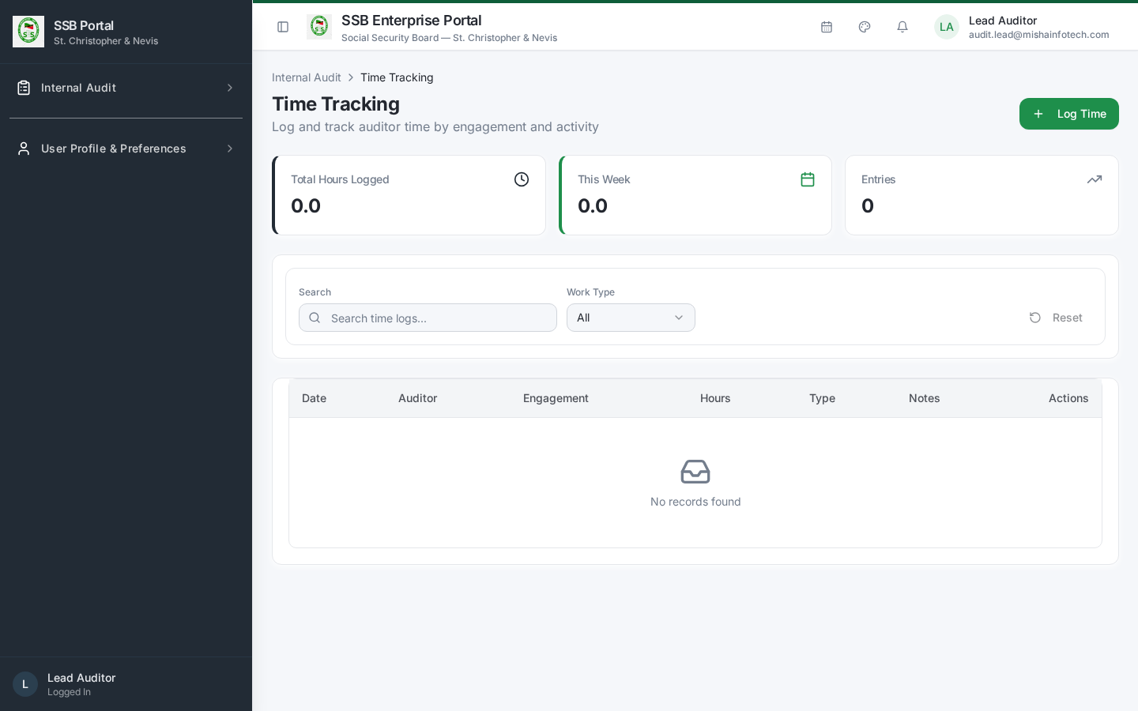
Time tracking

10. What you cannot do
Action | Who does it
Launch or close an engagement | Lead Auditor / Head of Internal Audit
Approve a finding for issuance | Lead Auditor
Sign off quality review | Quality Reviewer
Approve or close the annual plan | Head of Internal Audit
Change audit configuration or risk settings | Audit Administrator
Controls you are not entitled to use are hidden, not merely disabled.

Document Control — Version History & Change Log
Document owner: Head of Internal Audit Classification: Internal
Review cycle: Annually, or on any change to the Internal Audit module.
Version | Date | Author | Summary of change | Approval
1.0 | 2026-08-30 | Internal Audit / Platform Team | First issued manual, generated from the live TEST environment (routes, tabs, governed commands and screenshots). | Reviewed: Lead Auditor. Approved by Head of Internal Audit on: Pending

How to record an update
- Add a new row at the top of the table for every content change — never edit a released row.
- Increment the minor version (1.1, 1.2 …) for clarifications and screenshot refreshes; increment the major version (2.0) when a process, role or gate changes.
- State the change in business terms (what a reader must now do differently), not file edits.
- The manual is only “released” once the Head of Internal Audit records an approval date. Until then it is marked Pending and must not be used as certification evidence.
- Re-export the PDF and DOCX from the Internal Audit User Manuals page after each approval.

Change log
Version | Change | Sections affected
1.0 | Initial release. | All

