Internal Audit — Quality Reviewer Manual
Role: Quality Reviewer (IA_QUALITY_REVIEWER) Test account: w4-cert-qa@certification.invalid / audit.qa@… Owns: independent quality assurance over engagements before the report is issued and before the engagement can be closed.

1. Your access
You are scoped to the engagements on which you are named as quality reviewer. Those engagements open in the normal workspace; you have read access to every working tab so you can form an independent view, and write access to the Quality Review tab only.
Screen | Route | Use for
Action Centre → Quality Review | /audit/action-centre?tab=qa | Your review queue
Audit workspace → Quality Review | /audit/audits/:id | Perform and conclude the review
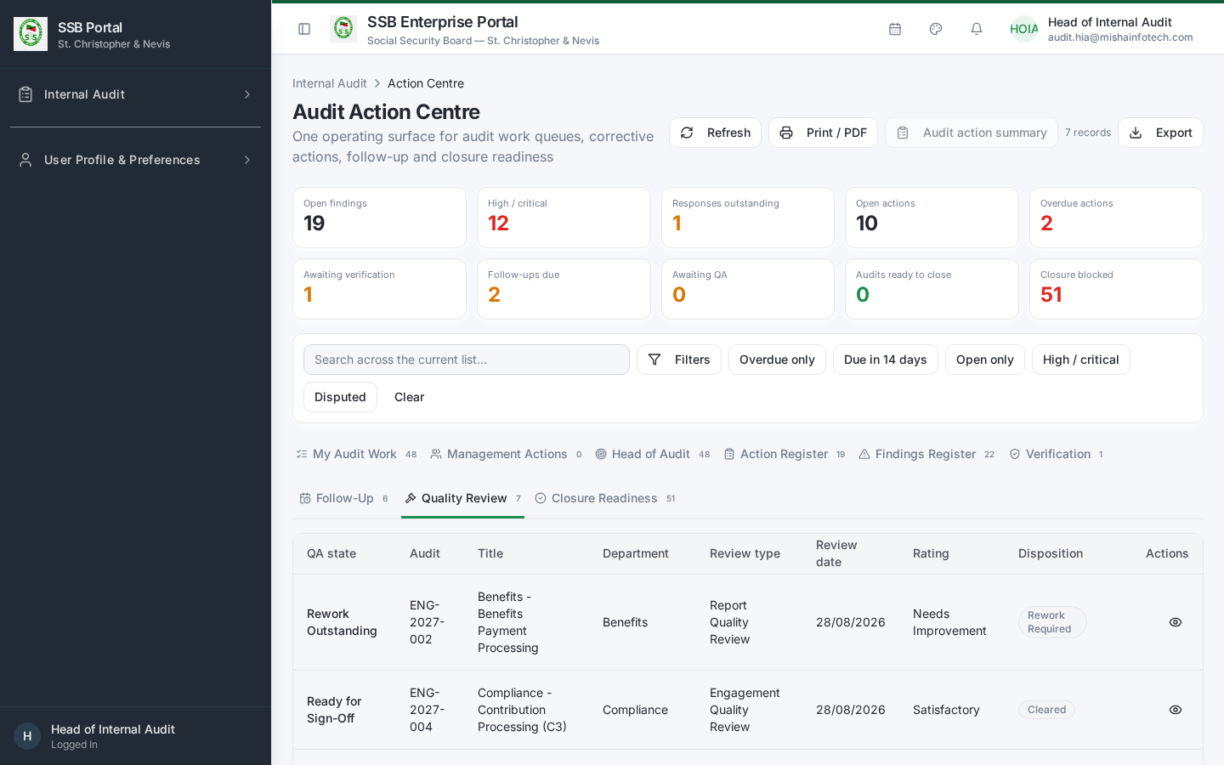
Quality review queue

2. Starting a review
- Open the engagement from the Quality Review queue.
- Go to the Quality Review tab and choose Start Review, selecting the review type (in-flight review or pre-issuance review).
- The review record is created on the server and the engagement is flagged as under QA.
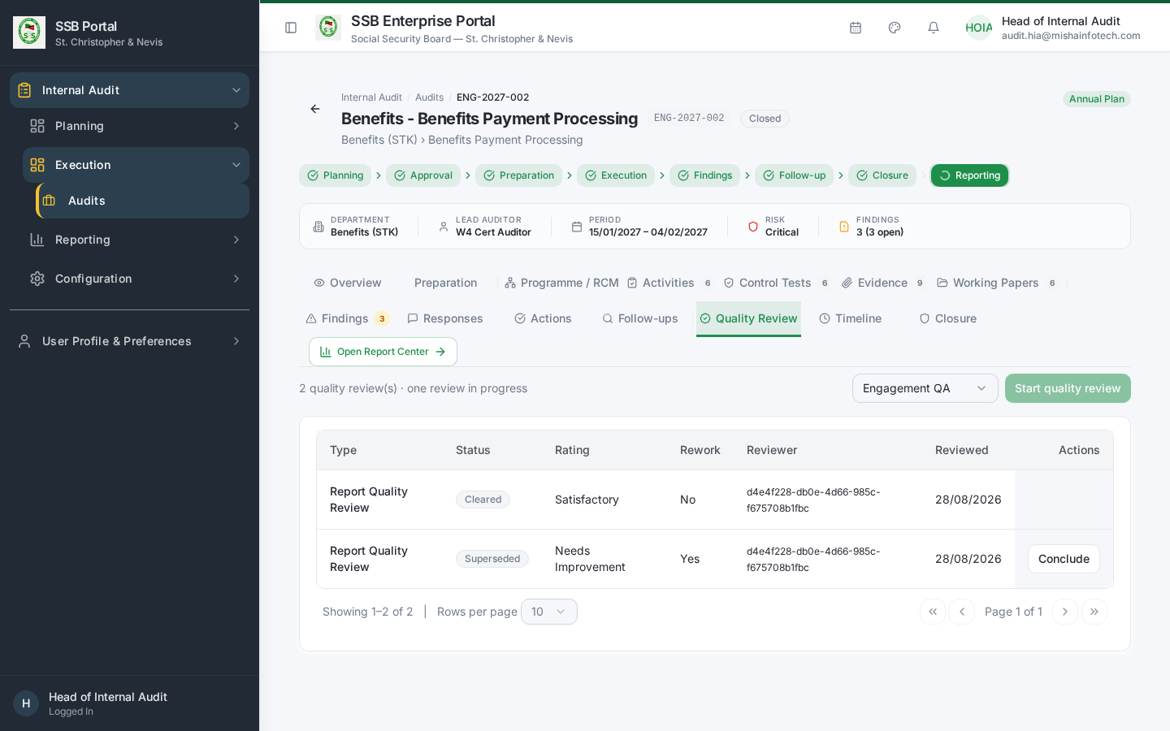
Quality review tab

3. What to review
Work through the QA checklist. It covers, at minimum:
Area | Question
Planning | Was the engagement scoped from the approved plan and the assessed risks?
Preparation | Was the department notified and the scope confirmed before fieldwork?
Programme | Does the RCM cover the material risks, and does each test address its control?
Fieldwork | Is every activity complete, with sample basis and population recorded?
Evidence | Is each conclusion supported by linked, sourced evidence?
Working papers | Do they show objective, work performed, results and conclusion, and are they reviewed?
Findings | Do they state condition, criteria, cause, effect and recommendation, with a defensible severity?
Responses | Does every finding have a management response, and are disputes properly escalated?
Report | Does the report reflect the findings and the agreed actions, with a supported overall rating?
Independence | Were segregation-of-duties requirements met, and are any exceptions logged?
Record a result and a note against each checklist item. Notes are part of the permanent record.

4. Concluding the review
Choose one outcome:
Outcome | Effect
Satisfactory | QA is signed off. The Lead Auditor can issue the report; closure is unblocked on this criterion.
Rework required | The engagement returns to the audit team with your specific rework points. Report issuance is blocked until you re-review and conclude Satisfactory.
Set the quality rating, add your conclusion, and sign off. The sign-off records your identity and timestamp and cannot be edited afterwards — a later change requires a new review.

5. Independence and segregation of duties
- You must not have performed fieldwork on the engagement you review.
- If the Head of Internal Audit is both approver and quality reviewer (a small-shop situation), the system records a logged SoD exception on the sign-off. It does not silently allow it, and the exception is visible in the audit trail and the certification reports.

6. Gates you enforce
Gate | Enforced where
No report issuance while QA is outstanding or in rework | Server-side, on the issuance command
No engagement closure without a signed-off quality review | Server-side, in the closure evaluation
If either gate fires, the screen names the missing quality review rather than showing a generic error.

Document Control — Version History & Change Log
Document owner: Head of Internal Audit Classification: Internal
Review cycle: Annually, or on any change to the Internal Audit module.
Version | Date | Author | Summary of change | Approval
1.0 | 2026-08-30 | Internal Audit / Platform Team | First issued manual, generated from the live TEST environment (routes, tabs, governed commands and screenshots). | Reviewed: Lead Auditor. Approved by Head of Internal Audit on: Pending

How to record an update
- Add a new row at the top of the table for every content change — never edit a released row.
- Increment the minor version (1.1, 1.2 …) for clarifications and screenshot refreshes; increment the major version (2.0) when a process, role or gate changes.
- State the change in business terms (what a reader must now do differently), not file edits.
- The manual is only “released” once the Head of Internal Audit records an approval date. Until then it is marked Pending and must not be used as certification evidence.
- Re-export the PDF and DOCX from the Internal Audit User Manuals page after each approval.

Change log
Version | Change | Sections affected
1.0 | Initial release. | All

