Internal Audit — Management Respondent Manual
Role: Management Respondent (IA_MANAGEMENT_RESPONDENT) Test accounts: w4-cert-mgmt-benefits@certification.invalid, audit.mgmt.benefits@…, audit.mgmt.compliance@…, audit.mgmt.finance@… Owns: your department’s response to audit findings, the corrective actions arising, and the evidence that they were implemented.
You are not an auditor. Your screens are deliberately limited to your own queues, and you see only findings and actions belonging to your department.

1. Your workspace
Sidebar → Internal Audit → Management Workspace:
Entry | Route | Purpose
My Work | /audit/action-centre?tab=management | Everything owed by you, oldest first
Findings Register | /audit/action-centre?tab=findings | Findings raised against your department
Corrective Actions | /audit/action-centre?tab=register | Actions you own, with target dates
Follow-Ups | /audit/action-centre?tab=followup | Scheduled verification of your actions
Auditor-only surfaces — Head of Audit, Verification, Quality Review, Closure Readiness — are not shown to you.
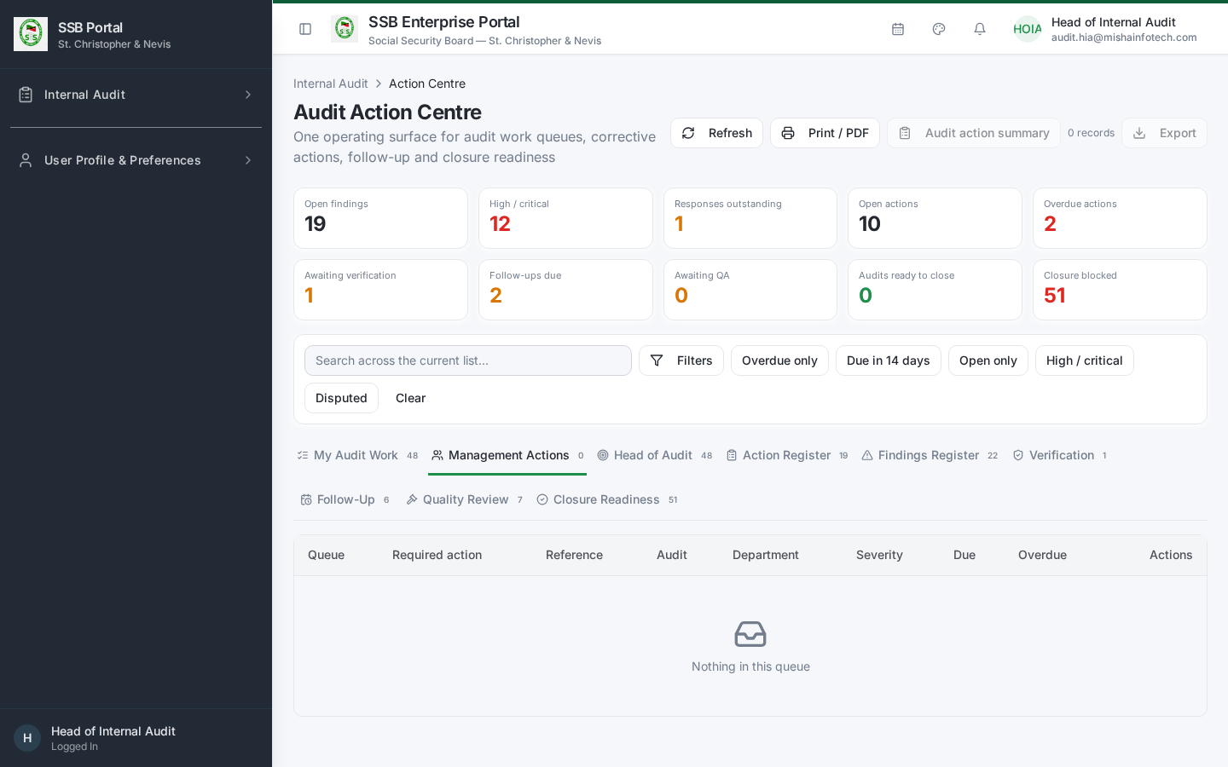
Management actions queue

2. Notifications you will receive
All audit communications reach you by email and as in-app notifications:
Event | When
Engagement notification | An audit of your department is launched
Information request | The audit team needs documents or data, with a required-by date
Response required | A finding has been sent to you for a management response
Response reminder | The response deadline is approaching
Action due soon / overdue | A corrective action you own is approaching or past its target date
Escalation | An overdue action is escalated to your senior management
Report issued | The final audit report for your department is available

3. Responding to a finding
- Open My Work and select the finding.
- Read the condition, criteria, cause, effect and the recommendation, and inspect the linked evidence.
- Choose your management position:
Position | Meaning | What is required
Accepted | You agree with the finding and the recommendation | An action plan, owner and target date
Partially accepted | You agree in part | State precisely what you accept and what you do not, plus an action plan for the accepted part
Rejected / Disagree | You do not accept the finding | A written rationale with supporting facts. The finding is retained and the disagreement is recorded in the report; the Head of Internal Audit resolves the dispute.
- Enter the response text, the action plan, the responsible person and the target date, then submit.
- The response is versioned. If the audit team returns it for clarification, you edit and resubmit — the previous version stays in the record.
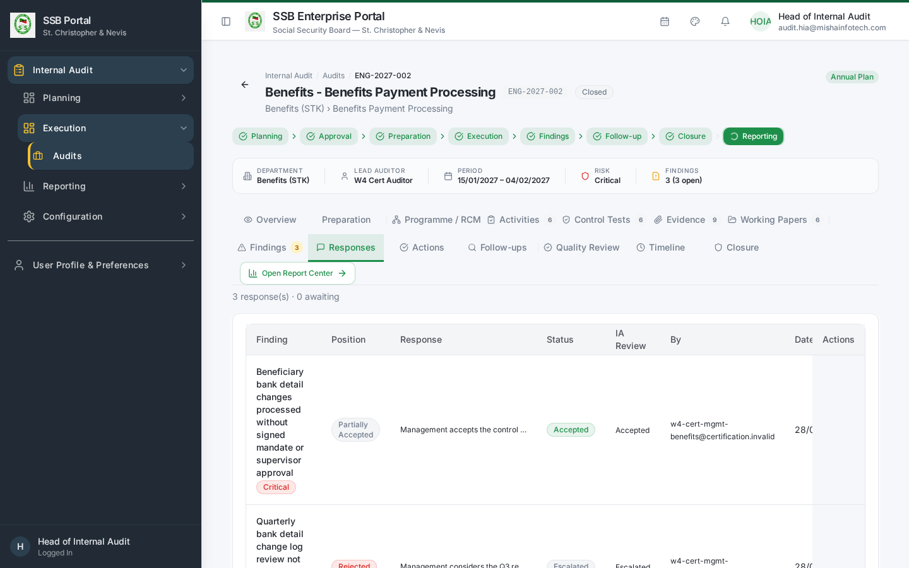
Management responses

4. Working a corrective action
- Open Corrective Actions and select the action.
- Move it through its lifecycle as work progresses: Open → In Progress → Completed (submitted for verification).
- When you submit completion, add a completion note and attach the evidence proving the action was implemented. Evidence is mandatory — a claim without evidence is rejected at verification.
- You cannot close an action yourself. Internal Audit verifies independently and closes it.

Needing more time
Use Request extension on the action, with a reason and a proposed new target date. The extension must be decided by Internal Audit; the original target date and the decision are both retained. Do not simply let an action go overdue — overdue high and critical actions are escalated automatically.
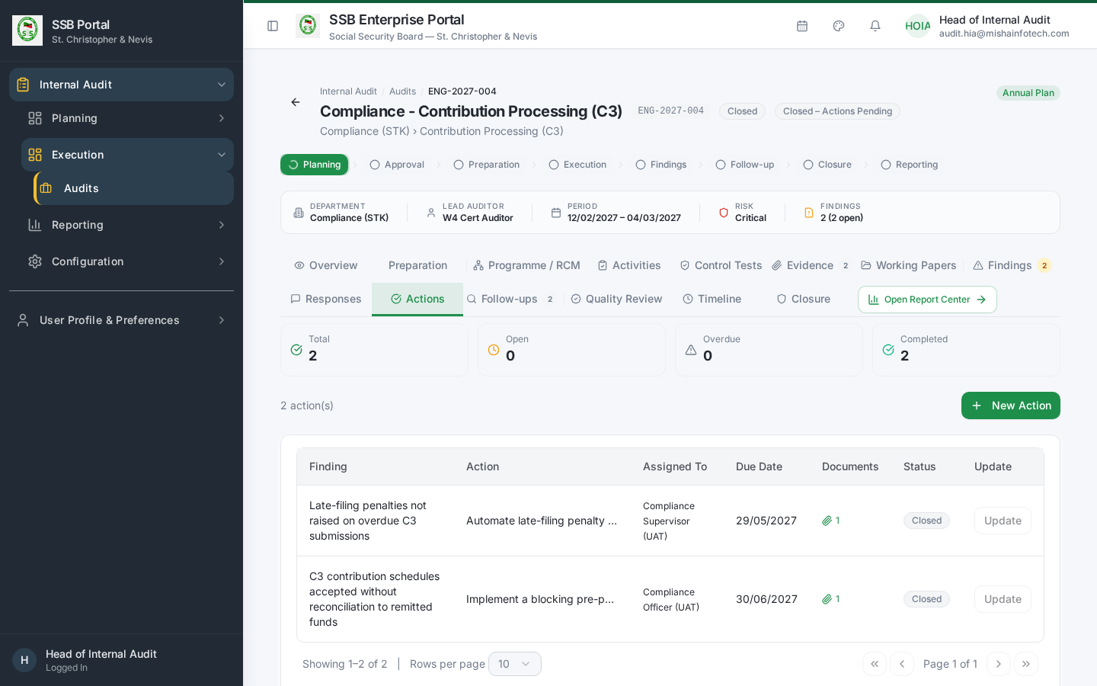
Actions pending monitoring

5. Follow-ups
The Follow-Ups tab shows when Internal Audit will verify your implemented actions. Have the evidence in place before the follow-up date. If verification fails, the action returns to you with the reason and a revised date.
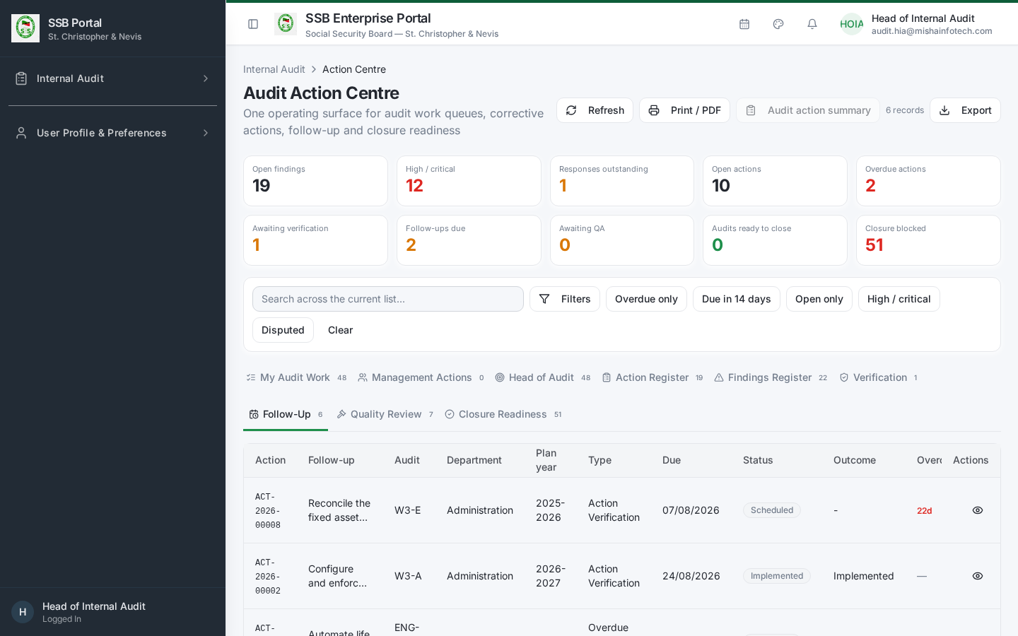
Follow-up register

6. After the audit closes
An engagement can close as Closed – Actions Pending. That does not release you: your open actions stay in your queue, keep emitting reminders, and remain subject to verification and escalation until they are verified and closed.
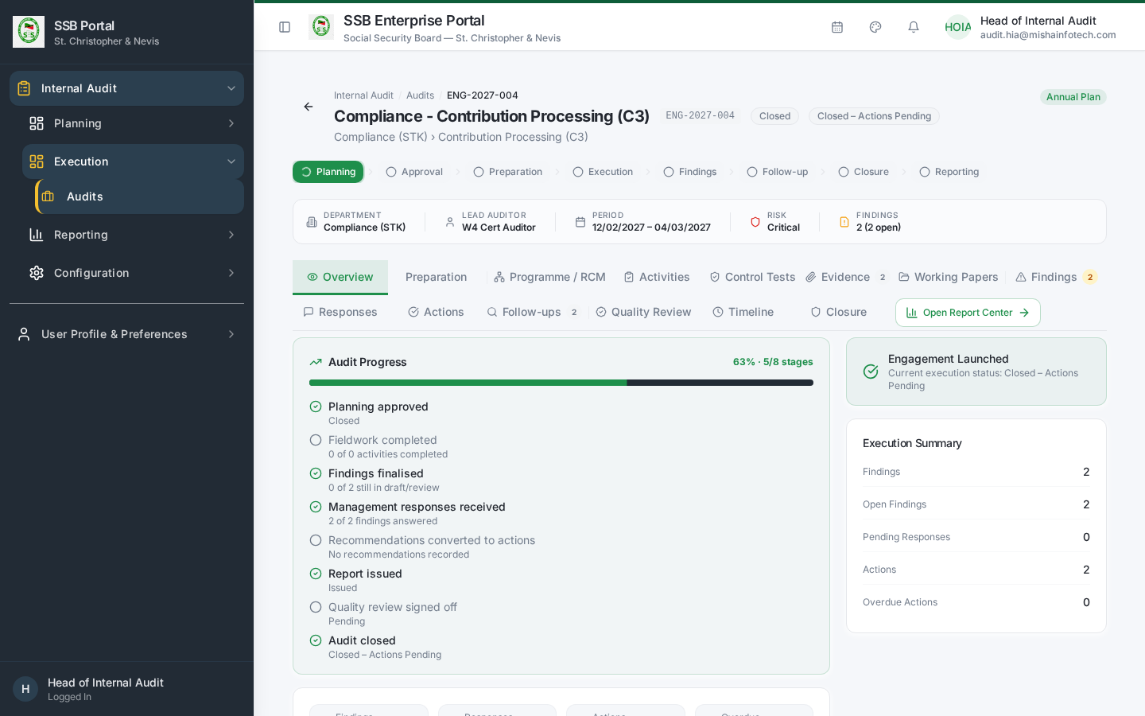
Closed – actions pending

7. Quick answers
Question | Answer
Can I edit a finding? | No. You can dispute it in your response.
Can I close my own action? | No. Internal Audit verifies and closes it.
Can I see another department’s findings? | No. Your view is scoped to your department.
Where do I upload evidence? | On the action itself, when submitting completion.
Who resolves a dispute? | The Head of Internal Audit or an independent reviewer.

Document Control — Version History & Change Log
Document owner: Head of Internal Audit Classification: Internal
Review cycle: Annually, or on any change to the Internal Audit module.
Version | Date | Author | Summary of change | Approval
1.0 | 2026-08-30 | Internal Audit / Platform Team | First issued manual, generated from the live TEST environment (routes, tabs, governed commands and screenshots). | Reviewed: Lead Auditor. Approved by Head of Internal Audit on: Pending

How to record an update
- Add a new row at the top of the table for every content change — never edit a released row.
- Increment the minor version (1.1, 1.2 …) for clarifications and screenshot refreshes; increment the major version (2.0) when a process, role or gate changes.
- State the change in business terms (what a reader must now do differently), not file edits.
- The manual is only “released” once the Head of Internal Audit records an approval date. Until then it is marked Pending and must not be used as certification evidence.
- Re-export the PDF and DOCX from the Internal Audit User Manuals page after each approval.

Change log
Version | Change | Sections affected
1.0 | Initial release. | All

