Internal Audit — Audit Administrator Manual
Role: Audit Administrator (IA_AUDIT_ADMIN, usually held alongside Head of Internal Audit) Owns: master data, risk configuration, module settings, document and communication templates, escalation roles and auditor resources.
Configuration drives behaviour everywhere else in the module. Set it up in the order below — later steps depend on earlier ones.

1. Golden path — set-up order
# | Step | Screen
1 | Audit configuration and feature flags | /audit/config
2 | Departments (audit universe) | /audit/departments
3 | Business functions per department | /audit/functions
4 | Auditor profiles | /audit/auditors
5 | Risk configuration (scales, weights, thresholds) | /audit/risk-settings
6 | Risk assessments and register | /audit/risk-assessment, /audit/risk-register
7 | Escalation roles and SLA / notification rules | /audit/escalation-roles, /audit/config
8 | Document and output settings | /audit/document-templates
9 | Communication templates | /audit/templates
10 | First annual plan | /audit/audit-plans

2. Departments and business functions
Departments (/audit/departments) links the organisation’s departments into the audit universe: office, head of department (a real profile), contact email and phone, status and the derived risk rating. This is the only department list the module uses — the Risk Register and every engagement read from it.
Business Functions (/audit/functions) records the functions inside each department, each with a risk level. Functions are the unit that is risk-assessed and put in scope on an engagement.
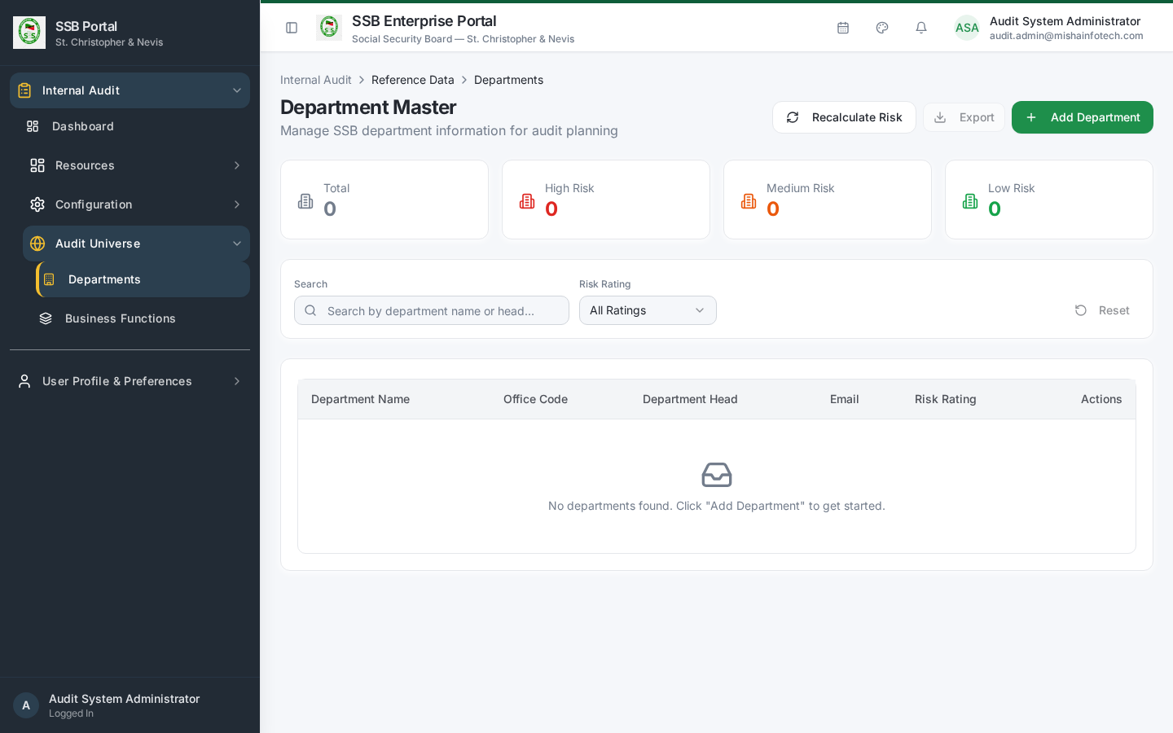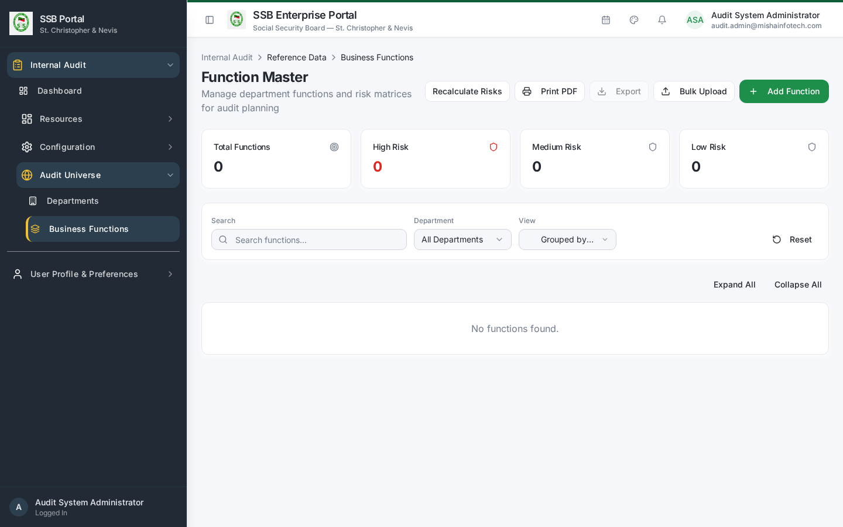

3. Risk configuration
/audit/risk-settings defines the scoring model used everywhere:
Setting | Effect
Likelihood levels (1–5) | The vertical axis of the risk matrix
Impact levels (1–5) | The horizontal axis
Risk criteria and weights | How factor scores combine into a risk score
Classification thresholds | Score bands for Low / Medium / High / Critical
Control effectiveness levels | The percentage by which effective controls reduce inherent risk
Audit frequency by risk band | How often an entity should be audited — feeds plan proposals
Changing thresholds re-classifies existing entities the next time they are assessed; it does not rewrite historical assessments.
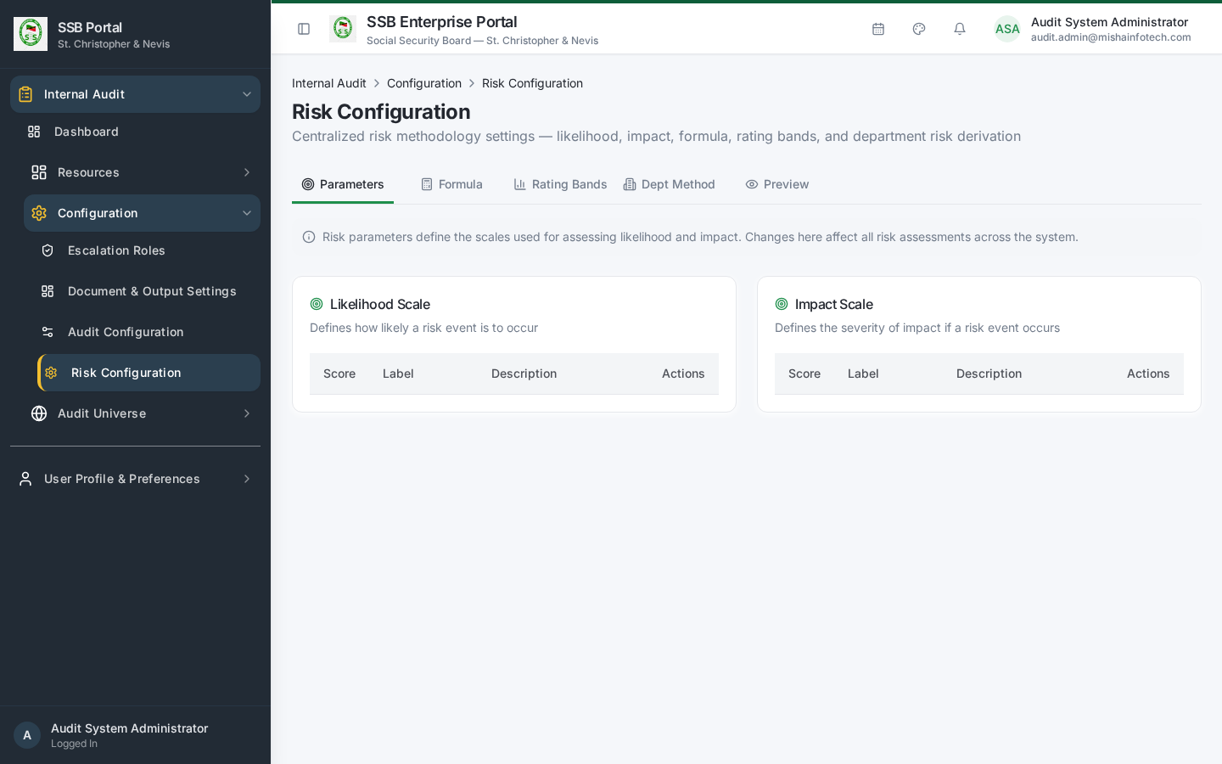
Risk configuration

4. Risk assessment and register
- Risk Assessment (/audit/risk-assessment) — score each function against the configured criteria. Saving an assessment synchronises the department’s risk rating.
- Entity Risk Summary (/audit/entity-summary) — consolidated position per entity.
- Risk Matrix (/audit/risk-matrix) — the heat map presented to the audit committee.
- Risk Register (/audit/risk-register) — the standing register, keyed on department and business function.
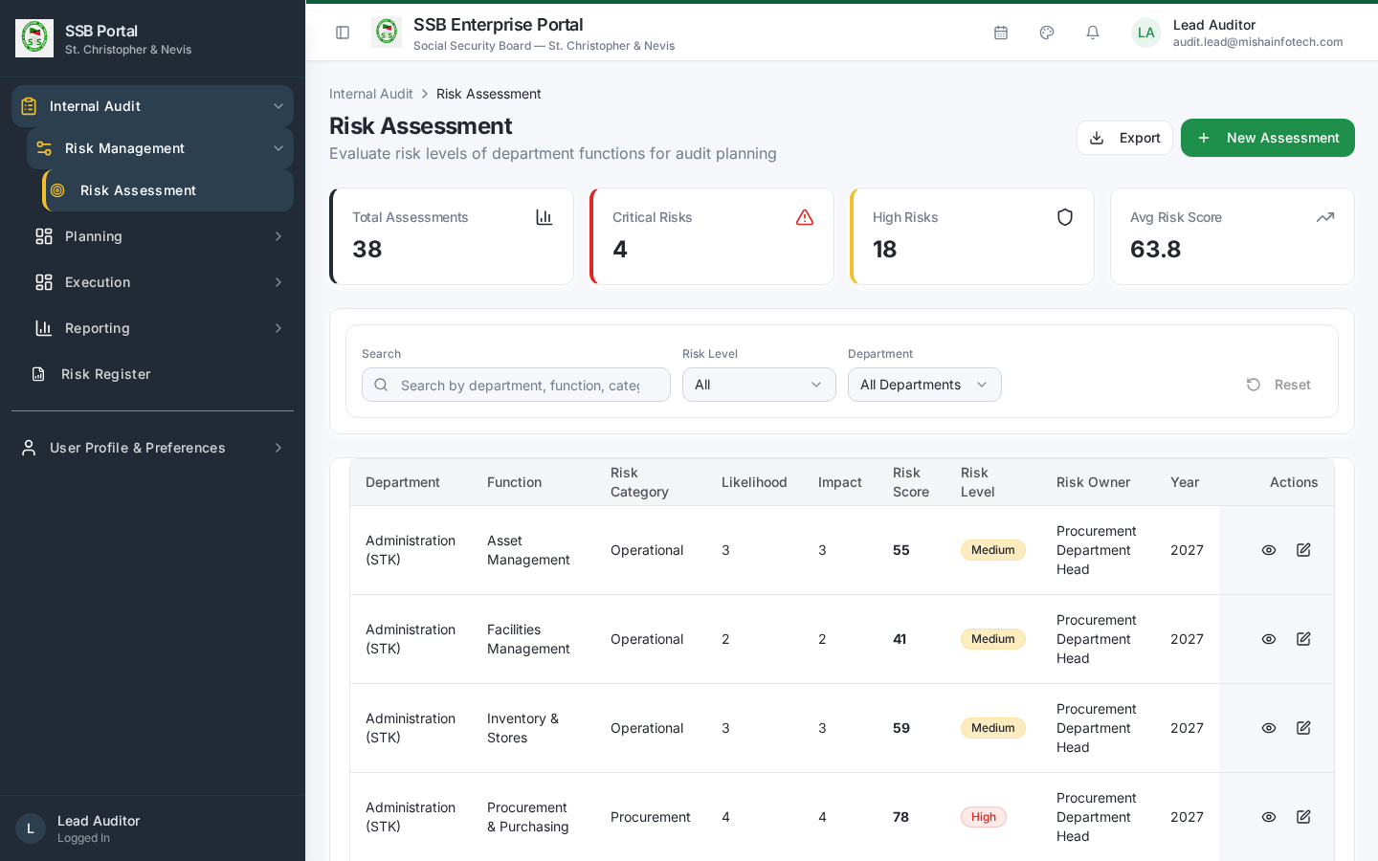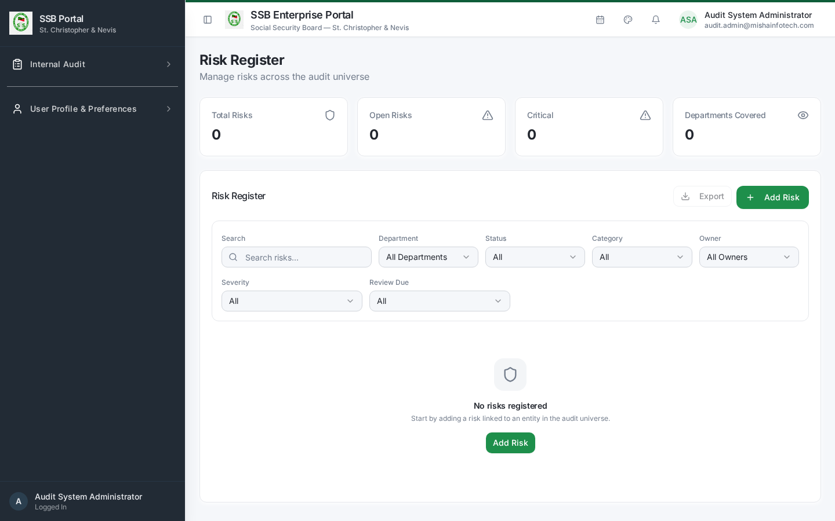

5. Module configuration
/audit/config groups the operational settings:
Section | Controls
Planning engine | Audit frequency defaults, planning horizon, capacity assumptions, the Revise-Plan guard (Block / Warn / Allow)
Approvals | Which lifecycle steps need approval and by which role
Activity types | The catalogue of fieldwork activity types
Notifications & SLA | Response deadlines, reminder lead times (for example 7 / 3 / 1 day), overdue escalation intervals
Reference settings | Severity labels, ratings, dispositions
Feature flags | Which optional Internal Audit surfaces are enabled
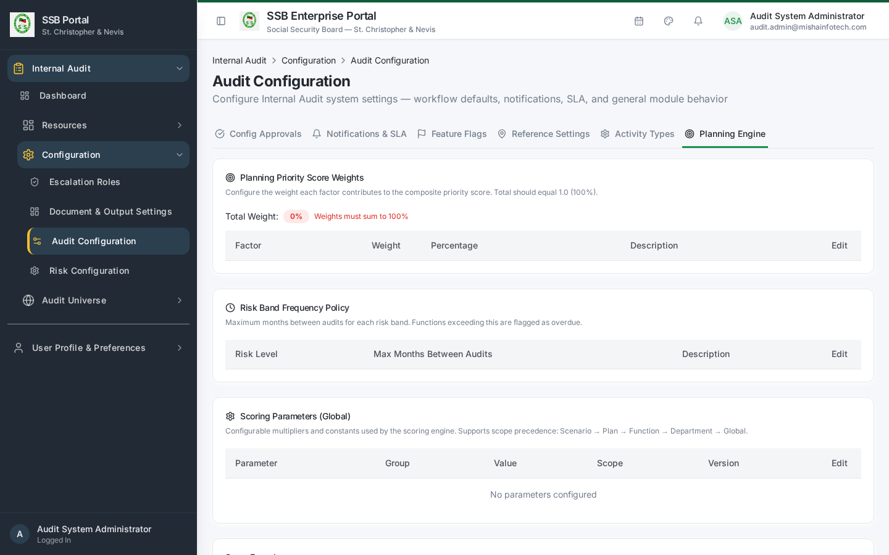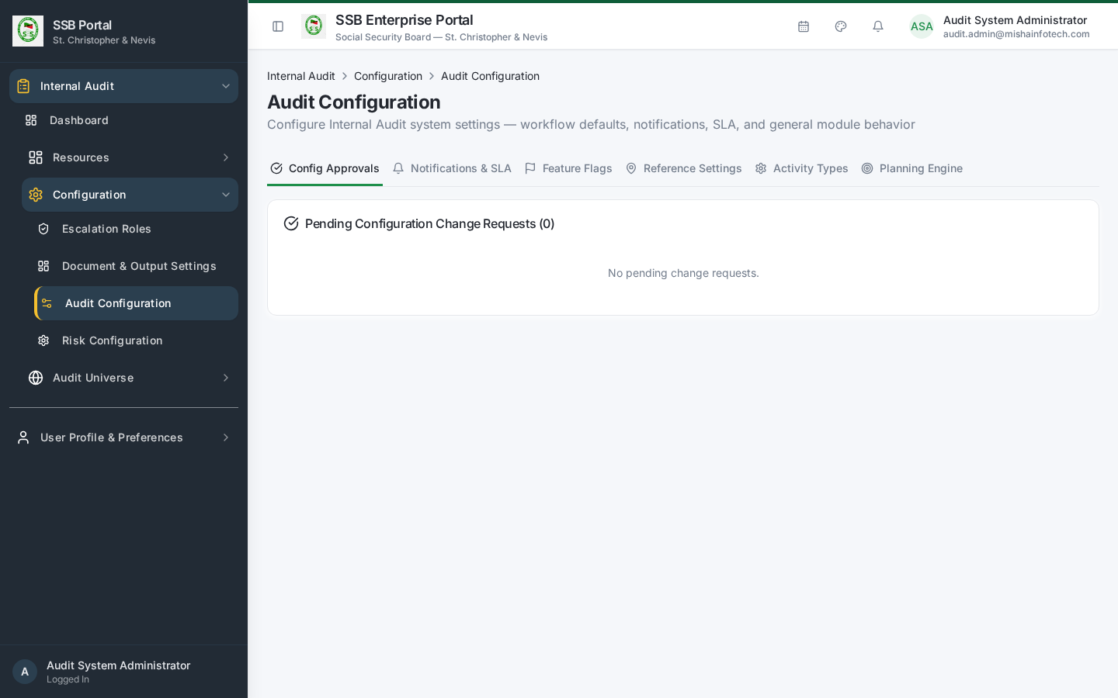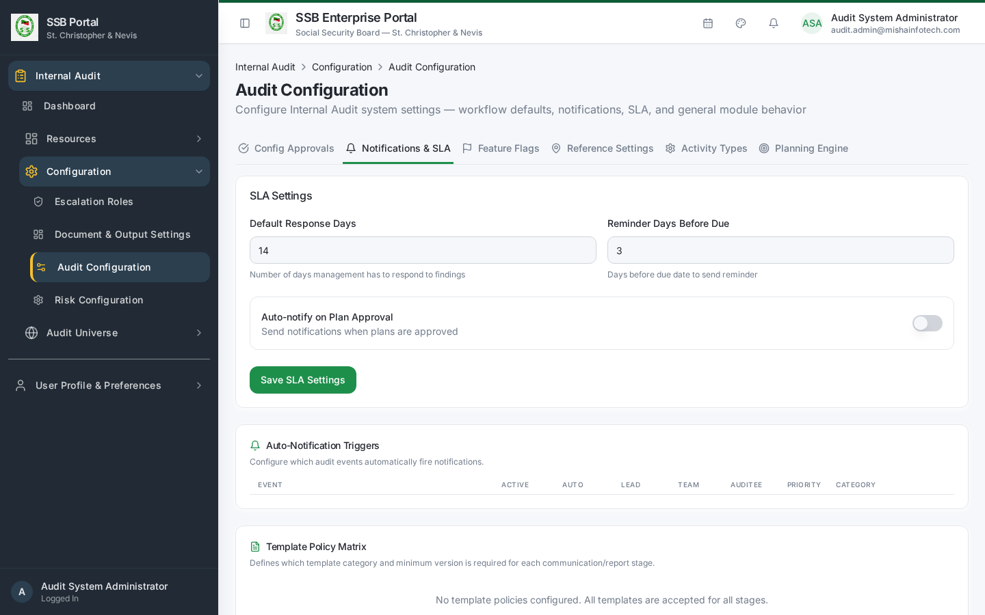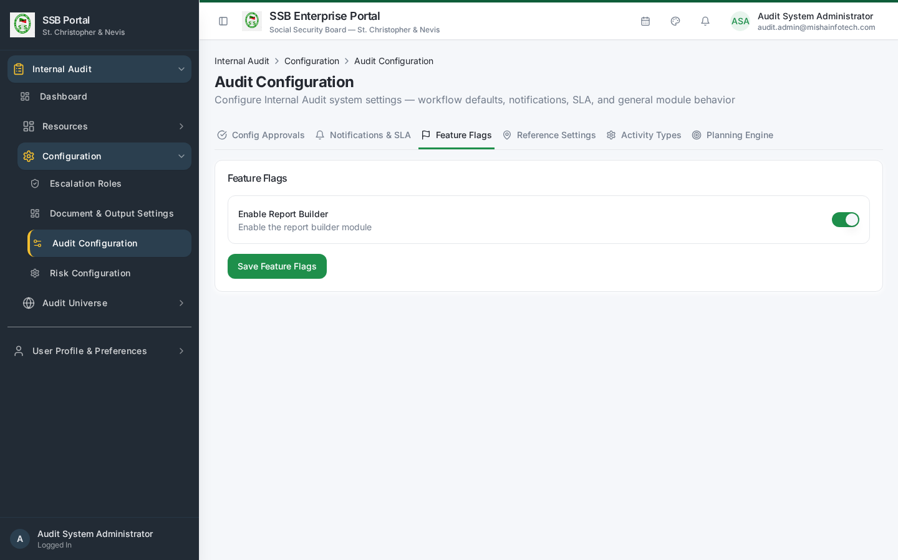

6. Escalation roles
/audit/escalation-roles maps each escalation level to a real office holder — for example overdue action → department head → director → Head of Internal Audit. Escalation notifications resolve their recipients from this register, so keep it current when people change roles.
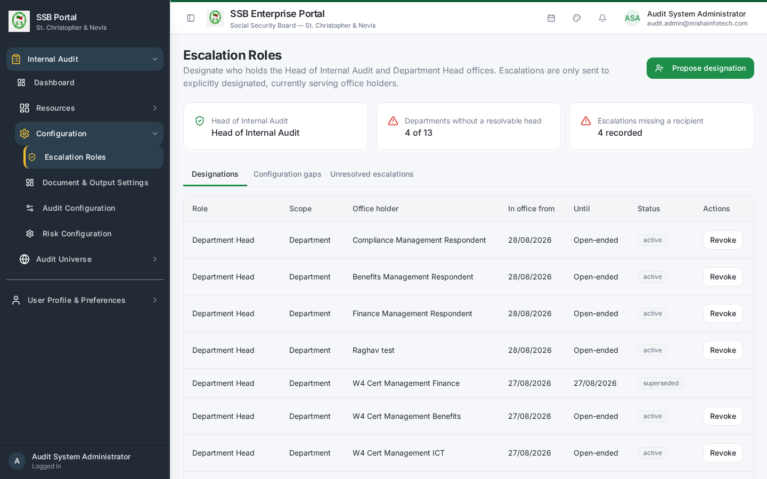
Escalation roles

7. Documents and communications
- Document & Output Settings (/audit/document-templates) — letterhead, signature blocks, footers and disclaimers used on generated audit letters and reports, and the numbering format for engagements, findings and actions.
- Communication Templates (/audit/templates) — opens the platform’s Core Template Designer filtered to the AUDIT module. Every Internal Audit notification is a catalogued event with published Email and In-App template versions. Edit content there; never create a parallel audit-only mail or SMS mechanism.
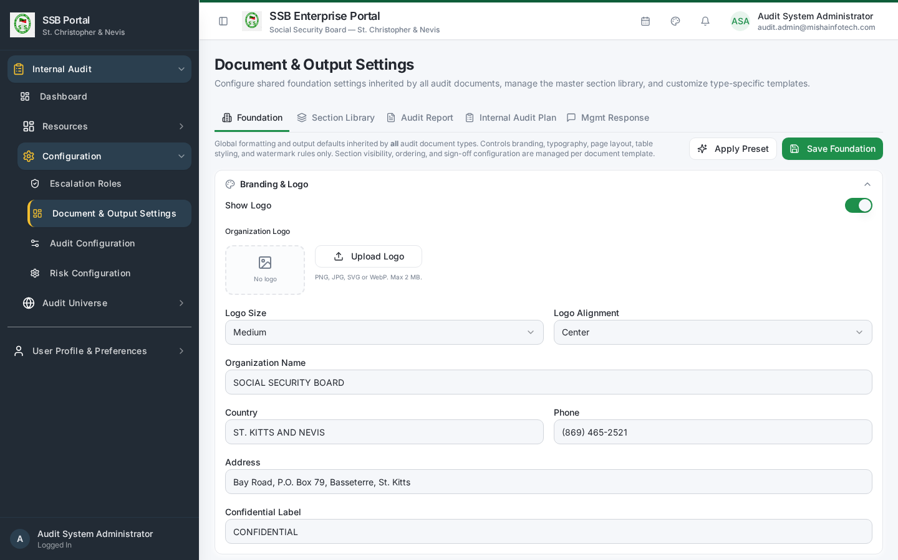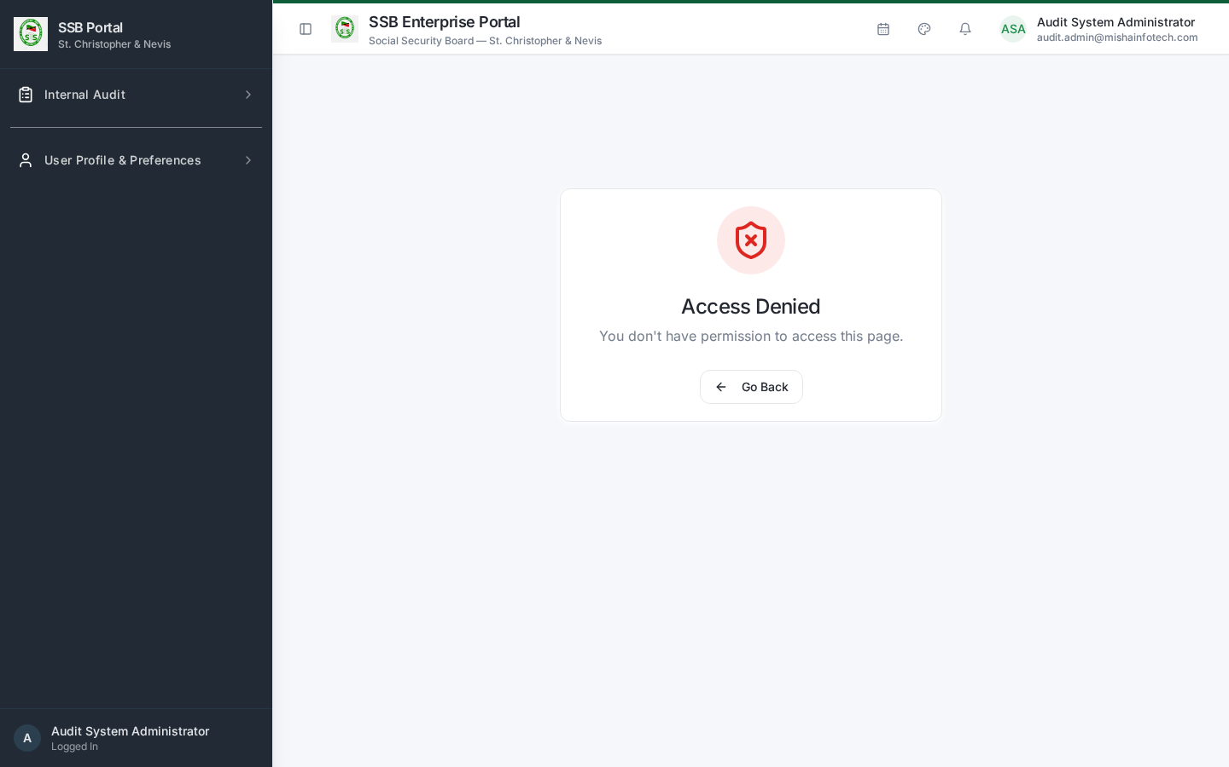

8. Auditor resources
Screen | Purpose
Auditor Profiles (/audit/auditors) | Link a platform profile to an auditor record with specialisation, qualification and status. A person only counts as audit team once they have an auditor profile — this is what separates auditors from management respondents.
Workload & Capacity (/audit/workload) | Available days per auditor against planned engagement days
Auditor Leave (/audit/leave) | Leave and vacation, subtracted from capacity
Time Tracking (/audit/time-tracking) | Actual hours per engagement and activity
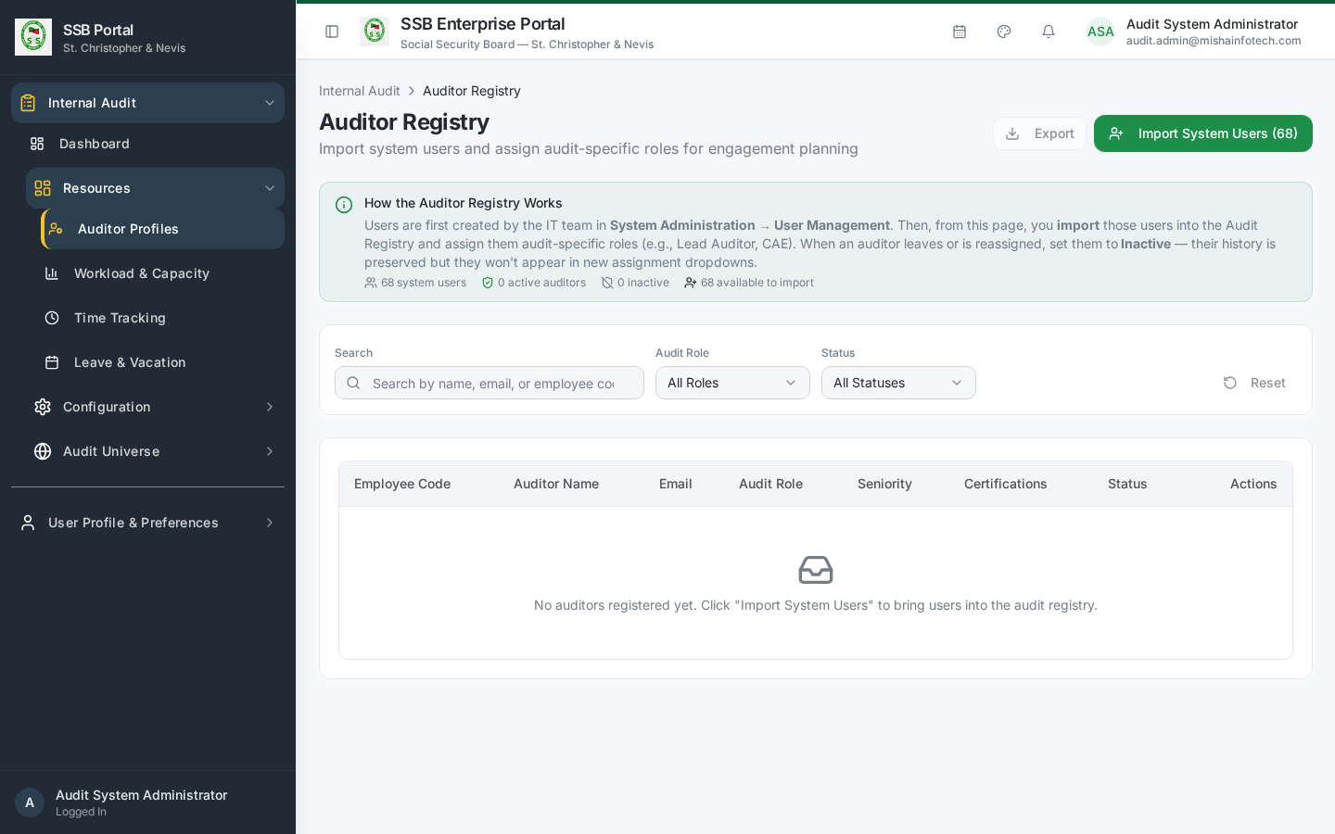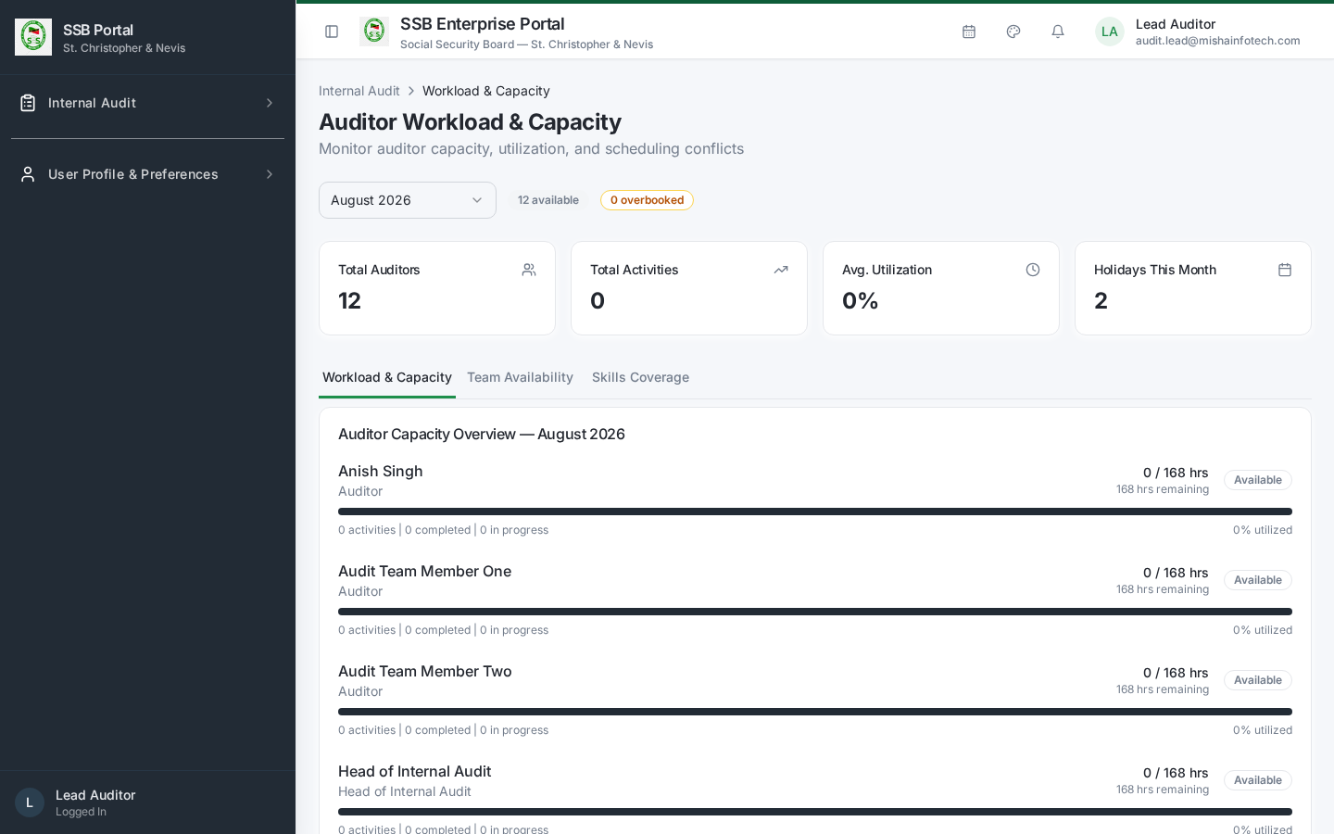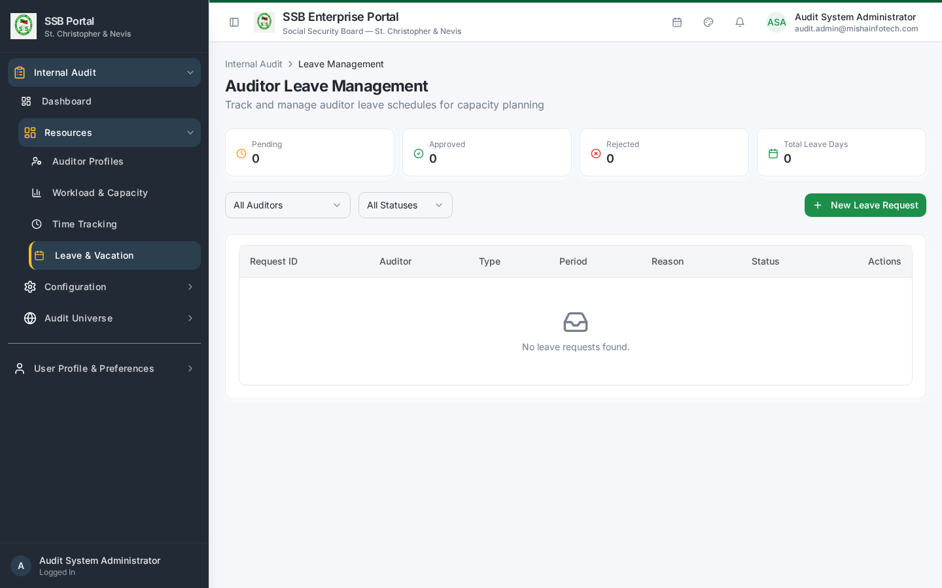

9. Roles and permissions
The five Internal Audit roles and the entitlements behind each screen are administered in the platform’s Role & Permission screens. The key registry actions are:
Module | Actions
internal_audit | view
audit_plans | create, edit, submit
plan_approval | approve, reject
audit_engagements | create, edit, assign, launch, close
activity_workbench, control_testing | execute
evidence_management, working_papers | create, edit
findings_recommendations | create, edit, approve
management_responses | create, edit
action_tracking | create, edit, close
follow_up_tracker | create, edit, close
audit_report_center | create, issue
quality_review | create, approve
plan_closeout | approve, close
audit_configuration | configure
audit_risk_configuration | view, edit, configure
risk_register, risk_assessment | create, edit
Grant these to the five roles — Head of Internal Audit, Lead Auditor, Audit Team Member, Quality Reviewer, Management Respondent — rather than to individuals.

10. Administrator health checks
Frequency | Check
Weekly | Communication Compliance report — every required audit notification delivered
Monthly | Auditor profiles and escalation roles still match the org chart
Quarterly | Risk configuration still matches the approved methodology
Annually | Audit universe refresh: new departments and functions added before planning starts

Document Control — Version History & Change Log
Document owner: Head of Internal Audit Classification: Internal
Review cycle: Annually, or on any change to the Internal Audit module.
Version | Date | Author | Summary of change | Approval
1.0 | 2026-08-30 | Internal Audit / Platform Team | First issued manual, generated from the live TEST environment (routes, tabs, governed commands and screenshots). | Reviewed: Lead Auditor. Approved by Head of Internal Audit on: Pending

How to record an update
- Add a new row at the top of the table for every content change — never edit a released row.
- Increment the minor version (1.1, 1.2 …) for clarifications and screenshot refreshes; increment the major version (2.0) when a process, role or gate changes.
- State the change in business terms (what a reader must now do differently), not file edits.
- The manual is only “released” once the Head of Internal Audit records an approval date. Until then it is marked Pending and must not be used as certification evidence.
- Re-export the PDF and DOCX from the Internal Audit User Manuals page after each approval.

Change log
Version | Change | Sections affected
1.0 | Initial release. | All

