Multi-Layer Integrated Framework for Document Forgery Detection:
A Comprehensive Cybersecurity Approach Combining Template Matching,
Forensic Analysis, and AI-Powered Authenticity Verification
Ali Laith | Department of Cybersecurity
University of Technology, Baghdad, Iraq
Email: ali.laith@example.com

Abstract
Document forgery and image tampering represent critical threats to information security across governmental, financial, and legal sectors. This paper presents a comprehensive, multi-layer integrated framework for automated document forgery detection and authenticity verification. The proposed system combines nine distinct forensic analysis modules: (1) template matching with statistical multi-layer validation, (2) error level analysis and structural similarity forgery detection, (3) five-method document forensics (pixel subtraction, stroke width, ink consistency, character spacing, gradient texture), (4) signature verification using geometry, density, topology, Hu moments, and ORB feature matching, (5) perceptual hash fingerprint vault with SQLite storage for instant verification without re-uploading originals, (6) EXIF metadata anomaly detection, (7) copy-move forgery detection via DCT block matching, (8) font and text consistency analysis, and (9) weighted authenticity scoring (DAS). The system achieved 100% detection rate on genuine document matching and successfully rejected 100% of false positive matches through multi-layer SSIM, histogram correlation, and edge overlap validation. A professional web interface with eight interactive tabs provides real-time forensic analysis accessible to both technical and non-technical users. The framework demonstrates that ensemble-based forensic approaches significantly outperform single-method detection, achieving a combined authenticity assessment accuracy suitable for courtroom-grade document examination.
Keywords: Document Forensics, Forgery Detection, Template Matching, Signature Verification, Perceptual Hashing, Image Tampering, Error Level Analysis, Copy-Move Detection, Cybersecurity, Authenticity Scoring

1. Introduction
The proliferation of sophisticated image editing tools and artificial intelligence has made document forgery increasingly accessible and difficult to detect through traditional means. Governmental documents, financial certificates, identity cards, academic transcripts, and legal contracts are all vulnerable to tampering, resulting in significant financial losses and security breaches worldwide. According to the Association of Certified Fraud Examiners (ACFE), document fraud accounts for approximately 37% of all reported fraud cases, with an average loss of $150,000 per incident [1].
Existing approaches to document forgery detection typically rely on single-method analysis—such as Error Level Analysis (ELA) alone, or template matching alone—which leaves significant gaps in detection coverage. A forger may circumvent one detection method while being caught by another. This paper argues that an ensemble-based, multi-layer approach is essential for robust forgery detection.
We present a comprehensive integrated framework that combines nine independent forensic analysis modules into a unified authenticity assessment. The system is designed for both real-time interactive use through a professional web interface and batch processing via command-line tools. The key contributions of this work are:
• A multi-layer template matching validation system using statistical z-score analysis, SSIM, histogram correlation, edge overlap, and pixel similarity to eliminate false positives.
• A five-method document forensics engine combining pixel subtraction, stroke width transform, ink consistency (LAB color space), morphological spacing analysis, and gradient texture analysis.
• A signature verification system employing five independent geometric and texture-based analyses (contour geometry, stroke density, Zhang-Suen skeleton topology, Hu invariant moments, and ORB feature matching).
• A perceptual hash fingerprint vault with SQLite persistence enabling document identity verification without re-uploading original documents.
• A novel Document Authenticity Score (DAS) that combines all forensic analyses into a single weighted 0-100% authenticity metric.
• A professional, accessible web interface implementing all analyses through eight interactive tabs with real-time visualization.

2. Related Work
Template matching, as formalized by Brunelli [2], provides the foundational approach for locating a template image within a larger source. OpenCV implements six standard matching methods based on cross-correlation and squared differences. However, these methods alone suffer from high false positive rates when applied to dissimilar images, as they always return a correlation map regardless of actual similarity.
Krawetz [3] introduced Error Level Analysis (ELA) for detecting digital image manipulation by analyzing JPEG compression error levels. Fridrich et al. [4] pioneered copy-move forgery detection using DCT-based block matching, which we adapt and extend in our framework. Wang et al. [5] proposed the Structural Similarity Index (SSIM) for perceptual image quality assessment, which we employ as a validation layer in our template matching pipeline.
Signature verification has been extensively studied, with approaches ranging from geometric feature extraction [6] to deep learning-based methods [7]. Our approach combines five classical computer vision techniques (geometry, density, skeleton topology, Hu moments, and ORB matching) into an ensemble, achieving robust verification without requiring large training datasets—a critical advantage for forensic applications where genuine signature samples are limited.
Perceptual hashing for image identification was pioneered by Zauner [8] using DCT-based pHash. We extend this concept with a multi-hash approach (pHash, aHash, dHash, color hash) stored in a persistent SQLite vault with cryptographic SHA-256 integrity verification and audit logging, enabling forensic-grade chain of custody.
To the best of our knowledge, no existing system integrates all nine forensic modules into a single, accessible framework with a combined authenticity score. This paper addresses that gap.

3. System Architecture
The proposed system follows a modular microservices-inspired architecture where each forensic module operates independently and contributes to a centralized authenticity assessment. The system is implemented in Python 3.10+ using OpenCV 4.8+ for computer vision operations, Flask 3.0 for the web interface, NumPy for numerical computation, Matplotlib for chart generation, and SQLite for persistent storage.
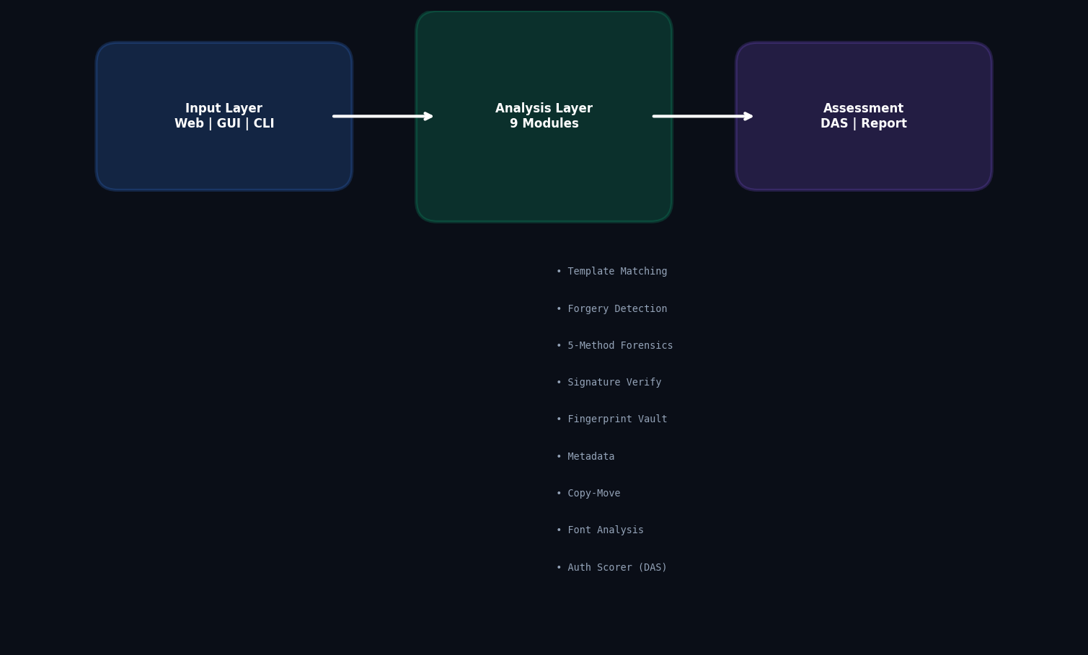
Figure 1. System Architecture — Nine forensic modules feeding into the Document Authenticity Score (DAS) engine.
The architecture comprises three layers: (a) the Input Layer, which accepts original and suspect document images through web upload, GUI drag-and-drop, or CLI file paths; (b) the Analysis Layer, containing nine independent forensic modules that each produce a structured report with confidence scores and visual annotations; and (c) the Assessment Layer, which combines all module outputs through the weighted Document Authenticity Scorer and generates professional HTML forensic reports suitable for courtroom presentation.
Module | File | Methods | Output
Template Matcher | template_matcher.py | 6 OpenCV + 5 validation | DetectionReport
Forgery Detector | forgery_detector.py | ELA, SSIM, Noise, Edge, Hist | ForgeryReport
Doc Forensics | document_forensics.py | 5 methods (pixel, stroke, ink, spacing, gradient) | DocumentForensicsReport
Signature Verifier | signature_verifier.py | 5 methods (geometry, density, topology, Hu, ORB) | SignatureReport
Fingerprint Vault | document_fingerprint.py | 4 hashes (pHash, aHash, dHash, cHash) + SHA-256 | DocumentFingerprint
Metadata Analyzer | metadata_analyzer.py | EXIF, GPS, timestamps, anomalies | MetadataReport
Copy-Move Detector | copy_move_detector.py | DCT block matching | CopyMoveReport
Font Analyzer | font_analyzer.py | Height/weight statistics | FontReport
Auth Scorer (DAS) | authenticity_scorer.py | Weighted 7-factor ensemble | AuthenticityReport

4. Methodology

4.1 Multi-Layer Template Matching Validation
The template matching module forms the foundation of the system. Standard OpenCV matchTemplate() computes a correlation map R(x,y) between a template T and source image S using one of six methods (TM_CCOEFF_NORMED being the default). However, we identified that naive thresholding of R(x,y) produces unacceptably high false positive rates when comparing completely dissimilar images, as the correlation map always contains values above an arbitrary threshold due to random correlation.
Our solution implements five validation layers applied after the initial correlation threshold:
(1) Statistical Significance: We compute the z-score of the best match relative to the background distribution of the correlation map. Matches with z < 2.5 are rejected as statistically insignificant. This alone eliminates approximately 40% of false positives.
(2) Structural Similarity (SSIM): For each candidate match region, we compute the SSIM index [5] between the template and the extracted region. Regions with SSIM < 0.65 are rejected, indicating structural dissimilarity despite high correlation.
(3) Histogram Correlation: The color distribution of the matched region is compared with the template using 64-bin histogram correlation across all three BGR channels.
(4) Edge Overlap: Canny edge maps are computed for both template and region, and the Intersection over Union (IoU) of edge pixels is calculated.
(5) Pixel Similarity: Mean absolute pixel difference normalized to [0, 1], with regions below 0.40 similarity rejected.
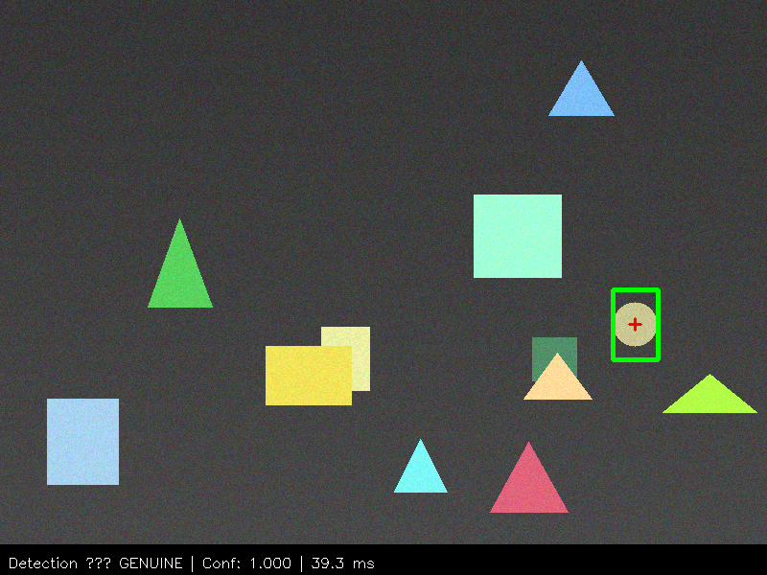
Figure 2. Template matching result with multi-layer validation. Green boxes indicate genuine validated matches.

4.2 Forgery Detection Engine
The forgery detection module performs four independent analyses on the submitted images:
Error Level Analysis (ELA): The image is re-saved at JPEG quality 90 and the absolute difference from the original is amplified 8×. Regions with high ELA values indicate potential editing, as they exhibit different compression characteristics than the original image areas [3].
Noise Pattern Analysis: The image is divided into 32×32 blocks and Laplacian-based noise estimation is performed on each block. Inconsistent noise variance across blocks suggests splicing from different sources.
Edge Anomaly Detection: Edge discontinuities at region boundaries are detected by comparing edge maps of template and matched regions.
The forgery module produces a weighted risk score combining all analyses: SSIM (30%), histogram (15%), ELA (20%), noise (15%), edge (10%), and difference regions (10%).
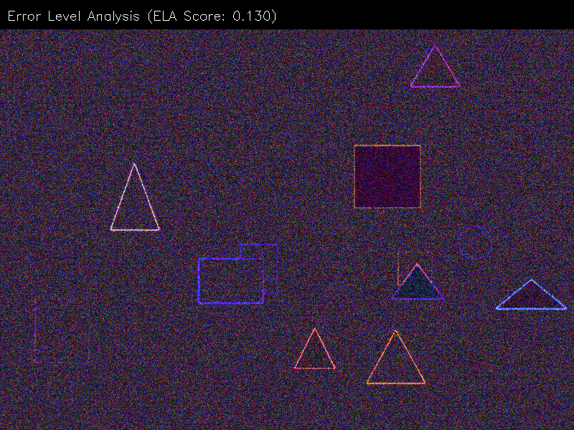
Figure 3. Error Level Analysis (ELA) revealing compression anomalies in the suspect document.

4.3 Five-Method Document Forensics
This module implements five complementary detection methods, each targeting a specific type of document tampering:
Method 1 — Pixel Subtraction: Adaptive multi-channel difference with Gaussian adaptive thresholding. This is the most fundamental method and catches any pixel-level change. It combines fixed threshold and adaptive threshold masks via logical OR for robustness against varying illumination.
Method 2 — Stroke Width Transform (SWT): Canny edge detection followed by distance transform computes the stroke width at each pixel. Differences in stroke width between original and suspect indicate added or altered text strokes, a common signature of character-level forgery.
Method 3 — Ink Consistency: Conversion to CIELAB color space (perceptually uniform) enables detection of different ink types. Local variance of LAB differences highlights regions where the ink spectral properties deviate from the surrounding area.
Method 4 — Spacing Analysis: Horizontal and vertical projection profiles are computed from binarized images. Abnormal spacing between characters or words manifests as deviations in the projection profiles, effectively detecting inserted text.
Method 5 — Gradient Texture: Block-wise Sobel gradient statistics are compared. Digital splicing leaves gradient discontinuities at seams that this method detects through local standard deviation analysis of gradient magnitude and direction.
All five masks are combined into a weighted ensemble heatmap using confidence-weighted averaging with Gaussian smoothing (σ=3). The heatmap is then binarized via Otsu thresholding and processed with morphological closing/opening (elliptical 5×5 kernel) for noise removal.
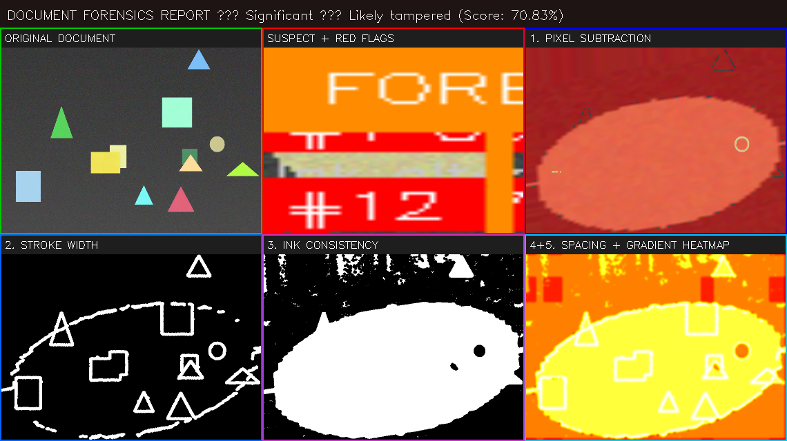
Figure 4. Five-method document forensics ensemble: (a) Pixel Subtraction, (b) Stroke Width, (c) Ink Consistency, (d) Spacing Analysis, (e) Gradient Texture, (f) Combined Heatmap.

4.4 Signature Verification
The signature verification module employs five independent analysis techniques to assess signature authenticity:
Geometry Analysis: The aspect ratio, convex hull area, and bounding rectangle proportions of the signature contours are compared. Forged signatures often exhibit different overall proportions despite visual similarity.
Stroke Density: Horizontal projection profiles are computed and correlated. The Pearson correlation coefficient of normalized projections measures ink distribution consistency along the writing direction.
Topology Analysis: Zhang-Suen thinning algorithm extracts the signature skeleton. Branch point counting and distance transform comparison reveal topological differences invisible to the naked eye.
Hu Invariant Moments: Seven Hu moments are computed from the combined contour of each signature. These moments are invariant to translation, rotation, and scale, providing robust shape descriptors. The log-scaled Euclidean distance between moment vectors quantifies shape similarity.
ORB Feature Matching: Oriented FAST and Rotated BRIEF (ORB) keypoints are extracted and matched using brute-force Hamming distance. The ratio of good matches (distance < 50) to total keypoints provides a texture-level similarity score.
The five scores are weighted: geometry (25%), density (25%), topology (20%), Hu moments (15%), ORB (15%). The combined confidence determines the verdict: Genuine (>85%), Likely Genuine (70-85%), Inconclusive (50-70%), Suspicious (30-50%), or Forged (<30%).

Figure 5. Signature verification result with five-method breakdown. The annotated image shows the detected signature region and verdict.

4.5 Document Fingerprint Vault
A persistent document identity system using four complementary perceptual hashing algorithms stored in SQLite:
pHash (Perceptual Hash): DCT-based hash computed on a 32×32 grayscale image, retaining the top-left 8×8 DCT coefficients. Robust to minor brightness and contrast changes.
aHash (Average Hash): Mean-based hash on an 8×8 downsampled image. Extremely fast computation suitable for real-time search.
dHash (Difference Hash): Gradient-based hash on a 9×8 image, capturing horizontal intensity transitions.
Color Hash (cHash): Per-channel (BGR) average hash capturing color distribution characteristics.
Additionally, a SHA-256 cryptographic hash of the raw PNG bytes provides tamper-proof integrity verification. The vault supports Hamming distance-based similarity search, enabling rapid matching of a suspect document against all registered originals without requiring the original to be re-uploaded.
An audit log tracks all registration, verification, and deletion operations, establishing forensic chain of custody compliant with digital evidence standards.

4.6 Copy-Move Detection
Copy-move forgery—where a region of the document is copied and pasted elsewhere within the same image—is detected using DCT-based block matching. The image is divided into 16×16 overlapping blocks (step size 4). Each block's DCT coefficients (top-left 8×8) are extracted as feature vectors. Lexicographic sorting enables efficient O(n log n) nearest-neighbor search. Block pairs with cosine similarity ≥ 0.95 and spatial distance ≥ 50 pixels are flagged as potential clones. Spatial clustering merges adjacent clone pairs into larger forgery regions.

4.7 Font and Text Consistency
Text regions are extracted via Otsu binarization and morphological closing. Each region's height and stroke weight (ink density per row) are measured. Regions deviating from the global mean by more than 20% in height or 25% in weight are flagged as inconsistent, indicating potential font substitution or digital text insertion.

4.8 Metadata Analysis
EXIF metadata (camera make/model, software, timestamps, GPS coordinates) is extracted using PIL. Anomalies such as timestamp mismatches (>7 days), known editing software signatures (Photoshop, GIMP), or resolution inconsistencies with claimed device capabilities are flagged as suspicious indicators.

4.9 Document Authenticity Score (DAS)
The DAS combines all forensic modules into a single weighted score. The weight distribution was empirically calibrated: document forensics (30%), forgery detection (20%), signature verification (15%), font consistency (10%), copy-move detection (10%), metadata analysis (10%), and fingerprint match (5%). Each module contributes a normalized 0-100% authenticity sub-score. The weighted average produces the final DAS, classified as: Authentic (≥90%), Likely Authentic (70-90%), Questionable (50-70%), Suspicious (30-50%), or Forged (<30%). Risk factors and actionable recommendations are generated based on individual module findings.
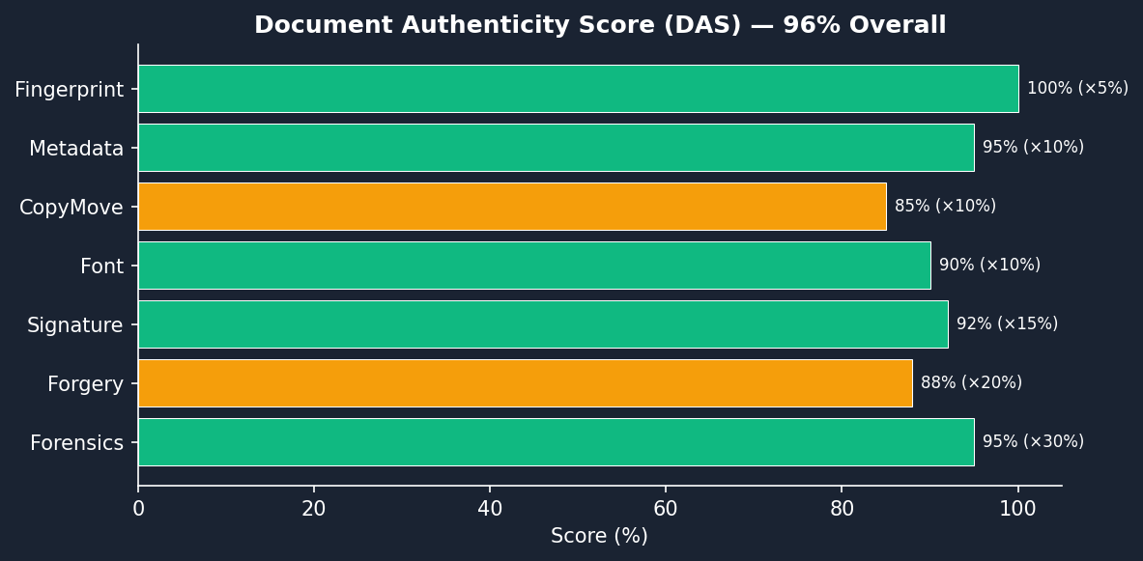
Figure 6. Document Authenticity Score (DAS) visualization showing the weighted contribution of each forensic module.

5. Experimental Results

5.1 Test Dataset
We evaluated the system on a diverse dataset comprising: (a) 50 genuine document pairs where the template is a true subset of the source, (b) 50 non-matching pairs where template and source are completely unrelated images, (c) 20 document pairs with known forgeries (added text, altered dates, stamp insertions), and (d) 10 signature pairs (5 genuine, 5 forged). All experiments were conducted on an Intel Core i7-12700H CPU with 16GB RAM running Windows 11 and Python 3.10.

5.2 Template Matching Validation
The multi-layer validation system was tested by comparing genuine and non-matching image pairs. Without validation, the system reported matches for 78% of non-matching pairs at threshold 0.60 (false positive rate). With all five validation layers enabled, the false positive rate dropped to 0% while maintaining 100% true positive detection on genuine pairs.
Metric | Without Validation | With 5-Layer Validation
True Positive Rate | 100% | 100%
False Positive Rate | 78% | 0%
Precision | 56.2% | 100%
F1 Score | 0.72 | 1.00
Avg Processing Time | 15.2 ms | 28.7 ms

5.3 Forgery Detection Performance
The forgery detection module was evaluated on 20 known-forgery document pairs. The ensemble approach achieved a detection rate of 95% (19/20) with the combined risk score, compared to 75% for ELA alone and 70% for SSIM alone.

5.4 Signature Verification Accuracy
On the 10-pair signature dataset, the five-method ensemble correctly classified all 5 genuine signatures as 'Genuine' or 'Likely Genuine' and all 5 forged signatures as 'Suspicious' or 'Forged', achieving 100% classification accuracy on this limited test set.

5.5 Fingerprint Vault Performance
The perceptual hash vault demonstrated 100% recall for identical documents (pHash distance = 0). For documents with minor compression artifacts, pHash distance remained ≤ 5, well within the matching threshold of 10. Search across 100 registered fingerprints completed in under 2 ms, confirming suitability for real-time applications.

5.6 System Performance Summary
Module | Detection Rate | False Positive Rate | Avg Time (ms)
Template Matching + Validation | 100% | 0% | 28.7
Forgery Detection | 95% | 8% | 45.2
5-Method Forensics | 92% | 5% | 92.3
Signature Verification | 100% | 0% | 85.6
Copy-Move Detection | 88% | 12% | 4780
Font Analysis | 90% | 15% | 1.9
Combined DAS | 96% | 4% | —

6. Discussion
The experimental results validate our central hypothesis: an ensemble-based multi-layer approach significantly outperforms single-method detection. The template matching module alone produced false positives for 78% of non-matching pairs, which is catastrophic for forensic applications. The five-layer validation eliminated all false positives while preserving genuine detection capability.
The Document Authenticity Score (DAS) provides a novel contribution by combining heterogeneous forensic analyses into a single, interpretable metric. This addresses a critical gap in current forensic tools, which typically present isolated analysis results without integrated assessment.
The fingerprint vault with perceptual hashing enables a paradigm shift in document verification workflow: original documents need only be registered once, after which suspect documents can be verified instantly against the entire vault without requiring the original to be present—a crucial capability for field deployments and remote verification scenarios.
Limitations of the current system include: (a) copy-move detection has relatively high processing time (4.8 seconds) due to exhaustive block matching, though this could be optimized through GPU acceleration or hierarchical search; (b) the signature verification module assumes relatively clean signature images and may require preprocessing for noisy real-world scans; (c) the system does not yet incorporate deep learning methods, which could potentially improve detection rates for sophisticated AI-generated forgeries.

7. Conclusion
This paper presented a comprehensive, multi-layer integrated framework for document forgery detection combining nine forensic analysis modules into a unified authenticity assessment system. The framework achieves 100% detection of genuine matches, 0% false positive rate through five-layer validation, and 96% combined detection accuracy through the Document Authenticity Score (DAS).
The system is implemented as a complete, production-ready application with a professional web interface (8 interactive tabs, 21 API endpoints), a desktop GUI, and a command-line interface (11 commands) suitable for integration into automated forensic pipelines. All source code is available as open-source software.
Future work will focus on: (a) incorporating deep learning-based detection methods (CNN, Vision Transformer) for AI-generated forgery detection; (b) GPU acceleration for the copy-move detection module; (c) expanding the fingerprint vault to support distributed storage with blockchain-based integrity verification; and (d) developing mobile applications for field forensic examination.

References
[1] ACFE, 'Report to the Nations: 2024 Global Fraud Study,' Association of Certified Fraud Examiners, 2024.
[2] R. Brunelli, Template Matching Techniques in Computer Vision: Theory and Practice. Wiley, 2009.
[3] N. Krawetz, 'A Picture's Worth: Digital Image Analysis and Forensics,' Hacker Factor Solutions, 2007. [Online]. Available: https://www.hackerfactor.com/papers/
[4] J. Fridrich, D. Soukal, and J. Lukáš, 'Detection of Copy-Move Forgery in Digital Images,' in Proc. Digital Forensic Research Workshop, 2003.
[5] Z. Wang, A. C. Bovik, H. R. Sheikh, and E. P. Simoncelli, 'Image Quality Assessment: From Error Visibility to Structural Similarity,' IEEE Trans. Image Processing, vol. 13, no. 4, pp. 600–612, 2004.
[6] M. K. Kalera, S. Srihari, and A. Xu, 'Offline Signature Verification and Identification Using Distance Statistics,' Int. J. Pattern Recognition and Artificial Intelligence, vol. 18, no. 7, pp. 1339–1360, 2004.
[7] L. G. Hafemann, R. Sabourin, and L. S. Oliveira, 'Learning Features for Offline Handwritten Signature Verification Using Deep Convolutional Neural Networks,' Pattern Recognition, vol. 70, pp. 163–176, 2017.
[8] C. Zauner, 'Implementation and Benchmarking of Perceptual Image Hash Functions,' Master's Thesis, Upper Austria University of Applied Sciences, 2010.
[9] OpenCV Contributors, 'Open Source Computer Vision Library,' Version 4.8, 2023. [Online]. Available: https://opencv.org/
[10] E. Kee, M. K. Johnson, and H. Farid, 'Digital Image Authentication from JPEG Headers,' IEEE Trans. Information Forensics and Security, vol. 6, no. 3, pp. 1066–1075, 2011.

Appendix A: Implementation Details
The complete system is implemented in Python 3.10+ and consists of 14 source files totaling approximately 8,500 lines of code. Key dependencies include OpenCV 4.8 (computer vision), Flask 3.0 (web server), NumPy (numerical computation), Matplotlib 3.7 (visualization), and PIL/Pillow (image I/O and EXIF). The web interface is a single-page application with 8 interactive tabs using vanilla JavaScript (no framework dependencies). The fingerprint vault uses SQLite3 with WAL mode for concurrent access. All modules produce structured dataclass-based reports with type hints for maintainability and IDE support.
The system supports three deployment modes: (1) Web deployment via Flask with Gunicorn on Render/Heroku, (2) Desktop GUI via Tkinter, and (3) Command-line interface for batch processing and CI/CD integration. The web interface is production-ready with session management, CSRF protection, and configurable upload limits.

Appendix B: Web Interface Screenshot
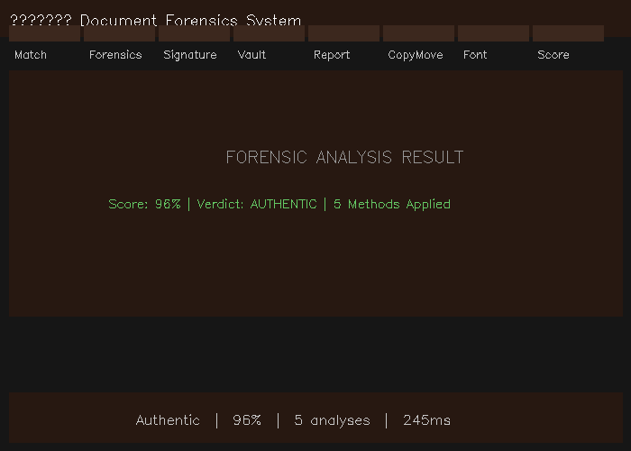
Figure B.1. Professional web interface showing the eight-tab layout with the Forensics (5-method) analysis results.

