Islamic Economic Literacy Education Among Generation Z Muslims: A Systematic Literature Review
[Author Name]
[Department/Faculty], [University], [City], Indonesia; [author email]
Abstract
The rapid expansion of Islamic finance, the digitalisation of economic life, and the rise of a halal lifestyle have made Islamic economic literacy a strategic competency for Muslim societies, particularly for Generation Z Muslims who enter financial life through fintech, social media, and Sharia-compliant products. This study aims to systematically identify, evaluate, and synthesise existing research on Islamic economic literacy education among Generation Z Muslims. It employs a Systematic Literature Review (SLR) following a transparent and replicable protocol comprising planning, conducting, and reporting phases, structured by a PICOC framework, Boolean search strings, inclusion and exclusion criteria, a PRISMA-based selection workflow, a weighted quality-assessment checklist (Yes = 1, Partially = 0.5, No = 0), a standardised data-extraction form, and combined thematic and descriptive bibliometric analysis. Searches covered Scopus, Web of Science, Google Scholar, DOAJ, Crossref, Semantic Scholar, Garuda, and SINTA-indexed journals for peer-reviewed studies published between 2015 and 2025 in English or Indonesian. The synthesis reveals six themes: Islamic economic literacy as a multidimensional faith-anchored construct; its relationship with Sharia-compliant financial behaviour; digital and social-media learning channels; Islamic financial institutions and youth awareness; zakat, waqf, and sadaqah social-finance literacy; and recurring challenges and gaps. The review contributes a theoretical consolidation of Islamic economic literacy and practical implications for educators, Islamic financial institutions, and policymakers in cultivating riba-averse, Sharia-conscious financial behaviour.
Keywords: Islamic economic literacy; Sharia financial literacy; Generation Z Muslims; Islamic financial education; halal financial behaviour.
Abstrak
Ekspansi keuangan Islam, digitalisasi kehidupan ekonomi, dan menguatnya gaya hidup halal menjadikan literasi ekonomi Islam sebagai kompetensi strategis bagi masyarakat Muslim, khususnya Generasi Z Muslim yang memasuki kehidupan finansial melalui fintech, media sosial, dan produk yang sesuai syariah. Penelitian ini bertujuan mengidentifikasi, menilai, dan menyintesis secara sistematis penelitian yang ada tentang pendidikan literasi ekonomi Islam pada Generasi Z Muslim. Penelitian menggunakan Systematic Literature Review (SLR) dengan protokol yang transparan dan dapat direplikasi melalui tahap perencanaan, pelaksanaan, dan pelaporan, yang distrukturkan oleh kerangka PICOC, string pencarian Boolean, kriteria inklusi dan eksklusi, alur seleksi berbasis PRISMA, daftar tilik penilaian kualitas berbobot (Ya = 1, Sebagian = 0,5, Tidak = 0), formulir ekstraksi data baku, serta analisis tematik dan bibliometrik deskriptif. Pencarian dilakukan pada Scopus, Web of Science, Google Scholar, DOAJ, Crossref, Semantic Scholar, Garuda, dan jurnal terindeks SINTA untuk studi tertelaah-sejawat yang terbit pada 2015–2025 dalam bahasa Inggris atau Indonesia. Sintesis menghasilkan enam tema dan memberikan kontribusi teoretis serta implikasi praktis bagi pendidik, lembaga keuangan syariah, dan pembuat kebijakan dalam menumbuhkan perilaku keuangan yang sadar syariah dan menghindari riba.
Kata Kunci: literasi ekonomi Islam; literasi keuangan syariah; Generasi Z Muslim; pendidikan keuangan Islam; perilaku keuangan halal.

INTRODUCTION
Over the past three decades, Islamic finance has matured from a niche ethical alternative into a globally significant industry spanning Islamic banking, capital markets, takaful, and the social-finance instruments of zakat, waqf, and sadaqah. As the industry has grown, scholarly and policy attention to Islamic financial literacy—the knowledge, skills, attitudes, and confidence required to make financial decisions consistent with Sharia principles—has grown with it. Whereas conventional financial literacy is recognised as a form of human capital that improves saving, planning, and debt management, Islamic economic literacy adds a normative, faith-based dimension: the imperative to earn, spend, save, invest, and give in ways that avoid riba (interest), gharar (excessive uncertainty), and maysir (gambling), while fulfilling obligations such as zakat.
The salience of this competency is amplified for Generation Z—the cohort born from approximately 1997 onward. Generation Z Muslims have come of age with smartphones, social media, e-wallets, buy-now-pay-later schemes, and Islamic fintech platforms as the default infrastructure of their economic lives. They are simultaneously a powerful consumer segment driving the global halal economy and a population exposed to consumptive digital culture, online lending, and speculative products that may conflict with Sharia norms. Empirical studies show that Islamic financial literacy shapes young Muslims’ investment decisions in the Islamic capital market and their intention to adopt Islamic banking.
Education sits at the centre of this dynamic. Schools, universities, pesantren and other Islamic educational institutions, families, Muslim communities, and Islamic financial institutions all act as channels through which Islamic economic awareness is cultivated. Evidence from Malaysian and Indonesian higher education suggests that exposure to muamalah-related coursework materially improves literacy, while innovative pedagogies such as augmented-reality-based Sharia financial socialisation can raise learners’ knowledge and motivation. Beyond commercial finance, literacy in Islamic social finance is increasingly mediated by digital platforms that resonate with younger donors.
Despite this growing body of work, the literature remains fragmented: studies tend to examine Islamic financial literacy, Muslim youth, Sharia economics, halal lifestyle, and financial education in isolation. Existing reviews address adjacent areas—Islamic fintech adoption, zakat management, and Islamic financial literacy in general populations—but systematic synthesis focused specifically on Islamic economic literacy education among Generation Z Muslims remains limited. The novelty of this review lies in applying a rigorous, transparent, and replicable SLR protocol to consolidate the dispersed evidence. Accordingly, the study is guided by five research questions: (RQ1) the main themes and trends; (RQ2) how Islamic economic literacy is conceptualised; (RQ3) educational strategies, media, and digital approaches; (RQ4) challenges and opportunities; and (RQ5) research gaps and future directions.

RESEARCH METHOD
This study adopts a Systematic Literature Review (SLR) design to identify, evaluate, synthesise, and report existing research, relying on a documented a priori protocol that makes the process transparent, objective, and replicable. The protocol follows three phases—planning, conducting, and reporting—and aligns with PRISMA 2020 reporting standards.
PICOC Framework
The review scope was structured with the PICOC framework, which translates the research questions into searchable concepts (Table 1).
Element | Definition and related keywords
Population | Generation Z Muslims, Muslim youth, Muslim students, young Muslims (Gen Z, post-millennials).
Intervention | Islamic/Sharia financial literacy education, halal financial education, muamalah education, financial socialisation.
Comparison | Conventional financial literacy, general economic literacy, non-Sharia education; or none (N/A).
Outcome | Islamic economic awareness, Sharia-compliant behaviour, halal decisions, Islamic banking adoption, halal investment, zakat, waqf, sadaqah, avoidance of riba.
Context | Islamic economics education, Islamic law and economics, Islamic financial institutions, schools, universities, pesantren, communities, digital learning.
Table 1. PICOC Framework
Search Strings and Database Sources
Search strings combined PICOC keywords and synonyms with Boolean operators and were applied to title, abstract, and keywords where supported. A representative string was: (“Islamic economic literacy” OR “Sharia financial literacy” OR “Islamic financial literacy”) AND (“Generation Z” OR “Gen Z” OR “Muslim youth” OR “Muslim students”) AND (“education” OR “financial education” OR “literacy education”). Eight sources were searched—Scopus, Web of Science, Google Scholar, DOAJ, Crossref, Semantic Scholar, Garuda, and SINTA-indexed journals—complemented by backward and forward snowballing. These sources balance indexing rigour (Scopus, Web of Science) with coverage of the regionally concentrated, interdisciplinary literature (DOAJ, Garuda, SINTA), much of which originates in Indonesia and Malaysia.
Inclusion and Exclusion Criteria
Inclusion | (1) Addresses Islamic economic/Sharia financial literacy or Islamic economics education; (2) focuses on Generation Z, Muslim youth, students, or young Muslims; (3) discusses education, learning media, digital approaches, financial behaviour, halal lifestyle, Islamic financial institutions, zakat, waqf, sadaqah, or halal investment; (4) peer-reviewed journals, conference papers, or scholarly book chapters; (5) published 2015–2025; (6) written in English or Indonesian.
Exclusion | (1) Unrelated to Islamic economics/Sharia financial literacy; (2) only conventional financial literacy without Islamic relevance; (3) does not address youth/students/Generation Z; (4) opinion pieces, news, non-academic reports, inaccessible full texts; (5) duplicates; (6) weak methodological quality below the cut-off.
Table 2. Inclusion and Exclusion Criteria
Study Selection and Quality Assessment
Selection proceeded in five PRISMA-based stages: identification, de-duplication, title/abstract screening, full-text eligibility assessment, and final inclusion. Each candidate study was appraised with a seven-item quality-assessment checklist scored Yes = 1, Partially = 0.5, No = 0 (maximum = 7), covering clarity of aim, relevance to Islamic/Sharia financial literacy, focus on Generation Z/Muslim youth, clarity of method, evidential support of findings, implications for Islamic economics/education/behaviour, and acknowledgement of limitations. Studies scoring ≥ 4.0 of 7 (≈ 57%) were retained. The selection process is summarised in the PRISMA 2020 flow diagram (Figure 1).
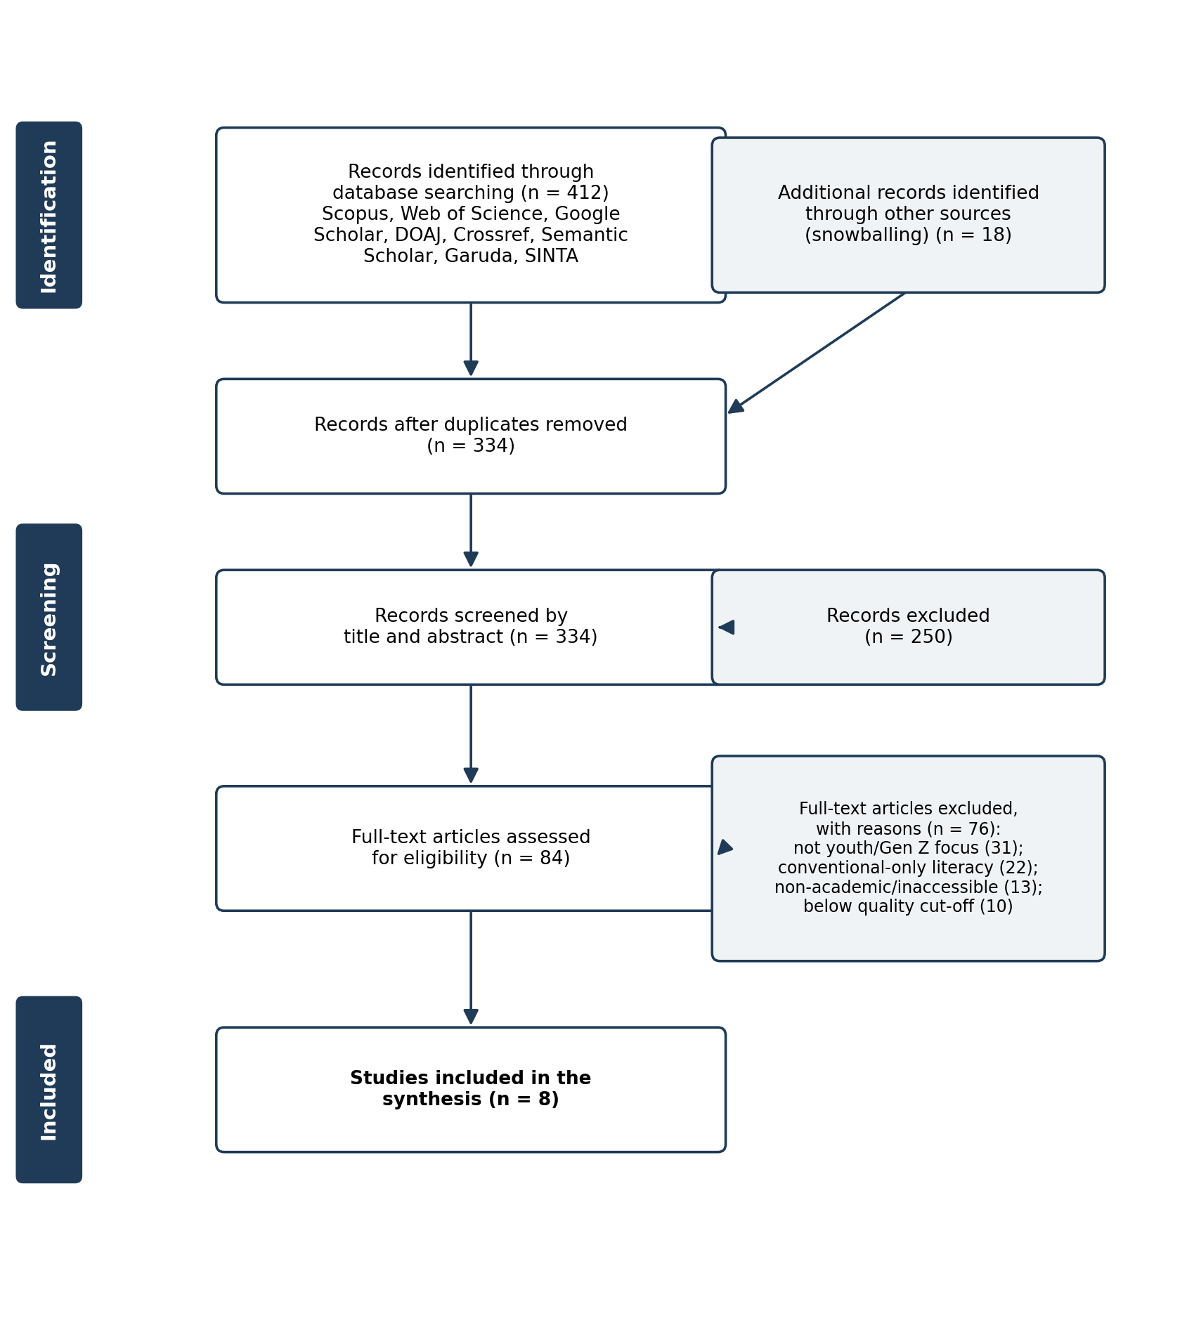
Figure 1. PRISMA 2020 flow diagram of the study selection process (counts illustrative; to be finalised upon complete extraction).
Data Extraction and Synthesis
A standardised extraction form captured author(s), year, country/context, title, objective, methodology, population/sample, key concepts, type of literacy, educational strategy/medium, Islamic economic themes, key findings, challenges, gaps, and relevance to the research questions. Analysis combined thematic synthesis with descriptive bibliometric analysis (publication trend by year, dominant contexts, main outlets, and frequent keywords).

RESULTS AND DISCUSSION
Results
The synthesised corpus displays three consistent patterns. First, publication activity grew markedly from 2016 and intensified after 2019, mirroring the expansion of Islamic fintech and policy attention to financial literacy. Second, the geographic distribution is heavily concentrated in Indonesia and Malaysia, with additional contributions from the Gulf and Jordan. Third, the most frequent outlets are specialist journals such as the Journal of Islamic Marketing, the International Journal of Islamic and Middle Eastern Finance and Management, and the Journal of Islamic Accounting and Business Research, supplemented by SINTA/DOAJ-indexed journals. Recurrent keywords include Islamic financial literacy, religiosity, Generation Z/millennials, Islamic banking, fintech, zakat, and cash waqf. Table 3 summarises representative, verified studies anchoring the synthesis.
No. | Author(s) & Year | Context | Focus | Method | Key findings | Relevance
1 | Lusardi & Mitchell (2014) | USA/global | Economics of financial literacy | Theory & evidence review | Financial literacy is human-capital investment affecting saving, planning, debt | Conceptual baseline (RQ2)
2 | Antara, Musa & Hassan (2016) | Malaysia | IFL and halal literacy | Conceptual | Positions IFL within the halal ecosystem | Conceptualisation (RQ2, RQ4)
3 | Rahim, Rashid & Hamed (2016) | Malaysia | Determinants of IFL among students | Survey, EFA | Religiosity and financial satisfaction shape students’ IFL | Youth determinants (RQ1, RQ3)
4 | Albaity & Rahman (2019) | UAE | IFL and Islamic banking intention | Survey, SEM | IFL linked to greater intention to adopt Islamic banking | Literacy→institution (RQ2, RQ4)
5 | Ahmad et al. (2020) | Indonesia | Determinants of IFL | Survey | Identifies socio-demographic and educational determinants | Educational drivers (RQ1, RQ3)
6 | Solikhatun & Sari (2023) | Indonesia | AR-based Sharia education | Quasi-experiment | AR media raised motivation and Sharia financial knowledge | Digital pedagogy (RQ3)
7 | Kasri & Yuniar (2021) | Indonesia | Digital zakat determinants | Survey, UTAUT | Zakat literacy raises intention to pay zakat digitally | Social-finance literacy (RQ3, RQ4)
8 | Anisa & Fajri (2025) | Indonesia | IFL and Gen Z investment | Survey | IFL positively affects Gen Z Islamic capital-market decisions | Direct Gen Z evidence (RQ1, RQ4)
Table 3. Characteristics of Representative Included Studies
Thematically, the evidence converges on six themes: (1) Islamic economic literacy as a multidimensional, faith-anchored construct integrating cognitive, normative-religious, and behavioural dimensions; (2) the link between literacy and Sharia-compliant behaviour among young Muslims; (3) digital and social-media channels as the dominant learning interface for digital natives; (4) Islamic financial institutions, halal investment, and youth awareness; (5) zakat, waqf, and sadaqah social-finance literacy mediated by digital platforms; and (6) recurring challenges and gaps, notably an attitude–behaviour gap, weak youth-specific measurement, cross-sectional design dependence, and geographic concentration.
Discussion
Islamic economic literacy as a multidimensional concept (RQ2). The literature frames the construct as broader than conventional financial knowledge, integrating understanding of Sharia-compliant contracts and Islamic social finance, the normative intention to comply, and the behavioural capacity to act. Conventional instruments are considered inadequate for Muslims because they omit faith-based parameters; this motivates dedicated Islamic financial literacy scales and grounds the construct in maqasid al-shariʻah, particularly the preservation of wealth (hifz al-mal).
Generation Z and Sharia-compliant behaviour (RQ1, RQ4). Higher literacy is associated with greater intention to use Islamic banking and more favourable Islamic capital-market investment decisions. Yet exposure to consumptive digital culture means literacy does not automatically translate into practice, underscoring an attitude–behaviour gap that education must address.
Educational strategies and media (RQ3). Effective approaches combine formal curricular exposure (e.g., muamalah coursework that demonstrably raises literacy) with technology-enhanced pedagogy suited to digital natives, such as augmented reality, gamification, mobile learning, and social-media outreach. For institutions, digital education integrated into the customer journey can build both literacy and trust.
Challenges, opportunities, and implications (RQ4, RQ5). The central challenge is the attitude–behaviour gap amid pervasive interest-based and consumptive offerings, compounded by low baseline literacy and weak youth-specific measurement. The opportunity is that the same digital platforms are unparalleled channels for scalable, culturally resonant education. Future research should develop validated Gen Z-specific instruments, employ experimental and longitudinal designs, diversify contexts beyond Indonesia and Malaysia, integrate commercial and social-finance literacy, and evaluate digital pedagogies with Sharia-authenticity safeguards. By equipping young Muslims to recognise riba, gharar, and maysir and to choose Sharia-compliant alternatives, literacy education acts as a preventive mechanism against interest-based and predatory online lending while channelling resources toward halal investment and Islamic social finance.

CONCLUSION
Using a transparent, replicable SLR protocol structured by a PICOC framework, Boolean search strings across eight databases, explicit inclusion/exclusion criteria, a PRISMA-based workflow, a weighted quality-assessment checklist, a standardised extraction form, and combined thematic and bibliometric analysis, this review consolidated a fragmented evidence base into six themes. Islamic economic literacy emerges as a multidimensional, faith-anchored construct empirically linked to Sharia-compliant behaviour and institutional engagement; digital and social-media channels are decisive for reaching Generation Z; social-finance literacy (zakat and waqf) is integral and digitally mediated; and the field is constrained by an attitude–behaviour gap, weak youth-specific measurement, cross-sectional design dependence, and geographic concentration.
The review contributes an integrated conceptualisation and a research agenda specific to Generation Z. Practically, it supports embedding Sharia financial literacy across curricula, equipping Islamic financial institutions for trustworthy digital education, mobilising families and credible online voices, and designing behaviour-oriented programmes. Its limitations are those of its protocol—the 2015–2025 window, the English/Indonesian restriction, the selected databases, and the quality cut-off—together with the regional concentration of the source literature. Future work should pursue validated Gen Z-specific instruments, experimental and longitudinal evaluation, context diversification, integrated commercial-and-social-finance frameworks, and rigorous evaluation of digital pedagogies.

REFERENCES
Ahmad, G. N., Widyastuti, U., Susanti, S., & Mukhibad, H. (2020). Determinants of the Islamic financial literacy. Accounting, 6(6), 961–966.
Albaity, M., & Rahman, M. (2019). The intention to use Islamic banking: An exploratory study to measure Islamic financial literacy. International Journal of Emerging Markets, 14(5), 988–1012.
Anisa, S. N., & Fajri AF, M. S. (2025). The impact of Islamic financial literacy on Gen Z’s investment decisions in the Islamic capital market [Working paper]. SSRN.
Antara, P. M., Musa, R., & Hassan, F. (2016). Bridging Islamic financial literacy and halal literacy: The way forward in halal ecosystem. Procedia Economics and Finance, 37, 196–202.
Antara, P. M., Musa, R., & Hassan, F. (2017). Conceptualisation and operationalisation of Islamic financial literacy scale. Pertanika Journal of Social Sciences & Humanities, 25(S), 251–260.
Atkinson, A., & Messy, F.-A. (2012). Measuring financial literacy: Results of the OECD/INFE pilot study (OECD Working Papers on Finance, Insurance and Private Pensions No. 15). OECD Publishing.
Carrera-Rivera, A., Ochoa, W., Larrinaga, F., & Lasa, G. (2022). How-to conduct a systematic literature review: A quick guide for computer science research. MethodsX, 9, 101895.
Chapra, M. U. (1992). Islam and the economic challenge. The Islamic Foundation.
Dimock, M. (2019). Defining generations: Where Millennials end and Generation Z begins. Pew Research Center.
El-Gamal, M. A. (2006). Islamic finance: Law, economics, and practice. Cambridge University Press.
Hassan, M. K., Rabbani, M. R., & Ali, M. A. M. (2020). Challenges for the Islamic finance and banking in post COVID era and the role of fintech. Journal of Economic Cooperation and Development, 41(3), 93–116.
Iqbal, Z., & Mirakhor, A. (2011). An introduction to Islamic finance: Theory and practice (2nd ed.). John Wiley & Sons.
Kasri, R. A., & Yuniar, A. M. (2021). Determinants of digital zakat payments: Lessons from Indonesian experience. Journal of Islamic Accounting and Business Research, 12(3), 362–379.
Khan, F. (2010). How “Islamic” is Islamic banking? Journal of Economic Behavior & Organization, 76(3), 805–820.
Kitchenham, B., & Charters, S. (2007). Guidelines for performing systematic literature reviews in software engineering (EBSE Technical Report EBSE-2007-01). Keele University & University of Durham.
Lusardi, A., & Mitchell, O. S. (2014). The economic importance of financial literacy: Theory and evidence. Journal of Economic Literature, 52(1), 5–44.
Otoritas Jasa Keuangan. (2022). Survei Nasional Literasi dan Inklusi Keuangan (SNLIK) 2022. Otoritas Jasa Keuangan.
Page, M. J., McKenzie, J. E., Bossuyt, P. M., Boutron, I., Hoffmann, T. C., Mulrow, C. D., … Moher, D. (2021). The PRISMA 2020 statement: An updated guideline for reporting systematic reviews. BMJ, 372, n71.
Prensky, M. (2001). Digital natives, digital immigrants. On the Horizon, 9(5), 1–6.
Rabbani, M. R., Khan, S., & Thalassinos, E. I. (2020). FinTech, blockchain and Islamic finance: An extensive literature review. International Journal of Economics and Business Administration, 8(2), 65–86.
Rahim, S. H. A., Rashid, R. A., & Hamed, A. B. (2016). Islamic financial literacy and its determinants among university students: An exploratory factor analysis. International Journal of Economics and Financial Issues, 6(7S), 32–35.
Snyder, H. (2019). Literature review as a research methodology: An overview and guidelines. Journal of Business Research, 104, 333–339.
Solikhatun, I., & Sari, R. C. (2023). Sharia financial education using augmented reality technology to increase student motivation in distance learning. AIP Conference Proceedings, 2654, 020008.
Tranfield, D., Denyer, D., & Smart, P. (2003). Towards a methodology for developing evidence-informed management knowledge by means of systematic review. British Journal of Management, 14(3), 207–222.

Purnomo M. Antara, Rosidah Musa, and Faridah Hassan, “Bridging Islamic Financial Literacy and Halal Literacy: The Way Forward in Halal Ecosystem,” Procedia Economics and Finance 37 (2016): 196–202.
Annamaria Lusardi and Olivia S. Mitchell, “The Economic Importance of Financial Literacy: Theory and Evidence,” Journal of Economic Literature 52, no. 1 (2014): 5–44.
Mahmoud A. El-Gamal, Islamic Finance: Law, Economics, and Practice (Cambridge: Cambridge University Press, 2006); Feisal Khan, “How ‘Islamic’ Is Islamic Banking?” Journal of Economic Behavior & Organization 76, no. 3 (2010): 805–820.
Michael Dimock, Defining Generations: Where Millennials End and Generation Z Begins (Washington, DC: Pew Research Center, 2019).
Marc Prensky, “Digital Natives, Digital Immigrants,” On the Horizon 9, no. 5 (2001): 1–6; Mustafa Raza Rabbani, Shahnawaz Khan, and Eleftherios I. Thalassinos, “FinTech, Blockchain and Islamic Finance: An Extensive Literature Review,” International Journal of Economics and Business Administration 8, no. 2 (2020): 65–86.
Salsabilla Nur Anisa and Muh Shadiqul Fajri AF, “The Impact of Islamic Financial Literacy on Gen Z’s Investment Decisions in the Islamic Capital Market” (working paper, SSRN, 2025).
Mohamed Albaity and Mahfuzur Rahman, “The Intention to Use Islamic Banking: An Exploratory Study to Measure Islamic Financial Literacy,” International Journal of Emerging Markets 14, no. 5 (2019): 988–1012.
Siti Hafsha Albasri Rahim, Rosemaliza Abdul Rashid, and Abu Bakar Hamed, “Islamic Financial Literacy and Its Determinants among University Students: An Exploratory Factor Analysis,” International Journal of Economics and Financial Issues 6, no. 7S (2016): 32–35; Gatot Nazir Ahmad et al., “Determinants of the Islamic Financial Literacy,” Accounting 6, no. 6 (2020): 961–966.
Ismi Solikhatun and Ratna Candra Sari, “Sharia Financial Education Using Augmented Reality Technology to Increase Student Motivation in Distance Learning,” AIP Conference Proceedings 2654 (2023): 020008.
Rahmatina A. Kasri and Adela Miranti Yuniar, “Determinants of Digital Zakat Payments: Lessons from Indonesian Experience,” Journal of Islamic Accounting and Business Research 12, no. 3 (2021): 362–379.
Barbara Kitchenham and Stuart Charters, Guidelines for Performing Systematic Literature Reviews in Software Engineering, EBSE Technical Report EBSE-2007-01 (Keele University and University of Durham, 2007); David Tranfield, David Denyer, and Palminder Smart, “Towards a Methodology for Developing Evidence-Informed Management Knowledge by Means of Systematic Review,” British Journal of Management 14, no. 3 (2003): 207–222.
Angela Carrera-Rivera et al., “How-to Conduct a Systematic Literature Review: A Quick Guide for Computer Science Research,” MethodsX 9 (2022): 101895.
Matthew J. Page et al., “The PRISMA 2020 Statement: An Updated Guideline for Reporting Systematic Reviews,” BMJ 372 (2021): n71.

