Electric Drive Laboratory Report



------------------------------------------------------------------

DC machine

------------------------------------------------------------------

Jingyang Wang 0900085786

University of Bologna

Automation Engineering

Chapter one

Overview

* 1. The scheme of the system

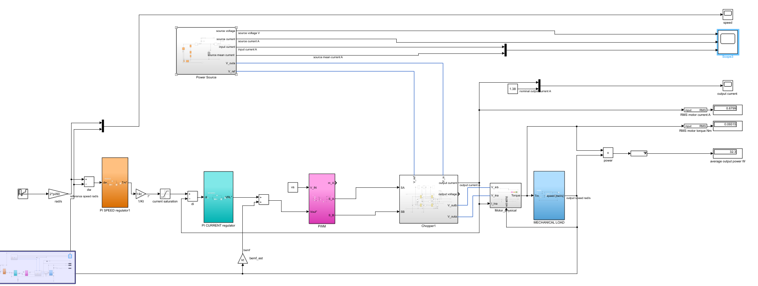

Fig1. 1.1 The scheme of the whole system

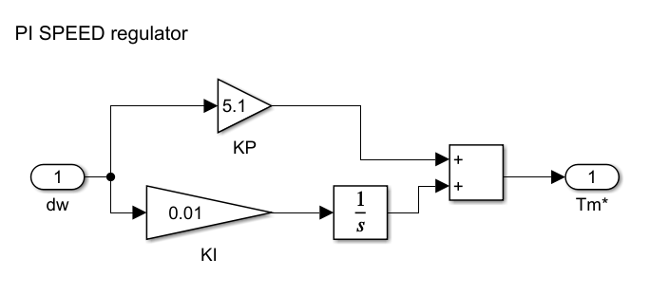

Fig1.1.2 The scheme of the speed regulator

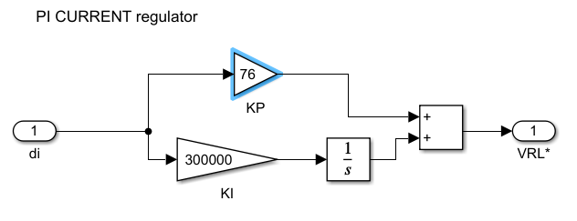

Fig1. 1.3 The scheme of the current regulator

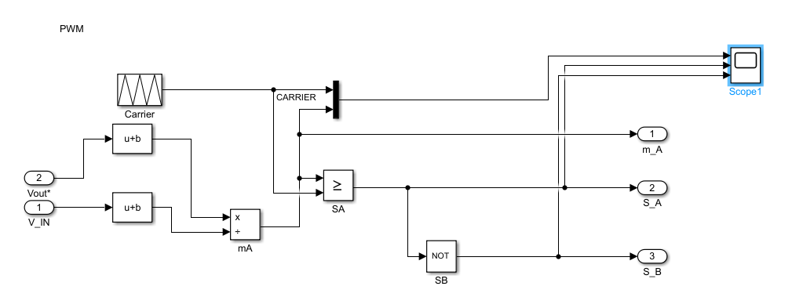

Fig1. 1.4 The scheme of the PWM subsystem

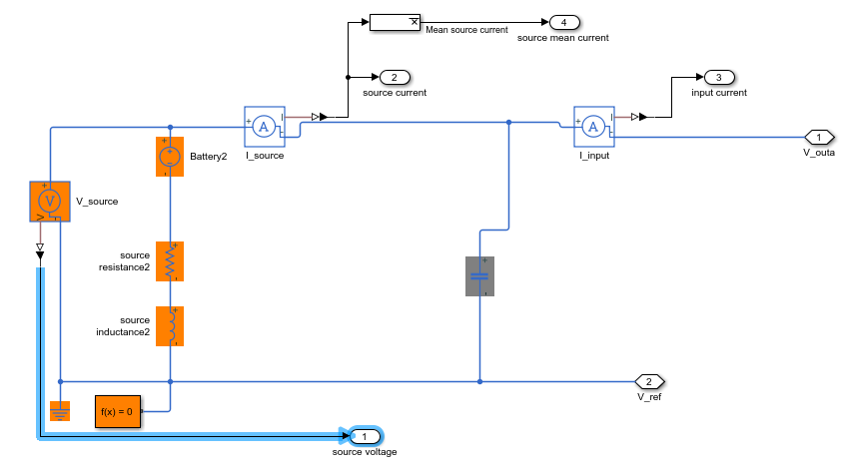

Fig1. 1.5 The scheme of the power source subsystem

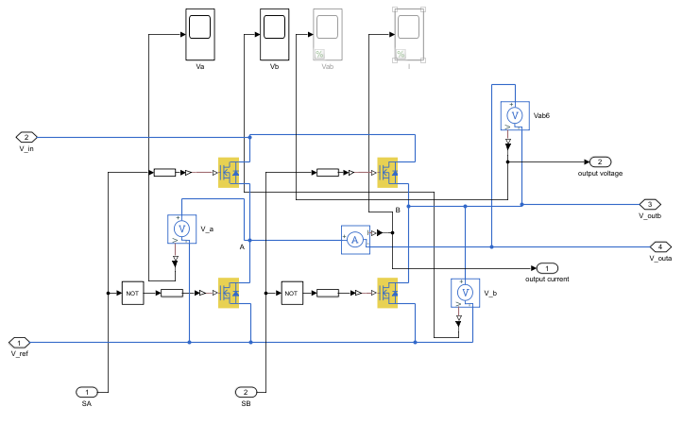

Fig1. 1.6 The scheme of the Chopper subsystem

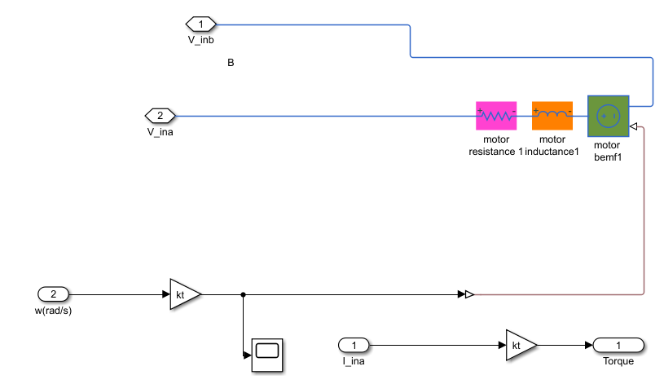

Fig1. 1.7 The scheme of the Motor subsystem

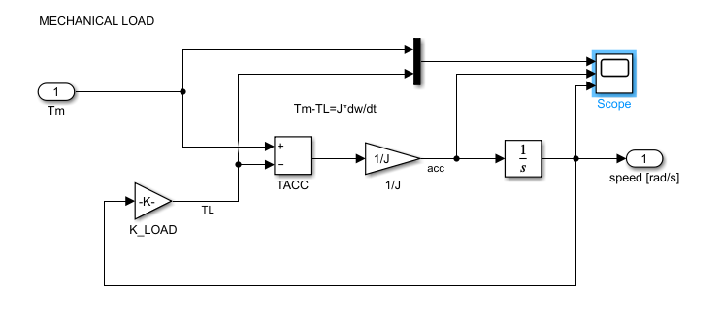 Fig1. 1.8 The scheme of the Load subsystem

* 1. Parameters

|  |  |  |  |
| --- | --- | --- | --- |
| fsw(PWM) | 1e+06HZ | Kt(torque) | 0.137 |
| r(motor) | 6.61Ohm | Ks(speed) | 70 |
| l(motor) | 1.7E-03 | J(total) | 1.83e-05Nm |
| torqueSlope | 2.646E-04Nm/s | ls(source) | 0.72mH |
| vs(source) | 72V | periodDuty | 1s |
| rs(source) | 0.72Ohm | MaxCurrent | 2.8A |

Table1.2.1 Parameters in plant

|  |  |
| --- | --- |
| Speed regulator | Current regulator |
| P: 5.1 | P: 76 |
| I: 0.01 | I: 300000 |

Table1.2.2 Parameters in regulator

Chapter two

Performance

* 1. Numerical output

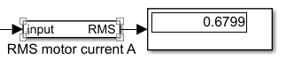

Fig2.1.1 The RMS output current in period duty

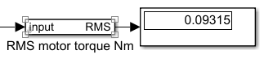

Fig2.1.2 The RMS output torque in period duty

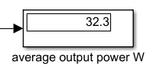

Fig2.1.3 The RMS power in period duty

* 1. Scope output

2.2.1 Output current ripple at high frequency in steady state operation:

Ipk-pk/IOUT_nominal            <10%

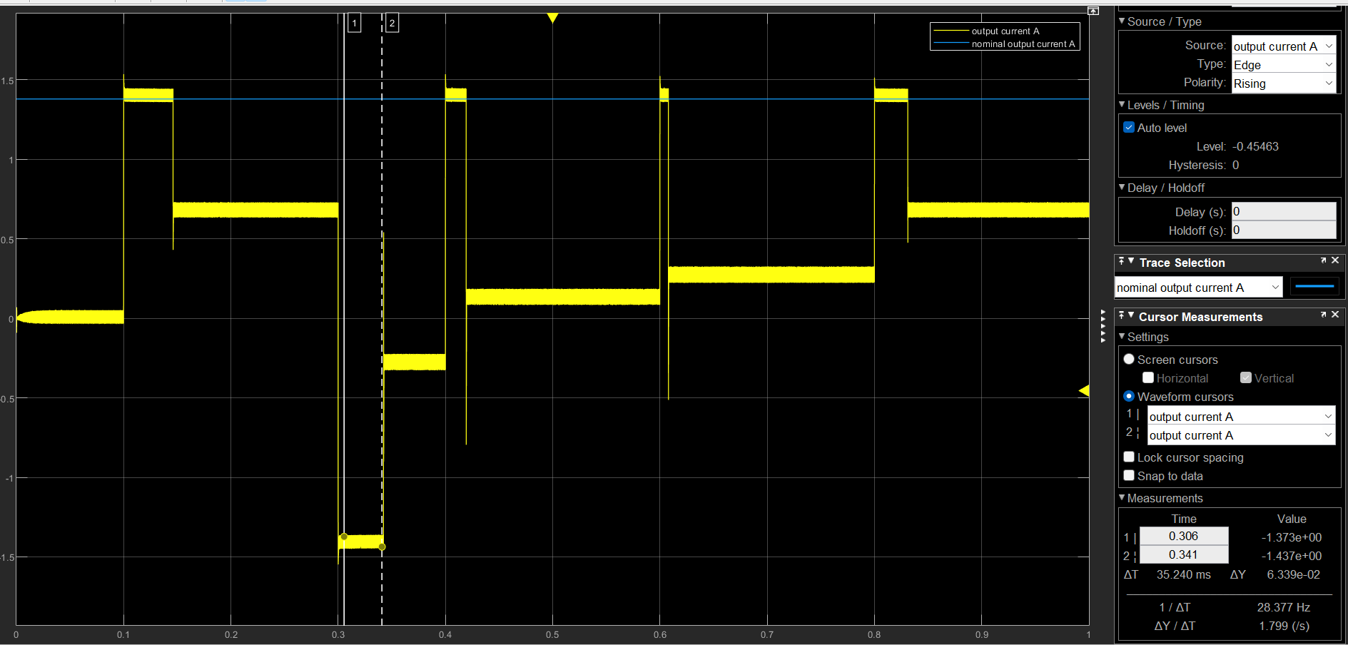

Fig2.2.1.1 Output current vs. Nominal current

We can find the pk-pk osillation is around 6.34e-02(A), less than 10% IOUT_nominal(1.38 A)

2.2.2 Input current ripple at high frequency in steady state operation

Ipk-pk/ISOURCE_mean <1%

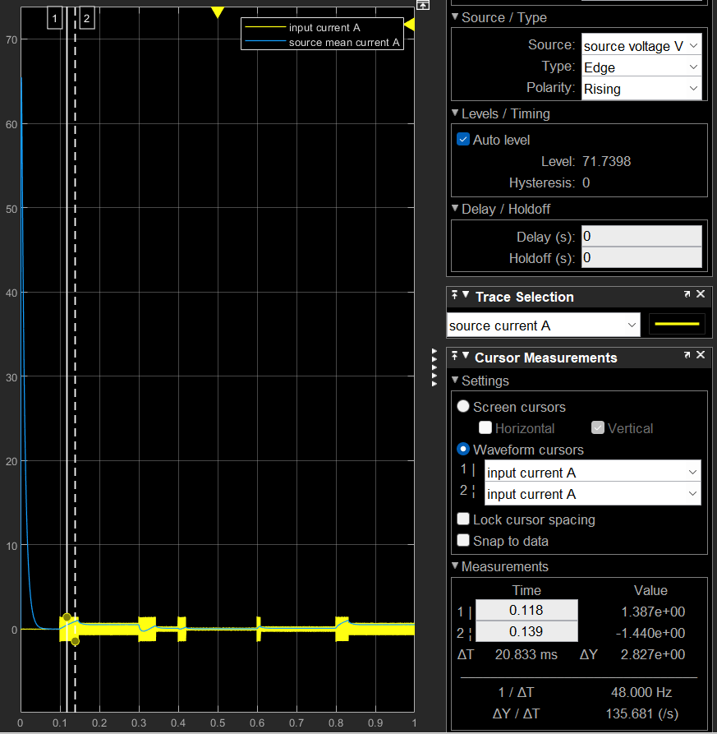

Fig2.2.2.1 input current vs. mean source current

2.2.3 Speed range of stable operation

-125% to 125% of nominal speed

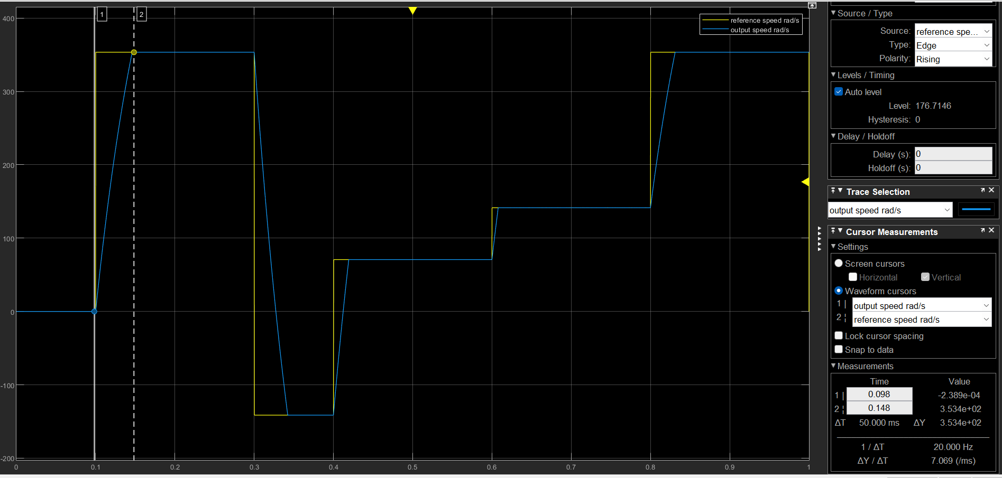

Fig2.2.3.1 Output speed vs. reference speed

When the motor is running in the steady state, the speed range is -158.9rad/s to 355.6rad/s(125% Nominal speed).

2.2.4 Load current lower than the converter max output current in any operating condition



Fig2.2.4.1 Load current vs. Nominal current

The load current is lower than convertor’s max output current 2.8A.

2.2.5 Speed overshoot with the reference graph < 1%

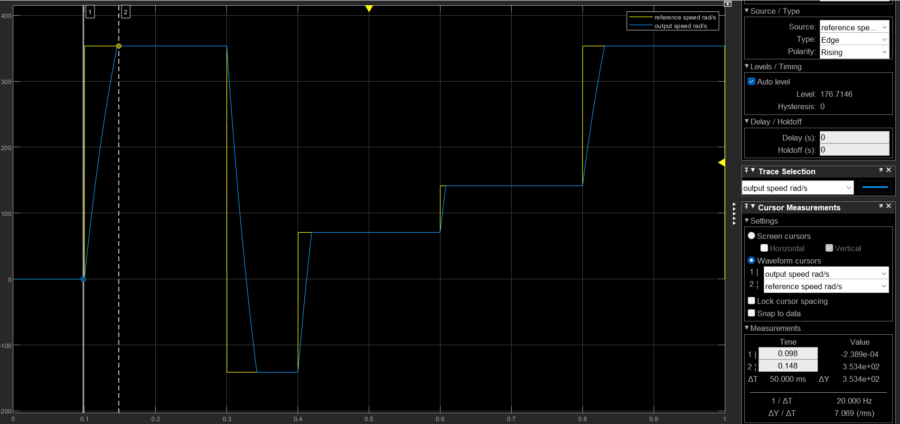

Fig2.2.5.1 Output speed vs. reference speed

2.2.6 Rise time with the reference graph. <100ms



Fig2.2.6.1 Output speed vs. reference speed

The max rise time is around 50 ms

2.2.7 Steady state speed error with the references graph < 1%

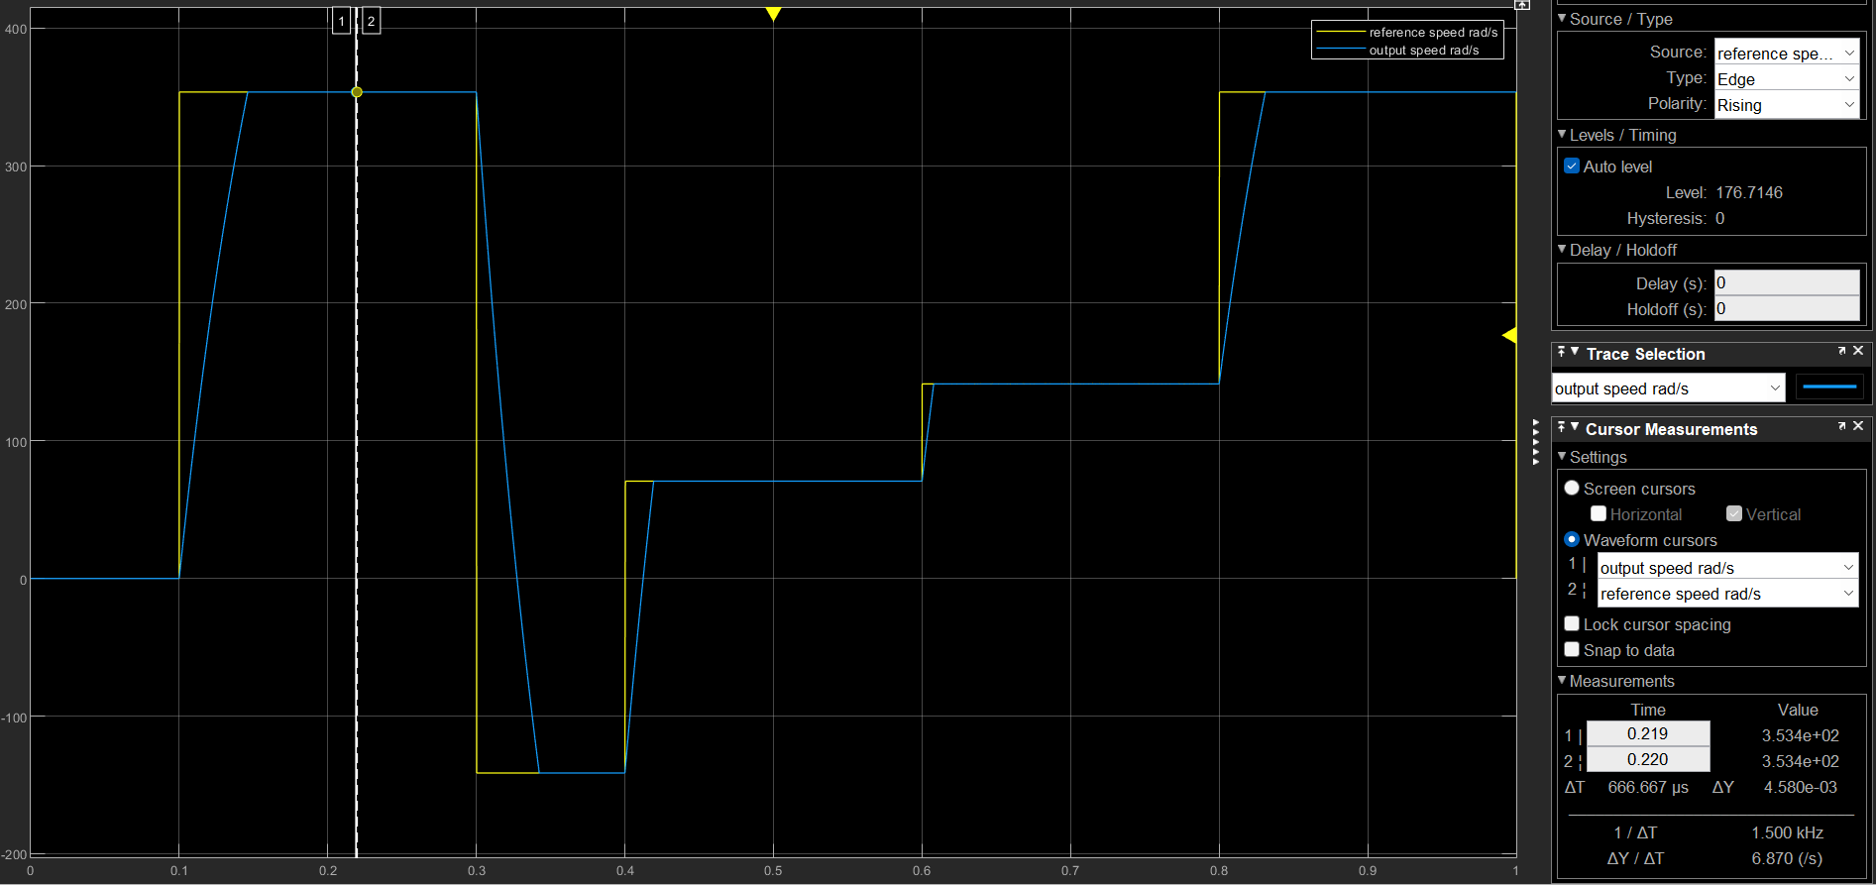

Fig2.2.7.1 Output speed vs. reference speed

The steady state error is 4.58e-03 rad/s

* 1. Table summary

|  |  |  |  |
| --- | --- | --- | --- |
|  | Parameters | Units | Value |
| 9.1 | RMS motor torque | N.m | 0.09315 |
| 9.2 | RMS motor current | A | 0.6799 |
| 9.3 | RMS output power | W | 32.3 |
| 9.4 | RIPPLE OF OUTPUT CURRENT | / | <4.59% |
| 9.5 | RIPPLE OF INPUT CURRENT | / | N |
| 9.6 | SPEED RANGE | / | -125% - 125% |
| 9.7 | LESS THAN MAX CURRENT | A | SATISIFIED |
| 9.8 | SPEED OVERSHOOT | / | NULL |
| 9.9 | RISE TIME | ms | MAX IS 50 |
| 9.10 | TRACKING ERROR | / | <1% |

Attention:

For tuning the parameters:

1. Theoratical Calculation

Current Regulator:

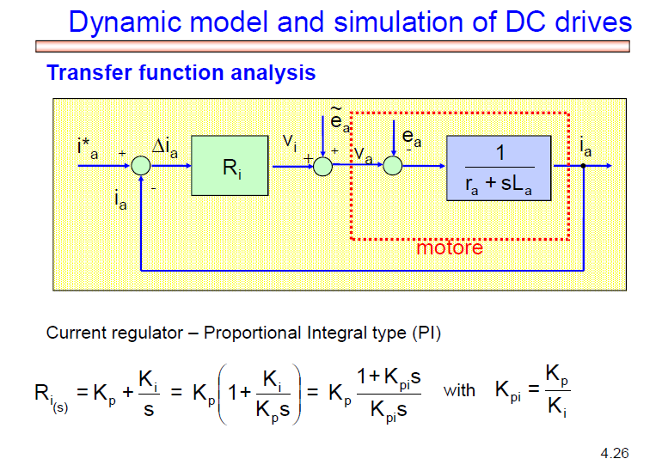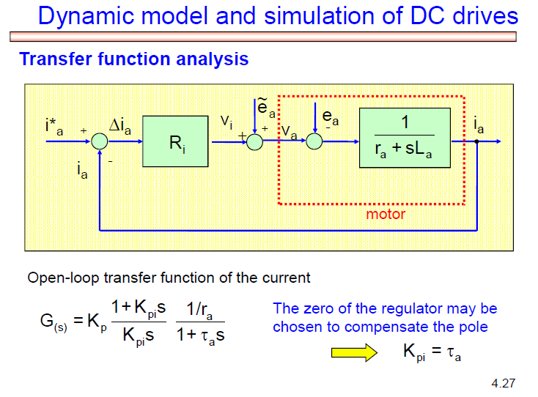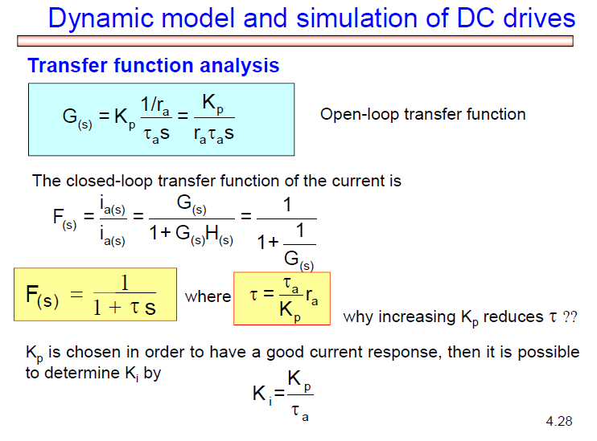

As fot Speed Regulator, there is also the transfer function to tune the parameters. But the inner loop is enough to achieve the purpose and just choose a pair of gains you want for speed loop.

1. Use Script for tuning.

That should be uploaded to the github.(Jason Irayshon)

For choosing the fsw:  
Fix step simulation: Sampling pricinple should be considered

I choose the half of the fsw as the step, the result won’t be strongly affected, because of the PWM block.

