{#students}

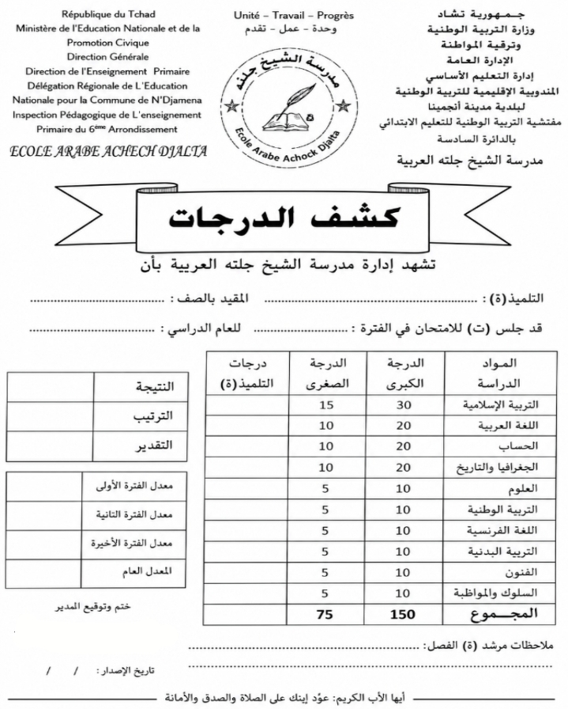
{name}

{%pageBreak}
{/students}

