Final Year Project Proposal
FAST School of Computing | National University of Computer and Emerging Sciences

Project Metadata
Project Title: Localized Offline Urdu (Nastaliq) Handwritten Ledger Digitization and Automated Auditing Platform
Declared Stream: Stream B (Application-Derived)
Primary SDG Alignment: SDG 8 (Decent Work & Economic Growth) and SDG 9 (Industry, Innovation, and Infrastructure). This system strengthens local enterprise productivity by digitizing traditional accounting workflows without compromising commercial confidentiality.
Group Members: Irbaz Ali 23i-2075, Talal Shahid 23i-0594, Muhammad Ibarhim 23i-2533
Supervisor: Sir Irfanullah

1. Problem Statement & Operational Context
In Pakistani wholesale markets, millions of daily commercial transactions are recorded manually in physical registers (Khatas) using cursive handwritten Urdu (Nastaliq). While functional on-site, this manual record-keeping creates severe operational bottlenecks, high error rates in debit/credit tallies, and limits business scalability.
Crucially, commercial merchants and informal sector dealers routinely reject cloud-based SaaS accounting tools due to strict data-sovereignty concerns, fearing third-party data aggregation or exposure to external tax authorities.
The Core Problem: There is currently no software solution capable of ingesting images of handwritten Urdu ledger pages, automatically segmenting tabular entries, routing statistical recognition uncertainties through a Human-in-the-Loop (HITL) review gate, and performing mathematical self-auditing—all executing strictly within a zero-cloud, offline local deployment environment.

1.1 Target Data Format (Physical Khata)
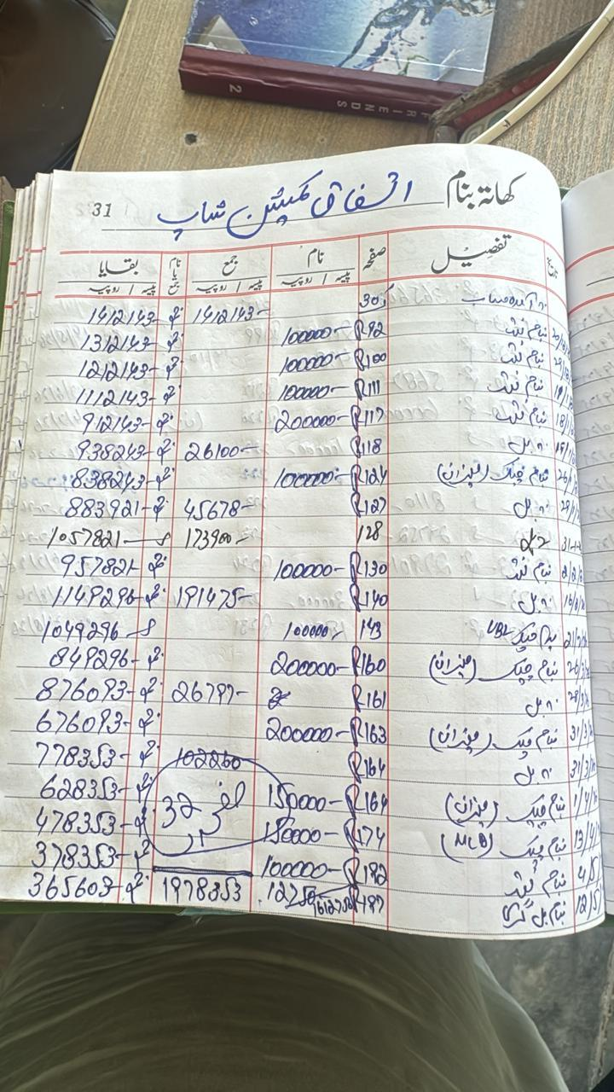
Figure 1: Representative sample of an unconstrained handwritten Urdu commercial ledger showing faded ink, curved pages, and manual crossings—proving standard OCR will fail.

2. Solution Landscape & Gap Analysis
This project is grounded in a structural comparison across commercial products and generic APIs:
Existing Solution | Core Technical Approach | Evidenced Limitations / Failure Modes | Implication for This Project
Local Khata Apps (EasyKhata, Udhaar) | Manual CRUD data entry; centralized cloud database. | Zero OCR automation; requires 100% manual typing. Uploads private turnover records to cloud servers. | We automate the input layer while retaining 100% offline data sovereignty.
Cloud OCR APIs (Google Vision, AWS) | Generalized deep learning OCR hosted in the cloud. | Nastaliq accuracy drops <60%; outputs unstructured plain text blocks without tabular debit/credit relationships. | We utilize domain-constrained sequence modeling with tabular cell segmentation.
Enterprise ERPs (QuickBooks, SAP) | Rule-based financial reconciliation; standard Latin OCR. | Incompatible with cursive Nastaliq and unstructured Pakistani ledger layouts. | Custom-engineered for regional register structures and bookkeeping habits.

3. Complex Computing Problem (CCP) Justification
This project meets the requirements of a Complex Computing Problem under the Seoul Accord and FAST guidelines:
- Conflicting Requirements: The system must balance the compute-heavy demands of sequence-based neural networks with the strict constraint of executing locally on standard merchant hardware without external cloud APIs.
- Beyond Standard Practice: Unlike horizontal Latin text, handwritten Nastaliq features diagonal ligatures and vertical character stacking. Off-the-shelf OCR frameworks fail completely; solving this requires custom image preprocessing and statistical confidence modeling.
- Zero-Defect Financial Integrity (Significant Consequences): Financial audits cannot tolerate OCR hallucinations. We introduce a deterministic confidence gate that routes uncertain predictions to a rapid HITL UI before ledger mutation occurs.
- Infrequent Issues (Row-Level Security): To prevent internal tampering by bookkeepers (Munshis), the system utilizes row-level HMAC cryptographic signatures and append-only database triggers, creating a tamper-evident audit trail without a full blockchain.

4. Proposed Architecture & Data Flow
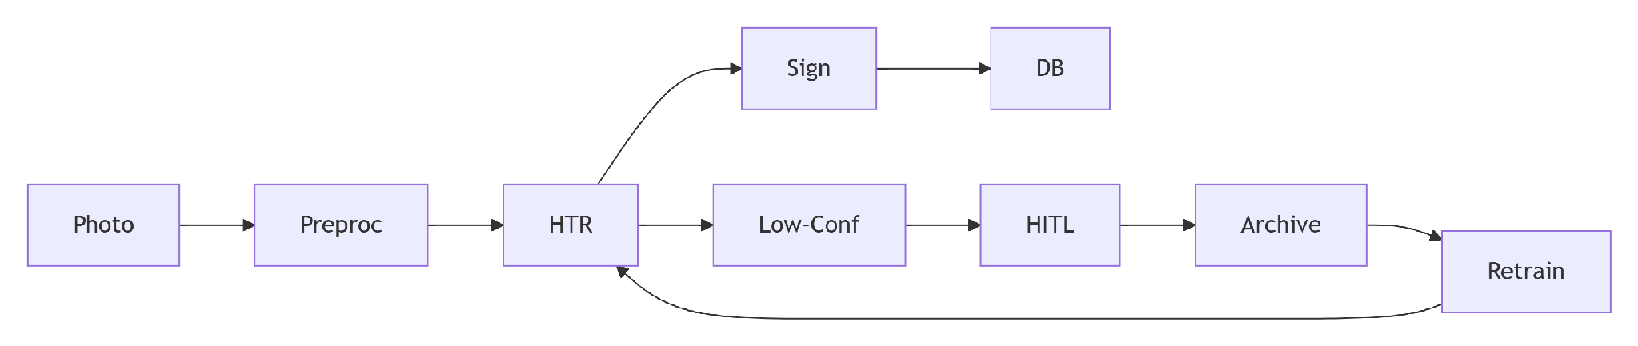
Figure 2: System architecture demonstrating the offline-first pipeline, from OpenCV preprocessing and TrOCR extraction to the HITL confidence gate, HMAC signing, and continuous retraining loop.

5. Dependency Classification & Contribution
To satisfy university dependency and ownership policies, all components are classified as follows:
- Support Components: Docker, PostgreSQL, Next.js, FastAPI, OpenCV. (Supplies boilerplate; no student CCP claims made here).
- Core-Assist Components: Pre-trained TrOCR/CRNN base weights (Hugging Face). (Supplies baseline feature extraction).
- Core-Replacement Components: None. (No closed-source commercial APIs are used to solve the core problem).
Formal Contribution Statement: We contribute an offline-first financial digitization pipeline combining perspective-invariant Urdu tabular segmentation, domain-constrained HTR, cryptographic row-level HMAC security, and a confidence-gated HITL verification mechanism that continuously adapts to individual handwriting styles through local transfer learning.

6. Proposal-Stage Proof of Concept (POC)
To fulfill the Gate 1 approval condition, the group will present the following technical spike at the proposal defense:
- Risk Tested: Generic open-source OCR models fail catastrophically on un-flattened, skewed photographs of handwritten Nastaliq ledgers.
- Evidence to Present: A comparative run feeding the image WhatsApp Image 2026-08-31 at 11.53.52 AM.jpeg into standard OCR (showing garbage output) versus an OpenCV-preprocessed pipeline showing deskewed, isolated tabular bounding boxes, justifying the need for targeted preprocessing and HITL confidence routing.

7. Evaluation & User Acceptance Testing (UAT) Plan
- Quantitative Metrics: Character Error Rate (CER) and Word Error Rate (WER) across financial columns; Confidence-Rejection Calibration (verifying the threshold accurately catches 98%+ of misread entries).
- End-to-End Task Completion Time: Total minutes required to scan, verify, and commit a 50-row ledger page versus pure manual entry.
- UAT (Acceptance): Supervised sessions conducted with local wholesale shopkeepers utilizing real register samples to measure user fatigue and error recovery speed in the review UI.

8. RAID Register (Risks, Assumptions, Issues, Dependencies)
Type | Description | Impact | Mitigation Strategy
Risk | Column Misalignment: CV pipeline might mix up Debit/Credit columns due to missing lines. | High | Enforce strict OpenCV vertical contour mapping to lock spatial coordinates.
Risk | HITL User Fatigue: Flagging too many entries will exhaust the user. | High | Implement a continuous fine-tuning worker to rapidly learn the specific user's handwriting, reducing the HITL trigger rate over time.
Risk | Munshi Access Overreach: Bookkeepers have owner-level access, creating risks of internal tampering. | High | Implement strict Role-Based Access Control (RBAC) paired with cryptographic Row-Level HMAC and append-only audit logs.
Risk | Entity Resolution: Name variations (e.g., M. Ali vs Muhammad Ali) create duplicate accounts. | Medium | Implement an Alias Mapping table so operators can link variations to a primary ID.
Dependency | Offline Edge Compute: AI requires local compute power to run without cloud APIs. | Medium | Use lightweight, quantized HTR architectures optimized for standard hardware.

9. Team Ownership & Two-Semester Timeline
Primary Responsibilities:
- Member 1 (CV & Machine Learning): OpenCV image preprocessing (perspective correction, binarization, segmentation), CRNN/TrOCR sequence modeling, and confidence scoring algorithms.
- Member 2 (Full-Stack & HITL Engine): Next.js user interface, high-throughput verification workflow, FastAPI backend orchestration, and Role-Based Access Control (RBAC) implementation.
- Member 3 (Database, Audit Logic & Security): PostgreSQL schema design, double-entry balancing engine, Row-Level HMAC cryptography implementation, continuous fine-tuning worker, and Docker deployment.
High-Level Milestones:
- Proposal Defense (Gate 1): Feasibility spike shown (OpenCV preprocessing & baseline OCR failure analysis).
- Mid-1 (Gates 2 & 3): SRS & SDS baselined; tabular cell segmentation and base HTR model trained.
- Final-1 (Core Build Accepted): End-to-end working core (Image -> HTR -> Basic HITL UI -> DB Commit).
- Mid-2 (Gate 4): Automated audit engine and HMAC security integrated; local fine-tuning pipeline active.
- Final-2 (Gate 5): Complete containerized deployment; formal UAT completed; final engineering report.

