Protues中单片机驱动lcd12864液晶显示屏仿真：

Protues中lcd12864是无字库的，要让它显示一个数字或者汉字或者图片，都需要先对其取模。那么首先介绍介绍一款比较好用的取模软件，百度搜索“zimoV2.2”就可以了。下面先介绍这个取模软件的使用方法：
1.打开软件，界面如下：
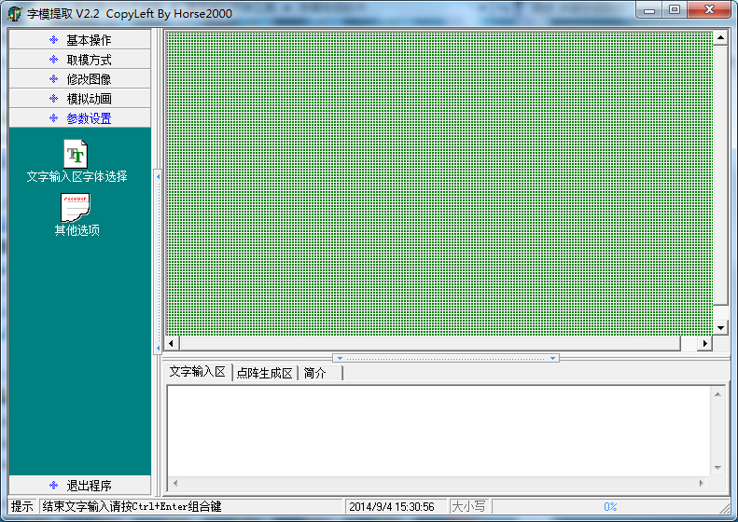
- 通常我们显示汉字用的是16×16的像素大小，而显示数字用的是16×8的格式，那么选择文字输入区字体选择，弹出的界面选择如下：
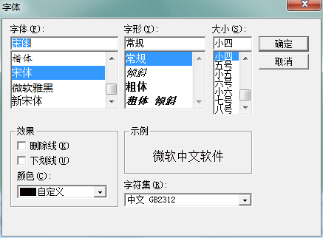
- 其次在“其他选项”中，选择如下：
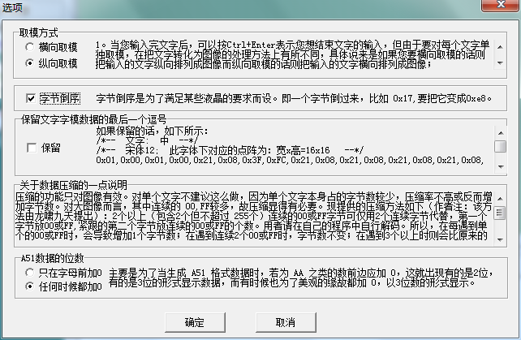
- 上面设置好之后我们就可以在文字输入区输入汉字了，以“Ctrl”+“Enter”结束：
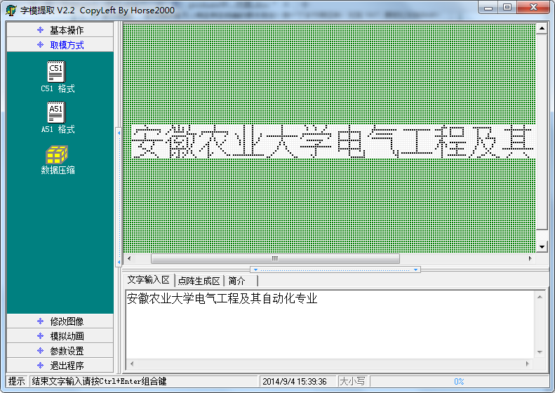
- 然后点击“C51格式”，在点阵生成区就会出现相应的模如下，我们可以把每个汉字对应的模存放在相应的数组中：
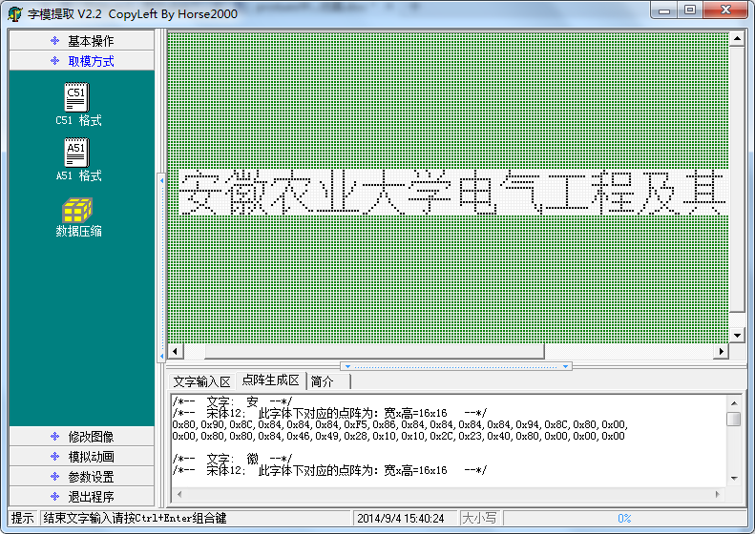

上面为取模软件的使用方法，下面开始正式教给读者单片机驱动lcd12864液晶显示屏的方法，在这之前，需要对无字库lcd12864液晶显示屏有个基础的了解，相关引脚如下：
管脚名称 | LEVER | 管脚功能描述
VSS | 0 | 电源地
VDD | +5.0V | 电源电压
V0 | - | 液晶显示器驱动电压
D/I(RS) | H/L | D/I=“H”，表示DB7∽DB0为显示数据  D/I=“L”，表示DB7∽DB0为显示指令数据
R/W | H/L | R/W=“H”，E=“H”数据被读到DB7∽DB0  R/W=“L”，E=“H→L”数据被写到IR或DR
E | H/L | R/W=“L”，E信号下降沿锁存DB7∽DB0  R/W=“H”，E=“H”DDRAM数据读到DB7∽DB0
DB0 | H/L | 数据线
DB1 | H/L | 数据线
DB2 | H/L | 数据线
DB3 | H/L | 数据线
DB4 | H/L | 数据线
DB5 | H/L | 数据线
DB6 | H/L | 数据线
DB7 | H/L | 数据线
CS1 | H/L | H:选择芯片(右半屏)信号
CS2 | H/L | H:选择芯片(左半屏)信号
RET | H/L | 复位信号,低电平复位
VOUT | -10V | LCD驱动负电压
LED+ | - | LED背光板电源
LED- | - | LED背光板电源

通过控制CS1和CS2可以用来使能左半屏和右半屏，两个半屏的页和列都是相同的，如下图：
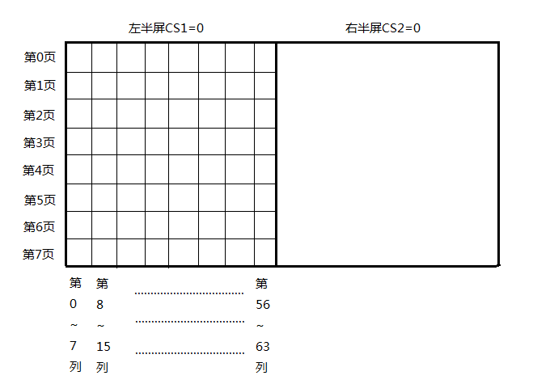
根据上图，如果我们需要在某个位置显示相应内容，如在左半屏的第0页和第2页的第0列至第15列的区域里显示汉字“农”。

按照上面的描述，我们就不需要在深究lcd12864液晶显示屏的内部原理以及相关指令，我们需要一个封装好的C模块文件（API），直接调用对应的函数即可。具体如下：
- 假设有一个已经编写好的函数LCDWriteNum (char leftright, char page, char column, char num[]) ，
参数leftright用来使能左半屏或者右半屏（‘L’或者’R’），
参数page用来选择在哪一页显示（0~7），
参数column用来选择在哪一列显示（0~64），
参数num[] 即为待显示数字的模。
这样我们要在12864的左半屏第2页和第3页的第3列至第10列的16×8区域里显示数字5，可以调用函数LCDWriteNum (‘L’, 2, 3, num5[]) 即可（num5[]数组为数字5的模）。
- 假设有一个已经编写好的函数LCDWriteNumBlack (char leftright, char page, char column, char num[]) ，
参数leftright用来使能左半屏或者右半屏（‘L’或者’R’），
参数page用来选择在哪一页显示（0~7），
参数column用来选择在哪一列显示（0~64），
参数num[] 即为待显示数字的模。
这样我们要在12864的左半屏第2页和第3页的第3列至第10列的16×8区域里以黑色背景来显示数字5，可以调用函数LCDWriteNumBlack(‘L’, 2, 3, num5[]) 即可（num5[]数组为数字5的模）。
- 假设有一个已经编写好的函数LCDWriteChinese (char leftright, char page, char column, char chinese[]) ，
参数leftright用来使能左半屏或者右半屏（‘L’或者’R’），
参数page用来选择在哪一页显示（0~7），
参数column用来选择在哪一列显示（0~64），
参数num[] 即为待显示汉字的模。
这样我们要在12864的左半屏第2页和第3页的第3列至第10列的16×8区域里显示汉字“农”，可以调用函数LCDWriteChinese(‘L’, 2, 3, nong[]) 即可（nong[]数组为汉字“农”的模）。
- 假设有一个已经编写好的函数LCDWriteChineseBlack (char leftright, char page, char column, char chinese[]) ，
参数leftright用来使能左半屏或者右半屏（‘L’或者’R’），
参数page用来选择在哪一页显示（0~7），
参数column用来选择在哪一列显示（0~64），
参数num[] 即为待显示汉字的模。
这样我们要在12864的左半屏第2页和第3页的第3列至第10列的16×8区域里以黑色背景来显示汉字“农”，可以调用函数LCDWriteChineseBlack(‘L’, 2, 3, nong[]) 即可（nong[]数组为汉字“农”的模）。

下面附上lcd12864模块代码：
lcd12864.h文件内容：
#ifndef __LCD12864_H
#define __LCD12864_H
#include <reg51.h>

#define LCDDispOff 0x3e
#define LCDDispOn 0x3f
#define PageAdd 0xb8 // 页地址
#define LCDColAdd 0x40 // 列地址
#define StartLine 0xc0 // 行地址

#define LCDData P0

sbit LCDCs1 = P2^0; // 片选 1
sbit LCDCs2 = P2^1; // 片选 2
sbit LCDRet = P2^2; // 复位端
sbit LCDRw = P2^3; // “数据/指令” 选择
sbit LCDRs = P2^4; // “读/写” 选择
sbit LCDEn = P2^5; // “读/写” 使能

/*函数声明，供模块内部使用*/
static void LCDDelay (char t); // 延时函数
static void CheckState ( ); // 检测忙标志
static void write_com (char cmdcode); // 写指定
static void write_data (char LCDDispdata); // 写数据

/*函数声明，外部调用*/
void LCDInit ( );// 12864 初始化
void LCDClear ( );// 12864 清屏
void LCDWriteChinese (char leftright, char page, char column, char chinese[]); //12864指定页指定列显示一个汉字
void LCDWriteChineseBlack (char leftright, char page, char column, char chinese[]);//12864 指定页指定列显示一个汉字，以黑色背景白色文本显示
void LCDWriteNum (char leftright, char page, char column, char num[]);//12864 指定屏指定页指定列显示一个数字
void LCDWriteNumBlack (char leftright, char page, char column, char num[]);// 12864 指定屏指定页指定列显示一个数字，以黑色背景白色文本显示

#endif

lcd12864.c文件内容：
#include "lcd12864.h"

void LCDDelay (char t)
{
char i, j;
for (i = 0; i < t; i ++ )
for (j = 0; j < 10 ;j ++ );
}

void CheckState ( )
{
char dat;
LCDRs = 0;
LCDRw = 1;
do
{
dat = 0x00;
LCDEn = 1;
LCDDelay (2);
LCDEn = 0;
dat = 0x80 & dat;
}
while (! (dat == 0x00));
}

void write_com (char cmdcode)
{
CheckState ( );
LCDRs = 0;
LCDRw = 0;
LCDData = cmdcode;
LCDDelay (2);
LCDEn = 1;
LCDDelay (2);
LCDEn = 0;
}

void write_data (char LCDDispdata)
{
CheckState ( );
LCDRs = 1;
LCDRw = 0;
LCDData = LCDDispdata;
LCDDelay (2);
LCDEn = 1;
LCDDelay (2);
LCDEn = 0;
}

void LCDInit ( )
{
LCDDelay (100);
LCDCs1 = 1;
LCDCs2 = 1;
LCDDelay (100);
write_com (LCDDispOff);
write_com (PageAdd+0);
write_com (StartLine+0);
write_com (LCDColAdd+0);
write_com (LCDDispOn);
}

void LCDClear ( )
{
char k, j;
LCDCs1 = 0;
LCDCs2 = 0;
write_com (PageAdd+0);
write_com (LCDColAdd+0);
for (k = 0; k < 8; k++)
{
write_com (PageAdd+k);
for (j = 0; j < 64; j ++ )
{
write_com (LCDColAdd+j);
write_data (0x00);
}
}
}

void LCDWriteChinese (char leftright, char page, char column, char chinese[])
{
char i = 0, j = 0;
if (leftright == 'L')
{
LCDCs1 = 0;
LCDCs2 = 1;
}
else if (leftright == 'R')
{
LCDCs1 = 1;
LCDCs2 = 0;
}
for ( i = 0; i < 2; i ++ )
{
write_com (PageAdd + page + i);
write_com (LCDColAdd + column);
for (j = 0; j < 16; j ++)
{
write_data(chinese[16*i+j]);
}
}
}

void LCDWriteChineseBlack (char leftright, char page, char column, char chinese[])
{
char i = 0, j = 0;
if (leftright == 'L')
{
LCDCs1 = 0;
LCDCs2 = 1;
}
else if (leftright == 'R')
{
LCDCs1 = 1;
LCDCs2 = 0;
}
for ( i = 0; i < 2; i ++ )
{
write_com (PageAdd + page + i);
write_com (LCDColAdd + column);
for (j = 0; j < 16; j ++)
{
write_data(~chinese[16*i+j]);
}
}
}

void LCDWriteNum (char leftright, char page, char column, char num[])
{
char i = 0, j = 0;
if (leftright == 'L')
{
LCDCs1 = 0;
LCDCs2 = 1;
}
else if (leftright == 'R')
{
LCDCs1 = 1;
LCDCs2 = 0;
}
for ( i = 0; i < 2; i ++ )
{
write_com (PageAdd + page + i);
write_com (LCDColAdd + column);
for (j = 0; j < 8; j ++)
{
write_data(num [8*i+j] );
}
}
}

void LCDWriteNumBlack (char leftright, char page, char column, char num[])
{
char i = 0, j = 0;
if (leftright == 'L')
{
LCDCs1 = 0;
LCDCs2 = 1;
}
else if (leftright == 'R')
{
LCDCs1 = 1;
LCDCs2 = 0;
}
for ( i = 0; i < 2; i ++ )
{
write_com (PageAdd + page + i);
write_com (LCDColAdd + column);
for (j = 0; j < 8; j ++)
{
write_data(~ num [8*i+j] );
}
}
}

现在我们可以小试牛刀了，把上面两个文件加入工程里，在main.c文件里添加如下代码：
#include "lcd12864.h"

/* 汉字”安“，格式 16*16 */
char code an[] = {0x80,0x90,0x8C,0x84,0x84,0x84,0xF5,0x86,0x84,0x84,0x84,0x84,0x94,0x8C,0x80,0x00,
0x00,0x80,0x80,0x84,0x46,0x49,0x28,0x10,0x10,0x2C,0x23,0x40,0x80,0x00,0x00,0x00};
/* 汉字”徽“，格式 16*16 */
char code hui[] = {0x10,0x88,0xC4,0x23,0xAE,0x68,0x2F,0x28,0xAE,0x20,0xD8,0x17,0x10,0xF0,0x10,0x00,
0x01,0x00,0xFF,0x48,0x29,0x8D,0xFB,0x09,0xAC,0x48,0x37,0x08,0x36,0x41,0x80,0x00};
/* 汉字”农“，格式 16*16 */
char code nong[] = {0x20,0x18,0x08,0x08,0x08,0xC8,0x38,0xCF,0x08,0x08,0x08,0x08,0xA8,0x18,0x00,0x00,
0x10,0x08,0x04,0x02,0xFF,0x40,0x20,0x00,0x03,0x04,0x0A,0x11,0x20,0x40,0x40,0x00};
/* 汉字”业“，格式 16*16 */
char code ye1[] = {0x00,0x10,0x60,0x80,0x00,0xFF,0x00,0x00,0x00,0xFF,0x00,0x00,0xC0,0x30,0x00,0x00,
0x40,0x40,0x40,0x43,0x40,0x7F,0x40,0x40,0x40,0x7F,0x42,0x41,0x40,0x40,0x40,0x00};
/* 汉字”大“，格式 16*16 */
char code da[] = {0x20,0x20,0x20,0x20,0x20,0x20,0x20,0xFF,0x20,0x20,0x20,0x20,0x20,0x20,0x20,0x00,
0x80,0x80,0x40,0x20,0x10,0x0C,0x03,0x00,0x03,0x0C,0x10,0x20,0x40,0x80,0x80,0x00};
/* 汉字”学“，格式 16*16 */
char code xue[] = {0x40,0x30,0x11,0x96,0x90,0x90,0x91,0x96,0x90,0x90,0x98,0x14,0x13,0x50,0x30,0x00,
0x04,0x04,0x04,0x04,0x04,0x44,0x84,0x7E,0x06,0x05,0x04,0x04,0x04,0x04,0x04,0x00};
/* 汉字”电“，格式 16*16 */
char code dian[] = {0x00,0x00,0xF8,0x88,0x88,0x88,0x88,0xFF,0x88,0x88,0x88,0x88,0xF8,0x00,0x00,0x00,
0x00,0x00,0x1F,0x08,0x08,0x08,0x08,0x7F,0x88,0x88,0x88,0x88,0x9F,0x80,0xF0,0x00};
/* 汉字”气“，格式 16*16 */
char code qi1[] = {0x20,0x10,0x4C,0x47,0x54,0x54,0x54,0x54,0x54,0x54,0x54,0xD4,0x04,0x04,0x00,0x00,
0x00,0x00,0x00,0x00,0x00,0x00,0x00,0x00,0x00,0x00,0x00,0x0F,0x30,0x40,0xF0,0x00};
/* 汉字”工“，格式 16*16 */
char code gong[] = {0x00,0x04,0x04,0x04,0x04,0x04,0x04,0xFC,0x04,0x04,0x04,0x04,0x04,0x04,0x00,0x00,
0x20,0x20,0x20,0x20,0x20,0x20,0x20,0x3F,0x20,0x20,0x20,0x20,0x20,0x20,0x20,0x00};
/* 汉字”程“，格式 16*16 */
char code cheng[]= {0x24,0x24,0xA4,0xFE,0x23,0x22,0x00,0x3E,0x22,0x22,0x22,0x22,0x22,0x3E,0x00,0x00,
0x08,0x06,0x01,0xFF,0x01,0x06,0x40,0x49,0x49,0x49,0x7F,0x49,0x49,0x49,0x41,0x00};
/* 汉字”及“，格式 16*16 */
char code ji[] = {0x00,0x00,0x02,0x02,0xFE,0x42,0x82,0x02,0x42,0x72,0x4E,0x40,0xC0,0x00,0x00,0x00,
0x80,0x40,0x30,0x0C,0x83,0x80,0x41,0x46,0x28,0x10,0x28,0x46,0x41,0x80,0x80,0x00};
/* 汉字”其“，格式 16*16 */
char code qi2[] = {0x00,0x04,0x04,0x04,0xFF,0x24,0x24,0x24,0x24,0x24,0xFF,0x04,0x04,0x04,0x00,0x00,
0x08,0x08,0x88,0x48,0x2F,0x09,0x09,0x09,0x09,0x09,0x2F,0x48,0x88,0x08,0x08,0x00};
/* 汉字”自“，格式 16*16 */
char code zi[] = {0x00,0x00,0x00,0xF8,0x88,0x8C,0x8A,0x89,0x88,0x88,0x88,0xF8,0x00,0x00,0x00,0x00,
0x00,0x00,0x00,0xFF,0x44,0x44,0x44,0x44,0x44,0x44,0x44,0xFF,0x00,0x00,0x00,0x00};
/* 汉字”动“，格式 16*16 */
char code dong[] = {0x40,0x44,0xC4,0x44,0x44,0x44,0x40,0x10,0x10,0xFF,0x10,0x10,0x10,0xF0,0x00,0x00,
0x10,0x3C,0x13,0x10,0x14,0xB8,0x40,0x30,0x0E,0x01,0x40,0x80,0x40,0x3F,0x00,0x00};
/* 汉字”化“，格式 16*16 */
char code hua[] = {0x00,0x80,0x60,0xF8,0x07,0x00,0x00,0x00,0xFF,0x40,0x20,0x10,0x08,0x04,0x00,0x00,
0x01,0x00,0x00,0xFF,0x00,0x04,0x02,0x01,0x3F,0x40,0x40,0x40,0x40,0x40,0x78,0x00};
/* 汉字”专“，格式 16*16 */
char code zhuan[]= {0x40,0x40,0x48,0x48,0x48,0xC8,0x78,0x4F,0x48,0x48,0x48,0x48,0x48,0x40,0x40,0x00,
0x00,0x00,0x00,0x00,0x03,0x12,0x12,0x22,0x22,0x52,0x8A,0x06,0x00,0x00,0x00,0x00};
/* 汉字”业“，格式 16*16 */
char code ye2[] = {0x00,0x10,0x60,0x80,0x00,0xFF,0x00,0x00,0x00,0xFF,0x00,0x00,0xC0,0x30,0x00,0x00,
0x40,0x40,0x40,0x43,0x40,0x7F,0x40,0x40,0x40,0x7F,0x42,0x41,0x40,0x40,0x40,0x00};
/* 汉字”胡“，格式 16*16 */
char code hu[] = {0x00,0x10,0x90,0x90,0xFF,0x90,0x90,0x10,0x00,0xFE,0x22,0x22,0x22,0xFE,0x00,0x00,
0x00,0x00,0x3F,0x10,0x10,0x10,0xBF,0x40,0x30,0x0F,0x02,0x42,0x82,0x7F,0x00,0x00};
/* 汉字”保“，格式 16*16 */
char code bao[] = {0x00,0x80,0x60,0xF8,0x07,0x00,0x3E,0x22,0x22,0xE2,0x22,0x22,0x3E,0x00,0x00,0x00,
0x01,0x00,0x00,0xFF,0x20,0x11,0x09,0x05,0x03,0xFF,0x03,0x05,0x09,0x11,0x20,0x00};
/* 汉字”进“，格式 16*16 */
char code jin[] = {0x40,0x40,0x42,0xCC,0x00,0x80,0x88,0x88,0xFF,0x88,0x88,0xFF,0x88,0x88,0x80,0x00,
0x00,0x40,0x20,0x1F,0x20,0x40,0x50,0x4C,0x43,0x40,0x40,0x5F,0x40,0x40,0x40,0x00};

/* 数字“0”，格式 16*8 */
char code num0[ ] = {0x00,0xE0,0x10,0x08,0x08,0x10,0xE0,0x00,0x00,0x0F,0x10,0x20,0x20,0x10,0x0F,0x00};
/* 数字“1”，格式 16*8 */
char code num1[ ] = {0x00,0x10,0x10,0xF8,0x00,0x00,0x00,0x00,0x00,0x20,0x20,0x3F,0x20,0x20,0x00,0x00};
/* 数字“2”，格式 16*8 */
char code num2[ ] = {0x00,0x70,0x08,0x08,0x08,0x88,0x70,0x00,0x00,0x30,0x28,0x24,0x22,0x21,0x30,0x00};
/* 数字“3”，格式 16*8 */
char code num3[ ] = {0x00,0x30,0x08,0x88,0x88,0x48,0x30,0x00,0x00,0x18,0x20,0x20,0x20,0x11,0x0E,0x00};
/* 数字“4”，格式 16*8 */
char code num4[ ] = {0x00,0x00,0xC0,0x20,0x10,0xF8,0x00,0x00,0x00,0x07,0x04,0x24,0x24,0x3F,0x24,0x00};
/* 数字“5”，格式 16*8 */
char code num5[ ] = {0x00,0xF8,0x08,0x88,0x88,0x08,0x08,0x00,0x00,0x19,0x21,0x20,0x20,0x11,0x0E,0x00};
/* 数字“6”，格式 16*8 */
char code num6[ ] = {0x00,0xE0,0x10,0x88,0x88,0x18,0x00,0x00,0x00,0x0F,0x11,0x20,0x20,0x11,0x0E,0x00};
/* 数字“7”，格式 16*8 */
char code num7[ ] = {0x00,0x38,0x08,0x08,0xC8,0x38,0x08,0x00,0x00,0x00,0x00,0x3F,0x00,0x00,0x00,0x00};
/* 数字“8”，格式 16*8 */
char code num8[ ] = {0x00,0x70,0x88,0x08,0x08,0x88,0x70,0x00,0x00,0x1C,0x22,0x21,0x21,0x22,0x1C,0x00};
/* 数字“9”，格式 16*8 */
char code num9[ ] = {0x00,0xE0,0x10,0x08,0x08,0x10,0xE0,0x00,0x00,0x00,0x31,0x22,0x22,0x11,0x0F,0x00};

/*指针数组，存放数字0~9的模*/
char code * numble[ ] = {num0, num1, num2, num3, num4, num5, num6, num7, num8, num9};

void delay (int t)
{
int i, j;
for (i = t; i > 0; i --)
for (j = 125; j > 0 ;j --);
}

void main (void)
{
int i, j, mm;
LCDInit ( );
LCDClear ( );
while (1)
{
LCDWriteChinese ('L', 0, 0, an);
delay (100);
LCDWriteChinese ('L', 0, 16, hui);
delay (100);
LCDWriteChinese ('L', 0, 32, nong);
delay (100);
LCDWriteChinese ('L', 0, 48, ye1);
delay (100);
LCDWriteChinese ('R', 0, 0, da);
delay (100);
LCDWriteChinese ('R', 0, 16, xue);
delay (100);
LCDWriteChinese ('L', 2, 0, dian);
delay (100);
LCDWriteChinese ('L', 2, 16, qi1);
delay (100);
LCDWriteChinese ('L', 2, 32, gong);
delay (100);
LCDWriteChinese ('L', 2, 48, cheng);
delay (100);
LCDWriteChinese ('R', 2, 0, ji);
delay (100);
LCDWriteChinese ('R', 2, 16, qi2);
delay (100);
LCDWriteChinese ('R', 2, 32, zi);
delay (100);
LCDWriteChinese ('R', 2, 48, dong);
delay (100);
LCDWriteChinese ('L', 4, 0, hua);
delay (100);
LCDWriteChinese ('L', 4, 16, zhuan);
delay (100);
LCDWriteChinese ('L', 4, 32, ye2);
delay (100);
LCDWriteChinese ('L', 6, 0, hu);
delay (100);
LCDWriteChinese ('L', 6, 16, bao);
delay (100);
LCDWriteChinese ('L', 6, 32, jin);
delay (100);
delay (1000);
LCDClear ( );
LCDWriteChineseBlack ('L', 0, 0, an);
delay (100);
LCDWriteChineseBlack ('L', 0, 16, hui);
delay (100);
LCDWriteChineseBlack ('L', 0, 32, nong);
delay (100);
LCDWriteChineseBlack ('L', 0, 48, ye1);
delay (100);
LCDWriteChineseBlack ('R', 0, 0, da);
delay (100);
LCDWriteChineseBlack ('R', 0, 16, xue);
delay (100);
LCDWriteChineseBlack ('L', 2, 0, dian);
delay (100);
LCDWriteChineseBlack ('L', 2, 16, qi1);
delay (100);
LCDWriteChineseBlack ('L', 2, 32, gong);
delay (100);
LCDWriteChineseBlack ('L', 2, 48, cheng);
delay (100);
LCDWriteChineseBlack ('R', 2, 0, ji);
delay (100);
LCDWriteChineseBlack ('R', 2, 16, qi2);
delay (100);
LCDWriteChineseBlack ('R', 2, 32, zi);
delay (100);
LCDWriteChineseBlack ('R', 2, 48, dong);
delay (100);
LCDWriteChineseBlack ('L', 4, 0, hua);
delay (100);
LCDWriteChineseBlack ('L', 4, 16, zhuan);
delay (100);
LCDWriteChineseBlack ('L', 4, 32, ye2);
delay (100);
LCDWriteChineseBlack ('L', 6, 0, hu);
delay (100);
LCDWriteChineseBlack ('L', 6, 16, bao);
delay (100);
LCDWriteChineseBlack ('L', 6, 32, jin);
delay (100);
delay (1000);
LCDClear ( );
for (mm = 0; mm < 10; mm ++)
{
for (i = 0; i < 4; i ++)
{
for (j = 0; j < 8; j ++)
{
LCDWriteNum ('L', 2*i, 8*j, numble[mm]);
LCDWriteNum ('R', 2*i, 8*j, numble[mm]);
}
}
delay (500);
}
delay (1000);
LCDClear ( );
for (mm = 0; mm < 10; mm ++)
{
for (i = 0; i < 4; i ++)
{
for (j = 0; j < 8; j ++)
{
LCDWriteNumBlack ('L', 2*i, 8*j, numble[mm]);
LCDWriteNumBlack ('R', 2*i, 8*j, numble[mm]);
}
}
delay (500);
}
delay (1000);
LCDClear ( );
}
}

仿真效果如下：
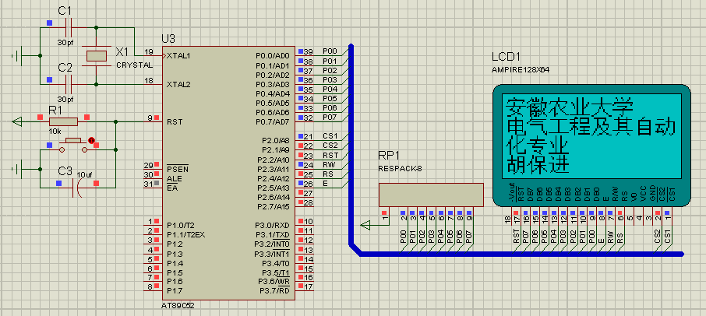

以上为封装好的函数调用方法，如需了解内部一些原理，请参考其他文档。

