Examine Yourselves International Mission Foundation (EYIMF)
Serving Souls. Meeting Needs. Glorifying Christ.
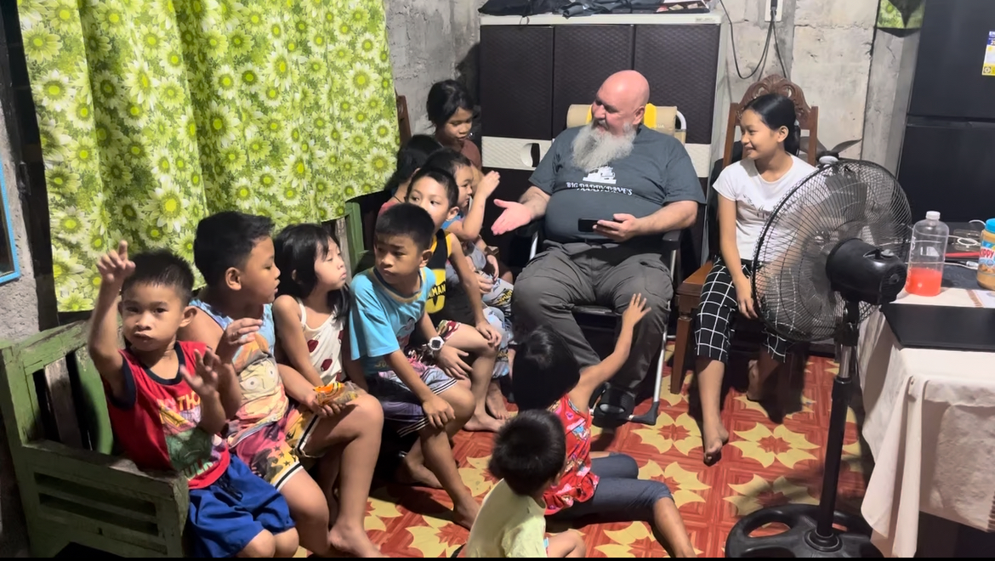 | 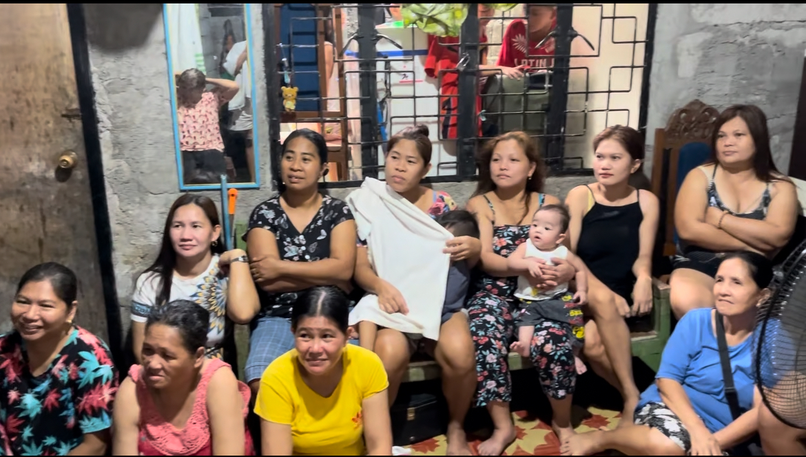  EYIMF  EXAMINE YOURSELVES  INTERNATIONAL MISSION  FOUNDATION
A Ministry of Faith in Action — Philippines Outreach
Examine Yourselves International Mission Foundation (EYIMF) stands as a living testimony of faith in action—uniting prayer, teaching, and compassionate outreach to reflect the heart of Christ in the Philippines. Through Bible training, food distribution, and community care, we aim to see lives transformed, homes restored, and churches established under the authority of God’s Word.
What We Do
Teach the Word
We proclaim Christ through discipleship, Bible study, and evangelism. Every believer is equipped with Scripture-centered truth to walk boldly in faith.
Feed the Hungry
Each week, EYIMF provides food packs for 36 families—meeting physical needs while sharing the Bread of Life.
Community Care
We pray with families, visit the sick, encourage the lonely, and help those in crisis. Every act of compassion points hearts back to the hope found in Jesus Christ.
Your Church Can Make a Difference  By partnering with EYIMF, your church can help us:  - Extend food distribution to 70 families per month.  - Supply Tagalog/KJV Bibles to local believers  - Establish home churches across new barangays  - Train and equip Filipino ministers for Gospel service  Our Goal  To sustain our outreach, EYIMF seeks 65 monthly supporters at $20 each. This will provide the $1,300.00 monthly funding needed to continue feeding families, distributing Bibles, and establishing new home Churches across the Philippines. | How You Can Help  Pray — for revival, provision, and lasting transformation in the Philippines.  Partner — sponsor a family, a Bible order, or a full outreach program.  Provide — through one-time or recurring support to sustain ongoing ministry.  Contact & Giving  santamissions@gmail.com  www.santamissions.org

“If a brother or sister be naked, and destitute of daily food,
And one of you say unto them, Depart in peace, be ye warmed and filled;
notwithstanding ye give them not those things which are needful to the body; what doth it profit?” — James 2:14–17

