Hardware Group LTD.

3 Tsar Ivan Shishman Street

Plovdiv, 4000, Bulgaria

+359 883 364 469

[om](mailto:info@irdroid.com)

http://www.irdroid.com

# Irdroid WiRF433 Development Board

|  |  |  |  |  |
| --- | --- | --- | --- | --- |
| Description | | | | |
| The Irdroid WiFi RF433Mhz Development Board is a home automation board that will allow you to rapidly design WiFi home automation systems. The Development board is practically fully functional Linux Computer, running the free and open source OpenWRT Linux Distribution. The WiRF433 will allow you to remotely control RF Sockets and RF Light bulbs / switches via HTML5 web page and / or via any standard LIRC Client for Android, PC or Windows OS. The WiRF433 Development Computer also runs a Telnet / SSH daemons, Web Server and you have all the board’s GPIO’s available on PIN Headers. The Board comes with all the software source code, schematics and user manuals.  **The WiRF433 Development board features:**   * Ralink RT5350 Embedded Soc @ 360 Mhz * 32MB SDRAM Memory * 4MB Flash Memory (For Kernel, filesystem and Openwrt) * I2C, SPI , UART1 & UART2 Serial Interfaces, USB 2.0 Interface * Two Ethernet Interfaces (WAN , LAN) * One RF433 MHz Transmitter Module, connected and controlled by SoC GPIO0   **Software:**   * Preinstalled Ralink Bootloader & OpenWrt firmware with custom software for controlling RF Outlets, thanks to the on board RF433Mhz RF interface. * Embedded webserver serving pages that allow the RC Switches / Light Bulbs and Outlets to be controlled remotely. * Lirc daemon that also provides Remote control for the outlets via any compatible LIRC client (Supports Android, Linux, Windows etc) | | | | |
| Applications | | | | |
| * WiFi RF Sockets and Switch control & Automation * IoT (Internet of Things) Projects / Connect embedded HW to the Internet * Home Automation / Industrial automation * Building Automation * WiFi Remote Garage door control * Garden lighting control and automation * Garden watering systems and automation   With The Irdroid WiFi RF433Mhz Development Computer you will be able to rapidly design and develop IoT (Intenet of Things) Projects, connects embedded hardware to the Internet and control monitor home / industrial appliances. All the Source Code – The Linux Distribution, the Build system for compiling new software for this particular board is available for download from Github or from our website. Setting up a development environment for this board is easy and will save you a lot of time if you choose our board and software. | | | | |
| Pricing | | | | |
| Order Code | Description | Qty 1- 10 | Qty. 10 - 100 | >100 |
| 1346 | Irdroid WiRF433 Development Board | $40 | $35 | $32 |

Specifications ( Supply Voltage DC 12V @ 25 Celsius):

|  |  |  |
| --- | --- | --- |
| Typical DC Characteristics | | Notes |
| Board nominal Voltage | 12V DC | The nominal voltage of the board |
| WiFi current | 140mA | Wifi to serial,AP mode or Client mode |
| One rj45 current | 120mA | Serial to RJ45. |
| Two rj45 cuurent | 135mA | One is Wan anther is LAN |
| WiFi and two rj45 | 160mA | Default Mode/Factory Mode |
| Centre frequency accuracy | +/-25ppm | Additional +/-15ppm allowance |
| Typical RF Characteristics | | Notes |
| Receive sensitivity | -70dBm |  |
| Maximum Transmit power | 18dBm/15dBm/13.5dBm | 802.11b/g/n |
| RF Port impedance – Ipex onnector | 50 ohm | 2.4 - 2.5GHz |
| VSWR (max) | 2:01 | 2.4 - 2.5GHz |
| Centre frequency accuracy | +/-25ppm | Additional +/-15ppm allowance |
| Peripherals | | Notes |
| WiFi Relay module 802.11n | 1pcs | Irdroid Wifi Relay module |
| Ethernet port WAN | 1pcs | 100mbps |
| Ethernet port LAN | 1pcs | 100mbps |
| RF433 Mhz Transmitter | 1pcs | Transmitter frequency 433.9 Mhz |

Pinout Configuration:

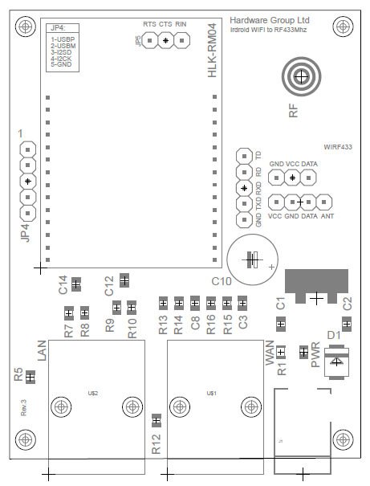

Pin Assignment

|  |  |  |
| --- | --- | --- |
| Pin No | Signal Type | Description |
| JP4 - 1 | USB-P | USB-P |
| JP4 - 2 | USB-M | USB-M |
| JP4 - 3 | I2C SD | I2C SD |
| JP4 - 4 | I2C CLK | I2C CLK |
| JP4 - 5 | GND | GND |
| JP5 - 1 | RTS | RTS |
| JP5 - 2 | CTS | CTS |
| JP5 - 3 | RIN | RIN |

Electrical Characteristics (WiFi Module)

|  |  |  |
| --- | --- | --- |
| Parameter | Min | Max |
| Module supply voltage VCC | 3.9V | 5.5V |
| Module Voltage Output VO3.3 | 3.1V | 3.5 |
| Module Voltage Output VO1.8 | 1.65V | 1.9 |
| GPIO Voltage | 3.1V | 3.5V |
| Storage temperature | -40ºC | 95ºC |

Outline Drawing



Board dimensions & Information:

* 71.7 x 56.2mm
* Power Supply DC 12V 2.0mm Jack

Document Changes:

V1.0 Initial Release