AMERICAN UNIVERSITY OF ARMENIA

*College of Science and Engineering*

**CS 260 Image Processing**

**PROJECT**

**PRELIMINARY DEADLINE**: Sunday, December 08 2019, before 09:00 am SHARP

**FINAL DEADLINE**: Tuesday, December 17 2019, before 09:00 am SHARP

**CONTACTS**: Irina Tirosyan, irina_tirosyan@edu.aua.am

Yeva Gabrielyan, yeva_gabrielyan19@alumni.aua.am

Suren Khachatryan, [skhachat@aua.am](mailto:skhachat@aua.am)

**Stage 1**

1. Multiple experiments on the pictures with Standard Behavior showed that smoothness can be achieved by applying the following filter sequence:

Median (Radius 1.0) 🡪 Gaussian Blur (Radius 0.5) 🡪 Mean (Radius 0.7).

Example of smoothened layers:

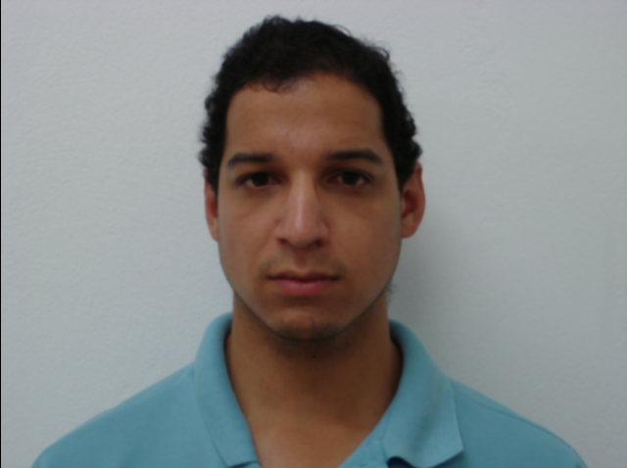 🡪 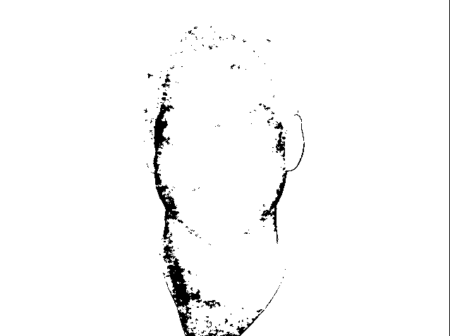 🡪 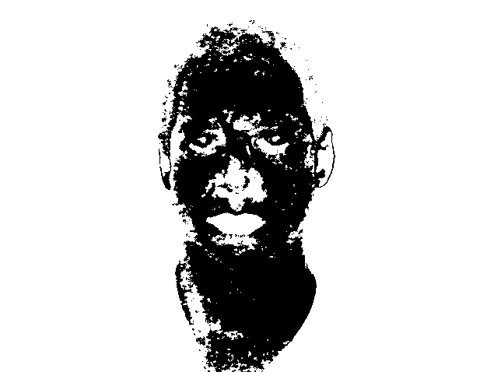

🡪 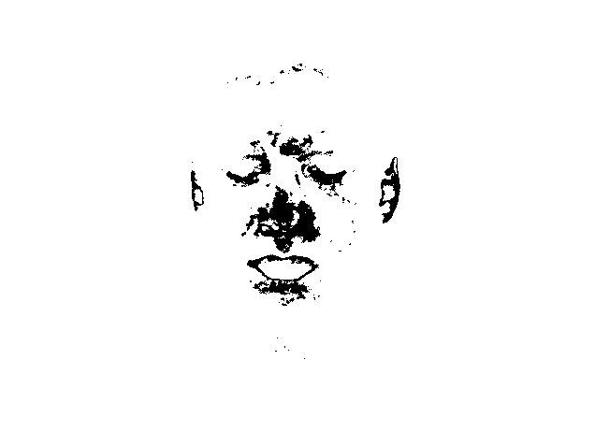🡪 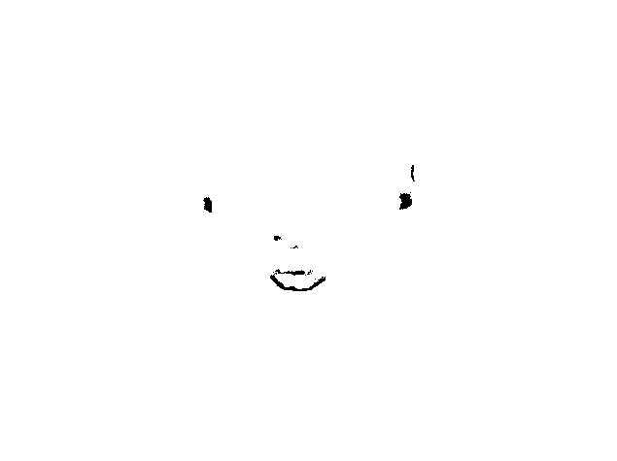

1. Using the following matrix in Convolve, gave very similar results to the ones obtained in point1.

30 30 30

30 90 30

30 30 30

Example of smoothened layers:

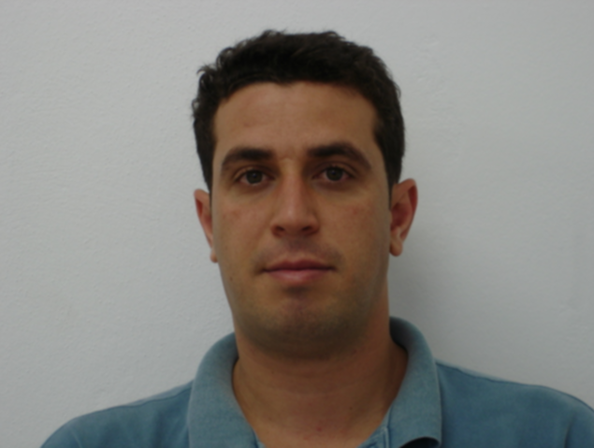 🡪 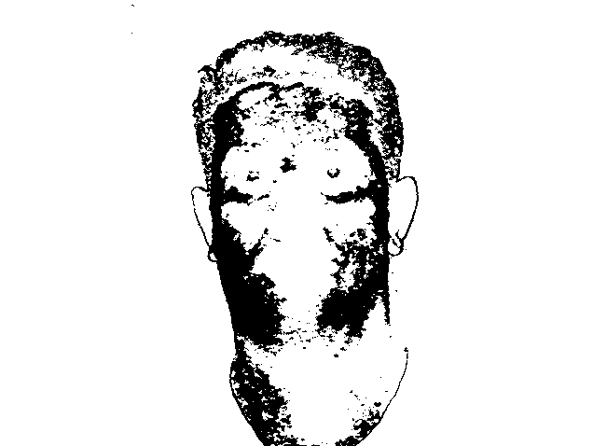🡪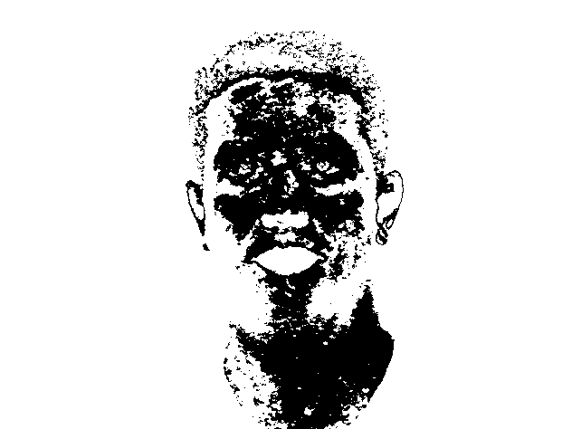

🡪 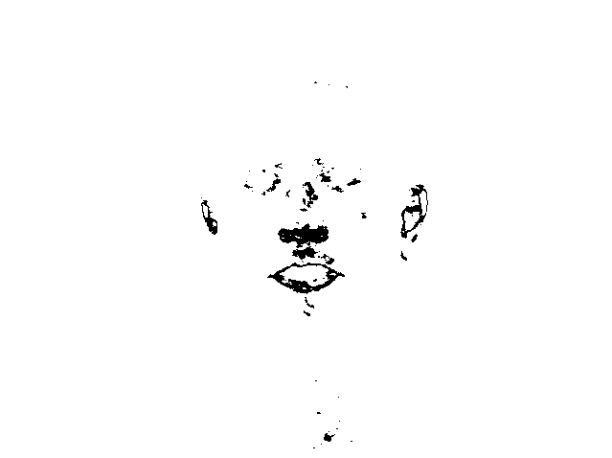🡪 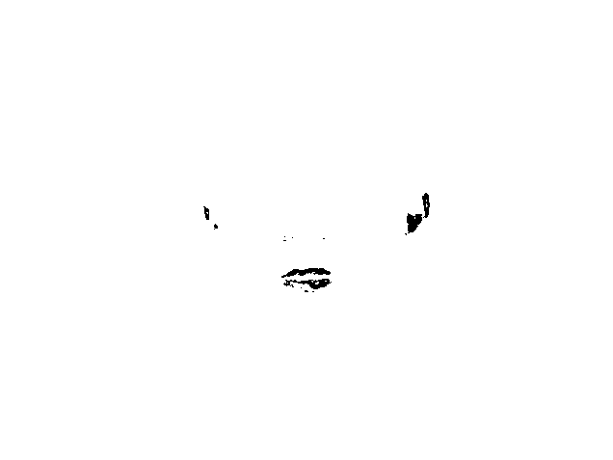

1. For the following task, some visual observations have been made. In addition, a plugin was created for the calculation of Orientation and Eccentricity (Stage0 🡪 A09…93 folder path). It needs some correction.

Some parallels:

Layer0

8_11 8_4 8_10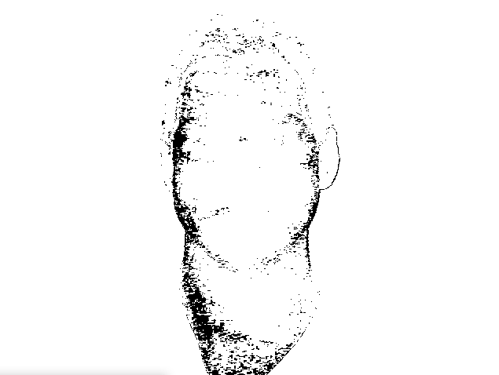 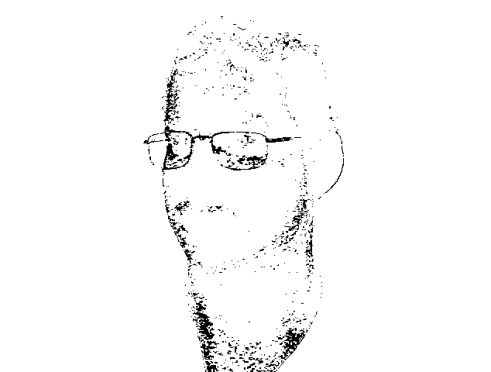 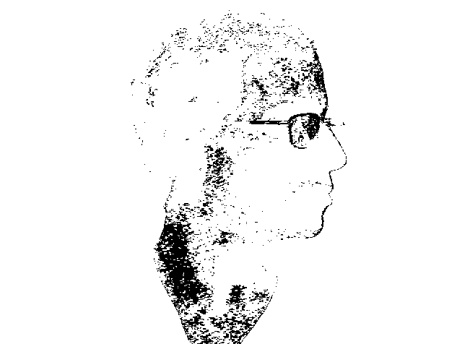

Layer1

8_11 8_4 8_10

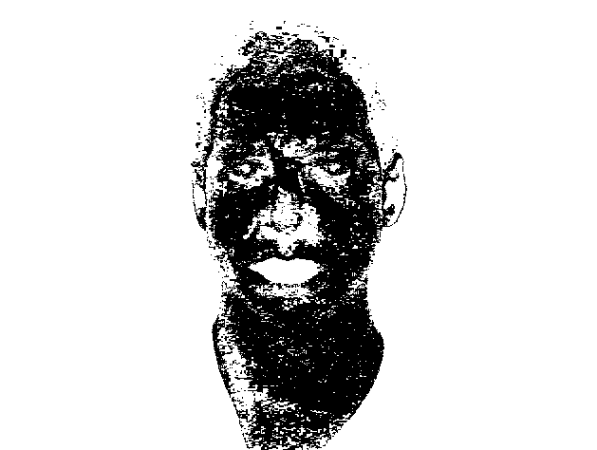 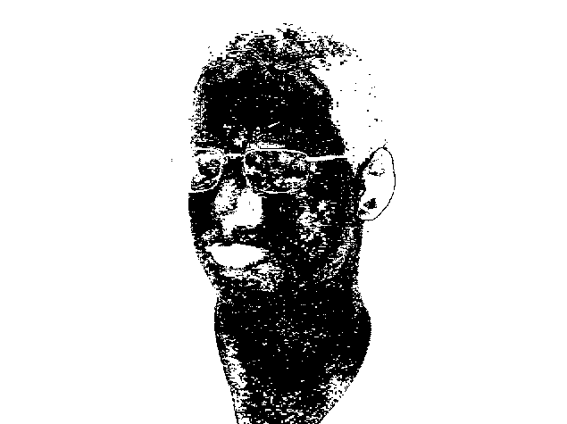 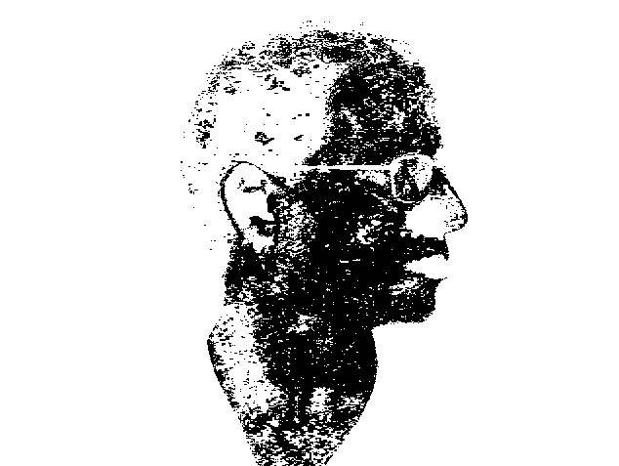

Layer2

44_11 44_4 44_10

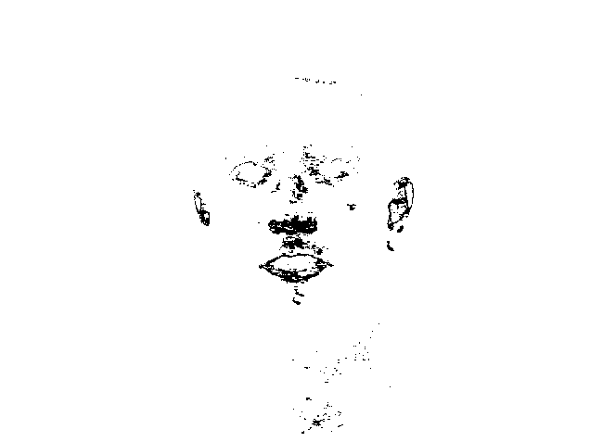 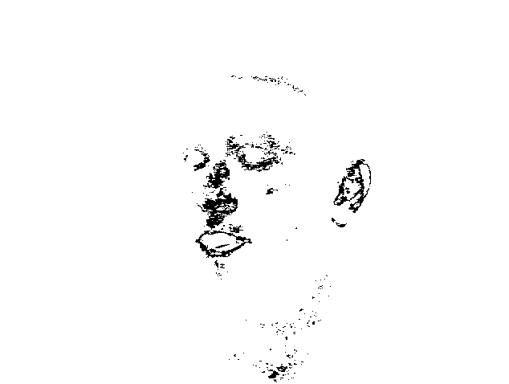 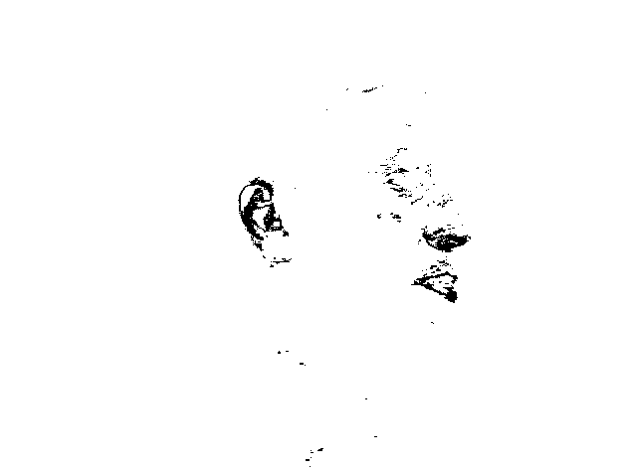

Layer3

44_11 44_4 44_10

