# Contributors

Lilit Adamyan and Iren Okminyan.

# Project description and questions

In this activity you will respond to four questions. Please read the directions below carefully and complete the assignment in full.

Remember that to respond to the questions you should consider a functional quantum computer, defined as satisfying the following requirements:

1. It can solve a problem more efficiently than a classical computer (e.g., quantum supremacy)
2. It can solve a meaningful problem (i.e., not a toy problem)

Choose a qubit modality that you think will be the first one in supporting a functional quantum computer. You can find about different qubit modalities in the handbook, Chapter 3.

### Which modality do you think would be the first to support a functional quantum computer?

Respond to questions 1 and 2 (300 words each)

1. Why do you think your chosen modality will be the first one in supporting a functional quantum computer? Compare at least three modalities.
2. Think about the second modality that might be also a good candidate and answer the same as above.

### When do you think the first functional quantum computer will be created?

Respond to questions 3 and 4 (300 words each)

1. Why do you think it will take the time that you chose to create the first functional quantum computer? Argue at least two reasons.
2. Think about the time frame of the second modality that might also be a good candidate. Argue at least two reasons.

# Introduction

In order to choose a modality that in our opinion will be the first one to support a functional quantum computer let's discuss and compare them. So we will talk about Superconducting Qubits(SQ), Trapped Ions (TI) and Neutral Atoms (NA).

To assess qubit modalities and compare them to one another we should consider these requirements for physical implementation of quantum computation:

1. Well-characterized quantum two-level systems that can be employed as qubits.

2. An ability to initialize the qubits.

3. An ability to measure quantum bits one by one, without disturbing the others.

4. A set of quantum operations on the qubits : “quantum gates”. And we will compare gate fidelity and gate speed as it quantifies the quality of a gate operation, and it is used to compare qubit modalities of varying types.

5. Decoherence times that are long enough to be able to carry out the computation or error correction.

DiVincenzo Criteria:

6. Connectivity

1. SQ, TI, NA are scalable systems:

SQ: they’re manufactured on silicon wafers using materials and tools common to CMOS foundries. In this sense, they’re lithographically scalable to large numbers of qubits.

TI: If trapped ion computer researchers can solve the scaling problem with lasers, they have a good chance of exceeding the capabilities of superconductors.

NA: neutral atoms will require integrated optics to ultimately be scalable, something that’s not yet been implemented, although concepts exist for its implementation.

2. for initialization all 3 are doing pretty well.

3. The measurement of neutral atoms is extremely slow and would certainly limit the ultimate clock speed of an error-corrected system.

4. Gate fidelity for SQ is 99.5%, for TI is 99.9%, for NA is 80%. Gate speed for SQ is much faster than for the others.

5. Coherence time for SQ is shorter.

6. QS has limited gate connectivity to qubits.

From 2006 up to now most quantum computing systems are TI or SQ based.

As for these comparisons and based on statistics of released quantum computers we can conclude that SQ and TA are definitely the leading candidates.

# Question 1

Superconducting Qubits

superconducting qubits are manufactured, artificial atoms. They’re lithographically scalable to large numbers of qubits. It’s a straightforward path to increasingly complex circuitry with many interconnected qubits. Today, there are a large number of major corporations pursuing superconducting qubits, including Google, IBM, and Intel, as well as startup companies like D-Wave and Rigetti. As you can see from the picture these are the leaders of quantum computing battle. And currently they all support SQ.

Google has reached a point that’s referred to as quantum supremacy, a point where a quantum computer has performed a task that could not be calculated exactly on classical computers.

In 2018, multiple major modalities of superconducting qubits with unique parameters tuned for different applications have achieved coherence times that exceed the most lenient thresholds for quantum error correction.

Superconducting qubits and Trapped Ions are leading modalities. With some indexes such as gate figiality(99.9 vs 99.5), connectivity, coherence Trapped Ions can perform better results, But for superconducting qubits gate speed is much fuster and one designs these superconducting quantum circuits and their properties. But the main point that forces us to think that Superconducting qubits will be first to support a functional quantum computer as Superconducting qubits will steadily improve as a result of the financial resources of our biggest and best tech companies. Financial support is vital for any scientific project realization and as Superconducting qubits are so popular they can further attract significant investments.

All leading players in the superconducting camp have made their smaller chips accessible externally to software and service companies and preferred partners. Some have opened lower-performing versions and simulators to the community at large. This sign of commercial readiness strengthens the general expectation that superconducting qubits could lead over other technologies. If we look at the chart we can see that for the last years Top companies are producing better results exactly with superconducting qubits.

# Question 2

Trapped Ions

A primary advantage is that many of the DiVincenzo criteria are satisfied. Trapped ions offer a platform for high-coherence qubits and high-precision, universal quantum control.

Trapped ions are attractive because they leverage a substantial existing technology base, one that goes back three decades to the development of atomic clocks and mass spectrometers. Today, there are a growing number of commercial efforts pursuing or supporting the development of trapped ion qubits, including a startup company called IonQ, Alpine Quantum Technologies (AQT) and The Fortune 100.

But the power of a quantum computer is not simply a question of how many qubits it has; it’s equally important how well each of them performs. Although trapped ions operate more slowly than superconducting qubits, they’ve demonstrated a larger degree of connectivity between the ions, and this may help to offset the relatively slow speed by making problem embedding more efficient. And finally, from a technology standpoint, trapped ion qubits leverage both microwave and data communications technology. The lasers used in trapped ion experiments have application to atomic clocks, precision navigation, even biology and optogenetics. Developing compact instrumentation– for example, size, weight, power, even cost–will benefit an array of technologies even beyond trapped ions.

It has been established techniques to perform all the operations required for quantum computing using trapped ions, and the properties of the ions themselves allow for very low error on these operations. In fact, researchers in the field of trapped ion quantum computing have demonstrated basic quantum computing primitives in a few ion experiments that approach or surpass the fidelity levels we think we need for useful large-scale systems. In addition, a few tens of ions have been trapped and individually manipulated as well, though not simultaneously with the highest fidelity gates. The remaining challenge, therefore, is to maintain the exquisite level of quantum control that has been shown to be possible, while scaling systems to many ions.

All the required operations for performing quantum computing with trapped ions have been demonstrated in research groups around the world.

# Question 3

According to IBM statistics quantum volume, which is a numerical value, that indicates the relative complexity of a problem that can be solved by the quantum computer, doubles each year. IBM tested Quantum Volume on 4 of its quantum computers.

For the foreseeable future, quantum computers will use noisy qubits with relatively high error rates and short coherence times. We are still in the experimental stages of error correction. We know functional error correction will likely require a thousand or more error-correction qubits for every computational qubit. Decoherence of quantum states is a significant obstacle we will have to overcome to build scalable and reliable quantum computers. Simple logic and the Quantum Growth Chart tells us that to reach quantum advantage by 2025, we need quantum computers with much higher Quantum Volumes, perhaps with a numerical value of 1000 or more.

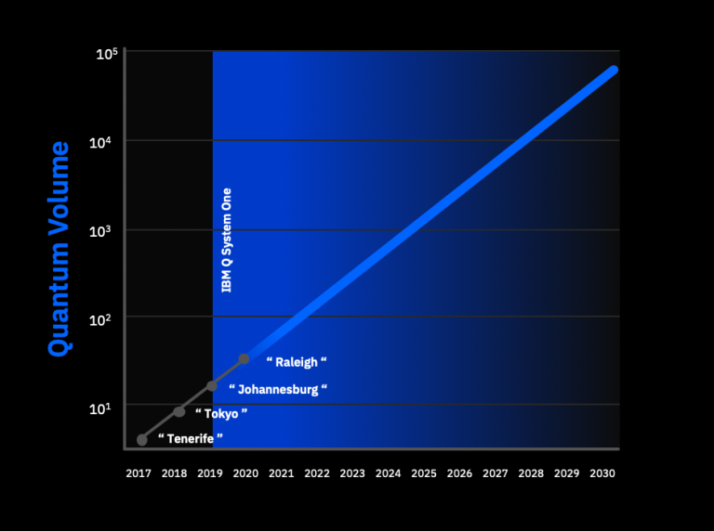

The apparent quantum supremacy achievement marks just the first of many steps necessary to develop practical quantum computers. The fragility of qubits makes it challenging to maintain specific quantum states over longer periods of time when performing computational operations. That means it’s far from easy to cobble together large arrays involving the thousands or even millions of qubits that will likely be necessary for practical, general-purpose quantum computing. And as we can predict from the qubit numbers of quantum computers created from 2006 up to now the maximal number of qubits are nearly getting 1.6 times more each 2 year. So roughly speaking from 2028 we can expect from thousands to million qubit computers. Such huge qubit arrays will require error correction techniques that can detect and fix errors in the many individual qubits working together. This will also enlog the time of functional quantum computing.

So we think that the functional computer will be created nearly in 2030.

# Question 4

As for TI quantum computers we think that they will succeed nearly after the success of SQ ones.

IonQ Has the Most Powerful TI based Quantum Computers With 79 qubits and 160 Stored Qubits. This happened in december 2018, 9 months after Google’s 72 qubit superconducting quantum computer. The time difference of success between SQ and TI from a quantum volume perspective is not long, they are nearly in the same wave. In 2030, there will be fully error-corrected quantum computers with 100,000 to millions of overall qubits but only 1 in 1000 will be used for calculations. The rest will be needed for error-correction.

We can support our reasoning with one of the articles of Project 2 - [Observation of a Many-Body Dynamical Phase Transition with a 53-qubit Quantum Simulator](https://www.nature.com/articles/nature24654). This article is one of the indicators that creating TI quantum technology has a big potential. This quantum simulator was the largest quantum simulation, and therefore, was revolutionary. As the experts working on this project stated, their product has all chances not only to grow to an even bigger and multi-functional simulator, but lead to the first universal quantum computer. The sensation that this simulator made in the scientific world also suggests that this technology should be taken seriously.

Also, we found a very an interesting article [[1904.04178] Trapped-Ion Quantum Computing: Progress and Challenges](https://arxiv.org/abs/1904.04178) that very nicely illustrated what TI technology is, how it works, what benefits it has, the challenges it faces and concludes that Trapped Ions made great contribution to Quantum products and they will continue doing so. The article also talks about the possibility to scale Trapped Ion computers. It ends with the acknowledgment of the difficult challenges of TI computers, however, challenges exist to be completed, and in this case, the reward will be a very powerful quantum computer, and even more.

# Links

<https://www.nature.com/articles/nature24654>

<https://arxiv.org/abs/1904.04178>