

### 

### PROJECT

**“PAWSCARE AMBULANTA”**

### PART I – INTRODUCTION 3

### PART II – TEHNICAL DOCUMENTATION 4

### PART III – CONCULSION 30

## INTRODUCTION

Welcome to "Paws Care" - your go-to platform for pet care. By registering and logging in, you gain incredible possibilities. Say goodbye to phone calls and waiting in lines - schedule appointments with veterinarians and other pet service providers online. Share blogs, stories, and tips with the community, and showcase photos of your beloved pets. Join "Paws Care" and experience the convenience and enjoyment of pet care.

## **PROJECT OVERVIEW**

We began by finding a suitable template that perfectly aligned with our vision and customized it to meet our specific requirements. The first task was creating essential pages such as the homepage, contact page, and complete HTML and CSS structure. To provide access to specific features, we implemented user login and registration functionality.

Next, we focused on developing a blogging system that allowed users to create, view, like, and comment on blogs. Users had full control over their own blogs, with the ability to edit or delete them. We also implemented user profiles, enabling users to create personalized profiles, add profile pictures, provide their birthdate, contact information, and links to their social media profiles. On their profiles, users could see the number of published blogs, along with likes and comments received.

To enhance user experience, we implemented a search functionality, making it easier for users to navigate and find specific content on the website. Additionally, we incorporated a pet gallery feature, allowing users to showcase pictures of their beloved pets. The gallery displayed the latest six images on the index page, while the rest could be viewed in a separate section. Users could delete their own images and interact with others' pictures by liking, commenting, and replying to comments.

Another essential functionality we implemented was appointment scheduling. Users could easily and quickly schedule appointments, view their upcoming appointments, and make changes if needed. Detailed information about scheduled appointments was sent to users via email, which they provided in the appointment form. Users could also access their scheduled appointments on their profiles.

These functionalities, ranging from blogging and user profiles to appointment scheduling and pet galleries, make our platform an all-in-one solution for pet enthusiasts. We strive to provide a seamless and enjoyable experience for users to connect, share, and care for their beloved pets.

TECHNICAL DOCUMENTATION

1.0HEADER

**Description:**

**As a User**, I want the header to include a navigation bar with links that allow me to easily navigate to different pages on the website. When I am logged in, I would like to see a button to visit my profile and a button to log out.

**As an Admin**, I want the header to be reusable across all pages, providing consistent functionality and design. I expect the header to include a selection of links and buttons that grant me access to specific pages and features relevant to my administrative tasks.

**Acceptance criteria:**

**As a user:**

* I can see a header with a logo and a dropdown menu containing links to different sections of the website.
* I can see a search form for searching.
* I can see buttons for login and registration in the main menu.
* I can access the home page, which leads to the main index HTML.
* I can access the blog page, which, when opened, displays a dropdown menu with options to add a blog post.
* I can access the gallery page, which leads to a gallery of favorite pets. When opened, the dropdown menu includes an option to add an image.
* I can access the appointment page, which leads to a form for adding a scheduled appointment, as well as a page to view all my scheduled appointments.
* I can access the contact page, which provides information such as phone numbers and a map of the veterinary clinic.

### When I'm not logged in:

I see login and registration buttons in the main menu.

### When I'm logged in and have my own profile:

I see buttons for logout and profile in the main menu. Clicking on the profile button allows me to visit my profile and edit settings, such as password.



### When I'm logged in but don't have my own profile:

I see a logout button and the option to create a profile. After creating a profile, I can visit and edit it.



**As an admin:**

* I can customize the website logo and navigation links.
* I can modify the visual style of the navigation links.
* I can change the username and avatar in the admin panel.
* I can customize the visual style of the header.
* I can add or remove action buttons for login and registration.
* The header can be reused on every page.

## 1.1 Search

**Description:**

**As an Admin**, I wanted to create a search form in the navbar to facilitate users in searching for blogs and user profiles on the website.

**As a User**, I would like to have a search form that makes it easier for me to find what I'm interested in on the website.

**Acceptance criteria:**

**As a User**

* I can see that there is a search form next to the dropdown menu.
* I can see that when I enter text in the form and press the "search" button, I will be redirected to another page where I will get the results for what I searched for.
* I can see that if my search does not have any results, I only get the text of my search but not a link to explore further.

**As an Admin:**

* I can change the placement of the search form on the page.
* I can modify the way the search form is displayed.
* I can adjust the size of the input field.
* I can change the color and size of the search button.
* I can modify the text on the search button.
* I can customize the appearance of the page and the link that displays the search results.
* I can customize the layout of the page that shows when the search results are not found.



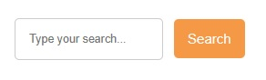

**search result search form**

2.0Footer

**Description:**

**As an Admin**, I want the footer to be reusable for every page, and I want it to include important elements such as a phone number, social network links, and the opening hours of the veterinary clinic.

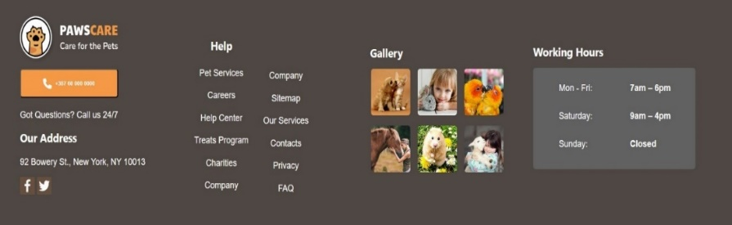**As a User**, I want the footer to be useful and contain important information such as the phone number, social media links, and the working hours of the veterinary clinic, so that I can easily find and contact the clinic.

**Acceptance criteria:**

**As a User:**

* I can see a recognizable logo in the footer that represents the veterinary clinic.
* I can see a prominent button with contact information, including phone number, address, and social media icons.
* I can see a helpful section in the footer that provides information about the services offered.
* I can see a mini gallery displaying interesting pictures of animals.
* I can see the working hours section in the footer, which provides information about the clinic's operating hours.

**As an Admin**:

* I have the ability to edit and change the website logo in the footer.
* I can modify the links in the footer and customize their visual style.
* I have the option to add or remove buttons and links for specific actions.
* I can adjust the visual style of buttons, menu links, and social media icons in the footer.
* I can also customize the visual style of the header.
* The footer is designed to be reusable on every page.

3.0Registration

**Description:**

**As a User**, I want to be able to quickly and easily register on the site. Additionally, I want the option to easily access the login form if I already have an account.

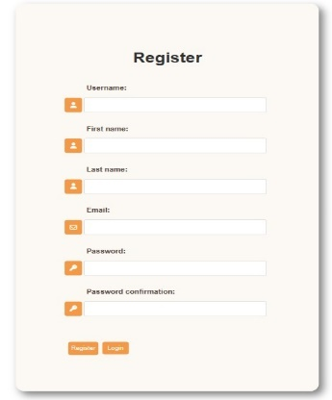**As an Admin,** I want to provide the user with a simple and clean registration form. I want user to have a log in button on the side if he already have an account.

**Acceptance criteria:**

**As a User:**

* I can see a registration form where I can enter my username, first name, last name, password, and confirm password.
* I can see a registration button that allows me to submit the form and create a new account.
* I can see a success message displayed as "Registration Successful" if the registration process is successful.
* I can see an error message or be redirected back to the registration form if there is an issue with the registration.
* I can see a login button at the bottom of the form to easily access the login page.

**As an Admin:**

* I can see and manage the registration form for users.
* I can modify and customize the fields and layout of the registration form.
* I can add additional validation or requirements to the registration process.
* I can configure the success message displayed upon successful registration.
* I can access and administer user accounts created through the registration form.

4.0Login

**Description:**

**As a User,** I want to be able to quickly and easily logout from the site through my account page.

**As an Admin,** I want to provide the user with a simple and easy logout.

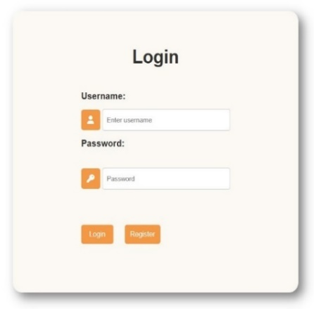

**Acceptance criteria:**

**As a User:**

* I can see a login form with fields to enter my username and password.
* I can see a navigation button in the navbar that leads me to the login form.
* If I haven't registered yet, I can see a button in the login form that takes me to the registration form in case I forgot to register previously.

**As an Admin:**

* I can change the visual style of the logout button.
* I can change its location.
* I can change the redirection after a successful log out.
* I can edit the pop-up notification container, as well as the context inside it, for a successful log out.
* I have the ability to customize the login form and its visual style.
* I can add or remove additional fields or buttons in the login form to suit specific requirements.

5.0Loguot

**Description:**

**As a User,** I want to be able to quickly and easily logout from the site through my account page.

**As an Admin,** I want to provide the user with a simple and easy logout.

**Acceptance criteria:**

**As a User:**

* I can see the logout link "Logout" in the navbar if I am logged in.
* Clicking on the logout button logs me out and redirects me to the login page.
* A pop-up notification confirms the successful logout.

**As an Admin:**

* I can change the visual style of the logout button.
* I can adjust the location of the logout button in the navbar.
* I can customize the redirection after a successful logout.
* I can edit the content of the pop-up notification container for successful logouts.



6.0HOMPAGE

## Hero section

**Description:**

**As a User**, I would like to have a simple banner with a welcoming text and a button that takes me to a page where I can get more detailed information and explore the offered services.

**As an Admin**, I would like to attract the attention of users with a cute banner that welcomes them and provides them with the opportunity for further information.

**Acceptance criteria:**

**As a User:**

* I can see an eye-catching image of an adorable pet in the hero section, capturing my attention.
* I can read the text "WELCOME TO PAWSCARE! Best Care Of Our Little Friends" displayed in the hero section, creating a welcoming atmosphere.
* I can click on the "LEARN MORE" button to navigate to the contact page, allowing me to gather more information and easily get in touch. I can observe small cards below the main text, showcasing a selection of services, such as:
* I can see the card for Pet Boarding, offering a safe and comfortable place for dogs and cats to stay while their owners are away.
* I can see the card for Dog Walking, indicating that professional dog walking services are provided to ensure pets get the exercise they need.
* I can see the card for Pet Grooming, highlighting grooming services aimed at pampering and enhancing the appearance of pets.

**As an Admin:**

* I can change the image of the pet in the hero section to attract users' attention.
* I can modify the welcome text on the page. I can customize the appearance of the "Learn More" button and change its destination.
* I can alter the design of the service cards and update the content displayed on them.

## 6.2About

**Description:**

**As an admin in** the "about" section, I would like to point out that PAWSCARE is a leading supplier of specialized services and solutions for pets. I also wanted to express the importance of people's care for animals.

**As a user**, I want to have a section where I can see the expertise of the staff and their attitude towards animals.

**Acceptance criteria:**

**As a User**

* I can see on the right side a text that tells me about the attitude of the staff towards the animals as well as some of the advantages of this clinic.
* I can see some of the prominent services such as "skilled personnel" "best veterinarians" "pets care 24/7" "quality food"
* I can see on the left a picture of a happy dog.

**As an Admin**

I can change the size of the title

* I can change the content of the text
* I change the color of letters
* I can change the font
* I can delete a certain part of the text
* I can resize the image as well as its size
* I can delete the picture
* I can change the background color of the sketch
* I can change the arrangement of the elements in the section
* I am an admin, and in the "services" section I wanted to show some of the many jobs we offer
* I am a user and I would like to see a section showing the services I can get from the veterinary clinic.
* I am a user
* I can see the title and text that indicates the benefits and services offered by the given page
* I can see cards with pictures of pets and special services such as best activity veterinary care hotel for pets
* Me as an admin
* I can change the title
* I can change the font size
* The color of the letters
* Shape of picture cards
* Layout of picture cards
* Text below images
* I can delete pictures

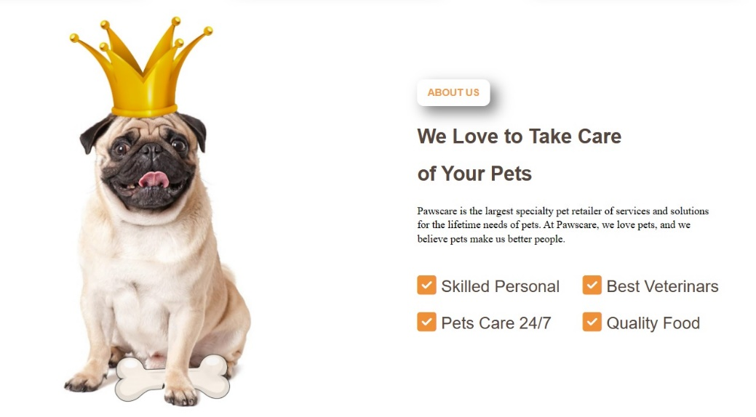

## 6.3Adventages

**Description:**

**I as an admin** in the “adventages section” wanted to show in an interesting way the benfits of our ambulance.

**I as an user** wanted to see the section in which they can show me the adventages of this ambulance and why should I chose it.

**Acceptance criteria:**

**As an User**

* I can see the “benefit section” which is divided in two parts.
* I can see on the left side the new pages which can be opened and can show text when I click the button “read more”
* When I open the new page I can see the text which is telling about the adventage of this ambulance.
* I can see on the left side cute picture of dog and cat.

**As an Admin**

* I can change the look of headline in “adventage section”
* I can change the way of accessing text in this section.
* I can change the look of new pages with highlight adventages.
* I can change the arrangement of the new pages.
* I can change the picture of the pet from the right side.

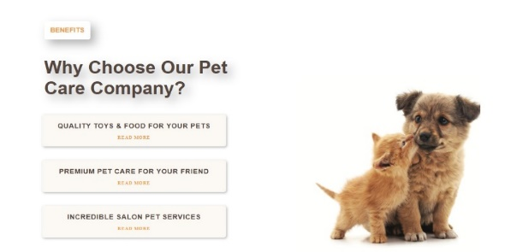

# 6.4Services

**Description:**

**As an Admin**, I wanted to display the services offered by our veterinary clinic in the "Services" section.

**As a User**, I would like to have a section where I can see the services provided by the veterinary clinic.

**Acceptance criteria:**

**As a User**

* I can see that this section is divided into two parts.
* I can see that the top part contains the heading "What We Can Offer" and text describing this clinic and its approach to pets.
* I can see that the bottom part consists of a section with images and highlighted services.
* I can see that there are three images displayed in a row.
* I can see that these images are in the form of cards and consist of an image and the name of the service.
* Some of the services I can see are pet boarding, the best activities for pets, and veterinary care.

**As an Admin**

* I can change the background color of the section.
* I can modify the content of the heading.
* I can change the color, font, and size of the heading.
* I can rearrange the displayed cards.
* I can replace the images in the cards.

## 

## 6.5Facts

**Description:**

As an Admin in the "facts" section, I wanted to highlight important facts about our clinic

As a User, I wanted to see a section where the facts about that clinic will be presented to me.

**Acceptance criteria:**

**As a User**

* I'm a user, I see a background image of a dog.
* I see that on that picture there is a title in the learn more button and the “paws” icon
* I can see on the right a section of 4 smaller tabs on which the facts are highlighted.
* I see that they have over 250 satisfied customers
* I see they have a dedicated team with 10+ years of work experience
* I see their team consists of 15+ members
* I see they have worked with 360+ pets
* Below I can see an interactive card with logo tags that rotate when I hover over them.

**As An Admin**

* I can change the title
* I can change the color of the socks
* I can change the size of the title
* I can change the size and appearance of the "learn more" button.
* I can change the background photo
* I can change the arrangement of elements
* I can change highlighted facts
* I can change the interactive card, its color, the layout of the logo display on it and the way they behave when hovering.

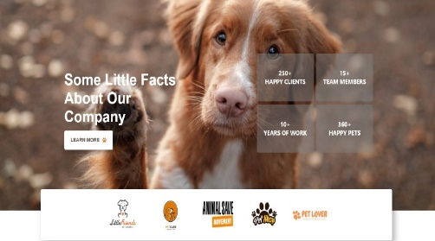

# 6.6Gallery

**Description:**

**I as admin,** with this section “gallery” I wanted to make a part which is convinient for registrated users. This section could enable them to share images of their pets and also to like and images of other pets.

**As a user**, I would like to have a section where I can post pictures of my pets and also view, like, and comment on pictures of other people's pets.

**Acceptance criteria:**

**As an User**

* I can see that first and the last pictures are highlighted because they are wider than the others.
* When I access the drop down manu , I can see the option of “add image”
* I can see when I add image in that form , it shows up in my galley on home page.
* When I press the button I can see a new page.
* I can see the headline “Paws Care Gallery”
* Under the headline I can see a lot of pictures that were added by user.
* I can see that the pitcures are I the shape of cards and that under each picture there is a usrename of the person that added that picture and also his picture.
* I can see that next to the picture and his user name there are a button on which says “show”
* I can see that there is a button under every picture, and also I can see that under the picture that I published there is a button “delete”
* When I press the button “show” I can see a new page, and that page there is a picture on which I pressed and which is enlarged.
* And again I can see his username and the picture which added this picture.
* I can see that under that picture there is a button on which says “like” and there is an icon for like.
* I can see that next to this button there is a number of likes.
* When I press the like button, I see that the number of likes increases and the button changes to 'Unlike' with an unlike icon.
* I can see that next to this button for likes there is a button on which says “commnet” and there is also an icon of comments.
* I can see that when I click on that button it leads me on the form for adding comments.
* I can see that next to that button there is also a number of comments.
* I can see that under this picture there are comments.
* I can see there is also a picture and userename of this person who comments that picture, under the text who wrote that. I can see that under this comment there are date and time.
* I can see that under this comment there is a button for like, which functions on the same way as liking the picture.
* I can that under this comment there is form on which I can replay to comment.
* I can see that the form of replay looks the same as the comment himself, and only difference is that replay has darker background. All the other possibilities are same.
* I can see that when I add my comment or replay, pop up the button for delete, which I don’t have when I look other comments and replays.

As an Admin

* I can change the schedule of look od gallery
* I can change the look of the form for adding pictures.
* I can change the look of pictures and text when I hover the pictures.
* I can change the look of the button which lead me to the gallery whit the pictures.
* I can change the headline on the page with picture.
* I can change the look of the gallery and the arrangement of pictures.
* I can change the look of the pictures, the display for username and his pictures.
* I can change the form of the button for showing and deleting.
* I can change the appearance of the like and comment buttons, as well as modify their functionality.
* I can change the look of the form for adding comments.
* I can change the appearance of comments by modifying the font, letter color, and background color.
* I can change the way and the arrangement of users photograph and as well I can change text and date of adding comments.
* I can change the form of reply on the comment
* I can change the look of like button and delete button

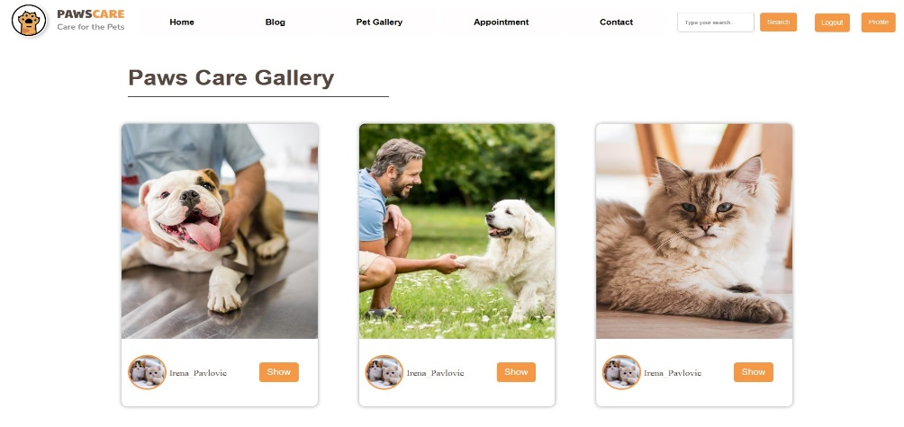

# 6.7Testimonials

**Description:**

**As an Admin** in this section, wanted to show opinions from our patients.

**As a User** I wish there was a section in which I can see the opinion of other people.

**Acceptance criteria:**

**As an User**

* I can see the headline and the text about the roles of this page.
* I can see the photographs of people with their pets. I can see the names of users and the breed of their pets.
* I can see their opinions on the vet ambulance.
* I can see the number of “paws” the gave.
* I can change the colors and font of the text.
* I can change the photographs of users and also add text.

**As an admin**

* I can change the appearance of titles in this section.
* I can change the layout of the display.
* I can change the way it is presented.
* I can change the users to be displayed.
* I can change the appearance of user photos.
* I can delete and add users and text.

7.0Blog

**Description:**

**I'm an admin** and I wanted to create a section for the blog where my cross-breeders will add their experiences, who can post pictures of their pets and funny stories about them. I wanted that functionality to be easy and representative for them.

**I am a user** and I would like to have a section where I can publish my blogs in an easy and simple way.

**Acceptance criteria:**

**As an User**

* I see that if I am logged in, I can access the blog browsing section very easily via the navbar
* I see that in the section for blogs there are two options blog and add blog
* I see that if I click on the blog option, the blogs of all users are listed
* I see that the blogs are displayed in the tab
* I see that the image is shown first if there is one
* I see that immediately below the picture is the date of publication and then the name of the user
* I see that a large title is displayed and that there is text below it
* I see that I can read the whole text if I press the "learn more" button
* When I do that, I'm taken to another page that shows details about that blog
* The same photo is shown in a larger format
* I see that the date of publication, the title username AND the user's picture are displayed again
* I see that in the right corner there is a button for liking the photo
* I see the number of likes next to it
* I see that next to the like button there is a comment button in the number of comments
* I see that the entire text of the blog is under the photo
* I see that under the text that the user has written there are also details about him, such as pictures, username, short biography and social networks
* I see that under the description of the user there are comments.
* I see that it consists of a picture and the username of the user who assigned the comment and the comment itself
* Under the comment I see the text "add your comment"
* I can click on that text and then the form for adding a new comment opens.
* I see that below there are buttons to return to the page with blogs, to display the profile of the user whose blog it is, as well as buttons to edit and delete the post if it is your blog, if it is not there, they will not appear.
* I see that if I press the "add post" option in the navbar, it takes me to the for u to add a new post
* The form consists of a picture on the page that says "add your post" and a picture for entry
* I see that the entry forms "Title" "Title tag" "body" and "image" are similar.
* I see that when I fill out the form requirements and press the "Post" button located below the field, my post is published and I can see it on the blogs page.
* I can edit my blog by going to the detailed view of my blog and pressing the "edit post" button, then a new form will open with filled-in fields with data that I already entered when publishing them, I can change them and press the update button
* If I want to delete my blog, I press the delete button, I see that it asks me again if I want to delete the photo, if I'm sure, I press delete again and it will be deleted
* I can also press the back button to return only to the detail and display if I'm unsure about deleting the photo.

**As an Admin**

* I can change the appearance of the displayed blogs
* I can change the font color
* I can change the image published on the blog from the AMD panel
* I can change the title
* I can change the user
* I can change the text written by the user
* I can delete any blog
* I can change the "learn more" button
* I can change the number of likes and the like button
* I can collect likes and comments
* I can change the biography of the crosser who published the blog
* I can change the appearance of the form for adding a comment as well as the way it is accessed
* I can change the buttons that are used to return to the first page, display the user profile, update and delete

8.0Appointment

**Description:**

**I'm an admin** and I wanted to create a simple system for scheduling appointments that will make it easier for users to schedule appointments for their pets without phoning and standing in line. Like I, they move or ask for their appointment in a unique way

**I am a user** and I would like to have a simple scheduling system so that I don't have to wait in line or call the phone to make an appointment.

**Acceptance criteria:**

**As a User**

* I see that there is an appointment section in the navbar
* I see that when I hover over it, I get the options add appointment and show appointment
* I can click on the item add appointment, when I do that a form for scheduling an appointment appears
* I see that the form consists of a background photo of the pet AND a field for entering the term.
* I see the input fields "Patient Name", "Animal Breed", "Animal Age", "Time", "Date", "Appointment Reason"
* I see that below the input field there is a button that says make an appointment
* I see that when I fill out the form and press the button, I get the message "appointment successfully scheduled"
* I see that if I try to schedule an already taken appointment, I get the message "The term is already taken. Please choose another date and time.”
* I see that if I try to make an appointment on Sunday, I get a message "
* Scheduling on Sundays is not possible."
* I recently noticed that if I try to make an appointment too late or too early, I get this message "
* You can schedule an appointment only between 8 AM and 6 PM.”
* I see that after the scheduled appointment, I receive a message on my email about the scheduled appointment, as well as the time of the appointment.
* I see that when I visit show appointment, I get a card with my scheduled appointments and all the data I entered during the appointment.
* At the bottom of the card I have two buttons, one for canceling the appointment and the other for changing the appointment.
* I see that if I press the button to change the appointment, I get the same appearance of the appointment form with all my data. When I change what I wanted and save the appointment, I get a tick with the new appointment and an email message
* I notice in the update if the appointment does not meet the conditions specified during the appointment, so we receive a new messages indicating that we can make another appointment.
* If I want to cancel an appointment, all I have to do is press the cancel button and the appointment will be canceled, also deleted from our appointment cards.
* I can see that messages about appointments that have been moved and canceled are coming to my email.

**As an Admin**

* I can change the background image on the appointment page
* I can change the appearance of the fields, the color of the letters and the font
* I can change the appearance of the appointment button
* I can change the text of the incoming message as well as its appearance
* I can change the mail that arrives to the user, its appearance and the text inside it
* I can change the appointment conditions
* I can change the appearance of cards with scheduled topics
* Their way of showing
* I can change the information displayed in them
* I can change the appearance of the button for changing and canceling an appointment
* I can change the appearance of the email that arrives when changing and canceling
* I can edit and delete all appointments

9.0Contact page

**Description:**

**I, as an admin**, wanted to create a special contact page to make it easier for users to find the location of our clinic as well as to contact us via message.

**As a user**, I would like to have a contact page where I can easily contact and find a clinic.

**Acceptance criteria:**

**As a User**

* I can see the "contact" option in the navbar
* I see that when I click on it, I am transferred to another page

## 9.1 Hero section for contact page

**Description:**

**As an admin,** I wanted to create a hero action for the contact page that would be similar to the hero section on the home page, and highlight the functionality of this page in the title.

**As a user,** I want to see the hero section on the contact page, which should be similar to the initial one, and I expect to see the heading 'Contact' that indicates it is the contact page.

**Acceptance criteria:**

**As a User**

* I can see a large background - a picture of a cat
* I can see the big "Contacts" text over that photo.

**As an admin**

* I can change the background photo
* I can resize that photo
* I can change the title
* I can change the font of the title
* I can change the color of the titles and the place where they will be displayed

## 9.2 Info section

**Description:**

**I, as an admin**, wanted to create a section with information in which I will mention the email address and the number where the owners can contact us, I also wanted to show our location on the map for easy navigation.

**As a user**, I want to have an info section where important information are displayed so that I can easily get in touch and find a veterinary clinic.

**Acceptance criteria:**

**As a User**

* I see that the info section is divided into two parts
* I see that on the left side there is a big title "stay connected"
* I see that under the title there are 3 cards that indicate the address of the clinic, the email of the clinic and the phone number where I can contact them.
* I see that when I move the cursor over the cards, they change color
* I see that on the right there is a map showing the location of the clinic

**As an Admin**

* I can change the arrangement of elements on this section
* I can change the color, size and text in the title
* I can change the layout of the information cards
* I can change the information inside the cards
* I can change the color of the cards that change when hovering
* I can change the size and shape of the cards
* I can change the way the map is displayed as well as the location that will be displayed on it

## Send message sections

**Description:**

**As an admin**, I wanted to create a section in which there will be a form for sending messages in order to enable users to contact us more easily, as well as to see what suits users the most.

**As a user**, I would like to have a section where I can easily and simply send a message, get in touch and give my opinion.

**Acceptance criteria:**

**As a User**

* I can see the form for sending messages
* I can see that there are 3 fields in which I enter my username, my email and a message
* I can see that under the field there is a button nom says "GET IN TOUCH"
* I see that when I fill out the form and press that button I get the message "Thank you for your message!"
* I also see that the messages I sent can appear on my profile in the "Message" section.

**As an Admin**

* I can change the size and background color of the message form
* I can modify the size and appearance of input fields
* I can customize the color and text on the send message button
* I can edit the content of the message based on user input
* I can adjust the placement of the displayed message
* I can customize the design and display of messages on user profiles.

10.0 User Profile

**Description:**

**I, as an admin**, wanted to enable my registered users to create their own profiles, where they can add their picture, some social network, date of birth, email and phone number, and on which there will be statistics related to that user, his scheduled appointments, statistics, his sent messages..

**I am a user** and I would like to be able to create my own profile that when I visit I can see all my interactions on this website.

**Acceptance criteria:**

**As a User**

* I can see in the upper right corner in the navbar the button for "Create Profile"
* I see that when I press that button, I get a form for creating a profile, which consists of a field for entering a biography, a profile photo, a url for the social network Instagram, a phone number, a field for entering an email and a date of sale.
* I see that under that form there is a button that says "Create Profile"
* I see that if I fill in those fields and press the create profile button, I'm taken to the home page.
* I see that in the place where the create profile button used to be, there is now a button that says "profile"
* I see that when I move the cursor over that button, a small drop-down menu with 2 items "Edit Setting" and "Show Profile" opens.
* -Profile view
* When I press the show profile button, I am transferred to my profile page, where the information that I entered in the form during creation is displayed.
* I see that my profile is divided into several parts
* I see that there is a menu on the right side where my profile photo is highlighted and username at the top of the menu, I see that there are different options under the photo.
* I see that there is a "List Blog" option, when I click on that option I am transferred to the page where the blogs of all chroniclers are displayed, I see that I can view each blog in detail and only my own blogs can be edited and deleted.
* I see that there is a message option, when I enter it I can view all the messages I sent in the contact form
* I see that there is an update account option, when I click on it, I get a card with all the information that I entered when creating the profile, which I can change, and then by clicking on the "update profile page" button, I save those changes
* I see an add image option that when I click on it I get a form to enter a photo that when I enter and save it is displayed on my home page in the gallery section as o on the "Paws Cre Gallery" page that I can access from my navbar.
* I see the appointment option, which when I press it, I will be transferred to a page where all my scheduled appointments are displayed, which I can change or delete, if I have no scheduled appointments, I see the message "You have no scheduled appointments."
* I see the logout option, which when I press it, I am logged out of my profile.
* I see that next to the menu there is a display of all the blogs that I have published, if there are no published blogs, the message "You haven't published any blogs yet" is displayed, and below there is an add blog button that provides a form for adding a blog.
* I see that my published blogs are located one below the other presented in tabs that show the image, title, number of likes and the publication date of my blog
* I see that there is also a "learn more" button on the tabs, which when I press it, I will be transferred to a detailed view of the published blog.
* I see that 3 blogs are displayed one below the other, and below them is pagination, which enables the viewing and display of all blogs.
* I see that next to the blogs there is a tab with my data, which consists of social network icons that, when clicked, lead to the social network
* Below the icons is my profile picture
* I see that under the profile picture there is my username and the data I entered, such as my phone number, email, date of birth
* I see that at the bottom of the card there are buttons for delete and update profiles
* I see that next to the tab with my data there are 3 tabs that represent blog statistics
* The first tab represents the total number of likes on all published blogs
* The second card represents the number of polishes on all
* The third tab represents the number of comments on all blogs
* I see that below there is a message from a do-gooder, which is shown on a piece of paper holding a dog and a cat
* I see that if I click on edit segttings, I will be transferred to the page where my files are displayed, username, firstname, lastname, password will pop up, which I can change

**As an Admin**

* I can change the appearance of the profile creation button
* I can mention the place where it will be displayed
* I can change the data entry form to create a profile
* I can change the path that takes the user to the home page after creating a profile
* I can change the way the profile is displayed and edit settings in the navbar
* I can change the appearance of the profile
* I can delete and edit the user profile
* can change the composition and appearance of the options in navbar
* I can change the way user information is displayed
* I can change the appearance and printing of blog statistics
* I can apply the method of displaying the welcome message
* I can change the way all user blogs are displayed
* I can change the way pagination is displayed
* I can change the message that is displayed if the user has no published blogs
* I can change the layout of the "edit settings" page.

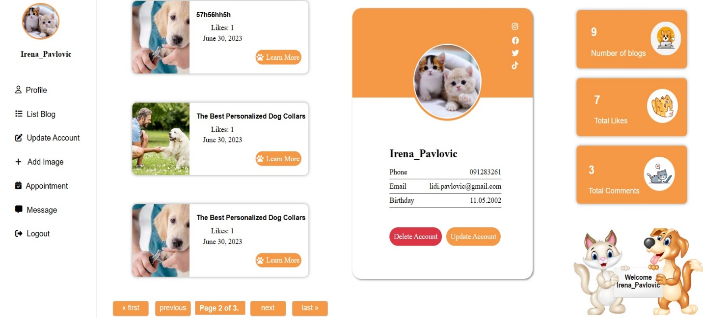

# CONCLUSION

This project has been successfully completed with the guidance and support of our mentor. Throughout the project, we have gained valuable knowledge and grown both personally and professionally. Moving forward, we have plans to further enhance the aesthetics of the page to improve its overall appearance. Additionally, we aim to enhance the functionalities and explore opportunities for adding new features. Refactoring the code is also on our agenda to optimize it and make it more efficient. We are excited to continue working on this project and strive for continuous improvement.