**MySQL Labs**

**MySQL (Day1):**

|  |  |
| --- | --- |
| **1** | **Create a database called grades** |
|  | **CREATE DATABASE grades** |
| **2** | **Create the following tables in the grades database:**  ***courses***  ***course_id*** *int pk*  *course_name varchar(100) not null*  *credit_hour int*  ***students_courses***  ***course_id*** *int*  ***student_id*** *int*  *grade int*  *reg_date date*  ***students***  ***student_id*** *int pk*  *student_name varchar (100) not null*  *email varchar (50)*  *tel varchar (20)* |
|  | **use grades**  **CREATE TABLE students (_id INT primary key, student_name varchar(100) NOT NULL, email varchar(50),  tel varchar(20))**  **CREATE TABLE courses (course_id INT primary key, course_name varchar(100) NOT NULL, credit_hour INT)  CREATE TABLE students_courses (**  **course_id INT,**  **student_id INT,**  **grade INT,**  **reg_date DATE,**  **PRIMARY KEY (course_id, student_id),**  **FOREIGN KEY (course_id) REFERENCES courses(course_id),**  **FOREIGN KEY (student_id) REFERENCES students(_id)**  **);** |
| **3** | **Modify the students table to allow for longer Student names (150 char)**  **Confirm your modification.** |
|  | **ALTER TABLE students MODIFY COLUMN student_name VARCHAR(150) NOT NULL;** |
| **4** | **Add constraint to force unique email for each student** |
|  | **ALTER TABLE students ADD CONSTRAINT unique_email UNIQUE(email);** |
| **5** | **Get Time, Date, Current user, MySQL Version using prompt?** |
|  | TIME: SELECT CURTIME(); Date: SELECT CURDATE(); VERSION: select VERSION(); CURRENT USER : SELECT CURRENT_USER(); |
| **6** | **Add gender column for the students table. It holds two value (male or female)** |
|  | **ALTER TABLE students add gender ENUM(‘male,’female’)** |
| **7** | **Add birth_date column for the students table.** |
|  | **ALTER TABLE students add birth_date DATE;** |
| **8** | **Drop the student_name column and replace it with first name and last name.** |
|  | **ALTER TABLE students**  **ADD first_name VARCHAR(100),**  **ADD last_name VARCHAR(100); UPDATE students**  **SET first_name = SUBSTRING_INDEX(student_name, ' ', 1),**  **last_name = SUBSTRING_INDEX(student_name, ' ', -1); ALTER TABLE students  DROP COLUMN student_name;** |

**Part II**

**Populate your tables with the following records:**

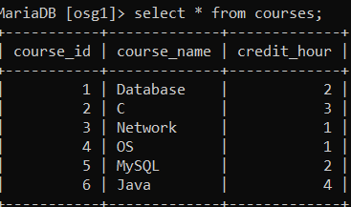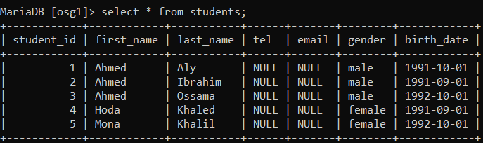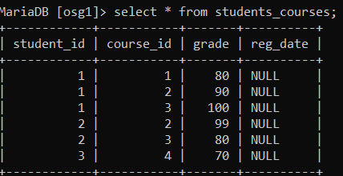

|  |  |
| --- | --- |
| **1** | **Display all students’ information.** |
|  | **SELECT * FROM students;** |
| **2** | **Display male students only.** |
|  | **Select * from students where gender =’male’;** |
| **3** | **Display the number of female students.** |
|  | **Select COUNT(gender) from students where gender =’female’;** |
| **4** | **Display the students’ data for the students who are born before 1992-10-01.** |
|  | **Select \*** from students where birth_date <’ **1992-10-01**’ |
| **5** | **Display the students’ data for the students who are born after 1991-10-01.** |
|  | **Select \*** from students where birth_date >’ **1992-10-01**’ |