Group 13

Author: 任怡静

Software  
 Requirements

Painkiller Injection System

Table of Contents

System Objective 2

Domain Analysis 2

System Architecture 4

Use Cases 5

Message pass Analysis 5

Software Requirements 7

R1: PasswordUI 7

R2: NurseUI 7

R3: Patient Button 8

R4: Control System 8

R5: Pump 8

## System Objective

In this project, we are developing a software that can control a drug pump to inject appropriate amount of drug to patients.

The system fit the medical standard that the drug injected. The max total amount per day is 3ml and the maximum injection amount per hour is 1ml.The range of baseline injection is 0.01-0.1ml/min, and the bolus is 0.2-0.5ml/shot.

By providing interconnected, hierarchical access authorities interfaces to patient and nurse, the system can receive input (baseline injected per minute, bolus injected per shot, and time gap between two bolus injections) from an authorized account (nurse account) and display on the interface, then take confirmation to start the injection process or interchange value during injection.

The system will provide supervisor with real-time amount of injection amount during the last hour, injection amount during last day, the time frame of the most recent bolus injection.

The system gives baseline as long as the injection amount during last hour and last day do not exceed the medical standard, stop when limits reached, and restart the injection the next day. The system also gives a bolus if and only if patient press the bolus button to ask bolus and the injection amount during last hour and last day do not exceed the medical standard. All of which can make the injection more efficient to manage for medics and ensures the safety of patients.

## Domain Analysis

The participants of activities in a drug pump process can be categorized into Nurse and Patient.

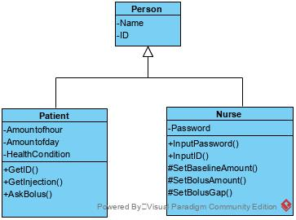

The relationships among different participants are shown as follows:

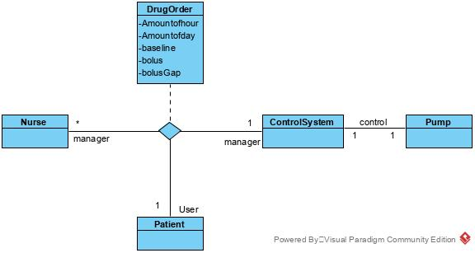

Here is the sequence of events for nurse input corresponding password to enter the control system, and input information to start the baseline injection, stops the pump at some time by pushing Off button.

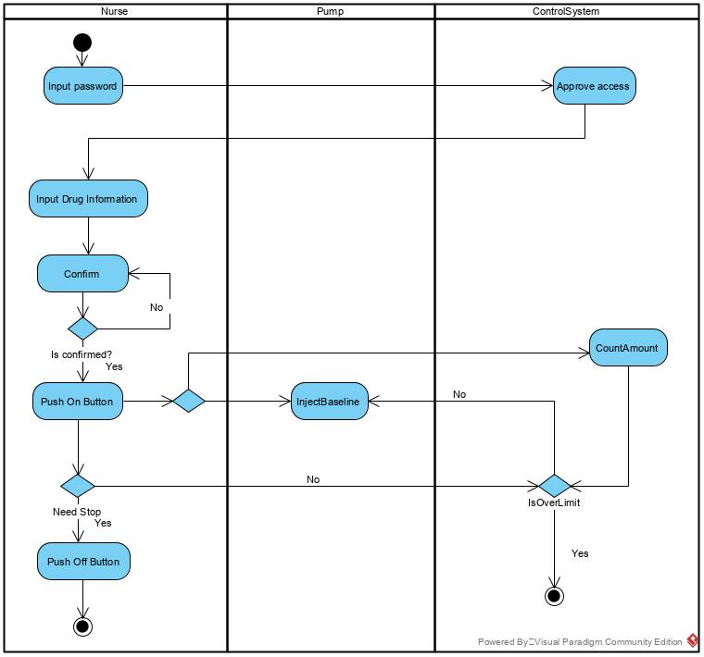

Here is the sequence of events for a patient using the pump when requesting a bolus:

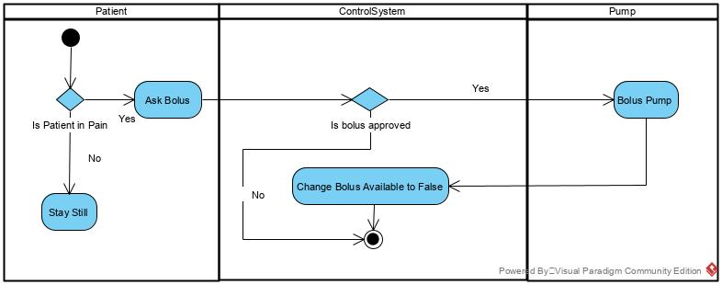

## System Architecture

From the information above, we will design a software system that the pump system holds all the set data such as baseline per minute, bolus per shot, and bolus gap and so on.

The PasswordUI will confirm ID and password, and give access to nurseUI if password is correct

The ControlSystem to judge any requests before sending signals to the physical pump, nurseUI and PatientButton. The Pump will receive from ControlSystem, and process the orders to the physical pump.

The nurseUI and PatientButton are attached to physical architectures, where nurseUI attached to physical pump to display information like the status of the physical pump, amount of baseline injection and bolus injection during last hour and day and so on, the nurseUI will also allow nurse to initiate information and update information of the drug injected, all the confirmed information will be sent back to the ControlSystem for adjustment, also for validation. PatientButton is attached to a physical button for patient to press, and will display status of whether the bolus is available and send message to ControlSystem for verification.

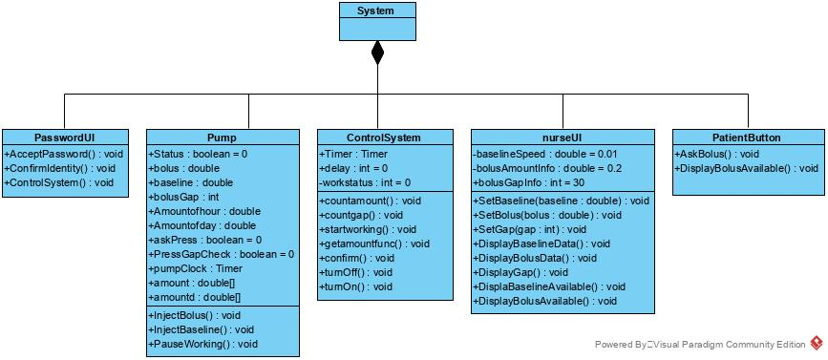

## Use Cases

The system can achieve the following use cases from the nurse’s and the patient’s perspectives:

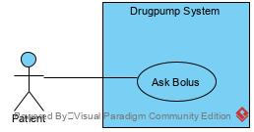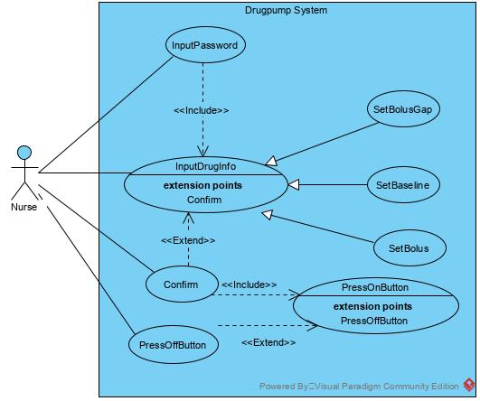

## Message pass Analysis

Here is a diagram of How the message flow when the nurse enters ID and password to make attempt to access the nurseUI:

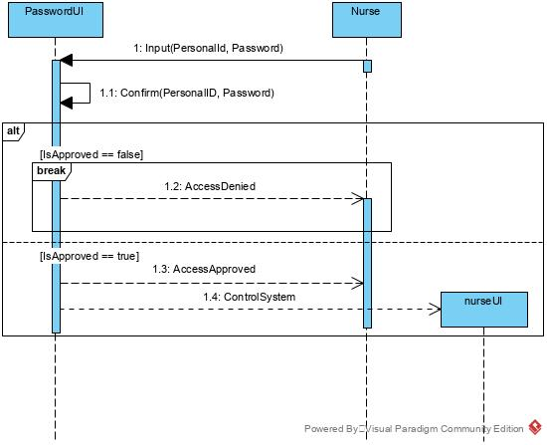

Here is a diagram of How the message flow when the nurse input the data, press confirm to enable the “On Button”, and the drug pump gives baseline constantly, and at some time of the process, the nurse pressed the “Off Button”:

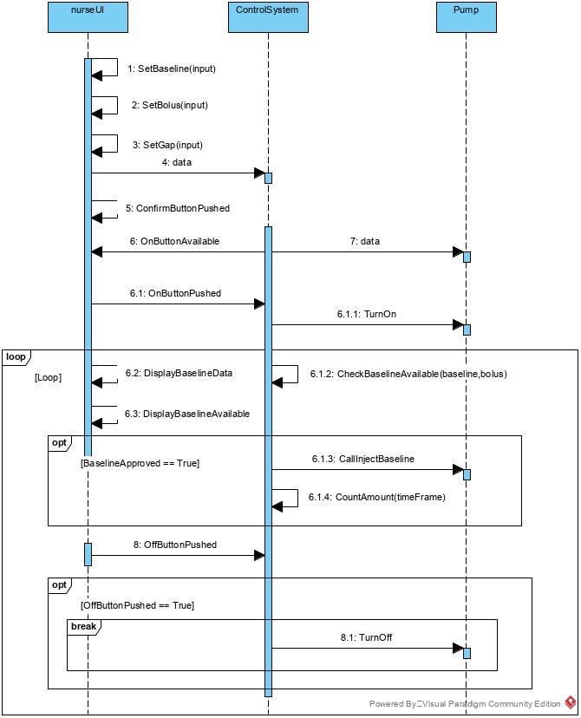

Here is a diagram of how message flow when a patient requires for a bolus:

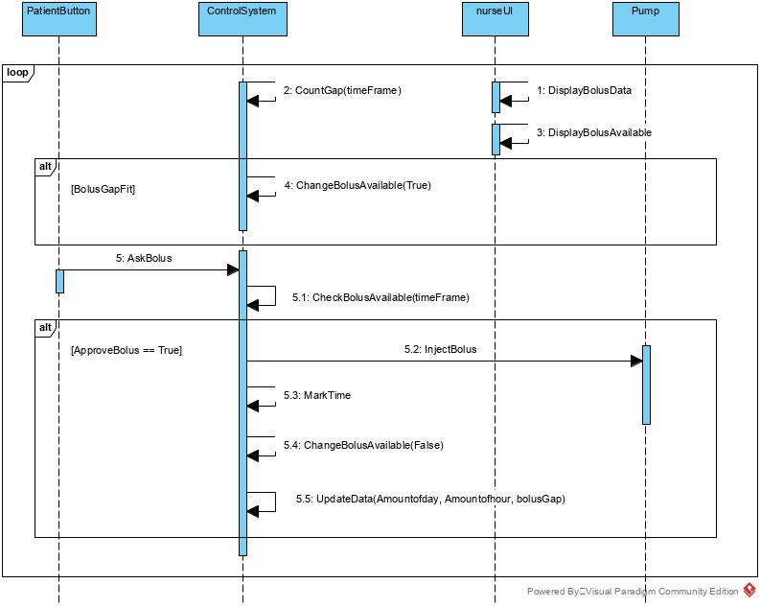

## Software Requirements

### R1: PasswordUI

* R1.1: A person will always have access to nurseUI if input the right ID and password.
  + R1.1.1: The user should be able to input his/her ID and password.
  + R1.1.2: The user should see the nurseUI after entering his/her ID and password correctly, and get a warning of incorrect password or ID.

### R2: NurseUI

* R2.1: The nurse should be able to input the drug information into the nurseUI
  + R2.1.1: The nurse should be able to set baseline injected per minute, bolus per shot and bolus gap which fit the medical requirement mentioned in System Objective section.
  + R2.1.2: The nurse must press confirm to get access to the “On Button”.
* R2.2: The nurseUI should always be under inspection
  + R2.2.1: The nurse should be able to inspect the current set baseline per minute, bolus per shot and bolus gap on the interface.
  + R2.2.2: The nurse should be able to inspect the real-time amount of dose injected in the past 1 hour and past 1 day on the interface.
  + R2.2.3: The status of the pump, whether baseline and bolus is available should be displayed on the interface.
* R2.3: The nurse should be able to modify an input at any time
  + R2.3.1: The nurse should be able to update the data during the injection process, and only send the data to ControlSystem after confirmation, otherwise a warn should be displayed.
* R2.4: The nurse should always be able to stop the pump at any time
  + R2.4.1: The nurse should be able to stop the pump when injection is finished.
  + R2.4.2: The nurse should be able to stop the pump when he/she judges to do so during the process.

### R3: Patient Button

* R3.1: The patient should be able to press the button during the pump is working
* R3.2: The patient should not be able to press the button too frequently
  + R3.2.1: The button will give no reaction if the control system judges the interval of two button press is too short.
  + R3.2.2: The PatientButton’s Bolus Available light will be red if bolus not available.

### R4: Control System

* R4.1: The control system should be able to verify the requests during process
  + R4.1.1: The control system should be able to verify baseline injected during last hour to fit the medical requirement and the setup by nurse.
  + R4.1.2: The control system should be able to verify bolus injected time fit the medical requirement and setup by nurse
  + R4.1.3: The control system should be able to verify when PatientButton send the AskBolus request.
* R4.2: The control system should be able to communicate with other modules
  + R4.2.1: The control system should be able decide whether to let Pump execute InjectBaseline or not.
  + R4.2.2: The control system should be able to decide whether to let the Pump execute InjectBolus or not.

### R5: Pump

* R5.1: The ControlSystem will always be able to give signals to Pump when the machine is on.