Group 13

Author: 陈怡珺

Software Specifications

Drug Pump System

Table of Contents

System Architecture 3

Software Specifications 3

S1: PasswordUI implementation 3

S2: nurseUI Implementation 5

S3:Controlsys Implementation…………………………………………………………………………………………………………8

S4:PatientButton Implementation…………………………………………………………………………………………………10

## System Architecture

The system architecture is shown below:

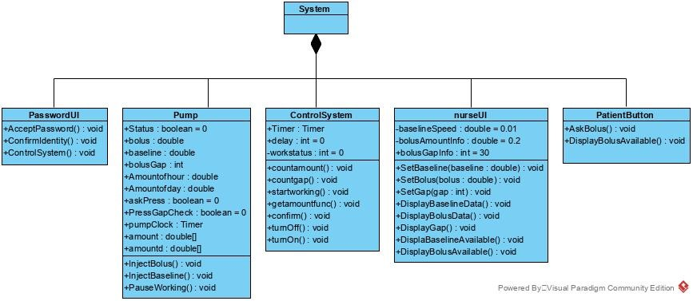

## Software Specifications

### S1: PasswordUI implementation

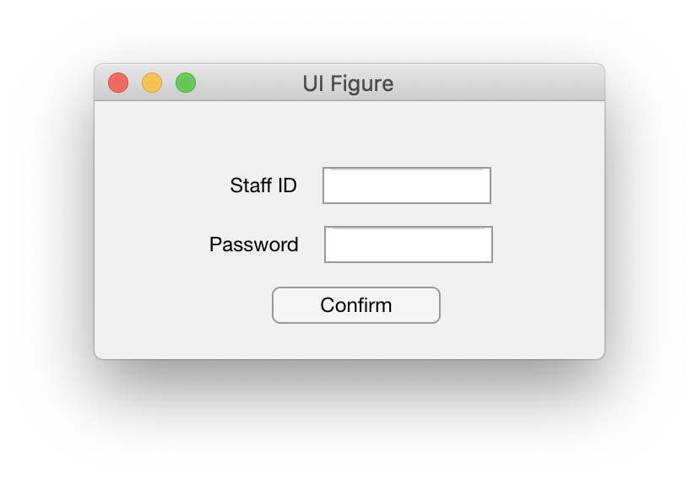

#### S1.1: Login

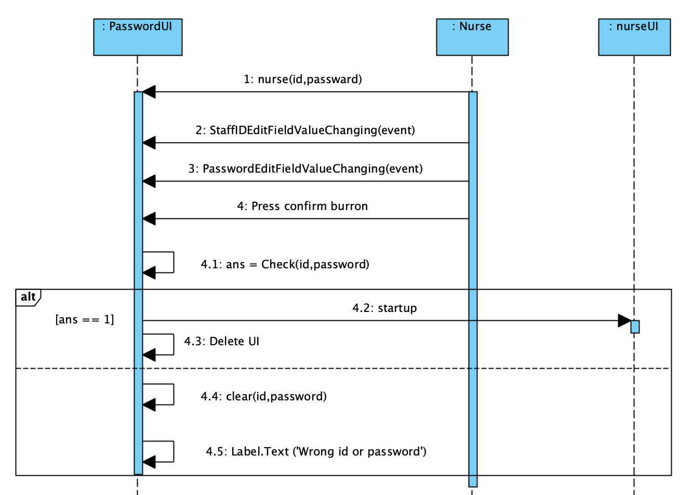

* S1.1.1: Login in to start nurseUI

1. Nurse set id and password and pass these data to passwordUI in advance.
2. Input id to passwordUI.
3. Input password to passwordUI.
4. Press confirm button.
5. Check whether id and password input match to setted nurse information.
6. If match, start nurseUI and close passwordUI.
7. If not, clear id field and password field and show the message “Wrong id or Password”

### S2: nurseUI Implementation

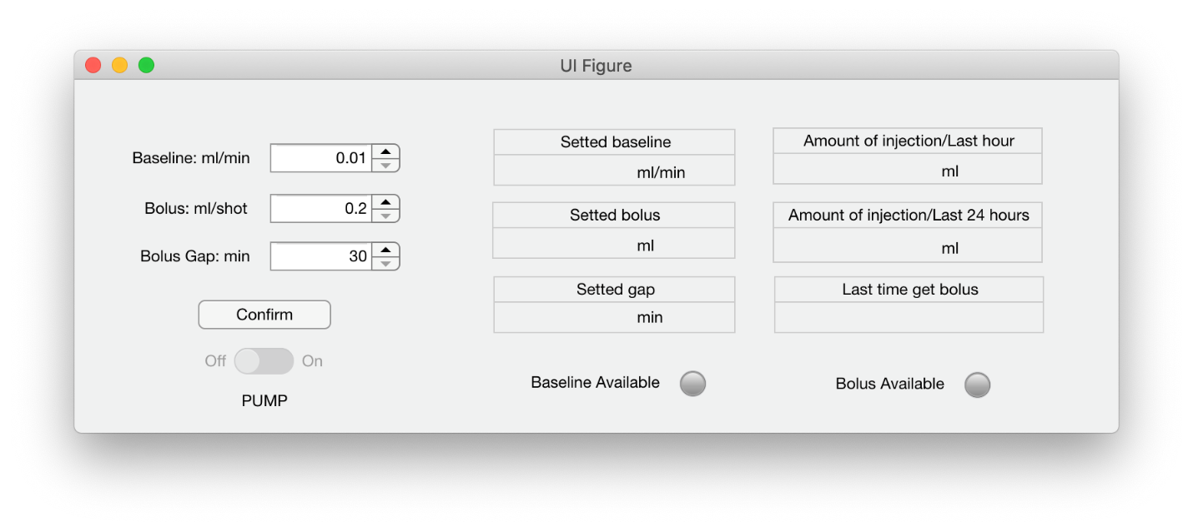

#### S1.1: Start pump

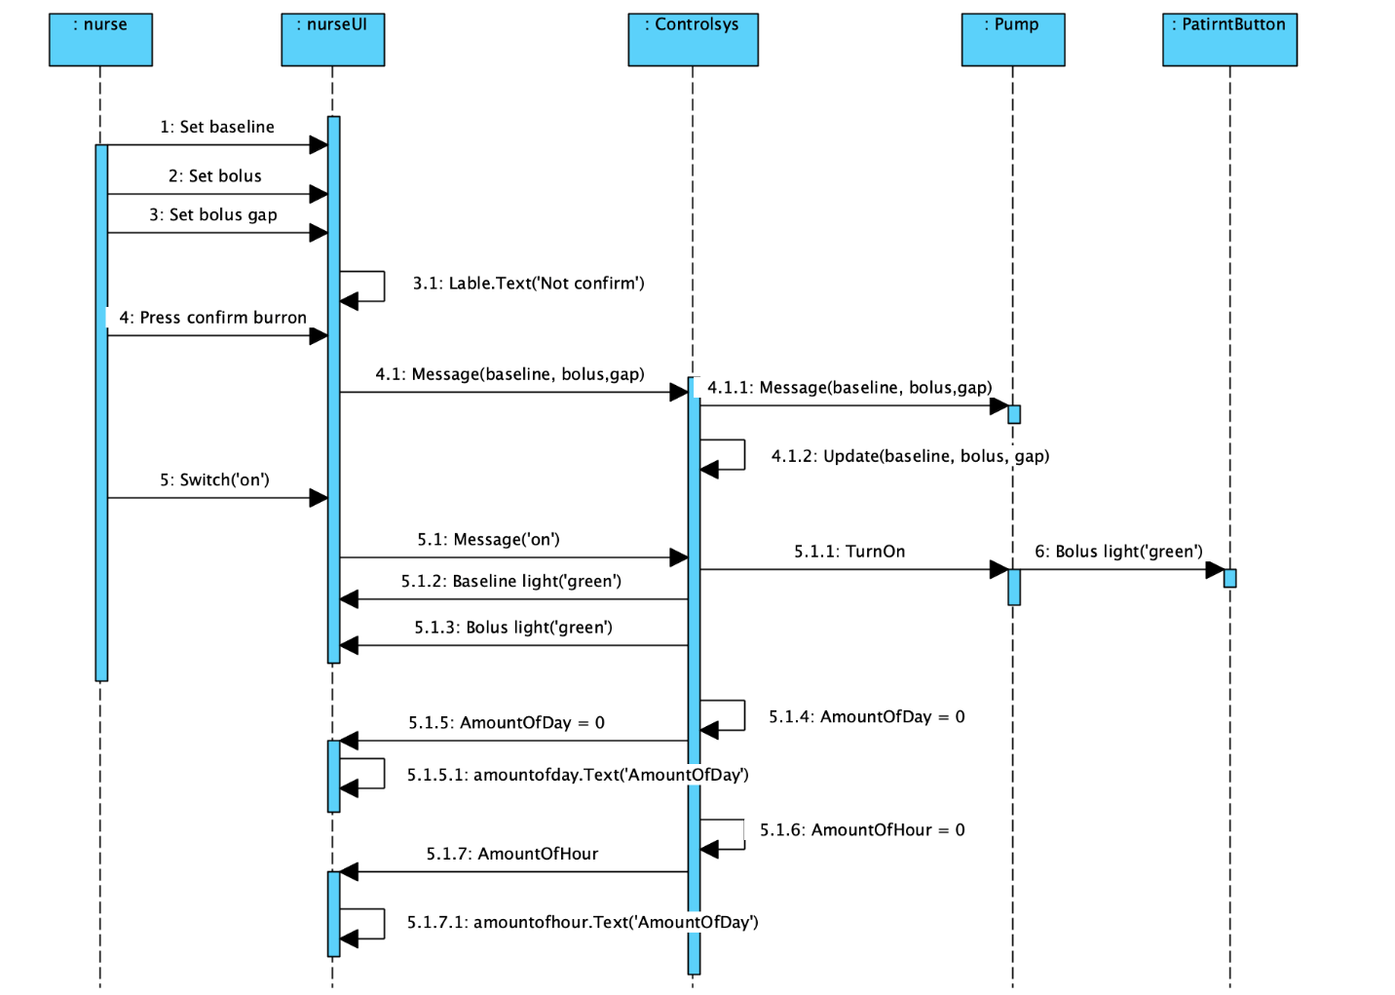

* S2.1.1: Start pump

1. Roll baseline spinner to choose baseline.
2. Roll bolus spinner to choose bolus.
3. Roll gap spinner to choose gap.
4. Show ‘Not confirm’ to remind nurse to confirm.
5. Confirm button pushed.
6. NurseUI pass new data to controlsys
7. Controlsys update data.
8. Controlsys pass new data to pump.
9. Switch on.
10. NurseUI pass ask ‘on’ to controlsys.
11. Controlsys turn on pump.
12. Bolus(Available) light on PatientButton turns from ‘grey’ to ‘green’
13. Baseline(Available) light on nurseUI turns from ‘grey’ to ‘green’
14. Bolus(Available) light on nurseUI turns from ‘grey’ to ‘green’
15. Set amount of day to 0.
16. Pass amount of day to nurseUI.
17. Show aamount of day on nurseUI.
18. Set amount of hour to 0.
19. Pass amount of hour to nurseUI.
20. Show aamount of day on nurseUI.

#### S1.2: Change data

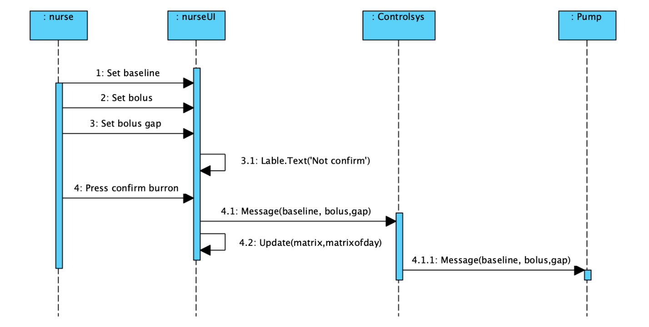

* ­­ S2.1.2: Change data after pump stars working.

1. Roll baseline spinner to choose baseline.
2. Roll bolus spinner to choose bolus.
3. Roll gap spinner to choose gap.
4. Show ‘Not confirm’ to remind nurse to confirm.
5. Confirm button pushed.
6. NurseUI pass new data to controlsys
7. Controlsys update data.
8. Controlsys pass new data to pump.

#### S1.3: Shut pump

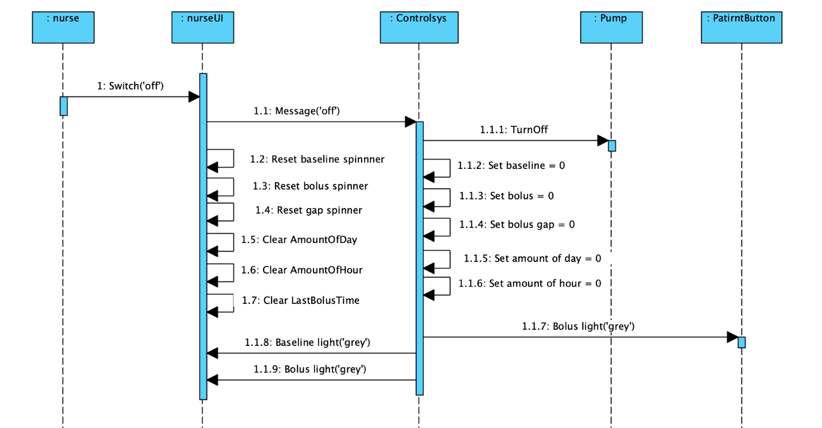

* S2.1.3: Shut down pump.

1. Switch off.
2. NurseUI pass ask ‘off’ to controlsys.
3. Controlsys shut pump.
4. Reset baseline spinner.
5. Reset bolus spinner.
6. Reset gap spinner.
7. Clear AmountOfDay.
8. Clear AmountOfHour.
9. Clear LastBolusTime.
10. Set baseline 0.
11. Set bolus 0.
12. Set gap 0.
13. Set amount of day 0.
14. Set amount of hour 0.
15. Bolus(Available) light on PatientButton turns to ‘grey’.
16. Baseline(Available) light on nurseUI turns to ‘grey’.
17. Bolus(Available) light on nurseUI turns to ‘grey’.

### S3: Controlsys Implementation

#### S1.1: Control pump working

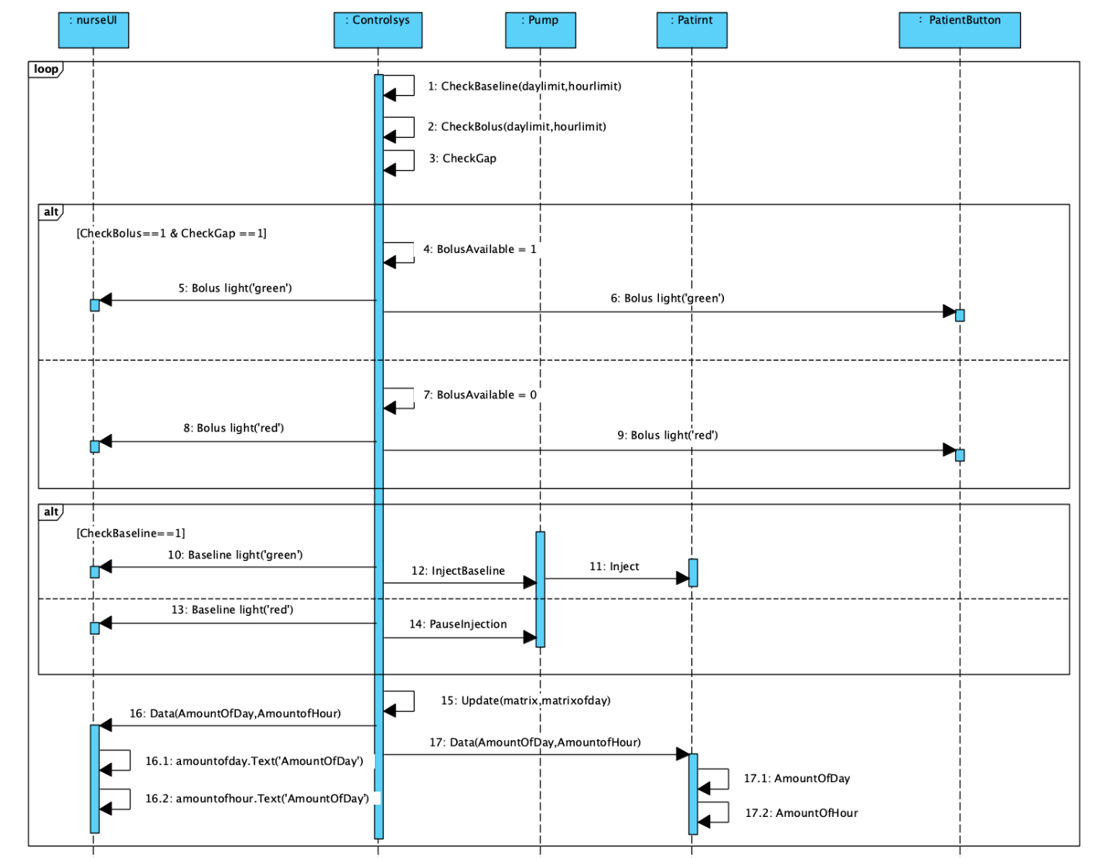

* S3.1.1: Every-minute basic work

1. Check baseline limit.
   1. Check whether amount of day plus baseline will be larger than day limit.
   2. Check whether amount of hour plus baseline will be larger than hour limit
2. Check bolus limit.
   1. Check whether amount of day plus bolus will be larger than day limit.
   2. Check whether amount of hour plus bolus will be larger than hour limit
3. Check whether gap is smaller than asked gap.
   1. If gap is larger than or equal to the asked one, set GapAvailable to 1.
   2. If gap is smaller than asked one, set GapAvailable to 0 and gap plus 1.
4. Assign bolus lights.
   1. If check of bolus pass and GapAvailable is equal to 1, set BolusAvailable to 1 and turn both bolus(available) light ‘green’.
   2. If check of bolus not pass or GapAvailable is not equal to 1, set BolusAvailable to 0 and turn both bolus(available) light ‘red’.
5. Inject baseline.
   1. If check of baseline pass, turn both baseline(available) light ‘green’ and ask pump to inject baseline.
   2. If check of baseline not pass, turn both baseline(available) light ‘red’ and pause injection.
6. Update the matrix(the record of hour) and the matrixd(the record of day).
7. Count and pass amount of day and amount of hour to nurseUI.
8. Count and pass amount of day and amount of hour to patient’s info.
9. NurseUI update AmountOfHour.Text to show new amount of hour.
10. NurseUI update AmountOfDay.Text to show new amount of day.
11. Patient’s info update new amount of hour.
12. Patient’s info update new amount of day.

### S4: PatientButton Implementation

#### S1.1: Get bolus

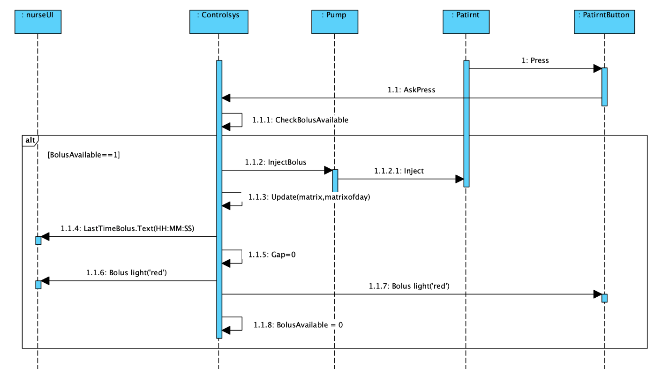

* S4.1.1: Get bolus

1. Press PatientButton
2. Pass AskPress info to Controlsys
3. Controlsys check the BolusAvailable
4. If BolusAvailable is equal to 1, Controlsys ask pump to inject bolus.

Pump inject bolus to patirnt.

Controlsys update the matrix(the record of hour) and the matrixd(the record of day).

Pass the inject time to nurseUI, and nurseUI will show the time as the last time when patient got bolus.

Set the gap to 0.

Controlsys turns both bolus(available) lights from ‘green’ to ‘grey’.

Set BolusAvailable to 0.

1. If BolusAvailable is equal to 0, do nothing.