Group 13

Author: Liu Chengqi, Ren Yijing and Chen Yijun

Traceability Report

Painkiller Injection System

Table of Contents

System Architecture 2

Software Traceability 2

## System Architecture

The system architecture is shown below:

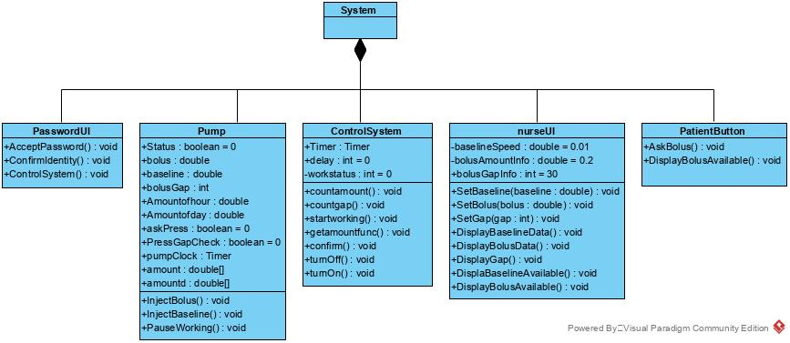

## Software Traceability

|  |  |  |
| --- | --- | --- |
|  | Is implemented by | Is validated by |
| R1.1.1 | S1.1.1.2 | T2.1, T3.1 |
| R1.1.2 | S1.1.1.5 | T2.1, T3.1 |
| R2.1.1 | S2.1.1.1  S2.1.1.2  $2.1.1.3 | T2.1, T3.2 |
| R2.1.2 | S2.1.1.5  S2.1.1.9 | T2.1, T3.2 |
| R2.2.1 | S2.1.1.1  S2.1.1.2  S2.1.1.3 | T2.1, T3.3 |
| R2.2.2 | S3.1.1.9  S3.1.1.10 | T2.1, T3.3 |
| R2.2.3 | S3.1.1.4  S3.1.1.5.a | T2.1, T3.3 |
| R2.3.1 | S1.2 | T2.1, T3.4 |
| R2.4.1 | S1.3 | T2.1, T3.6 |
| R2.4.2 | S1.3 | T2.1, T3.6 |
| R3.1 | S4.1.1.1 | T2.1, T3.3 |
| R3.2.1 | S4.1.1.3.b | T2.1, T3.3 |
| R3.2.2 | S3.1.1.4 | T2.1, T3.3 |
| R4.1.1 | S3.1.1.1 | T2.1, T3.3, T3.5 |
| R4.1.2 | S3.1.1.2 | T2.1, T3.3, T3.5 |
| R4.1.3 | S4.1.1.3 | T2.1, T3.3, T3.5 |
| R4.2.1 | S3.1.1.5 | T2.1, T3.3, T3.5 |
| R4.2.2 | S3.1.1.4 | T2.1, T3.3 |
| R5.1 | S3.1.1.5  S4.1.1.a | T2.1, T3.3, T3.4, T3.5 |