Group 13

Author: Liu Chengqi, Ren Yijing and Chen Yijun

Traceability Report

Painkiller Injection System

Table of Contents

System Architecture 2

Software Traceability 2

## System Architecture

The system architecture is shown below:

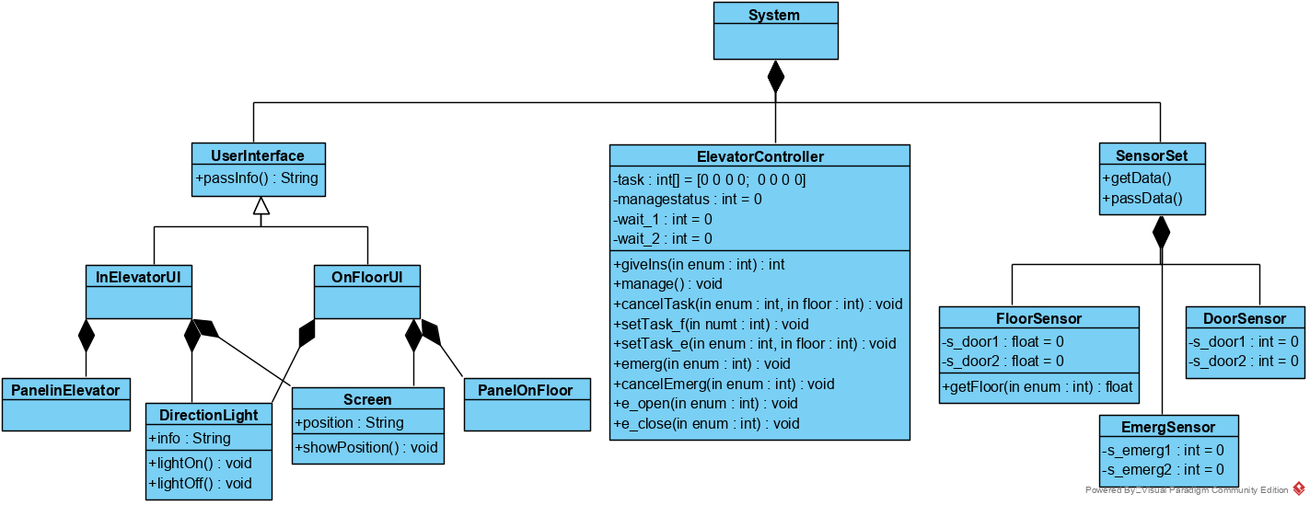

(InElevator UI means the ButtonPanel_e.m. OnFloorUI means the ButtonPanel_f1.m, ButtonPanel_f2.m and ButtonPanel_f3.m.)

## Software Traceability

|  |  |  |
| --- | --- | --- |
|  | Is implemented by | Is validated by |
| R1.1.1 | S1.1，S2.1 |  |
| R1.1.2 | S1.1，S2.1 |  |
| R1.2.1 | S1.2 |  |
| R1.2.2 | S1.3 |  |
| R1.3 | S1.4 |  |
| R1.4 | S1.1 |  |
| R1.5 | S1.1 |  |
| R2.1.1 | S1.1, S2.1 |  |
| R2.1.2 | S2.1 |  |
| R2.2 | S1.1, S2.1 |  |
| R2.3 | S2.1 |  |
| R2.4 | S2.1 |  |
| R2.5 | S2.1 |  |
| R3.1.1 | S1.1, S2.1 |  |
| R3.1.2 | S1.1, S2.1 |  |
| R3.1.3 | S1.1, S2.1 |  |
| R3.1.4 | S1.1, S2.1 |  |
| R3.2 | S1.1, S1.4, S2.1 |  |
| R3.3.1 | S1.1, S2.1 |  |
| R3.3.2 | S1.1, S2.1 |  |
| R3.3.3 | S1.1, S2.1 |  |
| R3.4 | S1.1, S2.1 |  |
| R3.5.1 | S1.1, S2.1 |  |
| R3.5.2 | S1.1, S2.1 |  |
| R3.5.3 | S1.1, S2.1 |  |
| R3.6.1 | S1.1, S1.3, S2.1 |  |
| R3.6.2 | S1.1, S1.3, S2.1 |  |
| R3.6.3 | S1.1, S1.3, S2.1 |  |
| R3.6.4 | S1.1, S1.2, S2.1 |  |
| R3.6.5 | S1.1, S1.3, S2.1 |  |
| R3.7.1 | S1.1, S2.1 |  |
| R3.7.2 | S1.1, S2.1 |  |
| R3.7.3 | S1.1, S2.1 |  |
| R4.1.1 | S1.1, S2.1 |  |
| R4.1.2 | S1.1, S2.1 |  |
| R4.2 | S1.1, S1.4, S2.1 |  |