Group 13

Author: 陈怡珺

User Manual

Elevator System

Table of Contents

System Architecture 2

Passenger Manual 2

## System Architecture

The system architecture is shown below:

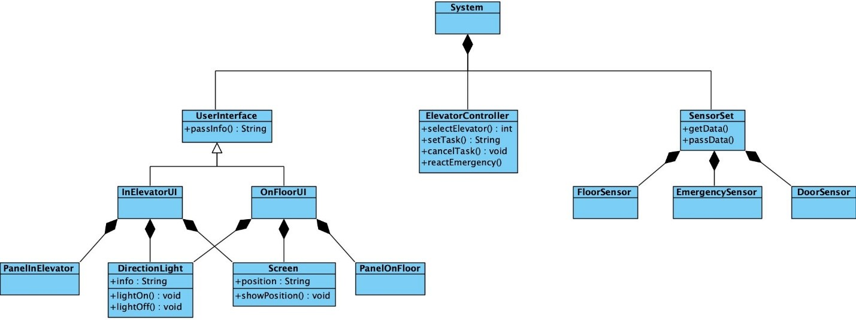

## Passenger Manual

On each floor, there is an UI which is shown below:

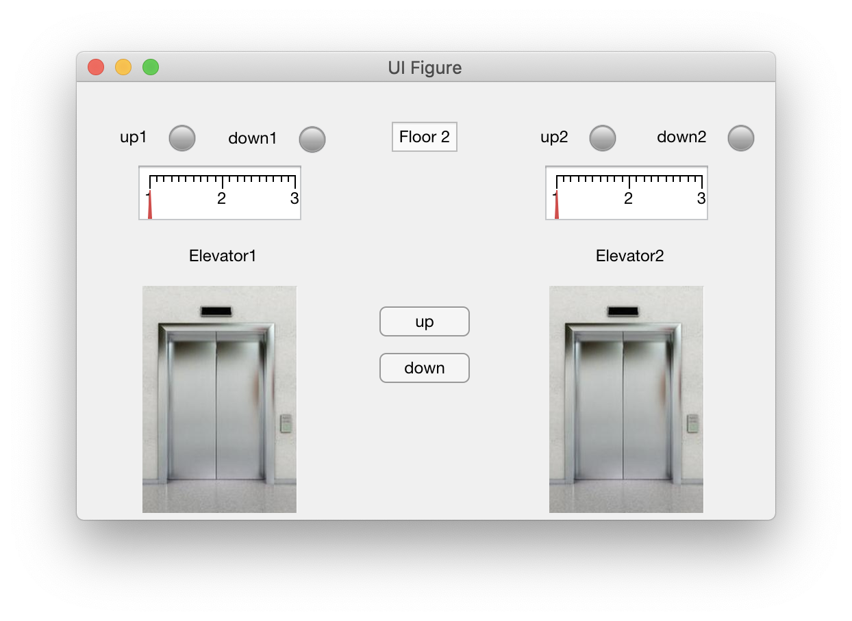

#### When passenger wants to take elevator.

#### Get position

Passenger can know the floor he/she is on by watching the floor no.

#### Ask for elevator

If passenger want to go up, press up button.

If passenger want to go down, press down button.

#### When an elevator stops moving and open door

If it is going to move up, the ’up’ light on.

If it is going to move down, the ’down’ light on.

If it is not going to move up or down, both ‘up’ and ‘down’ light off.

#### Get the position of elevator

Watch the screen on the top, which shows the position of elevator.

In each elevator, there is an UI which is shown below:

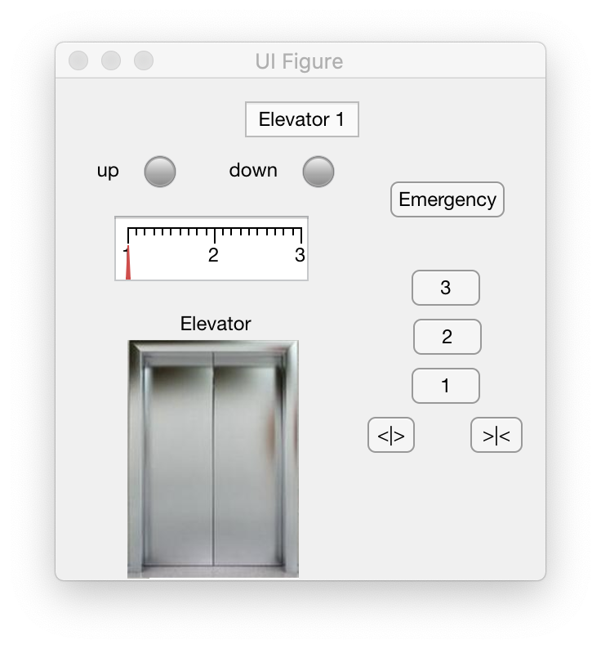

#### After walking into elevator

#### When elevator door is open

If passenger want to hold door open, press’<|>’ button.

If passenger want to close door in advance, press’>|<’ button.

#### Ask destination

Press the button which shows the no. of the floor wanted.

#### Get the position of elevator

Watch the screen on the top, which shows the position of elevator.

#### Get the direction of elevator

If elevator goes up, the ‘up’ light is on.

If elevator goes down, the ‘down’ light is on.

#### When emergency occurs

Press emergency button to let staff know the situation.