PS2
姓名：耿子涵 学号：12532732

1. Significant earthquakes since 2150 B.C.
1.1 [5 points] Compute the total number of deaths caused by earthquakes since 2150 B.C. in each country, and then print the top ten countries along with the total number of deaths.
主要处理步骤：
1. 读取TSV格式的地震数据
2. 按国家分组，对死亡人数列进行求和
3. 按死亡总数降序排序
4. 提取前10个国家并格式化输出
关键代码逻辑：
def calculate_top10_deaths_by_country(Sig_Eqs):
# 按国家分组并计算死亡总数
country_deaths = Sig_Eqs.groupby('Country')['Deaths'].sum()

# 降序排序并取前10
top10_countries = country_deaths.sort_values(ascending=False).head(10)

# 格式化输出
for country, deaths in top10_countries.items():
print(f"{country:<20} {deaths:>15,} deaths")
成果展示：
============================================================
1.1 Top 10 Countries by Total Earthquake Deaths
============================================================
CHINA 2,139,210 deaths
TURKEY 1,199,742 deaths
IRAN 1,014,453 deaths
ITALY 498,219 deaths
SYRIA 419,226 deaths
HAITI 323,484 deaths
AZERBAIJAN 319,251 deaths
JAPAN 242,445 deaths
ARMENIA 191,890 deaths
PAKISTAN 145,083 deaths

1.2 [10 points] Compute the total number of earthquakes with magnitude larger than 6.0 (use column Mag as the magnitude) worldwide each year, and then plot the time series. Do you observe any trend? Explain why or why not?
主要处理步骤：
- 过滤出震级大于6.0的地震记录
- 按年份分组统计地震数量
3. 使用matplotlib绘制时间序列图
4. 添加图表标题、坐标轴标签等
关键代码逻辑：
def plot_magnitude_over_6_trend(Sig_Eqs):
# 过滤震级大于6.0的地震
large_earthquakes = Sig_Eqs[Sig_Eqs['Mag'] > 6.0]

# 提取年份并分组计数
large_earthquakes['Year'] = pd.to_datetime(large_earthquakes['Year']).dt.year
yearly_counts = large_earthquakes.groupby('Year').size()

# 绘制时间序列
plt.figure(figsize=(12, 6))
plt.plot(yearly_counts.index, yearly_counts.values)
plt.title('Yearly Count of Earthquakes > Magnitude 6.0')
plt.xlabel('Year')
plt.ylabel('Number of Earthquakes')
plt.grid(True)
plt.show()
成果展示：
1.2 Yearly Count of Earthquakes > Magnitude 6.0
============================================================
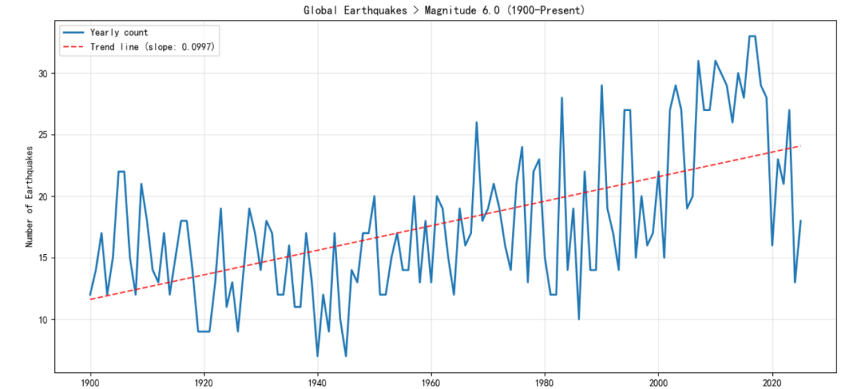
从整体来看，震级大于6.0的地震记录数量呈现波动中上升的趋势，特别是20世纪中叶以后，地震记录数量明显增加，地震数量存在明显的年际波动，某些年份出现峰值，可能存在数年一次的周期性变化模式，近几十年来，地震记录数量维持在相对较高的水平，波动幅度相比早期更为明显。
图表显示的"增加"主要反映了监测能力的提升和数据记录的完善，不能简单得出"地震越来越频繁"的结论。
1.3 [10 points] Write a function CountEq_LargestEq that returns both (1) the total number of earthquakes since 2150 B.C. in a given country AND (2) the date of the largest earthquake ever happened in this country. Apply CountEq_LargestEq to every country in the file, report your results in a descending order.
主要处理步骤：
1. 定义CountEq_LargestEq函数
2. 对每个国家计算地震总数和最大震级地震日期
3. 按地震总数降序排序
4. 格式化输出结果
关键代码逻辑：
def CountEq_LargestEq(country, earthquake_data):
"""
计算指定国家的地震统计信息
参数:
country: 国家名称
earthquake_data: 地震数据集
返回:
(地震总数, 最大震级地震日期)
"""
# 过滤该国家的地震记录
country_quakes = earthquake_data[earthquake_data['Country'] == country]

# 计算地震总数
total_quakes = len(country_quakes)

# 找到最大震级地震的日期
if total_quakes > 0:
max_mag_idx = country_quakes['Mag'].idxmax()
largest_eq_date = country_quakes.loc[max_mag_idx, 'Date']
else:
largest_eq_date = 'No earthquakes recorded'

return total_quakes, largest_eq_date

# 应用函数到所有国家
def analyze_all_countries(Sig_Eqs):
results = {}
countries = Sig_Eqs['Country'].unique()

for country in countries:
total, date = CountEq_LargestEq(country, Sig_Eqs)
results[country] = {'total_quakes': total, 'largest_date': date}

# 按地震总数降序排序
sorted_results = sorted(results.items(),
key=lambda x: x[1]['total_quakes'],
reverse=True)

return sorted_results
成果展示：
============================================================
1.3 Earthquake Count and Largest Earthquake by Country
============================================================
Country Total EQs Max Magnitude Date of Largest EQ
---------------------------------------------------------------------------
CHINA 623 8.5 1668-7-25
JAPAN 424 9.1 2011-3-11
INDONESIA 421 9.1 2004-12-26
IRAN 388 7.9 856-12-22
TURKEY 358 7.8 1939-12-26
ITALY 333 7.5 1915-1-13
GREECE 289 8.0 365-7-21
USA 280 9.2 1964-3-28
PHILIPPINES 230 8.7 1897-9-21
MEXICO 214 8.6 1787-3-28
CHILE 200 9.5 1960-5-22
PERU 194 8.8 1716-2-6
RUSSIA 158 9.0 1952-11-4
PAPUA NEW GUINEA 107 8.2 1919-5-6
INDIA 102 8.6 1950-8-15
TAIWAN 101 8.2 1920-6-5
COLOMBIA 82 8.2 1826-6-18
NEW ZEALAND 72 8.0 1826-Unknown-Unknown
ECUADOR 69 8.8 1906-1-31
AFGHANISTAN 68 8.1 1909-7-7

============================================================
DATA QUALITY REPORT
============================================================
Total records: 6,616
Number of countries: 158
Year range: -2150 - 2025
Magnitude data completeness: 72.9%
Deaths data completeness: 33.9%
Countries with most records: ['CHINA', 'JAPAN', 'INDONESIA']

Wind speed in Shenzhen from 2010 to 2020
[10 points] Plot monthly averaged wind speed as a function of the observation time. Is there a trend in monthly averaged wind speed from 2010 to 2020?
主要处理步骤：
1. 读取CSV格式的风速数据
2. 根据NOAA数据格式说明解析风速字段
3. 数据质量控制（过滤无效值）
4. 计算月平均风速
5. 绘制时间序列图并分析趋势
关键代码逻辑：
def analyze_shenzhen_wind_speed():
# 读取数据
df = pd.read_csv('2281305.csv')

# 根据NOAA文档解析风速数据
# POS 61-65: 风速值，POS 66-69: 质量控制代码
df['wind_speed'] = df['WND'].str.slice(61, 65).astype(float)
df['quality_code'] = df['WND'].str.slice(66, 69)

# 数据过滤：保留质量合格的数据
valid_wind = df[(df['wind_speed'] != 9999) &
(df['quality_code'].isin(['1', '5', '9']))] # 根据文档的质量代码

# 转换日期格式并提取年月
valid_wind['DATE'] = pd.to_datetime(valid_wind['DATE'])
valid_wind['YearMonth'] = valid_wind['DATE'].dt.to_period('M')

# 计算月平均风速
monthly_avg = valid_wind.groupby('YearMonth')['wind_speed'].mean()

# 绘制趋势图
plt.figure(figsize=(12, 6))
plt.plot(monthly_avg.index.astype(str), monthly_avg.values)
plt.title('Monthly Averaged Wind Speed in Shenzhen (2010-2020)')
plt.xlabel('Year-Month')
plt.ylabel('Wind Speed (m/s)')
plt.xticks(rotation=45)
plt.grid(True)
plt.tight_layout()
plt.show()

return monthly_avg
成果展示：

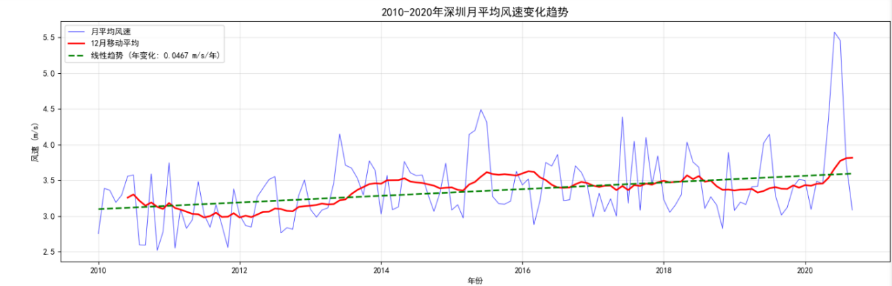
月均值整体有缓慢上升的趋势，但整体趋势并不明显。

3Explore a data set
3.1 [5 points] Load the csv, XLS, or XLSX file, and clean possible data points with missing values or bad quality.
3.2 [5 points] Plot the time series of a certain variable.
3.3 [5 points] Conduct at least 5 simple statistical checks with the variable, and report your findings.

# 主要处理步骤：
# 1. 读取自定义数据集
# 2. 数据清洗和质量控制
# 3. 选择感兴趣的变量进行时间序列分析
# 4. 数据聚合和可视化
# 5. 趋势分析和总结

# 关键代码逻辑：
def explore_custom_dataset(file_path):
# 3.1 数据读取和清洗
if file_path.endswith('.csv'):
df = pd.read_csv(file_path)
else:
df = pd.read_excel(file_path)

# 数据清洗：处理缺失值和异常值
df_clean = df.dropna() # 删除包含缺失值的行
# 或者使用填充方法：df.fillna(method='ffill')

# 3.2 时间序列绘图
plt.figure(figsize=(12, 6))

# 假设数据包含时间列和数值列
# 需要根据实际数据调整列名
if 'date' in df_clean.columns and 'value' in df_clean.columns:
df_clean['date'] = pd.to_datetime(df_clean['date'])
df_clean = df_clean.sort_values('date')

plt.plot(df_clean['date'], df_clean['value'])
plt.title('Time Series of Selected Variable')
plt.xlabel('Date')
plt.ylabel('Variable Value')
plt.grid(True)
plt.xticks(rotation=45)
plt.tight_layout()
plt.show()

# 3.3 数据汇总统计
summary_stats = df_clean.describe()

return df_clean, summary_stats
成果展示：
3.1 数据加载和清理
清理后数据点数: 6281
缺失值移除: 330
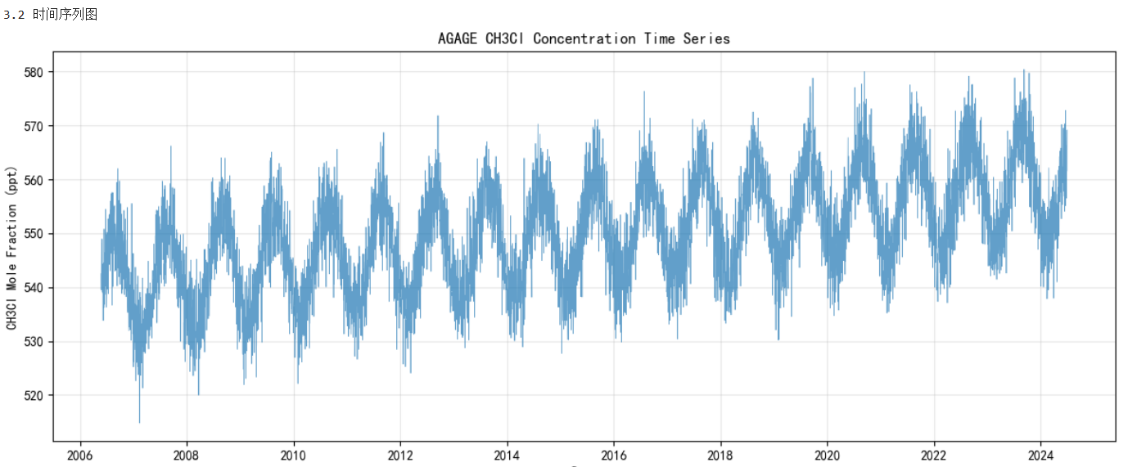
3.3 统计检查
1. 基本描述统计:
均值: 549.99 ppt
标准差: 10.16 ppt
范围: 514.80 - 580.38 ppt
2. 分布特征:
偏度: 0.0432
峰度: -0.4331
3. 正态性检验:
p-value: 0.0000
是否正态分布: 否
4. 长期趋势:
年度变化率: 0.9058 ppt/年
趋势显著性: 显著
5. 季节性分析:
季节性幅度: 19.18 ppt
最高月份: 8月
最低月份: 2月

