S1: behavioural analysis with brms

I. S. Plank

2025-02-04

# S1.1 Introduction

This R Markdown script analyses behavioural data from the FAB (face attention bias) paradigm of the EMBA project. The data was preprocessed before being read into this script.

The task is modeled after Jakobsen et al. (2021), *Attention, Perception, & Psychophysics* and the authors were kind enough to share their stimuli. Each trial starts with a black fixation cross on a white background. Then, a cue consisting of a pair of pictures, one object and one face, is shown with one picture on the left and one on the right of the previous location of the fixation cross. In line with Moore et al. (2012), *J Autism Dev Disord*, we set the duration of the cue presentation to 200ms. Afterwards, a target square appears either at the previous location of the face or the object. Subjects task is to determine the location (right or left) of the target as fast and accurate as possible. The target only disappears when the participant gives their answer.

The visual angle of the target was 1.17 degrees, the visual angle of the cues was 4.25 and the distance of the centre of the target and cue from the fixation cross was 2.67 degrees.

## Some general settings

# number of simulations  
nsim = 250  
  
# set number of iterations and warmup for models  
iter = 3000  
warm = 1000  
  
# set the seed  
set.seed(2468)

## Package versions

The following packages are used in this RMarkdown file:

## [1] "R version 4.3.0 (2023-04-21 ucrt)"

## [1] "knitr version 1.42"  
## [1] "ggplot2 version 3.4.2"  
## [1] "brms version 2.19.0"  
## [1] "designr version 0.1.13"  
## [1] "bridgesampling version 1.1.2"  
## [1] "tidyverse version 2.0.0"  
## [1] "ggpubr version 0.6.0"  
## [1] "ggrain version 0.0.4"  
## [1] "bayesplot version 1.10.0"  
## [1] "SBC version 0.2.0.9000"  
## [1] "rstatix version 0.7.2"  
## [1] "BayesFactor version 0.9.12.4.4"  
## [1] "bayestestR version 0.15.1"

## General info

We planned to determine the group-level effect subjects following Barr (2013). For each model, experiment specific priors were set based on previous literature or the task (see comments in the code).

We performed prior predictive checks as proposed in Schad, Betancourt and Vasishth (2020) using the SBC package based on the original design with three groups. To do so, we create 250 simulated datasets where parameters are simulated from the priors. These parameters are used to create one fake dataset. Both the true underlying parameters and the simulated discrimination values are saved.

Then, we create graphs showing the prior predictive distribution of the simulated discrimination threshold to check whether our priors fit our general expectations about the data. Next, we perform checks of computational faithfulness and model sensitivity as proposed by Schad, Betancourt and Vasishth (2020) and implemented in the SBC package. We create models for each of the simulated datasets. Last, we calculate performance metrics for each of these models, focusing on the population-level parameters. We did not rerun SBC after adding the exploratory sample of ADHD+ASD.

We base our assessment of the hypothesis on the posterior distributions. Therefore, we perform posterior prdictive checks and in some cases simplify the model by aggregating values to improve posterior fit.

## Preparation and group comparisons

First, we load the data and combine it with demographic information including the diagnostic status of the subjects. Then, all predictors are set to sum contrasts. We have a look at the demographics describing our four diagnostic groups: adults with ADHD, autistic adults, autistic adults with ADHD (explorative) and adults without any neurological and psychiatric diagnoses.

Since this is sensitive data, we load the anonymised version of the processed data at this point but also leave the code we used to create it.

# check if the data file exists, if yes load it:  
if (!file.exists("FAB_data.RData")) {  
  
 # get demo info for subjects  
 df.sub = read_csv(file.path("/home/emba/Documents/EMBA/CentraXX", "EMBA_centraXX.csv"),   
 show_col_types = F) %>%  
 mutate(  
 diagnosis = recode(diagnosis, "CTR" = "COMP")  
 )  
   
 # set the data path  
 dt.path = "/home/emba/Documents/EMBA/BVET"  
 dt.explo = "/home/emba/Documents/EMBA/BVET-explo"  
   
 # load excluded participants (low accuracy)  
 exc = c(scan(file.path(dt.path, 'FAB_exc.txt'), what="character", sep=NULL),  
 scan(file.path(dt.explo, 'FAB_exc.txt'), what="character", sep=NULL))  
 df.exc = df.sub %>% filter(subID %in% exc) %>%   
 select(diagnosis) %>%   
 group_by(diagnosis) %>% count()  
   
 # load the behavioral data and merge with group  
 df.fab = merge(df.sub %>% select(subID, diagnosis, RAADS_total, ASRS_total),   
 readRDS(file = paste0(dt.path, '/df_FAB.RDS')), all.y = T) %>%  
 mutate_if(is.character, as.factor)  
 df.exp = merge(df.sub %>% select(subID, diagnosis, RAADS_total, ASRS_total),   
 readRDS(file = paste0(dt.explo, '/df_FAB.RDS')), all.y = T) %>%  
 mutate_if(is.character, as.factor)  
   
 # only keep participants included in the study in the subject data frame  
 subIDs = as.character(c(unique(df.fab$subID), unique(df.exp$subID)))  
 df.sub = df.sub %>% filter(subID %in% subIDs)  
   
 # load the eye tracking data and only keep participants included in the study,  
 # so no people with more than 33% mistakes, no people without any saccades   
 # and no people with too many blinks  
 df.sac = rbind(readRDS(file.path(dt.explo, "FAB_ET_data.rds")),  
 readRDS(file.path(dt.path, "FAB_ET_data.rds"))) %>%  
 merge(., df.sub %>% select(subID, diagnosis), keep.y = T)  
   
 # check groups of people who had no relevant saccades at all  
 df.nosac = df.sac %>% filter(is.na(trl)) %>%  
 group_by(diagnosis) %>%  
 count()  
  
 # anonymise the data  
 df.fab = df.fab %>%  
 mutate(  
 PID = subID,  
 subID = as.factor(as.numeric(subID))  
 )  
 df.exp = df.exp %>%  
 mutate(  
 PID = subID,  
 subID = as.factor(as.numeric(subID) + length(unique(df.fab$subID)))  
 )  
   
 # get a correspondence of original PIDs and anonymised subIDs  
 df.recode = rbind(df.fab %>% select(PID, subID) %>% distinct(),  
 df.exp %>% select(PID, subID) %>% distinct())  
 recode = as.character(df.recode$subID)  
 names(recode) = df.recode$PID  
 df.fab = df.fab %>% select(-PID)  
 df.exp = df.exp %>% select(-PID)  
   
 # anonymise ET data in the same way  
 df.sac$subID = str_replace_all(df.sac$subID, recode)  
   
 # print gender frequencies and compare them across groups  
 tb.gen = xtabs(~ gender + diagnosis, data = df.sub)  
 ct.full = contingencyTableBF(tb.gen,   
 sampleType = "indepMulti",   
 fixedMargin = "cols")  
 # since only DAN in the ADHD group, we try again after excluding them  
 ct.mf = contingencyTableBF(tb.gen[2:3,],   
 sampleType = "indepMulti",   
 fixedMargin = "cols")  
 tb.gen = xtabs(~ gender + diagnosis + cis, data = df.sub)  
   
 # get the gender descriptions of the not-male and not-female participants  
 gen.desc = unique(tolower(df.sub[df.sub$gender == "dan",]$gender_desc))  
   
 # check which outcomes of interest are normally distributed  
 df.sht = df.sub %>%   
 group_by(diagnosis) %>%  
 shapiro_test(age, iq, BDI_total, ASRS_total, RAADS_total, TAS_total) %>%  
 mutate(  
 sig = if_else(p < 0.05, "*", "")  
 )  
   
 # most of the measures are not normally distributed;  
 # therefore, we compute ranks for these outcomes  
 df.sub = df.sub %>%   
 mutate(  
 rage = rank(age),  
 rBDI = rank(BDI_total),  
 rRAADS = rank(RAADS_total),  
 rTAS = rank(TAS_total),  
 diagnosis = as.factor(diagnosis)  
 )  
   
 # now we can compute our ANOVAs  
 aov.age = anovaBF(rage ~ diagnosis, data = df.sub)  
 aov.iq = anovaBF(iq ~ diagnosis, data = df.sub)  
 aov.BDI = anovaBF(rBDI ~ diagnosis, data = df.sub)  
 aov.ASRS = anovaBF(ASRS_total ~ diagnosis, data = df.sub)  
 aov.RAADS = anovaBF(rRAADS ~ diagnosis, data = df.sub)  
 aov.TAS = anovaBF(rTAS ~ diagnosis, data = df.sub)  
   
 # ...and put everything in a new dataframe for printing  
 measurement = "Age"  
 ADHD = sprintf("%.2f (±%.2f)",   
 mean(df.sub[df.sub$diagnosis == "ADHD",]$age),   
 sd(df.sub[df.sub$diagnosis == "ADHD",]$age)/  
 sqrt(nrow(df.sub[df.sub$diagnosis == "ADHD",])))  
 ASD = sprintf("%.2f (±%.2f)",   
 mean(df.sub[df.sub$diagnosis == "ASD",]$age),   
 sd(df.sub[df.sub$diagnosis == "ASD",]$age)/  
 sqrt(nrow(df.sub[df.sub$diagnosis == "ASD",])))  
 `ADHD+ASD` = sprintf("%.2f (±%.2f)",   
 mean(df.sub[df.sub$diagnosis == "BOTH",]$age),   
 sd(df.sub[df.sub$diagnosis == "BOTH",]$age)/  
 sqrt(nrow(df.sub[df.sub$diagnosis == "BOTH",])))  
 COMP = sprintf("%.2f (±%.2f)",   
 mean(df.sub[df.sub$diagnosis == "COMP",]$age),   
 sd(df.sub[df.sub$diagnosis == "COMP",]$age)/  
 sqrt(nrow(df.sub[df.sub$diagnosis == "COMP",])))  
 logBF10 = sprintf("%.3f", aov.age@bayesFactor[["bf"]])  
 df.table = data.frame(measurement, ADHD, ASD, `ADHD+ASD`, COMP, logBF10)  
 df.table = rbind(df.table,  
 c(  
 "ASRS",  
 sprintf("%.2f (±%.2f)",   
 mean(df.sub[df.sub$diagnosis == "ADHD",]$ASRS_total),   
 sd(df.sub[df.sub$diagnosis == "ADHD",]$ASRS_total)/  
 sqrt(nrow(df.sub[df.sub$diagnosis == "ADHD",]))),  
 sprintf("%.2f (±%.2f)",   
 mean(df.sub[df.sub$diagnosis == "ASD",]$ASRS_total),   
 sd(df.sub[df.sub$diagnosis == "ASD",]$ASRS_total)/  
 sqrt(nrow(df.sub[df.sub$diagnosis == "ASD",]))),  
 sprintf("%.2f (±%.2f)",   
 mean(df.sub[df.sub$diagnosis == "BOTH",]$ASRS_total),   
 sd(df.sub[df.sub$diagnosis == "BOTH",]$ASRS_total)/  
 sqrt(nrow(df.sub[df.sub$diagnosis == "BOTH",]))),  
 sprintf("%.2f (±%.2f)",   
 mean(df.sub[df.sub$diagnosis == "COMP",]$ASRS_total),   
 sd(df.sub[df.sub$diagnosis == "COMP",]$ASRS_total)/  
 sqrt(nrow(df.sub[df.sub$diagnosis == "COMP",]))),  
 sprintf("%.3f", aov.ASRS@bayesFactor[["bf"]])  
 ),  
 c(  
 "BDI",  
 sprintf("%.2f (±%.2f)",   
 mean(df.sub[df.sub$diagnosis == "ADHD",]$BDI_total),   
 sd(df.sub[df.sub$diagnosis == "ADHD",]$BDI_total)/  
 sqrt(nrow(df.sub[df.sub$diagnosis == "ADHD",]))),  
 sprintf("%.2f (±%.2f)",   
 mean(df.sub[df.sub$diagnosis == "ASD",]$BDI_total),   
 sd(df.sub[df.sub$diagnosis == "ASD",]$BDI_total)/  
 sqrt(nrow(df.sub[df.sub$diagnosis == "ASD",]))),  
 sprintf("%.2f (±%.2f)",   
 mean(df.sub[df.sub$diagnosis == "BOTH",]$BDI_total),   
 sd(df.sub[df.sub$diagnosis == "BOTH",]$BDI_total)/  
 sqrt(nrow(df.sub[df.sub$diagnosis == "BOTH",]))),  
 sprintf("%.2f (±%.2f)",   
 mean(df.sub[df.sub$diagnosis == "COMP",]$BDI_total),   
 sd(df.sub[df.sub$diagnosis == "COMP",]$BDI_total)/  
 sqrt(nrow(df.sub[df.sub$diagnosis == "COMP",]))),  
 sprintf("%.3f", aov.BDI@bayesFactor[["bf"]])  
 ),  
 c(  
 "Gender (diverse/agender/non-binary - female - male)",  
 sprintf("%d - %d - %d",   
 nrow(df.sub[df.sub$diagnosis == "ADHD" & df.sub$gender == "dan",]),   
 nrow(df.sub[df.sub$diagnosis == "ADHD" & df.sub$gender == "fem",]),   
 nrow(df.sub[df.sub$diagnosis == "ADHD" & df.sub$gender == "mal",])),  
 sprintf("%d - %d - %d",   
 nrow(df.sub[df.sub$diagnosis == "ASD" & df.sub$gender == "dan",]),   
 nrow(df.sub[df.sub$diagnosis == "ASD" & df.sub$gender == "fem",]),   
 nrow(df.sub[df.sub$diagnosis == "ASD" & df.sub$gender == "mal",])),  
 sprintf("%d - %d - %d",   
 nrow(df.sub[df.sub$diagnosis == "BOTH" & df.sub$gender == "dan",]),   
 nrow(df.sub[df.sub$diagnosis == "BOTH" & df.sub$gender == "fem",]),   
 nrow(df.sub[df.sub$diagnosis == "BOTH" & df.sub$gender == "mal",])),  
 sprintf("%d - %d - %d",   
 nrow(df.sub[df.sub$diagnosis == "COMP" & df.sub$gender == "dan",]),   
 nrow(df.sub[df.sub$diagnosis == "COMP" & df.sub$gender == "fem",]),   
 nrow(df.sub[df.sub$diagnosis == "COMP" & df.sub$gender == "mal",])),  
 sprintf("%.3f", ct.full@bayesFactor[["bf"]])  
 ),  
 c(  
 "IQ",  
 sprintf("%.2f (±%.2f)",   
 mean(df.sub[df.sub$diagnosis == "ADHD",]$iq),   
 sd(df.sub[df.sub$diagnosis == "ADHD",]$iq)/  
 sqrt(nrow(df.sub[df.sub$diagnosis == "ADHD",]))),  
 sprintf("%.2f (±%.2f)",   
 mean(df.sub[df.sub$diagnosis == "ASD",]$iq),   
 sd(df.sub[df.sub$diagnosis == "ASD",]$iq)/  
 sqrt(nrow(df.sub[df.sub$diagnosis == "ASD",]))),  
 sprintf("%.2f (±%.2f)",   
 mean(df.sub[df.sub$diagnosis == "BOTH",]$iq),   
 sd(df.sub[df.sub$diagnosis == "BOTH",]$iq)/  
 sqrt(nrow(df.sub[df.sub$diagnosis == "BOTH",]))),  
 sprintf("%.2f (±%.2f)",   
 mean(df.sub[df.sub$diagnosis == "COMP",]$iq),   
 sd(df.sub[df.sub$diagnosis == "COMP",]$iq)/  
 sqrt(nrow(df.sub[df.sub$diagnosis == "COMP",]))),  
 sprintf("%.3f", aov.iq@bayesFactor[["bf"]])  
 ),  
 c(  
 "RADS-R",  
 sprintf("%.2f (±%.2f)",   
 mean(df.sub[df.sub$diagnosis == "ADHD",]$RAADS_total),   
 sd(df.sub[df.sub$diagnosis == "ADHD",]$RAADS_total)/  
 sqrt(nrow(df.sub[df.sub$diagnosis == "ADHD",]))),  
 sprintf("%.2f (±%.2f)",   
 mean(df.sub[df.sub$diagnosis == "ASD",]$RAADS_total),   
 sd(df.sub[df.sub$diagnosis == "ASD",]$RAADS_total)/  
 sqrt(nrow(df.sub[df.sub$diagnosis == "ASD",]))),  
 sprintf("%.2f (±%.2f)",   
 mean(df.sub[df.sub$diagnosis == "BOTH",]$RAADS_total),   
 sd(df.sub[df.sub$diagnosis == "BOTH",]$RAADS_total)/  
 sqrt(nrow(df.sub[df.sub$diagnosis == "BOTH",]))),  
 sprintf("%.2f (±%.2f)",   
 mean(df.sub[df.sub$diagnosis == "COMP",]$RAADS_total),   
 sd(df.sub[df.sub$diagnosis == "COMP",]$RAADS_total)/  
 sqrt(nrow(df.sub[df.sub$diagnosis == "COMP",]))),  
 sprintf("%.3f", aov.RAADS@bayesFactor[["bf"]])  
 ),  
 c(  
 "TAS",  
 sprintf("%.2f (±%.2f)",   
 mean(df.sub[df.sub$diagnosis == "ADHD",]$TAS_total),   
 sd(df.sub[df.sub$diagnosis == "ADHD",]$TAS_total)/  
 sqrt(nrow(df.sub[df.sub$diagnosis == "ADHD",]))),  
 sprintf("%.2f (±%.2f)",   
 mean(df.sub[df.sub$diagnosis == "ASD",]$TAS_total),   
 sd(df.sub[df.sub$diagnosis == "ASD",]$TAS_total)/  
 sqrt(nrow(df.sub[df.sub$diagnosis == "ASD",]))),  
 sprintf("%.2f (±%.2f)",   
 mean(df.sub[df.sub$diagnosis == "BOTH",]$TAS_total),   
 sd(df.sub[df.sub$diagnosis == "BOTH",]$TAS_total)/  
 sqrt(nrow(df.sub[df.sub$diagnosis == "BOTH",]))),  
 sprintf("%.2f (±%.2f)",   
 mean(df.sub[df.sub$diagnosis == "COMP",]$TAS_total),   
 sd(df.sub[df.sub$diagnosis == "COMP",]$TAS_total)/  
 sqrt(nrow(df.sub[df.sub$diagnosis == "COMP",]))),  
 sprintf("%.3f", aov.TAS@bayesFactor[["bf"]])  
 )  
 ) %>% arrange(measurement)  
   
 # save it all  
 save(df.fab, df.sac, df.exp, df.sht, ct.full, ct.mf, df.exc,   
 df.nosac, gen.desc, tb.gen, df.table,  
 file = "FAB_data.RData")  
   
} else {  
   
 load("FAB_data.RData")  
   
}  
  
# print the group of excluded participants based on low accuracy (< 2/3)  
kable(df.exc)

| diagnosis | n |
| --- | --- |
| ADHD | 1 |
| ASD | 1 |

rm(df.exc)  
  
# print the group of the participants included in behavioural and eye tracking   
kable(merge(  
 df.sac %>% filter(!is.na(trl)) %>% select(subID, diagnosis) %>% distinct() %>%   
 group_by(diagnosis) %>% summarise(`sample size eye tracking` = n()),  
 rbind(df.fab, df.exp) %>% select(subID, diagnosis) %>% distinct() %>%   
 group_by(diagnosis) %>% summarise(`sample size behavioural` = n())  
 ))

| diagnosis | sample size eye tracking | sample size behavioural |
| --- | --- | --- |
| ADHD | 16 | 23 |
| ASD | 19 | 24 |
| BOTH | 22 | 23 |
| COMP | 21 | 24 |

# Note: eye-tracking only collected if calibration accuracy < 0.5, then exclusion:  
# 1 due to more than 1/3 blinks   
# 2 due to no relevant saccades  
# how many have been removed due to no relevant saccades?  
kable(df.nosac)

| diagnosis | n |
| --- | --- |
| ASD | 1 |
| COMP | 1 |

rm(df.nosac)  
  
# print the outcome of the shapiro tests  
kable(df.sht %>% arrange(variable))

| diagnosis | variable | statistic | p | sig |
| --- | --- | --- | --- | --- |
| ADHD | ASRS_total | 0.9304718 | 0.1119616 |  |
| ASD | ASRS_total | 0.9512379 | 0.2881380 |  |
| BOTH | ASRS_total | 0.9547574 | 0.3660251 |  |
| COMP | ASRS_total | 0.9192136 | 0.0561186 |  |
| ADHD | BDI_total | 0.8170622 | 0.0007279 | * |
| ASD | BDI_total | 0.8078769 | 0.0003974 | * |
| BOTH | BDI_total | 0.8324214 | 0.0013277 | * |
| COMP | BDI_total | 0.7421016 | 0.0000383 | * |
| ADHD | RAADS_total | 0.9257590 | 0.0885842 |  |
| ASD | RAADS_total | 0.9449707 | 0.2103029 |  |
| BOTH | RAADS_total | 0.9524787 | 0.3291283 |  |
| COMP | RAADS_total | 0.8449398 | 0.0017635 | * |
| ADHD | TAS_total | 0.9593558 | 0.4504806 |  |
| ASD | TAS_total | 0.9181140 | 0.0530706 |  |
| BOTH | TAS_total | 0.9445280 | 0.2245560 |  |
| COMP | TAS_total | 0.8727860 | 0.0059679 | * |
| ADHD | age | 0.9180376 | 0.0604839 |  |
| ASD | age | 0.9492659 | 0.2611939 |  |
| BOTH | age | 0.9503886 | 0.2981103 |  |
| COMP | age | 0.8104190 | 0.0004382 | * |
| ADHD | iq | 0.9648751 | 0.5684099 |  |
| ASD | iq | 0.9579062 | 0.3978177 |  |
| BOTH | iq | 0.9583546 | 0.4309600 |  |
| COMP | iq | 0.9505974 | 0.2791247 |  |

rm(df.sht)  
  
# print the outcome of the two contingency tables for comparison  
# based on full sample with agender, diverse and non-binary in one category  
ct.full@bayesFactor

## bf error time code  
## Non-indep. (a=1) -4.405795 0 Tue Feb 4 12:40:32 2025 670836618895

# based on female and male participants only  
ct.mf@bayesFactor

## bf error time code  
## Non-indep. (a=1) -2.737336 0 Tue Feb 4 12:40:32 2025 67081f5f6975

# combine explorative and original data  
df.fab = rbind(df.fab, df.exp)  
  
# set the levels of the diagnosis factor  
df.fab$diagnosis = factor(df.fab$diagnosis,   
 levels = c("ADHD", "ASD", "BOTH", "COMP"))  
  
# set and print the contrasts  
contrasts(df.fab$cue) = contr.sum(2)  
contrasts(df.fab$cue)

## [,1]  
## face 1  
## object -1

contrasts(df.fab$diagnosis) = contr.sum(4)  
contrasts(df.fab$diagnosis)

## [,1] [,2] [,3]  
## ADHD 1 0 0  
## ASD 0 1 0  
## BOTH 0 0 1  
## COMP -1 -1 -1

# print final group comparisons for the paper  
kable(df.table)

| measurement | ADHD | ASD | ADHD.ASD | COMP | logBF10 |
| --- | --- | --- | --- | --- | --- |
| ASRS | 43.39 (±2.61) | 32.54 (±1.62) | 46.43 (±1.94) | 25.04 (±1.68) | 20.618 |
| Age | 26.70 (±1.51) | 28.58 (±1.46) | 30.22 (±1.72) | 27.42 (±1.15) | -1.726 |
| BDI | 8.09 (±1.77) | 11.21 (±2.12) | 8.61 (±1.71) | 2.25 (±0.62) | 7.763 |
| Gender (diverse/agender/non-binary - female - male) | 2 - 9 - 12 | 0 - 12 - 12 | 3 - 12 - 8 | 0 - 11 - 13 | -4.406 |
| IQ | 108.35 (±2.46) | 111.31 (±2.95) | 112.93 (±2.34) | 109.90 (±1.92) | -2.170 |
| RADS-R | 92.61 (±8.74) | 152.92 (±8.32) | 146.52 (±6.97) | 44.58 (±7.15) | 30.978 |
| TAS | 50.22 (±2.58) | 63.17 (±1.48) | 56.48 (±2.15) | 39.08 (±1.93) | 20.118 |

The three diagnostic groups are similar in age, IQ and gender distribution. However, they seem to differ in their questionnaire scores measuring ADHD (ASRS), depression (BDI), autism (RAADS) and alexithymia (TAS).

# S1.2 Reaction times

First, we analyse the reaction times for all correctly answered trials to assess whether participants answer faster if the target appears at the previous location of the face, which we refer to as face attention bias (FAB). In our preregistration, we formulated the following hypotheses:

H1a) COMP participants react faster in response to targets appearing on the side of the face compared to targets appearing on the side of the object (face attention bias; Jakobsen et al., 2021). H1b) ADHD participants react slower than COMP participants in both cue conditions (Sonuga-Barke et al., 2004). H1c) ASD participants react slower than COMP participants in both cue conditions (Ghosn et al., 2018). H1d) Face attention bias is decreased in ASD participants compared to COMP participants (Moore et al., 2012). H1e) Face attention bias in ADHD participants differs from face attention bias in COMP participants.

## Full model

### Simulation-based calibration

First, we attempted to use a full model for the data. This model includes multiple instances of each stimulus per participant in each of the conditions (face cue or object cue). Therefore, we need slopes for the cue per subject as well as for cue, diagnosis and their interaction for the stimulus.

code = "FAB"  
  
# full model formula  
f.fab = brms::bf(rt.cor ~ diagnosis * cue + (cue | subID) + (cue * diagnosis | stm) )  
  
# set informed priors based on previous results  
priors = c(  
 # general priors based on SBV  
 prior(normal(6, 0.3), class = Intercept),  
 prior(normal(0, 0.5), class = sigma),  
 prior(normal(0, 0.1), class = sd),  
 prior(lkj(2), class = cor),  
 # face attention bias effect based on Jakobsen et al. (2021)  
 prior(normal(-0.01, 0.04), class = b, coef = cue1),  
 # ADHD subjects being slower based on Pievsky & McGrath (2018)  
 prior(normal(0.025, 0.04), class = b, coef = diagnosis1),  
 # ASD subjects being slower based on Morrison et al. (2018)  
 prior(normal(0.025, 0.04), class = b, coef = diagnosis2),  
 # decreased FAB in ASD subjects based on Moore et al. (2012)  
 prior(normal(0.01, 0.04), class = b, coef = diagnosis2:cue1),  
 # no specific expectations for FAB in ADHD  
 prior(normal(0, 0.04), class = b),  
 # shift  
 prior(normal(200, 100), class = ndt)  
)  
  
# check if the SBC already exists  
if (file.exists(file.path(cache_dir, sprintf("df_res_%s.rds", code)))) {  
 # load in the results of the SBC  
 df.results = readRDS(file.path(cache_dir, sprintf("df_res_%s.rds", code)))  
 df.backend = readRDS(file.path(cache_dir, sprintf("df_div_%s.rds", code)))  
 dat = readRDS(file.path(cache_dir, sprintf("dat_%s.rds", code)))  
} else {  
 # perform the SBC  
 gen = SBC_generator_brms(f.fab, data = df.fab, prior = priors,  
 family = shifted_lognormal,  
 thin = 50, warmup = 20000, refresh = 2000)  
 bck = SBC_backend_brms_from_generator(gen, chains = 4, thin = 1,  
 init = 0.1, warmup = warm, iter = iter)  
 dat = generate_datasets(gen, nsim)  
 saveRDS(dat, file.path(cache_dir, sprintf("dat_%s.rds", code)))  
 res = compute_SBC(dat,   
 bck,  
 cache_mode = "results",   
 cache_location = file.path(cache_dir, sprintf("res_%s", code)))  
 df.results = res$stats  
 df.backend = res$backend_diagnostics  
 saveRDS(df.results, file = file.path(cache_dir, paste0("df_res_", code, ".rds")))  
 saveRDS(df.backend, file = file.path(cache_dir, paste0("df_div_", code, ".rds")))  
}

We start by investigating the rhats and the number of divergent samples. This shows that 6 of 250 simulations had at least one parameter that had an rhat of at least 1.05, and 1 model had divergent samples (mean number of samples of the simulations with divergent samples: 4). This suggests that this model performs well.

Next, we can plot the simulated values to perform prior predictive checks.

# create a matrix out of generated data  
dvname = gsub(" ", "", gsub("[\\|~].*", "", f.fab)[1])  
dvfakemat = matrix(NA, nrow(dat[['generated']][[1]]), length(dat[['generated']]))   
for (i in 1:length(dat[['generated']])) {  
 dvfakemat[,i] = dat[['generated']][[i]][[dvname]]  
}  
truePars = dat$variables  
  
# set large values to a max  
dvfakemat[dvfakemat > 2000] = 2000  
  
# compute one histogram per simulated data-set   
binwidth = 20   
breaks = seq(0, max(dvfakemat, na.rm=T) + binwidth, binwidth)   
histmat = matrix(NA, ncol = length(dat), nrow = length(breaks)-1)   
for (i in 1:nrow(truePars)) {  
 histmat[,i] = hist(dvfakemat[,i], breaks = breaks, plot = F)$counts   
}  
# for each bin, compute quantiles across histograms   
probs = seq(0.1, 0.9, 0.1)   
quantmat= as.data.frame(matrix(NA, nrow=dim(histmat)[1], ncol = length(probs)))  
names(quantmat) = paste0("p", probs)  
for (i in 1:dim(histmat)[1]) {  
 quantmat[i,] = quantile(histmat[i,], p = probs)  
}  
quantmat$x = breaks[2:length(breaks)] - binwidth/2 # add bin mean   
p1 = ggplot(data = quantmat, aes(x = x)) +   
 geom_ribbon(aes(ymax = p0.9, ymin = p0.1), fill = c_light) +   
 geom_ribbon(aes(ymax = p0.8, ymin = p0.2), fill = c_light_highlight) +   
 geom_ribbon(aes(ymax = p0.7, ymin = p0.3), fill = c_mid) +   
 geom_ribbon(aes(ymax = p0.6, ymin = p0.4), fill = c_mid_highlight) +   
 geom_line(aes(y = p0.5), colour = c_dark, linewidth = 1) +   
 labs(title = "Distribution of simulated discriminations", y = "", x = "") +  
 theme_bw()  
  
tmpM = apply(dvfakemat, 2, mean) # mean   
tmpSD = apply(dvfakemat, 2, sd)   
p2 = ggplot() +   
 stat_bin(aes(x = tmpM), fill = c_dark) +   
 labs(x = "Mean RTs (ms)", title = "Means of simulated RTs") +  
 theme_bw()  
p3 = ggplot() +   
 stat_bin(aes(x = tmpSD), fill = c_dark) +   
 labs(x = "SD RTs (ms)", title = "SDs of simulated RTs") +  
 theme_bw()  
p = ggarrange(p1,   
 ggarrange(p2, p3, ncol = 2, labels = c("B", "C")),   
 nrow = 2, labels = "A")  
annotate_figure(p,   
 top = text_grob("Prior predictive checks: reaction times",   
 face = "bold", size = 14))

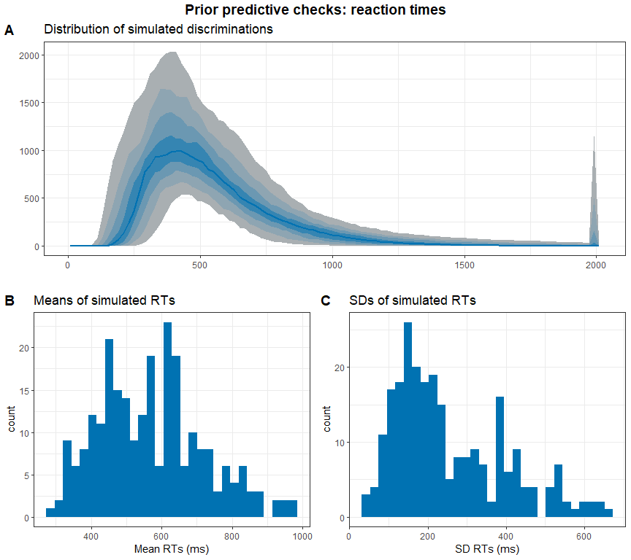

Subfigure A shows the distribution of the simulated data with bluer bands being more likely than greyer bands. It shows a distribution that fits our expectations about reaction times in a simple decision task. The same applies to the distribution of the means and standard deviations in the simulated datasets. We go ahead with these priors and check the results of the SBC. We only plot the results from the models that had no divergence issues.

# get simulation numbers with issues  
rank = max(df.results$max_rank)  
check = merge(df.results %>%   
 group_by(sim_id) %>%   
 summarise(  
 rhat = max(rhat, na.rm = T),   
 mean_rank = mean(max_rank)  
 ) %>%   
 filter(rhat >= 1.05 | mean_rank != rank),   
 df.backend %>% filter(n_divergent > 0), all = T)  
  
# plot SBC with functions from the SBC package focusing on population-level parameters  
df.results.b = df.results %>%   
 filter(substr(variable, 1, 2) == "b_") %>%   
 filter(!(sim_id %in% check$sim_id))  
p1 = plot_ecdf_diff(df.results.b) + theme_bw() + theme(legend.position = "none") +  
 scale_x_continuous(breaks=scales::pretty_breaks(n = 3)) +  
 scale_y_continuous(breaks=scales::pretty_breaks(n = 3))  
p2 = plot_rank_hist(df.results.b, bins = 20) + theme_bw() +  
 scale_x_continuous(breaks=scales::pretty_breaks(n = 3)) +  
 scale_y_continuous(breaks=scales::pretty_breaks(n = 3))  
p3 = plot_sim_estimated(df.results.b, alpha = .8) + theme_bw() +  
 scale_x_continuous(breaks=scales::pretty_breaks(n = 3)) +  
 scale_y_continuous(breaks=scales::pretty_breaks(n = 3))  
p4 = plot_contraction(df.results.b,   
 prior_sd = setNames(  
 c(as.numeric(  
 gsub(".*, (.+)\\).*", "\\1",   
 priors[priors$class == "Intercept",]$prior)),   
 as.numeric(  
 gsub(".*, (.+)\\).*", "\\1",   
 priors[priors$class == "b",]$prior))),   
 unique(df.results.b$variable))) +  
 theme_bw() +  
 scale_x_continuous(breaks=scales::pretty_breaks(n = 3)) +  
 scale_y_continuous(breaks=scales::pretty_breaks(n = 3))  
  
p = ggarrange(p1, p2, p3, p4, labels = "AUTO", ncol = 1, nrow = 4)  
annotate_figure(p, top =   
 text_grob("Computational faithfulness and model sensitivity",   
 face = "bold", size = 14))

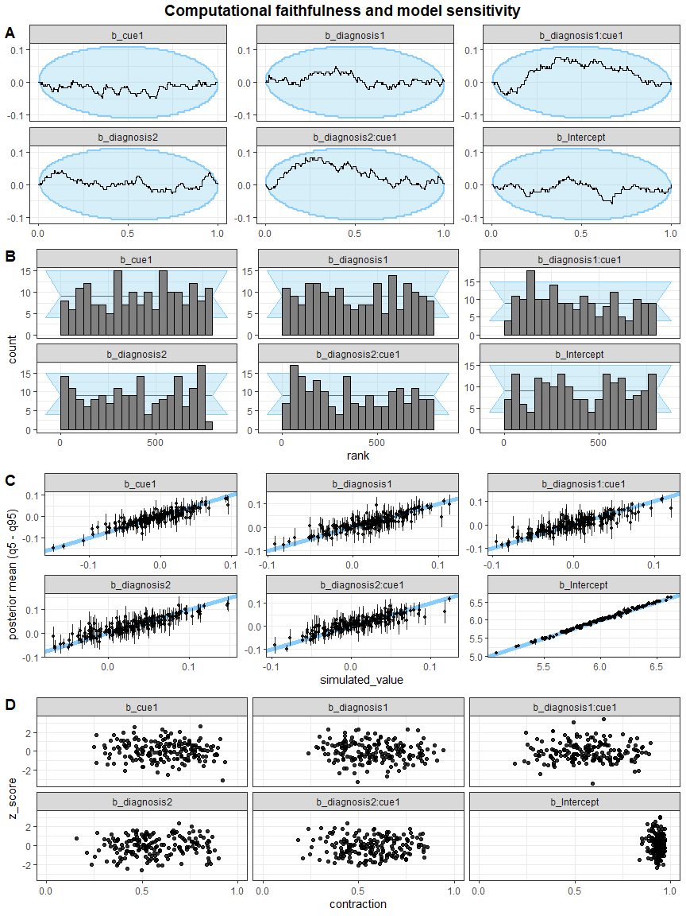

Next, we check the ranks of the parameters. If the model is unbiased, these should be uniformly distributed (Schad, Betancourt and Vasishth, 2020). The sample empirical cumulative distribution function (ECDF) lies within the theoretical distribution (95%) and the rank histogram also shows ranks within the 95% expected range, although there are some small deviations. We judge this to be acceptable.

Then, we investigated the relationship between the simulated true parameters and the posterior estimates. Although there are individual values diverging from the expected pattern, most parameters were recovered successfully within an uncertainty interval of alpha = 0.05.

Last, we explore the z-score and the posterior contraction of our population-level predictors. The z-score “determines the distance of the posterior mean from the true simulating parameter”, while the posterior contraction “estimates how much prior uncertainty is reduced in the posterior estimation” (Schad, Betancourt and Vasisth, 2020). All of this looks good for this model.

### Posterior predictive checks

As the next step, we fit the model to the data, check whether there are divergence or rhat issues, and then check whether the chains have converged.

# fit the full model  
set.seed(2469)  
m.fab = brm(f.fab,  
 df.fab, prior = priors,  
 family = shifted_lognormal,  
 iter = iter, warmup = warm,  
 backend = "cmdstanr", threads = threading(8),  
 file = "m_fab_full"  
 )  
rstan::check_hmc_diagnostics(m.fab$fit)

##   
## Divergences:

## 0 of 8000 iterations ended with a divergence.

##   
## Tree depth:

## 0 of 8000 iterations saturated the maximum tree depth of 10.

##   
## Energy:

## E-BFMI indicated no pathological behavior.

# check that rhats are below 1.01  
sum(brms::rhat(m.fab) >= 1.01, na.rm = T)

## [1] 0

# check the trace plots  
post.draws = as_draws_df(m.fab)  
mcmc_trace(post.draws, regex_pars = "^b_",  
 facet_args = list(ncol = 3)) +  
 scale_x_continuous(breaks=scales::pretty_breaks(n = 3)) +  
 scale_y_continuous(breaks=scales::pretty_breaks(n = 3))

## Scale for x is already present.  
## Adding another scale for x, which will replace the existing scale.

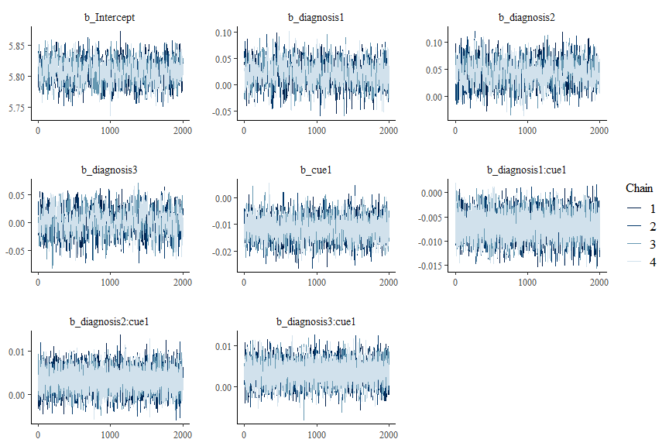

This model has no pathological behaviour with E-BFMI, no divergent samples and no rhat that is higher or equal to 1.01. Therefore, we go ahead and perform our posterior predictive checks.

# get posterior predictions  
post.pred = posterior_predict(m.fab, ndraws = nsim)  
  
# check the fit of the predicted data compared to the real data  
p1 = pp_check(m.fab, ndraws = nsim) +   
 theme_bw() + theme(legend.position = "none") + xlim(0, 2000)  
  
# get rid of NAs in data frame for plotting  
df.fab.na = df.fab[!is.na(df.fab$rt.cor),]  
  
# distributions of means compared to the real values per group  
p2 = ppc_stat_grouped(df.fab.na$rt.cor, post.pred, df.fab.na$diagnosis) +   
 theme_bw() + theme(legend.position = "none")  
  
# distributions of means compared to the real values per cue  
p3 = ppc_stat_grouped(df.fab.na$rt.cor, post.pred, df.fab.na$cue) +   
 theme_bw() + theme(legend.position = "none")  
  
p = ggarrange(p1, p2, p3,  
 nrow = 3, ncol = 1, labels = "AUTO")  
annotate_figure(p,   
 top = text_grob("Posterior predictive checks: RTs",   
 face = "bold", size = 14))

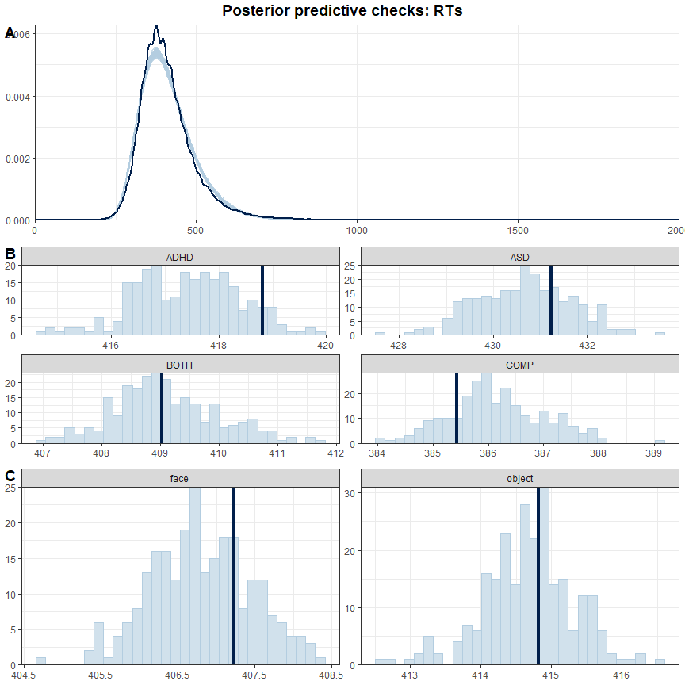

Although the overall shape in subfigure A of the simulated data fits well with the real data, the model seems to underestimate the reaction times of the ADHD and ASD groups and overestimate the reaction times of the COMP group: the dark blue line shows the mean of the actual dataset while the light blue bars show the distribution of the predicted data.

Since we are interested in accurate estimates, we decide to aggregate with the median of the reaction times per stimulus (face-object cue combination) and cue. Then, there are no missing values in the data and we model an estimate for each specific stimulus and cue combination for each participant.

## Aggregated model

First, we compute the aggregation and have a quick look at the resulting data.

# keep full dataframe  
df.fab.full = df.fab  
  
# aggregate reaction times  
df.fab = df.fab %>%  
 group_by(subID, diagnosis, stm, cue) %>%  
 summarise(  
 rt.cor = median(rt.cor, na.rm = T)  
 ) %>% ungroup() %>%  
 mutate_if(is.character, as.factor)  
  
# set and print the contrasts  
contrasts(df.fab$cue) = contr.sum(2)  
contrasts(df.fab$cue)

## [,1]  
## face 1  
## object -1

contrasts(df.fab$diagnosis) = contr.sum(4)[c(1,2,4,3),]  
contrasts(df.fab$diagnosis)

## [,1] [,2] [,3]  
## ADHD 1 0 0  
## ASD 0 1 0  
## BOTH -1 -1 -1  
## COMP 0 0 1

summary(df.fab)

## subID diagnosis stm cue rt.cor   
## 1 : 72 ADHD:1656 1_10 : 188 face :3384 Min. :256.0   
## 2 : 72 ASD :1728 1_11 : 188 object:3384 1st Qu.:364.0   
## 3 : 72 BOTH:1656 1_12 : 188 Median :394.8   
## 4 : 72 COMP:1728 1_7 : 188 Mean :406.6   
## 5 : 72 1_8 : 188 3rd Qu.:435.5   
## 6 : 72 1_9 : 188 Max. :919.0   
## (Other):6336 (Other):5640

There are now no NAs in the data, because no one made an error on all instances of one stimulus combination.

### Stimulation-based calibration

We again perform an SBC. The model formula and priors can stay the same.

code = "FAB_agg"  
  
# check if the SBC already exists  
if (file.exists(file.path(cache_dir, sprintf("df_res_%s.rds", code)))) {  
 # load in the results of the SBC  
 df.results = readRDS(file.path(cache_dir, sprintf("df_res_%s.rds", code)))  
 df.backend = readRDS(file.path(cache_dir, sprintf("df_div_%s.rds", code)))  
 dat = readRDS(file.path(cache_dir, sprintf("dat_%s.rds", code)))  
} else {  
 # perform the SBC  
 gen = SBC_generator_brms(f.fab, data = df.fab, prior = priors,   
 family = shifted_lognormal,  
 thin = 50, warmup = 20000, refresh = 2000)  
 bck = SBC_backend_brms_from_generator(gen, chains = 4, thin = 1,  
 init = 0.1, warmup = warm, iter = iter)  
 set.seed(468)  
 if (file.exists(file.path(cache_dir, sprintf("dat_%s.rds", code)))) {  
 dat = readRDS(file.path(cache_dir, sprintf("dat_%s.rds", code)))  
 } else {  
 dat = generate_datasets(gen, nsim)  
 saveRDS(dat, file.path(cache_dir, sprintf("dat_%s.rds", code)))  
 }  
 res = compute_SBC(dat,   
 bck,  
 cache_mode = "results",   
 cache_location = file.path(cache_dir, sprintf("res_%s", code)))  
 df.results = res$stats  
 df.backend = res$backend_diagnostics  
 saveRDS(df.results, file = file.path(cache_dir, paste0("df_res_", code, ".rds")))  
 saveRDS(df.backend, file = file.path(cache_dir, paste0("df_div_", code, ".rds")))  
}  
  
set.seed(4682)

We start by investigating the rhats and the number of divergent samples. This shows that 3 of 250 simulations had at least one parameter that had an rhat of at least 1.05, and 2 models had divergent samples (mean number of samples of the simulations with divergent samples: 17.5). This suggests that this model performs well enough and only few simulated models exhibit issues.

Next, we can plot the simulated values to perform prior predictive checks.

# create a matrix out of generated data  
dvname = gsub(" ", "", gsub("[\\|~].*", "", f.fab)[1])  
dvfakemat = matrix(NA, nrow(dat[['generated']][[1]]), length(dat[['generated']]))   
for (i in 1:length(dat[['generated']])) {  
 dvfakemat[,i] = dat[['generated']][[i]][[dvname]]  
}  
truePars = dat$variables  
  
# set large values to a max  
dvfakemat[dvfakemat > 2000] = 2000  
  
# compute one histogram per simulated data-set   
binwidth = 20   
breaks = seq(0, max(dvfakemat, na.rm=T) + binwidth, binwidth)   
histmat = matrix(NA, ncol = length(dat), nrow = length(breaks)-1)   
for (i in 1:nrow(truePars)) {  
 histmat[,i] = hist(dvfakemat[,i], breaks = breaks, plot = F)$counts   
}  
# for each bin, compute quantiles across histograms   
probs = seq(0.1, 0.9, 0.1)   
quantmat= as.data.frame(matrix(NA, nrow=dim(histmat)[1], ncol = length(probs)))  
names(quantmat) = paste0("p", probs)  
for (i in 1:dim(histmat)[1]) {  
 quantmat[i,] = quantile(histmat[i,], p = probs)  
}  
quantmat$x = breaks[2:length(breaks)] - binwidth/2 # add bin mean   
p1 = ggplot(data = quantmat, aes(x = x)) +   
 geom_ribbon(aes(ymax = p0.9, ymin = p0.1), fill = c_light) +   
 geom_ribbon(aes(ymax = p0.8, ymin = p0.2), fill = c_light_highlight) +   
 geom_ribbon(aes(ymax = p0.7, ymin = p0.3), fill = c_mid) +   
 geom_ribbon(aes(ymax = p0.6, ymin = p0.4), fill = c_mid_highlight) +   
 geom_line(aes(y = p0.5), colour = c_dark, linewidth = 1) +   
 labs(title = "Distribution of simulated discriminations", y = "", x = "") +  
 theme_bw()  
  
tmpM = apply(dvfakemat, 2, mean) # mean   
tmpSD = apply(dvfakemat, 2, sd)   
p2 = ggplot() +   
 stat_bin(aes(x = tmpM), fill = c_dark) +   
 labs(x = "Mean RTs (ms)", title = "Means of simulated RTs") +  
 theme_bw()  
p3 = ggplot() +   
 stat_bin(aes(x = tmpSD), fill = c_dark) +   
 labs(x = "SD RTs (ms)", title = "SDs of simulated RTs") +  
 theme_bw()  
p = ggarrange(p1,   
 ggarrange(p2, p3, ncol = 2, labels = c("B", "C")),   
 nrow = 2, labels = "A")  
annotate_figure(p,   
 top = text_grob("Prior predictive checks: reaction times",   
 face = "bold", size = 14))

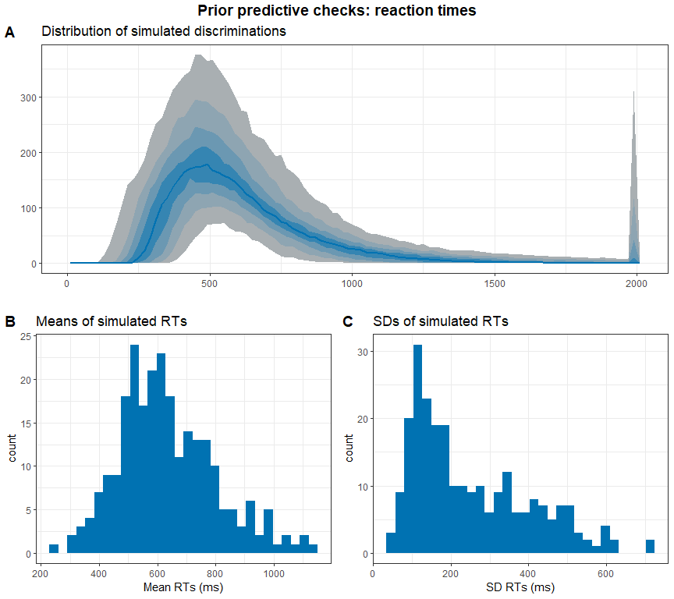

Again, this all looks good.

# get simulation numbers with issues  
rank = max(df.results$max_rank)  
check = merge(df.results %>%   
 group_by(sim_id) %>%   
 summarise(  
 rhat = max(rhat, na.rm = T),   
 mean_rank = mean(max_rank)  
 ) %>%   
 filter(rhat >= 1.05 | mean_rank != rank),   
 df.backend %>% filter(n_divergent > 0), all = T)  
  
# plot SBC with functions from the SBC package focusing on population-level parameters  
df.results.b = df.results %>%   
 filter(substr(variable, 1, 2) == "b_") %>%   
 filter(!(sim_id %in% check$sim_id))  
p1 = plot_ecdf_diff(df.results.b) + theme_bw() + theme(legend.position = "none") +  
 scale_x_continuous(breaks=scales::pretty_breaks(n = 3)) +  
 scale_y_continuous(breaks=scales::pretty_breaks(n = 3))  
p2 = plot_rank_hist(df.results.b, bins = 20) + theme_bw() +  
 scale_x_continuous(breaks=scales::pretty_breaks(n = 3)) +  
 scale_y_continuous(breaks=scales::pretty_breaks(n = 3))  
p3 = plot_sim_estimated(df.results.b, alpha = .8) + theme_bw() +  
 scale_x_continuous(breaks=scales::pretty_breaks(n = 3)) +  
 scale_y_continuous(breaks=scales::pretty_breaks(n = 3))  
p4 = plot_contraction(df.results.b,   
 prior_sd = setNames(  
 c(as.numeric(  
 gsub(".*, (.+)\\).*", "\\1",   
 priors[priors$class == "Intercept",]$prior)),   
 as.numeric(  
 gsub(".*, (.+)\\).*", "\\1",   
 priors[priors$class == "b",]$prior))),   
 unique(df.results.b$variable))) +  
 theme_bw() +  
 scale_x_continuous(breaks=scales::pretty_breaks(n = 3)) +  
 scale_y_continuous(breaks=scales::pretty_breaks(n = 3))  
  
p = ggarrange(p1, p2, p3, p4, labels = "AUTO", ncol = 1, nrow = 4)  
annotate_figure(p,   
 top = text_grob("Computational faithfulness and model sensitivity",   
 face = "bold", size = 14))

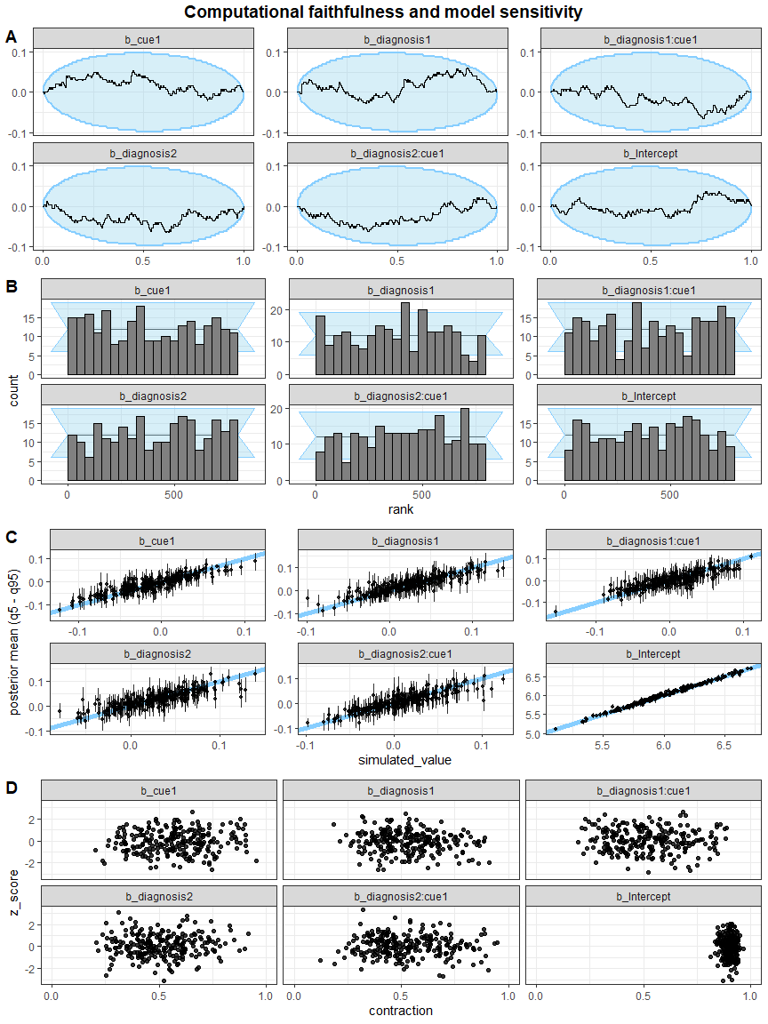

Rank histogramms, sample ECDF, the relationship between the simulated true parameters and the posterior estimates as well as z-score and posterior contraction of our population-level predictors all are acceptable for this model as well.

### Posterior predictive checks

As the next step, we fit the model to the data, check whether there are divergence or rhat issues, and then check whether the chains have converged.

# fit the final model  
set.seed(6824)  
m.fab = brm(f.fab,  
 df.fab, prior = priors,  
 family = shifted_lognormal,  
 iter = iter, warmup = warm,  
 backend = "cmdstanr", threads = threading(8),  
 file = "m_fab_final"  
 )  
rstan::check_hmc_diagnostics(m.fab$fit)

##   
## Divergences:

## 0 of 8000 iterations ended with a divergence.

##   
## Tree depth:

## 0 of 8000 iterations saturated the maximum tree depth of 10.

##   
## Energy:

## E-BFMI indicated no pathological behavior.

# check that rhats are below 1.01  
sum(brms::rhat(m.fab) >= 1.01, na.rm = T)

## [1] 0

# check the trace plots  
post.draws = as_draws_df(m.fab)  
mcmc_trace(post.draws, regex_pars = "^b_",  
 facet_args = list(ncol = 3)) +  
 scale_x_continuous(breaks=scales::pretty_breaks(n = 3)) +  
 scale_y_continuous(breaks=scales::pretty_breaks(n = 3))

## Scale for x is already present.  
## Adding another scale for x, which will replace the existing scale.

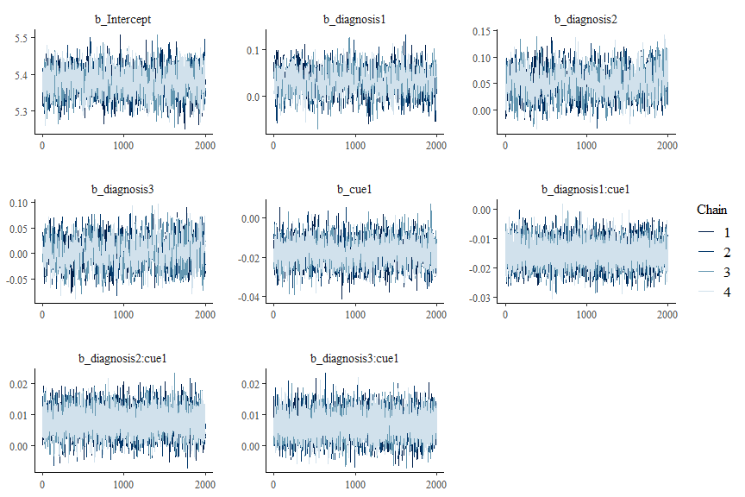

This model has no pathological behaviour with E-BFMI, no divergent samples and no rhat that is higher or equal to 1.01. Therefore, we go ahead and perform our posterior predictive checks.

# get posterior predictions  
post.pred = posterior_predict(m.fab, ndraws = nsim)  
  
# check the fit of the predicted data compared to the real data  
p1 = pp_check(m.fab, ndraws = nsim) +   
 theme_bw() + theme(legend.position = "none")  
  
# distributions of means compared to the real values per group  
p2 = ppc_stat_grouped(df.fab$rt.cor, post.pred, df.fab$diagnosis) +   
 theme_bw() + theme(legend.position = "none")  
  
# distributions of means compared to the real values per cue  
p3 = ppc_stat_grouped(df.fab$rt.cor, post.pred, df.fab$cue) +   
 theme_bw() + theme(legend.position = "none")  
  
p = ggarrange(p1, p2, p3,  
 nrow = 3, ncol = 1, labels = "AUTO")  
annotate_figure(p,   
 top = text_grob("Posterior predictive checks: RTs",   
 face = "bold", size = 14))

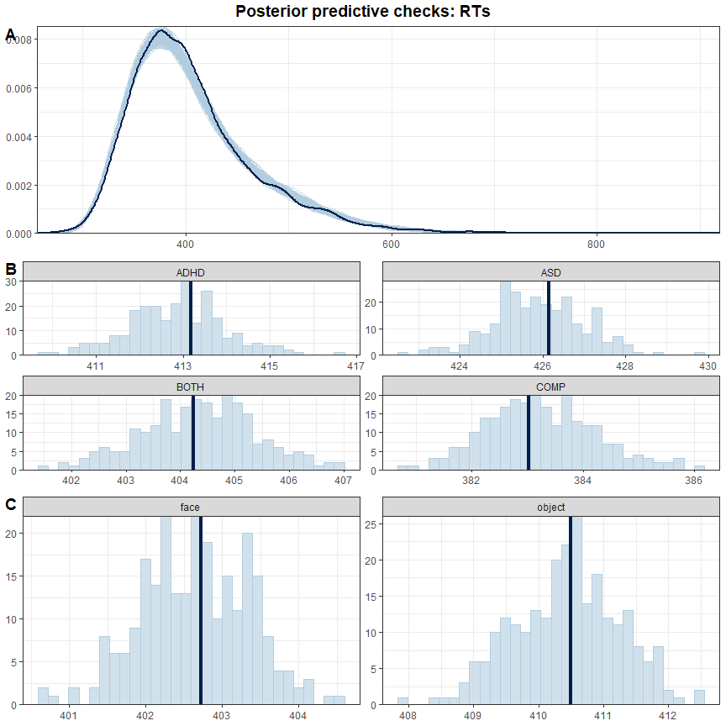

This model fits our data much better.

### Inferences

Now that we are convinced that we can trust our model, we have a look at its estimate and use the hypothesis function to assess our hypotheses and perform explorative tests.

# print a summary  
summary(m.fab)

## Family: shifted_lognormal   
## Links: mu = identity; sigma = identity; ndt = identity   
## Formula: rt.cor ~ diagnosis * cue + (cue | subID) + (cue * diagnosis | stm)   
## Data: df.fab (Number of observations: 6768)   
## Draws: 4 chains, each with iter = 3000; warmup = 1000; thin = 1;  
## total post-warmup draws = 8000  
##   
## Group-Level Effects:   
## ~stm (Number of levels: 36)   
## Estimate Est.Error l-95% CI u-95% CI Rhat  
## sd(Intercept) 0.03 0.00 0.02 0.03 1.00  
## sd(cue1) 0.03 0.00 0.03 0.04 1.00  
## sd(diagnosis1) 0.01 0.00 0.00 0.02 1.00  
## sd(diagnosis2) 0.00 0.00 0.00 0.01 1.00  
## sd(diagnosis3) 0.01 0.00 0.00 0.01 1.00  
## sd(cue1:diagnosis1) 0.00 0.00 0.00 0.01 1.00  
## sd(cue1:diagnosis2) 0.00 0.00 0.00 0.01 1.00  
## sd(cue1:diagnosis3) 0.00 0.00 0.00 0.01 1.00  
## cor(Intercept,cue1) -0.30 0.15 -0.57 0.03 1.00  
## cor(Intercept,diagnosis1) -0.12 0.26 -0.60 0.45 1.00  
## cor(cue1,diagnosis1) 0.01 0.26 -0.50 0.51 1.00  
## cor(Intercept,diagnosis2) -0.07 0.29 -0.60 0.51 1.00  
## cor(cue1,diagnosis2) -0.05 0.29 -0.58 0.51 1.00  
## cor(diagnosis1,diagnosis2) -0.01 0.30 -0.58 0.57 1.00  
## cor(Intercept,diagnosis3) 0.06 0.27 -0.49 0.57 1.00  
## cor(cue1,diagnosis3) 0.18 0.27 -0.41 0.66 1.00  
## cor(diagnosis1,diagnosis3) -0.12 0.30 -0.66 0.49 1.00  
## cor(diagnosis2,diagnosis3) -0.08 0.31 -0.65 0.54 1.00  
## cor(Intercept,cue1:diagnosis1) 0.03 0.28 -0.51 0.55 1.00  
## cor(cue1,cue1:diagnosis1) -0.06 0.28 -0.58 0.49 1.00  
## cor(diagnosis1,cue1:diagnosis1) 0.00 0.30 -0.56 0.57 1.00  
## cor(diagnosis2,cue1:diagnosis1) -0.00 0.30 -0.57 0.56 1.00  
## cor(diagnosis3,cue1:diagnosis1) -0.03 0.30 -0.59 0.54 1.00  
## cor(Intercept,cue1:diagnosis2) -0.21 0.28 -0.69 0.40 1.00  
## cor(cue1,cue1:diagnosis2) -0.01 0.28 -0.54 0.53 1.00  
## cor(diagnosis1,cue1:diagnosis2) 0.03 0.29 -0.54 0.58 1.00  
## cor(diagnosis2,cue1:diagnosis2) 0.04 0.30 -0.54 0.61 1.00  
## cor(diagnosis3,cue1:diagnosis2) -0.05 0.29 -0.59 0.53 1.00  
## cor(cue1:diagnosis1,cue1:diagnosis2) -0.09 0.31 -0.65 0.53 1.00  
## cor(Intercept,cue1:diagnosis3) -0.10 0.28 -0.62 0.46 1.00  
## cor(cue1,cue1:diagnosis3) -0.15 0.28 -0.65 0.43 1.00  
## cor(diagnosis1,cue1:diagnosis3) 0.05 0.30 -0.52 0.61 1.00  
## cor(diagnosis2,cue1:diagnosis3) 0.06 0.30 -0.53 0.62 1.00  
## cor(diagnosis3,cue1:diagnosis3) -0.02 0.30 -0.59 0.55 1.00  
## cor(cue1:diagnosis1,cue1:diagnosis3) -0.08 0.30 -0.63 0.52 1.00  
## cor(cue1:diagnosis2,cue1:diagnosis3) -0.01 0.30 -0.58 0.57 1.00  
## Bulk_ESS Tail_ESS  
## sd(Intercept) 2578 4611  
## sd(cue1) 2693 4533  
## sd(diagnosis1) 2411 3394  
## sd(diagnosis2) 4155 4612  
## sd(diagnosis3) 3402 4152  
## sd(cue1:diagnosis1) 3823 4565  
## sd(cue1:diagnosis2) 3982 4324  
## sd(cue1:diagnosis3) 3597 3381  
## cor(Intercept,cue1) 1826 3831  
## cor(Intercept,diagnosis1) 13054 5814  
## cor(cue1,diagnosis1) 13349 6130  
## cor(Intercept,diagnosis2) 16827 5305  
## cor(cue1,diagnosis2) 17348 5809  
## cor(diagnosis1,diagnosis2) 9760 6457  
## cor(Intercept,diagnosis3) 15806 5807  
## cor(cue1,diagnosis3) 12478 6278  
## cor(diagnosis1,diagnosis3) 7439 6368  
## cor(diagnosis2,diagnosis3) 7729 6017  
## cor(Intercept,cue1:diagnosis1) 15320 6384  
## cor(cue1,cue1:diagnosis1) 16067 5911  
## cor(diagnosis1,cue1:diagnosis1) 10215 6390  
## cor(diagnosis2,cue1:diagnosis1) 7492 6359  
## cor(diagnosis3,cue1:diagnosis1) 7425 7042  
## cor(Intercept,cue1:diagnosis2) 11799 6187  
## cor(cue1,cue1:diagnosis2) 15752 5325  
## cor(diagnosis1,cue1:diagnosis2) 10817 6320  
## cor(diagnosis2,cue1:diagnosis2) 8245 6495  
## cor(diagnosis3,cue1:diagnosis2) 6974 6717  
## cor(cue1:diagnosis1,cue1:diagnosis2) 6068 6426  
## cor(Intercept,cue1:diagnosis3) 14585 6447  
## cor(cue1,cue1:diagnosis3) 11674 6152  
## cor(diagnosis1,cue1:diagnosis3) 8962 5900  
## cor(diagnosis2,cue1:diagnosis3) 6889 6461  
## cor(diagnosis3,cue1:diagnosis3) 8014 7067  
## cor(cue1:diagnosis1,cue1:diagnosis3) 6829 6746  
## cor(cue1:diagnosis2,cue1:diagnosis3) 6471 6914  
##   
## ~subID (Number of levels: 94)   
## Estimate Est.Error l-95% CI u-95% CI Rhat Bulk_ESS Tail_ESS  
## sd(Intercept) 0.21 0.02 0.18 0.24 1.00 1249 2259  
## sd(cue1) 0.02 0.00 0.01 0.02 1.00 3696 5257  
## cor(Intercept,cue1) -0.04 0.14 -0.32 0.24 1.00 7658 6980  
##   
## Population-Level Effects:   
## Estimate Est.Error l-95% CI u-95% CI Rhat Bulk_ESS Tail_ESS  
## Intercept 5.38 0.03 5.31 5.45 1.00 1000 1967  
## diagnosis1 0.03 0.03 -0.02 0.08 1.00 1053 1809  
## diagnosis2 0.05 0.03 0.00 0.10 1.00 959 1959  
## diagnosis3 0.00 0.03 -0.05 0.06 1.00 1055 2006  
## cue1 -0.02 0.01 -0.03 -0.01 1.00 2074 3747  
## diagnosis1:cue1 -0.01 0.00 -0.02 -0.01 1.00 8305 7001  
## diagnosis2:cue1 0.01 0.00 0.00 0.02 1.00 8591 7066  
## diagnosis3:cue1 0.01 0.00 -0.00 0.01 1.00 8207 7062  
##   
## Family Specific Parameters:   
## Estimate Est.Error l-95% CI u-95% CI Rhat Bulk_ESS Tail_ESS  
## sigma 0.13 0.00 0.13 0.14 1.00 5963 5842  
## ndt 183.19 5.64 171.94 193.62 1.00 5982 5698  
##   
## Draws were sampled using sample(hmc). For each parameter, Bulk_ESS  
## and Tail_ESS are effective sample size measures, and Rhat is the potential  
## scale reduction factor on split chains (at convergence, Rhat = 1).

# get the estimates and compute groups  
df.m.fab = as_draws_df(m.fab) %>%   
 select(starts_with("b_")) %>%  
 mutate(  
 b_COMP = - b_diagnosis1 - b_diagnosis2 - b_diagnosis3,  
 ASD = b_Intercept + b_diagnosis2,  
 ADHD = b_Intercept + b_diagnosis1,  
 BOTH = b_Intercept + b_diagnosis3,  
 COMP = b_Intercept + b_COMP  
 )  
  
# plot the posterior distributions  
df.m.fab %>%   
 select(starts_with("b_")) %>%  
 pivot_longer(cols = starts_with("b_"), names_to = "coef", values_to = "estimate") %>%  
 filter(coef != "b_Intercept") %>%  
 mutate(  
 coef = case_match(coef,  
 "b_diagnosis1" ~ "ADHD",  
 "b_diagnosis2" ~ "ASD",  
 "b_diagnosis3" ~ "ADHD+ASD",  
 "b_COMP" ~ "COMP",  
 "b_cue1" ~ "Face",  
 "b_diagnosis1:cue1" ~ "Interaction: ADHD",  
 "b_diagnosis2:cue1" ~ "Interaction: ASD",  
 "b_diagnosis3:cue1" ~ "Interaction: ADHD+ASD"  
 ),  
 coef = fct_reorder(coef, desc(estimate))  
 ) %>%   
 group_by(coef) %>%  
 mutate(  
 cred = case_when(  
 (mean(estimate) < 0 & quantile(estimate, probs = 0.975) < 0) |  
 (mean(estimate) > 0 & quantile(estimate, probs = 0.025) > 0) ~ "credible",  
 T ~ "not credible"  
 )  
 ) %>% ungroup() %>%   
 ggplot(aes(x = estimate, y = coef, fill = cred)) +  
 geom_vline(xintercept = 0, linetype = 'dashed') +  
 ggdist::stat_halfeye(alpha = 0.7) + ylab(NULL) + theme_bw() +  
 scale_fill_manual(values = c(credible = c_dark, c_light)) +   
 theme(legend.position = "none")

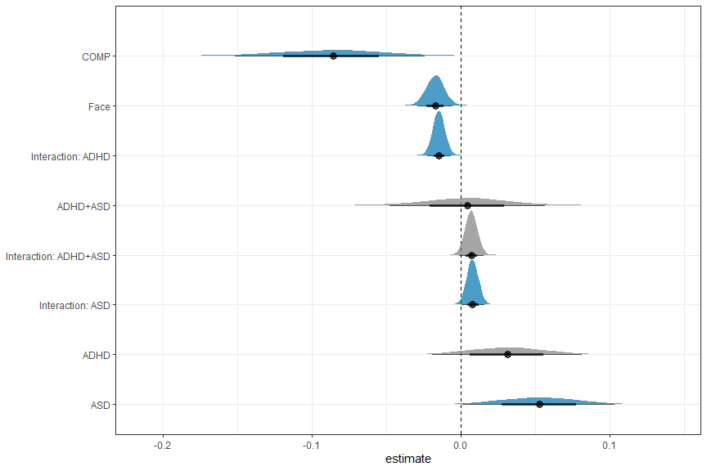

# H1a: FAB effect in COMP  
h1a = hypothesis(m.fab,   
 "0 < 2*(diagnosis1:cue1 + diagnosis2:cue1 + diagnosis3:cue1 - cue1)")  
h1a

## Hypothesis Tests for class b:  
## Hypothesis Estimate Est.Error CI.Lower CI.Upper Evid.Ratio  
## 1 (0)-(2*(diagnosis... < 0 -0.03 0.02 -0.06 -0.01 77.43  
## Post.Prob Star  
## 1 0.99 *  
## ---  
## 'CI': 90%-CI for one-sided and 95%-CI for two-sided hypotheses.  
## '*': For one-sided hypotheses, the posterior probability exceeds 95%;  
## for two-sided hypotheses, the value tested against lies outside the 95%-CI.  
## Posterior probabilities of point hypotheses assume equal prior probabilities.

# H1b: ADHD slower than COMP  
h1b = hypothesis(m.fab,   
 "0 < 2*diagnosis1 + diagnosis2 + diagnosis3")  
h1b

## Hypothesis Tests for class b:  
## Hypothesis Estimate Est.Error CI.Lower CI.Upper Evid.Ratio  
## 1 (0)-(2*diagnosis1... < 0 -0.12 0.05 -0.2 -0.04 139.35  
## Post.Prob Star  
## 1 0.99 *  
## ---  
## 'CI': 90%-CI for one-sided and 95%-CI for two-sided hypotheses.  
## '*': For one-sided hypotheses, the posterior probability exceeds 95%;  
## for two-sided hypotheses, the value tested against lies outside the 95%-CI.  
## Posterior probabilities of point hypotheses assume equal prior probabilities.

# H1c: ASD slower than COMP  
h1c = hypothesis(m.fab,   
 "0 < 2*diagnosis2 + diagnosis1 + diagnosis3")  
h1c

## Hypothesis Tests for class b:  
## Hypothesis Estimate Est.Error CI.Lower CI.Upper Evid.Ratio  
## 1 (0)-(2*diagnosis2... < 0 -0.14 0.05 -0.22 -0.06 443.44  
## Post.Prob Star  
## 1 1 *  
## ---  
## 'CI': 90%-CI for one-sided and 95%-CI for two-sided hypotheses.  
## '*': For one-sided hypotheses, the posterior probability exceeds 95%;  
## for two-sided hypotheses, the value tested against lies outside the 95%-CI.  
## Posterior probabilities of point hypotheses assume equal prior probabilities.

# H1d: FAB in ASD decreased compared to COMP  
h1d = hypothesis(m.fab,   
 "0 < 4*diagnosis2:cue1 + 2*diagnosis1:cue1 + 2*diagnosis3:cue1")  
h1d

## Hypothesis Tests for class b:  
## Hypothesis Estimate Est.Error CI.Lower CI.Upper Evid.Ratio  
## 1 (0)-(4*diagnosis2... < 0 -0.02 0.01 -0.04 0.01 6.9  
## Post.Prob Star  
## 1 0.87   
## ---  
## 'CI': 90%-CI for one-sided and 95%-CI for two-sided hypotheses.  
## '*': For one-sided hypotheses, the posterior probability exceeds 95%;  
## for two-sided hypotheses, the value tested against lies outside the 95%-CI.  
## Posterior probabilities of point hypotheses assume equal prior probabilities.

# H1e: FAB in ADHD differs from FAB in COMP (undirected)  
h1e = hypothesis(m.fab,   
 "0 > 4*diagnosis1:cue1 + 2*diagnosis2:cue1 + 2*diagnosis3:cue1",   
 alpha = 0.025)  
h1e

## Hypothesis Tests for class b:  
## Hypothesis Estimate Est.Error CI.Lower CI.Upper Evid.Ratio  
## 1 (0)-(4*diagnosis1... > 0 0.03 0.01 0 0.06 71.73  
## Post.Prob Star  
## 1 0.99 *  
## ---  
## 'CI': 95%-CI for one-sided and 97.5%-CI for two-sided hypotheses.  
## '*': For one-sided hypotheses, the posterior probability exceeds 97.5%;  
## for two-sided hypotheses, the value tested against lies outside the 97.5%-CI.  
## Posterior probabilities of point hypotheses assume equal prior probabilities.

# Exploration  
  
# E1: FAB generally  
e1 = hypothesis(m.fab, "2*cue1 < 0", alpha = 0.025)  
e1

## Hypothesis Tests for class b:  
## Hypothesis Estimate Est.Error CI.Lower CI.Upper Evid.Ratio Post.Prob Star  
## 1 (2*cue1) < 0 -0.03 0.01 -0.06 -0.01 306.69 1 *  
## ---  
## 'CI': 95%-CI for one-sided and 97.5%-CI for two-sided hypotheses.  
## '*': For one-sided hypotheses, the posterior probability exceeds 97.5%;  
## for two-sided hypotheses, the value tested against lies outside the 97.5%-CI.  
## Posterior probabilities of point hypotheses assume equal prior probabilities.

# E2: FAB effect in ADHD  
e2 = hypothesis(m.fab, "0 < -2*cue1 - 2*diagnosis1:cue1", alpha = 0.025)  
e2

## Hypothesis Tests for class b:  
## Hypothesis Estimate Est.Error CI.Lower CI.Upper Evid.Ratio  
## 1 (0)-(-2*cue1-2*di... < 0 -0.06 0.01 -0.09 -0.04 Inf  
## Post.Prob Star  
## 1 1 *  
## ---  
## 'CI': 95%-CI for one-sided and 97.5%-CI for two-sided hypotheses.  
## '*': For one-sided hypotheses, the posterior probability exceeds 97.5%;  
## for two-sided hypotheses, the value tested against lies outside the 97.5%-CI.  
## Posterior probabilities of point hypotheses assume equal prior probabilities.

# E3: FAB effect in ASD  
e3 = hypothesis(m.fab, "0 < -2*cue1 - 2*diagnosis2:cue1", alpha = 0.025)  
e3

## Hypothesis Tests for class b:  
## Hypothesis Estimate Est.Error CI.Lower CI.Upper Evid.Ratio  
## 1 (0)-(-2*cue1-2*di... < 0 -0.02 0.01 -0.05 0.01 9.39  
## Post.Prob Star  
## 1 0.9   
## ---  
## 'CI': 95%-CI for one-sided and 97.5%-CI for two-sided hypotheses.  
## '*': For one-sided hypotheses, the posterior probability exceeds 97.5%;  
## for two-sided hypotheses, the value tested against lies outside the 97.5%-CI.  
## Posterior probabilities of point hypotheses assume equal prior probabilities.

# E4: FAB effect in ADHD+ASD  
e4 = hypothesis(m.fab, "0 < -2*cue1 - 2*diagnosis3:cue1", alpha = 0.025)  
e4

## Hypothesis Tests for class b:  
## Hypothesis Estimate Est.Error CI.Lower CI.Upper Evid.Ratio  
## 1 (0)-(-2*cue1-2*di... < 0 -0.02 0.01 -0.05 0.01 12.84  
## Post.Prob Star  
## 1 0.93   
## ---  
## 'CI': 95%-CI for one-sided and 97.5%-CI for two-sided hypotheses.  
## '*': For one-sided hypotheses, the posterior probability exceeds 97.5%;  
## for two-sided hypotheses, the value tested against lies outside the 97.5%-CI.  
## Posterior probabilities of point hypotheses assume equal prior probabilities.

# E5: FAB in ADHD differs from FAB in ASD  
e5 = hypothesis(m.fab,   
 "0 < -2*diagnosis1:cue1 + 2*diagnosis2:cue1", alpha = 0.025)  
e5

## Hypothesis Tests for class b:  
## Hypothesis Estimate Est.Error CI.Lower CI.Upper Evid.Ratio  
## 1 (0)-(-2*diagnosis... < 0 -0.05 0.01 -0.07 -0.02 7999  
## Post.Prob Star  
## 1 1 *  
## ---  
## 'CI': 95%-CI for one-sided and 97.5%-CI for two-sided hypotheses.  
## '*': For one-sided hypotheses, the posterior probability exceeds 97.5%;  
## for two-sided hypotheses, the value tested against lies outside the 97.5%-CI.  
## Posterior probabilities of point hypotheses assume equal prior probabilities.

# E6: FAB in ADHD differs from FAB in BOTH  
e6 = hypothesis(m.fab,   
 "0 < -2*diagnosis1:cue1 + 2*diagnosis3:cue1", alpha = 0.025)  
e6

## Hypothesis Tests for class b:  
## Hypothesis Estimate Est.Error CI.Lower CI.Upper Evid.Ratio  
## 1 (0)-(-2*diagnosis... < 0 -0.04 0.01 -0.07 -0.02 2665.67  
## Post.Prob Star  
## 1 1 *  
## ---  
## 'CI': 95%-CI for one-sided and 97.5%-CI for two-sided hypotheses.  
## '*': For one-sided hypotheses, the posterior probability exceeds 97.5%;  
## for two-sided hypotheses, the value tested against lies outside the 97.5%-CI.  
## Posterior probabilities of point hypotheses assume equal prior probabilities.

# E7: FAB in ASD differs from FAB in BOTH  
e7 = hypothesis(m.fab,   
 "0 < -2*diagnosis2:cue1 + 2*diagnosis3:cue1", alpha = 0.025)  
e7

## Hypothesis Tests for class b:  
## Hypothesis Estimate Est.Error CI.Lower CI.Upper Evid.Ratio  
## 1 (0)-(-2*diagnosis... < 0 0 0.01 -0.02 0.03 0.79  
## Post.Prob Star  
## 1 0.44   
## ---  
## 'CI': 95%-CI for one-sided and 97.5%-CI for two-sided hypotheses.  
## '*': For one-sided hypotheses, the posterior probability exceeds 97.5%;  
## for two-sided hypotheses, the value tested against lies outside the 97.5%-CI.  
## Posterior probabilities of point hypotheses assume equal prior probabilities.

# E8: FAB in COMP differs from FAB in BOTH  
e8 = hypothesis(m.fab,   
 "0 < 2*diagnosis1:cue1 + 2*diagnosis2:cue1 + 4*diagnosis3:cue1",   
 alpha = 0.025)  
e8

## Hypothesis Tests for class b:  
## Hypothesis Estimate Est.Error CI.Lower CI.Upper Evid.Ratio  
## 1 (0)-(2*diagnosis1... < 0 -0.01 0.01 -0.04 0.01 5.26  
## Post.Prob Star  
## 1 0.84   
## ---  
## 'CI': 95%-CI for one-sided and 97.5%-CI for two-sided hypotheses.  
## '*': For one-sided hypotheses, the posterior probability exceeds 97.5%;  
## for two-sided hypotheses, the value tested against lies outside the 97.5%-CI.  
## Posterior probabilities of point hypotheses assume equal prior probabilities.

# extract predicted differences in ms instead of log data  
df.new = df.fab %>%   
 select(diagnosis, cue) %>%   
 distinct() %>%  
 mutate(  
 condition = paste(diagnosis, cue, sep = "_")  
 )  
df.ms = as.data.frame(  
 fitted(m.fab, summary = F,   
 newdata = df.new %>% select(diagnosis, cue),   
 re_formula = NA))  
colnames(df.ms) = df.new$condition  
  
# calculate our difference columns  
df.ms = df.ms %>%  
 mutate(  
 COMP = rowMeans(select(., matches("COMP_.*")), na.rm = T),  
 ADHD = rowMeans(select(., matches("ADHD_.*")), na.rm = T),  
 ASD = rowMeans(select(., matches("ASD_.*")), na.rm = T),  
 BOTH = rowMeans(select(., matches("BOTH_.*")), na.rm = T),  
 FAB = rowMeans(select(., matches(".*_object")), na.rm = T) -  
 rowMeans(select(., matches(".*_face")), na.rm = T),  
 FAB_COMP = COMP_object - COMP_face,  
 FAB_ADHD = ADHD_object - ADHD_face,  
 FAB_ASD = ASD_object - ASD_face,  
 FAB_BOTH = BOTH_object - BOTH_face,  
 h1b = ADHD - COMP,  
 h1c = ASD - COMP,  
 h1d = FAB_COMP - FAB_ASD,  
 h1e = FAB_ADHD - FAB_COMP,  
 BOTH_COMP = BOTH - COMP  
 )

As hypothesised, both autistic adults and adults with ADHD exhibited increased overall reaction times compared with the COMP group (COMP - ADHD: *estimate* = -0.12 [-0.2, -0.04], *posterior probability* = 99.29%; COMP - ASD: *estimate* = -0.14 [-0.22, -0.06], *posterior probability* = 99.78%). The model predicts that participants in the comparison group react 25.081ms [5.021, 45.753] faster than the participants in the ADHD group and 29.908ms [9.084, 50.831] faster than autistic participants. Additionally, the model predicts that the participants in the comparison group react 19.023ms [-1.549, 38.963] faster than adults in the ADHD+ASD group.

Our Bayesian linear mixed model with the median of correct reaction times as the outcome and diagnostic status, cue (face or object) and their interaction confirmed a face attention bias in our comparison group: COMP participants reacted faster in response to targets appearing on the side of the face compared to targets appearing on the side of the object (*estimate* = -0.03 [-0.06, -0.01], *posterior probability* = 98.72%). FAB was not credibly decreased in ASD participants compared to COMP participants (*estimate* = -0.02 [-0.04, 0.01], *posterior probability* = 87.34%). However, FAB was credibly higher in the ADHD than the COMP group (*estimate* = 0.03 [0, 0.06], *posterior probability* = 98.62%). Specifically, predicted reaction times based on the model estimate a FAB of 6.881ms [1.072, 12.924] in the COMP group, 14.469ms [8.076, 21.209] in the ADHD group, 4.37ms [-2.193, 10.975] in the ASD group as well as 4.566ms [-1.623, 10.709] in the ADHD+ASD group. These estimates are reflected in our exploration of the FAB in the separate clinical groups with our model revealing a credible FAB effect in the ADHD (*estimate* = -0.06 [-0.09, -0.04], *posterior probability* = 100%) but not the ASD (*estimate* = -0.02 [-0.05, 0.01], *posterior probability* = 90.38%) and the ADHD+ASD group (*estimate* = -0.02 [-0.05, 0.01], *posterior probability* = 92.77%).

## Plots

# overall median reaction times  
df.fab %>%   
 group_by(subID, diagnosis, cue) %>%  
 summarise(  
 rt.cor = mean(rt.cor, na.rm = T)  
 ) %>%  
 mutate(  
 diagnosis = recode(diagnosis, "BOTH" = "ADHD+ASD")  
 ) %>%   
 ggplot(aes(diagnosis, rt.cor, fill = cue, colour = cue)) + #  
 geom_rain(rain.side = 'r',  
boxplot.args = list(color = "black", outlier.shape = NA, show_guide = FALSE, alpha = .8),  
violin.args = list(color = "black", outlier.shape = NA, alpha = .8),  
boxplot.args.pos = list(  
 position = ggpp::position_dodgenudge(x = 0, width = 0.3), width = 0.3  
),  
point.args = list(show_guide = FALSE, alpha = .5),  
violin.args.pos = list(  
 width = 0.6, position = position_nudge(x = 0.16)),  
point.args.pos = list(position = ggpp::position_dodgenudge(x = -0.25, width = 0.1))) +  
 ylim(0, 700) +  
 scale_fill_manual(values = custom.col2) +  
 scale_color_manual(values = custom.col2) +  
 labs(title = "Median reaction times",   
 x = "",   
 y = "reaction time (ms)") +  
 theme_bw() +   
 theme(legend.position = "bottom",   
 plot.title = element_text(hjust = 0.5),   
 legend.direction = "horizontal",   
 text = element_text(size = 15))

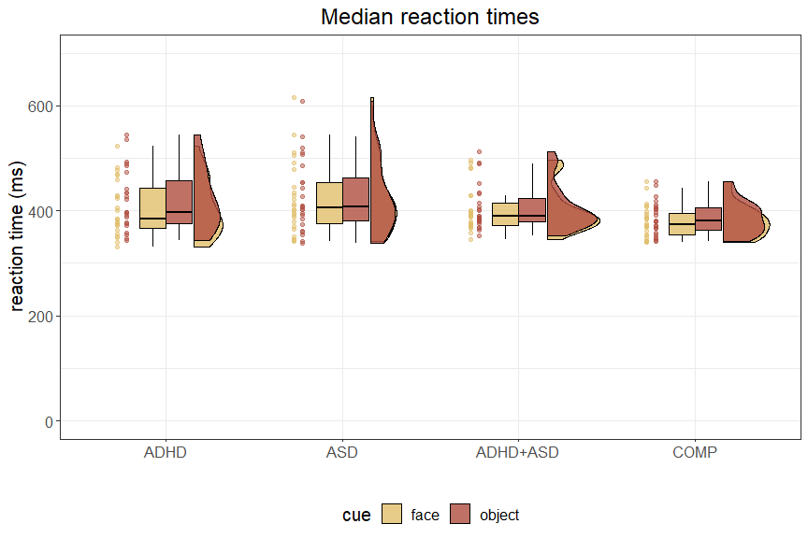

ggsave("Fig3_rts.pdf",   
 units = "mm",   
 width = 170,  
 height = 100,  
 dpi = 300)

## Bayes factor analysis

To complement our hypothesis testing using brms::hypothesis(), we perform a Bayes Factor (BF) analysis. The BF is the ratio of the marginal likelihoods of the data given two models. We will compare models containing different combinations of population-level effects to the model only containing the intercept on the population-level and all group-level effects. The BF depends on the priors that were used, because it indicates a change in our belief after seeing the data. Therefore, we perform a sensitivity analysis comparing the BF based on our chosen priors with narrower and wider priors.

# set the directory in which to save results  
sense_dir = file.path(getwd(), "_brms_sens_cache")  
main.code = "fab"  
  
# describe priors  
pr.descriptions = c("chosen",  
 "sdx2", "sdx4", "sdx8",   
 "sdx0.5", "sdx0.25", "sdx0.125"  
 )  
  
# check which have been run already  
if (file.exists(file.path(sense_dir, sprintf("df_%s_bf.csv", main.code)))) {  
 pr.done = read_csv(  
 file.path(sense_dir, sprintf("df_%s_bf.csv", main.code)),   
 show_col_types = F) %>%  
 select(priors) %>% distinct()  
 pr.descriptions = pr.descriptions[!(pr.descriptions %in% pr.done$priors)]  
}  
  
if (length(pr.descriptions) > 0) {  
 # rerun the model with more iterations for bridgesampling  
 set.seed(7788)  
 m.fab.bf = brm(f.fab,  
 df.fab, prior = priors,  
 family = shifted_lognormal,  
 iter = 40000, warmup = 10000,  
 backend = "cmdstanr", threads = threading(8),  
 file = "m_fab_bf", silent = 2,  
 save_pars = save_pars(all = TRUE)  
 )  
}  
  
# loop through them  
for (pr.desc in pr.descriptions) {  
 tryCatch({  
 # use function to compute BF with the described priors  
 bf_sens_2int(m.fab.bf, "diagnosis", "cue", pr.desc,   
 main.code, # prefix for all models and MLL  
 file.path(sense_dir, "log_FAB.txt"), # log file  
 sense_dir # where to save the models and MLL  
 )  
 },  
 error = function(err) {  
 message(sprintf("Error for %s: %s", pr.desc, err))  
 }  
 )  
}  
  
# read in the results  
df.fab.bf = read_csv(file.path(sense_dir,   
 sprintf("df_%s_bf.csv", main.code)),   
 show_col_types = F)  
  
# check the sensitivity analysis result per model  
df.fab.bf %>%  
 filter(`population-level` != "1") %>%  
 mutate(  
 sd = as.factor(case_when(  
 priors == "chosen" ~ "1",  
 substr(priors, 1, 3) == "sdx" ~ gsub("sdx", "", priors),  
 T ~ priors)  
 ),  
 order = case_when(  
 priors == "chosen" ~ 1,  
 substr(priors, 1, 3) == "sdx" ~ as.numeric(gsub("sdx", "", priors)),  
 T ~ 999),  
 sd = fct_reorder(sd, order)  
 ) %>%  
 ggplot(aes(y = bf.log,   
 x = sd,   
 group = `population-level`,   
 colour = `population-level`)) +  
 geom_point() +  
 geom_line() +  
 geom_vline(xintercept = "1") +  
 geom_hline(yintercept = 0) +  
 ggtitle("Sensitivity analysis with the intercept-only model as reference") +  
 scale_colour_manual(values = custom.col) +  
 theme_bw() +  
 theme(legend.position = "bottom",   
 axis.text.x = element_text(angle = 90, vjust = 0.5, hjust = 1))

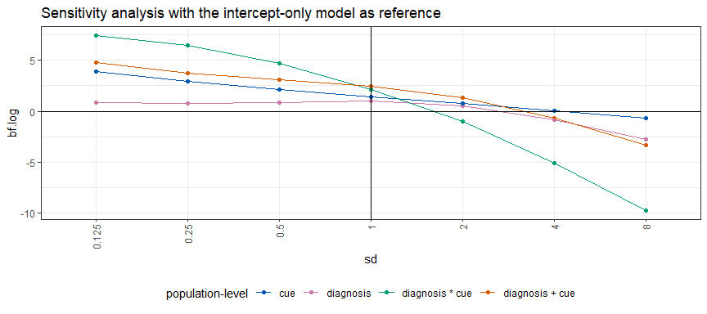

Quite a few models outperform the intercept model unless very wide priors are used. Therefore, we plot the models containing predictors with the model containing both predictors but no interaction as the reference model to take a closer look.

# compare to main effects model as reference  
df.fab.bf %>%  
 filter(`population-level` != "1") %>%  
 group_by(priors) %>%  
 mutate(bf.log = bf.log - bf.log[`population-level` == "diagnosis + cue"]) %>%  
 ungroup() %>%  
 mutate(  
 sd = as.factor(case_when(  
 priors == "chosen" ~ "1",   
 substr(priors, 1, 3) == "sdx" ~ gsub("sdx", "", priors),  
 T ~ priors)  
 ),  
 order = case_when(  
 priors == "chosen" ~ 1,   
 substr(priors, 1, 3) == "sdx" ~ as.numeric(gsub("sdx", "", priors)),  
 T ~ 999),  
 sd = fct_reorder(sd, order)  
 ) %>%  
 ggplot(aes(y = bf.log,   
 x = sd,   
 group = `population-level`,   
 colour = `population-level`)) +   
 geom_point() +  
 geom_line() +   
 geom_vline(xintercept = "1") +  
 theme_bw() +  
 ggtitle("Sensitivity analysis with the 'diagnosis + cue' model as reference") +  
 scale_colour_manual(values = custom.col) +  
 theme(legend.position = "bottom",   
 axis.text.x = element_text(angle = 90, vjust = 0.5, hjust = 1))

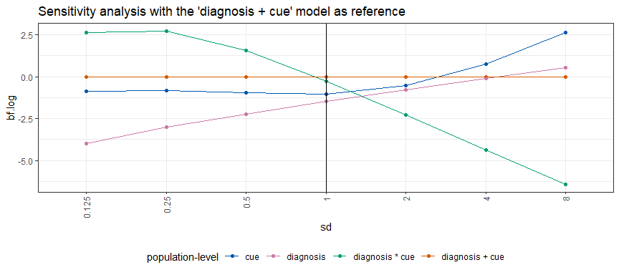

Here, we can see that the results are not very consistent. While with narrower priors, the model including both main effects and the interaction outperforms the others, our chosen priors result in the model only including the main effects having the highest Bayes Factor. Then, with wider priors, the model only including the main effect cue performs best for our data.

# create a data frame with the comparisons  
kable(df.fab.bf %>% filter(priors == "chosen") %>% select(-priors) %>%  
 filter(`population-level` != "1") %>% arrange(desc(bf.log)), digits = 3)

| population-level | bf.log |
| --- | --- |
| diagnosis + cue | 2.463 |
| diagnosis * cue | 2.173 |
| cue | 1.419 |
| diagnosis | 1.000 |

The comparison of the models reveals the model containing both main effects on the population-level to be the best model as measured by the BF when using our chosen priors.

Specifically, there is anecdotal evidence in favour of this model underlying the data observed compared to the model including the interaction (log(*BF*) = 0.289), anecdotal evidence in favour of this model compared to the model including only the predictor cue (log(*BF*) = 1.043), moderate evidence in favour of this model compared to the one only including the predictor diagnosis (log(*BF*) = 1.463) as well as strong evidence in favour of this model compared to the model only including the intercept on the population-level (log(*BF*) = 2.463).

# S1.3 Explorative analysis of FAB specifically

Since the reaction times differ in general between our groups, we calculate subject-specific Cohen’s d.

df.fabd = df.fab.full %>%  
 group_by(subID, diagnosis, stm, cue, RAADS_total, ASRS_total) %>%  
 # summarise the median reaction time for each stimulus pair  
 summarise(  
 rt.cor = median(rt.cor, na.rm = T)  
 ) %>%  
 pivot_wider(names_from = cue, values_from = rt.cor) %>%  
 # calculate the fab purely based on reaction times  
 mutate(  
 fab = object - face  
 ) %>% group_by(subID, diagnosis, RAADS_total, ASRS_total) %>%  
 # calculate the cohen's d  
 summarise(  
 fab.d = lsr::cohensD(x = object, y = face, method = "paired")  
 ) %>% ungroup() %>%  
 # center questionnaire values and scale between -1 and 1  
 mutate(  
 ASRS = scale(ASRS_total, scale = F)/max(scale(ASRS_total, scale = F)),  
 RADS = scale(RAADS_total, scale = F)/max(scale(RAADS_total, scale = F))  
 )

Now, let’s assess whether we can predict the subject-specific fab in cohen’s d based on diagnostic group.

# set some priors  
priors = c(  
 # general priors assuming small effect of FAB  
 prior(normal(0.2, 0.5), class = Intercept),  
 prior(normal(0, 0.5), class = sigma),  
 # no specific expectations for group differences  
 prior(normal(0, 0.20), class = b)  
)  
  
# fit the linear model with the questionnaires as covariates  
set.seed(2424)  
m.fabd = brm(fab.d ~ diagnosis + RADS + ASRS, data = df.fabd,   
 prior = priors,  
 iter = iter, warmup = warm,  
 backend = "cmdstanr", threads = threading(8),  
 file = "m_fab_cohd"  
 )  
rstan::check_hmc_diagnostics(m.fabd$fit)

##   
## Divergences:  
##   
## Tree depth:  
##   
## Energy:

# check that rhats are below 1.01  
sum(brms::rhat(m.fabd) >= 1.01, na.rm = T)

## [1] 0

# check the trace plots  
post.draws = as_draws_df(m.fabd)  
mcmc_trace(post.draws, regex_pars = "^b_",  
 facet_args = list(ncol = 3)) +  
 scale_x_continuous(breaks=scales::pretty_breaks(n = 3)) +  
 scale_y_continuous(breaks=scales::pretty_breaks(n = 3))

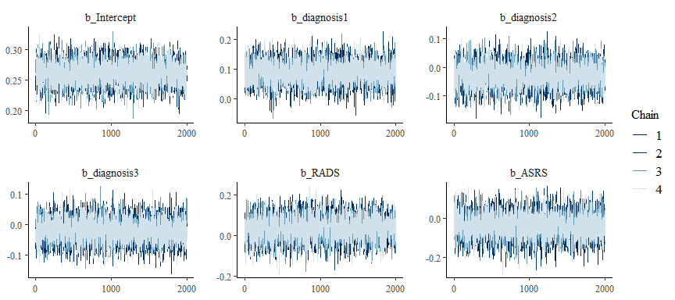

# perform posterior predictive checks  
post.pred = posterior_predict(m.fabd, ndraws = nsim)  
pp_check(m.fabd, ndraws = nsim) +   
 theme_bw() + theme(legend.position = "none")

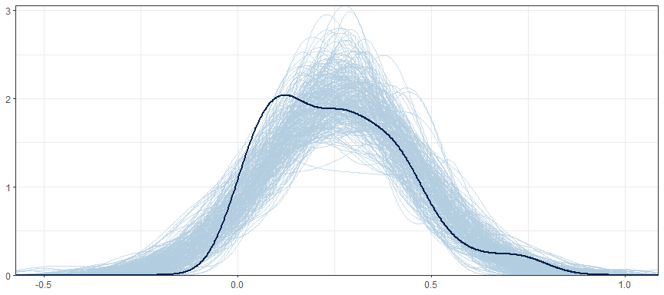

ppc_stat_grouped(df.fabd$fab.d, post.pred, df.fabd$diagnosis) +   
 theme_bw() + theme(legend.position = "none")

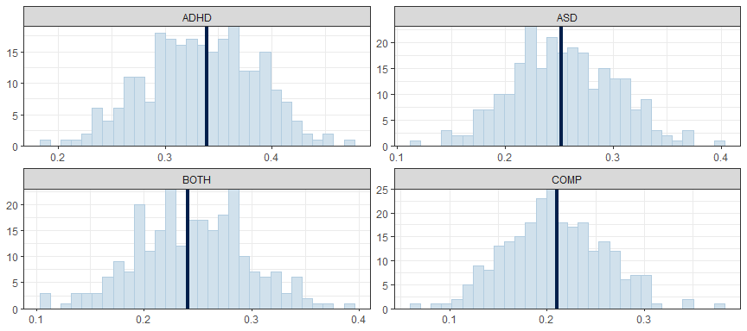

# print a summary  
summary(m.fabd)

## Family: gaussian   
## Links: mu = identity; sigma = identity   
## Formula: fab.d ~ diagnosis + RADS + ASRS   
## Data: df.fabd (Number of observations: 94)   
## Draws: 4 chains, each with iter = 3000; warmup = 1000; thin = 1;  
## total post-warmup draws = 8000  
##   
## Population-Level Effects:   
## Estimate Est.Error l-95% CI u-95% CI Rhat Bulk_ESS Tail_ESS  
## Intercept 0.26 0.02 0.22 0.30 1.00 7697 5543  
## diagnosis1 0.09 0.04 0.02 0.16 1.00 5315 5777  
## diagnosis2 -0.03 0.04 -0.11 0.05 1.00 4492 5196  
## diagnosis3 -0.02 0.04 -0.09 0.05 1.00 6076 5480  
## RADS 0.04 0.06 -0.07 0.15 1.00 4725 5610  
## ASRS -0.04 0.06 -0.16 0.09 1.00 4918 5669  
##   
## Family Specific Parameters:   
## Estimate Est.Error l-95% CI u-95% CI Rhat Bulk_ESS Tail_ESS  
## sigma 0.18 0.01 0.15 0.20 1.00 7477 6068  
##   
## Draws were sampled using sample(hmc). For each parameter, Bulk_ESS  
## and Tail_ESS are effective sample size measures, and Rhat is the potential  
## scale reduction factor on split chains (at convergence, Rhat = 1).

# plot the posterior distributions  
as_draws_df(m.fabd) %>%   
 select(starts_with("b_")) %>%  
 mutate(  
 b_COMP = - b_diagnosis1 - b_diagnosis2 - b_diagnosis3  
 ) %>%   
 pivot_longer(cols = starts_with("b_"), names_to = "coef", values_to = "estimate") %>%  
 filter(coef != "b_Intercept") %>%  
 mutate(  
 coef = substr(coef, 3, nchar(coef)),  
 coef = case_match(coef,  
 "diagnosis1" ~ "ADHD",  
 "diagnosis2" ~ "ASD",  
 "diagnosis3" ~ "ADHD+ASD",  
 .default = coef  
 ),  
 coef = fct_reorder(coef, desc(estimate))  
 ) %>%   
 group_by(coef) %>%  
 mutate(  
 cred = case_when(  
 (mean(estimate) < 0 & quantile(estimate, probs = 0.975) < 0) |  
 (mean(estimate) > 0 & quantile(estimate, probs = 0.025) > 0) ~ "credible",  
 T ~ "not credible"  
 )  
 ) %>% ungroup() %>%   
 ggplot(aes(x = estimate, y = coef, fill = cred)) +  
 geom_vline(xintercept = 0, linetype = 'dashed') +  
 ggdist::stat_halfeye(alpha = 0.7) + ylab(NULL) + theme_bw() +  
 scale_fill_manual(values = c(credible = c_dark, c_light)) +   
 theme(legend.position = "none")

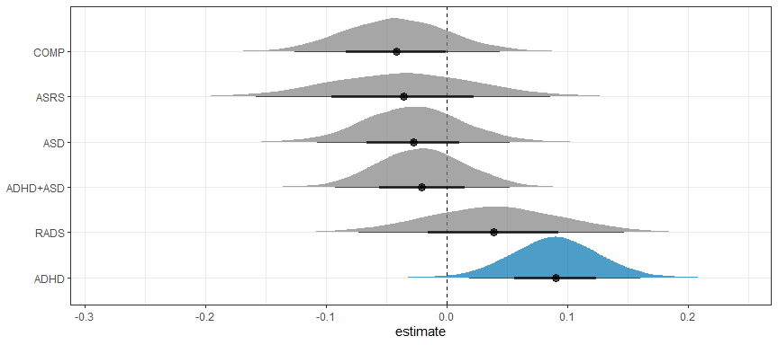

# assess differences between ADHD and COMP  
e1 = hypothesis(m.fabd, "0 < 2*diagnosis1 + diagnosis2 + diagnosis3", alpha = 0.025)  
e1

## Hypothesis Tests for class b:  
## Hypothesis Estimate Est.Error CI.Lower CI.Upper Evid.Ratio  
## 1 (0)-(2*diagnosis1... < 0 -0.13 0.06 -0.25 -0.01 58.26  
## Post.Prob Star  
## 1 0.98 *  
## ---  
## 'CI': 95%-CI for one-sided and 97.5%-CI for two-sided hypotheses.  
## '*': For one-sided hypotheses, the posterior probability exceeds 97.5%;  
## for two-sided hypotheses, the value tested against lies outside the 97.5%-CI.  
## Posterior probabilities of point hypotheses assume equal prior probabilities.

# assess differences between ASD and COMP  
e2 = hypothesis(m.fabd, "0 < diagnosis1 + 2*diagnosis2 + diagnosis3", alpha = 0.025)  
e2

## Hypothesis Tests for class b:  
## Hypothesis Estimate Est.Error CI.Lower CI.Upper Evid.Ratio  
## 1 (0)-(diagnosis1+2... < 0 -0.01 0.07 -0.15 0.12 1.4  
## Post.Prob Star  
## 1 0.58   
## ---  
## 'CI': 95%-CI for one-sided and 97.5%-CI for two-sided hypotheses.  
## '*': For one-sided hypotheses, the posterior probability exceeds 97.5%;  
## for two-sided hypotheses, the value tested against lies outside the 97.5%-CI.  
## Posterior probabilities of point hypotheses assume equal prior probabilities.

# assess differences between ADHD+ASD and COMP  
e3 = hypothesis(m.fabd, "0 < diagnosis1 + diagnosis2 + 2*diagnosis3", alpha = 0.025)  
e3

## Hypothesis Tests for class b:  
## Hypothesis Estimate Est.Error CI.Lower CI.Upper Evid.Ratio  
## 1 (0)-(diagnosis1+d... < 0 -0.02 0.07 -0.16 0.12 1.58  
## Post.Prob Star  
## 1 0.61   
## ---  
## 'CI': 95%-CI for one-sided and 97.5%-CI for two-sided hypotheses.  
## '*': For one-sided hypotheses, the posterior probability exceeds 97.5%;  
## for two-sided hypotheses, the value tested against lies outside the 97.5%-CI.  
## Posterior probabilities of point hypotheses assume equal prior probabilities.

# assess influences of questionnaires  
e4 = hypothesis(m.fabd, "0 < RADS", alpha = 0.025)  
e4

## Hypothesis Tests for class b:  
## Hypothesis Estimate Est.Error CI.Lower CI.Upper Evid.Ratio Post.Prob Star  
## 1 (0)-(RADS) < 0 -0.04 0.06 -0.15 0.07 3.02 0.75   
## ---  
## 'CI': 95%-CI for one-sided and 97.5%-CI for two-sided hypotheses.  
## '*': For one-sided hypotheses, the posterior probability exceeds 97.5%;  
## for two-sided hypotheses, the value tested against lies outside the 97.5%-CI.  
## Posterior probabilities of point hypotheses assume equal prior probabilities.

e5 = hypothesis(m.fabd, "0 > ASRS", alpha = 0.025)  
e5

## Hypothesis Tests for class b:  
## Hypothesis Estimate Est.Error CI.Lower CI.Upper Evid.Ratio Post.Prob Star  
## 1 (0)-(ASRS) > 0 0.04 0.06 -0.09 0.16 2.57 0.72   
## ---  
## 'CI': 95%-CI for one-sided and 97.5%-CI for two-sided hypotheses.  
## '*': For one-sided hypotheses, the posterior probability exceeds 97.5%;  
## for two-sided hypotheses, the value tested against lies outside the 97.5%-CI.  
## Posterior probabilities of point hypotheses assume equal prior probabilities.

# assess FAB in general  
e6 = hypothesis(m.fabd, "0 < Intercept", alpha = 0.025)  
e6

## Hypothesis Tests for class b:  
## Hypothesis Estimate Est.Error CI.Lower CI.Upper Evid.Ratio Post.Prob  
## 1 (0)-(Intercept) < 0 -0.26 0.02 -0.3 -0.22 Inf 1  
## Star  
## 1 *  
## ---  
## 'CI': 95%-CI for one-sided and 97.5%-CI for two-sided hypotheses.  
## '*': For one-sided hypotheses, the posterior probability exceeds 97.5%;  
## for two-sided hypotheses, the value tested against lies outside the 97.5%-CI.  
## Posterior probabilities of point hypotheses assume equal prior probabilities.

# ...and in the groups  
e7 = hypothesis(m.fabd, "0 < Intercept + diagnosis1", alpha = 0.025)  
e7

## Hypothesis Tests for class b:  
## Hypothesis Estimate Est.Error CI.Lower CI.Upper Evid.Ratio  
## 1 (0)-(Intercept+di... < 0 -0.35 0.04 -0.43 -0.27 Inf  
## Post.Prob Star  
## 1 1 *  
## ---  
## 'CI': 95%-CI for one-sided and 97.5%-CI for two-sided hypotheses.  
## '*': For one-sided hypotheses, the posterior probability exceeds 97.5%;  
## for two-sided hypotheses, the value tested against lies outside the 97.5%-CI.  
## Posterior probabilities of point hypotheses assume equal prior probabilities.

e8 = hypothesis(m.fabd, "0 < Intercept + diagnosis2", alpha = 0.025)  
e8

## Hypothesis Tests for class b:  
## Hypothesis Estimate Est.Error CI.Lower CI.Upper Evid.Ratio  
## 1 (0)-(Intercept+di... < 0 -0.23 0.04 -0.32 -0.15 Inf  
## Post.Prob Star  
## 1 1 *  
## ---  
## 'CI': 95%-CI for one-sided and 97.5%-CI for two-sided hypotheses.  
## '*': For one-sided hypotheses, the posterior probability exceeds 97.5%;  
## for two-sided hypotheses, the value tested against lies outside the 97.5%-CI.  
## Posterior probabilities of point hypotheses assume equal prior probabilities.

e9 = hypothesis(m.fabd, "0 < Intercept + diagnosis3", alpha = 0.025)  
e9

## Hypothesis Tests for class b:  
## Hypothesis Estimate Est.Error CI.Lower CI.Upper Evid.Ratio  
## 1 (0)-(Intercept+di... < 0 -0.24 0.04 -0.32 -0.16 Inf  
## Post.Prob Star  
## 1 1 *  
## ---  
## 'CI': 95%-CI for one-sided and 97.5%-CI for two-sided hypotheses.  
## '*': For one-sided hypotheses, the posterior probability exceeds 97.5%;  
## for two-sided hypotheses, the value tested against lies outside the 97.5%-CI.  
## Posterior probabilities of point hypotheses assume equal prior probabilities.

e10 = hypothesis(m.fabd, "0 < Intercept - diagnosis1 - diagnosis2 - diagnosis3", alpha = 0.025)  
e10

## Hypothesis Tests for class b:  
## Hypothesis Estimate Est.Error CI.Lower CI.Upper Evid.Ratio  
## 1 (0)-(Intercept-di... < 0 -0.22 0.05 -0.31 -0.13 Inf  
## Post.Prob Star  
## 1 1 *  
## ---  
## 'CI': 95%-CI for one-sided and 97.5%-CI for two-sided hypotheses.  
## '*': For one-sided hypotheses, the posterior probability exceeds 97.5%;  
## for two-sided hypotheses, the value tested against lies outside the 97.5%-CI.  
## Posterior probabilities of point hypotheses assume equal prior probabilities.

Similarly to our full model, this model suggests that subject-specific FAB is only attenuated in the ADHD group (ADHD versus COMP: *estimate* = -0.13 [-0.25, -0.01], *posterior probability* = 98.31%; ASD versus COMP: *estimate* = -0.01 [-0.15, 0.12], *posterior probability* = 58.34%; ADHD+ASD versus COMP: *estimate* = -0.02 [-0.16, 0.12], *posterior probability* = 61.31%). Furthermore, there is no credible association between FAB and questionnaires assessing ASD (RADS: *estimate* = -0.04 [-0.15, 0.07], *posterior probability* = 75.11%) or ADHD (ASRS: *estimate* = 0.04 [-0.09, 0.16], *posterior probability* = 71.95%). Overall, the model estimates an average effect size across groups of 0.261 [0.225, 0.297] (*posterior probability* = 100%), which is considered to be small according to Cohen (1988). Furthermore, this model estimates a credible FAB effect in all four groups (ADHD: *estimate* = -0.35 [-0.43, -0.27], *posterior probability* = 100%; ASD: *estimate* = -0.23 [-0.32, -0.15], *posterior probability* = 100%; ADHD+ASD: *estimate* = -0.24 [-0.32, -0.16], *posterior probability* = 100%; COMP: *estimate* = -0.22 [-0.31, -0.13], *posterior probability* = 100%)

Last, let’s plot these subject-specific effect sizes.

# focus on the FAB effect  
df.fabd %>%  
 mutate(  
 diagnosis = recode(diagnosis, "BOTH" = "ADHD+ASD")  
 ) %>%   
 ggplot(aes(diagnosis, fab.d, fill = diagnosis, colour = diagnosis)) + #  
 geom_rain(rain.side = 'r',  
boxplot.args = list(color = "black", outlier.shape = NA, show_guide = FALSE, alpha = .8),  
violin.args = list(color = "black", outlier.shape = NA, alpha = .8),  
boxplot.args.pos = list(  
 position = ggpp::position_dodgenudge(x = 0, width = 0.3), width = 0.3  
),  
point.args = list(show_guide = FALSE, alpha = .5),  
violin.args.pos = list(  
 width = 0.6, position = position_nudge(x = 0.16)),  
point.args.pos = list(position = ggpp::position_dodgenudge(x = -0.25, width = 0.1))) +  
 geom_hline(yintercept = 0) +  
 scale_fill_manual(values = custom.col) +  
 scale_color_manual(values = custom.col) +  
 labs(title = "Face attention bias",   
 x = "",   
 y = "cohen's d") +  
 theme_bw() +   
 theme(legend.position = "none",   
 plot.title = element_text(hjust = 0.5),   
 legend.direction = "horizontal",   
 text = element_text(size = 15))

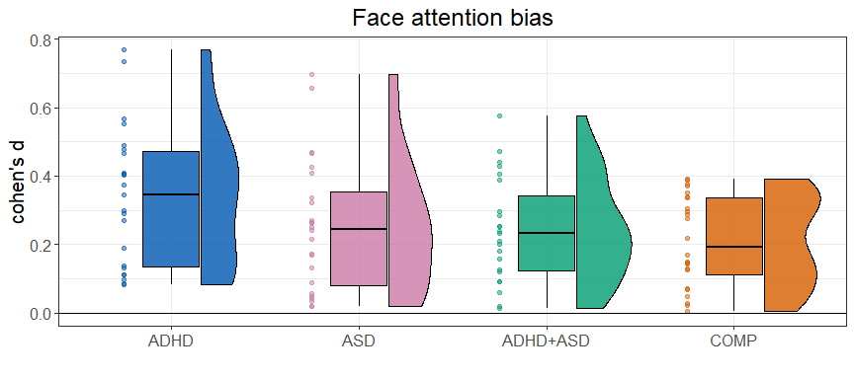

ggsave("Fig4_FAB.pdf",   
 units = "mm",   
 width = 170,  
 height = 70,  
 dpi = 300)

# S1.4 Explorative analysis of RTs on trials without saccades

Since saccadic behaviour may have influenced reaction times, we rerun the model concerning reaction times with only trials where no saccades were produced.

# aggregate saccades  
df.sac.agg = df.sac %>%   
 group_by(subID, diagnosis, trl) %>%  
 summarise(  
 n.sac = n()  
 )  
  
# merge together  
df.sac.fab = merge(df.fab.full, df.sac.agg, all.x = T) %>%  
 # only keep people with at least one saccade  
 group_by(subID) %>%  
 mutate(  
 n.sac.total = sum(n.sac, na.rm = T)  
 ) %>%  
 # only keep trials with saccades %>%  
 filter(n.sac.total > 0) %>%  
 filter(is.na(n.sac)) %>%  
 # compute median rt.cor  
 group_by(subID, diagnosis, cue, stm) %>%  
 summarise(  
 rt.cor = median(rt.cor, na.rm = T)  
 )  
  
# set the contrasts  
contrasts(df.sac.fab$cue) = contr.sum(2)  
contrasts(df.sac.fab$cue)

## [,1]  
## face 1  
## object -1

contrasts(df.sac.fab$diagnosis) = contr.sum(4)  
contrasts(df.sac.fab$diagnosis)

## [,1] [,2] [,3]  
## ADHD 1 0 0  
## ASD 0 1 0  
## BOTH 0 0 1  
## COMP -1 -1 -1

# run the model  
set.seed(1357)  
m.rtsac = brm(f.fab,  
 df.sac.fab, prior = priors,  
 family = shifted_lognormal,  
 iter = iter, warmup = warm,  
 backend = "cmdstanr", threads = threading(8),  
 file = "m_fab_sac"  
 )  
rstan::check_hmc_diagnostics(m.fab$fit)

##   
## Divergences:  
##   
## Tree depth:  
##   
## Energy:

# check that rhats are below 1.01  
sum(brms::rhat(m.fab) >= 1.01, na.rm = T)

## [1] 0

# check the trace plots  
post.draws = as_draws_df(m.fab)  
mcmc_trace(post.draws, regex_pars = "^b_",  
 facet_args = list(ncol = 3)) +  
 scale_x_continuous(breaks=scales::pretty_breaks(n = 3)) +  
 scale_y_continuous(breaks=scales::pretty_breaks(n = 3))

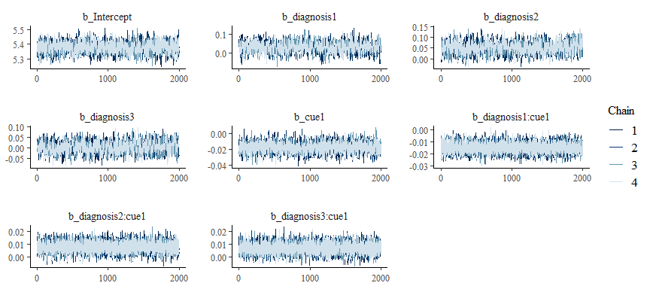

# get posterior predictions  
post.pred = posterior_predict(m.rtsac, ndraws = nsim)  
  
# check the fit of the predicted data compared to the real data  
p1 = pp_check(m.rtsac, ndraws = nsim) +   
 theme_bw() + theme(legend.position = "none")  
  
df.sac.fab = df.sac.fab %>% drop_na()  
  
# distributions of means compared to the real values per group  
p2 = ppc_stat_grouped(df.sac.fab$rt.cor, post.pred, df.sac.fab$diagnosis) +   
 theme_bw() + theme(legend.position = "none")  
  
p = ggarrange(p1, p2,   
 nrow = 2, ncol = 1, labels = "AUTO")  
annotate_figure(p,   
 top = text_grob("Posterior predictive checks: RTs of trials w/o saccades",   
 face = "bold", size = 14))

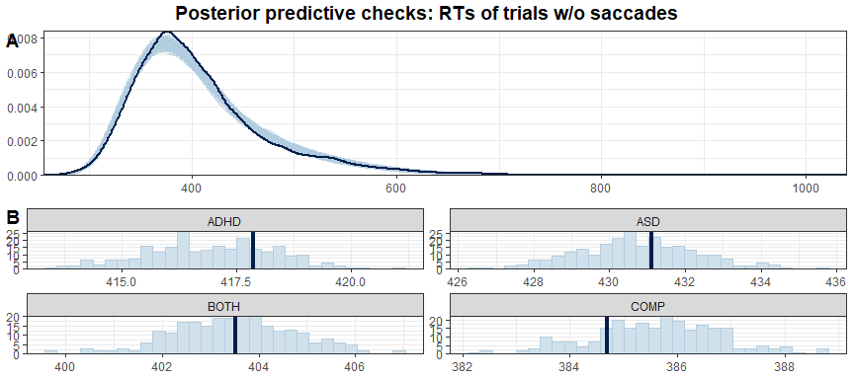

# print a summary  
summary(m.rtsac)

## Family: shifted_lognormal   
## Links: mu = identity; sigma = identity; ndt = identity   
## Formula: rt.cor ~ diagnosis * cue + (cue | subID) + (cue * diagnosis | stm)   
## Data: df.sac.fab (Number of observations: 5507)   
## Draws: 4 chains, each with iter = 3000; warmup = 1000; thin = 1;  
## total post-warmup draws = 8000  
##   
## Group-Level Effects:   
## ~stm (Number of levels: 36)   
## Estimate Est.Error l-95% CI u-95% CI Rhat  
## sd(Intercept) 0.03 0.00 0.02 0.04 1.00  
## sd(cue1) 0.03 0.01 0.03 0.05 1.00  
## sd(diagnosis1) 0.01 0.00 0.00 0.02 1.00  
## sd(diagnosis2) 0.01 0.00 0.00 0.02 1.00  
## sd(diagnosis3) 0.01 0.00 0.00 0.02 1.00  
## sd(cue1:diagnosis1) 0.01 0.01 0.00 0.02 1.00  
## sd(cue1:diagnosis2) 0.01 0.01 0.00 0.02 1.00  
## sd(cue1:diagnosis3) 0.01 0.00 0.00 0.02 1.00  
## cor(Intercept,cue1) -0.35 0.16 -0.64 -0.01 1.00  
## cor(Intercept,diagnosis1) -0.05 0.29 -0.59 0.51 1.00  
## cor(cue1,diagnosis1) -0.03 0.28 -0.57 0.52 1.00  
## cor(Intercept,diagnosis2) -0.05 0.28 -0.57 0.51 1.00  
## cor(cue1,diagnosis2) 0.01 0.29 -0.55 0.55 1.00  
## cor(diagnosis1,diagnosis2) -0.04 0.30 -0.62 0.54 1.00  
## cor(Intercept,diagnosis3) 0.06 0.28 -0.49 0.59 1.00  
## cor(cue1,diagnosis3) 0.14 0.28 -0.44 0.64 1.00  
## cor(diagnosis1,diagnosis3) -0.10 0.31 -0.67 0.50 1.00  
## cor(diagnosis2,diagnosis3) -0.03 0.30 -0.60 0.56 1.00  
## cor(Intercept,cue1:diagnosis1) -0.01 0.27 -0.54 0.53 1.00  
## cor(cue1,cue1:diagnosis1) 0.12 0.27 -0.44 0.61 1.00  
## cor(diagnosis1,cue1:diagnosis1) 0.02 0.30 -0.56 0.58 1.00  
## cor(diagnosis2,cue1:diagnosis1) 0.05 0.30 -0.54 0.60 1.00  
## cor(diagnosis3,cue1:diagnosis1) 0.04 0.30 -0.56 0.59 1.00  
## cor(Intercept,cue1:diagnosis2) -0.13 0.27 -0.62 0.42 1.00  
## cor(cue1,cue1:diagnosis2) -0.14 0.27 -0.62 0.41 1.00  
## cor(diagnosis1,cue1:diagnosis2) -0.01 0.30 -0.58 0.57 1.00  
## cor(diagnosis2,cue1:diagnosis2) 0.05 0.30 -0.55 0.60 1.00  
## cor(diagnosis3,cue1:diagnosis2) -0.05 0.30 -0.60 0.53 1.00  
## cor(cue1:diagnosis1,cue1:diagnosis2) -0.11 0.30 -0.66 0.50 1.00  
## cor(Intercept,cue1:diagnosis3) 0.01 0.28 -0.53 0.56 1.00  
## cor(cue1,cue1:diagnosis3) -0.20 0.29 -0.69 0.41 1.00  
## cor(diagnosis1,cue1:diagnosis3) 0.06 0.30 -0.53 0.63 1.00  
## cor(diagnosis2,cue1:diagnosis3) 0.02 0.30 -0.56 0.60 1.00  
## cor(diagnosis3,cue1:diagnosis3) -0.04 0.30 -0.61 0.54 1.00  
## cor(cue1:diagnosis1,cue1:diagnosis3) -0.08 0.30 -0.63 0.51 1.00  
## cor(cue1:diagnosis2,cue1:diagnosis3) -0.05 0.30 -0.61 0.55 1.00  
## Bulk_ESS Tail_ESS  
## sd(Intercept) 3106 4456  
## sd(cue1) 2601 4435  
## sd(diagnosis1) 3532 3349  
## sd(diagnosis2) 3258 3804  
## sd(diagnosis3) 3163 3949  
## sd(cue1:diagnosis1) 2447 3969  
## sd(cue1:diagnosis2) 2361 3162  
## sd(cue1:diagnosis3) 3166 3185  
## cor(Intercept,cue1) 1794 3337  
## cor(Intercept,diagnosis1) 8837 5660  
## cor(cue1,diagnosis1) 10064 6009  
## cor(Intercept,diagnosis2) 10168 5496  
## cor(cue1,diagnosis2) 9424 5287  
## cor(diagnosis1,diagnosis2) 6878 6178  
## cor(Intercept,diagnosis3) 9295 6046  
## cor(cue1,diagnosis3) 8671 5783  
## cor(diagnosis1,diagnosis3) 6278 5790  
## cor(diagnosis2,diagnosis3) 6698 5977  
## cor(Intercept,cue1:diagnosis1) 9404 5857  
## cor(cue1,cue1:diagnosis1) 8548 5082  
## cor(diagnosis1,cue1:diagnosis1) 5979 6263  
## cor(diagnosis2,cue1:diagnosis1) 5349 6031  
## cor(diagnosis3,cue1:diagnosis1) 5925 6047  
## cor(Intercept,cue1:diagnosis2) 8687 5244  
## cor(cue1,cue1:diagnosis2) 8930 5654  
## cor(diagnosis1,cue1:diagnosis2) 6850 6249  
## cor(diagnosis2,cue1:diagnosis2) 5902 6296  
## cor(diagnosis3,cue1:diagnosis2) 5842 6562  
## cor(cue1:diagnosis1,cue1:diagnosis2) 5714 6531  
## cor(Intercept,cue1:diagnosis3) 9582 5473  
## cor(cue1,cue1:diagnosis3) 7071 5759  
## cor(diagnosis1,cue1:diagnosis3) 6610 6347  
## cor(diagnosis2,cue1:diagnosis3) 6585 6409  
## cor(diagnosis3,cue1:diagnosis3) 6512 5979  
## cor(cue1:diagnosis1,cue1:diagnosis3) 6043 6392  
## cor(cue1:diagnosis2,cue1:diagnosis3) 5949 6805  
##   
## ~subID (Number of levels: 78)   
## Estimate Est.Error l-95% CI u-95% CI Rhat Bulk_ESS Tail_ESS  
## sd(Intercept) 0.23 0.02 0.20 0.27 1.00 1095 2041  
## sd(cue1) 0.02 0.00 0.02 0.03 1.00 3296 5354  
## cor(Intercept,cue1) -0.08 0.15 -0.36 0.21 1.00 5259 5851  
##   
## Population-Level Effects:   
## Estimate Est.Error l-95% CI u-95% CI Rhat Bulk_ESS Tail_ESS  
## Intercept 5.34 0.04 5.27 5.41 1.00 997 2546  
## diagnosis1 0.03 0.03 -0.02 0.09 1.01 901 1664  
## diagnosis2 0.05 0.03 -0.00 0.11 1.01 1012 2153  
## diagnosis3 0.00 0.03 -0.06 0.06 1.00 773 1973  
## cue1 -0.02 0.01 -0.03 -0.00 1.00 2539 3794  
## diagnosis1:cue1 -0.01 0.01 -0.03 -0.00 1.00 4191 5250  
## diagnosis2:cue1 0.01 0.01 -0.00 0.02 1.00 5165 5560  
## diagnosis3:cue1 0.00 0.01 -0.01 0.02 1.00 5345 6070  
##   
## Family Specific Parameters:   
## Estimate Est.Error l-95% CI u-95% CI Rhat Bulk_ESS Tail_ESS  
## sigma 0.16 0.00 0.16 0.17 1.00 4289 5109  
## ndt 193.98 5.10 183.53 203.36 1.00 4197 4904  
##   
## Draws were sampled using sample(hmc). For each parameter, Bulk_ESS  
## and Tail_ESS are effective sample size measures, and Rhat is the potential  
## scale reduction factor on split chains (at convergence, Rhat = 1).

# H1a: FAB effect in COMP  
h1a = hypothesis(m.rtsac,   
 "0 < 2*(diagnosis1:cue1 + diagnosis2:cue1 + diagnosis3:cue1 - cue1)")  
h1a

## Hypothesis Tests for class b:  
## Hypothesis Estimate Est.Error CI.Lower CI.Upper Evid.Ratio  
## 1 (0)-(2*(diagnosis... < 0 -0.03 0.02 -0.06 0 33.48  
## Post.Prob Star  
## 1 0.97 *  
## ---  
## 'CI': 90%-CI for one-sided and 95%-CI for two-sided hypotheses.  
## '*': For one-sided hypotheses, the posterior probability exceeds 95%;  
## for two-sided hypotheses, the value tested against lies outside the 95%-CI.  
## Posterior probabilities of point hypotheses assume equal prior probabilities.

# H1b: ADHD slower than COMP  
h1b = hypothesis(m.rtsac,   
 "0 < 2*diagnosis1 + diagnosis2 + diagnosis3")  
h1b

## Hypothesis Tests for class b:  
## Hypothesis Estimate Est.Error CI.Lower CI.Upper Evid.Ratio  
## 1 (0)-(2*diagnosis1... < 0 -0.12 0.06 -0.21 -0.03 45.51  
## Post.Prob Star  
## 1 0.98 *  
## ---  
## 'CI': 90%-CI for one-sided and 95%-CI for two-sided hypotheses.  
## '*': For one-sided hypotheses, the posterior probability exceeds 95%;  
## for two-sided hypotheses, the value tested against lies outside the 95%-CI.  
## Posterior probabilities of point hypotheses assume equal prior probabilities.

# H1c: ASD slower than COMP  
h1c = hypothesis(m.rtsac,   
 "0 < 2*diagnosis2 + diagnosis1 + diagnosis3")  
h1c

## Hypothesis Tests for class b:  
## Hypothesis Estimate Est.Error CI.Lower CI.Upper Evid.Ratio  
## 1 (0)-(2*diagnosis2... < 0 -0.14 0.06 -0.23 -0.05 147.15  
## Post.Prob Star  
## 1 0.99 *  
## ---  
## 'CI': 90%-CI for one-sided and 95%-CI for two-sided hypotheses.  
## '*': For one-sided hypotheses, the posterior probability exceeds 95%;  
## for two-sided hypotheses, the value tested against lies outside the 95%-CI.  
## Posterior probabilities of point hypotheses assume equal prior probabilities.

# H1d: FAB in ASD decreased compared to COMP  
h1d = hypothesis(m.rtsac,   
 "0 < 4*diagnosis2:cue1 + 2*diagnosis1:cue1 + 2*diagnosis3:cue1")  
h1d

## Hypothesis Tests for class b:  
## Hypothesis Estimate Est.Error CI.Lower CI.Upper Evid.Ratio  
## 1 (0)-(4*diagnosis2... < 0 -0.02 0.02 -0.05 0.02 3.87  
## Post.Prob Star  
## 1 0.79   
## ---  
## 'CI': 90%-CI for one-sided and 95%-CI for two-sided hypotheses.  
## '*': For one-sided hypotheses, the posterior probability exceeds 95%;  
## for two-sided hypotheses, the value tested against lies outside the 95%-CI.  
## Posterior probabilities of point hypotheses assume equal prior probabilities.

# H1e: FAB in ADHD differs from FAB in COMP (undirected)  
h1e = hypothesis(m.rtsac,   
 "0 > 4*diagnosis1:cue1 + 2*diagnosis2:cue1 + 2*diagnosis3:cue1",   
 alpha = 0.025)  
h1e

## Hypothesis Tests for class b:  
## Hypothesis Estimate Est.Error CI.Lower CI.Upper Evid.Ratio  
## 1 (0)-(4*diagnosis1... > 0 0.03 0.02 -0.01 0.07 13.71  
## Post.Prob Star  
## 1 0.93   
## ---  
## 'CI': 95%-CI for one-sided and 97.5%-CI for two-sided hypotheses.  
## '*': For one-sided hypotheses, the posterior probability exceeds 97.5%;  
## for two-sided hypotheses, the value tested against lies outside the 97.5%-CI.  
## Posterior probabilities of point hypotheses assume equal prior probabilities.

This model confirmed the same hypotheses with the exception for the difference in FAB between COMP and ADHD group which is not credible anymore (*estimate* = 0.03 [-0.01, 0.07], *posterior probability* = 93.2%). This change could indicate that difference in saccadic behaviour may partly drive these group differences.

# S1.5 Explorative analysis of errors

Last but not least, we are going to explore possible differences with regards to mean accuracies using a Bayesian ANOVA.

# aggregate mean accuracy per condition and person  
df.acc = df.fab.full %>%   
 group_by(subID, diagnosis, cue) %>%   
 summarise(acc = mean(acc)*100)  
  
# check normal distribution  
df.acc %>% group_by(diagnosis, cue) %>%  
 shapiro_test(acc) %>%  
 mutate(  
 sig = if_else(p < 0.05, "*", "")  
 )

## # A tibble: 8 × 6  
## diagnosis cue variable statistic p sig   
## <fct> <fct> <chr> <dbl> <dbl> <chr>  
## 1 ADHD face acc 0.504 0.0000000940 "*"   
## 2 ADHD object acc 0.621 0.00000154 "*"   
## 3 ASD face acc 0.901 0.0230 "*"   
## 4 ASD object acc 0.791 0.000213 "*"   
## 5 BOTH face acc 0.946 0.241 ""   
## 6 BOTH object acc 0.903 0.0291 "*"   
## 7 COMP face acc 0.814 0.000500 "*"   
## 8 COMP object acc 0.787 0.000180 "*"

# rank transform the data  
df.acc = df.acc %>%  
 ungroup() %>%  
 mutate(  
 racc = rank(acc)  
 )  
  
# run the ANOVA  
aov.acc = anovaBF(racc ~ diagnosis*cue, data = df.acc)  
extractBF(aov.acc, logbf = T)

## bf error time  
## diagnosis -1.693491 4.545861e-06 Tue Feb 4 16:19:15 2025  
## cue -1.813963 6.252025e-04 Tue Feb 4 16:19:15 2025  
## diagnosis + cue -3.470806 4.489892e-02 Tue Feb 4 16:19:15 2025  
## diagnosis + cue + diagnosis:cue -6.165765 1.367654e-02 Tue Feb 4 16:19:16 2025  
## code  
## diagnosis 4bac2a0e7897  
## cue 4bac7a9b6f68  
## diagnosis + cue 4bac71d4bda  
## diagnosis + cue + diagnosis:cue 4bac443044f9

# print overall accuracy rates  
df.acc %>%   
 group_by(diagnosis, cue) %>%   
 summarise(mean_accuracy = mean(acc, na.rm = T),   
 se_accuracy = sd(acc, na.rm = T)/sqrt(n()))

## # A tibble: 8 × 4  
## # Groups: diagnosis [4]  
## diagnosis cue mean_accuracy se_accuracy  
## <fct> <fct> <dbl> <dbl>  
## 1 ADHD face 96.6 0.968  
## 2 ADHD object 96.4 0.895  
## 3 ASD face 96.9 0.557  
## 4 ASD object 97.6 0.413  
## 5 BOTH face 97.8 0.350  
## 6 BOTH object 97.8 0.411  
## 7 COMP face 97.8 0.409  
## 8 COMP object 97.7 0.431

df.acc %>%   
 group_by(diagnosis) %>%   
 summarise(mean_accuracy = mean(acc, na.rm = T),   
 se_accuracy = sd(acc, na.rm = T)/sqrt(n()))

## # A tibble: 4 × 3  
## diagnosis mean_accuracy se_accuracy  
## <fct> <dbl> <dbl>  
## 1 ADHD 96.5 0.652  
## 2 ASD 97.3 0.347  
## 3 BOTH 97.8 0.267  
## 4 COMP 97.8 0.294

Accuracies were generally high, with a grand average of 97.36% accurate responses across diagnostic groups. None of the models outperformed the intercept-only model, therefore, we conclude that there were no differences between diagnostic groups, cues or their interaction with regards to accuracies.

## Plots

# overall accuracies  
df.acc %>%  
 ggplot(aes(diagnosis, acc, fill = cue, colour = cue)) + #  
 geom_rain(rain.side = 'r',  
boxplot.args = list(color = "black", outlier.shape = NA, show_guide = FALSE, alpha = .8),  
violin.args = list(color = "black", outlier.shape = NA, alpha = .8),  
boxplot.args.pos = list(  
 position = ggpp::position_dodgenudge(x = 0, width = 0.3), width = 0.3  
),  
point.args = list(show_guide = FALSE, alpha = .5),  
violin.args.pos = list(  
 width = 0.6, position = position_nudge(x = 0.16)),  
point.args.pos = list(position = ggpp::position_dodgenudge(x = -0.25, width = 0.1))) +  
 ylim(0, 100) +  
 scale_fill_manual(values = custom.col2) +  
 scale_color_manual(values = custom.col2) +  
 labs(title = "Mean accuracies", x = "", y = "percent") +  
 theme_bw() +   
 theme(legend.position = "bottom",   
 plot.title = element_text(hjust = 0.5),   
 legend.direction = "horizontal",   
 text = element_text(size = 15))

