Milena Dimitrova
milena.bd@gmail.com
Bundle GENERATOR PLUGIN FOR ECLIPSE

NOTES

СЪДЪРЖАНИЕ

1. How-to 3
1.1. Download 3
1.2. Installation 3
1.3. User Guide 3
1.3.1. Write source file 3
1.3.2. Generate bundle files 3

How-to

Download
Download jar file from:
RSA download location:
https://docs.google.com/leaf?id=0B--DgGs4sG-OZTNkNTkzYmMtMWE4MS00ZWMwLWE4NGYtNzVjMmRkYTViY2Yx&hl=en_US&authkey=CNmO-ZYC
Eclipse download location:
https://docs.google.com/leaf?id=0B--DgGs4sG-OMzM5ZjNhMmItZjcyNi00MmQ0LTk3NjQtNTdhMGQzZDVhMWMx&hl=en_US&authkey=COe666EI

Installation
1) Stop Eclipse
2) Copy jar file in eclipse installation directory \eclipse\ dropins
3) Start Eclipse
4) Right click on any file within Project Explorer view
6) See "Generate bundle files..." menu
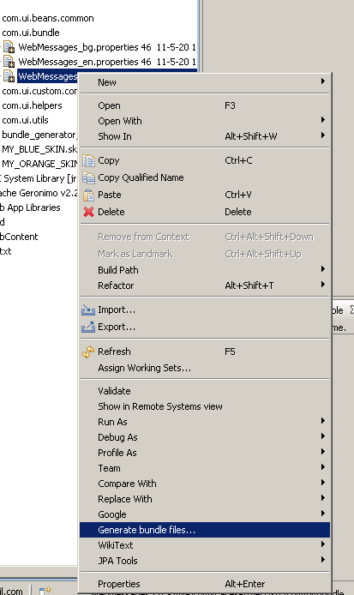

User Guide

Write source file
Example source file:
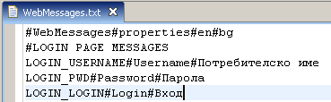

First line contains settings for the generator.
- # - words separator
- WebMessages - output file name
- properties - output file extension
- en - locale for English language (locale1)
- bg - locale for Bulgarian language (locale2)
.
.
.
- N - locale for N language (localeN)

Comment lines
Comment lines begin with "#"

Translated lines
bundle keyword#Translated word for locale1#Translated word for locale2#Translated word for localeN

Generate bundle files
Right click on the source "txt" file -> Click "Generate bundle files..."
Refresh destination directory.

Examples

Example 1:
# - used for Separator
Example source file:
Example result output:
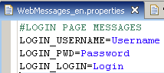

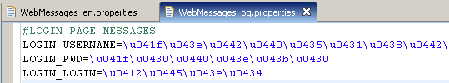

Example 2
~ - used for Separator
Example source file:
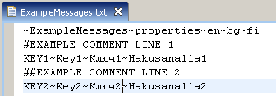
Example result output:
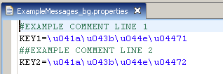
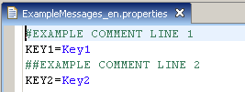
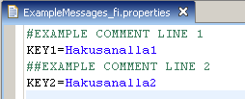

NOTE!!! "|" is RESERVED word and cannot be used for separator!

