ChatCV Chat Bot Manual

About:

This manual contains a description of the bot flow and information about how some additions can be made in the flow.

Flow:

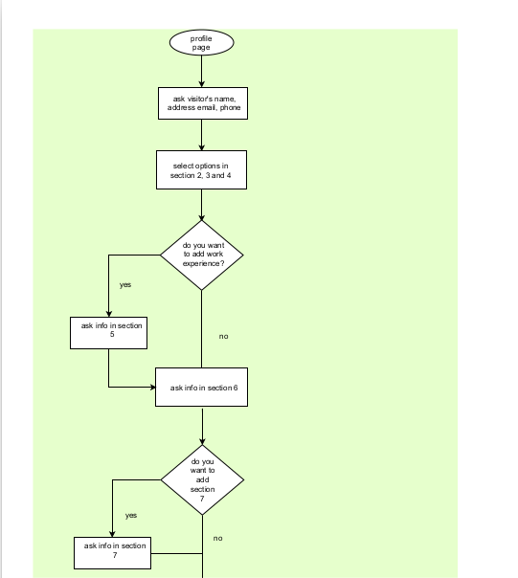

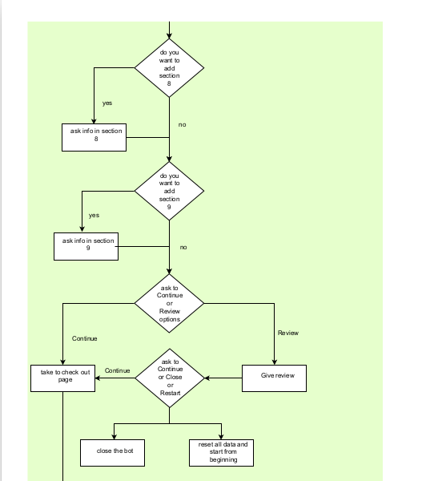

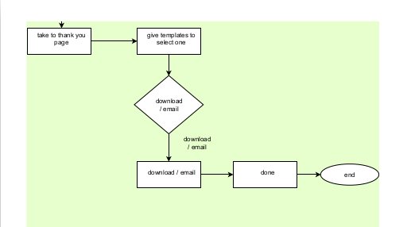

**Directory/Set up Structure of the chat bot:**

The location of our chatcv chatbot scripts is “wp-content/themes/twentytwentytwo/assets/js”. Let’s call it the JS folder.

Inside the JS folder, there is a javascript source file, ‘main_chatcv.js’, and 4 directories/folders.

The ‘main_chatcv.js’ file contains the setup for each profile page. For example, for each profile page it will import it related profile options of section 2-4 and then start the chat flow.

The only change in this file will be made when adding a new profile page.

The 4 directories contain modules for the chat bot.

The ‘flow’ directory contains modules for chatbot flow.

The ‘methods’ directory contains the modules which handle additional functions like interacting with API and verification.

The ‘profiles’ directory contains related profiles for each page. Whenever a new profile page will be created, its profile will be created in this directory following the instructions given in next steps.

The ‘templates-scripts’ directory contains modules for creating HTML templates for the CV. Any of the templates is imported only when it’s selected on the thank you page. This directory contains a ‘createTemplate.js’ file and the rest are ‘templateX.js’ files. The ‘createTemplate.js’ is being used to create the templates from the templates specified in the directory and selected from the given options.

**Steps to add/modify the chatbot styles/appearance:**

The location of our chatcv chatbot styles is “wp-content/themes/twentytwentytwo/assets/css/”. If you wish to change the appearance or styles of the bot, modify this stylesheet, just do not modify the restricted lines.

**Steps to add profiles:**

If you want to add a new profile page and want to set up the bot for that page, follow the following steps.

1. inside the JS folder, open the folder ‘profiles’
2. create a new file in it and name it ‘profileX.js’ [where X = 1,2,3,4,5,6,....]. For example, for profile page 10 create a file with name ‘profile10.js’
3. copy the contents from the already provided templates and paste in the new profile file
4. change each list’s and limits options as per your requirement and save the file, if do not want to limit the selection, keep the limit=false  
   ** only change options inside the arrays/lists of options  
   ** there are three sections in each profileX.js file  
   ** instructions have also been written inside the the profileX.js files
5. inside the main JS folder, open the file ‘main_chatcv.js’
6. under the ‘SECTION PAGE HANDLER’ there are URL for each page and their respective profiles imported
7. copy any of the if-else statement, except that of ‘custom thank you page’, from the mentioned section and paste above the custom thank you page and just change the page URL and file name.  
   For example, copy from line 46 to 55, from line 46 do not copy starting curly braces ‘}’ and do not forget to copy the curly braces ‘}] from line 55, this becomes as given below,  
     
    else if (URL== "https://chatcv.net/?page_id=193&preview=true") {

import('./profiles/profile2.js').then(module => {

Ask.section2 = module.section2();

Ask.section3 = module.section3();

Ask.section4 = module.section4();

});

botButton()

chatFlow()

}

1. click right after ‘}’ on line 55 and paste the copied lines here
2. you can see URL== ‘https://………….. ‘, change the URL to the new URL, i.e URL=’<https://url.of.the.new.profile.page>’
3. change the file name to the new file, in our case, it becomes   
    import('./profiles/profile10.js').then(module => {
4. rest will remain the same
5. save and close the file
6. delete the browser’s cache and it is ready to go

**Changing questions:**

For this purpose it is recommended to download the complete JS folder. Open it with VSCode.

I have already explained the procedure for adding new profiles and changing their options.

If you want to change any question, then only the file inside the ‘flow’ directory or the ‘main_chatcv.js’ file will be changed.

If you want to change the welcome/greeting statements, then just change them in the Welcome.js file, inside the ‘flow’ directory.

After greetings the bot asks for a name. This is the question asked in ‘main_chatcv.js’ file. If you want to ask for a name in a different phrase, change this name asking question. and then in the ‘chatcvbot.js’ file change the question in the if statement at line 163.

Now if you want to change any question in the flow, then highlight the whole question with your cursor and press ctrl + d until the IDE highlights all the occurrences of the question, then you can replace your question at all the places simultaneously. and this will not affect the flow.

**Adding and changing Templates:**

I do not recommend changing or adding the templates by yourself. Because this requires knowledge of HTML, CSS and JAVASCRIPT.  
  
**Adding or changing API:**

This is also not recommended to be done by the hands unaware of python.