Software Requirement Specifications
WorkNexus



Submitted by
Name: Ali Irfan
Reg. no.: f22binft1m01285@iub.edu.pk

Submitted to
Mr. Muzamil ur Rehman

Department of Information Technology
Faculty of Computing
The Islamia University of Bahawalpur

Meeting Details
Sr. No | Details | Date | Supervisor Signature

REVISION HISTORY
Version | Date | Description | Author
1.0 | 05-12-2025 | Initial SRS Draft | Ali Irfan

Summary
WorkNexus is a web-based management system designed to streamline operations for small to mid-sized service companies and digital agencies. It centralizes key functions such as employee management, project tracking, task assignment, time logging, and payroll estimation into a single, role-based platform.
Developed following IEEE 830 standards, this system provides Admins, HR Managers, Project Managers, and Employees with an intuitive interface to improve collaboration, reduce manual errors, and enhance project visibility.
Built as a Minimum Viable Product (MVP), WorkNexus focuses on core operational efficiency, scalability for future enhancements, and usability for non-technical users. The system is implemented using React.js, Node.js, and PostgreSQL, ensuring a modern, reliable, and maintainable solution for everyday business operations.

Contents
Meeting Details 2
REVISION HISTORY 2
1. INTRODUCTION 6
1.1 Purpose 6
1.2 Scope 6
1.3 Product Perspective 6
1.4 Definitions, Acronyms & Abbreviations 6
1.5 Proposed Technologies 7
1.6 Overview 8
2. OVERALL DESCRIPTION 8
2.1 Product Functions 8
2.2 User Characteristics 9
2.3 Constraints 9
2.4 Assumptions & Dependencies 9
3. SPECIFIC REQUIREMENTS 10
3.1 Functional Requirements (FR) 10
3.2 Non-Functional Requirements 11
3.3 System Models – Use Case Diagrams 12
4. SYSTEM DIAGRAMS 14
4.1 Use Case Diagrams 14
4.2 Class Diagram 14
4.3 Activity Diagram 16
4.4 ERD Diagram 16
5. APPENDICES 17
5.1 Appendix A: PlantUML Source Code – Use Case Diagrams 17
5.2 Appendix B: PlantUML Source Code – Activity Diagram 21
5.3 Appendix C: PlantUML Source Code – Class Diagram 21
5.4 Appendix D: PlantUML Source Code – ERD (Logical) 24
6 References 25

1. INTRODUCTION

1.1 Purpose
This Software Requirements Specification (SRS) provides a comprehensive description of WorkNexus, a web-based management system designed for small and mid-level service-based companies and agencies. The document outlines system functionality, constraints, user characteristics, use cases, and detailed functional & non-functional requirements.
This SRS serves as a contract between the developer (student) and supervisor, ensuring clarity and mutual understanding of the project.

1.2 Scope
WorkNexus automates internal operations of service-based companies by integrating Employee Management, Department Management, Project Tracking, Task Assignment, Time Logging, and Payroll Estimation into a unified platform.
The system is intended for organizational use, supporting Admin, HR Manager, Project Managers, and Employees.
Key goals include:
- Centralizing operational data
- Improving communication and collaboration
- Facilitating accurate payroll estimation
- Providing structured dashboards for role-based insights
- Simplifying project and employee tracking
The current scope excludes client login, automated payment gateways, and advanced AI analytics. These may be considered in future releases.

1.3 Product Perspective
WorkNexus is a new standalone system, but designed such that it can integrate with future third-party services (emails, analytics, or API-based integrations).
The platform is role-based, offering access based on user permissions:
- Admin → Full system access
- HR → Employee & payroll modules
- Project Manager → Projects & tasks modules
- Employees → Assigned tasks and time logging

1.4 Definitions, Acronyms & Abbreviations
Definitions
Term | Definition
Admin | System owner with full access to all modules
HR Manager | Manages employees, departments, payroll and onboarding
Project Manager | Manages projects, assigns tasks, monitors progress
Employee | Assigned tasks/projects and logs work hours
Client | A non-system user whose project information is recorded
Payroll | Salary calculated by fixed, hourly or revenue-share models
MVP | Minimum Viable Product - core functionality with essential features only
Acronyms
Acronym | Meaning
SRS | Software Requirements Specification
PM | Project Manager
HR | Human Resources
UI | User Interface
DB | Database
API | Application Programming Interface
Document Conventions
- Functional Requirements (FR) are numbered by module (e.g., FR010-FR014 = Employee Management)
- Non-Functional Requirements (NFR) are prefixed with their category
- All requirements use "shall" to indicate mandatory functionality per IEEE 830

1.5 Similar Systems and Literature Review
Existing project management tools such as Trello, Asana, and ClickUp provide task and project tracking capabilities but do not offer integrated payroll estimation or compensation management. Human Resource platforms like BambooHR focus primarily on employee records and administrative tasks but lack a connection between project-level time tracking and payroll calculations. WorkNexus addresses these limitations by unifying employee management, project tracking, task assignment, time logging, and payroll estimation into a single, role-based system. This integration allows service-based agencies and digital teams to manage operations efficiently while reducing manual errors and improving project visibility across all roles.

1.6 Proposed Technologies
Frontend:
- React.js framework with TanStack React Query for advanced state, data management.
- TailwindCSS for responsive UI styling
- shadcn/ui for production-ready component library
- Chart.js (or Recharts) for dashboard visualizations
Backend:
- Node.js with Express framework
- RESTful API architecture
- JWT for authentication and authorization
Database:
- PostgreSQL for relational data storage
- Prisma ORM for database operations
- Neon serverless PostgreSQL hosting for scalable, cloud-based database deployment
DevOps:
- Git & GitHub for version control
- Vercel for frontend deployment
- Render / Railway for backend deployment
- Postman / Thunder Client for API testing and endpoint verification

1.7 Overview
This document details system functionality, system behavior, user types, and structural components. Subsequent sections define functional requirements, non-functional requirements, and system models.

2. OVERALL DESCRIPTION

2.1 Product Functions
Major functional modules:
Authentication & Access Control
- Admin creates HR and PM accounts
- HR creates employee accounts and resets passwords
- Role-based access control for all system functions
Employee & Department Management
- Create, update, and maintain detailed employee profiles
- Create departments (Development, Graphics, SEO, Shopify, etc.)
- Assign employees to departments
- Track employee availability and work history
Project & Task Management
- Create and manage projects with multiple payment models
- Assign project managers and teams to projects
- Create and assign tasks to employees
- Track completion status and logged hours
- Monitor project progress and deadlines
Payroll Estimation
- Fixed salary calculation
- Hourly rate calculation based on logged hours
- Revenue-share calculation based on project revenue percentage
- Generate payroll reports for HR review
Client Module
- Store client name, company, email
- Link clients with associated projects
- Store client project URLs/API links
Role-Based Dashboards
- HR Dashboard: employee statistics, department views, payroll summaries
- Project Manager Dashboard: project status, task completion rates, team performance
- Employee Dashboard: assigned tasks, time logging interface, work history

2.2 User Characteristics
User Type | Typical Count | Technical Skill | Description
Admin | 1 | Medium–High | System owner with complete access to all modules
HR Manager | 1 | Medium | Controls employees, departments, and payroll
Project Managers | 2–5 | Medium | Manages projects, tasks, and team assignments
Employees | 10–15 | Basic | Receives tasks and logs working hours

2.3 Constraints
- System must run in a modern browser (Chrome, Firefox, Edge)
- Internet connection required for all operations
- HR controls account creation; no public signup functionality
- Password reset functionality is HR-based only
- System is designed as an MVP, not yet optimized for enterprise scalability
- Limited to one company instance (single tenant architecture)

2.4 Assumptions & Dependencies
- All users can operate standard web browsers
- Managerial staff understand basic project tracking concepts
- Payroll calculations depend on accurate employee and project data entry
- Future integrations (email notifications, analytics) may require external API access
- System will be hosted on a dedicated server with regular backups

3. SPECIFIC REQUIREMENTS

3.1 Functional Requirements (FR)

3.1.1 Authentication Module
FR001: System shall allow Admin to create HR and Project Manager accounts.
FR002: System shall allow HR to create employee accounts.
FR003: System shall allow HR to reset employee passwords.
FR004: System shall authenticate users based on email/username and password.
FR005: System shall enforce role-based access control for all system functions.

3.1.2 Employee Management
FR010: System shall store employee details (name, contact, role, department).
FR011: System shall allow HR to update employee information.
FR012: System shall allow employees to view their profiles.
FR013: System shall maintain employee work history and assignments.
FR014: System shall allow HR to deactivate an employee profile.

3.1.3 Department Management
FR020: System shall allow HR to create departments.
FR021: System shall allow assignment of employees to departments.
FR022: System shall list employees under each department with filtering options.

3.1.4 Project Management
FR030: System shall allow PM to create projects with title, description, and timeline.
FR031: System shall allow selection of payment model (fixed/hourly/revenue-share).
FR032: System shall allow PM to assign employees to a project team.
FR033: System shall allow PM to update project status and progress.
FR034: System shall display project timelines and deadlines with visual indicators.

3.1.5 Task Management
FR040: System shall allow PM to create tasks with descriptions and deadlines.
FR041: System shall assign tasks to specific employees with notifications.
FR042: System shall allow employees to view their assigned tasks.
FR043: System shall allow employees to log hours worked on tasks.
FR044: System shall track task status (pending/in-progress/completed) with visual indicators.

3.1.6 Payroll Module
FR050: System shall calculate payroll based on the chosen payment model.
FR051: For fixed salary: system shall compute salary proportionally for time period.
FR052: For hourly rate: system shall multiply hourly rate by total logged hours.
FR053: For revenue-share: system shall calculate employee share based on project revenue percent.
FR054: System shall generate printable payroll reports for HR review.

3.1.7 Client Information Module
FR060: System shall allow PM to store client details (name, company, contact).
FR061: System shall link each project with a specific client record.
FR062: System shall store client project links (website/API/store URLs) for reference.

3.1.8 Dashboards
FR070: HR Dashboard shall display employees, departments, and payroll summaries.
FR071: PM Dashboard shall display projects, tasks, progress metrics, and team performance.
FR072: Employee Dashboard shall show assigned tasks, time logging interface, and work history.

3.2 Non-Functional Requirements

Performance
NFR-P001: System pages shall load within 3–5 seconds under normal load.
NFR-P002: Dashboard data updates shall occur in under 2 seconds after fetch.

Security
NFR-S001: Passwords shall be encrypted using industry-standard hashing algorithms.
NFR-S002: Role-based access control shall restrict unauthorized operations across all modules.
NFR-S003: System shall prevent common web vulnerabilities including SQL injection and cross-site scripting.

Usability
NFR-U001: UI must be intuitive for non-technical users with minimal training required.
NFR-U002: Navigation shall require no more than 3 clicks to reach any core function from the dashboard.
NFR-U003: System shall provide contextual help and tooltips for complex operations.

Reliability
NFR-R001: System shall maintain 90–95% uptime in the demo environment.
NFR-R002: Errors shall be logged with timestamps and context for diagnosis and resolution.
NFR-R003: System shall provide user-friendly error messages for common mistakes.

3.3 System Models – Use Case Diagrams
The system functionality is modeled using three complementary use case diagrams, developed in PlantUML. These diagrams capture all core interactions between users and the system across operational, tracking, and financial domains.

Diagram 1: Core Operations
Focus: Authentication, user management, employee/project/task setup.
Actors: Admin, HR Manager, Project Manager, Employee.
Key use cases:
- User Login
- Manage User Accounts
- Manage Employees
- Assign to Departments
- Manage Projects
- Assign Team to Projects
- Manage Tasks
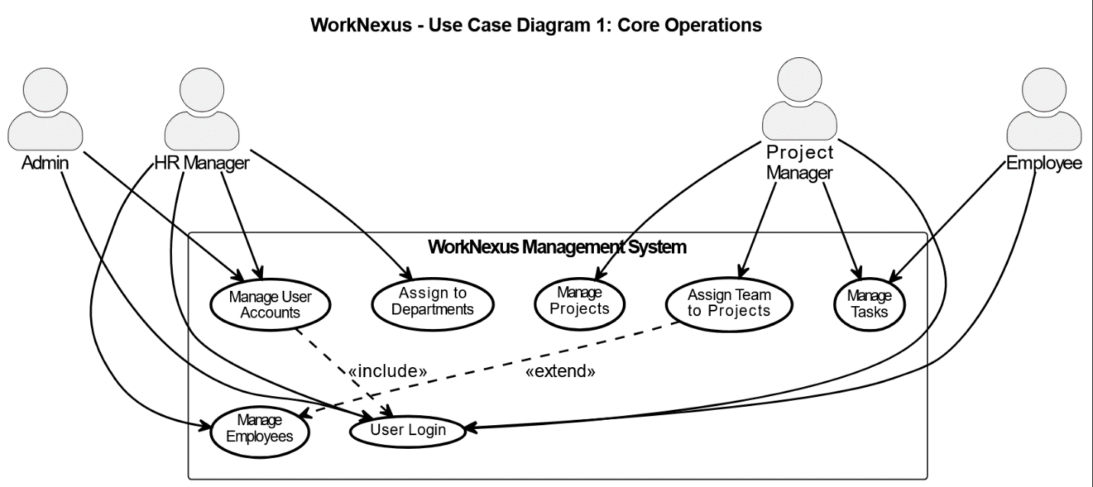
Figure 1 WorkNexus – Use Case Diagram 1: Core Operations

Diagram 2: Execution & Tracking
Focus: Day-to-day task execution, progress monitoring, and dashboards.
Actors: All roles.
Key use cases:
- Log Working Hours
- Update Task Status
- Track Project Progress
- Manage Client Information
- View Role-Based Dashboard

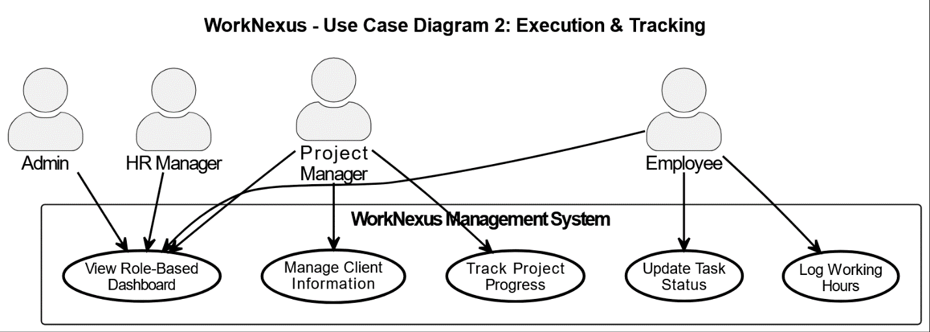
Figure 2 WorkNexus – Use Case Diagram 2: Execution and Tracking

Diagram 3: Payroll & Reports
Focus: Compensation calculation and reporting.
Actors: Admin, HR Manager, Project Manager.
Key use cases:
- Generate Payroll
- Calculate Fixed Salary
- Calculate Hourly Payment
- Calculate Revenue Share
- Process Payments
- Generate Reports
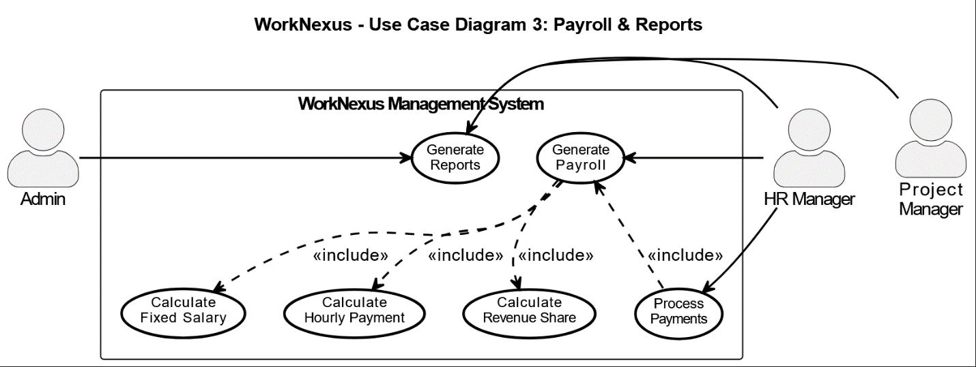
Figure 3 WorkNexus – Use Case Diagram 3: Payroll and Reports
Note: The complete PlantUML source code for all diagrams is provided in Appendix A.

4. SYSTEM DIAGRAMS

4.1 Use Case Diagrams
See Section 3.3 for detailed descriptions and images of all three use case diagrams.

4.2 Class Diagram
The class diagram presents the structural design of the WorkNexus system, depicting core classes, their key attributes and operations, and the relationships among them. It provides a static view of the system architecture used to guide implementation.
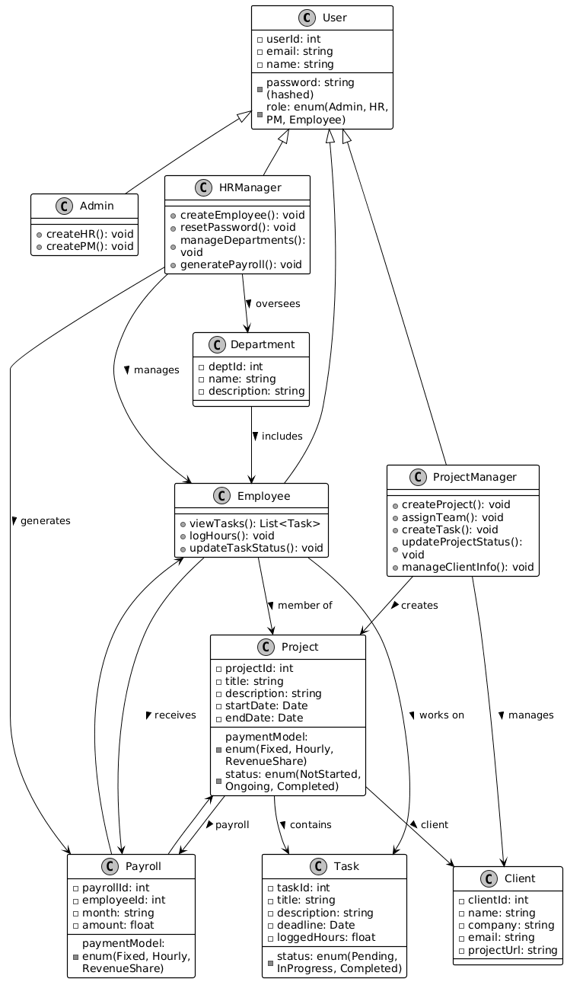
Figure 4 WorkNexus – Class Diagram

4.3 Activity Diagram
The activity diagram models the dynamic behavior of the system by illustrating the flow of control and actions across key user-driven workflows. It captures essential processes involving multiple actors and system responses.

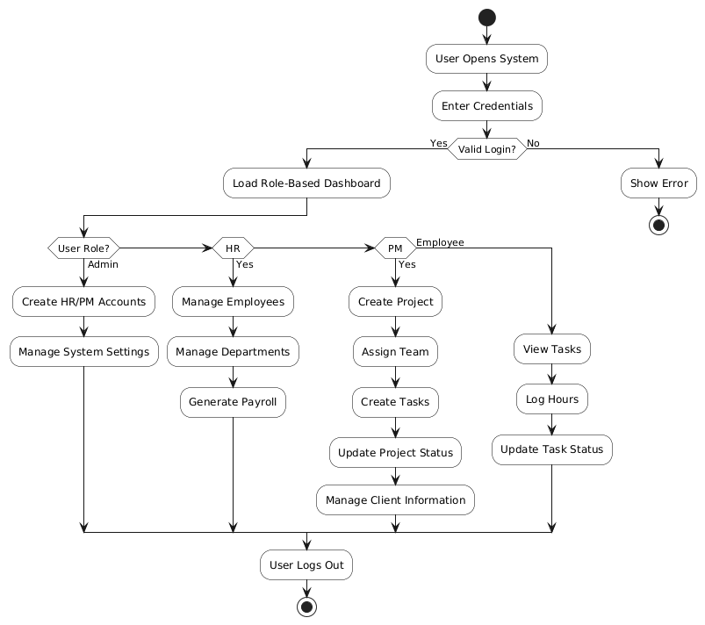
Figure 5 WorkNexus – Activity Diagram

4.4 ERD Diagram
The Entity-Relationship Diagram (ERD) outlines the logical data model of the system, showing major entities, their attributes, primary and foreign key relationships, and cardinality. It serves as the foundation for database design and implementation.

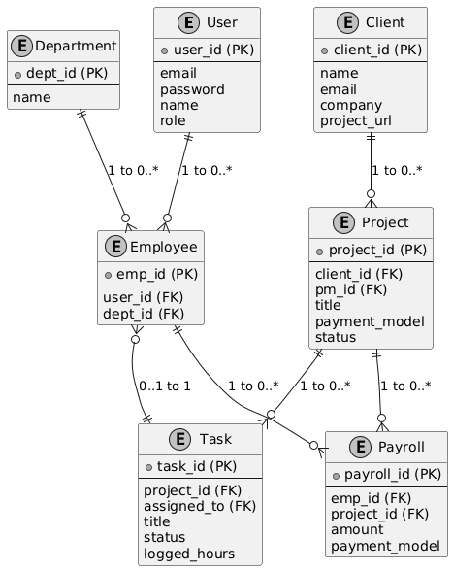
Figure 6 WorkNexus – Entity-Relationship Diagram (Logical)

5. APPENDICES

5.1 Appendix A: PlantUML Source Code – Use Case Diagrams
Plantuml
@startuml WorkNexus Use Case Diagram 1 - Core Operations

' Title and styling - Black and White
title WorkNexus - Use Case Diagram 1: Core Operations
skinparam monochrome true
skinparam actorStyle awesome
skinparam shadowing false
skinparam usecase {
BackgroundColor White
BorderColor Black
BorderThickness 2
ArrowColor Black
ArrowThickness 1.5
FontSize 11
}
skinparam defaultTextAlignment center
skinparam nodesep 30
skinparam ranksep 40

' Single column of use cases
rectangle "WorkNexus Management System" {
usecase (User Login) as UC_Login
usecase (Manage User\nAccounts) as UC_Accounts
usecase (Manage\nEmployees) as UC_Employees
usecase (Assign to\nDepartments) as UC_Dept
usecase (Manage\nProjects) as UC_Projects
usecase (Assign Team\nto Projects) as UC_Team
usecase (Manage\nTasks) as UC_Tasks
}

' Actors on left
actor "Admin" as Admin
actor "HR Manager" as HR
actor "Project\nManager" as PM
actor "Employee" as EMP

' Connections
Admin --> UC_Login
Admin --> UC_Accounts

HR --> UC_Login
HR --> UC_Accounts
HR --> UC_Employees
HR --> UC_Dept

PM --> UC_Login
PM --> UC_Projects
PM --> UC_Team
PM --> UC_Tasks

EMP --> UC_Login
EMP --> UC_Tasks

' Relationships
UC_Accounts ..> UC_Login : <<include>>
UC_Team ..> UC_Employees : <<extend>>

@enduml

' ============================================

@startuml WorkNexus Use Case Diagram 2 - Execution & Tracking

' Title and styling - Black and White
title WorkNexus - Use Case Diagram 2: Execution & Tracking
skinparam monochrome true
skinparam actorStyle awesome
skinparam shadowing false
skinparam usecase {
BackgroundColor White
BorderColor Black
BorderThickness 2
ArrowColor Black
ArrowThickness 1.5
FontSize 11
}
skinparam defaultTextAlignment center
skinparam nodesep 30
skinparam ranksep 40

' Single column of use cases
rectangle "WorkNexus Management System" {
usecase (Log Working\nHours) as UC_Hours
usecase (Update Task\nStatus) as UC_Status
usecase (Track Project\nProgress) as UC_Progress
usecase (Manage Client\nInformation) as UC_Clients
usecase (View Role-Based\nDashboard) as UC_Dashboard
}

' Actors on left
actor "Admin" as Admin
actor "HR Manager" as HR
actor "Project\nManager" as PM
actor "Employee" as EMP

' Connections
Admin --> UC_Dashboard

HR --> UC_Dashboard

PM --> UC_Progress
PM --> UC_Clients
PM --> UC_Dashboard

EMP --> UC_Hours
EMP --> UC_Status
EMP --> UC_Dashboard

@enduml

' ============================================

@startuml WorkNexus Use Case Diagram 3 - Payroll & Reports

' Title and styling - Black and White
title WorkNexus - Use Case Diagram 3: Payroll & Reports
skinparam monochrome true
skinparam actorStyle awesome
skinparam shadowing false
skinparam usecase {
BackgroundColor White
BorderColor Black
BorderThickness 2
ArrowColor Black
ArrowThickness 1.5
FontSize 11
}
skinparam defaultTextAlignment center
skinparam nodesep 30
skinparam ranksep 40

top to bottom direction

' Actors on left
actor "Admin" as Admin
actor "HR Manager" as HR
actor "Project\nManager" as PM

' Single narrow column of use cases
rectangle "WorkNexus Management System" {
usecase (Generate\nPayroll) as UC_Payroll

usecase (Calculate\nFixed Salary) as UC_Fixed

usecase (Calculate\nHourly Payment) as UC_Hourly

usecase (Calculate\nRevenue Share) as UC_Revenue

usecase (Process\nPayments) as UC_Process

usecase (Generate\nReports) as UC_Reports
}

' Connections
Admin -right-> UC_Reports

HR -right-> UC_Payroll
HR -right-> UC_Process
HR -right-> UC_Reports

PM -right-> UC_Reports

' Relationships
UC_Payroll .down.> UC_Fixed : <<include>>
UC_Payroll .down.> UC_Hourly : <<include>>
UC_Payroll .down.> UC_Revenue : <<include>>
UC_Process .up.> UC_Payroll : <<include>>

@enduml

5.2 Appendix B: PlantUML Source Code – Activity Diagram
Plantuml
@startuml WorkNexus_ActivityDiagram_Compact

skinparam monochrome true
skinparam shadowing false
skinparam defaultFontName Calibri
skinparam activity {
BackgroundColor White
BorderColor Black
}

start

:User Opens System;
:Enter Credentials;

if (Valid Login?) then (Yes)
:Load Role-Based Dashboard;

if (User Role?) then (Admin)
:Create HR/PM Accounts;
:Manage System Settings;
elseif (HR) then (Yes)
:Manage Employees;
:Manage Departments;
:Generate Payroll;
elseif (PM) then (Yes)
:Create Project;
:Assign Team;
:Create Tasks;
:Update Project Status;
:Manage Client Information;
else (Employee)
:View Tasks;
:Log Hours;
:Update Task Status;
endif

:User Logs Out;
stop

else (No)
:Show Error;
stop
endif

@enduml

5.3 Appendix C: PlantUML Source Code – Class Diagram
Plantuml
@startuml WorkNexus_ClassDiagram

skinparam monochrome true
skinparam shadowing false
skinparam defaultFontName Calibri
skinparam wrapWidth 180
skinparam class {
BackgroundColor White
BorderColor Black
BorderThickness 1.2
ArrowColor Black
}

'================ CLASSES ================

class User {
- userId: int
- email: string
- password: string (hashed)
- name: string
- role: enum(Admin, HR, PM, Employee)
}

class Admin {
+ createHR(): void
+ createPM(): void
}

class HRManager {
+ createEmployee(): void
+ resetPassword(): void
+ manageDepartments(): void
+ generatePayroll(): void
}

class ProjectManager {
+ createProject(): void
+ assignTeam(): void
+ createTask(): void
+ updateProjectStatus(): void
+ manageClientInfo(): void
}

class Employee {
+ viewTasks(): List<Task>
+ logHours(): void
+ updateTaskStatus(): void
}

class Department {
- deptId: int
- name: string
- description: string
}

class Project {
- projectId: int
- title: string
- description: string
- startDate: Date
- endDate: Date
- paymentModel: enum(Fixed, Hourly, RevenueShare)
- status: enum(NotStarted, Ongoing, Completed)
}

class Task {
- taskId: int
- title: string
- description: string
- deadline: Date
- status: enum(Pending, InProgress, Completed)
- loggedHours: float
}

class Client {
- clientId: int
- name: string
- company: string
- email: string
- projectUrl: string
}

class Payroll {
- payrollId: int
- employeeId: int
- month: string
- paymentModel: enum(Fixed, Hourly, RevenueShare)
- amount: float
}

'================ RELATIONSHIPS ================

User <|-- Admin
User <|-- HRManager
User <|-- ProjectManager
User <|-- Employee

HRManager --> Employee : manages >
HRManager --> Department : oversees >
HRManager --> Payroll : generates >

ProjectManager --> Project : creates >
ProjectManager --> Client : manages >

Employee --> Task : works on >
Employee --> Project : member of >
Employee --> Payroll : receives >

Project --> Task : contains >
Project --> Client : client >
Project --> Payroll : payroll >

Department --> Employee : includes >

Payroll --> Employee
Payroll --> Project

@enduml

5.4 Appendix D: PlantUML Source Code – ERD (Logical)
Plantuml
@startuml WorkNexus - ERD (Logical)

' Styling
skinparam monochrome true
skinparam shadowing false
skinparam defaultFontName Calibri

entity "User" as User {
+ user_id (PK)
--
email
password
name
role
}

entity "Employee" as Employee {
+ emp_id (PK)
--
user_id (FK)
dept_id (FK)
}

entity "Department" as Department {
+ dept_id (PK)
--
name
}

entity "Project" as Project {
+ project_id (PK)
--
client_id (FK)
pm_id (FK)
title
payment_model
status
}

entity "Task" as Task {
+ task_id (PK)
--
project_id (FK)
assigned_to (FK)
title
status
logged_hours
}

entity "Client" as Client {
+ client_id (PK)
--
name
email
company
project_url
}

entity "Payroll" as Payroll {
+ payroll_id (PK)
--
emp_id (FK)
project_id (FK)
amount
payment_model
}

' Relationships
User ||--o{ Employee : "1 to 0..*"
Department ||--o{ Employee : "1 to 0..*"
Client ||--o{ Project : "1 to 0..*"
Project ||--o{ Task : "1 to 0..*"
Employee }o--|| Task : "0..1 to 1"
Project ||--o{ Payroll : "1 to 0..*"
Employee ||--o{ Payroll : "1 to 0..*"

@enduml

6 References
- IEEE Standard 830-1998 (Software Requirements Specification)
- University SRS Template (Provided Document)
- Project Domain Knowledge (Service-Based Business Operations)

