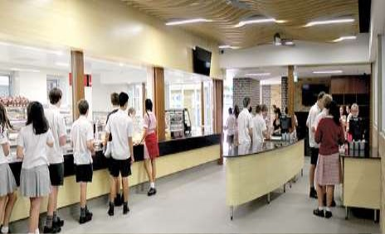

**CANTEEN MANAGEMENT SYSTEM**

**1 |** P a g e

**Table of Contents**

**Introduction----------------------------------------------------------------------------------------------------------------3**

**Why are you developing this project? --------------------------------------------------------------------------------3**

**Expected outcomes--------------------------------------------------------------------------------------------------------4**

**Flow Chart Diagram-----------------------------------------------------------------------------------------------------5**

**Algorithm--------------------------------------------------------------------------------------------------------------- 6**

**2 |** P a g e

**Introduction**

**Canteen Management System is a c++ standalone application which makes it easy for the customers/users to select the type of food they want to take. The system provides the feature to edit, add, delete, and select the food item of their choice, also there is no security issues because every user holds a unique username with its password.**

**It might have happened so many times that we cannot really go out and buy food or running out of fuel/electricity in the kitchen or may be don’t have time to cook, well not only in these cases but also for the lack of time issues, this system helps a lot since it is online and automated. Select the food item and the required quantity and just place the order. It saves time, energy and is easy to operate.**

**Almost every canteen and restaurant need such application in order to give convenience to their customers to let them select the items as per their wish and place the order from wherever they want which is effective and efficient.**

**Why are you developing this project?**

**A canteen facility is a supplementary system that is provided by an organization for their employees. Many employees in an organization use the canteen services as they do not have the time and the means to prepare their own food or are unable to get it.**

**In this era, organizations mostly hold the record of many employees which makes it difficult to manage the canteen with manual process. So, they need a centralized canteen management system that promotes efficiently operations to cover a large organizational workforce. This canteen management system provides a friendly user interface for menu designs, user to login and edit the order as per their needs.**

**Expected outcomes**

• **It will provide fast services to their customers. Usually what happened is people must go to the canteen and order the food items, they must wait in a queue for a long time to get their orders.**

• **It will provide a list of different items in the menu list with two different categories. User can select any item from the canteen and can order it online.**

• **Users should be able to login with the valid username and password. Users need to enter the username and password to place their order. Also, security is equally important in the system.**

• **A user will be able to edit the order. Here, users will be able to add, delete, edit and clear the food items from their order.**

• **It provides an easy user interface. The food items details will be their including the ID, name and price.**

**3 |** P a g e

**Flow Chart Diagram**

YES



|  |  |
| --- | --- |
|  | START |

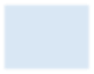

|  |  |
| --- | --- |
| LOGIN PAGE | |
|  |  |

|  |  |
| --- | --- |
| ENTER USERNAME &PASSWORD | |
|  |  |

|  |  |  |
| --- | --- | --- |
|  | |  |
| NO | ERROR LOGIN FAILED | |

|  |  |  |  |
| --- | --- | --- | --- |
| WANTTO LOGIN | NO |  |  |
| CANCEL | |



|  |  |
| --- | --- |
| TAKE THE USER TO HOMEPAGE (CONTROL PANEL) | |
| Y | ES |

|  |  |
| --- | --- |
| SELECT ITEMS NO | LOGOUT |

|  |  |
| --- | --- |
|  |  |
| YES YES | |

|  |  |
| --- | --- |
| SNACKS | |
|  |  |

|  |  |
| --- | --- |
| BEVERAGES | |
|  |  |

|  |  |  |  |  |  |
| --- | --- | --- | --- | --- | --- |
| ADD SNACKS | |  | | ADD BEVERAGES | |
|  |  | | | |  |
|  | | |  | | |

|  |  |
| --- | --- |
| MODIFY THE ITMES | STOP |

NO

|  |  |  |
| --- | --- | --- |
|  | YES | |
|  | ADD ITEMS EDIT ITEMS DELETEITEMS CLEAR |
|  | |

LOGINSUCCESS

YES

**5 |** P a g e

**Algorithm:**

* **Admin logins to the system and manage all the functionalities of Canteen Management System**
* **Admin can add, edit, delete and view the records of Food, Category, Canteen Employee, Sales**
* **Admin can manage all the details of Item, Customer, Canteen Record**
* **Admin can also generate reports of Food, Item, Category, Customer, Canteen Employee, Canteen Record**
* **Admin can search the details of Item, Canteen Employee, Canteen Record**
* **Admin can apply different level of filters on report of Food, Customer, Canteen Employee .**
* **Admin can tracks the detailed information of Item, Category, Customer,, Canteen Employee**
* **User can order food.**
* **User can delete the item.**
* **User accept the bill of food ordered**
* **User can keep track of his/her record.**