**Instructions**

Complete the following steps:

1. Use the D3 library to read in samples.json from the URL https://2u-data-curriculum-team.s3.amazonaws.com/dataviz-classroom/v1.1/14-Interactive-Web-Visualizations/02-Homework/samples.json.
2. Create a horizontal bar chart with a dropdown menu to display the top 10 OTUs found in that individual.
   * Use sample_values as the values for the bar chart.
   * Use otu_ids as the labels for the bar chart.
   * Use otu_labels as the hovertext for the chart.

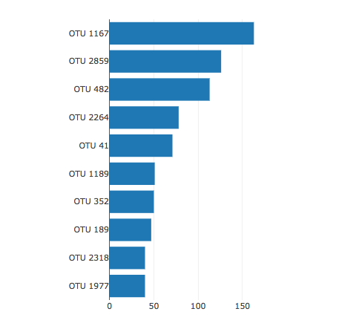

1. Create a bubble chart that displays each sample.
   * Use otu_ids for the x values.
   * Use sample_values for the y values.
   * Use sample_values for the marker size.
   * Use otu_ids for the marker colors.
   * Use otu_labels for the text values.

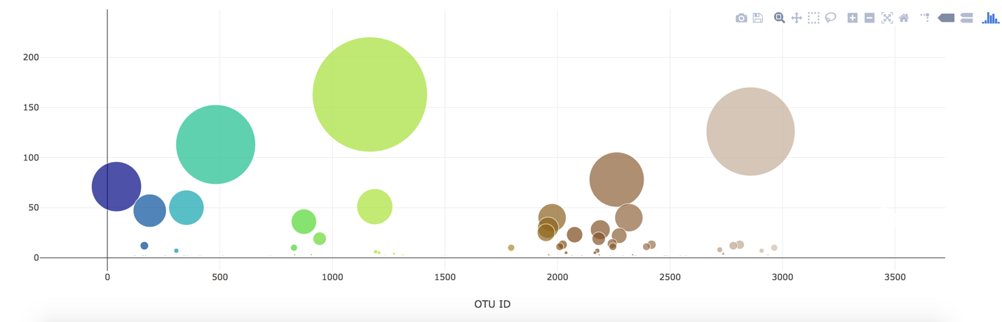

1. Display the sample metadata, i.e., an individual's demographic information.
2. Display each key-value pair from the metadata JSON object somewhere on the page.

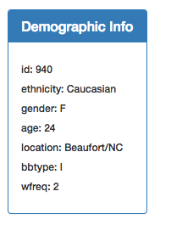

1. Update all the plots when a new sample is selected. Additionally, you are welcome to create any layout that you would like for your dashboard. An example dashboard is shown as follows:

