Tap and Track

Muhamad Irfan bin Zuhaimin

JANUARY 2025

Tap and Track,
A Mobile Application Attendance System

Muhamad Irfan bin Zuhaimin

A Project Report Submitted to the
College of Computing and Informatics
Universiti Tenaga Nasional
in Partial Fulfilment of the Requirements for the
Bachelor in Computer Science (Software Engineering) (Hons.)
JANUARY 2025

DECLARATION
I hereby declare that final year project is my original work except for quotations and citations have been duly acknowledged. I also declare that has not been previously and is not concurrently submitted for any degree program at Universiti Tenaga Nasional or at any other institutions. This final year project may be made available within the university library and may be borrowed, consulted, copied, or reproduced in accordance with the provision of the UNITEN Library Regulations from time to time made by the Library Committee.

Muhamad Irfan bin Zuhaimin
SW01082139
10/1/2025

APPROVAL PAGE
This project entitled:
“Tap and Track, a mobile application attendance system”
submitted by:
Muhamad Irfan bin Zuhaimin (SW01082139)
In requirement for the degree of Bachelor in Computer Science (Software Engineering College of Computing and Informatics, Universiti Tenaga Nasional has been accepted.
Supervisor: Faridah Hani Bte Mohamed Salleh, Ts. Dr
Signature: …………………….
Date: 10/1/2025

ACKNOWLEDGMENT
I would like to express my sincere gratitude to the following individuals and organizations for their invaluable support and guidance throughout the development of Tap and Track, an NFC-based attendance system:
Firstly, my esteemed supervisor, Dr Faridah Hani for their unwavering support, insightful guidance, and constructive criticism. Her expertise and encouragement were instrumental in shaping this project.
Next, Tumpat Solutions Sendirian Berhad, for providing the opportunity to implement this system and for their valuable feedback and support.
Lasty, I would like to thank my family and my friends as my motivation boost.

ABSTRACT
This project aims to develop an NFC-based attendance system to streamline the attendance tracking process for employees. The system utilizes NFC technology to record employee attendance by simply tapping an NFC tag on a mobile device. The captured data, including employee ID and timestamp, is then transmitted to a central server for storage and analysis. The system consists of an Android mobile application and a backend server. The mobile app serves as the interface for employees to record their attendance, while the backend server stores and processes the attendance data. The system also includes dashboard to be used by the human resources department to monitor and analyse attendance records. By leveraging NFC technology, this project aims to improve the efficiency and accuracy of attendance tracking, reduce administrative overhead, and provide valuable insights for human resources department.

TABLE OF CONTENTS
Page
DECLARATION ii
ACKNOWLEDGMENT v
ABSTRACT vi
TABLE OF CONTENTS vii
LIST OF TABLES ix
LIST OF Figures x
LIST OF ABBREVIATIONS xi
CHAPTER 1 INRODUCTION 12
1.1 Project Background 12
1.2 Problem Statement 12
1.3 Objective 13
1.4 Scope 14
1.4.1 User Scope 14
1.4.2 System Scope 14
CHAPTER 2 LITERATURE REVIEW 16
2.1 Similar Attendance System 16
2.1.1 Jibble 16
2.1.2 TimeTec 18
2.1.3 Sling 20
2.1.4 System Analysis 22
CHAPTER 3 REQUIREMENTS ANALYSIS 24
3.1 Requirements Elicitation 24
3.1.1 Interview Session 24
3.1.2 Observation 26
3.2 Requirement’s analysis 27
CHAPTER 4 DESIGN 28
4.1 Introduction 28
4.2 System Architecture 28
4.3 Database Design 29
4.4 System Design 30
CHAPTER 5 CONCLUSION AND RECOMMENDATIONS FOR FUTURE WORK 32
5.1 Conclusion 32
References 33
APPENDIX A System requirements specification 34

LIST OF TABLES
Table 1.4.1.1 User Scope 14
Table 1.4.2.1 Employee system scope 14
Table 1.4.2.2 Manager system scope 15
Table 1.4.2.3 Admin system scope 15
Table 2.1.4.1 Comparison between systems 22

LIST OF Figures
Figure 2.1.1 Record Attendance Page 16
Figure 2.1.2 Jibble Dashboard 17
Figure 2.1.3 Export Data Page 17
Figure 2.1.4 Home Screen of attendance app 18
Figure 2.1.5 Home page of leave system 19
Figure 2.1.6 Sling Dashboard 20
Figure 2.1.7 Sling Attendance Page 21
Figure 2.1.8 Announcement page 21
Figure 4.2.1 Use Case Diagram 28
Figure 4.3.1 Entity Relationship Diagram 29
Figure 4.4.1 Screen Map 30

LIST OF ABBREVIATIONS
NFC | Near Field Communication
RFID | Radio Field Identification
Mhz | Megahertz
QR | Quick Response

INRODUCTION

Project Background
Traditional attendance systems, such as fingerprint scanners and QR code systems, often face challenges related to efficiency, accuracy, and security. These methods can be time-consuming, prone to errors, and vulnerable to security breaches.
To address these issues, I propose a novel solution: Tap and Track, an NFC-based attendance system. This innovative system leverages NFC technology to streamline the attendance process, making it more efficient and user-friendly. By simply tapping an NFC tag on a designated device, employees can quickly and accurately record their attendance, reducing the risk of human error and improving overall efficiency.

Problem Statement
The company's current fingerprint attendance system, while seemingly convenient, presents several significant drawbacks. Primarily, the process of integrating new employees is inefficient and exposes them to potential security threats. New employees must physically visit the fingerprint scanner, often located at an external location, to register their biometric data. This not only inconveniences new hires but also exposes them to potential security risks. As it is located outside and touched by a lot of people, the fingerprint scanner is also prone to infections, bacteria and dirt.
Furthermore, the system's dual function as both an attendance tracker and door access control mechanism lead to operational inefficiencies. Overlapping names in attendance reports and the potential for unauthorized entry due to unlocked doors are common issues. The system's reliance on a single, stationary device also limits flexibility, especially for remote or outstation staff who cannot easily access the equipment.

The system's user interface is another significant concern. The small screen, slow response times, and complex export processes hinder efficient data management. These limitations often result in errors, delays, and overall frustration for both employees and administrators.

Objective
- To identify the requirements of Tap and Track, a mobile application attendance system that can accurately record the employee’s attendance regardless the location of the employees.
- To design the system of Tap and Track so that it is able to fulfil the requirements gathered.
- To develop a system to help ease the human resources department by automatically generating useful information such as employees not attending, monthly review and automatically calculate the work hours based on the recorded time for performance review.
- To verify and validate the developed system by testing the entire system from all point of user scope.

Scope

User Scope
User Type | Description
Employee | Normal employee in the company
Admin | Human resources admin
Manager | Managers of the company
Table 1.4.1.1 User Scope

System Scope
- Employee
Function | Description
Log In | To log in into the system
Record attendance | Clock in or clock out
View own attendance record | View own attendance record history
Request leave | Request Leave
Edit own profile | Edit personal details
Update mileage | Update the current vehicle mileage
View mileage | View all vehicle mileage
Log Out | Log out from the system
Table 1.4.2.1 Employee system scope

- Manager
Function | Description
Log In | To log in into the system
Record attendance | Clock in or clock out
View own attendance record | View own attendance record history
View team members attendance record | View team attendance record history
Approve Leave | Approve leave requested by team members
Edit own profile | Edit personal details
Update mileage | Update the current vehicle mileage
View mileage | View all vehicle mileage
Log Out | Log Out from the system
Table 1.4.2.2 Manager system scope
- Admin
Function | Description
Log In | To log in into the system
Record attendance | Clock in or clock out
View own attendance record | View own attendance record history
View entire company attendance record | View entire company attendance record history
User management | Add or remove employee
Edit own profile | Edit personal details
Update mileage | Update the current vehicle mileage
View mileage | View all vehicle mileage
Generate report | Generate report for human resources use
Log Out | Log Out from the system
Table 1.4.2.3 Admin system scope

LITERATURE REVIEW

Similar Attendance System
While there may not be a plethora of free, open-source attendance systems specifically designed for NFC-based tracking, several mobile apps offer core attendance tracking features. These apps, while not exclusively NFC-focused, can provide valuable insights into the design and implementation of such systems.

Jibble
Jibble is a versatile, free attendance tracking tool developed in the United States. Compatible with major platforms including Android, iOS, Windows and macOS, Jibble offers a mobile app for convenient daily attendance recording. Its robust features include overtime tracking, comprehensive reporting, and real-time data analysis.
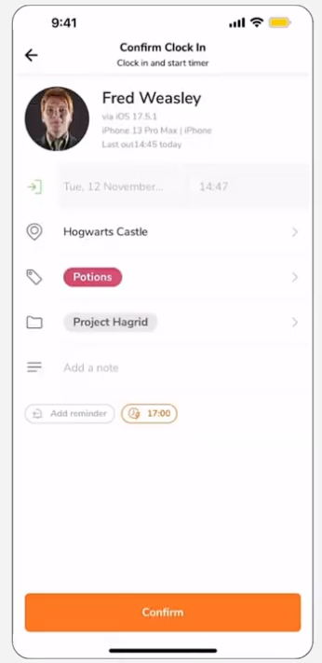
Figure 2.1.1 Record Attendance Page

Jibble's user-friendly interface simplifies the attendance process, while advanced features like facial recognition and geolocation enhance security and accuracy. The system efficiently converts attendance data into exportable CSV or XLS files, facilitating seamless integration with payroll systems and other HR tools.
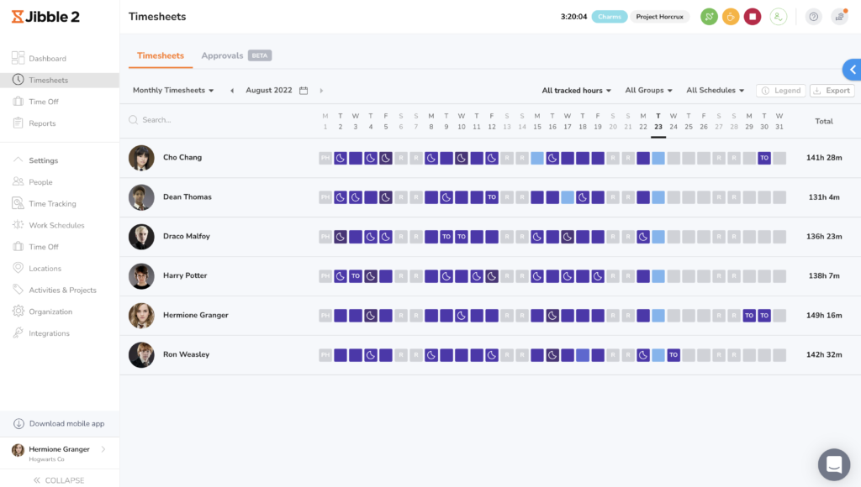
Figure 2.1.2 Jibble Dashboard
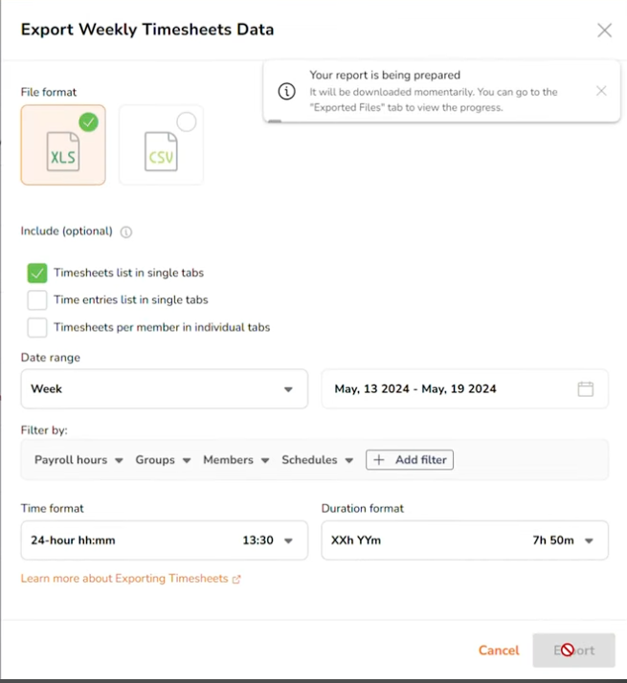
Figure 2.1.3 Export Data Page

While Jibble offers a range of features, it also presents potential drawbacks. Data security is a critical concern, and any vulnerabilities in the system could compromise sensitive employee information. Additionally, the use of geolocation and facial recognition raises privacy concerns for some users. Furthermore, the reliance on personal devices and stable internet connectivity can limit accessibility and flexibility for certain employees.

TimeTec
TimeTec is a company in Malaysia that provide multiple services mainly to assist in human resources department. TimeTec offers a comprehensive suite of cloud-based workforce management solutions, including TimeTec TA (Time Attendance) and TimeTec Leave. These systems are designed to automate and streamline attendance tracking, leave management, and scheduling processes for organizations of all sizes.
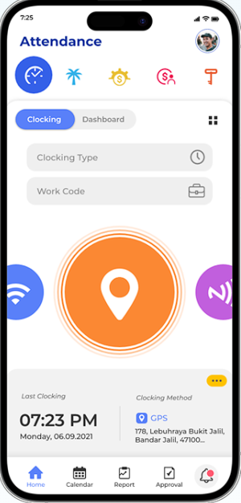
Figure 2.1.4 Home Screen of attendance app
Figure above shows TimeTec Time Attendance supports a variety of clocking methods, catering to diverse work environments including biometrics such as fingerprint scanning and facial recognition. Next TimeTec also provide a mobile app that have feature such as QR Code, NFC and geolocation fencing to record the attendance remotely. TimeTec can generate reports from overtime hours, attendance trend and other key matrics that are useful for the human resources department.
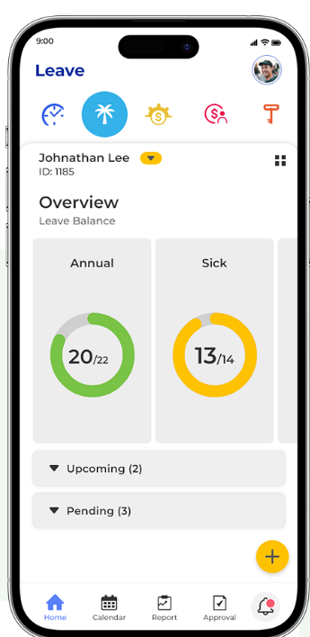
Figure 2.1.5 Home page of leave system
Next, the leave system by TimeTec, some of the highlighted features including an automated leave processing where it eliminates the paperwork process hence reducing errors and saving costs.

Sling
Sling, a versatile workforce management tool developed in the United States, offers a comprehensive suite of features for efficient scheduling and communication. Accessible across iOS, Android, and web platforms, Sling empowers businesses to streamline operations through features like employee scheduling, task management, and time and attendance tracking. Sling offers free usage for company under 50 employees and offer other plans suitable for the number of employees.
Sling offers time and attendance tracking via their app and website and could integrate with payroll system. The drag and drop schedule feature are easy to learn for create and manage employee schedules. Next, a built-in messaging platform for the members to use. Managers could create new task, assign to the employees and track those progress.
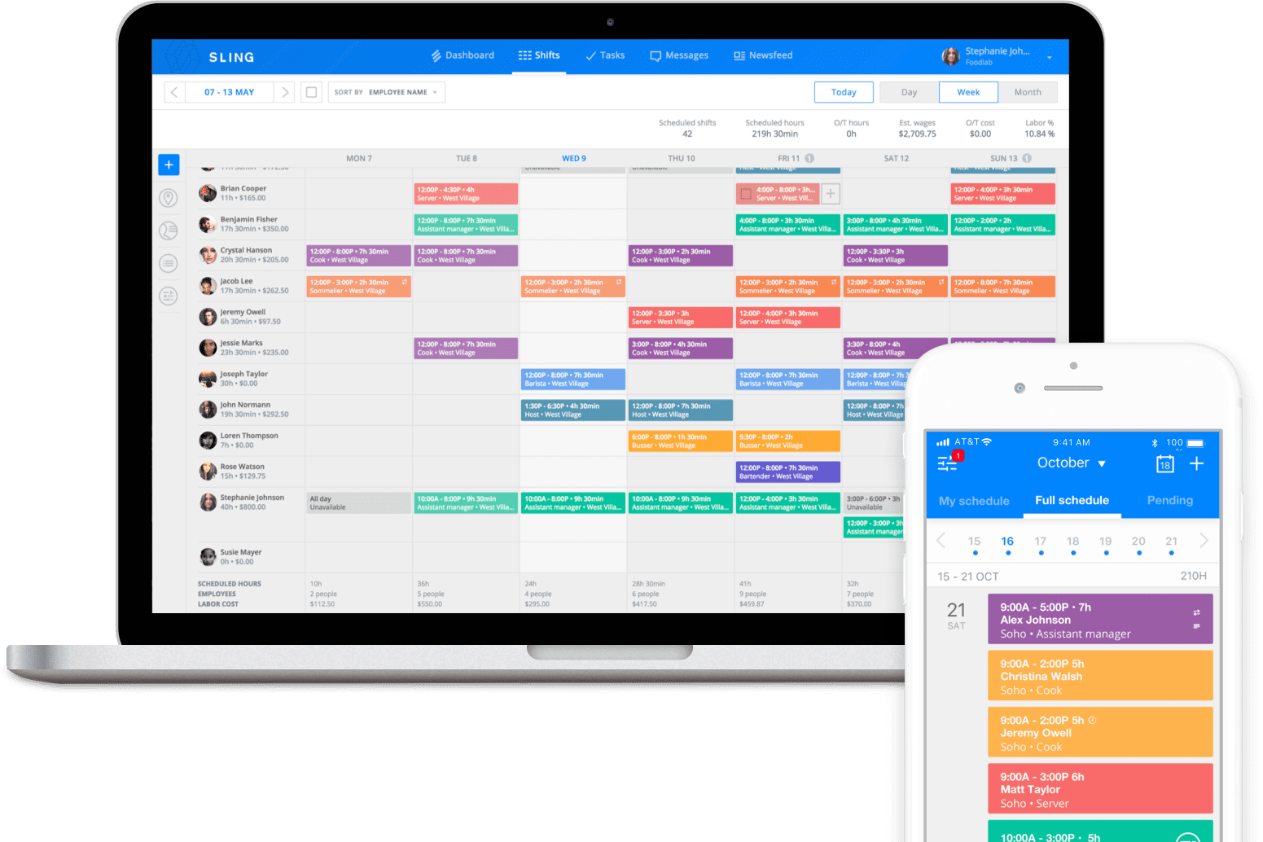
Figure 2.1.6 Sling Dashboard
The figure above shows Sling dashboard it is a multi-platform system that supports most browser and most mobile operating systems.
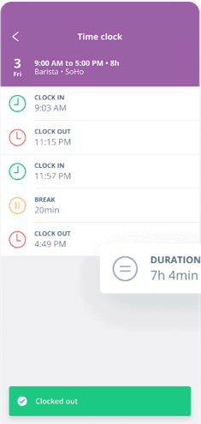
Figure 2.1.7 Sling Attendance Page
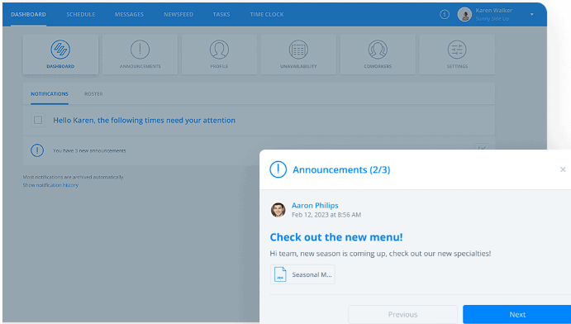
Figure 2.1.8 Announcement page
As for disadvantages, some users have reported receiving excessive notifications, which can be disruptive and hinder productivity due to the communication feature. Additionally, the system's simplicity, which is advantageous for small businesses, might not be sufficient for larger organizations with complex scheduling needs. Lastly, as a cloud-based solution, Sling relies on a stable internet connection, which can impact its usability in areas with limited connectivity.

System Analysis
 | Jibble | TimeTec | Sling
Pricing | Free | Subscription | Subscription
Internet Connection | Mandatory | Mandatory | Mandatory
Export data | Yes | Yes | No
Feature | API Integration | Integration with other systems provided from TimeTec | Built in communication system
Table 2.1.4.1 Comparison between systems
While Jibble, Cloud-TA, and Sling provide valuable attendance tracking features, Tap and Track stands out with its innovative use of NFC technology, which minimizes reliance on internet connectivity. This allows employees to log attendance via NFC tags, ensuring consistent functionality even without constant online access.
- Offline Functionality: Enables reliable attendance tracking in areas with limited or no internet access.
- Enhanced Security: Reduces the risk of cyberattacks and data breaches by limiting internet-based data transmissions.
- Comprehensive Data Export: Supports exporting attendance data in .xlsx format, ensuring smooth integration with external systems and analytical tools.
- Scalability: Easily adaptable to meet the needs of organizations of any size.
By combining mobile application with an intuitive design and data management, Tap and Track delivers a secure, efficient, and reliable attendance tracking solution tailored to Tumpat Solutions.

REQUIREMENTS ANALYSIS

Requirements Elicitation

Interview Session
An interview session with the human resources manager to identify the requirements and details regarding the current system and the desired system as well as its features. Provided below is the transcript of the interview.
Interviewer: Thank you for making time to meet me today. I'm proposing to develop one new system for the company, so I want to know what you think about current one and what you all need for the new system
HR Admin: No problem. Actually, we also looking forward to new system, so I'm happy to help.
Interviewer: Okay, first thing first, can you tell me about the system you're using now?
HR Admin: Now, we using that fingerprint scanner one. But actually, it's like dua dalam satu – use for clock in, clock out, and open the door also. But... that one got some problem, not so accurate.
Interviewer: Ahh, I see. So, because it's also for the door, sometimes the attendance is not correct, is it?
HR Admin: yes! Sometimes people come in early, just to lepak or make coffee, but already clock in. Payroll also problem, overtime also problem, haih, headache penat.
Interviewer: Okay, okay. So, what kind of things are important for a good attendance system?
HR Admin: Most important, of course, must be accurate! Cannot like now, gitu-gitu je. Then, must be easy to use for everyone. And then, if possible, must connect with our payroll system, so no need to do double work. Reports also important, we need to see all the data properly. And if can, good support and backup, so if got problem, can quickly get help.
Interviewer: What are you hoping for in the new system?
HR Admin: Firstly, must be accurate, efficient, easy to use... like that. Must be flexible also, can change-change according to our company punya needs. And of course, must be safe, cannot let stranger access our data. Big boss was thinking about using NFC card, but not sure yet.
Interviewer: How do you think a new system can improve things here?
HR Admin: Wah, can improve a lot, you know Can save time, no need to do so much manual work. Can reduce mistakes also. And can help us manage our staff better, make better decisions...
Interviewer: Any specific things you want to see in the new system?
HR Admin: Hmm... better scheduling, good leave system, can send notifications... maybe can even predict when people might take leave, it’s a maybe ye not must, so we can plan better. also, the other day boss did mention about a system to track our car’s mileage and when is the next service appointment date. This issue has occurred several times already, staff nak outstation, check kereta, kereta kena service pulak dah Tangguh kerja kat situ.
Interviewer: What about using NFC? Do you think it is good or not?
HR Admin: Hmm... I think it should be okay. Seems more accurate and secure. But must make sure everyone knows how to use, and should not be too expensive. Then using nfc can track attendance for those who are on site also.
Interviewer: Can you tell me about the different people who will use the system?
HR Admin: Sure, Got employees, managers, and then us HR people. Employees want to clock in/out easily, see their own records, apply for leave, all that. Managers want to see their team punya attendance, approve leave, and get reports. And HR, we need to control everything, make sure everything running smoothly add and delete employees like that.
Interviewer: Okay, last question. Can the managers and HR create separate attendance lists for different groups of employees?
HR Admin: Wah, that would be very good! Can track people who work outside, special projects, all that. Very useful!
Interviewer: Okay, I think that's all for now. Thank you so much for your time!
HR Admin: No problem, good luck with your project, feel free to ask me anything.

Observation
During my industrial training at Tumpat Solutions for 12 weeks. I observed how does the attendance systems works, from registering my biometrics to recording attendance daily, also following my supervisor to site. It is proven, that all of the problems stated in chapter one was true. The observation that employees struggle with the biometric scanner has led to the requirement for an alternative attendance tracking method, such as mobile application. Moreover, the need for better reporting and analytics has been translated into specific requirements for the system's reporting module.

Requirement’s analysis
This section details the analysis conducted on the gathered requirements to ensure they are clear, complete, consistent, and perfect fit for Tap and Track attendance tracking system. The requirements were prioritized based on their importance to core functionality, legal compliance, and user needs. High priority was given to accurate attendance tracking, data security, and adherence to laws and data privacy regulations in Malaysia. Features like advanced reporting and analytics were deemed lower priority and considered potential future enhancements.
The cost of implementing core features aligned with the project budget, ensuring economic feasibility. Operationally, the system was considered highly feasible due to its compatibility with the company's existing IT infrastructure and minimal maintenance needs.
A traceability matrix will be used to maintain clear links between requirements, design elements, and test cases throughout the development process. This ensures that all requirements are addressed and that the final system meets the needs of the company and its users.

DESIGN

Introduction
This chapter details the design of the "Tap and Track" attendance tracking system, outlining the key architectural decisions, user interface considerations, and database structure. The design process has been guided by the requirements elicited and analysed in the previous chapter, with a focus on creating a system that is user-friendly, efficient, secure, and scalable.

System Architecture
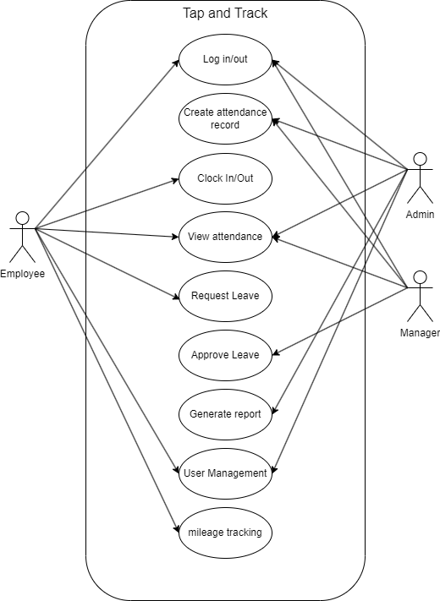
Figure 4.2.1 Use Case Diagram

The figure 4.2.1.1 shows Use case diagram. It provides a visual representation of the interactions between users and 'Tap and Track' attendance tracking system. It also visualises the interactions between users and the system. This diagram helped to identify the key functionalities and clarify the roles and responsibilities of different user types.

Database Design

Entitiy Relationship Diagram
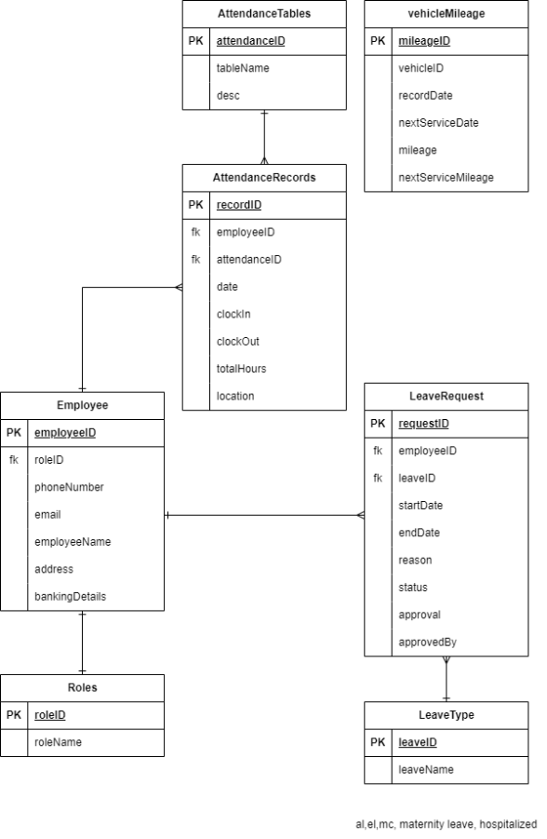
Figure 4.3.1 Entity Relationship Diagram
Figure 4.2.2.1 shows the ERD that illustrates the core entities of the system, including Employee, AttendanceRecords, LeaveRequest, and VehicleMileage. The relationships between these entities are represented using standard Crow's Foot notation, indicating the cardinality and participation constraints.

Database Normalization
The database design is applying the third level of normalization in database. The third level makes the data stored inside the database easier to manage and update the data. Next it would minimize data redundancy as it will reduce any duplication data in the database. Lastly, this level ensures all the data is consistent and accurate.

System Design
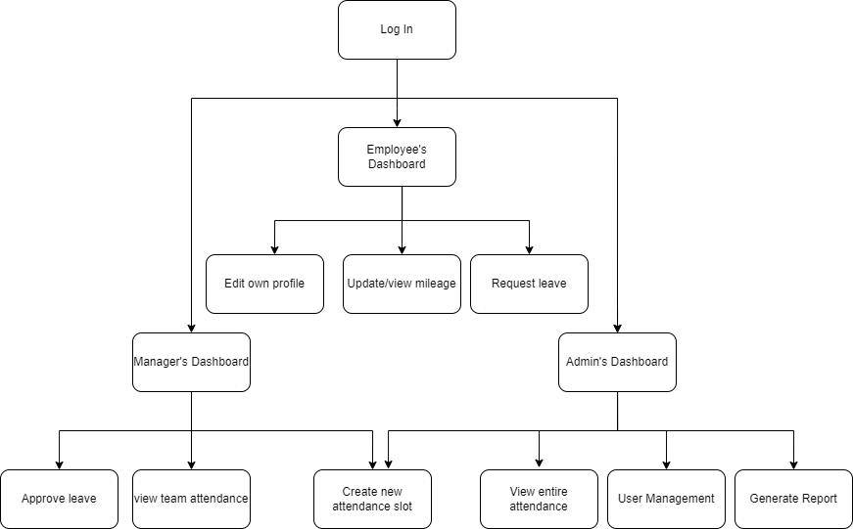
Figure 4.4.1 Screen Map
Figure 4.4.1 shows the screen map of the system, firstly users will log in via email and password. Then it will redirect to respective dashboard. For employee, they can record attendance, view attendance on the dashboard. Next, they could navigate to the update and view mileage page. They also can navigate to request leave page. Lastly, they could navigate to edit their own data page.
As for manager, they will have the same access as employee but having additional three page which is approve leave, view team attendance and create new attendance
Lastly, for the admin, they will get the same as employee as well as 3 additional pages which is view the entire company’s attendance, user management where admin could add or remove employee from the system and generate report for human resources department use.

CONCLUSION AND RECOMMENDATIONS FOR FUTURE WORK

Conclusion
This project has successfully designed and developed "Tap and Track," an attendance tracking system tailored to the specific needs of Tumpat Solutions. The system addresses the limitations of the existing fingerprint-based system by providing accurate time tracking, automated leave management, and efficient reporting capabilities. By incorporating mobile application and a user-friendly interface, "Tap and Track" promotes employee accountability, streamlines HR processes, and enhances overall workforce management.
The system's design adheres to the requirements elicited through interviews, observations, and analysis of the company's needs. The database design ensures data integrity and security, while the UI design prioritizes usability and accessibility for all user roles. The chosen technology stack aligns with the company's existing infrastructure and expertise, ensuring maintainability and scalability

References
Jibble. (n.d.). Jibble. Retrieved from Jibble: https://www.jibble.io
Sling. (n.d.). Features. Retrieved from Sling by Toast: https://getsling.com/features-2/
TimeTec. (2025). TimeTec. Retrieved from TimeTec: https://www.timeteccloud.com

APPENDIX A
System requirements specification

