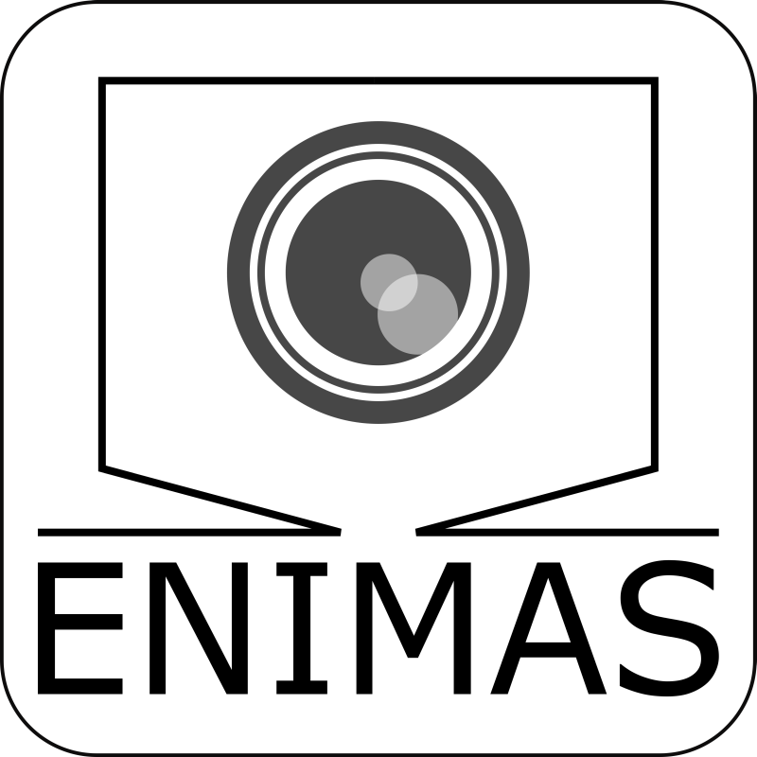

User Guide
  - ENIMAS2
V1.0 | August.2025

Inhalt
Introduction 3
− Purpose 3
− Target audience 3
− System requirements 3
Getting Started 3
Installation 3
− Locate the installer 3
− Run the installer 3
− Locate the installed Application 3
Launch the APP 3
Navigation 4
Overview 4
− Menu Bar 4
− Directory Manager 4
− Toolbar 4
− Video Display Area 4
− Classification Result Viewer 5
− Status Bar 5
Typical Workflow 6
Core Features 7
Select Device 7
Camera movement control 8
− Reference Axis 8
− Autofocus 8
Lens Management 10
− Lens Selection 10
− Lens Addition 10
− Lens Deletion: 11
Camera settings 12
− Exposure Time 12
− White Balance 12
− Gain 12
− Gamma Correction 13
Image save settings 14
− Enable Drawing Scale Bar 14
− Enable Cropping 15
− Enable Uniform Background 15
Orientation selection 16
Image acquisition 17
− Single Image 17
− Stacking Image 17
− Stacking Method Selection 18
− Image Displayment 18
Measurement 19
Classification 21
− Add Model 21
− Select Model 21
− Classify 22
Plugins 23
− Common Features 23
− Measurement Plugin 24
− Classification Plugin 25
− Uniform Background Plugin 25
− Cropping Plugin 25
Troubleshooting 26
− Missing .exe File Due to Antivirus Deletion 26
− Software Fails to Communicate with Hardware Device 26

Introduction

Purpose
This guide offers step-by-step guidance on how to use ENIMAS2 interface efficiently, helps users navigate key features and troubleshoot common issue.

Target audience
- Primary Users: End-users who interact with the UI daily.
- Secondary Users: Support staff who assist others with troubleshooting.

System requirements
- Python 3.10+ (Already installed)
- ArduCam Driver and SDK (Already installed)
- VAImaging Camera Driver and SDK: Galaxy Viewer (Already installed)
- Helicon Focus with license (Optional)

Getting Started

Installation
- Locate the installer: Download the installation package to your local device.

Run the installer
- Double click the install.bat file to start the installation process. A confirmation message “Installation complete.” will appear once completed.
- Note: The process can take long time, please wait patiently.

Locate the installed Application
- After installation completed, check the exist of ENIMAS2.exe on your desktop.
- If not found, verify if it exists in C:\Program Files\ENIMAS.
- If exists, right click ENIMAS2.exe in above folder.
- Select Send to → Desktop (create shortcut).

Launch the APP
Double click ENIMAS2.exe.

Navigation

Overview
The application window is divided into 6 main sections: Menu Bar, Directory Manager, Toolbar, Video Display Area, Classification Result Viewer, Status Bar.
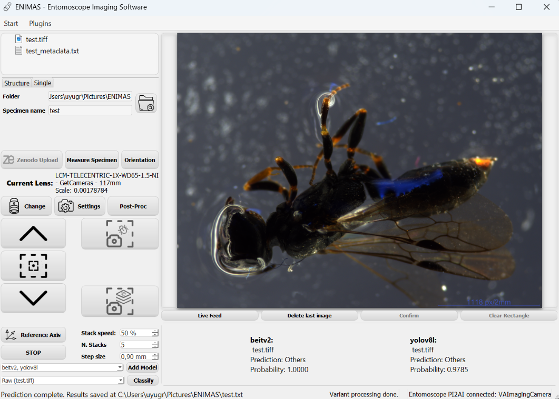
Figure 1 Application Main Interface Overview
- Menu Bar
Located at the top of the window, the Menu Bar provides dropdown access to device selection and plugin functions.
- Directory Manager
Directly below Menu Bar, showing image files and folders. Under the file view is a path selection area where user can specify the path for saving image.
- Toolbar
Positioned below Directory Manager on the left side of the window. The Tool Bar contains quick-access buttons for commonly used actions such as managing lenses, taking images and moving camera.
- Video Display Area
The central main workspace of the window, displays camera live feeding and captured image, allows user interaction such as annotating specimen on displayed static image.

- Classification Result Viewer
Located underneath Video Display Area, shows classification results of displayed image.
- Status Bar
At the bottom of the window, shows current state of the application, error messages and progress indicators.

Typical Workflow

Initial Setup
Open the application window Select connected device Reference axis Autofocus Camera settings

Image capture
Post-Proc Specify image saving path Take an image

Measurement
Measure Specimen Adjust bounding box Confirm Save annotated image

Classification
Select models for classification Select image variant for classification Classify

Core Features

Select Device
Start > Select Device, choose the connected device correctly.
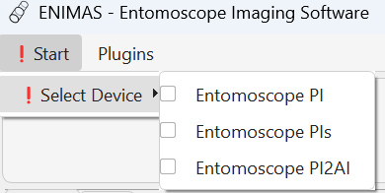
Figure 2 Select Device
Once the correct device is selected,
- The exclamation mark icon will disappear.
- Configuration parameters for selected device will be loaded and applied automatically.
- Current connection states and the camera type will be displayed at bottom right of the window.
- Reference axis and take single image function will be enabled.
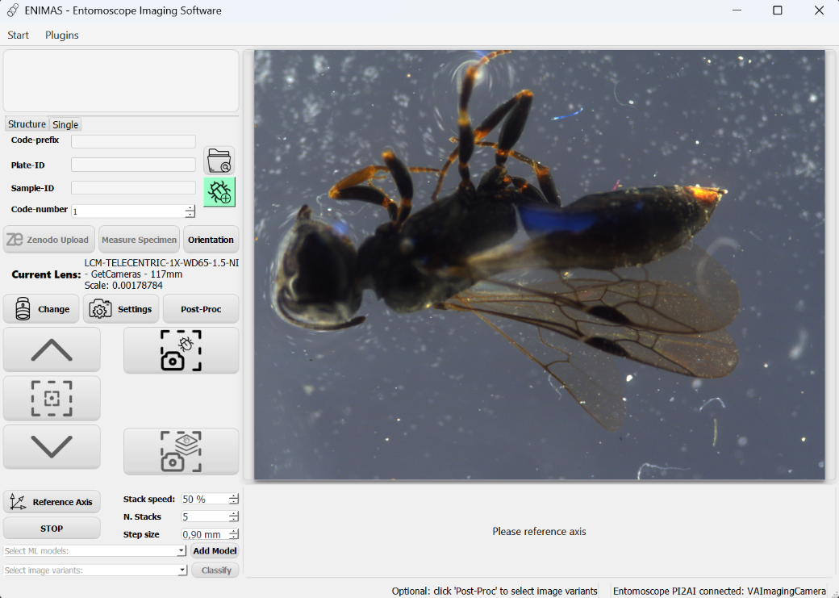
Figure 3 Device Selected

Camera movement control

Reference Axis
- Purpose:
- Define a fixed baseline orientation for camera movement.
- Ensure that all positional data are interpreted consistently.
- Usage:
Click “Reference Axis” button.
- Move camera to the sensor-detected highest point
- A dialog will appear promoting user that reference is in progress.
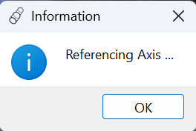
Figure 4 Reference Dialog
- Once reference is complete, the dialog box will close automatically and stacking method selection dialog appears. (see Section Core Features > Image Acquisition > Stacking Method Selection)
- All functions are enabled.
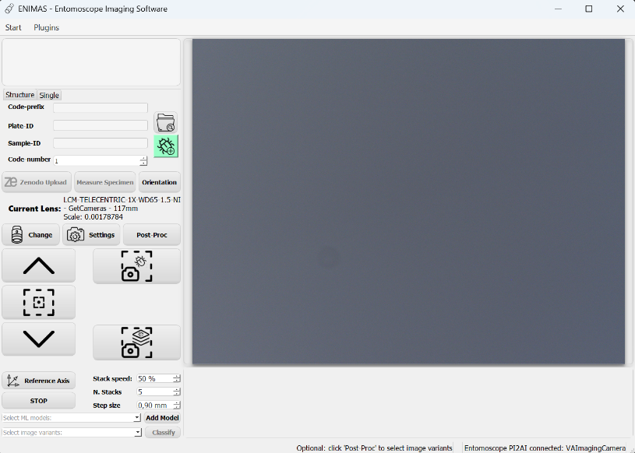
Figure 5 Referenced

Autofocus
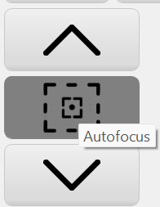
Move Down Button
Autofocus Button
Move Up Button
Figure 6 Autofocus Button
- Purpose:
- Move camera to focus height automatically.
- Help improve image quality.
- Reduce manual operations.
- Usage:
Click “Autofocus” Button
- A dialog box appears asking for confirmation of current lens.
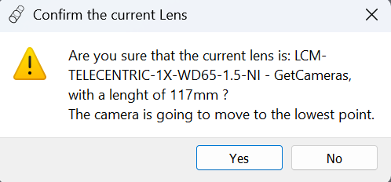
Figure 7 Confirmation Lens for Autofocus
- First camera will be moved down to the lowest point, then move up step by step. It will stop automatically near the position with maximum sharpness.
- Once the camera stopped moving, user can use move up/ move down buttons to fine-tune the position.
- The auto-focus height will be recorded for current lens. The next time this lens is selected, a dialog will appear prompting the user to move to the recorded focus height.
- If the camera movement does not stop near the optimal focus height, user should manually abort the autofocus process and choose to either restart autofocus or adjust manually.
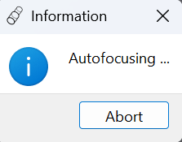
Figure 8 Autofocusing Dialog

Lens Management
Click “Lens Change” Button to launch Lens management dialog.
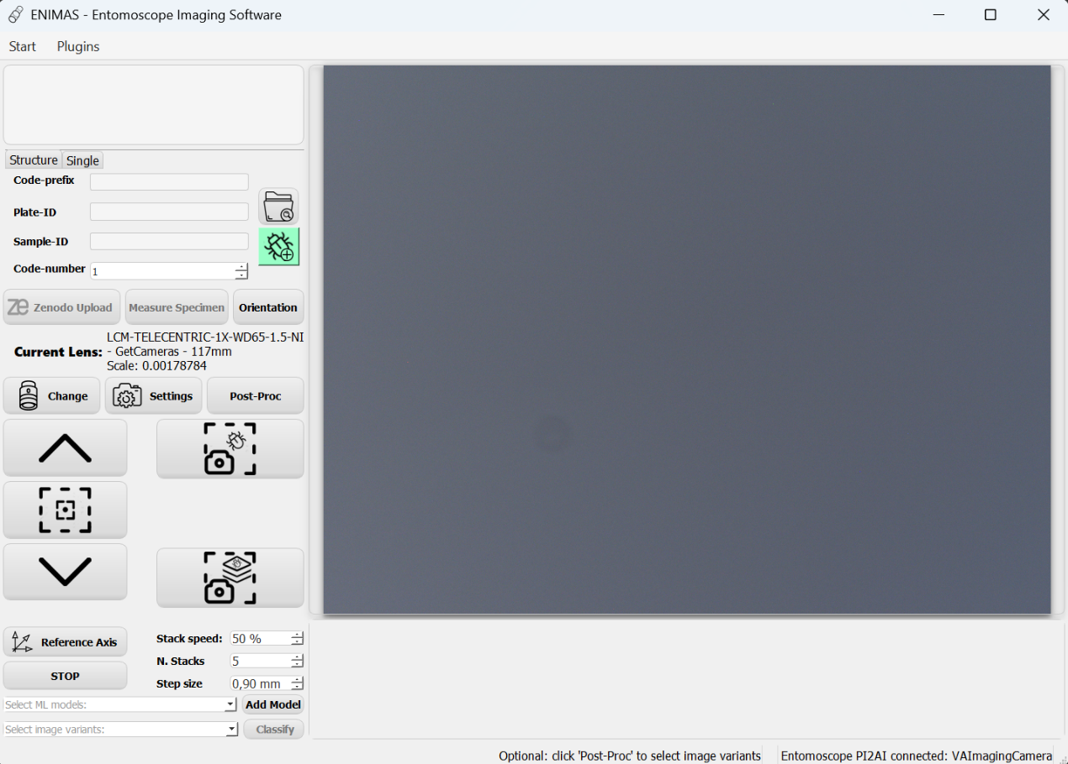
Figure 9 Lens Change Button

Lens Selection
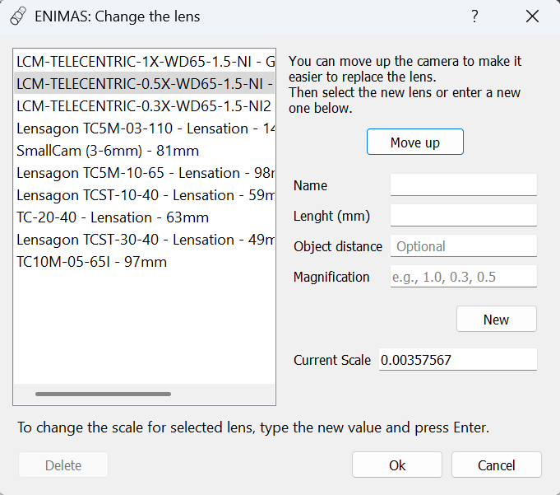
Figure 10 Lens Dialog
- Purpose:
- Apply new travel path automatically to prevent lens crashes the plate.
- Load scale of current lens for correct measurement.
- Usage:
- Click Move up to move the camera to the highest point for easier lens replacement. (Optional)
- Change lens.
- Select current lens name in the lens list if exists.
- Click “Ok” to confirm.
- To change the scale for selected lens, user can input expected scale value, then press Enter key.

Lens Addition
- Purpose:
- Store specific information for new lens, such as name, length, magnification factor, scale(mm/pixel).
- Ensure accurate scaling, measurement and documentation.
- Avoid the need to recalibrate after changing lens.
- Usage:
- Input Name, Length, Magnification.
- Click “New” to add a new lens to our list.
- Item “Name – Length” will be displayed in lenses list.
- If name or length is missing, an error message will appear in the status bar, which is located at the bottom of the lens dialog.
- If magnification factor is missing, scales for 2 cameras will set to None, user should input the scale manually after creating new lens item.
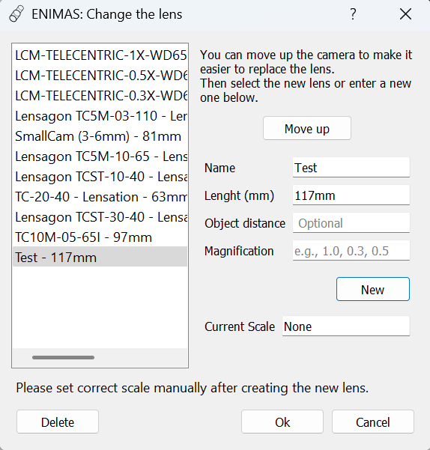
Figure 11 Missing scale for new lens
Note: Lens scale(mm/pixel) is an essential parameter for measurement, which can be calculated automatically by using the lens’ magnification values$M$: ${scale}_{b}={scale}_{a}×\frac{M_{a}}{M_{b}}$ .
- Lens Deletion: Select a lens, click “delete” to delete. (Optional)

Camera settings
Click “Camera Settings” button to launch camera settings dialog.
Figure 12 Camera Settings Button

Exposure Time
- Purpose:
- Control how long the camera sensor is exposure to light.
- Affect brightness and motion blur in the image.
- Usage:
- Manually slide or enter a number.
- Click “Auto Exposure time.

White Balance
- Purpose:
- Adjust the color of image.
- Ensure image appear natural under different lighting conditions.
- Prevent unwanted color casts.
- Usage:
- Manually slide or enter a number.
- Click “Auto White Balance”.
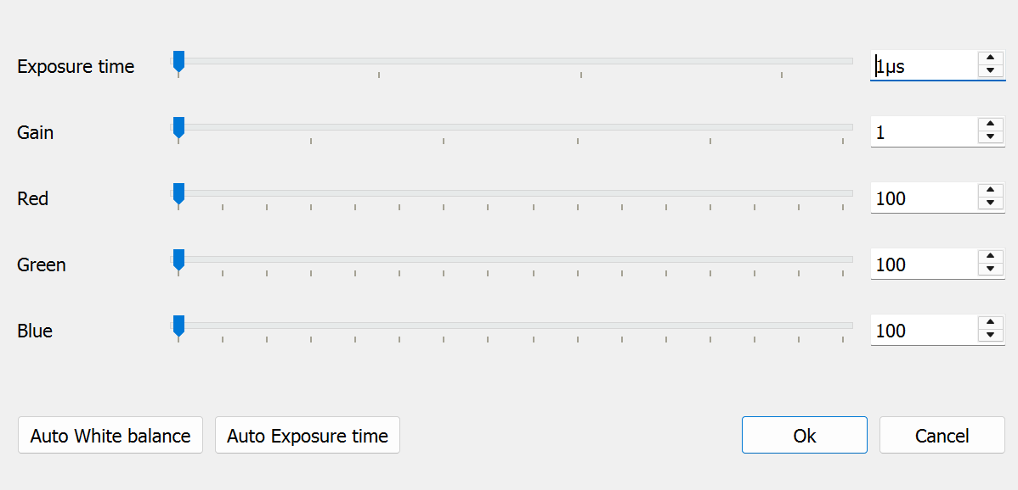
Figure 13 Arducam Camera Setting Dialog

Gain
- Purpose:
- Amplify the signal from a camera sensor.
- Improve visibility in low-light conditions.
- Usage:
- Manually slide or enter a number.
- Click “Auto Gain”.

Gamma Correction
- Purpose:
- Ensure the brightness and contrast appear natural to human vision.
- Improve visual fidelity.
- Usage: Enable the checkbox.
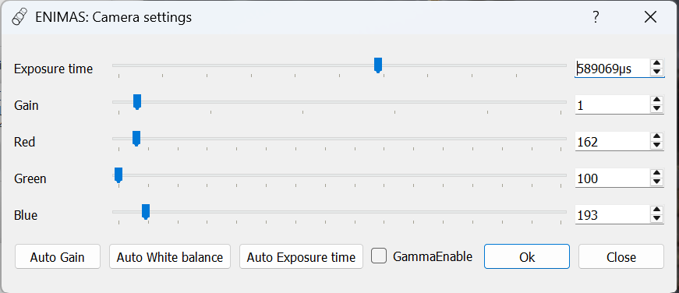
Figure 14 VAImaging Camera Setting Dialog

Image save settings
- Purpose:
- Use different image processing methods to save processed image variants.
- Provide multiple options for specimen classification.
- Provide reference for specimen measurement.
- Usage:
- Click “Post-Proc” to open image saving settings dialog.
- Enable the checkbox of desired image processing method.
- Click “Ok” to confirm the choice, then the dialog will close automatically.
- The selected methods will be displayed at the bottom of the dialog and the main application window.
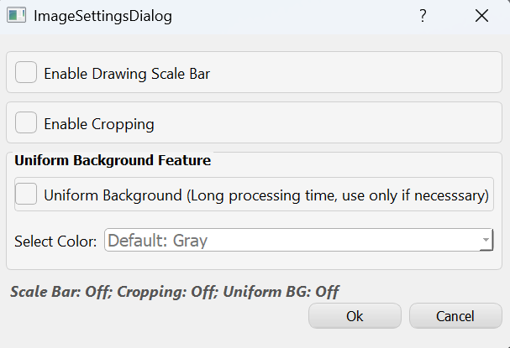
Figure 15 Image Save Settings Dialog

Enable Drawing Scale Bar
- Draw a scale bar on captured image, which will also be displayed on UI.
- The scale bar(pixel/mm) is calculated from Lens scale(mm/pixel).
- Ensure that every image has a visible reference for physical size.
Figure 16 Right Bottom Slice of an Image

Enable Cropping
- Save a cropped image after capturing an image if cropping enabled.
- Remove irrelevant background.
- Offer 2 cropping methods:
- YOLO-Fast: fast processing.
- BoxSegmenter-Accurate: more accurate but slower.
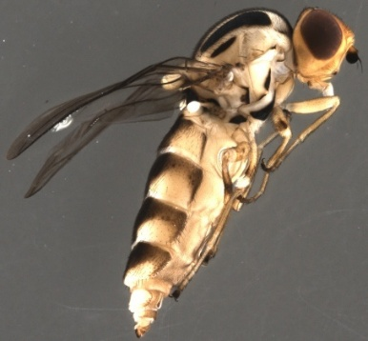
Figure 17 Cropped Image

Enable Uniform Background
- Save an image with uniform background after capturing an image if uniform background is enabled.
- Remove irrelevant background and replace it with a specified color.
- To use this feature, enable the checkbox and select a replacement color. (If none is selected, gray will be used as the default.)
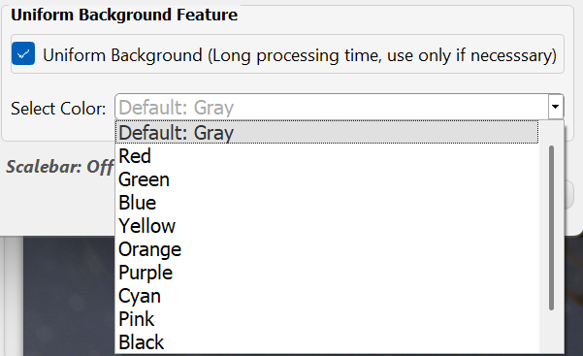
Figure 18 Replacement Color
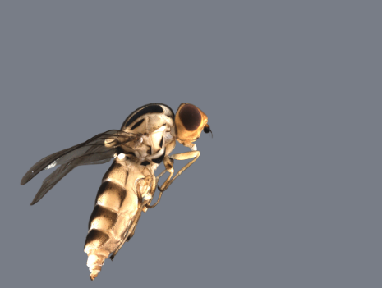
Figure 19 Uniform Background Image (Gray)

Orientation selection
- Click “ Orientation” to launch orientation dialog.
Figure 20 Orientation Button
- The specified orientation of the specimen will be recorded in _metadata.txt file, which is saved in the same folder as the captured image.
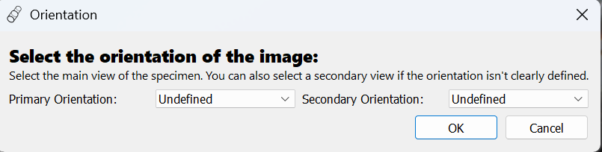
Figure 21 Orientation Dialog
- When the specimen is not perfectly positioned in one of the orientations, the secondary orientation can be specified as an auxiliary option.
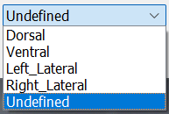
Figure 22 Orientations

Image acquisition

Single Image

Path Specification:
- Click folder icon to specify a folder for saving images. (Optional – Default path: C:\Users\You\Pictures\ENIMAS).
- Specify a name for the image to be captured.
- If the name already exists, a numerical code (start from _001) will be automatically added after the current name when taking an image.
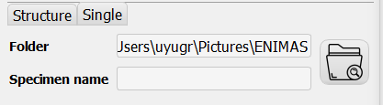
Figure 23 Single Image Path

Take Single Image: Click take single image button.
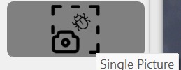
Figure 24 Take Single Image Button

Stacking Image

Path Specification:
- Input Code-Prefix, Plate-ID, Sample-ID.
- Click green insect icon to increase code number.
- Stacked image is saved in path:
C:\Users\You\Pictures\ENIMAS\{Code-Prefix}\{Plate-ID}\{Code-Prefix_Code-number}\
- Raw images for stacking will be saved in folder:
{Plate-ID}_{Code-Prefix_ Code-number}_ RAW_Data_{Code-number}
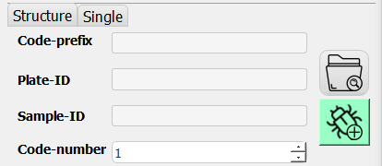
Figure 25 Stacking Image Path
- Take Stacking Image: Click take stacking image button.
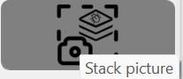
Figure 26 Take Stacking Image Button

Stacking Method Selection
- Right click taking stacking image button.
- Click “Change fuse method…” to launch method selection dialog.
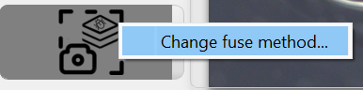
Figure 27 Stacking Method Selection Button
- Focus: Only use this method if installed — the path will be searched automatically. If not found, click “Browse” and select the path of HeliconFocus.exe manually.
- Self-made version: Use when no Helicon Focus software available.
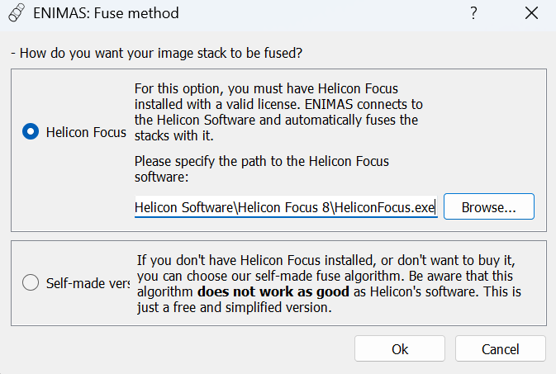
Figure 28 Stacking Method Selection Dialog

Image Displayment
- Captured image will be displayed at the place where the camera live feed was displayed.
- Click “Live-Feed” button to resume the camera live feeding.
- Click “Delete last image” button to delete current shown image and all relevant files, the background image processing will also stop.

Measurement
- Purpose:
- Runs automatic target detection on a captured image.
- Draws a bounding box on captured image.
- Converts the box into measured width and height.
- Reduces manual work.

Start Detection
- Click “Measure Specimen” button.
- A spinner icon is showing during processing.
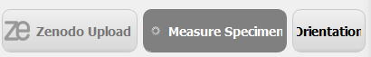
Figure 29 Spinner during Measurement

Detection Outcome
- If successful: an editable bounding box is placed on static showing image.
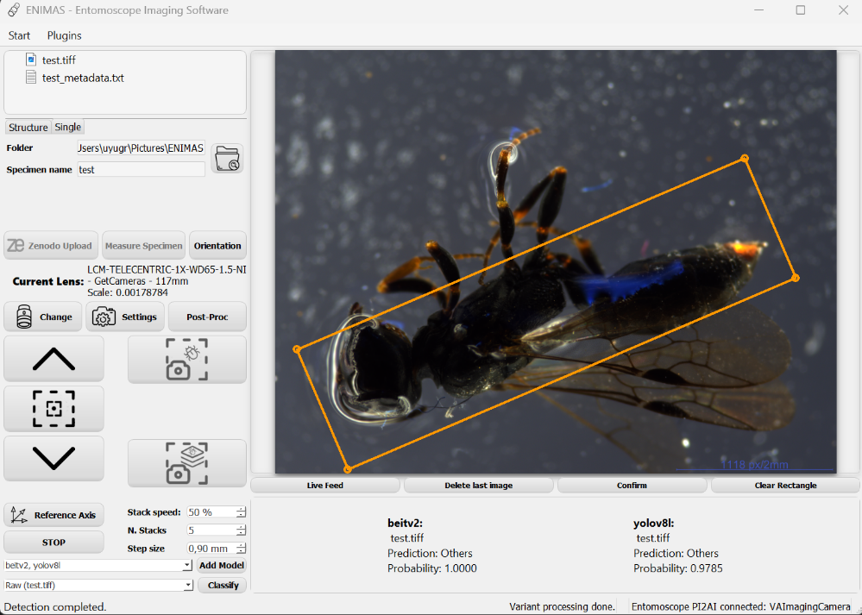
Figure 30 Specimen Detected
- If failed: A dialog appears: “No detection found in the image. Please annotate the image manually.” User can draw a bounding box manually on the static showing image.
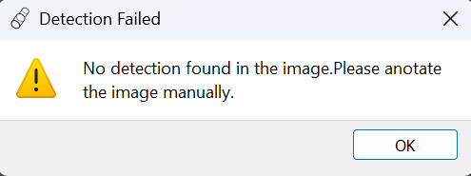
Figure 31 Detection Failed

Manually Drawing
- Move the cursor to where you want the box corner to be.
- Press and hold the left mouse button, then move mouse to drag the box to expected size.
- Release the button when the box has expected size.

Edit Bounding Box
- Move: place the cursor inside the box, keep pressing the left mouse button during dragging the box.
- Resize: place the cursor on one of the box corners, keep pressing the left mouse button while adjusting the box size.
- Rotate: press the left/right arrow keys to rotate the box.

Confirm
- Click “Confirm” button when the box is positioned and sized correctly.
- After confirming the editable box will be replaced with 2 highlighted edges and their length. (width and height in mm)
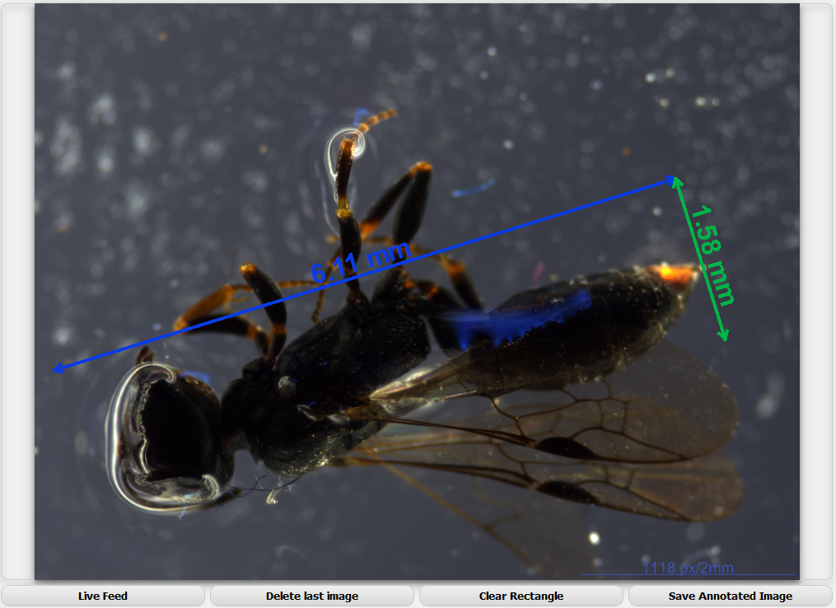
Figure 32 Box Confirmed

Clear Rectangle
- If you are not satisfied with current box or measurement result, click “Clear Rectangle” button to clear all the annotation and restart the measurement procedure or directly draw a box manually.

Save Measurement Result
- Click “Save Annotated Image” to save image with width and height annotated in the same folder as the captured image.
- The measurement result will also be saved in _metadata.txt file.

Classification

Add Model

Purpose:
- Add classification model from local folder.

Usage:
- Click “Add Model” button to launch add model dialog.
- Input the name of the model to create a folder to store the model.
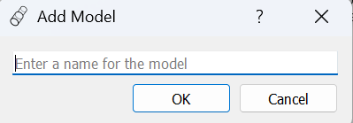
Figure 33 Add Model Dialog
- Click “OK”, Windows File Explorer will open.
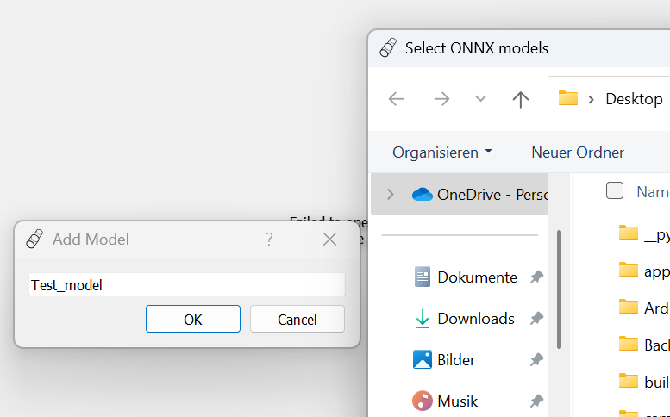
Figure 34 Select A Local Model File
- Select your local model file.

Select Model

Purpose:
- Select classification models.

Usage:
- Enable the checkboxes of desired models.
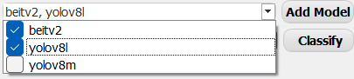
Figure 35 Select Model for Classification

Classify

Purpose:
- Automatically assign each image to one of the predefined classes.
- Save an excel file for the classified image.
- Display the classification result under the static showing image.

Usage:
- Select a desired image variant.
Note: if user deleted current displayed image or returned to camera live-feed, the image variant box will be cleared, classification is not possible.
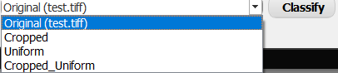
Figure 36 Select an Image Variant for Classification
- Click “Classify” button to start classification for the selected image variant.
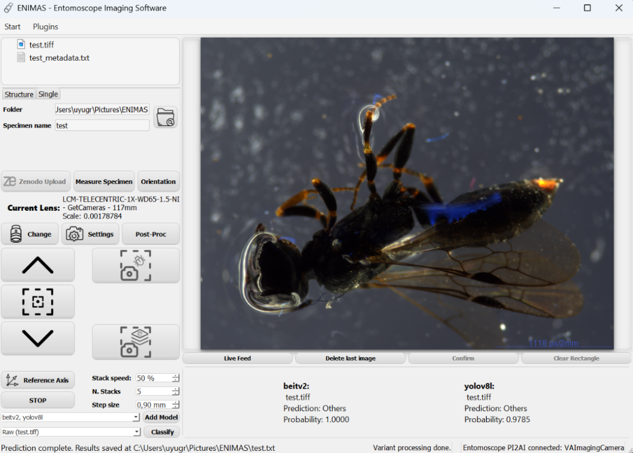
Figure 37 Classification Result

Plugins
To access plugins, navigate to the “Plugins” dropdown menu in the top-left menu bar of the application window. This menu displays a list of all available plugin functions.
- Purpose:
- Offer batch processing for image. (cropping, classification, measurement, background removal)
- Allow custom input and output path.
- Automatically load images in input folder.
- Record the processing result in an excel file.
- Usage: Click desired plugin to launch plugin window.

Common Features

Input & Output Path Selection
- Click “Browse” button to open windows file explorer.
- Select desired input & output path.
- The selected path will be displayed in the text input field.
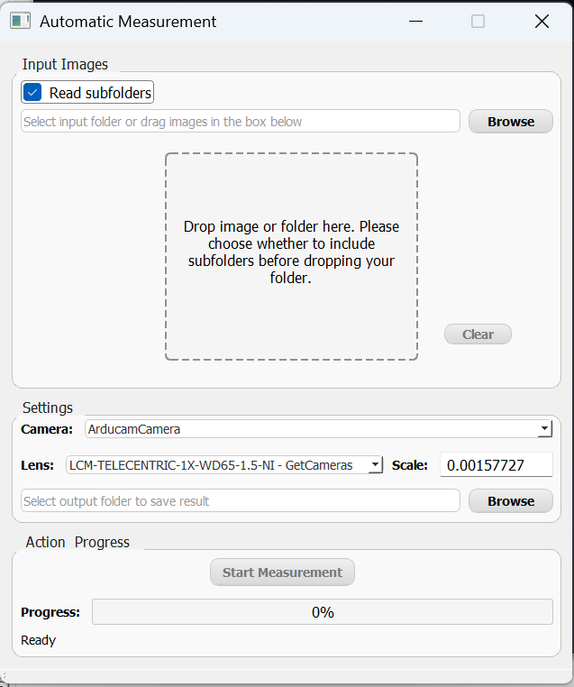
Figure 38 Input Path Selection
Figure 39 Output Path Selection
- Enable the "Read Subfolders" checkbox to include files from subfolders. Disable it to process only the top-level folder.

Drag-Drop
- First select whether to read the contents of subfolders.
- Open windows file explorer.
- Select desired input folders or individual images.
- Drag the selected items to the drag-drop area of opened plugin window. (Multiple drag-drop operations are allowed)
- The input path will be displayed in the text input field.
Figure 40 Drag-Drop Area

Save in Input Folder: Save the output excel file in input path if enabled.

Progress Bar
- Click “Start Measurement” after all the settings to start processing.
- Task processing progress will be displayed on progress bar.
Figure 41 Action Progress

Clear: Click “Clear” button to clear all the loaded images.

Measurement Plugin

Settings
For accurate measurement the lens scale needs to be defined. Before starting processing, the camera and lens need to be specified for the input images. Lens scale will automatically match the specified camera and lens.
Figure 42 Scale Settings
New Scale:
- Input specific scale in the input text field for scale.
- Press enter key.
- Input the corresponding camera and lens in the input text dialog.
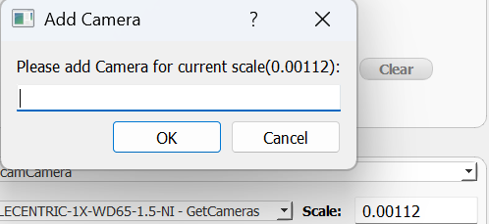
Figure 43 Add Camera Dialog
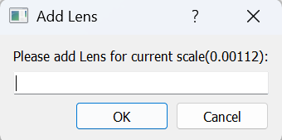
Figure 44 Add Lens Dialog
- The new scale information will also be recorded for future using.

Classification Plugin

Add Model & Model Selection
- See section Core Features > Classification.

Image Variant Selection
- Offers 4 image variants for classification: raw image, cropped image, uniform background image, cropped uniform background image.
- Select one desired image variant to enable “Start Classification” button.
- The amount of selected variant will be calculated automatically.
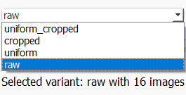
Figure 45 Image Variant Selection

Other functions
- See section Core Features > Plugins > Common Features.

Uniform Background Plugin

Color Selection
- Select color for uniform background.
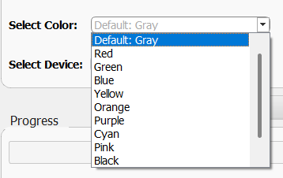
Figure 46 Color Selection

Device Selection
- Currently only CPU processing is supported.

Other Functions
- See section Core Features > Plugins > Common Features.

Cropping Plugin
- All functions see section Core Features > Plugins > Common Features.

Troubleshooting

Software Fails to Communicate with Hardware Device
Sometimes, the hardware connection may become unstable or interrupted during use. When user click a button on the application window, the command is not sent to hardware, which means there is no response from hardware.

Solution:
- Close the application window.
- Check the hardware connection, try to replug the connection.
- Launch the app again.

